**DETECTION OF ANIMALS IN AGRICULTURAL LAND** **USING CNN ALGORTHIM**

**Mrs.D.Maalini1 , S.Nivetha2 , C.Priya3 and P.Sangavi4**

1 Assistant Professor, Information Technology, V.S.B Engineering College, Karur,Tamilnadu, India.

e-mail: maalini.cse@gmail.com

2 Student, Information Technology, V.S.B Engineering College, Karur,Tamilnadu ,India.

e-mail: nivethatechit@gmail.com.

3 Student, Information Technology, V.S.B Engineering College, Karur,Tamilnadu ,India.

e-mail: sripriyachandrasekar2002@gmail.com

4 Student, Information Technology, V.S.B Engineering College, Karur,Tamilnadu, India.

e-mail: sangavi20011107@gmail.com.

**ABSTRACT**

Crop damage caused by animal attacks is one of the major threats in reducing the crop yield. Due to the expansion of cultivated land into previous wildlife habitat, crop raiding is becoming one of the most antagonizing human-wildlife conflicts. Farmers in India face serious threats from pests, natural calamities & damage by animals resulting in lower yields. Traditional methods followed by farmers are not that effective and it is not feasible to hire guards to keep an eye on crops and prevent wild animals. Since safety of both human and animal is equally vital, it is important to protect the crops from damage caused by animal as well as divert the animal without any harm. Thus, in order to overcome above problems and to reach our aim, we use deep learning to detect animals, entering into our farm by using deep neural network concept, a division in computer vision. In this project, we will monitor the entire farm at regular intervals through a camera which will be recording the surrounding throughout the day. With the help of a deep learning model, we detect the entry of animals and we play appropriate sounds to drive the animal away. This report specifies various libraries and concepts of convolutional neural networks used to create the model.

1. **INTRODUCTION**

Agriculture meets food demands of the population and also provides various raw materials for industries. Interference of animals in agricultural lands causes a huge loss of crops. Crop damage due to raiding wild animals has become a major issue of concern these days. Animals like wild buffalo, cow, and goat are extremely destructive and have also caused human casualties sometimes. The total losses in crop yield are high for potato and wheat in villages. Small farmers lose up to 40 to 50 percent of their crop to wild animals and they cannot take any harsh measures due to the strict wildlife laws. Human-animal conflict is rising intensely as elephants are a highly conflict prone wildlife species, especially in India. Thus, there is need for a system which can help the farmers to drive away these animals as soon as they learn about their intrusion.

A good crop yield with minimal expenditure is the need of the hour, and farmers who want to try this method need not spend much. Each farmer expects a good harvest at the beginning of every planting season. Farmers of the state face serious threats from frequent natural calamities like cyclone, flood, draught etc. Besides these, sudden pest attack and crop damages by domestic and wild animals at the harvesting season results a significant lower yields or sometimes complete loss of yields.

Neither farmers nor government officials are able to solve this issue and only trying to drive these animals back to the forest regions by beating drums, lighting fire crackers etc. Researchers and planners throughout the world are trying to find some alternative methods to solve this problems of farmers. A farmer near the forest or hilly region is not sure whether he would receive a good yield of his crop and feed his family members. Though some of the methods like wire fences and electric fences may be adopted to protect the crop from wild animals, these are costlier and the cost depends on size of the area. Moreover, it is allowed only for protection against endangered animal species.

Additionally, electric fences are kept away from any possible human contact and may be sometimes life threating. Hence, it is essential to use any electronic Automation which will not cause any danger to the wild animals as well as human beings. Here in our project we are implementing the Artificial intelligence technique to detect the animal intrusion in the farming lands. We use sound waves to distract the animals from the farming lands without any harmful to the animals as well as human beings. The placement of the Passive Infrared (PIR) sensor is in such a way that it gives a wider range for detection. In t, initially a glimpse of an existing system is given followed by the hardware description of the proposed system. Objectives and scope explain the aims of the system and the purpose of implementation of different components.

1. **OBJECTIVES**

* To study Image processing techniques and apply an algorithm for convolutional neural network.

* To design an automatic system to control animal crop detection using image processing.
* In the field of Deep Learning to provide a monitoring and repelling system for Animal crop attack.

1. **SCOPE**

1. To plan a security system for farm assurance.

2. Restrict the passage of animal into the farm.

3. Use GSM module for cautioning us.

4. Plan a system that sounds through solar animal anti-agents when animal attempts to go into the farm.

1. **LITERATURE SURVEY**

**1.“IoT Concept for Animal Detection Using ANN to Prevent Animal Vehicle Collision on Highways”-IEEE-2019**.

This paper uses two major algorithms such as the motion detection algorithm with the sensors and object recognition algorithm using artificial neural networks. In this paper we have used the motion detection PIR sensor to detect the animal movement near roads and the ANN for object recognition. Once the motion is detected the object recognition algorithm recognizes whether the motion detected was due to an animal movement or any other factors. If it is because of an animal movement it sends alerts through the LED signage boards and to the android application which uses Google maps to show alerts on the corresponding area through MQTT.

**2.** **“ANIMAL DETECTION USING DEEP LEARNING ALGORITHM”-ISSN-2020**

This proposed work develops an algorithm to detect the animals in wild life. Since there are many different animals manually identifying them can be a difficult task. This algorithm classifies animals based on their images so we can monitor them more efficiently. Animal detection and classification can help to prevent animal-vehicle accidents, trace animals and prevent theft. This can be achieved by applying effective deep learning algorithms.

**3. “Wild-Animal Recognition in Agriculture Farms Using W-COHOG for Agro-Security”-IEEE-2017**

In this paper, we proposed an algorithm to detect animals in a given image. WCoHOG is a Histogram oriented gradients based feature vector with better accuracy. It is an extension of Co-occurrence Histograms of Oriented Gradients (CoHOG). In this paper LIBLINEAR classifier is used in order to get better accuracy for high dimensional data. Experimental results prove that W-CoHOG performs better than existing state of the art methods.

**4. “Animal Behavior Classification Using DeepLabCut”-IEEE-2020**

In this paper, we introduce a method to classify animal behaviors from videos taken by a fixed-point camera. In order to classify animal behavior, it is necessary to detect and track the animals. Conventional approaches for detecting moving objects are based on background subtraction and frame subtraction. Conventional methods are not suitable for detection of animals kept indoors since they are susceptible to sunlight and shadow. We propose a method to track animals and classify their behavior using skeletal information obtained by DeepLabCut.

**5. “Smart Intrusion Detection System for Crop Protection by using Arduino”-IEEE-2020**

Traditional systems like humanoid scarecrows are used even today in an agricultural field to stop birds and animals from disturbing and feeding on growing crops. There are many loopholes in such ideas and so enhancing agricultural security has become a major issue these days. Thus, this paper focuses on proposing a system which detects the intruders, monitors any malicious activity and then reports it to the owner of the system. It acts as an adaptable system which provides a practicable system to the farmers for ensuring complete safety of their farmlands from any attacks or trespassing activities.

1. **EXISTING SYSTEM**

According to previous research in crop’s security, developing countries, which are using traditional storage facilities for staple food crops, can’t protect them, leading to 20- 30% loss of agricultural products such as rice, corn etc.

Currently available solutions targets only insects, pests and grain pathogens. While other study states 5 to 10% loss in rice crops on average, in Asia is due to damage caused by rodents.

This paper is oriented to accentuate the methods to solve such problems like identification of rodents, threats to crops and delivering real time notification based on information analysis and processing without human intervention. In this device, mentioned sensors and electronic devices are integrated using Python scripts. Based on attempted test cases, we were able to achieve success in 84.8% test cases.

**INPUT DATA**

**DATABASE**

**ALGORITHM**

1. **PROPOSED SYSTEM**

The main aim of our project is to protect the crops from damage caused by animal as well as divert the animal without any harm.

Animal detection system is designed to detect the presence of animal and offer a warning. In this project we used to detect the movement of the animal.

In this project, we will monitor the entire farm at regular intervals through a camera which will be recording the surrounding throughout the day. With the help of a deep learning model, we detect the entry of animals and we play appropriate sounds to drive the animal away.

This report specifies various libraries and concepts of convolutional neural networks used to create the model.

If any of the Animal is detected using CNN algorithm in the Agricultural land and send sms.

**INPUT IMAGES**

**IMAGE PROCESSING**

**DEEP LEARNING MODEL**

**CLASSIFICATION**

**ANIMAL DETECTED**

1. **MODULES DESCRIPTION**

* IMAGE DATASET COLLECTION
* IMAGE PREPROCESSING
* IMPORTING MODULES
* CAPUTURING THE IMAGES OF ANIMALS
* CAMERA INTERFACING

**1.IMAGE DATASET COLLECTION**

For this project, we must gather every image that makes a car appear to be animal image data. This is the project's most crucial step. Therefore, all of the visuals that we see come from real-time or recorded CCTV footage. The following procedures can be taken after we get the data.

**2.IMAGE PREPROCESSING**

After gathering all the images, pre-processing is required. Thus not all images can convey information clearly. So that we may prepare the images by renaming, resizing, and labelling them. Once the procedure is complete, we can use the photos to train our deep learning model.

**3.IMPORTING MODULES**

Following that, we must import all of the required library files. Library files are collections of functions and small execution codes. This library files will assist us in performing all of the necessary steps of object detection and image processing. We use important library files such as Tensor Flow, opencv, keras, and others in this project. These libraries will aid in making our deep learning model more efficient and adaptable for processing real-time images or videos.

**4. CAPTURING THE IMAGES OF ANIMALS**

For this project, we must gather every image that makes an animal crop. This is the project's most crucial step. Therefore, all of the visuals that we see come from real-time or recorded CCTV footage. The following procedures can be taken after we get the three animal datasets.

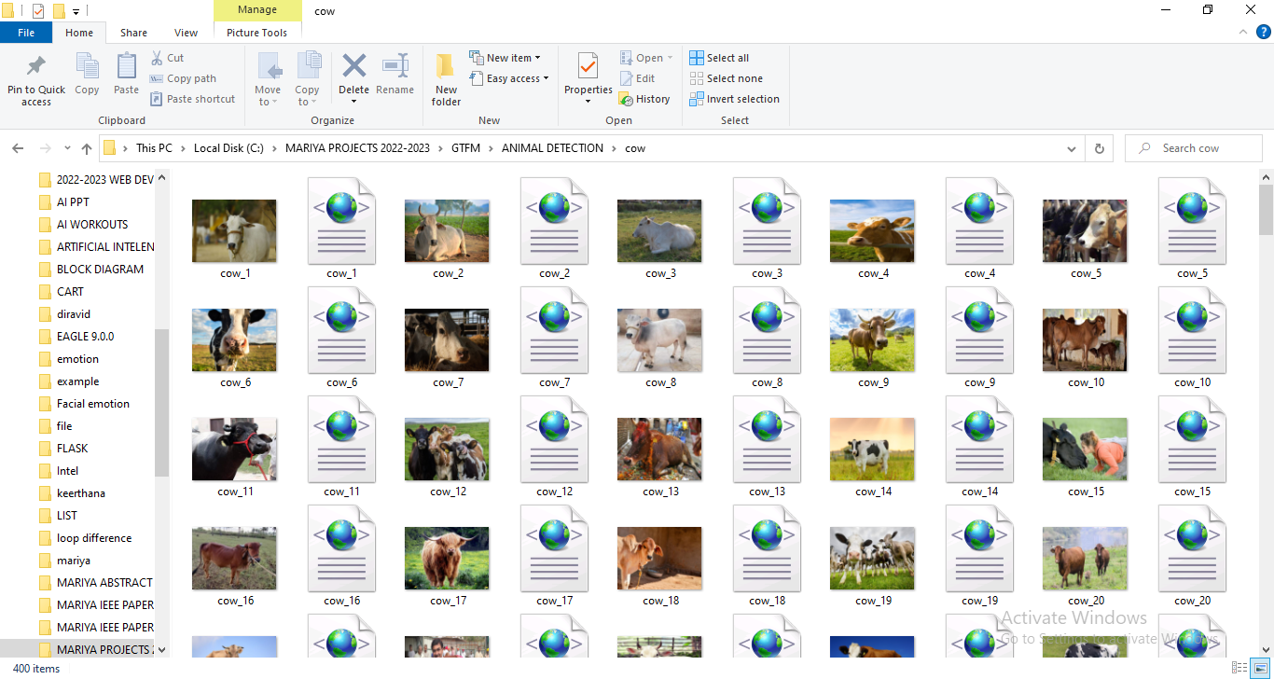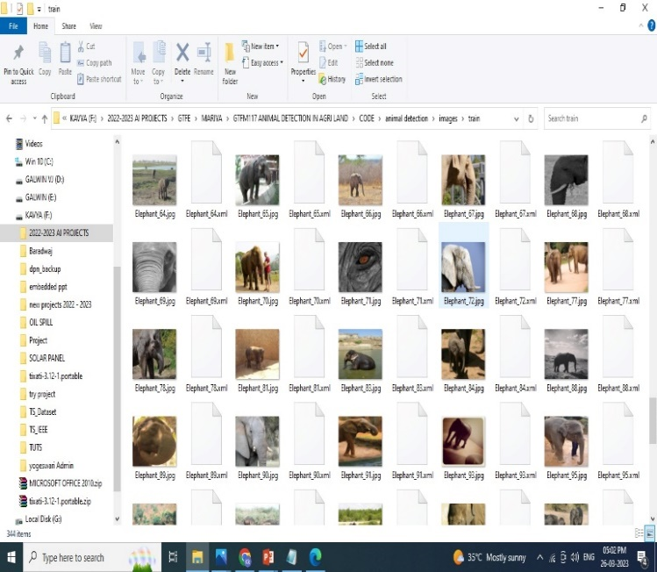

**5. CAMERA INTERFACING**

One of the most important steps in image processing is computer vision. As a result, we must connect the camera to our deep learning model. Because the computer will see all real-world objects through the camera. Motoring of all kinds of medium can be done using camera. The captured animal detecting can be produced as main source of proof if needed.

1. **ADVANTAGE**

The detecting animals that may be grazing or feeding on crops, farmers can take proactive measures to prevent crop damage, such as using scare devices or relocating the animals to other areas.

Animal detection can help farmers more efficiently monitor their land for potential threats or problems, allowing them to take action quickly and prevent potential losses.

Crop damage and improving efficiency, animal detection can help farmers save money in the long term

1. **DISADVANTAGE**

Wild animals, such a can cause significant damage to crops, which can lead to yield loss and reduced profitability for farmers.

Strategy is to implement animal monitoring measures, such as cameras or sensors, to detect animal activity early. By doing so, farmers can take preventive measures to protect their crops or livestock from damage or disease transmission.

Farmers can also work with local conservation organizations or government agencies to develop wildlife management plans that balance the needs of wildlife with the needs of farmers.

1. **APPLICATION**

The agriculture land animal of Cow, Elephant and tiger are commonly raised on agricultural land for their meat, milk, and eggs.

Animals such as cows, pigs, and chickens produce manure, which can be used as fertilizer to improve soil fertility. can help to control pests like rodents and insects on agricultural land.

Bees are important for pollinating crops, and many farmers keep bees on their agricultural land to improve crop yields.

1. **CONCLUSION**

Animal detection using CNN in agri land can be a powerful tool for farmers to monitor and manage their livestock. By training a CNN to recognize specific features of each type of animal, farmers can quickly and accurately detect the presence of their livestock and monitor their behaviour. This can help farmers identify potential health or safety issues early, as well as improve overall management and productivity. However, it's important to note that the success of animal detection using CNN in agriculture land depends on the quality and quantity of the data used to train the model, as well as the accuracy of the model itself. Further research and development in this area can lead to improved accuracy and more effective use of this technology in agriculture.

1. **FUTURE ENHANCEMENT**

Animal detection using deep learning is already a promising area of research that has seen significant advancements in recent years, and it is likely to continue to be a focus of future enhancement. Deep learning algorithms, such as convolutional neural networks (CNNs), have shown remarkable accuracy in detecting and classifying animals in images and videos. Animal detection using deep learning is the development of more efficient and accurate models. This can be achieved through the use of larger and more diverse datasets for training, as well as the development of more advanced deep learning architectures and optimization techniques.

1. **REFERENCES**

[1] Bayani, A., Tiwade, D., Dongre, A., Dongre, A. P., Phatak, R., & Watve, M. (2016). Assessment of crop damage by protected wild mammalian herbivores on the western boundary of Tadoba-Andhari Tiger Reserve (TATR), Central India. PloS one, 11(4).

[2] Rao, K. S., Maikhuri, R. K., Nautiyal, S., & Saxena, K. G. (2002). Crop damage and livestock depredation by wildlife: a case study from Nanda Devi Biosphere Reserve, India. Journal of environmental management, 66(3), 317-327.

[3] Bapat, V., Kale, P., Shinde, V., Neha, D., & Shaligram, A. (2017). WSN application for crop protection to divert animal intrusions in the agricultural land. Comput. Electron. Agric., 133, 88-96.

[4] Palita, S. K., & Purohit, K. L. (2008). Human-Elephant Conflict: Case Studies from Orissa and Suggested Measures for Mitigation. Proceedings of the seminar on Endemic and Endangered species of the Nilgiris

[5] Parikh, M., Gogoi, M., & Philip, S. (2017). Wild-Animal Recognition in Agriculture Farms Using W-COHOG for Agro-Security

[6] Govind S.K., Jayson E.A. (2018) Crop Damage by Wild Animals in Thrissur District, Kerala, India. In: Sivaperuman C., Venkataraman K. (eds) Indian Hotspots. Springer, Singapore

[7] Mehta, Piyush & Arun, Negi & Rashmi, Chaudhary & Janjhua, Yasmin & And, Thakur & Thakur, Pankaj. (2018). A Study on Managing Crop Damage by Wild Animals in Himachal Pradesh, International Journal of Agriculture Sciences,Volume 10, Issue 12, 2018, pp.-6438-6442.