**PROJECT TO REMOTELY POWER ON A PC**

**Abirami.H**(312820104001),**Mithun.D**(312820104048),**Bhuvaneshwari.P(**312820104014) Student, Computer Science and Engineering, Agni College of Technology,Chennai-603103,Tamil Nadu, India.

**Mrs.L.Prinslin.M.E**, Assistant Professor, Computer Science and Engineering, Agni College of Technology,Chennai-603103,Tamil Nadu, India

**Abstract**:

This project aims to develop a system that allows for the remote power-on of a PC. The system will consist of a hardware device that can be connected to the PC's power switch and a software component that can be installed on the PC. The hardware device will be designed to receive signals from a remote source, such as a mobile phone or a web application, and send a signal to the PC to turn on. The software component will be responsible for communicating with the hardware device and receiving the power-on signal. The project will involve designing and building the hardware device, developing the software component, and testing the system in different scenarios. The remote power-on system has potential applications in remote server management, home automation, and other similar contexts where the ability to power on a PC remotely is desirable.

**Introduction:**

The ability to remotely power on a PC has become increasingly important in today's world, where more and more people are working remotely and need to access their computer from different locations. Remote power-on capability allows a user to turn on their PC without physically being in front of it, which can save time and increase productivity.

Currently, there are several ways to remotely power on a PC, including Wake-on-LAN (WoL) and remote desktop software. However, these methods require the PC to be in a specific state, such as in sleep mode or connected to the network. Additionally, these methods may not work if the PC is completely turned off, which limits their effectiveness.

To address these limitations, this project aims to develop a system that can remotely power on a PC even if it is completely turned off. The system will consist of a hardware device and a software component that work together to send a signal to the PC's power switch to turn it on. The hardware device will be designed to receive signals from a remote source, such as a mobile phone or a web application, and send a signal to the PC to turn on. The software component will be responsible for communicating with the hardware device and receiving the power-on signal.

This project has the potential to be useful in a variety of contexts, including remote server management, home automation, and other scenarios where the ability to power on a PC remotely is desirable.

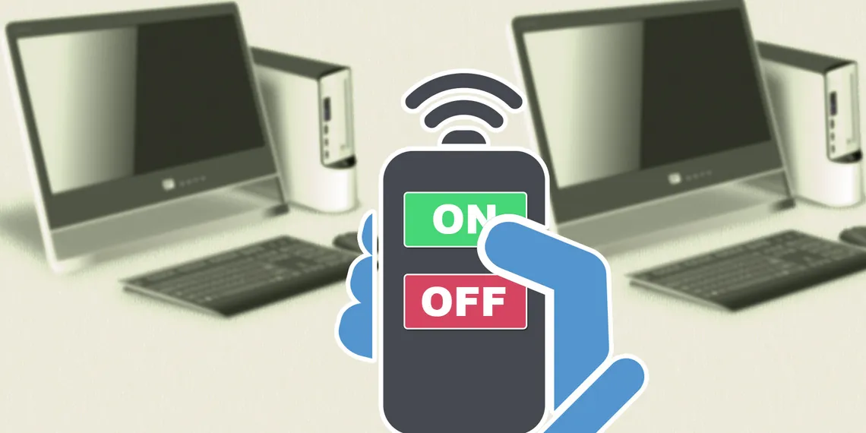

**Background Study:**

The ability to remotely power on a PC can be significant for various reasons. Here are some of them:

1. Accessibility: Remotely powering on a PC allows users to access their computer from a different location without the need to physically turn it on. This can be particularly useful for IT support staff who need to access computers remotely to provide assistance.

2. Convenience: Remotely powering on a PC can save time and effort, especially if the computer is located in a hard-to-reach place or if the user is away from the computer and needs to access it quickly.

3. Energy efficiency: Turning on a PC remotely only when it is needed can help reduce energy consumption and save on electricity costs, particularly in environments with multiple computers.

4.Home automation: Remotely powering on a PC can be integrated into a home automation system, allowing users to control various devices in their home from a central location.

5. Security: Remotely powering on a PC can be used as a security feature, as it allows users to monitor their computer and detect any unauthorized access attempts.

**Overview:**

Overall, remotely powering on a PC offers numerous benefits and can be a valuable feature in various settings, including offices, homes, and data centers.

The goal of the project is to develop a solution that allows users to remotely

power on a PC from a different location. This involves designing and implementing a hardware circuit that can control the power button of the PC and developing a software application that can send a command to the circuit to trigger the power-on process.

The hardware component of the project typically involves selecting a microcontroller or other electronic component that can interface with the PC's power button, and wiring the circuit in a way that allows the microcontroller to send a signal to the button to simulate a button press. The microcontroller is typically programmed to listen for commands from the software application and execute the power-on command when the appropriate signal is received.

The software component of the project typically involves developing a web application or other software program that can send commands to the microcontroller to trigger the power-on process. The web application is typically built using modern web technologies such as HTML, CSS, JavaScript, and jQuery, and may use a RESTful API to facilitate communication with the microcontroller.

Once the hardware and software components have been designed and implemented, the project is typically tested and validated to ensure that the remote power-on functionality works as expected. The project may also involve designing and implementing additional features, such as remote shutdown or reboot functionality, or integrating the remote power-on feature into a larger home automation or remote monitoring system.

**Wake-on-lan:**

Wake on LAN (WoL) is a network protocol that allows a computer or other networked device to be turned on or awakened from a sleep or power-off state remotely. This is achieved by sending a special network packet, called a "magic packet", to the device's network interface card (NIC). The magic packet contains the device's unique MAC address, which the NIC recognizes and uses to wake up the computer.

The Wake on LAN feature is useful for network administrators who need to remotely manage or troubleshoot computers on their network, or for individuals who want to access their home computer from a remote location. It can also be used to save power by allowing devices to enter a low-power state when not in use, but still be available for remote access when needed.

To use Wake on LAN, the computer or device must have a compatible NIC that supports the feature, and the BIOS or firmware settings must be configured to enable it. In addition, the network router or firewall must be configured to allow the magic packet to pass through to the device.

**How does wake-on-lan work?**

Wake-on-LAN (WoL) works by sending a special network packet, known as a "magic packet," to a computer that is in a low-power state, such as standby or hibernation. The magic packet contains the computer's MAC address, which is a unique identifier assigned to every network card. When the computer's network card receives the magic packet, it checks to see if the packet is addressed to its own MAC address. If it is, the network card signals the computer's power supply to turn on the computer, and the computer then boots up.

To send a Wake-on-LAN packet, you need to know the MAC address of the computer you want to wake up remotely. The MAC address can usually be found printed on a sticker on the network card, or you can use a command-line tool to retrieve it. Once you have the MAC address, you can use a Wake-on-LAN utility to send the magic packet to the computer.

To enable Wake-on-LAN on a computer, you need to make sure that its network card and BIOS support this feature. You may need to go into the BIOS settings to enable Wake-on-LAN, and you may also need to configure the network card to accept Wake-on-LAN packets.

One thing to keep in mind is that Wake-on-LAN packets are typically broadcast over the local network, so it is important to ensure that your network is secure and that only authorized users are able to send Wake-on-LAN packets to your computers. Additionally, Wake-on-LAN may not work if the computer is completely powered off, or if it is connected to a network that does not support Wake-on-LAN.

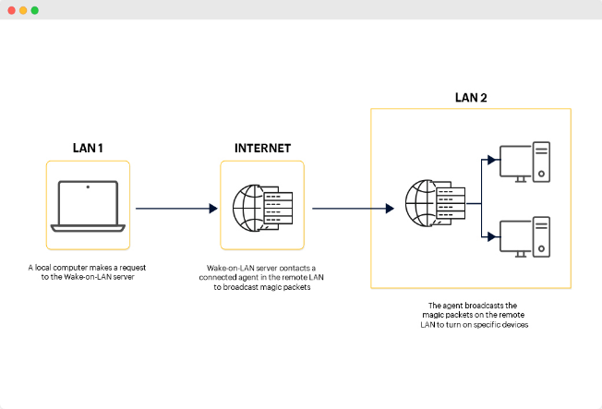

**Steps involved in waking up a pc using a wake on lan:**

Wake-on-LAN (WoL) is a protocol that allows a computer to be turned on remotely over a network. Wake-on-LAN is often used in situations where it is not practical to physically press the power button on a computer, such as when the computer is in a remote location or when the user is not physically present.

The following are the basic steps involved in setting up and using Wake-on-LAN:

**STEP 1:** Ensure that your computer's network card supports Wake-on-LAN. This feature is typically listed in the specifications for the network card. If your network card does not support Wake-on-LAN, you may need to purchase a separate network card that does support this feature.

**STEP 2:** Enable Wake-on-LAN in your computer's BIOS. The specific steps to enable Wake-on-LAN will vary depending on the manufacturer of your computer's motherboard. Consult your computer's documentation or the manufacturer's website for specific instructions.

**STEP 3:** Configure your computer's network card to accept Wake-on-LAN packets. This typically involves going into the network card's settings and enabling Wake-on-LAN support.

**STEP 4:** Obtain the MAC address of the computer you want to wake up remotely. The MAC address is a unique identifier assigned to every network card. You can typically

find the MAC address printed on a sticker on the network card, or you can use a command-line tool to retrieve the MAC address.

**STEP 5:** Install a Wake-on-LAN utility on the computer that will be used to send the Wake-on-LAN packet. There are many free and paid Wake-on-LAN utilities available for Windows, Mac, and Linux.

**STEP 6:**Configure the Wake-on-LAN utility to send a Wake-on-LAN packet to the MAC address of the computer you want to wake up remotely. The Wake-on-LAN packet can be sent over the local network or over the internet.

**STEP 7:**Send the Wake-on-LAN packet to the computer you want to wake up remotely. This can be done from another computer on the same network, or from a computer connected to the internet.

**Code creation:**

If everything is configured correctly, the Wake-on-LAN packet should be received by the computer's network card, which will then power on the computer.nnected to the internet.

To remotely power on a PC, you can use Wake-on-LAN (WoL) technology. Here's a sample code in Python that uses the wakeonlan library to send a WoL magic packet to the PC:

Python

import wakeonlan

mac_address = '00:11:22:33:44:55' # replace with the MAC address of the PC

wakeonlan.send_magic_packet(mac_address)

Make sure that the PC's BIOS settings are configured to support WoL, and that the network adapter is configured to allow the PC to be woken up remotely. You may also need to enable WoL in the operating system's power settings.

Note that WoL typically works only on local networks, so you'll need to be on the same network as the PC in order to send the magic packet. If you want to power on the PC from a different network, you'll need to configure port forwarding on the router that's connected to the PC.d be received by the computer's network card, which will then power on the computer.

**Limitations:**

Remotely powering on a PC can be a convenient feature, especially for system administrators or users who need to access their computer from a remote location. However, there are some limitations to this capability, including:

1. Hardware limitations: Not all computers are designed to support remote power-on. The computer's motherboard needs to have a specific feature called Wake-on-LAN (WoL) that enables it to receive a signal to power on.

2. Network limitations: To remotely power on a computer, both the computer and the device sending the signal need to be connected to the same local network. If the computer is not connected to the network, or if it is connected to a different network, it may not be possible to send the signal to power on the computer.

3. Security limitations: Remote power-on can be a security risk if not properly configured. For example, if someone gains unauthorized access to the device sending the signal, they could potentially power on the computer and access its data or resources.

4. Software limitations: To remotely power on a computer, you need to have access to software that can send the signal to power on the computer. This can be a limitation if the necessary software is not installed or configured properly.

5. Power limitations: Even if a computer is designed to support WoL, it may not be able to receive the signal if it is completely powered off or unplugged from the power source. In some cases, the computer may need to be in a specific sleep mode or hibernation mode to receive the WoL signal.

**Advantage:**

Remotely powering on a PC has several advantages, including:

1. Convenience: One of the biggest advantages of remotely powering on a PC is convenience. Users can turn on their computers from a remote location, which can be especially helpful for system administrators who need to access multiple computers on a network.

2. Energy savings: Remotely powering on a PC can help save energy by allowing users to turn on their computers only when they need them. This can be particularly useful for businesses with a large number of computers that are not needed all the time.

3. Cost savings: By reducing the amount of time that a computer is left on, businesses can save on electricity costs. In addition, remotely powering on a computer can help extend its lifespan by reducing wear and tear on the hardware.

4. Increased productivity: Remotely powering on a PC can help increase productivity by allowing users to access their computers more quickly. This can be particularly useful for workers who are frequently on the go or who work from multiple locations.

5. Security: Remotely powering on a PC can also help improve security by allowing system administrators to perform maintenance and updates outside of regular business hours, reducing the risk of disruption to users.

**Conclusion:**

In conclusion, remotely powering on a PC using Wake-on-LAN (WoL) protocol can be a convenient and energy-efficient way to access a computer from a remote location. It allows users to turn on their computers only when they need them, reducing energy consumption and costs. Additionally, WoL can improve productivity by allowing users to access their computers more quickly, and it can enhance security by enabling system administrators to perform maintenance and updates outside of regular business hours. However, there are some limitations to WoL, including hardware, network, security, software, and power limitations, which must be taken into account when using this technology. Overall, WoL can be a useful tool for businesses and individuals who need to access their computers remotely, but it is important to use it in a secure and responsible manner.

**Reference:**

* von Nagy, Andrew (8 November 2010). "Wake on Wireless LAN". Revolution Wi-Fi Blog. Retrieved 28 October 2015.
* Fleishman, Glenn (28 August 2009). "Wake on Demand lets Snow Leopard sleep with one eye open". Macworld. Archived from the original on 16 September 2009. Retrieved 15 September 2009. How it works, Energy Saver preference pane
* Essick, Kristi (31 October 1996). "Intel, IBM strike deal to lower PC ownership costs". Computerworld. New Zealand. Archived from the original on 2015-12-08. Retrieved 28 October 2015.
* "IBM Announces Universal Management - Industry's Most Comprehensive Tools to Lower Total Cost of Ownership". IBM News Room. 14 April 1998. Archived from the original on 2012-10-12. Retrieved 28 October 2015.
* "Ethernet Tips & Tricks". Less Watts. Archived from the original on November 26, 2007.
* "Understanding Wake On LAN". LANdesk.com. Retrieved 28 October 2015.
* "Plan how to wake up clients in Configuration Manager". Microsoft Docs. 2019-04-23. Retrieved 2020-10-29. ... By default, traditional wake-up packets are transmitted by using UDP port 9...
* WakeOnLAN on Wireshark wiki.
* Stevens, W. Richard (2007). "Chapter 12. Broadcasting and Multicasting". TCP/IP Illustrated, Volume 1: The Protocols. Archived from the original on 2014-11-06. Retrieved 28 October 2015.
* Haden, Rhys. "IP Addressing". Data Network Resource. Retrieved 28 October 2015.
* "Magic Packet Technology (White Paper, Publication# 20213, Rev: A Amendment/0)" (PDF). AMD. November 1995. Retrieved 28 October 2015.
* "About Subnet-Directed Broadcast Wake-Up Packets for Wake On LAN". Microsoft System Center Configuration Manager. 2007. Archived from the original on 2017-06-30. Retrieved 28 October 2015.
* Marshall, Allen. "ACPI In Windows Vista". WinHEC 2006. Microsoft. pp. 23–25.
* "Understanding 802.1X Authentication with Wake-on-LAN". Cisco Catalyst 6500 Release 12.2SX Software Configuration Guide.
* "Intel Centrino 2 with vPro technology and Intel Core2 processor with vPro technology" (PDF). Intel. Archived from the original (PDF) on 2008-12-06. Retrieved 7 August 2008.
* "Advanced Encryption Standard (AES) Instructions Set". Intel. Archived from the original on 2008-09-24. Retrieved 6 April 2008.
* "Hardening Measures Built into Intel Active Management Technology". Intel. Archived from the original on 2008-03-20. Retrieved 11 June 2008.
* "Xlife » Using Wake-On-LAN WoL/PME to power up your computer remotely". zuavra.net. Archived from the original on 8 March 2007. Retrieved 28 October 2015.
* "Intel® PRO/Wireless 3945ABG Network Connection – Overview". Intel.com. Archived from the original on 2009-02-01. Retrieved 28 October 2015.
* "How to connect the UIRT2 B". skynet.be. Archived from the original on 21 January 2007. Retrieved 28 October 2015.
* p, Jessica (16 August 2016). "Wake On Lan Tools". PCWDLD.com. Retrieved 9 September 2016.
* "'Wake on LAN' (WOL) behavior in Windows 8 and Windows 8.1". Microsoft. 2015. Retrieved 28 October 2015.
* "System Power States". Microsoft. Retrieved 28 October 2015.
* "HP Support document". Hewlett-Packard Support Center. Retrieved 4 January 2018.
* "About Wake on Demand and Bonjour Sleep Proxy". apple.com. Retrieved 28 October 2015.
* Brecht, Tim (2003). "Remote Wake-Up: Intel® Network Adapters User Guide". University of Waterloo. Retrieved 28 October 2015.
* "Router Port Forwarding Guides". portforward.com. Retrieved 28 October 2015**.**