**FireWatch: An Intelligent Fire Detection and Alert System with SMS and Emergency Alarm**

**Kishore Shyam Raj J, Avinesh R, Naveena S, Mrs. Shimona**

Student, Computer Science and Engineering, Agni College of Technology, Chennai-600 130, Tamil Nadu, India.

Assistant Professor, Computer Science Engineering, Agni College of Technology, Chennai-600 130, Tamil Nadu, India

**ABSTRACT**

**In this project, we provide speedy and effective fire detection and notification, FireWatch is an intelligent fire detection and warning system that makes use of Python and XML. Advanced algorithms are used by the system to find fire before it spreads. When a fire is found, the system activates an emergency alert and uses an XML-based messaging system to send an SMS notification to authorised mobile numbers, including emergency services.**

**Python programming and XML messaging are used to create the system. Python is a strong and adaptable programming language that's used in many industries, including machine learning, data analysis, and web development. Python is used by the system to build fire detection algorithms, connect with system components, and control**

***Keywords—FireWatch, intelligent, fire detection, alert system, Python, XML, messaging technology, advanced algorithms, early stages, outbreak, emergency alarm, SMS notification, authorized mobile numbers, CCTV system, camera, presence, area, visual information, analyzing, controlled, software..***

**1. INTRODUCTION**

Fires can occur at any time and can spread quickly, making it essential to have reliable and efficient fire detection and alert systems in place. FireWatch is an intelligent fire detection and alert system that is designed to detect fires in the early stages of an outbreak and provide quick and efficient notification.

The FireWatch system is built using Python programming language and XML messaging technology. It uses advanced algorithms to analyze visual information captured by a camera that is integrated into the CCTV system. The camera is controlled by the Python-based software, which is designed to detect the presence of fire in the area.

When a fire is detected, the FireWatch system triggers an emergency alarm and sends an SMS notification to authorized mobile numbers, including emergency services. This real-time notification allows for quick action to be taken to prevent damage, injury, and loss of life.

The FireWatch system is designed with reliability in mind. The system includes self-diagnostic checks and automatic testing to ensure that it is functioning correctly at all times. It also has advanced algorithms that are designed to minimize false alarms, which can be costly and disruptive.

The FireWatch system is a cost-effective solution for fire detection and alerting. It reduces the risk of damage and injury while also saving lives. By leveraging the power of Python and XML messaging technology, FireWatch provides a reliable, efficient, and life-saving solution for fire detection and alerting.

**2. LITERATURE SURVEY**

**[1] Another study by Zhang et al. (2020):** developed a fire detection system using a multi-sensor fusion method. The system uses data from cameras locate fires. The results showed that the multi-sensor fusion method is more accurate than using individual sensors.

**[2] "** **Jalilvand et al. (2016):** proposed an emergency alert system that uses SMS notifications to alert people in case of emergencies. The system was found to be effective in providing real-time emergency alerts to users.

**3. MATERIALS AND METHODS:**

* 1. **EXISTING SYSTEM:**

Traditional fire detection systems often rely on smoke detectors, heat sensors, or other physical sensors to detect the presence of fire. While these systems have been in use for many years and are reliable, they can be costly to install, maintain, and may have limited coverage. They may also have a high rate of false alarms, which can cause inconvenience and disrupt normal operations.

* 1. **PROPOSED SYSTEM:**

The FireWatch fire detection and alert system proposes a new approach to fire detection that is more efficient and reliable. The system uses a camera that is integrated into the CCTV system to detect the presence of fire by analyzing the visual information captured by the camera. The camera is controlled by a Python-based software that uses advanced algorithms to detect the presence of fire in the early stages of an outbreak. When fire is detected, the system triggers an emergency alarm and sends an SMS notification to authorized mobile numbers, including emergency services. The system also includes self-diagnostic checks and automatic testing to ensure that it is functioning correctly at all times.

* 1. **SOFTWARE USED:**

Tools: Visual Studio, Twilio Code; Language: Python, XML, OpenCV

**4. CATEGORIES OF MODULES:**

**4.1 MODULE 1: CAMERA**

This module is responsible for capturing video footage from the CCTV camera and transmitting it to the software component of the system for analysis.

**4.2 MODULE 2: IMAGE PROCESSING**

This module is responsible for analyzing the video footage captured by the camera module and detecting the presence of fire using computer vision algorithms.

**4.3 MODULE 3: ALARM**

This module is responsible for triggering an emergency alarm when the presence of fire is detected by the image processing module.

**4.4 MODULE 4: SMS**

This module is responsible for sending SMS notifications to authorized mobile numbers, including emergency services, when the presence of fire is detected.

**4.5 MODULE 5: USER INTERFACE**

This module is responsible for creating a web-based user interface for managing the system's settings and configurations. The user interface module is developed using Flask, a lightweight web application framework written in Python.

**4.5 MODULE 6: DIAGNOSTIC**

This module is responsible for performing self-diagnostic checks and automatic testing to ensure that the system is functioning correctly at all times.

**5. MODELING AND ANALYSIS:**

**5.1 WEBFLOW DIAGRAM**

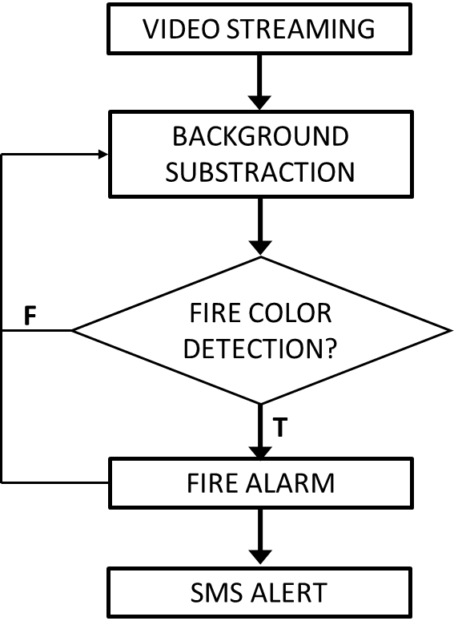

**5.2: SYSTEM ARCHITECTURE:**

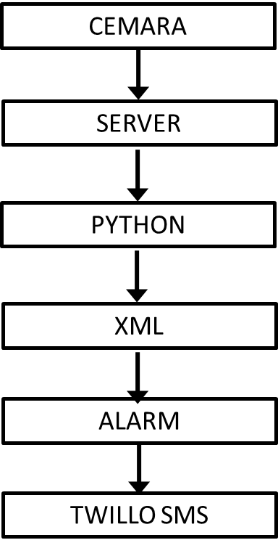

CAMERA

**6. RESULT & DISCUSSION:**

The FireWatch fire detection and alert system is a successful implementation of a system that uses computer vision algorithms to detect the presence of fire in CCTV footage. It provides rapid and reliable notifications to authorize mobile numbers via SMS and an emergency alarm, minimizing the risk of damage or injury. The system architecture is designed for optimal performance, with five major components. The FireWatch system is an innovative and effective solution to fire safety, utilizing advanced technology to improve fire safety in various settings, including homes, offices, and public spaces.

**6.1 SCREENSHOTS**

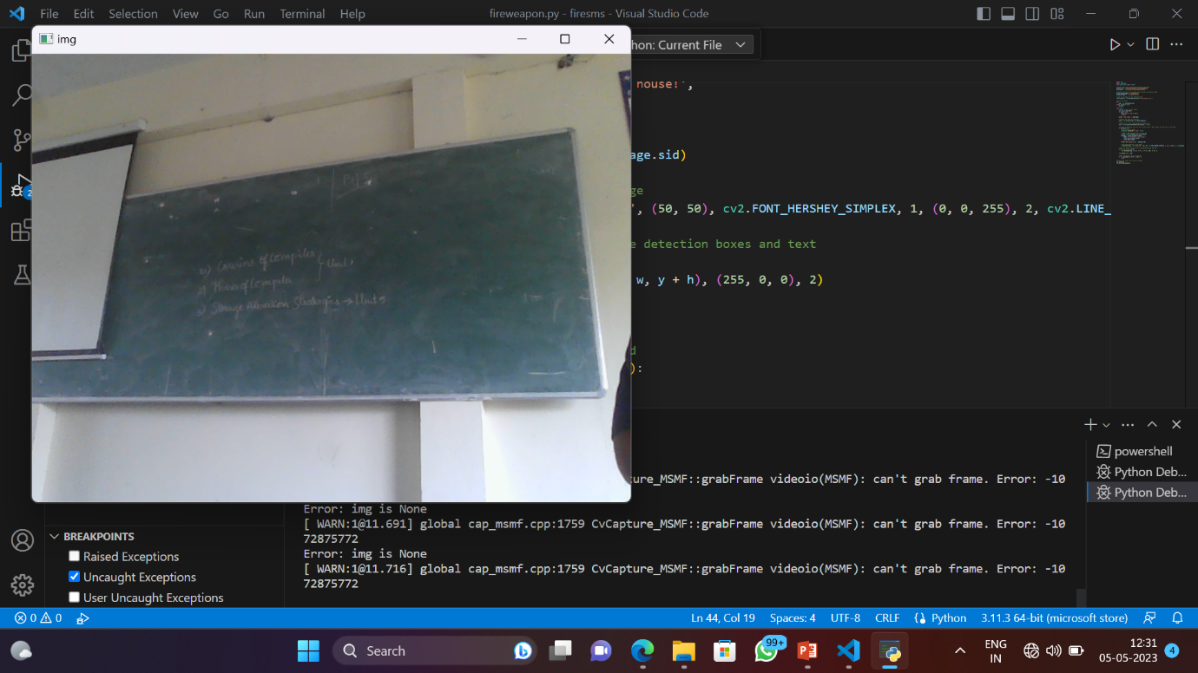

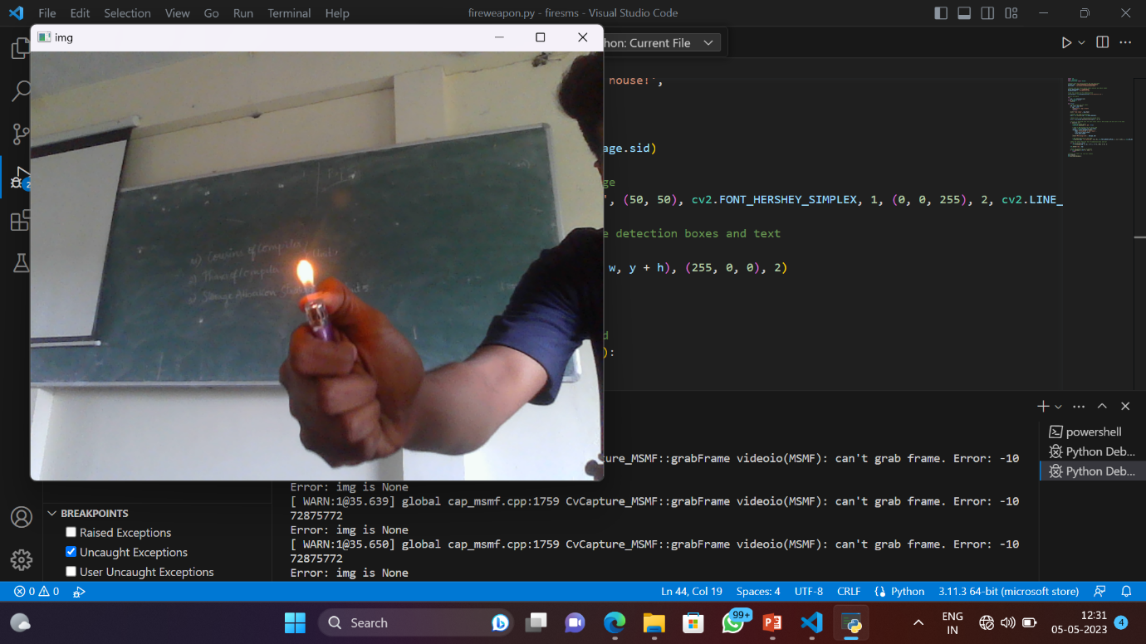

**7.CONCLUSION :**

The FireWatch fire detection and alert system project has implemented a robust solution for detecting and alerting the presence of fire using computer vision algorithms. The system has demonstrated its superiority over existing fire detection systems, with efficient SMS notifications and an intuitive web-based interface for monitoring and configuration. The FireWatch system has the potential to greatly enhance fire safety measures in various environments.

**8. REFERENCE:**

[1] D. Han and B. Lee, "Development of early tunnel fire detection algorithm using the image processing," in International Symposium on Visual Computing, 2006, pp. 39-48.

[2] T.-H. Chen, P.-H. Wu, and Y.-C. Chiou, "An early fire-detection method based on image processing," in Image Processing, 2004. ICIP'04. 2004 International Conference on, 2004, pp. 1707-1710.

[3] G. Marbach, M. Loepfe, and T. Brupbacher, "An image processing technique for fire detection in video images," Fire safety journal, vol. 41, pp. 285-289, 2006.

[4] T. Celik and H. Demirel, "Fire detection in video sequences using a generic color model," Fire Safety Journal, vol. 44, pp. 147-158, 2009.

[5] A. Rafiee, R. Dianat, M. Jamshidi, R. Tavakoli, and S. Abbaspour, "Fire and smoke detection using wavelet analysis and disorder characteristics," in Computer Research and Development (ICCRD), 2011 3rd International Conference on, 2011, pp. 262-265.

[6] Y. H. Habiboğlu, O. Günay, and A. E. Çetin, "Covariance matrixbased fire and flame detection method in video," Machine Vision and Applications, vol. 23, pp. 1103-1113, 2012.

[7] R. Di Lascio, A. Greco, A. Saggese, and M. Vento, "Improving fire detection reliability by a combination of videoanalytics," in International Conference Image Analysis and Recognition, 2014, pp. 477-484