Virtual Room design

Dhanush shetty

Department of Computer Application,

PES University,

Bengaluru, India

dhanushshetty712@gmail.com

Professor Dilip Kumar Maripuri,

Department of computer applications,

PES University,

Bengaluru,India

I. Abstract

This is an android based application that virtually shows items like sofas. cupboard etc. These things are virtually shown using google arcore**.**While building or constructing a home clients will have a different idea as to how they are going to set or display their room but on the other hand the design engineer will have a different idea as to how they will present the clients room. This frequently results in the client rejecting their space or changing the design of the room. This frequently occurs as a result of the design engineers' inability to help the clients visualize their work.

**Keywords:** AR, Firebase, DART, Virtual reality.

**II. Introduction**

Clients will have different ideas about how they want to arrange or present their rooms during the building or construction of a home, but the design engineer will have a different notion about how they would present the client's space.This frequently results in the client rejecting their space or changing the design of the room. This frequently occurs as a result of the design engineers' inability to help the clients visualize their work. This upcoming application will be created using an Android app.

This application may be used to further view the given product in the AR on the given platform because it was created for Android and can be used and run practically anywhere, making it highly portable—essential for any sort of design engineer's application. AR is exactly what it says it is: reality enhanced with clever modern components. Today's most popular AR applications use smartphones to display the carefully extended world.

Customers can use their smartphone's camera to capture the world around them, examine it on a screen, and rely on an AR application to enhance it in a variety of ways through digital overlays. Screens, eyewear, portable and mobile phones, and head-mounted displays are just a few of the devices that can display augmented reality. Knowing what AR isn't is just as important to comprehending what it is.

Unlike computer generated simulation (VR), augmented reality (AR) is unquestionably less lifelike. While computer produced reality forces users into a fully automated world and requires them to wear a special headgear, augmented reality (AR) allows users to continue interacting with the real world.

Augmented Reality is taken into consideration as a promising era. This era is providing an AR enjoy to the customers with immersive answers in numerous verticals. Likewise, Augmented Reality for the furnishings enterprise is introducing new possibilities for furnishings agencies. They can be capable of promoting their merchandise in a powerful way. AR is allowing the customers to get extra in-intensity info at the object. This is assisting the agencies in furnishings to convert their enterprise prospects

This application can also be upgraded to work with VR as well as with other OS as well.Augmented Reality is tied in with overlaying virtual enlivened objects onto true environmental factors. Clients with the assistance of cell phones can encounter reasonable perception whenever and anyplace. Utilizing AR virtual components, sounds, pictures, and recordings are a circuit in reality climate. Augmented Reality Applications come in two gatherings according to the use by any business brand

**III. Approach**

A. Proposed Solution

Users might utilize the system as a blueprint for the engineers by using it to show them graphically how the supplied set of equipment will appear in their houses. In this approach, augmented reality (AR) enables people to place 3D representations of things in a real environment to see how the room will look when it is furnished. Contrarily, computer generated reality (CGR) is a wholly fabricated virtual environment that also simulates 3D models of goods and everything else.The stimulating benefits of AR for bequest engineers, planners, vendors, and buyers are difficult to identify. Nevertheless, the situation is more lucid in the context of promoting and selling a business, where AR innovation is currently taking place in this industry.

B. AR Core

AR core is one of the main frameworks via which the elements are placed virtually. This ARCore is an official release from Google and this can be integrated to work with any system as needed.ARCore is Google’s foundation for building expanded reality encounters.

Utilizing different APIs, ARCore empowers your telephone to detect its current circumstance, figure out the world and connect with data. A portion of the APIs are accessible across Android and iOS to empower shared AR encounters. ARCore’s movement following innovation utilizes the telephone’s camera to distinguish fascinating focuses, called elements, and tracks how those focuses move after some time. With a blend of the development of these places and readings from the telephone’s inertial sensors, ARCore decides both the position and direction of the telephone as it travels through space.

As well as distinguishing central issues, ARCore can identify level surfaces, similar to a table or the floor, and can likewise gauge the typical lighting nearby around it. These capacities join to empower ARCore to construct its comprehension and might interpret its general surroundings.

**IV. TOOLS AND LIBRARIES USED**

1. Libraries used are as follows.
2. **VS Code.**

VS Code has an implicit component for tremendous quantities of bundles for testing android applications code age, and it may have a more extreme expectation to learn and adapt for fledglings contrasted with other code editors, Furthermore, it doesn’t have its own incorporated improvement climate (IDE) and depends on outer instruments for certain errands,

for example, investigating and testing. Regardless of these restrictions, VS Code remains a profoundly well known and generally utilized code manager among designers because of its strong highlights, adaptability, and Dynamic people group. It is also quite easy to use and has quite straightforward tools and usage.

1. **Android Studio**

The main reason for using android studio is that only via this all of the APK building and version deprecation is possible without this it is not possible. Android Studio was first reported at a Google I/O gathering in 2013 and was delivered to the overall population in 2014 after different beta forms. Before its delivery, Android improvement was taken care of transcendently through Obscuration IDE, which is a more conventional Java IDE.

**V. FUNCTIONAL REQUIREMENTS**

* **Login**

These are the people who will actually design the users room after the users have virtually seen the thing that they wanna place. Design engineering is a lifelong field that suits people from specialized and innovative foundations. Since it is a mix of design and engineering, experts in this field ought to have a decent comprehension of different subjects connecting with the two fields. In the event that you are wanting to turn into a design engineer, you want to have a few essential abilities and capabilities. In this article, we characterize what is a design engineer, frame their obligations, pay and vocation prospects, and examine how you can begin a lifelong in this field.

* **Selecting items**

Users are those people who will be using this application to design their room. The users can simply log in to the system via a google account and start using it. A user is one more name of a record equipped for signing into a PC or administration. For instance, individuals who sign into the PC Trust gatherings are viewed as a user or part. Any PC, administration, or program with numerous records utilizes user accounts that give every user their own authorizations, settings, and different information not available to different users.

* **AR view**

The main job of the admin is to just check if everything is in control. An admin is an individual who guarantees that an association works productively. Their particular obligations rely upon the kind of organization, association, or element where they work. Most importantly, administrators should be exceptionally coordinated and have great relational abilities.

**VI. METHODOLOGY**

1. **process flow**

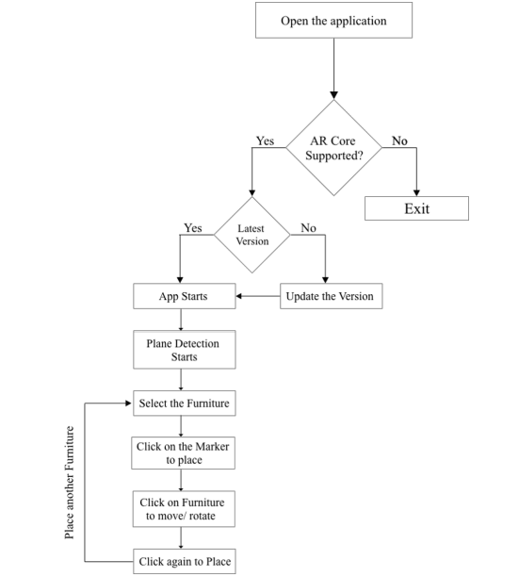

This flow will show exactly how and what kind of feature and functionalities the user can do when they enter into the application.

1. **Architecture**

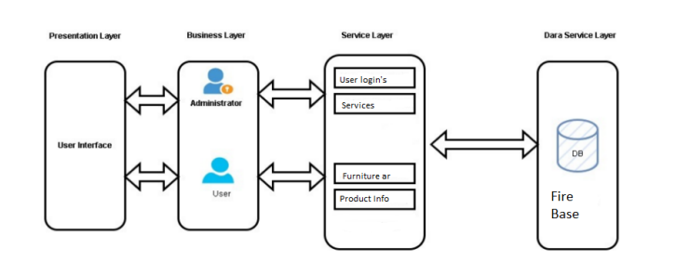

The architecture diagram portrays the visual portrayal of the generally speaking actual parts of the product model. This architecture diagram chiefly comprises four layers to be specific: the show layer, the business layer, the assistance layer, and the information administration layer. The show layer will comprise the connection page through which every one of the clients will associate with the framework. The business layer goes about as a scaffold between the show layer and the help layer. In the business layer ranchers, clients and the administrator will associate with the help layer. The help layer will contain every one of the functionalities of the particular clients. The information administration layer will characterize the capacity part of the framework

**VII. RESULTS**

The below images are of the project that has been implemented

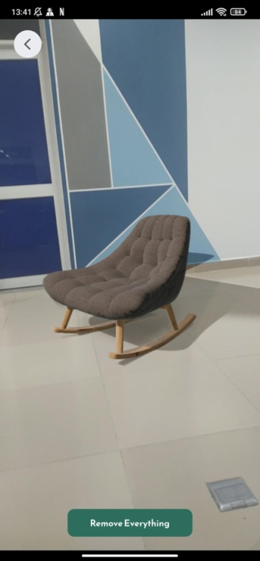 .

**CONCLUSION**

The system which is developed as of now is useful for users as it can be used to virtually see the products like furniture and various other things so that users can know what will look good in their home. Not only that this system can also be used by design engineers too so that they will be sure what will look good on the place they are constructing.

So as to conclude this project is not only helpful for users but to design engineers as well as visually shows them what will look good on the homes. This project will save time as well as money too. So as to conclude this application as of now works with most efficiency and has no error or bugs that is known of. This application works and delivers everything that is required.

**FUTURE WORK**

1. Incorporating an IOS system, as this system is only based on android too. This system can be further modified to save user liked designs on cloud so that it can be available Allowing customers to have the option of VR.
2. As of now this application is only working on AR but it can be further optimized enough to run VR on mobile devices using Google cardboard.
3. The application as of now cannot run on browser but it can be made possible to run on web and if it's on web it can run on any devices and OS.
4. This application can be further be worked on to create an e-commerce platform where users can directly buy the items from here

**References**

1. Carius, L. et al. (2022) “Cloud-based cross-platform collaborative AR in flutter,” 2022 IEEE Conference on Virtual Reality and 3D User Interfaces Abstracts and Workshops (VRW) [Preprint]. Available at: https://doi.org/10.1109/vrw55335.2022.00192.
2. Hargreaves, K. and Jopek, N. (2019) Flutter. Upperthong, Holmfirth, England: Kim Hargreaves.
3. Burd, B. (2020) Flutter. Hoboken, NJ: John Wiley amp; Sons.