**TRAFFIC SIGN RECOGNITION AND CLEARANCE FOR AMBULANCE USING RFID**

**Vishwas C P1, Amar S2, Sanjay C M3, Vignesh Raj Y R4**

1 Student, Department of Information Science and Engineering, Maharaja Institute of Technology, Mysore, India

2 Student, Department of Information Science and Engineering, Maharaja Institute of Technology, Mysore, India

3 Student, Department of Information Science and Engineering, Maharaja Institute of Technology, Mysore, India

4 Student, Department of Information Science and Engineering, Maharaja Institute of Technology, Mysore, India

**ABSTRACT**

Convolutional neural networks (CNNs) are frequently used to extract the characteristics of traffic signs and categorize them into matching classes. Traffic sign recognition (TSR) is an integral component of driver assistance systems. In India, traffic sign recognition now has a baseline thanks to this effort (INDIA Traffic Signs 3K). Two models were selected: Faster R-CNN and YOLOv5 to test which deep learning models were best for the TSR problem. With the use of specialized radio frequency identification (RFID) tags, an intelligent traffic management system was developed to seamlessly pass emergency vehicles. In a wireless communication lab, the prototype was put to the test with various combinations of inputs, and the experimental outcomes were as predicted.

**Keywords:** Traffic signs, Faster R-CNN, YOLOv5, CNN, INDIA Traffic Signs 3K, RFID, Congestion control, Traffic junction.

1. **INTRODUCTION**

Traffic sign recognition (TSR) has been used in many practical applications, such as driver assistance systems, autonomous cars, and intelligent mobile robots. However, there are some obstacles to TSR, such as the complicated traffic scene on the road and imbalanced class frequencies in the datasets. Prior to convolutional neural networks becoming widely utilized, several feature extraction techniques and machine learning algorithms were the most common ways for detecting traffic signs. The Histogram Oriented Gradients (HOG) method was first used to detect people in traffic scenes, and it involved calculating the gradients in a color picture together with normalized and weighted histograms. In India, the feature transform method was utilized to categorize window sliding, and a variety of machine learning techniques were used, including support vector machines, linear discriminant analysis ensembles, and random forests. India needs traffic control methods that are distinct from those used in Western nations because its roadways are crowded.

1. **METHODOLOGY**

**2.1 Traffic-Sign Recognition (TSR) in INDIA**

The development of a driver assistance system uses computer vision methods to identify traffic signs, but this activity often runs into ambiguous problems such as color fading, confusion, and fluctuations in size and form. Studies have been conducted to address these issues and offer strategies to improve traffic sign recognition performance.

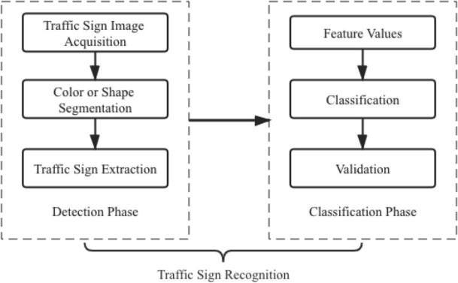

**Figure 1:** The workflow of traffic-sign Recognition.

**2.2 Data Collections**

This project used the iPhone 11's 12-megapixel wide-angle camera to take realistic photographs of traffic signs in India. The dataset (INDIA-Traffic-Signs 3K) consists of 3436 images and 3545 instances, including Stop (236 instances), Keep Left (536 instances), Road Diverges (505 instances), Road Bump (619 instances), Crosswalk Ahead (636 instances), Give Way at Roundabout (533 instances) and Roundabout Ahead (480 instances).

**Table 1** Examples of seven categories in our benchmark (INDIA-Traffic-Signs 3K)

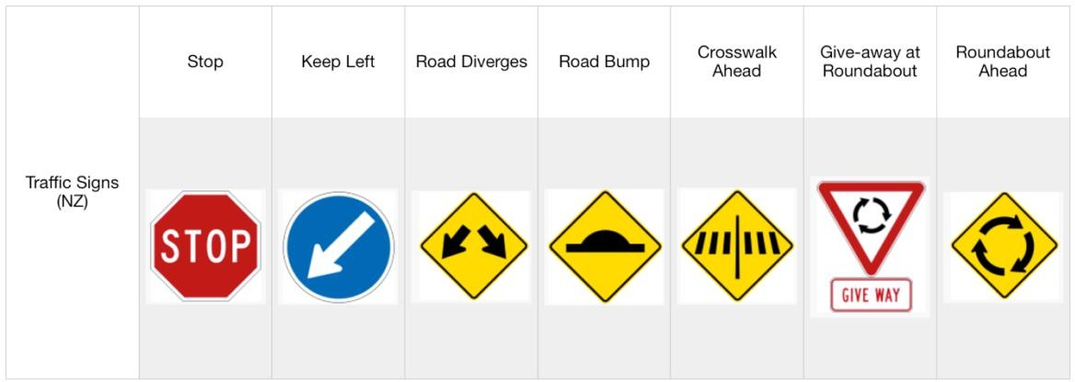

**2.3 Automatic Signal Control System**

This module has employed a 125 KHz RFID reader and passive RFID tags for an experiment. When a vehicle enters the receiver's range, an RFID tag will communicate its own RFID to the reader. In a 2-minute period, the microcontroller linked to the RFID reader will count the RFID tags read. The length of the green light is set to 30 seconds for counts more than 10 and 20 seconds for counts between 5 and 9. The orange light will last for two seconds and the red light for ten.

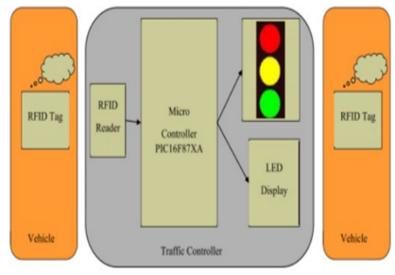

**Figure 2:** Implementation for automatic signal control

1. **MODELING AND ANALYSIS**

The first methods of object detection rely on feature extraction methods. Color and shape factors were used to complete traffic-sign identification and categorization tasks effectively. Images were transformed to various color systems, such as HSV (Hue, Saturation, Values), and a color probability model based on Otha space was used to find the probability maps for each color used in traffic signs. A green wave system was detailed to provide authorization to any emergency vehicle by turning all the red lights in its path to green. RFID traffic control is used to avoid problems associated with conventional traffic control systems and generates a dynamic time schedule for the movement of each traffic column in real time. This study's weakness is its failure to explore the lines of communication between the emergency vehicle and the traffic signal controller. RFID technology divides situations into emergencies and nonemergency’s, eliminating wasteful traffic congestion.

**3.1 Convolutional Neural Network**

CNNs are a class of deep neural networks used for visual imaging. Multilayer perceptron’s are found in CNNs, allowing for efficient overfitting of the data. Depth, stride, and zero-padding are the three hyperparameters that regulate the convolutional layer's output volume size. Depth determines how many neurons in a layer connect to the same area of the input volume, stride determines how deep the columns are allocated around the input's width and height, and zero padding controls the output volume's spatial dimensions.

**3.1 RFID Reader**

Radio Frequency Identification (RFID) is an IT technology that uses wireless communication to transfer signals without the use of hardware. It uses tags that are fastened to various components to store the specifics of the product or item being tracked. Active and passive tags are the two kinds of RFID technology, and their range is influenced by factors such as antenna, frequency, tag orientation, and environment.

1. **RESULTS AND DISCUSSION**

Our primary goal in this study is to assess how well neural network’s function when it comes to reading tiny traffic signals. As a result, we were more concerned with how to recognize traffic signs in India's diverse sizes. We utilized a scatter plot to more clearly display the distribution of various traffic sign sizes in our dataset. The INDIA Traffic Signs 3K dataset has 3,439 photos across 7 classes, with 1080 x 1440 pixel photos. The distribution of all classes is shown in Fig 3.

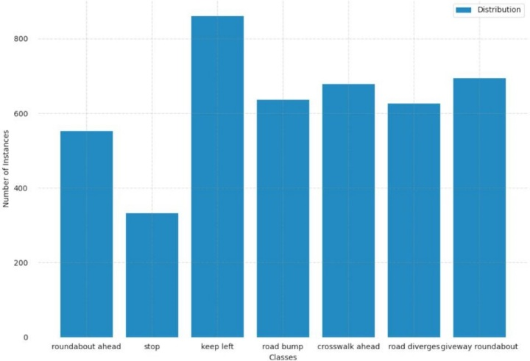

**Figure 3:** Implementation for automatic signal control

Figure 3 shows that the data distribution is satisfactory, except for the class "Stop". To improve the performance of two models, we split the data into two parts: 80% for training and 20% for validation.

* 1. **Experiment Results of Faster R-CNN**

This experiment used the Faster R-CNN model as a detector and VGG16 as a classifier to identify traffic-signs. Three metrics were used to assess performance: Precision, Recall, and Mean Average Precision with IoU 0.5 ([mAP@0.5](mailto:mAP@0.5)).

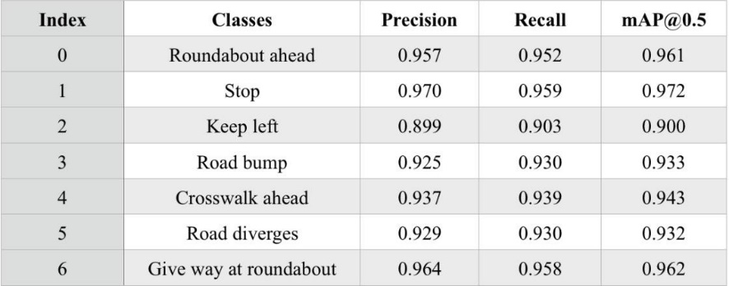**Table 2** Experimental results for Faster R-CNN across seven classes

The Faster R-CNN has a clear advantage in its ability to anticipate traffic signs, except for Keep Left, which has a Precision score of 0.899. The two classifications with the greatest accuracy scores are Stop and Road Diverges.

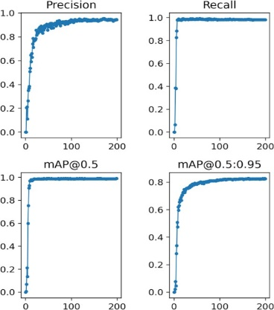

**Figure 4:** Several tested images with class index.

* 1. **Experimental Results of YOLOv5**

We used YOLOv5, a distinct end-to-end network from Faster R-CNN, to train a model based on the categorization of each of the dataset's seven classes. Table 3 presents the experimental findings.

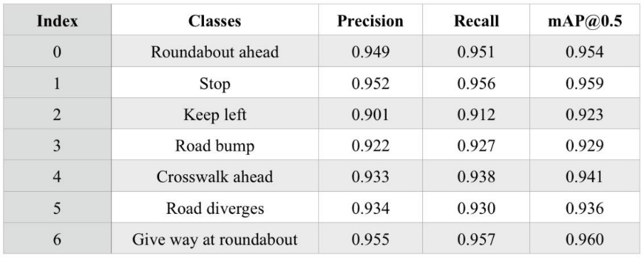**Table 3** Experimental results for YOLOv5 across seven

The recognition rate for stop signs in Table 3 is still accurate (0.952). However, the Keep Left prediction's accuracy has increased slightly (0.02). The YOLOv5's output consistently achieves results over 0.9 for traffic-sign identification.



**Figure 5:** The metrics for evaluating the overall performance of YOLOv5.

1. **CONCLUSION**

This paper provides a tailored benchmark for traffic-sign identification tasks across India. It has seven classifications of traffic signs from INDIA, with a total of 3,436 pictures. Two models that were run on the dataset produced very encouraging findings. The traffic policeman's human labor is reduced by automatic traffic light regulation based on the volume of traffic along the route, and the fastest possible arrival time is required for emergency vehicles like ambulances and fire engines. As long as the emergency vehicle is parked at the traffic intersection and has clearance, the traffic light changes to green. After the emergency vehicle has passed, the signal turns red.

1. **REFERENCES**
2. Al-Qizwini, M., Barjasteh, I., Al-Qassab, H., & Radha, H. (2017). Deep learning algorithm for autonomous driving using googlenet. In IEEE Intelligent Vehicles Symposium (IV).
3. Albawi, S., Mohammed, T. A., & Al-Zawi, S. (2017). *Understanding of a convolutional neural network.* In International Conference on Engineering and Technology (ICET)
4. Bochinski, E., Senst, T., & Sikora, T. (2017). Hyper-parameter optimization for convolutional neural network committees based on evolutionary algorithms. In IEEE International Conference on Image Processing (ICIP).
5. Chen, R.-C. (2019). Automatic license plate recognition via sliding-window DarkNet- YOLO deep learning. Image and Vision Computing, 87, 47-56.
6. Dalal, N., & Triggs, B. (2005). *Histograms of oriented gradients for human detection.* In IEEE Conference on Computer Vision and Pattern Recognition (CVPR'05).
7. Everingham, M., Van Gool, L., Williams, C. K., Winn, J., & Zisserman, A. (2010). The pascal visual object classes (VOC) challenge. *International Journal of Computer Vision, 88*(2), 303-338.
8. . R. Hegde, R. R. Sali, and M. S. Indira, “RFID and GPS based automatic lane clearance system for ambulance,” Int. J. Adv. Elect. Electron.Eng., vol. 2, no. 3, pp. 102–107, 2013.
9. Suárez-Paniagua, V., & Segura-Bedmar, I. (2018). Evaluation of pooling operations in convolutional architectures for drug-drug interaction extraction. BMC bioinformatics, 19(8), 39-47.
10. Redmon, J., Divvala, S., Girshick, R., & Farhadi, A. (2016). You only look once: Unified, real-time object detection. In IEEE Conference on Computer Vision and Pattern Recognition.
11. Zhu, Z., Liang, D., Zhang, S., Huang, X., Li, B., & Hu, S. (2016). Traffic-sign detection and classification in the wild. In IEEE Conference on Computer Vision and Pattern Recognition.