**IOT BASED SMART WHEEL-CHAIR**

**Dr. Pushpa D1, Manasvi P Shetty2, Prakruthi M3, Syed Haris4, Vijayalakshmi K5**

1Associate Professor, Department of Information Science and Engineering, Maharaja Institute of Technology Mysore, Mysore, Karnataka, India

2,3,4,5Undergraduate Student, Department of Information Science and Engineering, Maharaja Institute of Technology Mysore, Mysore, Karnataka, India

**ABSTRACT**

Many people suffer from temporary or permanent physical disabilities due to illness or accidents. For those daily activities are difficult and require a wheelchair for locomotion and is very essential. Manual or electrical wheelchair are satisfying most of the low and middle level disability person where they can use the wheelchair independently. However, in severe cases, it is difficult or impossible to use wheelchair independently. IoT-based smart wheelchair enhances mobility and independence for individuals with mobility impairments. The project integrates sensors, actuators, and communication modules with mobile app integration to enable obstacle detection and avoidance. Extensive testing validates the system's effectiveness in navigating complex environments. The project showcases the potential of IoT technology in creating intelligent wheelchair systems, empowering users with increased mobility, safety, and independence. It also provides an opportunity for visually or physically impaired persons with obstacle detection system, which minimize the chance of collision which using it. We tried to provide all the features required in a smart wheelchair at lowest price for the people to afford it without any difficulty and to use utmost independent on others.

**Keywords:** Smart Wheelchair, IoT Technology, ESP8266, Obstacle detection, Ultrasonic Sensor, Blynk.

1. **INTRODUCTION**

An idea to make the people life easier who are unable to walk alone due to accident, paralysis or old age. They have to depend on others for their needs. The one who use wheelchairs, have to depend on others for steering it, makes them to feel it difficult as they have to rely on others. An electrical wheelchair will give an independent feel for those who using the mechanical wheelchair. But, still most of the people don’t use smart wheelchair thinking that it is costly. The prevalence of mobility impairments and the challenges faced by individuals with limited mobility have sparked significant interest in developing innovative assistive technologies. One promising area of research is the integration of Internet of Things (IoT) technology into smart wheelchairs, enabling enhanced mobility and independence for wheelchair users. This research paper presents an IoT-based smart wheelchair project aimed at addressing these challenges and improving the quality of life for individuals with mobility impairments. Traditional manual wheelchairs offer limited assistance and often rely on the physical strength and dexterity of the user. However, advancements in IoT technology offer opportunities to create intelligent wheelchair systems that can sense and interact with the surrounding environment. By integrating sensors, actuators, and communication modules, these smart wheelchairs can provide real-time feedback, intelligent decision-making, and adaptive control mechanisms. The primary focus of this project is to develop an IoT-based smart wheelchair system with obstacle detection capabilities. Obstacle detection is crucial for ensuring user safety, as collisions with objects in the environment can lead to accidents and injuries. By employing various sensors such as ultrasonic, infrared, or laser sensors, the smart wheelchair can detect obstacles in real-time, accurately measure distances, and identify potential risks. IoT-based smart wheelchair project designed to enhance mobility and independence for individuals with mobility impairments. By integrating IoT technology and sensors, the project aims to create a wheelchair system capable of detecting and avoiding obstacles in real-time. Through comprehensive evaluations, the project aims to demonstrate the effectiveness and potential of IoT-based smart wheelchairs in improving the quality of life for wheelchair users.

1. **LITERATURE REVIEW**

The review of literature focuses on the past research studies that were conducted to assess the need for the disable and for their mobility without help from others. Various literatures related to smart wheelchair are being reviewed while designing the project many patents and research paper were studied some of which have been mentioned below:

1) The paper focuses on the development of an IoT-based smart wheelchair specifically designed for disabled individuals. The paper discusses the integration of IoT technology, sensors, and communication modules into the wheelchair system to enhance mobility and improve the overall user experience. The research highlights the importance of obstacle detection, navigation algorithms, and user-friendly interfaces. The study aims to provide a comprehensive solution that promotes independence and improves the quality of life for disabled individuals through the utilization of IoT-based smart wheelchairs.

2) In this paper, the authors have done a study on Human Machine Interface Wheel Chair by Using Wi-fi Communication for Disabled Person. The paper addresses the need for an efficient and user-friendly control system for wheelchairs, especially for individuals with disabilities. The proposed system aims to provide a seamless interface between the user and the wheelchair, allowing for easy navigation and control. The components of the system, which include a wheelchair equipped with sensors, a microcontroller, and a WI-FI module. The sensors are responsible for detecting the user's commands, such as forward, backward, left, and right movements. These commands are then transmitted to the microcontroller. The microcontroller processes the received commands and generates corresponding signals to control the wheelchair's movement. The WI-FI module facilitates the wireless communication between the wheelchair and the user interface device.

3) In this paper, the authors have designed an automated solution that enables easy maneuverability and control for enhanced mobility and independence. The research begins by discussing the components of the automated electric wheelchair system. These include a microcontroller, sensors, motors, and a power supply. The sensors are responsible for detecting the user's commands and environmental obstacles, while the microcontroller processes these inputs and controls the motors for appropriate wheelchair movements. The paper describes the design and implementation of the automated system, emphasizing the integration of various technologies to enhance the wheelchair's functionality. It discusses the use of sensors such as ultrasonic sensors and accelerometer sensors to detect obstacles and ensure safety during navigation.

4) In their paper, authors study on IoT Based Smart Wheelchair System with sensors utilized to gather data about the wheelchair's environment and the user's condition, while the actuators enable wheelchair movements based on the received inputs. The microcontroller processes the data and controls the operations of the wheelchair, and the wireless communication module facilitates communication between the wheelchair and external devices. The authors highlight the integration of IoT technology, which enables the wheelchair system to connect with various smart devices and services. They describe how the system can be linked to a smartphone or a tablet, allowing users to remotely control the wheelchair, receive notifications, and access additional features through dedicated applications. The paper also discusses the implementation of the smart wheelchair system and provides insights into its advantages. These include real-time monitoring of the user's health condition, automatic obstacle detection and avoidance, and location tracking.

5) In this paper, the authors have studied Smart Navigation of wheelchair using human machine interface. The paper addresses the need for an advanced wheelchair navigation system that allows users to interact with the wheelchair in a more intuitive and user-friendly manner. The proposed system incorporates an HMI to facilitate seamless communication and control. The research begins by discussing the components of the smart wheelchair navigation system. These include sensors, microcontrollers, actuators, and the HMI. The sensors detect the user's commands and environmental data, while the microcontroller processes these inputs. The actuators control the wheelchair's movements based on the received commands. The HMI acts as an interface between the user and the wheelchair system, allowing for easy and intuitive control. The authors describe the design and implementation of the HMI, which typically involves the use of a graphical user interface (GUI) displayed on a screen. The GUI provides various navigation options and allows users to select their desired direction and speed through touch or other input methods.

1. **PROBLEM STATEMENT**

A handicapped person with locomotive disabilities needs a wheelchair to perform functions that require him or her to move around. User can do so manually by pushing the wheelchair with his hands. However, many individuals have weak upper limbs or find the manual mode of operating too tiring. Hence it is desirable to provide them with a motorized wheelchair that can be controlled by a mobile app interface. Since the motorized wheelchair can move at a fair speed, it is important that it be able to detect obstacles automatically in real time. All this should be achieved at a cost that is affordable for as many handicapped people as possible, as well as for organizations that support them. With these requirements in mind, we propose an automated wheelchair using IoT with real-time obstacle detection capability.

1. **METHODOLOGY**

The Project is divided into 5 Phases:

A. System Design: The first step is to design the overall system architecture of the smart wheelchair. This includes selecting appropriate sensors for obstacle detection, determining the communication protocols, and designing the integration with a mobile application for navigation control.

B. Sensor Integration: Various sensors, such as ultrasonic, infrared, or laser sensors, are integrated into the wheelchair to detect obstacles in real-time. These sensors are strategically placed to provide accurate distance measurements and identify potential obstacles.

C. Communication Module Integration: Wireless communication modules, such as Bluetooth or Wi-Fi, are integrated into the wheelchair system to establish communication with the mobile application. This enables real-time transmission of sensor data and control commands.

D. Obstacle Detection: Ultrasonic sensor is used to analyze the sensor data and detect obstacles accurately. This sensor takes into account the readings, wheelchair speed, and user preferences to identify potential obstacles and calculate safe paths.

E. Integration with Mobile App: The mobile application (Blynk) is integrated with the smart wheelchair system, enabling users to control the wheelchair's movement, set navigation destinations, and receive real-time feedback on obstacle detection and navigation progress.

Components used:

1) Node MCU

2) Ultrasonic Sensor

3) Motor driver LN298N

4) DC motor

5) Power Supply

1. **DESIGN AND IMPLEMENTATION**

The architecture of the proposed model is show below:

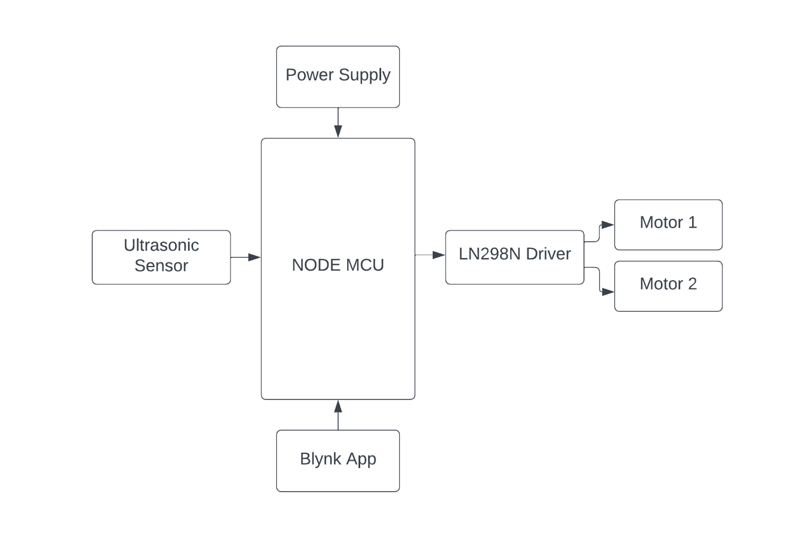

**Figure 1:** Block Diagram of the proposed system.

The Node MCU acts as the central control unit, receiving inputs from the ultrasonic sensor to detect obstacles. The movement of the wheelchair is controlled by the blynk app. The Blynk app provides a user-friendly interface for remote control and monitoring of the wheelchair. The power supply ensures the system has the necessary power.

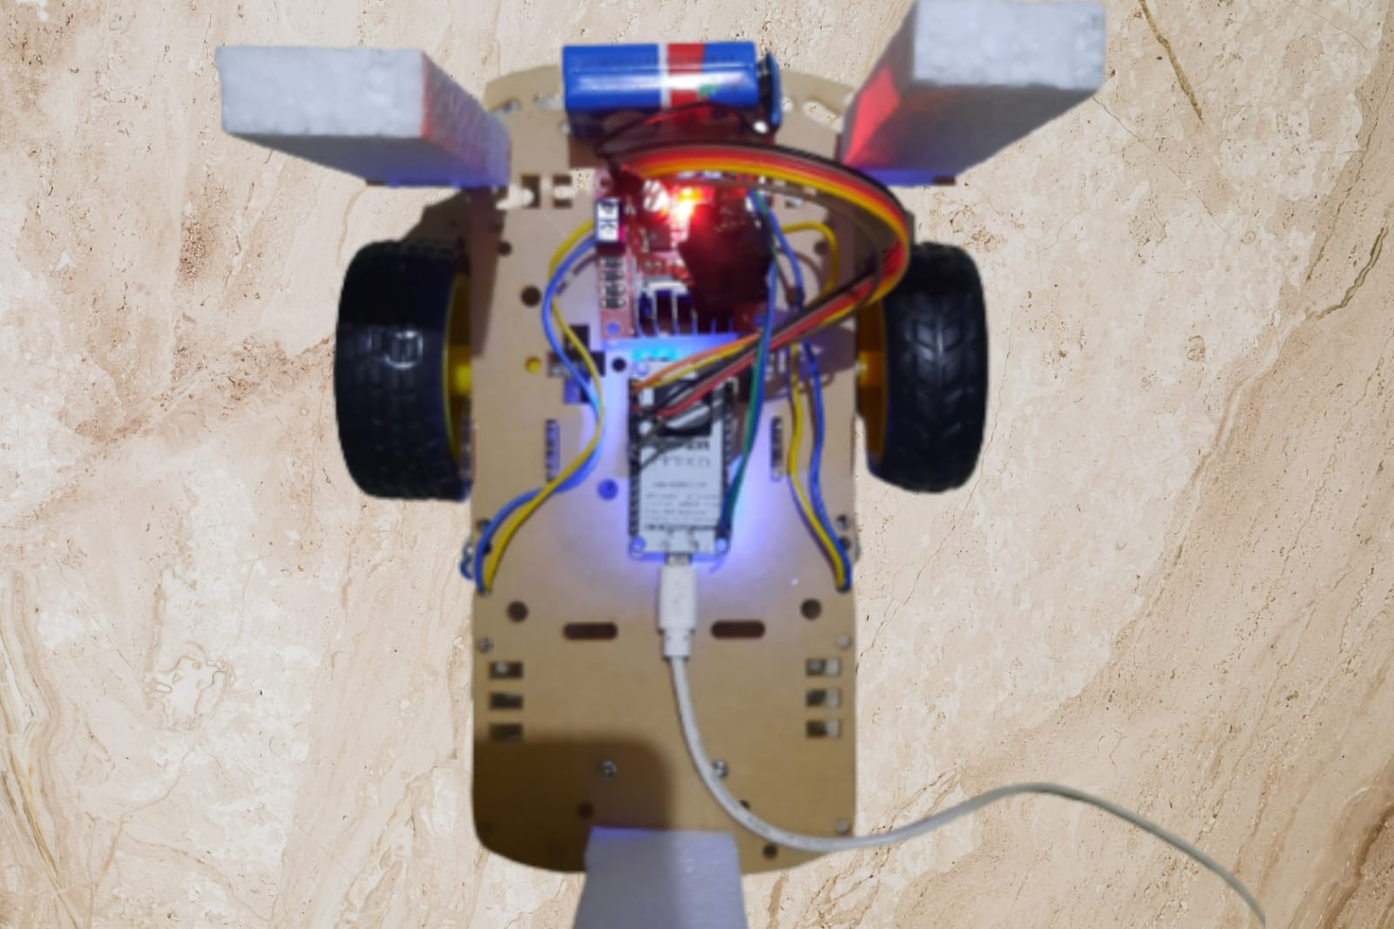

**Figure 2:** Hardware Implementation of the Proposed Model.

1. **RESULTS AND DISCUSSION**

The IoT-based smart wheelchair project effectively showed results in improving mobility and independence for wheelchair users. The mobile app integration successfully provided real-time obstacle detection to the user, enabling them to promptly respond and avoid potential collisions. The integrated sensors effectively detected and identified obstacles in real-time, providing accurate distance measurements. The integration of various components, including sensors, communication modules, and the mobile app, was successful. The system demonstrated reliability in detecting obstacles, transmitting data, and providing accurate navigation control. The project successfully integrated obstacle detection, mobile app navigation, and provided an enhanced user experience, highlighting the potential of IoT technology in creating intelligent wheelchair systems

1. **CONCLUSION**

In conclusion, the IoT-based smart wheelchair project with mobile app navigation and obstacle detection has demonstrated promising results in enhancing mobility and improving the user experience for wheelchair users. The integration of IoT technology, sensors, and mobile app control has provided accurate obstacle detection, efficient navigation, and real-time alerts, ensuring user safety and convenience. The project has highlighted the potential of IoT-based solutions in addressing the challenges faced by individuals with mobility impairments. The IoT-based smart wheelchair project can continue to evolve, offering even more advanced and user-centric features to enhance the mobility, independence, and overall quality of life for individuals with mobility impairments.

1. **REFERENCES**
2. T. Maryam Amur and Suresh Manic, "IoT Based Smart Wheelchair for Disabled People", International Conference on System, Computation, Automation and Networking, July 2021.
3. Sasikala P, “Human Machine Interface Wheel Chair by using WI-FI Communication for Disabled Person”, Fourth International Conference on Electronics Communication and Aerospace Technology(ICECA), 2020.
4. Monali Mundane, Nayan Garade, Vaishnavi Pawar, Vaishnavi Shete, Ujwal Shende, Dr. S. B. Warkad, “Automation of E-Wheelcair for physically Challenged People”, International Journal of Innovative Research In Technology(IJIRT 151380), 2021.
5. Nemil Panchamia, Shreyas Shah, Jainam Shastri, Archana Chaugule, “IOT Based Smart Wheelchair System”, Journal of VLSI Design and its Advancement Volume 3 Issue 3, 2020.
6. Rithik Richard, Shaik Mohammed Noor, Sri Charan, Shaik Adil Nadeem, Jyothy S T, "Smart Navigation of Wheelchair Using Human Machine Interface", Turkish Journal of Computer and Mathematics Education,Vol.12 No.12, 2021.