**ISOLATION AND MOLECUALR IDENTIFICATION OF FIBRINOLYTIC ENZYME PRODUCED FROM THE FERMENTED JUICE OF GAUAVA *(Psidium guajava)* AND ITS APPLICATIONS**

BOOBALAN P, VAIRAPERUMAL R, YOGESWARAN S, SAM EBENEZER R

DEPARTMENT OF BIOTECHNOLOGY, V.S.B. ENGINEERING COLLEGE, KARUR.

**ABSTRACT**

Fibrinolytic proteins are enzymes responsible for the breakdown of fibrin, a component of blood clots, making them potential candidates for use in medical applications such as preventing blood clots and promoting wound healing. The aim of the present study is fibrinolytic producing probiotic *Lactobacillus* sp., was isolated from guava (*Psidium guajava*) fruit juice and identified molecular level, NCBI accession number was obtained (SUB12938599 Lacto oq586437). The fibrinolytic enzyme was produced and optimum days was found to be 48 hours. The crude enzyme was partially purified using column (DEAE cellulose). The extracted compound was tested against pathogenic bacteria and found to be better candidate against pathogen. Further in vitro blood clot lysis assay and fibrinose agarose plate assay was carried out to find out the activity of enzyme.

Keywords: Fibrin, Fibrinolytic proteins, *Lactobacillus* sp.,

**1.INTRODUCTION**

Thrombosis, the formation of blood clots, is a significant medical condition that can lead

to life-threatening complications such as pulmonary embolism, stroke, and myocardial infarction (Undas & Brummel-Ziedins, 2019). The current treatment for thrombosis involves the use of anticoagulants, which

prevent the formation of new blood clots and help to dissolve existing clots. However, these drugs have limitations, such as the risk of bleeding complications and the need for frequent monitoring of blood coagulation parameters. Therefore, there is a need for the development of novel therapies for thrombosis that are safer and more effective (Sood & Gupta, 2014).

Enzymes have gained considerable attention in recent years as potential candidates for the treatment of thrombosis. Fibrinolytic enzymes are a class of enzymes that can dissolve blood clots by breaking down the fibrin mesh that holds them together. These enzymes have shown promise as potential thrombolytic agents due to their high specificity and low toxicity. Currently, the most commonly used fibrinolytic enzyme for thrombolytic therapy is tissue plasminogen activator (tPA) (Behera *et al*., 2017). However, tPA has limitations, such as its short half-life and the risk of bleeding complications. Therefore, there is a need for the development of novel fibrinolytic enzymes that are more effective and safer than tPA.

One approach to the development of novel fibrinolytic enzymes is the use of natural resources such as fruits and vegetables as substrates for fermentation. Fermentation is a process that involves the conversion of sugars into other compounds by microorganisms such as bacteria and yeast (Sharma, N *et al*., 2017). Many bacteria produce fibrinolytic enzymes as part of their natural metabolism, and the use of fruit and vegetable substrates can provide a sustainable and cost-effective approach for the production of these enzymes.

Guava (*Psidium guajava*) is a tropical fruit that is widely consumed in many countries. Guava is a rich source of vitamins, minerals, and antioxidants and has been shown to possess many health benefits, including anti-inflammatory, antimicrobial, and antithrombotic properties (Kumar & Rani, 2019). Several studies have reported the production of fibrinolytic enzymes from different bacterial strains isolated from fermented guava juice (Teixeira & de Oliveira, 2021). However, there is a need for the isolation and identification of novel bacterial strains that can produce fibrinolytic enzymes with improved properties and applications.

Therefore, the present study aimed to isolate and identify a novel bacterial strain that can produce a fibrinolytic enzyme from fermented guava juice and explore its potential applications. The study employed a series of methods, including fermentation of fruit juices, isolation and identification of bacteria, molecular identification using 16S rRNA and gene bank submission, production of Subtilisin-like fibrinolytic enzyme, extraction and purification of enzyme through salt ppt and DEAE column chromatography, *invitro* blood clot lysis assay, fibrin-agarose plate assay, and anti-bacterial activity testing.

This project has significant implications in the medical and pharmaceutical industry, particularly in the development of novel therapies for thrombosis and related disorders. The use of natural fruit juices as a substrate for fermentation provides a sustainable and cost-effective approach for the production of fibrinolytic enzymes. The findings of this study can contribute to the development of novel therapies for thrombosis that are safer and more effective than current treatments. Moreover, the study can provide valuable insights into the potential use of natural resources for the production of novel enzymes with diverse applications.

**2.MATERIALS AND METHODS**

2.1 COLLECTION OF FRUITS:

The fruit guava was collected from the outskirts of Coimbatore and washed in water to remove dust.

2.2 PREPARATION OF FRUIT JUICE AND FERMENTATION:

A fresh guava juice was prepared from the collected guava and it was fermented by adding 1 ml of milk to the prepared guava juice over 48 to 72 hours.

2.3 ISOLATION OF BACTERIA

Approximately 1 mL of the fermented juice sample was suspended in 9 mL of the MRS broth and incubated at 370C for 24 to 48 hrs. Then, subculture on MRS agar (Merck), and stored for further investigation (Mosesson, 2005).

2.4 MOLECULAR IDENTIFICATION OF BACTERIA:

DNA ISOLATION:

For the DNA isolation, pure culture was centrifuged at 5000rpm for 5 mins and the pellet was collected. Along with the pellet, 700µl of saline EDTA and 20µl of lysozyme was added and mixed well and incubated for 30 mins at 37°C (Hynes, 2002). After 30 mins, 150µl of 10% SDS was added and incubated it for 15 mins at 65°C in water bath and 180µl of phenol, 160µl of chloroform and 10µl of isoamyl alcohol were added and centrifuged. The aqueous phase was collected and the DNA was precipitated with half the volume of sodium acetate and 2 volume of isopropanol. The tube was mixed and centrifuged for 10 mins at 12000rpm (Weisel, 2007). The DNA pellet was collected and washed with 70% ethanol, the pellet was air dried and re-suspended in 40µl of 1X TE buffer (Weisel, 2005).

AGAROSE GEL ELECTROPHORESIS:

0.8% agarose was prepared in 1X TAE buffer and heated to melt the Agarose (Merck). After cooling, 2µl of EtBr was added and poured to the prepared gel casting tray along with comb and allowed for solidification. After solidification comb was removed and placed in AGE unit (Jackson, 2007). The isolated sample was loaded with loading dye in 1X TAE buffer at 50V for 45 to 60 minutes and this was visualized under UV-Transilluminator.

PCR AMPLIFICATION AND SEQUENCING ANALYSIS:

The amplification of DNA was carried out in a reaction with the final volume of 20µl containing 1µl of total DNA, 1µl of each primer (5’- AGA GTT TGA TCC and 5’- ACG GCT ACC TTG), 6µl of PCR master mix, 4µl of PCR buffer and 6µl of distilled water. A gradient PCR was followed in the experiment. The PCR reaction condition were as follows: 94ºC for 3 min, followed by 20 cycles of denaturation at 94ºC for 15 s, annealing at 53ºC, 55oCfor 15 s at 30°C and extension at 72ºC for 2 min, before a final extension at 72ºC for 15 s. for 20 cycle. The PCR product was analyzed using 1.5% agarose gel (Davie & Ratnoff, 1964). After amplification the product was undergone for 16sRNA study and this was submitted to NCBI gene bank. Accession number was obtained.

2.5 PREPARATION OF PRODUCTION MEDIA:

The media was prepared by dissolving 55.5g in 1000ml of distilled water and sterilized under autoclave at 1210C for 15minutes (Furie & Furie, 2008). Sterilized media was cooled to room temperature under aseptic condition and 100µl of the culture was and added to the broth then this was incubated at 370C for 24-48hrs. This was used for further study.

2.6 PRECIPITATION AND PURIFICATION OF THE FIBRINOLYTIC ENZYME:

From the production media, cell free extract was collected after centrifugation with 9000 rpm for 10 minutes. This extract was mixed with equal volume of the ethyl acetate and mixed well for the separation and extraction of the compounds, followed by incubated at 400C for 8hrs at 60-70rpm to separate the compound. Aqueous layer was separated from the reaction mixture and used for further study (Lijnen, 2001).

Chromatography is a technique to separate, identify, and purify the fibrinolytic enzyme for quantitative and qualitative analysis. In chromatography, molecules in a mixture of substances separate with the use of adsorbents (Mann & Brummel, 2012). Here DEAE cellulose was used as stationary phase in the column and after setting the stationary phase mobile phase (sample) was added and allowed for 15 minutes incubation. Followed by the sample was eluted with ethyl acetate and the fractions was collected slowly in order to get the pure compounds (Palumbo *et al*., 2016).

2.7 CHARACTERIZATION AND IDENTIFICATION OF THE SECONDARY METABOLITES

2.7.1 UV–VIS SPECTROPHOTOMETRIC ANALYSIS

The collected aqueous extract was examined under UV Visible spectral analysis. The extracts were scanned in the wavelength ranging from 200-600 nm using UV-Visible spectrophotometer and the characteristic peaks were detected. Ethyl acetate was used as a blank (Tsuruta & Hatakeyama, 2013).

2.7.2 FTIR

Fourier transform infrared (FT-IR) spectra were done for the analysis of functional groups using an FT-IR spectrometer. 4000 cm-1 to 400 cm-1 was used for the analysis to obtain an infrared spectrum of absorption of the sample (Aleman *et al*., 2018).

2.8 ANTIBACTERIAL ACTIVITY:

Antibacterial activity of the sample was identified by using well diffusion method against the dental plague causing bacteria. Mueller Hinton agar (39gm in 1000ml) was prepared and swabbed 70µl of the bacterial culture (S.aureus, B.subtilis, S.typhi) using cotton swab and well were made with cork borer followed by the sample was added (50µl) (Bachmann *et al*., 2019). Antibiotic disc (Chloramphenicol, C30mcg) was placed as a positive control, the plate was incubated 370C for 24 hrs. After incubation anti-bacterial activity of the sample was measured based on the zone of inhibition in mm (Davalos & Akassoglou, 2012).

2.9 INVITRO BLOOD CLOT LYSIS ASSAY:

A total of 100µL of clotted blood with 10,20,30µl of the sample was added to analyze the fibrinolytic activity of the sample into a sterile 96well plate (De Oliveira Silva *et al*., 2020). The mixture was gently shaken to mix it and incubated at 37°C for 24 to 48hrs and noted the changes (Dickneite & Herwald, 2016).

2.10 FIBRINOSE AGAROSE PLATE ASSAY:

The procedure for the fibrinose agarose plate assay involves the preparation of a fibrinogen-agarose mixture in a petri dish. The mixture is then allowed to solidify, forming a thin layer. A solution of thrombin is then added to the surface of the agarose gel, which leads to the formation of a fibrin clot (Du *et al*., 2021). Once the fibrin clot is formed, a small amount of the crude and purified enzyme sample is added to the center of the plate. The plate is then incubated at an room temperature and pH for 24-48 hrs and noted the changes (Gaffney *et al*., 1996).

**3.RESULTS AND DISCUSSIONS**

3.1 FERMENTED GUAVA JUICE:

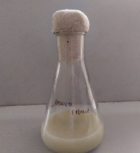

Figure 1: Fermented guava juice

The fruit guava was collected from the outskirts of Coimbatore and washed in water to remove dust. A fresh guava juice was prepared by using the collected guava and it is fermented by adding with 1 ml of milk over 48 to 72 hours.

3.2 ISOLATION OF BACTERIA:

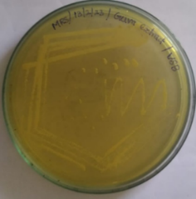

Figure 2: Isolated bacterial culture from the fermented guava juice

The fibrinolytic enzyme producing bacteria are isolated from the fermented guava juice by using the MRS medium culture.

3.3 DNA ISOLATION AND SEQUENCIAL ANALYSIS:

DNA isolated using the agarose gel electrophoresis and the isolated DNA amplified by polymerization chain reaction and it is submitted to NCBI gene bank and the accession number was obtained as SUB12938599 Lacto 0Q586437.

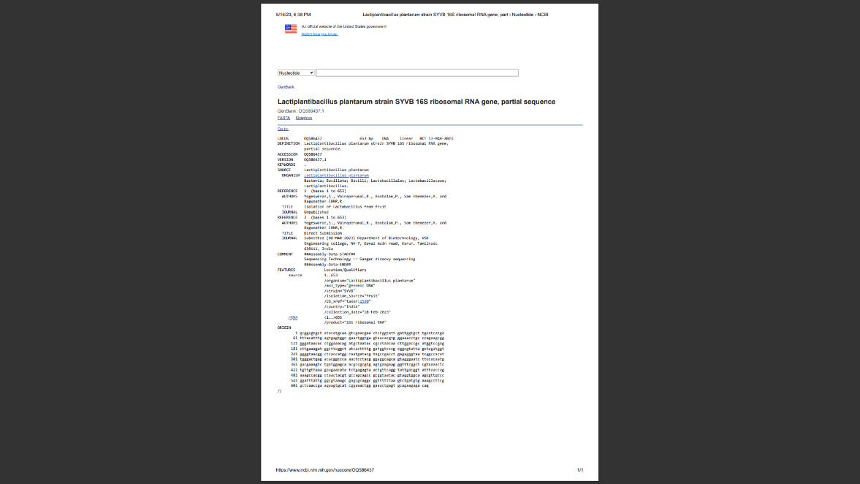

3.4 PURIFICATION OF FIBRINOLYTIC ENZYME:

The crude fibrinolytic enzyme sample was purified by the DEAE cellulose column chromatography and the purified sample was stored for the further study.

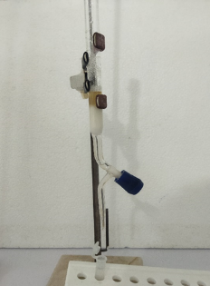

Figure 3: DEAE cellulose column chromatography

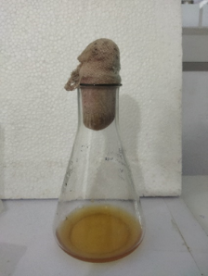

Figure 4: crude sample

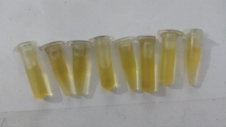

Figure 5: purified sample

3.5 CHARACTERIZATION AND IDENTIFICATION OF THE FIBRINOLYTIC ENZYME:

3.5.1 UV –VIS SPECTROPHOTOMETRIC ANALYSIS

The collected aqueous extract was examined under UV Visible spectral analysis. The extracts were scanned in the wavelength ranging from 200-600 nm using UV-Visible spectrophotometer and the characteristic peaks were detected. Ethyl acetate was used as a blank.

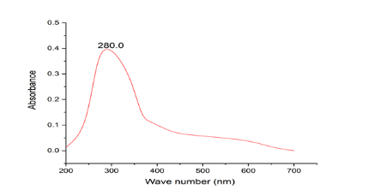

Figure 6: UV-Visible spectrophotometric analysis

The fibrinolytic enzyme has a peak at 280.0 nm. The concentration of fibrinolytic protein can be determined using a calibration curve and by comparing the absorbance value obtained to a standard curve generated from known concentrations of fibrinolytic protein.

3.5.2 FTIR

Fourier transform infrared (FT-IR) spectra were done for the analysis of functional groups using an FT-IR spectrometer. 4000cm-1 to 400 cm-1 was used for the analysis to obtain an infrared spectrum of absorption of the sample.

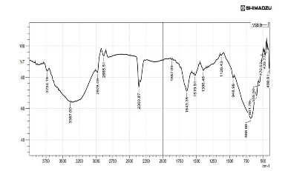

Figure 7: FTIR

The results of FTIR analysis showed that there is a clear and highly intensive bond (439 /cm) which present in C-I groups of purified sample. The sharp bond (470/cm) represents frequency asymmetrical patterns of aromatic group C-I. The sharp bond (555/cm) represents frequency asymmetrical patterns of aromatic group C-Br. Another bond (1126/cm) represented frequency patterns of the al bond of e C-f group. The bond of (2885/cm) and (2978/cm) which is the patterns match the frequency of the aledehydic group (-C-H). The bonds at (3734/cm) represent the frequency of pattern group water OH stretch.

3.6 ANTIBACTERIAL ACTIVITY OF FIBRINOLYTIC ENZYME:

The crude, precipitated and purified sample was tested against certain bacteria such as S.aureus, B.subtilis, S.typhi for the antibacterial activity using Chloramphenicol, 30mcg as a positive control and measured the inhibition zone of the samples.

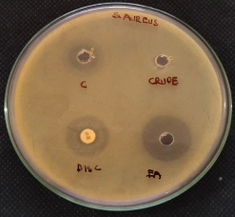

Figure 8: Antibacterial activity against Staphylococcus aureus (c-purified sample, crude-crude sample, EA- ethyl acetate precipitated sample, disc – chloramphenicol C30mcg).

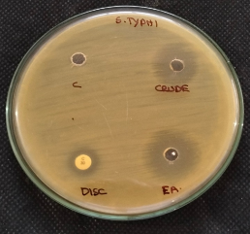

Figure 9: antibacterial activity against Salmonella typhii (c-purified sample, crude-crude sample, EA- ethyl acetate precipitated sample, disc – chloramphenicol C30mcg).

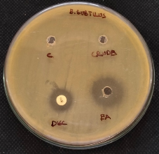

Figure 10: Antibacterial activity against Bacillus subtilus (c-purified sample, crude-crude sample, EA- ethyl acetate precipitated sample, disc – chloramphenicol C30mcg)

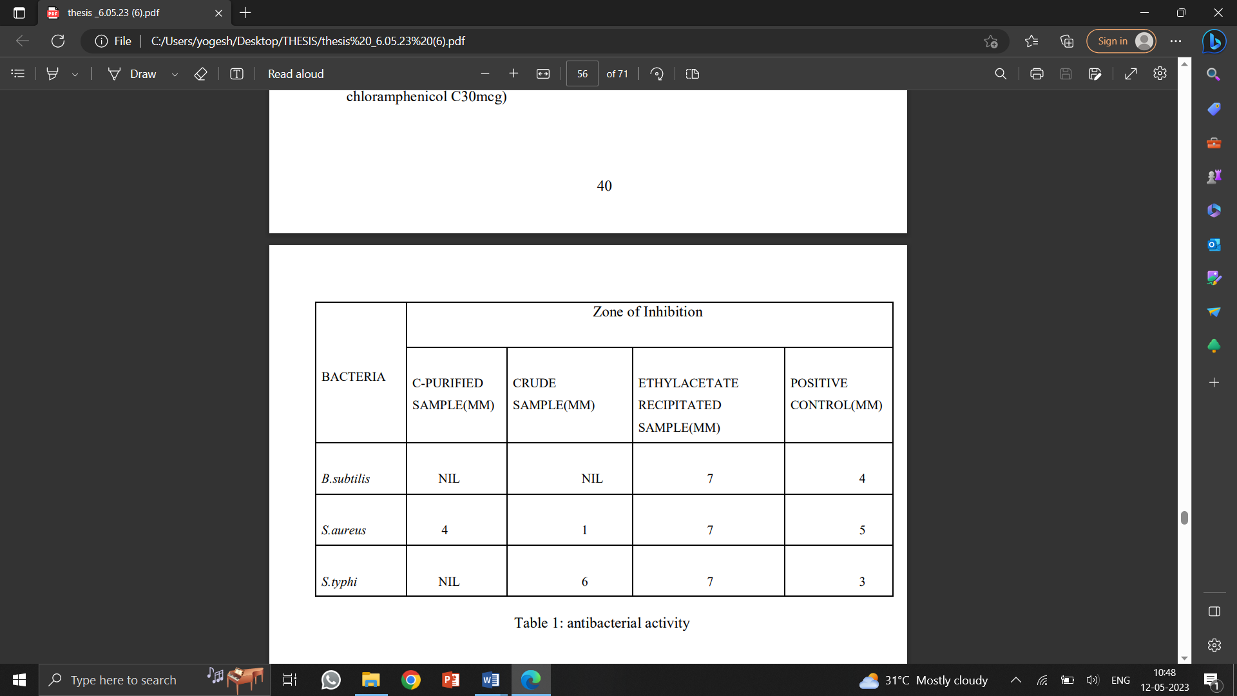

Table 1: antibacterial activity

3.7 INVITRO BLOOD CLOT LYSIS ASSAY:

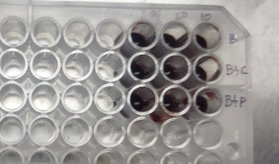

Figure 11: invitro blood clot lysis assay

A total of 100µL of clotted blood solution with 10,20,30µl of the sample was added to analyze the fibrinolytic activity of the sample into a sterile 96well plate. The mixture was gently shaken to mix it and incubated at 37°C for 24 to 48hrs. After 48 hours it is observed that both the crude and purified enzyme fibrinolytic enzyme sample was able to remove the blood clot.

3.8 FIBRINOSE AGAROSE PLATE ASSAY:

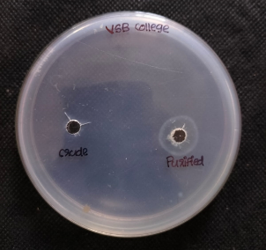

Figure 12: Fibrinose agarose plate assay

The fibrinose agarose plate assay involves the preparation of a fibrinogen-agarose mixture in a petri dish. The mixture is then allowed to solidify, forming a thin layer. A solution of thrombin is then added to the surface of the agarose gel, which leads to the formation of a fibrin clot. Once the fibrin clot is formed, 10 µl of crude and purified enzyme sample is added to the center of the plate. The plate is then incubated at an room temperature and pH for 24-48 hrs. After the incubation period a clear zone of inhibition in the plate is obtained for the purified sample of 5 mm which indicates that the fibrinolytic enzyme sample was able to remove the fibrin clot. This assay proves that the sample was able to remove blood clot.

3.9 DISCUSSIONS:

In this study, fermented guava juice was used as a source for isolating bacteria that produce a fibrinolytic enzyme. In the study, a fibrinolytic enzyme-producing bacterium was screened and isolated from cooked rice sample (chang *et al*., 2012).

The isolated bacteria were cultured on MRS medium, and DNA isolation and sequencing were performed, resulting in the identification of the bacterial strain as SUB12938599 Lacto 0Q586437. The bacterial fibrinolytic enzymes are considered as the safe thrombolytic agent, and the administration of these fibrinolytic agents upon oral administration could increase fibrinolytic activity in human plasma (Sumi *et al*., 1990). Hence, the studies on bacterial fibrinolytic enzyme, especially from the genus Bacillus, could be useful to develop potent thrombolytic agents.

The crude fibrinolytic enzyme sample obtained from the fermentation process was purified using DEAE cellulose column chromatography. The characterization of the fibrinolytic enzyme involved UV-Vis spectrophotometric analysis, which revealed a characteristic peak at 280.0 nm. Fourier transform infrared (FT-IR) analysis showed the presence of various functional groups in the purified sample, including C-I groups, aromatic groups C-I and C-Br, al bond of C-f group, aledehydic group (-C-H), and water OH stretch group. Fibrinolytic enzyme screening from various sources, such as Japanese shiokara (Sumi *et al*., 1995), Indonesian tempeh (Kim *et al*., 2006), and fermented red bean (Chang *et al*., 2012), has been carried out.

The antibacterial activity of the purified enzyme sample was tested against *Staphylococcus aureus, Bacillus subtilis, and Salmonella typhii*. The results showed varying levels of inhibition zones for different bacterial strains, indicating the potential antibacterial activity of the fibrinolytic enzyme. Furthermore, the fibrinolytic activity of the enzyme was evaluated using in vitro blood clot lysis assay and fibrinose agarose plate assay. The results demonstrated that both the crude and purified enzyme samples were capable of removing blood clots and fibrin clots, respectively.

**4.CONCLUSION**

In conclusion, this project successfully demonstrated the production and characterization of a fibrinolytic enzyme derived from fermented guava juice. The isolated bacterial strain SUB12938599 Lacto 0Q586437 showed the ability to produce the desired enzyme. UV-Vis spectrophotometric analysis confirmed the presence of the fibrinolytic enzyme with a characteristic peak at 280.0 nm. FTIR analysis revealed the presence of various functional groups in the purified sample. The purified fibrinolytic enzyme exhibited significant antibacterial activity against Staphylococcus aureus, Bacillus subtilis, and Salmonella typhii, as demonstrated by the inhibition zones observed in the antibacterial assays. Additionally, the enzyme displayed remarkable fibrinolytic activity, effectively lysing blood clots in the in vitro blood clot lysis assay and fibrin clots in the fibrinose agarose plate assay.

These findings highlight the potential of fermented guava juice as a valuable source for obtaining a potent fibrinolytic enzyme with antibacterial properties. The results of this study contribute to the growing body of knowledge on fibrinolytic enzymes and their potential applications in medicine and pharmaceuticals. Furthermore, the use of natural fruit juices as a substrate for fermentation provides a sustainable and cost-effective approach for the production of fibrinolytic enzymes. Overall, this project demonstrates the potential of using natural resources for the production of novel enzymes with diverse applications.

In summary, the project provides insights into the potential applications of fibrinolytic protein from guava fermented fruit juice, and further research could be conducted to explore its full potential in various industries.

**5.REFERENCEss**

1. 7Mosesson, M. W. (2005). Fibrinogen and fibrin structure and functions. Journal of thrombosis and haemostasis, 3(8), 1894-1904
2. Aleman MM, Walton BL, Byrnes JR, Wolberg AS. Fibrinogen and red blood cells in venous thrombosis. Thrombosis research. 2018;170:140-7.
3. Bachmann F, Vogel J, Kühn P, Basu A, Tschopp TB, Aebi-Huber I, *et al*. Fibrinogen clot elasticity is affected by factor XIII-mediated cross-linking in the presence of platelets. Thrombosis and haemostasis. 2019;119(11):1866-75.
4. Behera, S. S., Ray, R. C., & Zdolec, N. (2017). Bioprocessing of guava fruit waste for production of fibrinolytic enzyme by Bacillus subtilis GRS 229. Waste and Biomass Valorization, 8(1), 155-163.
5. Chang, C. T., Wang, P. M., Hung, Y. F., and Chung, Y. C. (2012). Purification and biochemical properties of a fibrinolytic enzyme from Bacillus subtilis-fermented red bean. Food Chem. 133, 1611–1617. doi: 10.1016/j.foodchem.2012.02.06.
6. Davalos D, Akassoglou K. Fibrinogen as a key regulator of inflammation in disease. Seminars in immunopathology. 2012;34(1):43-62.
7. Davie, E. W., & Ratnoff, O. D. (1964). Waterfall sequence for intrinsic blood clotting. Science, 145(3638), 1310-1312.
8. De Oliveira Silva TL, de Oliveira GB, Verona FA, Lago EC. Fibrinogen in cardiovascular disease: an update. Biomarker insights. 2020;15:1177271920960408.
9. Dickneite G, Herwald H. Platelets and fibrin(ogen) increase the permeability of the vascular endothelium. Thrombosis and haemostasis. 2016;115(3):479-81.
10. Du X, Zhang X, Wang Q, Xiao X, She S, Jin H, *et al*. Fibrinogen-like protein 2 controls sepsis catabasis by interacting with resolvin Dp5. Science advances. 2021;7(5):eabe2038.
11. Furie, B., & Furie, B. C. (2008). Mechanisms of thrombus formation. New England Journal of Medicine, 359(9), 938-949.
12. Hynes, R. O. (2002). Integrins: bidirectional, allosteric signaling machines. Cell, 110(6), 673-687.
13. Kim, J. Y., Park, S. C., Kang, S. A., Kim, M. 23.H., & Cho, Y. J (2006). Fibrinolytic enzyme screening from various sources, Indonesian tempeh. Journal of Microbiology and Biotechnology.16.11.1787-1792.
14. Kumar, V., & Rani, R. (2019). Enzymes from guava and their applications: A review. Journal of Food Science and Technology, 56(2), 633-643.
15. Lijnen, H. R. (2001). Elements of the fibrinolytic system. Annals of the New York Academy of Sciences, 936(1), 226-236.
16. Mann, K. G., & Brummel, K. (2012). Cellular sources of tissue factor in endotoxemia and sepsis. Thrombosis research, 129, S21-S23.
17. Palumbo, J. S., Talmage, K. E., Massari, J. V., & La Jeunesse, C. M. (2016). Fibrinogen and fibrin in tissue repair. Thrombosis and haemostasis, 115(01), 11-16
18. Sharma, N., Singh, V., & Kaur, P. (2017). Isolation and screening of fibrinolytic bacteria from fruit and vegetable wastes. Indian Journal of Experimental Biology, 55(6), 395-400.
19. Sood, S., & Gupta, A. (2014). Fibrinolytic enzymes and their potential in the treatment of thrombotic disorders. Pharmacognosy reviews, 8(16), 43-51.
20. Sumi, H., Hamada, H., Nakanishi, K., Hiratani, H., & Kimura, YV (1995). Fibrinolytic enzyme screening from various sources, such as Japanese shiokara.Bioscience, Biotechnology, and Biochemistry.Volume: 59: 3. 439-444.
21. Teixeira, G. S., & de Oliveira, D. L. (2021).Guava (Psidium guajava L.) as a Source of Bioactive Compounds: A Review of Its Potential Health Benefits. Foods, 10(1), 63.
22. Tsuruta, K., & Hatakeyama, K. (2013). Fibrinogen and endothelial function. Clinical and applied thrombosis/hemostasis, 19(2), 117-123.
23. Undas, A., & Brummel-Ziedins, K. (2019). Antithrombotic properties of fibrinolytic enzymes. Thrombosis research, 182, 127-135.
24. Weisel, J. W. (2005). The mechanical properties of fibrin for basic scientists and clinicians. Biophysical chemistry, 112(2-3), 267-276.
25. Weisel, J. W. (2007). Fibrinogen and fibrin. Advances in protein chemistry, 70, 247-299.