**MACHINE LEARNING BASED SMART CROP DISEASE DETECTION**

# Prathmesh Ugale 1, Hrishikesh Deshmukh 2, Abizer Fakhri 3, Prof. Tushar Kafare4

*1-3Student, Dept. of Electronics and Telecommunication Engineering, Sinhgad College of Engineering, Maharashtra, India.*

4*Assistant Professor, Dept. of Electronics and Telecommunication Engineering, Sinhgad College of Engineering, Maharashtra, India.*

# ABSTRACT

Here we discussed a system using ML model for the detection and prevention of diseases of plants from getting spread. For the image analysis, the CNN algorithm is used. It has many advantages for the use in big farms of crops. It automatically detects signs of disease whenever they appear on leaves of the plant. In pharmaceutical research, leaf disease detection is necessary and an important topic for research because it has advantages in monitoring crops in the farm and thus it automatically detects symptoms of disease by image processing by CNN algorithm. This report provides the best method for detection of plant diseases using image processing and also shows fertilizer on it. And also shows sensor results in particular areas, displaying the name of the disease, fertilizer and sensors result on the monitor display. To upgrade agricultural products, automatic detection of disease symptoms is useful. This will lead to an increase in productivity of farming.

**Keywords:** Plant Disease, CNN algorithm, Image detection, Machine learning.

# INTRODUCTION

Agriculture is the backbone of India and about 70% of the population depends on agriculture. Farmers have large range of diversity for selecting various suitable crops and finding the suitable pesticides for plant. Disease on plant leads to the significant reduction in both the quality and quantity of agricultural product. The studies of plant disease refer to the studies of visually observable patterns on the plants. Monitoring of health and disease on plant plays an important role in successful cultivation of crops in the farm. In early days the monitoring and analysis of plant diseases were done manually by an expert person in the field. This requires tremendous amount of work and also requires excessive processing time. Our system uses ML Model to detect healthy and unhealthy leaves by training images and finding accurate results.

# METHODOLOGY

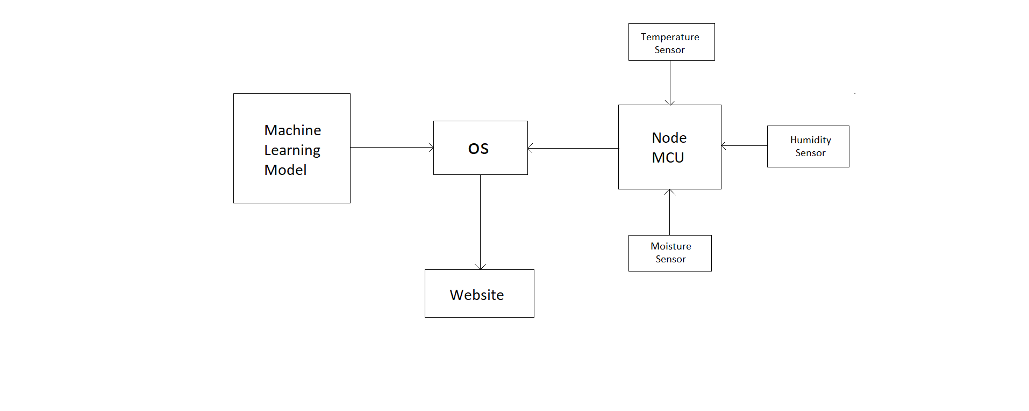

**Figure 1:** Block Diagram of crop disease detection.

**2.1 ML Model**

Machine learning trained and tested models which detect crop leaf disease are stored on operating device. You can check if a leaf is diseased or not on a locally hosted website by uploading an image on it.

**2.2 Operating Device**

The operating device serves as the central processing unit for the system. It stores the machine learning (ML) model, which was trained to detect plant leaf diseases. The operating device can be a personal computer (PC) or a similar device with sufficient computational power. It runs the necessary software, such as a Python IDE, to handle ML model inference and data processing.

**2.3 Node MCU**

The Node MCU is a microcontroller board based on the ESP8266 Wi-Fi module. It acts as the interface between the sensors and the operating device, providing connectivity to the internet. The Node MCU is equipped with a Wi-Fi module, allowing it to establish a wireless connection to the internet and communicate with the operating device.

**2.4 Temperature, Humidity and Soil moisture sensor**

The temperature and soil moisture sensors are connected to the Node MCU. The temperature sensor measures the ambient temperature in the environment. The soil moisture sensor measures the moisture level in the soil. These sensors provide real-time data on temperature and soil moisture, which are crucial for monitoring plant health and irrigation optimization.

**2.5 Website**

The operating device sends the sensor data, ML model output, and other relevant information to a website. To enable website integration, you can use software tools like XAMPP to set up a local web server or host the website on a remote server. The operating device communicates with the website using appropriate protocols and APIs to transmit the data securely. The website can display real-time information, such as temperature, soil moisture, and disease status, in a user-friendly manner. Users can access the website through their web browsers and view the data remotely, enabling them to monitor plant health and make informed decisions.

Overall, the block diagram illustrates the flow of data and interactions among the operating device, Node MCU with Wi-Fi module, sensors, ML model, and website. This system enables real-time monitoring of environmental conditions, disease detection, and data visualization through a web interface, enhancing agricultural practices and facilitating informed decision-making.

# 3. MODELING AND ANALYSIS

This figure shows how different components work together to make the whole system function properly.

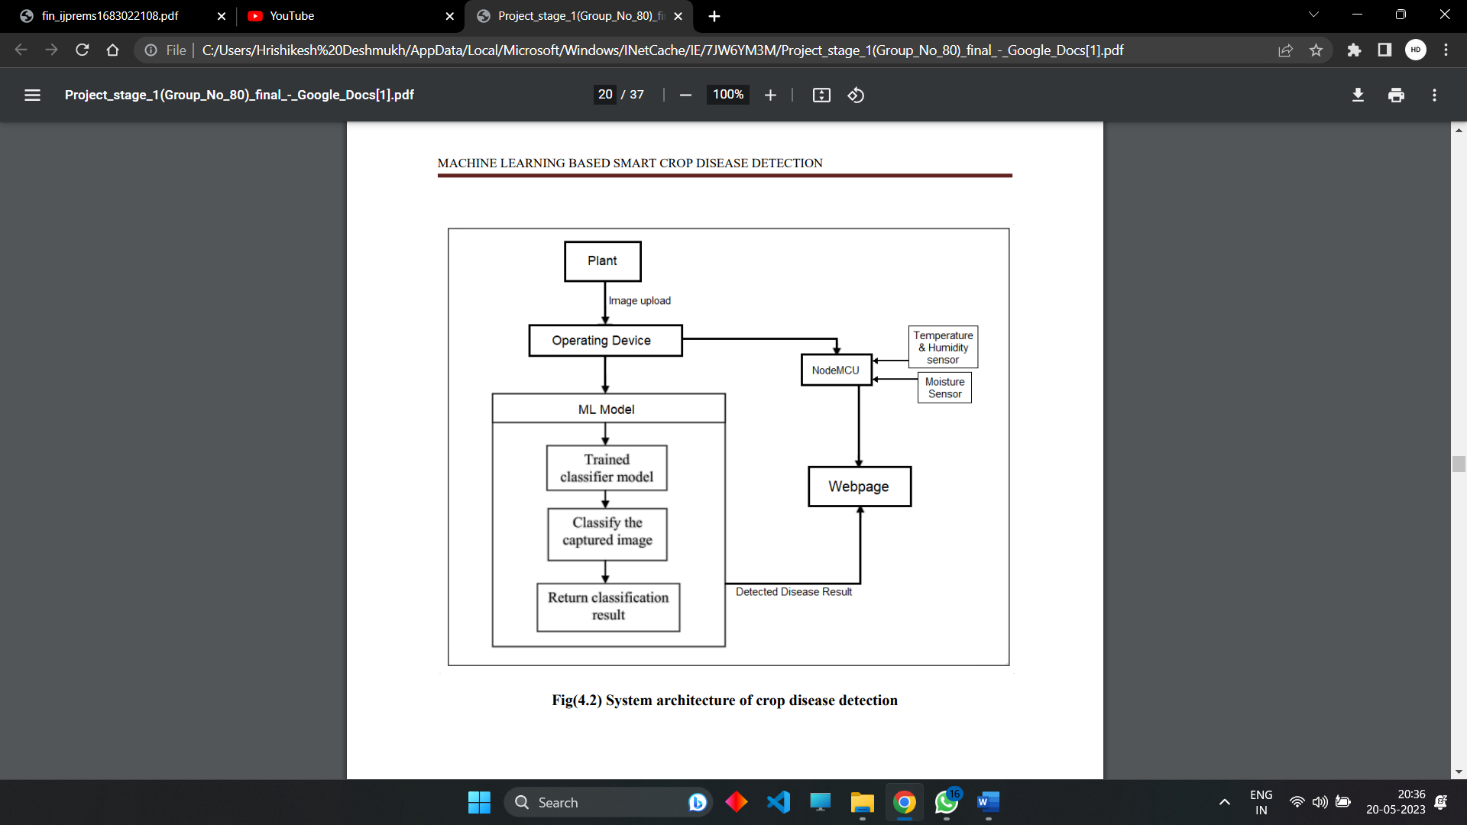

**Figure 2:**  System architecture of crop disease detection

A Convolutional Neural Network (CNN) is a deep learning algorithm primarily used for image recognition and computer vision tasks. It consists of several interconnected layers that learn to extract meaningful features from input images. Here's a concise explanation of how CNNs work:

1. Convolutional layer: The input image is convolved with a set of learnable filters, also known as kernels or feature detectors. Each filter scans the image in small regions, performing element-wise multiplication and aggregation to produce a feature map. Convolutional layers capture local patterns and spatial hierarchies.
2. Activation function: The feature map is then passed through a non-linear activation function (e.g., ReLU) to introduce non-linearity, allowing the network to learn complex relationships between features.
3. Pooling layer: To reduce spatial dimensionality and make the learned features more robust to variations, a pooling layer is applied. Common pooling methods include max pooling, which selects the maximum value in each region, and average pooling, which calculates the average value. Pooling reduces the computational complexity and helps with translation invariance.
4. Fully connected layer: The output of the convolutional and pooling layers is flattened and connected to a traditional neural network architecture, typically composed of fully connected layers. These layers learn high-level representations and make predictions based on the extracted features.
5. Output layer: The final fully connected layer is followed by an activation function suitable for the specific task, such as softmax for multi-class classification or sigmoid for binary classification. It generates the network's output probabilities or class predictions.
6. Training: CNNs are trained using backpropagation and optimization algorithms (e.g., stochastic gradient descent) to minimize a loss function. The loss is computed by comparing the predicted output with the true labels using appropriate metrics like cross-entropy.
7. Optimization: The network's weights and biases are updated iteratively during training to minimize the loss. This process is typically performed on batches of input images to improve computational efficiency.
8. Evaluation and prediction: Once trained, the CNN can be used for inference on new, unseen images. The forward pass through the network applies the learned filters and computes predictions based on the learned representations.

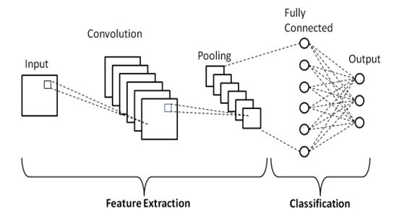

**Figure 3:**  CNN layers

# 4. RESULTS AND DISCUSSION

## In this project, we developed a crop disease detection system to identify common diseases in different types of plant like potato, wheat, corn etc.

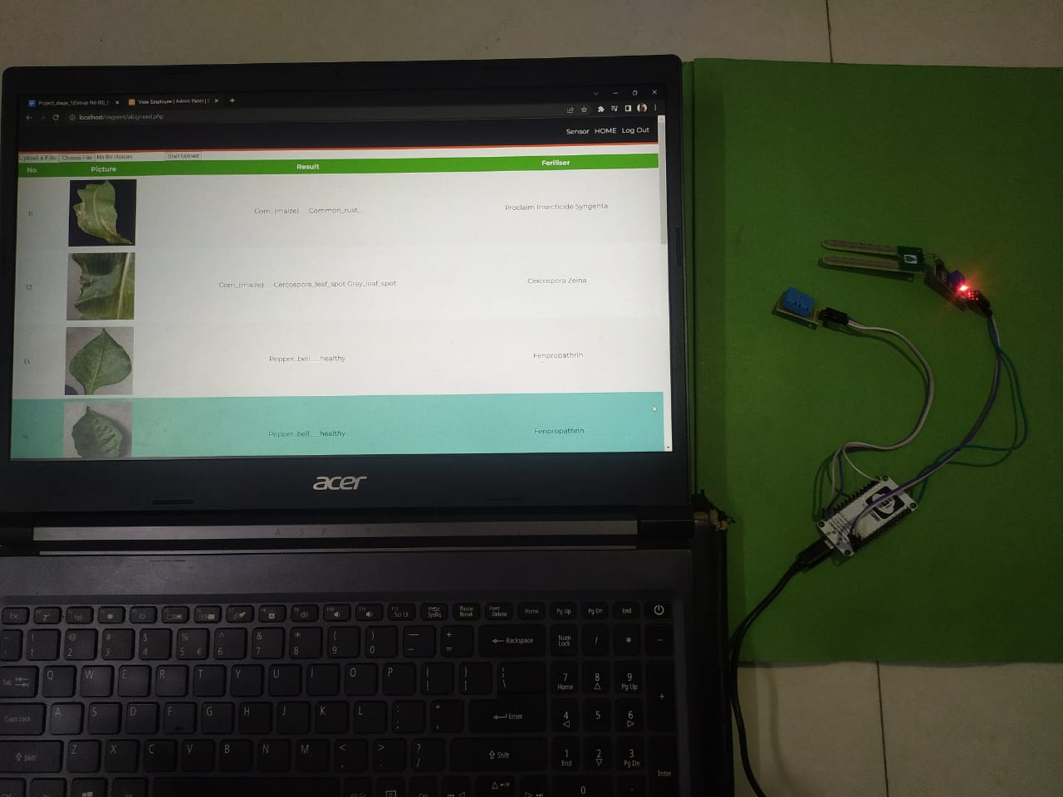

**Figure 4:**  Crop disease detection setup

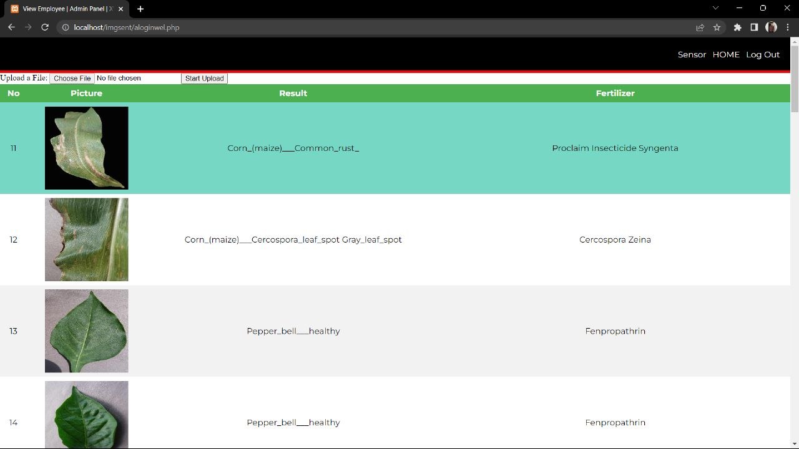

**Figure 5:** Webpage showing results of various diseases detected.

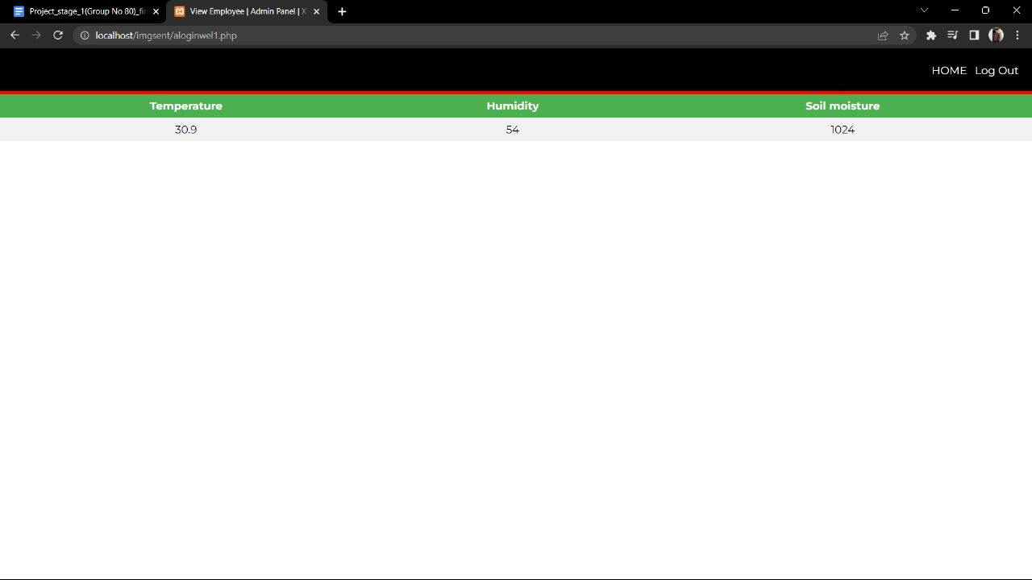

**Figure 6:** Webpage showing sensor results.

# 5. CONCLUSION

In conclusion, the crop leaf disease detection project utilizes advanced technologies and machine learning algorithms to accurately identify and classify diseases affecting crop leaves. By leveraging computer vision techniques and a comprehensive dataset of leaf images, the project aims to improve disease detection and provide timely interventions for farmers. The implementation of this project has the potential to significantly enhance crop management practices, reduce yield losses, and ultimately contribute to food security and sustainable agriculture.

# 6. REFERENCES

1. Sanjay B. Patil et al. “LEAF DISEASE SEVERITY MEASUREMENT USING IMAGE PROCESSING”, International Journal of Engineering and Technology Vol.3 (5), 2011, 297-301, DOI: 10.1109/ECS.2011.7090754
2. B. Bhanu, J. Peng, “Adaptive integrated image segmentation and object recognition”, In IEEE Transactions on Systems, Man and Cybernetics, Part C, volume 30, pages 427–441, November 2000, DOI: 10.1109/5326.897070
3. Keri Woods. ”Genetic Algorithms: Colour Image Segmentation Literature Review”, July 24, 2007, DOI: 10.1109/I2CT.2007.8226184
4. S.Beucher, F.Meyer. “The morphological approach to segmentation: The watershed transform”, in Mathematical Morphology Image Processing, E. R. Dougherty, Ed. New York Marcel Dekker, vol. 12, pp. 433–481, January 1993, DOI:10.1109/ICOEI.1993.8300913
5. Vijai singh,Varsha,Prof A K Misra, “Detection of unhealthy region of plant leaves using Image Processing and Genetic Algorithm” International Conference on Advances in Computer Engineering and Applications, March 2015, DOI:10.1109/ICACEA.2015.7164858
6. Mrunalini R. Badnakhe and Prashant R. Deshmukh, “An Application of K-Means Clustering and Artificial Intelligence in Pattern Recognition for Crop Diseases”, International Conference on Advancements in Information Technology, IPCSIT vol.20, 2011, DOI: 10.1109/ICIIECS.2011.8275901
7. Anand.H.Kulkarni, Ashwin Patil R. K., “Applying image processing technique to detect plant diseases”, International Journal of Modern Engineering Research, Vol.2, Issue.5, pp-3661-3664, Sep-Oct. 2012, DOI:10.1109/ICCCI.2012.8117730
8. Mr. Anand K. Hase, Ms. Priyanka S. Aher and Mr. Sudeep K. Hase, “Detection, Categorization and suggestion to cure infected plants of Tomato and Grapes by using OpenCV framework for Andriod Environment,” 2nd International Conference for Convergence in Technology (I2CT), April 2017, DOI: 10.1109/I2CT.2017.8226270
9. Kawaljit kaur and Chetan Marwaha, “Analysis of Diseases in Fruits using Image Processing Techniques,” International Conference on Trends in Electronics and Informatics ICEI, May 2017, DOI: 10.1109/ICOEI.2017.8300913
10. Ranjith, Saheer Anas, Ibrahim Badhusha, Zaheema OT, Faseela K, Minnuja Shelly, “Cloud Based Automated Irrigation And Plant Leaf Disease Detection System Using An Android Application,” International Conference on Electronics, Communication and Aerospace Technology ICECA, April 2017, DOI: 10.1109/ICECA.2017.8212798
11. Zia Ullah Khan, Tallha Akram, Syed Rameez Naqvi, Sajjad Ali Haider, Muhammad Kamran, Nazeer Muhammad, “Automatic Detection of Plant Diseases; Utilizing an Unsupervised Cascaded Design,” International conference of Electronics, Communication and Aerospace Technology (ICECA), April 2018, DOI: 10.1109/ICECA.2017.8212798
12. Chaitali G. Dhaware and Mrs. K.H. Wanjale, “A Modern Approach for Plant Leaf Disease Classification which Depends on Leaf Image Processing,” International Conference on Computer Communication and Informatics (ICCCI -2017), Jan. 2017, DOI: 10.1109/ICCCI.2017.8117733
13. Davoud Ashourloo, Hossein Aghighi, Ali Akbar Matkan, Mohammad Reza Mobasheri, and Amir Moeini Rad, “An Investigation Into Machine Learning Regression Techniques for the Leaf Rust Disease Detection Using Hyperspectral Measurement,” IEEE Journal of Selected Topics in Applied Earth Observations and Remote Sensing, August 2016, DOI: 10.1109/JSTARS.2016.2575360
14. Devendra P. Marathe, V. A. Patil, V. D. Chaudhari, "Reliable transfer of massage to alternative methods, i.e. Wi-fi, Bluetooth, ZigBee, Internet, M edia GPRS / GSM, IJET, vol 5, issue 7. Pp 2015.
15. Ghaiwat Savita N, Arora Parul. Detection and classification of plant leaf diseases using image processing techniques: a review. Int J Recent Adv Eng Technol 2014;2(3):2347– 812. ISSN (Online).
16. Y. Q. Xia, Y. Li, and C. Li, “Intelligent Diagnose System of Wheat Diseases Based on Android Phone,” J. of Infor. & Compu. Sci., vol. 12, pp.6845-6852, Dec. 2015.
17. Daba MH. Assessing local community perceptions on climate change and variability and its effects on crop production in selected districts of western Oromia, Ethiopia. J. Climatol. Weather Forecasting. 6, 216 (2018).
18. Aniah P, Kaunza-Nu-Dem MK, Ayembilla JA. Smallholder farmers’ livelihood adaptation to climate variability and ecological changes in the savanna agro ecological zone of Ghana, Heliyon, 5(4), e01492 (2019).
19. G. Anthonys and N. Wickramarachchi, “An image recognition system for crop disease identification of paddy fields in Sri Lanka,” International Conference on Industrial and Information Systems (ICIIS) Sri Lanka: IEEE, pp. 403-407, 2009.
20. D. J. Sena, F. Pinto, D. Queiroz and P. Viana, “Fall armyworm damaged maize plant identification using digital images.,” Biosyst Eng, vol. 85, no. 4, p. 449–454, 2003.
21. D. Al Bashish, M. Braik and S. Bani-Ahmad, “A framework for detection and classification of plant leaf and stem diseases.,” 2010 international conference on signal and image processing. IEEE, Chennai, p. 113–118, 2010.
22. S. B. Dhaygude and N. P. Kumbhar, “Agricultural plant Leaf Disease Detection Using Image Processing,” International Journal of Advanced Research in Electrical, Electronics and Instrumentation.