**BIO - CAPPED SELENIUM NANOPARTICLES CONJUGATED WITH BOVINE SERUM ALBUMIN FOR TARGETED THERAPY**

*Sangeetha. P, Charumathi. R ,Santhaseelan. C , Anishkumar. M*

*Department of biotechnology, V.S.B Engineering College,Karur.*

**ABSTRACT**

To perform the green synthesis of selenium nanoparticles capped with plant extract nanoparticles are nano-sized particles with the dimension ranging from 1-100 nm. The production of selenium nanoparticles typically employs one of three techniques: physical, chemical, or biological techniques. We can characterize the synthesized selenium nanoparticles through UV-visible Spectrophotometer, FT-IR, and XRD. After the characterization of selenium nanoparticles, they are bio-conjugated with bovine serum Albumin and determined the concentration of bovine serum albumin for bio-conjugation against the cancer cell lines. Finally molecular dynamic of bovine serum albumin - plant extract through bioinformatics tools using molecular docking. Green chemistry procedures emphasize the use of biological systems, which include microorganisms, and plant extract. Biological systems are used as capping, reducing, and stabilizing agents in replacement of chemical biogenic synthesis of selenium nanoparticles is nontoxic and economical and uses environmentally benign non-hazardous material such as phytochemicals from plant extracts. The second biggest cause of death in the world is cancer. Still, cancer does not have a targeted drug delivery. Selenium nanoparticles may be used as a covering or directly in solution at dosages that inhibit bacterial and cancerous growth. With an atomic number of 34, selenium corresponds to group 16 of the periodic table. Selenium has achieved a different position in the area of nanotechnology because of its large potential in the delivery of drugs and proteins. Selenium has both crystalline and amorphous structures in nature. Although selenium is an essential trace element for human health, there is a very thin line separating it from harm. It has different physiological roles in the human body such as antioxidants and prevents the formation of cancer.

**Key word:** Selenium nanoparticles, Bovine serum albumin, Plant extracts.

**INTRODUCTION**

Nano oncology has emerged as the biggest boon to the field of science and technology in the last few decades and has shown rapid growth, which has dramatically transformed the material science, biomedical, environmental, agricultural, and industrial domains (Vanya Nayak et al.,2021). Because it needs a non-toxic solvent and a moderate temperature, green synthesis using plant extract has become common. It also prevents cellular damage stimulated by free radicals by incorporation into antioxidant enzymes (Krystyna Pyrzynska et al.,2021). The second biggest cause of death in the world is cancer. Still, cancer does not have a targeted drug delivery. Selenium nanoparticles may be used as a covering or directly in solution at dosages that inhibit bacterial and cancerous growth (Raisa L. Silveira et al.,2019). With an atomic number of 34, selenium corresponds to group 16 of the periodic table. Selenium has achieved a different position in the area of nanotechnology because of its large potential in the delivery of drugs and proteins (Vanya Nayak et al.,2021). Selenium has both crystalline and amorphous structures in nature. Although selenium is an essential trace element for human health, there is a very thin line separating it from harm (Neha Bisht, et al.,2022) It has different physiological roles in the human body such as antioxidants and prevents the formation of cancer (Neha Bisht et al.,2022). Here, we use the *Withania Somnifera*(ashwagandha)*, Vitis vinifera*(grapes)*, and clitoria ternatea*(butterfly pea plant) as a plant extract. The Fabaceae family includes the annual leguminous herbaceous plant known as Clitoria ternatea (butterfly pea). Around the globe, the genus Clitoria is widely dispersed in tropical and subtropical habitats. Ternatins, anthocyanins derived from C. ternatea, are responsible for the blooms' distinctively intense blue color. By using these plant extract we synthesize the selenium nanoparticles with the addition of sodium selenite (Krystyna Pyrzynska et al.,2021). After the selenium nanoparticle preparation, we bio-conjugated the SeNPs with the bovine serum albumin and used them for cancer therapy. Green chemistry procedure place emphasis on the use of biological systems which include microorganisms, and plant extract. Biological systems are used as capping, reducing, and stabilizing agents in replacement of chemical biogenic synthesis of selenium nanoparticles is non-toxic, and economical, and uses environmentally benign non-hazardous material such as phytochemicals from plant extracts (Krystyna Pyrzynska et al.,2021). Elemental selenium has more importance in the field of biological, physical, and chemistry (Neha Bisht et al.,2022). For various samples, TEM analysis showed the existence of NPs with essentially identical sizes and shapes, and all NPs were protected by a layer of unwrinkled BSA. The expanded BSA coating's isoelectric point on the NP surface was consistently close to 4.7, the same as unconjugated BSA. Controls included BSA-free and cationic surfactant-coated Au NPs. Under the same circumstances, they demonstrated high hemolytic activity and very poor cell viability. As a result, BSA-coated NPs were thought to be the finest delivery systems for drugs and other potential biomedical uses. The sequencing of human DNA made possible by the human genome project has improved tools for detecting genomic, transcriptional, proteomic, and epigenetic alterations. The adoption of personalized medicine has been expedited by these technologies and innovative drug development. To individualize disease prevention, diagnosis, and therapy, personalized medicine makes use of ideas about the genetic and environmental causes of illness (Tarun Kumar Misra et al.,2009)**.** The promise of improving patient care lies in the optimization of treatment using targeted therapy, which uses molecules to target particular enzymes, growth factor receptors, and signal transducers to interfere with a variety of oncogenic cellular processes. This review summaries the most recent state-of-the-art uses of personalized medicine and focuses on targeted therapy for cancer therapeutics organized in accordance with the primary human carcinogenesis drivers (Tarun Kumar Misra et al.,2009).Nearly 7 million people die from cancer each year, making it one of the leading causes of mortality. The use of therapeutic antibodies or small molecules in new cancer targeted medicines has increased tumor specificity while reducing toxicity. Drug resistance, cancer stem cells, and high tumor interstitial fluid pressure are some of the ongoing difficulties in the fight against cancer.For instance, higher interstitial fluid pressure reduces the effectiveness of therapeutic drug absorption in many solid tumours. The use of ligand-targeted treatment, which can be utilised to make targeting more precise and deliver bigger dosages of anti-cancer medicine to tumour tissue, is one of the most promising approaches to overcoming such difficulties. Recent developments in the diagnosis and treatment of cancer are reviewed and discussed in this article.

**MATERIALS AND METHOD**

**PLANT COLLECTION**

The *vitis vinifera* seed, clitoria ternatea flower, withania somnifera root were collected from the outskirts of madurai and washed in water to remove dust. Then the seed, flower, root were shade dried for about 10-15 days.

**SOLVENT EXTRACTION**

The dried roots, seeds, flowers were coarsely powdered using an mortor and pestle and the dried powder of 4.8g of *vitis vinifera*, 0.6g of *clitoria ternatea*, 4.6g of *withania somnifera* were mixed with 50ml of distilled water. The solution were kept in 90˚c for 20 mins in water bath after the solution were filtered by using filter paper and then the extract was stored and used.

**PREPARATION OF SODIUM SELENATE**

0.315g of sodium selenate were mixed with 100ml of distilled water.

**SYNTHESIS OF SELENIUM NANOPARTICLES**

5 ml of plant extract mixed with 20 ml of 40mM selenate acid and mixed with 45 ml of distilled water. The mixed solution were kept in the water bath until the colour changes to reddish colour. After the colour changes the solution were kept in the centrifugation process for 20 minutes at 3500 rpm. Finally, the supernatant was removed and the pellet were diluted with distilled water.

**BIO CONJUGATION OF BOVINE SERUM ALBUMIN WITH SeNPs**

The synthesized nanoparticles are diluted with 8 ml distilled water and the PH was adjusted to 6.5. The bovine serum albumin solution was prepared(15mg BSA / 15 ml distilled water) and the PH was adjusted to 4.8 to 5.6. The 1ml of bovine serum albumin and 9 ml of plant derived selenium nanoparticles are mixed. Finally, the mixed solution were kept in the water bath for 45˚c.

**RESULT AND DISCUSSION**

**PLANT COLLECTION**

The *vitis vinifera* seed, clitoria ternatea flower, withania somnifera root were collected from the outskirts of madurai and washed in water to remove dust. Then the seed, flower, root were shade dried for about 10-15 days.

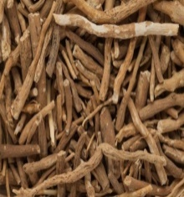 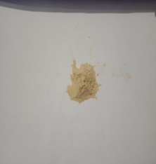

**Fig.1 *Withania somnifera* Fig.2*Withania somnifera powder***

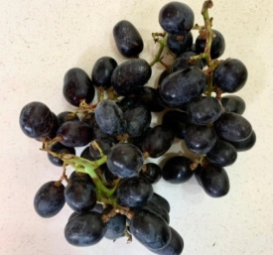 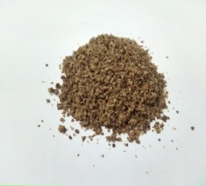

**Fig.3 *vitis vinifera* Fig.4 vitis vinifera powder**

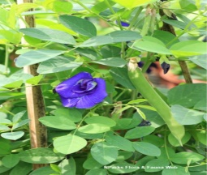 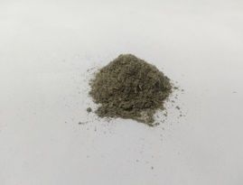

**Fig.5*Clitoriaternatea* Fig.6 Clitoria ternatea powder**

**SOLVENT EXTRACTION**

The dried roots, seeds, flowers were coarsely powdered using an mortor and pestle and the dried powder of 4.8g of *vitis vinifera*, 0.6g of *clitoria ternatea*, 4.6g of *withania somnifera* were mixed with 50ml of distilled water. The solution were kept in 90˚c for 20 mins in water bath after the solution were filtered by using filter paper and then the extract was stored and used.

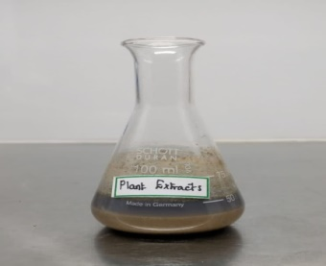 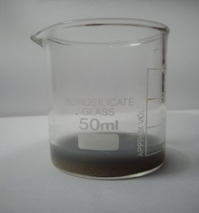

**Fig7. Before filteration of plant extract Fig.8 After filteration of plant extract**

**SYNTHESIS OF SELENIUM NANOPARTICLES**

5 ml of plant extract mixed with 20 ml of 40mM selenate acid and mixed with 45 ml of distilled water. The mixed solution were kept in the water bath until the colour changes to reddish colour. After the colour changes the solution were kept in the centrifugation process for 20 minutes at 3500 rpm. Finally, the supernatant was removed and the pellet were diluted with distilled water.

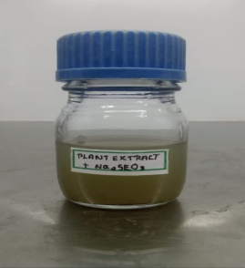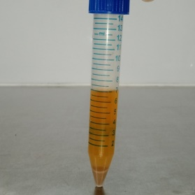

**Fig.9 Before synthesis of SeNPs Fig.10 After synthesis of SeNPs**

**CHARACTERAIZATION OF SELENIUM NANOPARTICLES**

**UV-VISIBLE SPECTROSCOPY**

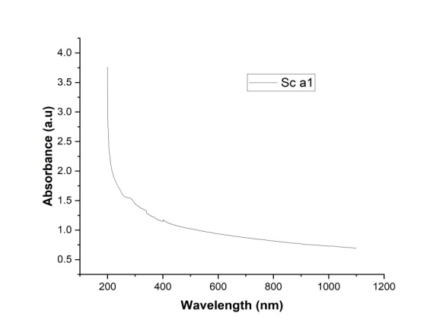

**Fig.11 Characteraization of SeNPs in UV**

Reduction of selenium ions into selenium nanoparticles during exposure to plant extracts and ascorbic acid was ob-served using UV-Vis spectra. The metal nanoparticles have free electrons, which give the SPR absorption band, due to the combined vibration of electrons of metal nanoparticles. Chitosan stabilized selenium nanoparticles shown the SPR band at 450 and 310 nm indicates the formation of selenium nanoparticles. Some of the minor peaks were also observed due to the presence of biomolecules from chitosan Fig 11. Previous studies have shown that the spherical Se-NPs contribute to the absorption bands at around 250-400nm in the UV-Visible spectra reported max at 280 nm at 355 nm at 380 nm.

**FT-IR**

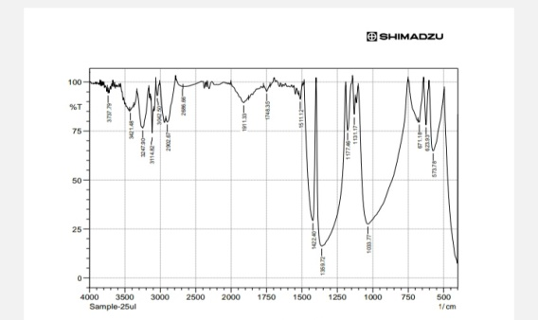

**Fig.12 Characteraization of SeNPs in FT-IR**

|  |  |  |
| --- | --- | --- |
| **LENGTH(cm-1)** | **FUNCTIONAL GROUP** | **VIBRATION** |
| 573.78 | HALOGEN COMPOUND | - |
| 623.93 | ALKYNES | BENDING VIBRATION |
| 671.18 | ALKYNES | BENDING VIBRATION |
| 1033.77 | AMINES | STRETCHING VIBRATION |
| 1131.17 | AMINES | STRETCHING VIBRATION |
| 1177.46 | AMINES | STRETCHING VIBRATION |
| 1359.72 | ALKANES, ALCOHOLS, PHENOLS,ALDEHYDES & KETONES | BENDING VIBRATION |
| 1422.4 | ALKANES,ALDEHYDES & KETONES | BENDING VIBRATION |
| 1511.12 | CARBOXYLIC ACID & DERIVATIVE | BENDING VIBRATION |
| 1748.35 | ALDEHYDES & KETONES | STRETCHING VIBRATION |
| 1911.33 | ALKENES | STRETCHING VIBRATION |
| 2686.66 | CARBOXYLIC ACID & DERIVATIVE | STRETCHING VIBRATION |
| 2908.67 | ALKANES | STRETCHING VIBRATION |
| 3042.5 | ALKENES | STRETCHING VIBRATION |
| 3114.82 | CARBOXYLIC ACID & DERIVATIVE | STRETCHING VIBRATION |
| 3246.9 | CARBOXYLIC ACID & DERIVATIVE ,ALCOHOLS AND PHENOLES | STRETCHING VIBRATION |
| 3421.48 | AMIDES | STRETCHING VIBRATION |
| 3737.79 | ALCOHOLS | - |

**Table no. 1 Characteraization of SeNPs in FT-IR**

The functional groups present in green synthesized chi-tosan-selenium nanoparticles were identified by FTIR spec-tra. FTIR analysed at different wavenumber range from 4000 to 500cm-1. The functional groups involved in the synthesis of selenium nanoparticles using chitosan were detected with the help of FT-IR analysis.

**SEM**

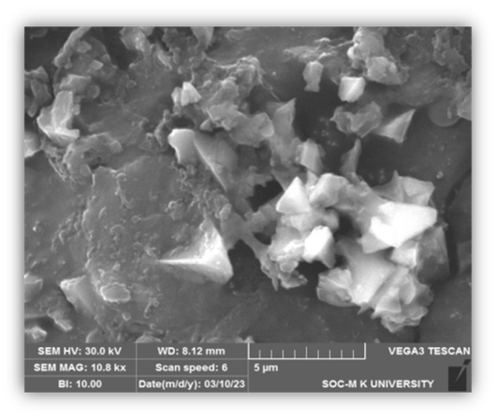

**Fig.13 Characteraization of SeNPs in SEM**

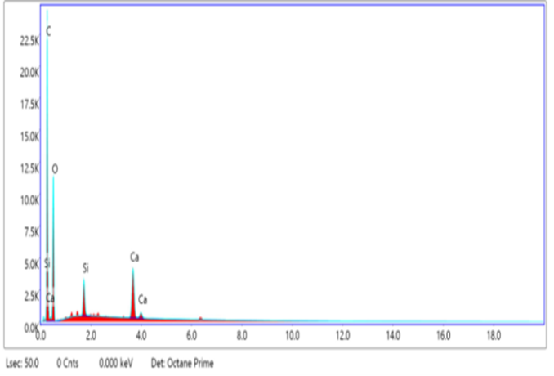

**Fig .14 Selected area analysis**

|  |  |  |  |  |  |  |  |  |
| --- | --- | --- | --- | --- | --- | --- | --- | --- |
| **Element** | **Weight %** | **Atomic %** | **Net Int** | **Error %** | **K ratio** | **Z** | **A** | **F** |
| **CK** | 56.25 | 64.07 | 2400.61 | 5.44 | 0.3187 | 1.0184 | 0.5561 | 1.0000 |
| **OK** | 40.56 | 34.68 | 1169.28 | 9.96 | 0.0510 | 0.9804 | 0.1283 | 1.0000 |
| **SiK** | 1.06 | 0.52 | 444.90 | 5.06 | 0.0068 | 0.9018 | 0.7012 | 1.0057 |
| **CaK** | 2.12 | 0.72 | 864.83 | 2.42 | 0.0200 | 0.8585 | 1.0609 | 1.0338 |

**Table no.2 Selected area analysis**

**BIO CONJUGATION OF BOVINE SERUM ALBUMIN WITH SeNPs**

The synthesized nanoparticles are diluted with 8 ml distilled water and the PH was adjusted to 6.5. The bovine serum albumin solution was prepared(15mg BSA / 15 ml distilled water) and the PH was adjusted to 4.8 to 5.6. The 1ml of bovine serum albumin and 9 ml of plant derived selenium nanoparticles are mixed. Finally, the mixed solution were kept in the water bath for 45˚c.

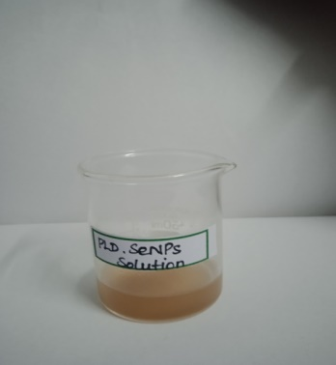

**Fig.15 Plant derived selenium nanoparticle solution**

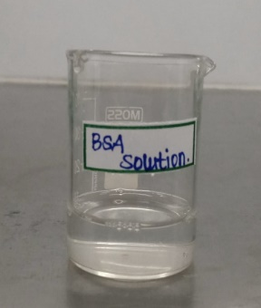

**Fig.16 Bovine serum albumin solution**

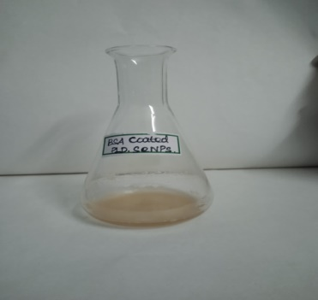

**Fig.17 BSA coated plant derived selenium nanoparticles solution**

**BIOCONJUGATION**

Bio-conjugation of BSA with plant derived selenium nanoparticles are find by the protein estimation . Protein estimation done through Bradford method at 595 nm. The blue colour was observed based on the OD value of 1.02, We confirmed thepresence of BSA in nanomaterial after synthesis.

**SELENIUM NANOPARTICLES AGAINST AGS CELL LINE STUDY**

|  |  |  |  |  |  |  |  |  |  |
| --- | --- | --- | --- | --- | --- | --- | --- | --- | --- |
| **Samples(µg/ml)** | |  |  | **Average** | **Percentage** | |  | **Average** | **stdvp** |
| VC | 0.178 | 0.239 | 0.263 | 0.226667 | 78.52941 | 105.4412 | 116.0294 | 100 | 15.78538 |
| 10 | 0.2 | 0.259 | 0.266 | - | 88.23529 | 114.2647 | 117.3529 | 106.6176 | 13.05929 |
| 20 | 0.176 | 0.324 | 0.308 | - | 77.64706 | 142.9412 | 135.8824 | 118.8235 | 29.25842 |
| 40 | 0.221 | 0.322 | 0.296 | - | 97.5 | 142.0588 | 130.5882 | 123.3824 | 18.89119 |
| 80 | 0.256 | 0.315 | 0.185 | - | 112.9412 | 138.9706 | 81.61765 | 111.1765 | 23.44747 |
| 160 | 0.206 | 0.201 | 0.212 | - | 90.88235 | 88.67647 | 93.52941 | 91.02941 | 1.983932 |

**Table. No.3 SeNPs against AGS cell line (C1)**

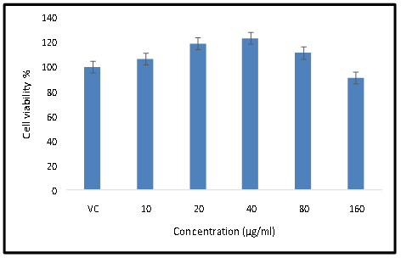

**Fig .18 SeNPs against AGS cell line (C1)**

|  |  |  |  |  |  |  |  |  |  |
| --- | --- | --- | --- | --- | --- | --- | --- | --- | --- |
| **Samples(µg/ml)** | |  |  | **Average** | **Percentage** | |  | **Average** | **Stdvp** |
| **VC** | 0.263 | 0.22 | 0.195 | 0.226 | 116.3717 | 97.34513 | 86.28319 | 100 | 12.4262 |
| **10** | 0.23 | 0.276 | 0.287 |  | 101.7699 | 122.1239 | 126.9912 | 116.9617 | 10.92442 |
| **20** | 0.324 | 0.327 | 0.273 |  | 143.3628 | 144.6903 | 120.7965 | 136.2832 | 10.96417 |
| **40** | 0.268 | 0.276 | 0.282 |  | 118.5841 | 122.1239 | 124.7788 | 121.8289 | 2.537559 |
| **80** | 0.255 | 0.327 | 0.291 |  | 112.8319 | 144.6903 | 128.7611 | 128.7611 | 13.00614 |
| **160** | 0.212 | 0.29 | 0.285 |  | 93.80531 | 128.3186 | 126.1062 | 116.0767 | 15.77413 |

**Table no. 4 SeNPs AGAINST AGS CELL LINE(C2)**

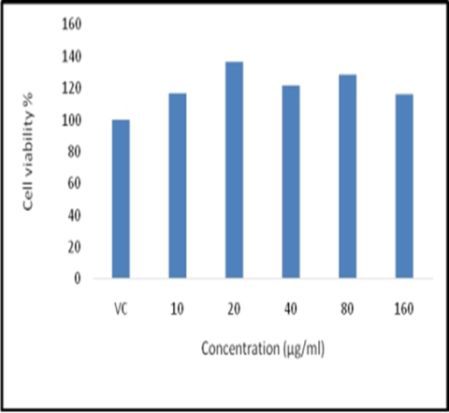

**Fig 19 SeNPs AGAINST AGS CELL LINE (C2)**

**CONCLUSION**

Sodium selenate acid combined with plant extract was used to create the selenium nanoparticles. The selenium nanoparticles' production was consistent with the red colour. The protein estimate determines the bio-conjugation of BSA with selenium nanoparticles generated from plants. Bradford method used to estimate protein. The OD value was used to determine the blue colour. After production, we verified the presence of BSA in the nanomaterial. This study's findings demonstrated the effectiveness of bio-conjugating bovine serum albumin with selenium nanoparticles against the AGS cell line. The AGS cell line is inhibited by it.

**REFERENCE**

1. Abinaya, M., Vaseeharan, B., Rekha, R., Shanthini, S., Govindarajan, M., Alharbi, N. S., ... & Al-Anbr, M. N. (2019). Microbial exopolymer-capped selenium nanowires–Towards new antibacterial, antibiofilm and arbovirus vector larvicides?. *Journal of Photochemistry and Photobiology B: Biology*, *192*, 55-67.
2. Akhavan, A., Kalhor, H. R., Kassaee, M. Z., Sheikh, N., & Hassanlou, M. (2010). Radiation synthesis and characterization of protein stabilized gold nanoparticles. *Chemical Engineering Journal*, *159*(1-3), 230-235.
3. Ashrafizadeh, M., Rafiei, H., Mohammadinejad, R., Farkhondeh, T., & Samarghandian, S. (2021). Anti-tumor activity of resveratrol against gastric cancer: A review of recent advances with an emphasis on molecular pathways. *Cancer Cell International*, *21*, 1-10.
4. Bajaj, M., Schmidt, S., & Winter, J. (2012). Formation of Se (0) nanoparticles by Duganella sp. and Agrobacterium sp. isolated from Se-laden soil of North-East Punjab, India. *Microbial cell factories*, *11*, 1-14.
5. Bano, I., Malhi, M., Khatri, P., Soomro, S. A., Sajjad, H., Leghari, A., ... & Soomro, M. (2019). Effect of dietary selenium yeast supplementation on morphology and antioxidant status in testes of young goat. *Pakistan Journal of Zoology*, *51*(3), 979.
6. Baptista, P. V., McCusker, M. P., Carvalho, A., Ferreira, D. A., Mohan, N. M., Martins, M., & Fernandes, A. R. (2018). Nano-strategies to fight multidrug resistant bacteria—“A Battle of the Titans”. *Frontiers in microbiology*, *9*, 1441.
7. Baskar, G., Lalitha, K., & Bikku George, G. (2019). Synthesis, characterization and anticancer activity of selenium nanobiocomposite of L-asparaginase. *Bulletin of Materials Science*, *42*, 1-7.
8. Benko, I., Nagy, G., Tanczos, B., Ungvari, E., Sztrik, A., Eszenyi, P., ... & Banfalvi, G. (2012). Subacute toxicity of nano‐selenium compared to other selenium species in mice. *Environmental Toxicology and Chemistry*, *31*(12), 2812-2820.
9. Bhattacharjee, A., Basu, A., & Bhattacharya, S. (2019). Selenium nanoparticles are less toxic than inorganic and organic selenium to mice in vivo. *The Nucleus*, *62*, 259-268.
10. Bisht, N., Phalswal, P., & Khanna, P. K. (2022). Selenium nanoparticles: A review on synthesis and biomedical applications. *Materials Advances*, *3*(3), 1415-1431.
11. Bisht, N., Phalswal, P., & Khanna, P. K. (2022). Selenium nanoparticles: A review on synthesis and biomedical applications. *Materials Advances*, *3*(3), 1415-1431.
12. Chakrabortty, S., Agrawalla, B. K., Stumper, A., Vegi, N. M., Fischer, S., Reichardt, C., ... & Weil, T. (2017). Mitochondria targeted protein-ruthenium photosensitizer for efficient photodynamic applications. *Journal of the American Chemical Society*, *139*(6), 2512-2519.
13. Chakrabortty, S., Agrawalla, B. K., Stumper, A., Vegi, N. M., Fischer, S., Reichardt, C., ... & Weil, T. (2017). Mitochondria targeted protein-ruthenium photosensitizer for efficient photodynamic applications. *Journal of the American Chemical Society*, *139*(6), 2512-2519.
14. Chakraborty, S., Joshi, P., Shanker, V., Ansari, Z. A., Singh, S. P., & Chakrabarti, P. (2011). Contrasting effect of gold nanoparticles and nanorods with different surface modifications on the structure and activity of bovine serum albumin. *Langmuir*, *27*(12), 7722-7731.
15. Chen, T., Wong, Y. S., Zheng, W., Bai, Y., & Huang, L. (2008). Selenium nanoparticles fabricated in Undaria pinnatifida polysaccharide solutions induce mitochondria-mediated apoptosis in A375 human melanoma cells. *Colloids and surfaces B: Biointerfaces*, *67*(1), 26-31.
16. Chung, S., Zhou, R., & Webster, T. J. (2020). Green synthesized BSA-coated selenium nanoparticles inhibit bacterial growth while promoting mammalian cell growth. *International Journal of Nanomedicine*, 115-124.
17. Cittrarasu, V., Kaliannan, D., Dharman, K., Maluventhen, V., Easwaran, M., Liu, W. C., ... & Arumugam, M. (2021). Green synthesis of selenium nanoparticles mediated from Ceropegia bulbosa Roxb extract and its cytotoxicity, antimicrobial, mosquitocidal and photocatalytic activities. *Scientific reports*, *11*(1), 1032..
18. El-Ramady, H., Abdalla, N., Alshaal, T., El-Henawy, A., Elmahrouk, M., Bayoumi, Y., ... & Schnug, E. (2018). Plant nano-nutrition: perspectives and challenges. *Nanotechnology, food security and water treatment*, 129-161.
19. El-Ramady, H., Faizy, S. E. D., Abdalla, N., Taha, H., Eva, D. S., Fari, M., ... & Brevik, E. C. (2020). Selenium and Nano-Selenium Biofortification for Human Health.
20. Eswayah, A. S., Smith, T. J., & Gardiner, P. H. (2016). Microbial transformations of selenium species of relevance to bioremediation. *Applied and environmental microbiology*, *82*(16), 4848-4859.
21. Ezhuthupurakkal, P. B., Polaki, L. R., Suyavaran, A., Subastri, A., Sujatha, V., & Thirunavukkarasu, C. (2017). Selenium nanoparticles synthesized in aqueous extract of Allium sativum perturbs the structural integrity of Calf thymus DNA through intercalation and groove binding. *Materials Science and Engineering: C*, *74*, 597-608.
22. Fernández-Llamosas, H., Castro, L., Blázquez, M. L., Díaz, E., & Carmona, M. (2016). Biosynthesis of selenium nanoparticles by Azoarcus sp. CIB. *Microbial cell factories*, *15*(1), 1-10.
23. Forootanfar, H., Adeli-Sardou, M., Nikkhoo, M., Mehrabani, M., Amir-Heidari, B., Shahverdi, A. R., & Shakibaie, M. (2014). Antioxidant and cytotoxic effect of biologically synthesized selenium nanoparticles in comparison to selenium dioxide. *Journal of Trace Elements in Medicine and Biology*, *28*(1), 75-79.
24. Ghotekar, S. (2019). Plant extract mediated biosynthesis of Al2O3 nanoparticles-a review on plant parts involved, characterization and applications. *Nanochemistry Research*, *4*(2), 163-169.
25. Giacomelli, C. E., & Norde, W. (2001). The adsorption–desorption cycle. Reversibility of the BSA–silica system. *Journal of Colloid and Interface Science*, *233*(2), 234-240.
26. Gudkov, S. V., Shafeev, G. A., Glinushkin, A. P., Shkirin, A. V., Barmina, E. V., Rakov, I. I., ... & Kalinitchenko, V. P. (2020). Production and use of selenium nanoparticles as fertilizers. ACS Omega 5: 17767–17774.
27. Gudkov, S. V., Shafeev, G. A., Glinushkin, A. P., Shkirin, A. V., Barmina, E. V., Rakov, I. I., ... & Kalinitchenko, V. P. (2020). Production and use of selenium nanoparticles as fertilizers. *ACS omega*, *5*(28), 17767-17774.
28. Hosnedlova, B., Kepinska, M., Skalickova, S., Fernandez, C., Ruttkay-Nedecky, B., Peng, Q., ... & Kizek, R. (2018). Nano-selenium and its nanomedicine applications: a critical review. *International journal of nanomedicine*, 2107-2128.
29. Hunter, W. J., Kuykendall, L. D., & Manter, D. K. (2007). Rhizobium selenireducens sp. nov.: a selenite-reducing α-Proteobacteria isolated from a bioreactor. *Current microbiology*, *55*, 455-460.
30. Hussein, H. A. A., Darwesh, O. M., & Mekki, B. B. (2019). Environmentally friendly nano-selenium to improve antioxidant system and growth of groundnut cultivars under sandy soil conditions. *Biocatalysis and agricultural biotechnology*, *18*, 101080.