**“Foot step power generation using piezoelectric tiles”**

**Jenkar K P1,**

**Vishnu Murthy M2,**

**Narendra Yadav G3,**

**Prof. G Rajaraman4,**

*1,2,3Student, Dept of CSE SAIT, Bengaluru Karnataka, India.

*4Prof. Dept of CSE SAIT, Bengaluru Karnataka, India.

# ABSTRACT

Human race requires energy at very rapid rate for their living and wellbeing from the time of their arrival on this planet, because of this reason power resources have been worn out and enervated. Proposal for the employment and application of extravagant energy in foots of human is very much to the purpose for extremely populated nations like China and India. Where the streets, rail and bus station are over peopled and packed like sardines moving around the clock. So, using such concept the power can be availed and deployed by converting mechanical energy to electrical energy. In the present scenario, the requirement for energy has been increasing in a distressing rate and the availability of the energy resources are not abundant for sustainable development and the need of the hour is to establish an economical pollution free inexhaustible energy resource to compensate the increasing demands. Since, walking is the most common activity in human day to day life, whenever a person walks he exhausts energy to the ground which goes as a waste. In order to preserve and make use of this energy we are converting it into electrical energy using piezoelectric effect. Piezoelectric effect is utilized by piezoelectric sensor producing output energy in the form of AC voltage. We proposed a system using piezoelectric sensors for power generation from footsteps and generated power is stored in the battery and we can see in the LCD display the generated power.

**Introduction**

At present, electricity is the necessary part of the human life in daily activities and demand of electricity is increasing exponentially day by day. Modern technology requires a vast amount of power in the form of electricity for its different operations. Worldwide electricity generation contributes maximum in pollution as the single largest source. Also, exponential increasing demands of electricity creating a large gap between demand and supply. Due to this, researcher and innovators working in the field of energy harvesting are trying to explore the alternate sources of energy and its feasible use. Accordingly, main objective of present day technology is to invent and provide a pollution free method of electricity from the growing human population that does not negatively impact the environment. In this technology, piezoelectric effect is used to generate the electricity. When pressure and strain are applied to a material which shows piezoelectric effect have the capability to build up an electrical charge. Piezoelectric sensors generate electricity when we apply pressure on the sensors. Piezoelectric materials act as a transducers and pressure exerted by the moving people transformed into electric current. In the recent scenario, the demand for energy has been increasing at an alarming rate and there has been a decrease in the availability of energy resources. For sustainable development, the need of the hour is to develop more efficient, pollution free and renewable energy resources to meet the unending demands. The depletion of fossil fuel has affected worldwide economics. This shows that we are too dependent on fossil fuel as a source of electrical power. Besides, fossil fuel as a source of electrical energy has contributed to a severe environmental pollution problem. Therefore, an alternative method to produce electricity has to be put in place. One of the most promising options is to generate the electric energy from the ambient source. Energy harvesting is defined as the process by which energy is derived from external sources in the environment and storing it in batteries for powering various systems. The most popular energy harvesting technologies are photovoltaic, wind and piezoelectric energy harvesting. Among the three, piezoelectric energy harvesting can be implemented in small and large scale and is relatively easy and cheap to Piezoelectric energy harvesting (PEH) is generating electrical power when the PZT disks are bent by applying mechanical force, human walking is one of the source. We proposed a system using piezoelectric sensors for powergeneration from footsteps and generated power is stored in the battery and we can see in the LCD display the generated power.

**LITERATURE REVIEW**

K. Somalaraju and J. G. Singh : In this work, we have improvised the energy scavenging tile and presented with the simulation results. Due to improvisation, power generation was increased. Load resistance and flywheel with different inertia’s are tested with the output power generation. Optimal load resistance of 7ohms is obtained by performing different operations with the load where it couldn’t generate from 1ohm and 50ohms. Different types of flywheels are used to determine the type of flywheel to be used with its moment of inertia to get better power output. Two unidirectional clutches are used to overcome the over damping of the scavenging device and the extension period of device working time. Performance of the device will be affected without clutches. Permanent magnet synchronous generator is used even though it is costlier due to its performance and due to its long-term use. Peak energy output from this device is generated more than 2 joules. An obtrusive result of 15Watts electrical power output is generated through this device which is more than previously generated within this dimensions and displacement as per mentioned literature review. The objective of increasing power output by using both upward and downward motion from the energy scavenging tile is satisfied with the match of the theoretical calculation.

# Kamboj, A. Haque, A. Kumar, V. K. Sharma and A. Kumar : In this paper, they have presented the design of power generation using footstep based on available piezoelectric sensors. Human race requires energy at very rapid rate for their living and wellbeing from the time of their arrival on this planet, because of this reason power resources have been worn out and enervated. Proposal for the employment and application of extravagant energy in foots of human is very much to the purpose for extremely populated nations like China and India. Where the streets, rail and bus station are over peopled and packed like sardines moving around the clock. So, using such concept the power can be availed and deployed by converting mechanical energy to electrical energy. In this paper we have calculated the various methodologies for foot step generation using piezoelectric sensors. The Experimental setup is discussed with all sub equipments. The results have been discussed in terms of output voltages. The plot between current and voltage shows the extent of power generated. The various merits are power generation is simply walking on the step and no need of fuel, power may also be generated by running or exercising on the step and battery may be used to store the conventional power. In future works one may attempt to overcome following limiting factors as it is only applicable for the particular place and limited power is generated using the conventional ICs present in market.

# 

# P. R. Prasad, A. Bhanuja, L. Bhavani, N. Bhoomika and B. Srinivas : This technique of power generation is easy and can be used in areas where the power is in short fall. The power generated in response to the applied pressure is given to the streetlights controlled by a switch and can be used for the basic needs like charging of lights, mobile phones without causing any adverse effect to the environment and depletion of natural resources. In this proposed work model, GPS tracking has been added and also streetlights switching technique comparing with existing model.

# 

# D. Dalabeih, B. Haws and S. Muhtaseb : The paper presents an experimental model for harvesting kinetic energy of footsteps. A feasibility analysis were performed to evaluate the expected power generation if commercial tiles are installed at the University of Jordan. A piezoelectric model for electric energy harvesting was built. Its output voltage was analyzed with represent to power output and pressure. Also feasibility study was made to find the expected power generation if commercial tiles are installed at the faculty of engineering which can be extended to other parts of the university which has around 40,000 students.

# PROPOSED SYSTEM

Calculate the total number of piezoelectric tiles needed based on the amount of foot traffic in the area.

Install the piezoelectric tiles on the floor, making sure they are properly connected in a series or parallel circuit.

Set up a microcontroller or other control system to monitor and regulate the voltage and current generated by the piezoelectric tiles.

When a person steps on a tile, the pressure generated by their weight causes the tile to deform slightly, generating a voltage across the piezoelectric material. The microcontroller measures the voltage and current generated by the tile and uses this information to calculate the power output.

The power generated by each tile is added together to calculate the total power output of the system.

The power output can be used to charge batteries, power electronic devices or directly supply power to the grid. The power output can be used to charge batteries, power electronic devices or directly supply power to the grid.

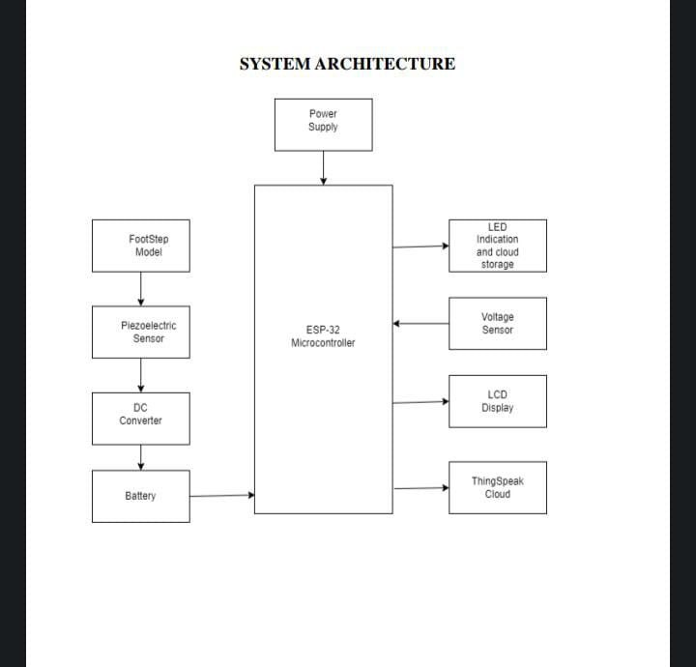

**Fig: Block Diagram of Foot step power generation using piezoelectric tiles**

**Arduino Nano Microcontroller**

The Arduino Nano is a small, complete, and breadboard-friendly board based on the ATmega328. It lacks only a DC power jack, and works with a Mini-B USB cable instead of a standard one

**Piezoelectric Sensor**

The piezoelectric sensor or Piezo Elements work on the principle of the piezoelectric effect. This effect measures changes in pressure, stain, temperature, acceleration, and force in the form of electrical charge or voltage. The materials which work under the piezoelectric effect are piezoelectric crystals, ceramic, bone, some proteins, and DNA. A piezoelectric sensor/element is a device that uses the piezoelectric effect, it is basically a device which converts voltage to vibration and vibration to voltage. It normally comes in handy to measure knock (knock sensor) or vibration (vibration sensor). This is a 27mm piezoelement.

**Voltage Sensor**

This is a simple but very useful module which uses a potential divider to reduce an input voltage by a factor of 5. The Voltage Sensor Module 25V allows you to use the analog input of a microcontroller to monitor voltages much higher than it capable of sensing.For example with a 0-5V analog input range, you are able to measure a voltage up to 25V. This voltage sensor module also includes convenient screw terminals for easy and secure connection of a wire. This module is based on the principle of resistive voltage divider design, can make the red terminal connector input voltage to 5 times smaller. Arduino analog input voltages up to 5 v, the voltage detection module input voltage not greater than 5Vx5=25V (if using 3.3V systems, input voltage not greater than 3.3Vx5=16.5V).

**16x2 LCD Display**

This is LCD1602 Parallel LCD Display that provides a simple and cost-effective solution for adding a 16×2 Black on RGB Liquid Crystal Display into your project. The display is 16 character by 2 line display has a very clear and high contrast black text upon a Gray background/backlight. This is a great Gray backlight LCD display. It is fantastic for Arduino based project. This LCD1602 Parallel LCD Display with Gray Backlight is very easy to interface with Arduino or Other Microcontrollers The values shown on the display can be either a simple text or numerical values read by the sensors, such as temperature or pressure, or even the number of cycles that the Arduino is performing.

**16x2 LCD Display**

A twelve-volt battery has six single cells in series producing a fully charged output voltage of 12.6 volts. A battery cell consists of two lead plates a positive plate covered with a paste of lead dioxide and a negative made of sponge lead, with an insulating material (separator) in between.

• Multipurpose Sealed Lead Acid Battery. Maintenance free and spill proof battery.

• Rechargeable battery that can be mounted in any position, resists shocks and vibration.

• Strong ABS and Wide Operating Temperature Range, Push type battery terminal.

• Safety Valve Regulated System.

• Sealed Lead-Acid Rechargeable Battery 12V 4.5Ah for UPS, Toys, Solar, Emergency lights, security device etc.

**RESULT**

As a result, it can prevent child fatalities in bore wells. The system employs various technologies such as IR technology, robotic arms, and safety airbags, which work together to rescue the child with minimal time. The system also includes a controlling device, the myDAQ, located at the ground level, which controls all the actions of the robot.

Resulting Images are:

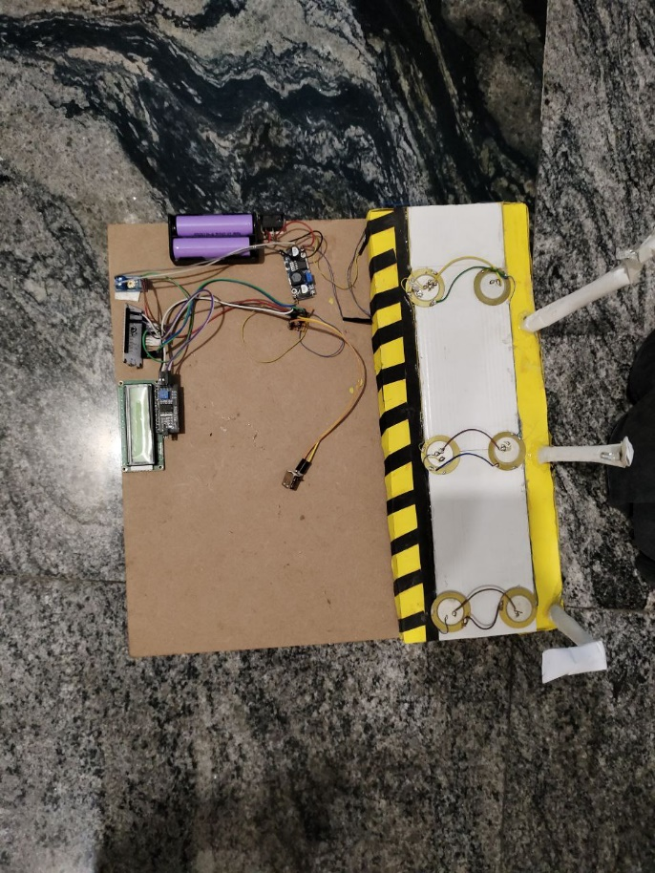

Fig: Overall outcome of the Project



Fig: graph for result

# ADVANTAGES AND APPLICATIONS

* Efficient and sustainable energy generation.
* Harnesses energy from human footstep movements.
* Reduces reliance on traditional power sources.
* Can be installed in high-traffic areas for maximum energy capture.
* Low maintenance requirements.
* Compatible with various surfaces and environments.
* Can be integrated into existing infrastructure.
* Provides a renewable and clean energy solution.
* Helps reduce carbon footprint.
* Potential for widespread adoption in public spaces and buildings.

**Applications & Features:**

* Mobile Charging
* Street Lighting
* Bus station lighting
* Emergency power failure stations
* Colleges
* Schools
* Cinema theaters
* Shopping complex

# CONCLUSION AND FUTURE SCOPE

At present, electricity is the necessary part of the human life in daily activities and demand of electricity is increasing exponentially day by day. Modern technology requires a vast amount of power in the form of electricity for its different operations. Worldwide electricity generation contributes maximum in pollution as the single largest source. So in order to provide solution this problem. We proposed a system using piezoelectric sensors for power generation from footsteps and generated power is stored in the battery and we can see in the LCD display the generated power. In the future this can be done in large scale in order to generate more electricity.

# REFERENCES

1. Somalaraju and J. G. Singh, "Enhancement of Power Generation From Electromagnetic Scavenging Tile," 2020 International Conference on Power Electronics & IoT Applications in Renewable Energy and its Control (PARC), Mathura, Uttar Pradesh, India, 2020, pp. 405-410, doi: 10.1109/PARC49193.2020.236638

2. Kamboj, A. Haque, A. Kumar, V. K. Sharma and A. Kumar, "Design of footstep power generator using piezoelectric sensors," 2017 International Conference on Innovations in Information, Embedded and Communication Systems (ICIIECS), Coimbatore, 2017, pp. 1-3, doi: 10.1109/ICIIECS.2017.8275890.

3. P. R. Prasad, A. Bhanuja, L. Bhavani, N. Bhoomika and B. Srinivas, "Power Generation Through Footsteps Using Piezoelectric Sensors Along with GPS Tracking," 2019 4th International Conference on Recent Trends on Electronics, Information, Communication & Technology (RTEICT), Bangalore, India, 2019, pp. 1499-1504, doi: 10.1109/RTEICT46194.2019.9016865.

4. D. Dalabeih, B. Haws and S. Muhtaseb, "Harvesting kinetic energy of footsteps on specially designed floor tiles," 2018 9th International Renewable Energy Congress (IREC), Hammamet, 2018, pp. 1-4, doi: 10.1109/IREC.2018.8362566.

5. M. R. Ruman, M. Das and S. M. Istiaque Mahmud, "Human Footsteps for Energy Generation by using Piezoelectric Tiles," 2019 Innovations in Power and Advanced Computing Technologies (i-PACT), Vellore, India, 2019, pp. 1-6, doi: 10.1109/i-PACT44901.2019.8960068.

6. R. M. Veena, B. H. Reddy and S. M. Shyni, "Maximum energy harvesting from electromagnetic micro generators by footsteps using photo sensor," 2016 International Conference on Computation of Power, Energy Information and Commuincation (ICCPEIC), Chennai, 2016, pp. 757-761, doi: 10.1109/ICCPEIC.2016.7557321.

7. T. B. A. Akib, H. Mehedi and M. Nazmuschayadat, "Electrical Energy Harvesting from the Foot Stress On Foot Overbridge Using Piezoelectric Tile," 2019 1st International Conference on Advances in Science, Engineering and Robotics Technology (ICASERT), Dhaka, Bangladesh, 2019, pp. 1-5, doi: 10.1109/ICASERT.2019.8934544.

8. P. Sirigireddy and P. B. Eladi, "Numerical Design of Novel piezoelectric generating structure that effectively utilizes the force generated from human motion," 2020 IEEE International Conference on Power Electronics, Smart Grid and Renewable Energy (PESGRE2020), Cochin, India, 2020, pp. 1-6, doi: 10.1109/PESGRE45664.2020.9070599.

9. M. Tanseer Ali, T. Jahin Khalid, A. Ahmed, N. Saabiq-Un and M. Rezuana Nancy, "Energy Harvesting from Human Locomotion using Piezoelectric Transducer-Based Shoe," 2019 IEEE International Conference on Power, Electrical, and Electronics and Industrial Applications (PEEIACON), Dhaka, Bangladesh, 2019.