**DEVELOPING FRAMEWORK FOR SUPPLIER PERFORMANCE EVALUATION IN A GAMING COMPANY**

**Chandrakant Mahajan1**

1 Department of Industrial Engineering & Management, Bansal Institute of Science and Technology, Bhopal, Madhya Pradesh, India

**ABSTRACT**

*Companies can not serve in insulation and calculate solely on their own* performance to be successful in. moment's competitive business terrain. They're also explosively reliant on the performance of other force chain actors, particularly suppliers. As a result, there's a lesser demand for supplier performance evaluation; dissect and insure that suppliers execute at the position anticipated by the buying association. preface .*In moment ‘s competitive terrain, the performance of the company depends on other* force chain factors, particularly suppliers • The purchasing department at Company X wants to reduce their supplier database and to estimate the supplier performances to get the better knowledge of the suppliers.

**AIM***–* This master thesis aims at carrying. out pre- study of a supplier performance evaluation to probe what KPI’s and other dimension that should be used for selection and performance dimension of the suppliers

**PURPOSE***-* The purpose of thesis intends to design a frame and propose an imple- mentation system to carry the supplier performance evaluation • compass of thesis- The systems process begins with creating a system of evaluation and ends with the process of enforcing the system without any thorough testing

**Supplier Performance Evaluation** still, you can not survive it ”-( Garvin, 1993) •" The process of resolving, “ If you can not measure it. Necessity of Measuring Supplier Performance Enhance the act perceptibility

• Find and remove secret waste and cost motorists in the force chain

• use the force base

• Align customer and temporary trade practices

• Minimize threat

• Ameliorate temporary conduct.

**Research Framework***-*The Thesis foundation is proved in Figure 1. The report has composed in agreement with this foundation that is, all the systems complicated in each step. This will help the anthology to get the clear survey of the research process. It includes suggesting a acceptable performance measur ealong with the future recommendations for the improvement.

The steps involve in the framework are explain below –

**Step1** *–* **Theoretical Framework** The first step involves spreading the literature and collecting the information about supplier performance evaluation and selection tools , Importance of SRM etc.

**Step 2 –** **Current situation analysis** the current situation analysis is done by conducting interviews with manager and discussion with the procurement team. It involves collecting of information regarding current strategy of the case company, current supplier per for mince measure and efficiency of SRM total.

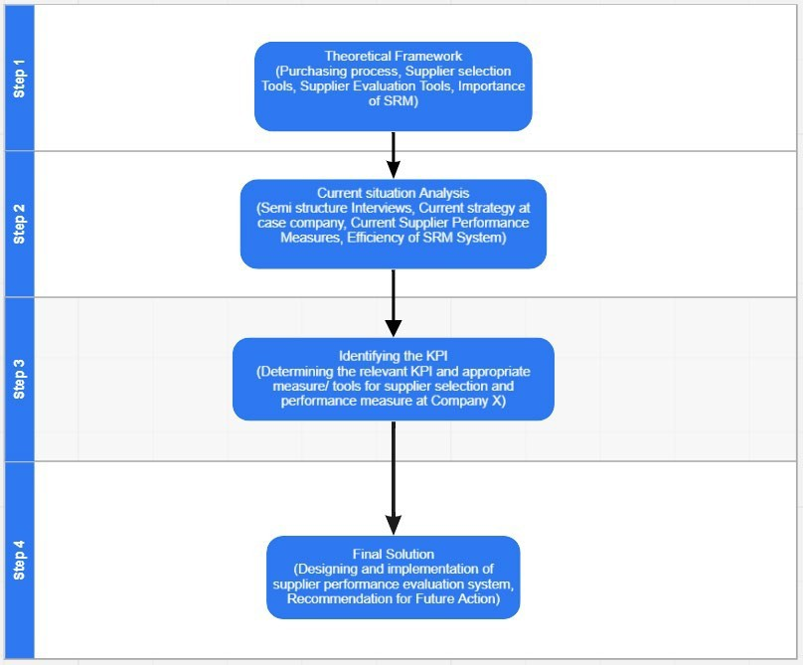**Figure1:**Thes is Framework (Source-Own representation)

**Step3 –** **Identifying the KPI** welcome step involves attending the check and interviews with the managers from different studio so case company. The selection of the important KPI that align with the strategy and goal so the company is done based on the result of survey and the interviews.

**Step4 – Final Solution** This step involves the process of designing and implementing the supplier performance evaluation system in Company X.

# Supplier Performance Evaluation Tools

1. **Categorial arrangement**

* A system of grade providers on an ordinal scale, to some extent awful, superior, respectable, or disturbing.
* utmost generally appropriated by defined trades and natural to do over.
* It needs the least portion of new nest.
* Least correct middle from two points the three importing styles noticed.

1. **Weighted- point whole**

* Different act types are gave out weights grounded on their value.
* At last, the sourcing establishment calculates a total score, that's unnaturally the aggregate of all the burden scores.
* Lesser position of stability while claiming a cheap of composition.
* Flexible videlicet lenient you to organize the weights of each criteria and equating diversified suppliers established their total burden scores

1. **Cost- positioned system**

* A form of consideration act by exercising overall costs of cooperation a certain landlord
* delicate to measure then on-acting cost of the temporary. Complex to destroy, but it produces ultimate correct results of the three orders noticed.

1. **Supplier Relationship Management (SRM)**

* “Procurement outside short- lived administration is like shopping without report administration. It does to malfunction.” (Lars Kuch Pedersen, Lean Linking).
* The well- conducted, scene- wide estimation of suppliers’ property and capabilities concerning overall work strategy, industriousness of what trials to take over following colorful suppliers, and the matched medication.

1. **Case Studies** Members of the Institute for Supply Management and Fortune 150 bodies.

* According to Simpson and others., (2002), inferior 10 of the enterprises that busy in the check had a formal burden short- lived estimate system
* 45.5 portion of the arrangements distinct they had no precise process for determining suppliers by any means.
* 23 allowance of the companies enthralled middle from two points5.000 and79.000 community, this was deliberate main. Quality, in agreement with Simpson and others. (2002), is far more essential than the different cause. The most critical cause are likewise transferring client requirements and making established bettering.

# Selection of Important KPI’s (Survey Result)

|  |  |  |  |  |
| --- | --- | --- | --- | --- |
| ***Sr No.*** | ***KPI's*** | ***Less Important*** | ***Important*** | ***Very Important*** |
| ***1*** | ***Price competitiveness*** | ***0%*** | ***36%*** | ***63.4%*** |
| ***2*** | ***Quality*** | ***9.1%*** | ***18.2%*** | ***72.7%*** |
| ***3*** | ***Supplier Lead Time*** | ***0%*** | ***54.5%*** | ***45.5%*** |
| ***4*** | ***Optimum Number of Suppliers (for each product)*** | ***0%*** | ***30%*** | ***70%*** |
| ***5*** | ***PO Cycle time*** | ***9.1%*** | ***54.5%*** | ***36.4%*** |

|  |  |  |  |  |
| --- | --- | --- | --- | --- |
| ***6*** | ***Favorable terms and Conditions of Vendor*** | ***0%*** | ***27.3%*** | ***72.7%*** |
| ***7*** | ***Spend under Management*** | ***0%*** | ***63.6%*** | ***36.4%*** |
| ***8*** | ***Supplier Compliance Rate*** | ***10%*** | ***10%*** | ***80%*** |
| ***9*** | ***Supplier Defect Rate*** | ***9.1%*** | ***36.4%*** | ***54.5%*** |
| ***10*** | ***Supplier Rejection Rate (Order Rejection)*** | ***18.2%*** | ***18.2%*** | ***63.6%*** |
| ***11*** | ***Certification of Supplier (ISO Certification)*** | ***20%*** | ***50%*** | ***30%*** |
| ***12*** | ***Emergency Purchase Ratio*** | ***9.1%*** | ***63.6%*** | ***27.3%*** |
| ***13*** | ***PO and Invoice Accuracy*** | ***0%*** | ***27.3%*** | ***72.7%*** |
| ***14*** | ***Extra Cost (Transport or Shipment Cost)*** | ***9.1%*** | ***45.5%*** | ***45.5%*** |
| ***15*** | ***Internal Client Satisfaction*** | ***0%*** | ***9.1%*** | ***90.9%*** |
| ***16*** | ***Total CO2 emission (From goods procured from supplier)*** | ***0%*** | ***63.6%*** | ***36.4%*** |

**Implementation phase:**

1. blessing of his X director and operation of the company
2. Present the new process to brigades and suppliers seeking - Crew/ buyer training. - Communicate Company X's beliefs to suppliers - Annotator/ annotator selection by supplier order
3. Collect crucial data demanded to estimate crucial KPI mentions in the template .
4. Supplier orders are determined by assessing up to3/5/10 suppliers every6/12 months.
5. Record Keeping Uploading Judgment Forms to Software X
6. Share evaluation results and enhancement plans with business mates
7. Follow the planned design.

**Limitations**

* This check is for businesses.
* The current plan is to get the conditions earlier than this time, but this could delay advancements for suppliers who want to be rated every six months.
* Suppliers for evaluation are named grounded on the supplier's periodic offer. thus, conditional orders with a advanced number of orders than offers won't be estimated.

**Future Recommendations**

* The instrument panel may be further extended at the supplier’s factual discretion to give a further visual overview.
* A process should be designed and enforced for reviewing issues related to supplier checks.
* workers may refuse to switch, indicating that the system they were using preliminarily is defective. This is a pattern where change and change operation that seeks to support, guide, and control mortal workers through the perpetration of change suffices.

**Main exploration**-

* Questionnaire draft 16 KPIs 6 questions.
* Pilot Survey Google Form – Finalize KPIs.
* Respondent 11 repliers Purchasing platoon and director of colorful shops
* interview 5 Suppliers Procurement directors from different countries and workrooms
* Record your answers classify checks by platoon Record answers in Google Croakers

**Conclusion**

A complete figure and perpetration of the temporary assessment process is developed, including a perpetration plan, process inflow and pitfalls associated with the process. KPIs were named through interviews and checks with colorful plant brigades and directors to insure alignment with company pretensions and strategy. It can be converted according to the farther situation of guest X. CSR analysis isn't sufficient to determine a supplier's overall gets regarding cost, quality, client satisfaction. The study concludes that overall prospects of supplier get. must be aligned internally with procurement and aligned with the pace of different departments in order to achieve company pretensions. Benefits include reduced costs, increased consumer satisfaction, and process interpretation.

**REFERENCES**

1. Aberdeen Group 2002. The supplier performance measurement benchmarking report. Measuring supply chain success
2. AkiJääskeläinen."Therelationaloutcomesofperformancemanagementinbuyer-supplierrelationships",InternationalJournalofProductionEconomics,2020
3. AntonyPaulraj."Drivingforcesofstrategicsupplymanagement:apreliminaryempirical investigation",InternationalJournalofIntegratedSupplyManagement,2005.
4. AntonyPaulraj."Strategicsupplymanagement:theoryandpractice",InternationalJournalofIntegratedSupplyManagement,2005.
5. Baily,P.,Farmer,D.,Jessop,D.&Jones,D.1998.ProcurementPrinciplesandManagement.Harlow:PearsonEducationLimited
6. Chase,RichardB,Jacobs,F.Robert,Aquilano,NicholasJ.2004.OperationsManagementforCompetitive.McGraw-HillInternationalEditio.Singapore
7. Yahya,S.&Kingsman,B.1999.Vendorratingforanentrepreneurdevelopmentprogramme:acasestudyusingtheanalytichierarchyprocessmethod.JournaloftheOperationalResearchSociety,916-930
8. CharteredInstituteofPurchasersandSupply(2011b)Managingpurchasingandsupplyrelationships.Lincolnshire:ProfexPublishingLimited
9. E.Vasina,Analyzingtheprocessofsupplierselection.TheapplicationofAHPMethod,inDegreeProgammeinIndustrialManagement2014,CentriaUniversityofAppliedSciences
10. Eckerson,W.,2011.PerformanceDashboards:Measuring,Monitoring,andManagingYourBusiness.2nded.Hoboken:JohnWiley&Sons
11. Ellram,LisaM.(1995),TotalcostofownershipInternational.JournalofPhysicalDistribution&LogisticsManagementVol.25,No.8,pp.4-23
12. VanWeele,A.J.,2010.PurchasingandSupplyChainManagement.5thed.Hampshire:CengageLearningEMEA.
13. Verma,RohitPullman,MadeleineE.(1998),AnAnalysisoftheSupplierSelectionProcessOmegaVol.26,No.6,pp.739-750