**“SMART ROBOT FOR CHILD RESCUE SYSTEM FROM BOREWELLS”**

**Mutturaj1,**

**Nandish B2,**

**Shreyas Naik3,**

**T Nandan Kumar4,**

**Prof. M Mohanapriya5,**

*1,2,3,4Student, Dept of CSE SAIT, Bengaluru Karnataka, India.

*5Prof. Dept of CSE SAIT, Bengaluru Karnataka, India.

# ABSTRACT

In India, bore well accidents are a common occurrence, with children getting trapped and losing their lives due to lack of rescue facilities. To address this issue, a robotic system for rescue tasks in bore wells has been proposed. The system includes a robotic arm that can attach a harness to the child using pneumatic arms for picking up. The robot also has a teleconferencing system for communicating with the child. The proposed system is quick, cost-effective, and accurate in rescuing the child. It consists of two modules, a rescuing system and a protection system, that work together to ensure the safety of the child during rescue. The protection system includes an airbag at the bottom of the passage to prevent the child from slipping further. The robot is operated by humans manually and monitored using a CCTV camera. The system provides the child with two levels of safety, one from the robotic holding at the top and the other from the safety airbag at the bottom. Overall, the proposed robotic system is a promising solution to address the distressing situation in India and save the lives of children stuck in bore wells. Bore well accidents resulting in the tragic loss of children's lives have been a growing concern in India due to the lack of effective rescue facilities. To address this issue, a robotic system for rescue tasks in bore wells has been proposed. This system incorporates a unique design that includes a robotic arm with pneumatic arms for attaching a harness to the trapped child for safe lifting. The robot is also equipped with a teleconferencing system to communicate with the child. The proposed system is quick, cost-effective, and accurate in rescuing the child within a short time span. The system is divided into two modules, a rescuing system, and a protection system. The protection system includes an airbag at the bottom of the passage to prevent the child from falling further. The robot is operated by humans manually, while monitoring is done using a CCTV camera. The system offers the child two levels of safety, one from the robotic holding at the top and the other from the safety airbag at the bottom. Overall, the proposed robotic system offers a promising solution to address the distressing situation in India and save the lives of children trapped in bore wells, thus reducing the mortality rate due to such accidents.

**INTRODUCTION**

In recent years, India has been facing a tragic and distressing situation with the increasing number of children falling into bore wells. These accidents have

resulted in the loss of innocent lives and have left families devastated. The bore wells are usually dug for

the purpose of obtaining groundwater, which is essential for the survival of people living in rural areas. However, due to a lack of proper safety measures, these bore wells often remain uncovered, posing a grave danger to children who accidentally fall in.

The normal rescue operation strategy involves digging a parallel pit to access the child and making adjacent holes to the walls of the bore well. However, this is a time-consuming and costly process that may not always be successful. In order to address this issue, researchers have proposed the use of rescue robots to quickly and efficiently rescue children who fall into bore wells. Rescue robotics is a field that involves the design and development of intelligent manipulators that are capable of performing a range of tasks, including rescue operations.

The proposed rescue robot is a step towards ensuring the safety of children and providing a fast and efficient rescue operation. The use of advanced technology such as robotics in rescue operations has the potential to save countless lives and prevent future accidents. It is essential that policymakers, stakeholders, and the public come together to support the development and implementation of such innovative solutions to ensure the safety and well-being of our future generations.

# LITERATURE REVIEW

Bharathi B et.al[1] depicts the plan of a robot for saving the kid from bore well. This robot is fit for moving underneath the drag well, as per the human comment by Pc, it will pick and spot dependent on the arm structures. It is worked through Pc with the assistance of remote zigbee innovation and remote camera which is used for video surveillance. The main drawback is that the arm structure can’t give adequate security to the child while lifting. Manish Raj et.al[2] depicts as the dimension of the drag well is slender for any grown-up in difficult and bright goes dim inside it, the rescuing task in that circumstance is very difficult. The automated framework which will join an outfit to the child utilizing inflated arms for rescuing the child. The video chatting method is also available for speaking with the child. The robotic arm is like clipper, so that the lifting mechanism is very difficult. Giridharan. M et.al[3] proposed a robotic system designed to rescue a child stuck in a bore well. The robot comprises three engines to facilitate the rescue operation. The first engine enables the up and down movement of the robot using a screw bar. The second engine is responsible for gripping the surface of the lead screw arrangement. Finally, the third engine is utilized to lift the child from the bore well through a rack and pinion arrangement. The robot's design allows for easy maneuverability based on the child's location, and the entire system can pivot accordingly. This flexibility in movement enables efficient rescue operations. While the proposed system appears to be a promising solution for child rescue in bore wells, there may be limitations in terms of the robot's ability to navigate through complex terrain. Further research and development may be required to ensure that the 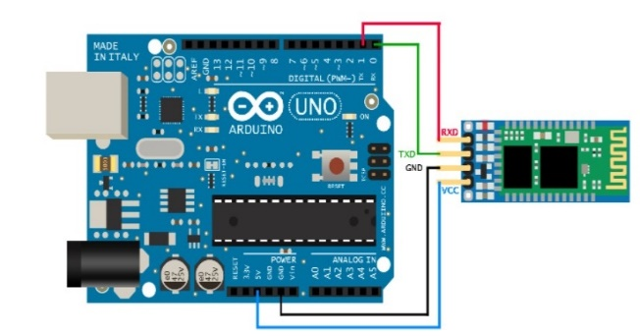system can operate effectively in real-world scenarios. Arthika et al. (2019) presented a study on the mechanism for safeguarding children from the dangers of bore wells. The researchers proposed the use of a temperature sensor to detect the temperature and a gas sensor to detect gas spillage in a specific region. The system also employs the ARM compression and expansion method for proper up and down movement. 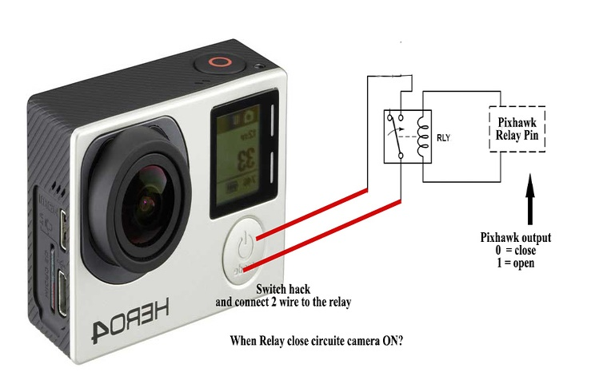A robotic arm, controlled through relay operation, is used for picking and placing the child in the event of a 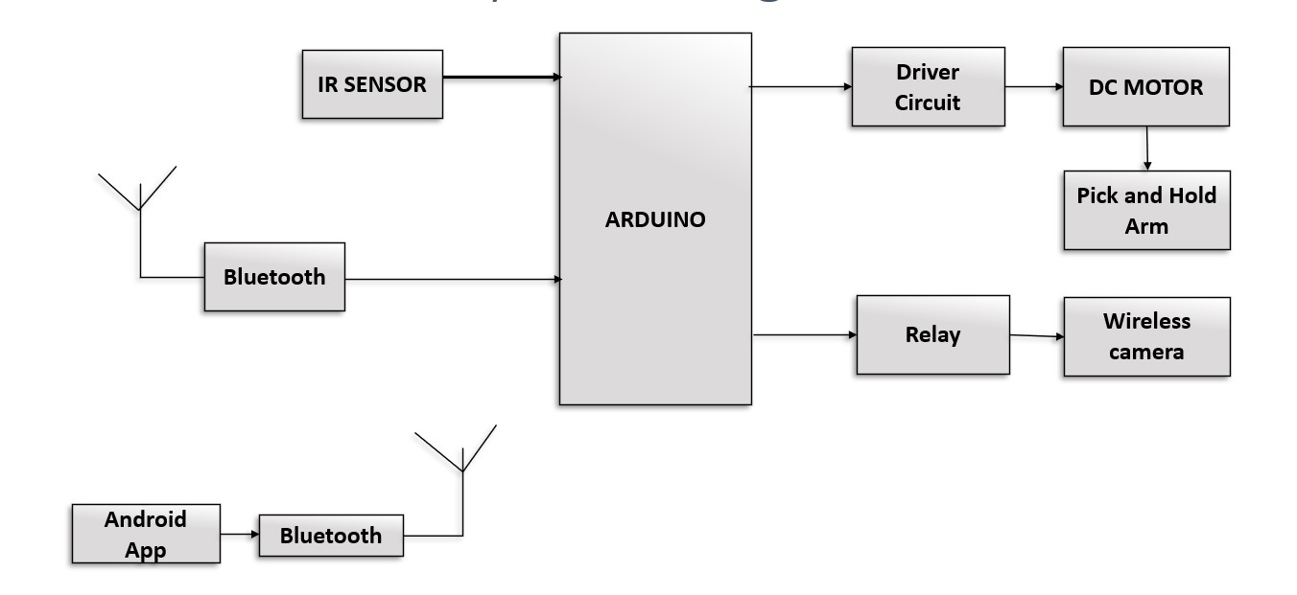fall. This innovative approach provides a quick and efficient means of safeguarding children. While this method shows promise, it is not without limitations. One major drawback is the difficulty of lifting a child using the gripping arm. This may pose a challenge, particularly in situations where the child is heavier or unresponsive. Nevertheless, the researchers' efforts towards addressing the issue of child safety in the context of bore wells are commendable. Their work highlights the importance of incorporating technology in enhancing child protection measures, particularly in areas prone to bore well accidents.

# PROPOSED SYSTEM

This proposed system goal is to construct and design of a smart robot to work in borehole rescue operations and to detect child inside the borewell. The robot has arm holder to pick the child from the borewell safely. And also we can observe the child conditions using camera.

**Fig: Block Diagram of SMART ROBOT FOR CHILD RESCUE SYSTEM FROM BOREWELLS**

**BLUETOOTH MODULE:**

The Bluetooth module is mainly Connect the Bluetooth module to the Arduino board using the appropriate pins. The pins required will vary depending on the module and the Arduino board used, but generally, the module will have pins for power, ground, TX, and RX. Pair the Bluetooth module with the device you want to communicate with. This typically involves putting the module into pairing mode and using the device's Bluetooth settings to search for and connect to the module. Send and receive data between the Arduino board and the connected device using the Bluetooth module. It also continuously checks for incoming data from the Bluetooth module and sends it to the computer over the USB serial connection.

Fig: Bluetooth Module Connecting to Arduino

**CAMERA MODULE:**

The camera is connected to the relay circuit involves using the output signal from the camera module to trigger the switching of a relay module. Connect the output signal from the camera module to the input signal of the relay module. This can be done by connecting the output pin of the camera module to the control input of

Fig: Camera module

the relay module. Make sure to use the appropriate resistors or transistors to match the voltage levels and current requirements of the camera and relay modules. The system can be tested by moving in front of the camera module and observing the behaviour of the load. If the load turns on or off as expected, the system is working correctly.

**IR SENSOR MODULE:**

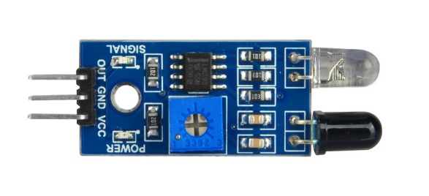Connecting an IR sensor to the Arduino is s a relatively simple process that can be done with a few jumper wires and a pull-up resistor. The output signal pin of the IR sensor should be connected to a digital input pin on the Arduino. You can choose any digital input pin, but it's recommended to use one with interrupt capability so that you can detect changes in the sensor output quickly.

Fig: IR sensor

**ARM HOLDER and DC MOTOR MODULE:**

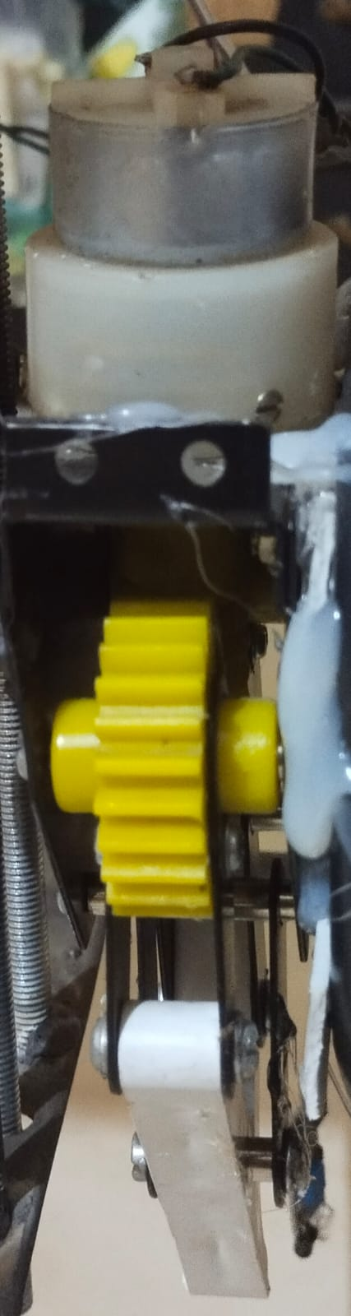The 12V centre shaft DC geared motor is a specialized type of DC motor with a cantered shaft and built-in gearbox. It combines high torque output with reduced speed, making it ideal for robotics, automation, and similar applications.

Fig: DC motor holding arm holder

Powered by a 12-volt DC source, the motor can be controlled using techniques like PWM or voltage regulation to adjust its speed and torque. Its gearing mechanism efficiently transfers power from the motor to the output shaft, enabling enhanced performance and versatility in various industrial and robotic system.

**RESULT**

As a result, it can prevent child fatalities in bore wells. The system employs various technologies such as IR technology, robotic arms, and safety airbags, which work together to rescue the child with minimal time. The system also includes a controlling device, the myDAQ, located at the ground level, which controls all the actions of the robot.

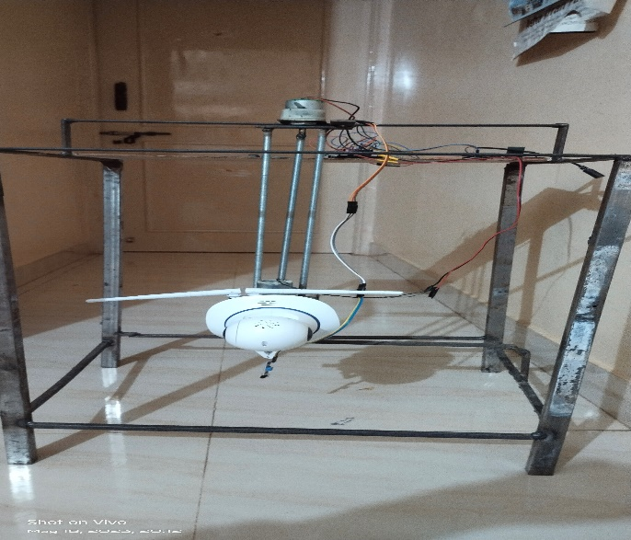Resulting Images are:

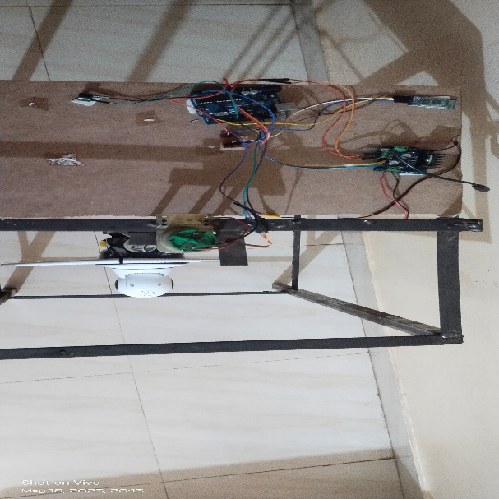Final Outcome(Front view)

Final outcome(Top view)

# ADVANTAGES AND APPLICATIONS

* Fully automated.
* Saving Man power.
* Economic.
* Possibility of auto control.
* Reduction in time consumption.

**Applications & Features:**

* Schools
* Colleges and other Organizations
* Small Play Grounds
* Some Small Open Spaces
* Campus or garden

# CONCLUSION

The Proposed Project is been successfully completed. The garden cleaning robot model prototype presents the design and implementation of an Automatic Garden cleaning System controlled by wirelessly and the speed of the vehicle can be reduced automatically due to the sensing of the obstacles. The model can be developed with more advanced speed control system for automobile safety, while realizing that this certainly requires tons of work and learning, like the programming and operation of microcontrollers and the automobile structure. Hence, the incorporation of all components in garden cleaning robot will maximize safety and also give such system a bigger market space and a competitive edge in the market.

**FUTURE SCOPE**

It is to develop an automatic device that can derived from control room by internet of thing that work of cleaning garden without any need of personnel and we need to just click a start button of the robot in smartphone application. This Project has a scope in the areas like a large floor area, like school grounds.

# REFERENCES

[1] B. Bharathi, B. Suchitha Samuel “Design And Construction Of Rescue Robot And Pipeline Inspection Using Zigbee” Internationaljournal Of Scientific, Engineering And Research (Ijser) Volume 1 Issue 1, September 2013.

[2] Sridhar Palaniswamy “ Life Saving Machine” The First International Conference On Interdisciplinary Research And Development, 31 May1 June 2011, Thailand.

[3] Manish Raj, P.Chakraborty And G.C.Nandi “Rescuerobotics In Bore Well Environment” Cornel University Library [V1] Mon, 9 Jun 2014 10:51:44 Gmt(244kb).

[4] R. R. Bhosale, P. R. Bodhe, and V. V. Kate, "Automated Borewell Rescue System using Microcontroller and IoT," International Journal of Innovative Research in Electrical, Electronics, Instrumentation and Control Engineering, vol. 7, no. 2, pp. 1686-1692, 2019.

[5] V. S. R. Reddy, R. C. Kumar, and D. V. S. S. Siva Sai, "Design and Implementation of Automatic Borewell Rescue System using Arduino Uno," International Journal of Engineering and Advanced Technology, vol. 9, no. 2, pp. 2197-2201, 2019.

[6] R. M. Patil, S. R. Patil, and S. B. Mane, "Development of Automated Borewell Rescue System using ARM Cortex-M3," International Journal of Computer Applications, vol. 140, no. 9, pp. 7-11, 2016.