**Face Detection Based Attendance System Using IOT**

**Gohil Priyankaba ,**

1

2

**ABSTRACT**

Attending may be an obligatory demand of each organization. Maintaining attending register daily may be a troublesome and time intense task. There square measure several automatic ways for an equivalent offered like Biometric, RFID, eye detection, voice recognition, and lots of a lot of. This paper provides Associate in nursing economical and sensible methodology for marking attending. Because it is thought that primary identification for any human is its face, face recognition provides Associate in nursing correct system that overcomes the ambiguities like faux attending, high cost, and time consumption. This method uses face recognizer.

**Keywords:** IOT Attendance, esp32-cam, google drive, web server.

1. **INTRODUCTION**

The **ESP32-CAM** is a tiny board that comes with a camera, micro SD card, and of course the ESP32 microcontroller for less than ten dollars. It also has Wi-Fi and Bluetooth capabilities making it an ideal choice for IoT projects. But working with the ESP32-CAM board can be an intimidating task because it requires an external programing board and it isn't as breadboard-friendly as compared to other microcontroller boards like Arduino nano, Node MCU etc.

we are going to build an **Attendance system using Face Recognition** by leveraging the power of the ESP-32 CAM board. Along with the ESP32-CAM board we will have an integrated power supply with 5-volt and 3.3-volt output that is powered by a 18650 cell.  It also has headers for directly mounting FTDI board and USB to TTL module with voltage switching options between 3.3V and 5V. Apart from this the board has a lot of additional features which are listed below, all these features will enable you to build interesting **battery powered IoT projects.** This board was made possible by [PCBWay](https://www.pcbway.com/" \t "_blank), who not only sponsored this project but also fabricated this ESP32 Attendance System PCB board for us. We will discuss more on this later for now, lets get back to the features of our project. The board provides,

* Access to all ESP32-CAM GPIO pins through both male and female connectors.
* Multiple connector pins for +5-volts, +3.3-volts, and Ground.
* Dedicated LEDs for indicating power and network connectivity.
* Powered with a adapter and comes with a charger and booster circuit.
* This board can be directly mounted on a wall for applications like Face Recognition, Motion detection, etc.
* IO0 Jumper for Programming Mode.

To test this ESP32-CAM development board we are going to build a **Face Recognition-based Attendance system**. It uses the **Camera Webserver** code from the ESP board for face recognition. Upon recognizing the face, the face ID with the name associated with it will be sent to Google Sheets.

1. **METHODOLOGY**

**Detection work to excel sheet method**

Facial recognition Methodology is being widely used in many projects as it has many advantages. There is requirement of data for the system in order to trace and track the individual and mark his/her attendance. The data is loaded by assigning each individual’s image with a corresponding id and name. Once the system starts, the option of taking image is available for which the pre-requirement is the input of id and name. More than 100 images will be taken in gray format using Open CV. These images will be the input for Haar cascade. Haar Cascade codes the pictures into binary code after converting them into binary image. Once the system is given input, it is trained by clicking on train image option available on the screen using a file called Trainer. Yml which is written in human readable data serialization language. The features of the face will be detected and stored for further actions. The dataset has to be created in the above said manner to further recognize the faces when needed. Track images option is used for detecting and recognizing the faces of individuals. After detecting the face of each individual, attendance will be marked in execlsheet along with the corresponding date and time.

**Component which used** HARDWARE: Adapter, GPS Antenna,FP6291 Boost Converter IC, Micro USB 2.0 B type 5 Pin Connector ,Resistor ,Capacitor, LED s, Inductor ,ESP32-CAM Board,AMS1117 3.3V Voltage Regulator,PCB,REES52 3.3 5V POWER SUPPLY MODULE,FTDI Converter.

SOFTWARE**:** GOOGLE DRIVE,IFTTT WEB ,AURDINO SOFTWARE,WEB SERVER 192.168.118.127.

1. **MODELING AND ANALYSIS**

* **PROPOSED SYSTEM**

The pre-processing step is used to detect face and mark in database.

Camera that detect a person and recognition face. If face matched then get student id and it mark as a present in data based. If there is face not match then get not match id and mark as student as absent in data based.

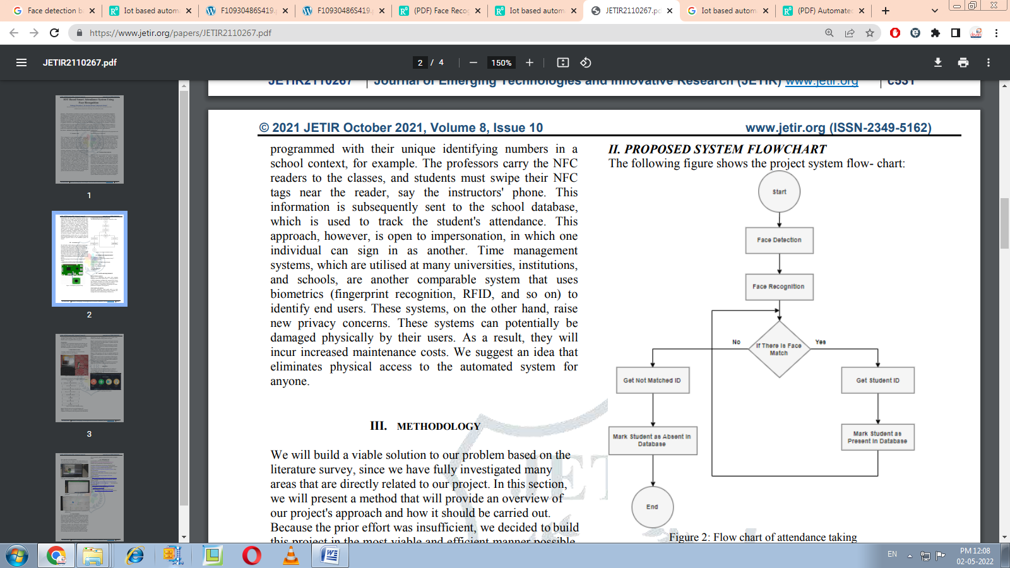

**Figure 1:**Flow of process

* **PROPOSED WORK**

We connect GPS antenna for better connection that connect with Esp32 CAM Is use for image capture. With ESP32 CAM 3.3 5v power supply is connect for Power supply. The main chip for the FT232, generates a virtual serial port after installing the driver , USB to take power, leads to the interface includes a 3.3V (<40mA), 5V, GND, TX, RX .in computer we build ifttt wed hook for data sheet in excel that all data is stored it created in google drive. And webserver is created for data streaming and capturing image. All data are taking in real time.

1. **RESULTS AND DISCUSSION**

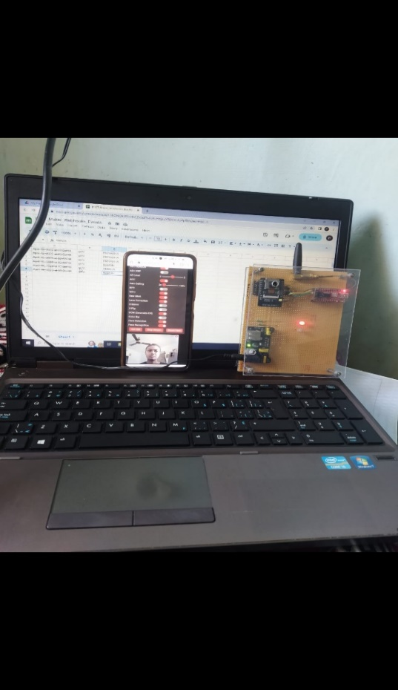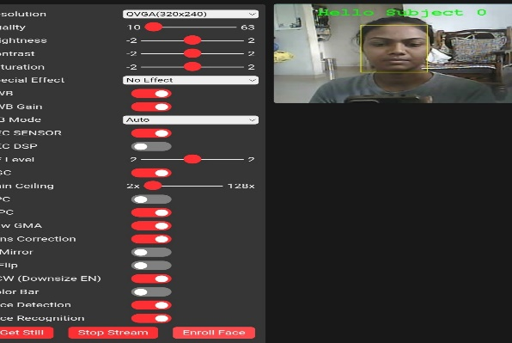

***Figure:2*** *Hardware analytic result* ***Figure:3*** *web server imsge stream*

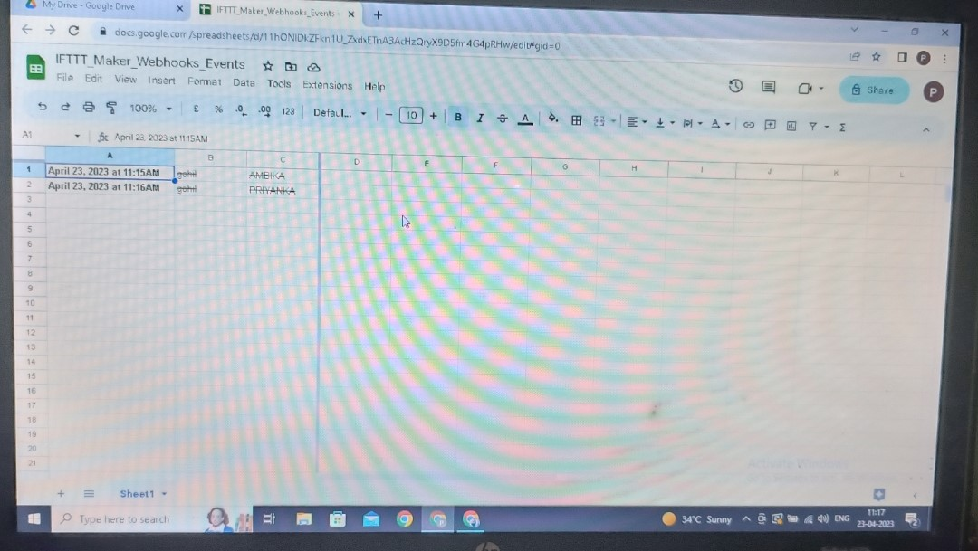

**Figure 4:** Google drive excel sheet

Followed the stages below to develop this system.

**1st Stage:**

* Tried to implement this technique.
* All component data taken.
* Data from aurdino will be utilized in C programming scripting.

**2nd stage:**

* The data will take its place according to .the ESP32-CAM Tto usb port used.
* Generate IFTTT WEB HOOK

**3rd stage:**

* Aurdino Programming Uplode in ESP32-CAM BOARD .
* A data get in excel sheet with real time.

1. **CONCLUSION**

We choose the Automated Attendance Monitoring System project after considering the demands of society's day-to-day needs and wants. As technology advances, we are more likely to think outside the box and come up with a game changing concept. Education is the most important thing that everyone should obtain because it is the foundation for a better lifestyle and will undoubtedly raise the living community's standard. Our educational system is lacking in student involvement in schools, colleges, and universities. Rather than attending lectures and studying, they prefer to stay away from class and keep themselves occupied with these devices.Low attendance means that pupils do not gain the knowledge that they are expected to obtain, knowledge.in this we can use for door lock,security.

1. **REFERENCES**

* <https://www.jetir.org/papers/JETIR2110267.pdf>
* <https://www.ijitee.org/wp-content/uploads/papers/v8i6s4/F10930486S419.pdf>
* [https://www.researchgate.net/ publication/337590875\_Face\_Recognition\_based\_smart\_attendance\_system\_using\_IOT](https://www.researchgate.net/%20publication/337590875_Face_Recognition_based_smart_attendance_system_using_IOT)
* [https://www.researchgate.net/publication/332709956 \_Iot\_based\_automated\_attendance\_with\_face\_recognition\_system](https://www.researchgate.net/publication/332709956%20_Iot_based_automated_attendance_with_face_recognition_system)
* [https://www.researchgate.net/ publication/332709956\_Iot\_based\_automated\_attendance\_with\_face\_recognition\_system](https://www.researchgate.net/%20publication/332709956_Iot_based_automated_attendance_with_face_recognition_system)
* <https://www.ijert.org/smart-attendance-system>- using-face-recognition
* <http://questjournals.org/jses/papers/Vol5-issue> 2/D05021829.PDF
* <http://www.globalscientificjournal.com/researchpaper>Class\_attendancerecord\_ based\_face\_recognition\_using\_rassberry\_pi.PDF
* <https://www.ijeat.org/wp> content/uplodes/paper/v8i2s/B10761282S18.PDF
* <http://eprints.utar.edu.my/2861/1/CT-2018>15039792.PDF