B2B Supply Chain Management With Conversational AI Using NLP Technology

**Vignesh G[3],**

UG scholar,

Department of Information Technology,

VSB Engineering College,

Karur.

**Surya Kumar N[1],**

UG scholar,

Department of Information Technology,

VSB Engineering College,

Karur.

**Tamil Selvan S[2],**

UG scholar,

Department of Information Technology,

VSB Engineering College,

Karur.

**Baskar D[4],**

Asssistant Professor,

Department of Information Technology,

VSB Engineering College,

Karur.

**ABSTRACT**

Supply chain partner onboarding is a critical process that involves the integration of new partners into a company's supply chain network. Traditional onboarding processes can be time-consuming and complex, involving multiple forms and manual data entry. Conversational AI and NLP (Natural Language Processing) can streamline the onboarding process by providing a more efficient and user-friendly experience for both the company and its partners. This paper proposes a solution for supply chain partner onboarding using conversational AI and NLP in a B2B context. The solution involves the development of a chatbot that can interact with supply chain partners using natural language. The chatbot is designed to guide partners through the onboarding process, answering questions and providing assistance along the way. The chatbot also uses NLP to extract and process data from the partner's responses, eliminating the need for manual data entry. The proposed solution has several benefits. First, it can significantly reduce the time and resources required for onboarding new partners. Second, it can improve the accuracy and completeness of the data collected during the onboarding process. Third, it can enhance the user experience for partners, making the onboarding process more user-friendly and accessible. To develop and implement the solution, we will use a combination of open-source NLP libraries and cloud-based conversational AI platforms. We will also conduct usertesting to evaluate the effectiveness and user experience of the chatbot. In conclusion, the proposed solution for supply chain partner onboarding using conversational AI and NLP has the potential to transform the way company’s onboard new partners, making the process more efficient, accurate, and user-friendly.

**I .INTRODUCTION**

Supply chain partner onboarding is a critical process for companies that rely on a network of partners to deliver goods and services to customers. Onboarding new partners involves multiple steps, including collecting data, verifying credentials, and establishing communication channels. Traditional onboarding processes can be time-consuming and complex, involving multiple forms and manual data entry. This can lead to errors, delays, and increased costs. Conversational AI and NLP offer a solution to these challenges. Conversational AI allows for natural language interactions between users and systems, while NLP enables the processing and analysis of unstructured data. Together, these technologies can streamline the onboarding process by providing a more efficient and user-friendly experience for both the company and its partners. In this paper, we propose a solution for supply chain partner onboarding using conversational AI and NLP in a B2B context. The solution involves the development of a chatbot that can interact with supply chain partners using natural language. The chatbot is designed to guide partners through the onboarding process, answering questions and providing assistance along the way. The chatbot also uses NLP to extract and process data from the partner's responses, eliminating the need for manual data entry. The remainder of this paper is organized as follows. First, we will provide an overview of the current state of supply chain partner onboarding and the challenges that companies face. Second, we will describe the proposed solution in more detail, including the architecture, design, and implementation. Third, we will discuss the benefits and potential drawbacks of the solution. Finally, we will conclude with recommendations for future research and implementation.

**II. RELATED WORKS**

**[1]** Partner management is typically a crucial activity among the other primary duties in the procurement process of B2B service providers. While B2B teams prioritise contract management and buying processes, partner management is sometimes disregarded. One possible rationale is that purchasing and contract management give more benefits than partner management. According to a McKinsey report [8], there is a far better relationship and the entire supply chain improves if suppliers and service providers keep in touch. Changes in processes or service innovations can aid in improving partner collaboration. AI implementation has resulted in a more efficient partner management approach.

[2] Even though conversational AI can't predict demand as AI can, it might be able to help forecast processes significantly. Every time the conversational AI bot interacts with a person, whether they are employees of your company or customers, the interaction is recorded and analyzed. After that, this data can be saved and used to forecast demand.

[3] Natural language processing (NLP), machine learning (ML), and artificial intelligence (AI) are used in conversational AI to produce human-like interactions and provide intelligent consumer insights. Subsequent to aggregating many years of information, associations are fabricating conversational computer-based intelligence answers for permit applications that might be useful to improve their tasks.

[4] The function of conversational AI is to facilitate dialogue between humans and systems. Your existing business apps will have a conversational layer added by a DRUID conversational AI assistant, which will automate internal processes and activate the entire back-office mechanism to act on data stored within your company's technological ecosystem. As a result, you will want to procure your responses and complete your errands quickly.

[5] Even though cutting-edge supply chain operations technologies like virtual reality and the metaverse are getting a lot of attention, there are already examples of how conversational AI is making SCM operations better and helping to meet demand.

[6] Demand volatility is one of the main issues in the supply chain function, according to a Gartner analysis. Products can be produced more precisely and in accordance with demand by businesses that are able to anticipate them. This is especially significant in light of the current issue with the global supply chain. On the off chance that there are unsold things on the racks and insufficient items to meet client assumptions, you could radically debilitate the client experience of your firm. Demand sensing generates estimates based on previous data to address this issue.

[7] Through increased forecasting data, businesses may be able to predict customer behavior more accurately, satisfy demand with greater confidence and supply products with significantly shorter lead times if they better comprehend and capture volatility in future demand. Demand is more granular and fragmented to meet the various fulfillment requirements in multiple categories and regional markets while accepting promotions and other variables that cause volatility..

[8] Due to automated execution, which provides an organization with a valuable tool, demand planners can now focus on more complex challenges and increase organizational performance with the assistance of their virtual AI assistants. Assuring an adequate supply of raw materials, forecast demand signals are clearly connected to the production schedule and plan. The all-out cost of tasks and asset proficiency bring about a 5-10% decrease in store network costs, saving time and cash to help venture and drive improvement.

[9] Manufacturers and retailers can no longer rely solely on previous supply chain planning practices in such a complex and volatile market. Instead, businesses may be able to significantly improve their operational and financial performance by employing conversational AI. As more businesses switch to more technologically advanced methods of operation, conversational AI is gaining traction in the retail and industrial sectors.

[10] In such a complicated and volatile market, manufacturers and retailers can no longer depend simply on prior supply chain planning practises. Instead, by using conversational AI, organizations may significantly enhance their financial and operational performance. Conversational AI is gaining traction in the industrial and retail industries as more businesses abandon old ways of operation in favour of more technologically sophisticated ones.

**III. PROPOSED SYSTEM**

In many ways, the current process is automated. It is, however, not intelligently structured. Our framework improves the partner onboarding process and facilitates partner collaboration. Some customer communication must take place in other languages. As a result, we've added multi-language support for bot interaction. Cost savings have also been identified as one of the most important factors for customers. As a result, a provision has been made to obtain the cost status based on the current usage of services.

A chatbot that is powered by AI and aimed at streamlining and automating processes in the supply chain is known as a supply chain chatbot. Chatbots can be incorporated into different parts of the store network, from stock administration and request following to coordinated factors and transportation. Here is a portion of the manners by which a store network chatbot can be utilized.

Management of Order: Chatbots can be used to handle questions and complaints, handle orders, and give customers real-time updates on their orders. Management of the Inventory: Chatbots can keep track of inventory levels and notify users when they fall below a predetermined threshold. They can also be used to control inventory replenishment and reordering.

Transport and logistics: Chatbots can assist with following shipments, give data on conveyance times, and help with transportation planning and coordination. Customer Service: Customer inquiries and complaints can be handled by chatbots, which offer immediate assistance and resolution. Information Examination: Chatbots can be utilized to gather and examine information on inventory network execution, assisting with distinguishing regions for development and enhancing production network processes. Supply chain chatbots can also increase customer satisfaction, reduce costs, and improve operational efficiency in addition to these advantages. Chatbots can assist businesses in better managing their supply chain operations and improving overall performance by automating routine tasks and providing real-time information to customers and stakeholders.

**IV.BLOCK DIAGRAM**

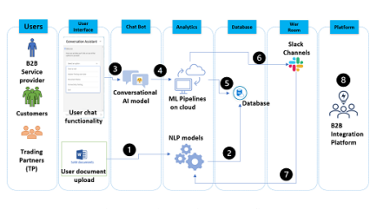

**Fig 1: Supply Chain on B2B(Business To Business) model**

**V. SYSTEM ARCHITECTURE**

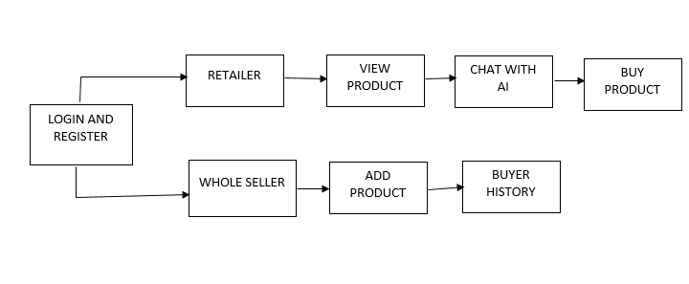

**VI. MODULES**

* Data Collection
* Data Pre-processing
* Split train test dataset
* Chabot
* NPL process

**VII. MODULES DESCRIPTION**

**DATA COLLECTION**

Conversational AI and NLP can help streamline the onboarding process by automating the collection and processing of data from potential partners. Here's an overview of how it could work:

* Chatbot-based Interface: The onboarding process could start with a chatbot-based interface that engages with potential partners and collects relevant data through natural language conversation.
* Natural Language Processing: The chatbot could use Natural Language Processing (NLP) to understand and extract data from the conversations with the partners. This could include information such as company name, size, industry, location, contact information, product/service offerings, and other relevant details.
* Integration with Existing Systems: The data collected through the chatbot could be integrated with existing systems, such as CRM or ERP, to ensure that the partner data is easily accessible and can be used for other business processes.
* Data Validation: The chatbot could also be programmed to validate the data collected from the partners by asking follow-up questions or performing data checks.
* Feedback and Support: The chatbot could also provide feedback and support to the partners during the onboarding process

**DATA PRE-PROCESSING**

The first step in data preprocessing is to clean the data collected from the partners. This could involve removing any duplicate or irrelevant data, correcting spelling errors, and standardizing the format of the data.

* Tokenization: The next step is to tokenize the cleaned data. This involves breaking down the text into individual words or phrases to facilitate further processing.
* Stop Word Removal: Stop words are words that do not add any meaningful information to the text, such as "and," "the," and "of." Removing stop words can help reduce the size of the data set and improve the accuracy of the analysis.
* Lemmatization or Stemming: Lemmatization or stemming involves reducing words to their base or root form to group together words with similar meanings. This can help improve the accuracy of the analysis by reducing the number of unique words that need to be processed.
* Part-of-Speech Tagging: Part-of-speech tagging involves identifying the grammatical structure of the text, such as nouns, verbs, and adjectives. This can help identify the most important words in the text and facilitate further analysis.
* Named Entity Recognition: Identifying and classifying named entities in the text, such as company names, product names, and locations, is part of named entity recognition. This may assist in locating essential information regarding the partners' offerings.
* Sentiment Analysis: The process of conducting sentiment analysis entails determining whether the text has a positive, negative, or neutral tone or sentiment. With the partners, this can assist in identifying potential issues or opportunities.

Once the data has been preprocessed, it can be used for further analysis, such as clustering or topic modeling, to identify patterns or trends in the data. This can help organizations make more informed decisions about which partners to onboard and how to manage their relationships with those partners.

**SPLIT TRAIN TEST DATASET**

The split train test dataset processing steps are given to below:

* Collect and Preprocess Data: The first step is to collect and preprocess the data as described earlier. This could involve cleaning the data, tokenizing, removing stop words, lemmatizing or stemming, part-of-speech tagging, named entity recognition, and sentiment analysis.
* Define the Training and Testing Data: The training data is the data used to train the machine learning model, while the testing data is used to evaluate the performance of the model.
* Define the Split Ratio: The split ratio determines how much of the data will be used for training and how much will be used for testing. A common split ratio is 80/20, where 80% of the data is used for training and 20% is used for testing. However, the split ratio can vary depending on the size and complexity of the dataset.
* Split the Dataset: Once the split ratio has been defined, the dataset can be split into training and testing data. This can be done using a variety of methods, such as random sampling or stratified sampling. Random sampling involves randomly selecting data points for the training and testing sets, while stratified sampling involves selecting data points based on specific criteria, such as industry or location.
* Train the Model: The training data can be used to train the machine learning model using algorithms such as decision trees, random forests, or neural networks. The model is trained to identify patterns and relationships in the data that can be used to predict outcomes.

Test the Model: The testing data is used to evaluate the performance of the model. The model's predictions are compared to the actual outcomes to determine the accuracy of the model. If the model's accuracy is not satisfactory, the model can be retrained using different algorithms or parameters.

**CHATBOT**

A chatbot module can be introduced to onboard supply chain partners using conversational AI and NLP. The chatbot can communicate with the supply chain partner and collect the required information in a conversational manner. NLP can help the chatbot understand the intent behind the partner's queries and respond accordingly.

* Efficiency: A chatbot module can automate the onboarding process, making it more efficient and less time-consuming. Supply chain partners can provide the required information at their own pace, without the need for human interaction.
* Accuracy: By integrating the chatbot module with existing systems, such as ERP or CRM, the data collected can be accurate and up-to-date, reducing the risk of errors and ensuring compliance.
* Flexibility: The chatbot module can be designed to handle a variety of scenarios, providing relevant information to the supply chain partner based on their specific needs.
* Scalability: As the number of supply chain partners increases, the chatbot module can scale to accommodate the growing demand.
* Cost-effectiveness: By automating the onboarding process, the cost of manual labor and resources can be reduced, ultimately leading to cost savings.

**NLP PROCESS**

* Text Preprocessing: The first step in the NLP process is text preprocessing. This involves cleaning the text data, removing stop words, tokenizing, stemming or lemmatizing, and part-of-speech tagging. This step helps to simplify the text data and make it easier to analyze.
* Named Entity Recognition: Named Entity Recognition (NER) is a process of identifying and classifying named entities in the text data, such as company names, locations, or people's names. NER can be used to extract important information about the partner and their business, such as their company name, location, or industry.
* Sentiment Analysis: Sentiment analysis is a process of identifying the sentiment or emotion in the text data. This can help determine whether the partner's responses are positive, negative, or neutral. Sentiment analysis can also help identify any concerns or issues the partner may have with the onboarding process.
* Topic Modeling: Topic modeling is a process of identifying the topics or themes in the text data. This can help identify the key areas of interest for the partner and the most common questions or concerns they have about the onboarding process. Topic modeling can also help identify any patterns or trends in the text data.
* Intent Recognition: Intent recognition is a process of identifying the intent or purpose of the text data. This can help determine what the partner is trying to achieve through the onboarding process and what information they need to provide to achieve their goals.
* Dialogue Management: Dialogue management involves managing the conversation between the partner and the conversational AI system. This can involve providing prompts or suggestions to the partner, responding to their questions or concerns, and guiding them through the onboarding process.

**VIII. EVALUATE METRICS**

* Accuracy: This measures the percentage of correctly classified instances (i.e., whether cyberbullying is present or not). The higher the accuracy, the better the performance of the system.
* Precision: This measures the proportion of true positives out of all positive predictions made by the system. High precision indicates that the system is making few false positive predictions.
* Recall: This measures the proportion of true positives out of all instances of cyberbullying in the dataset. High recall indicates that the system is making few false negative predictions.
* F1 Score: This is the harmonic mean of precision and recall, and is a single score that summarizes the overall performance of the system.
* AUC-ROC: This measures the area under the receiver operating characteristic curve, which plots the true positive rate against the false positive rate. A high AUC-ROC indicates that the system is able to correctly classify instances of cyberbullying with a low false positive rate.
* Confusion Matrix: This is a table that shows the number of true positives, false positives, true negatives, and false negatives made by the system. It provides a detailed view of the system's performance and can be used to calculate metrics such as precision, recall, and F1 score.

**IX. RESULTS AND DISCUSSIONS**

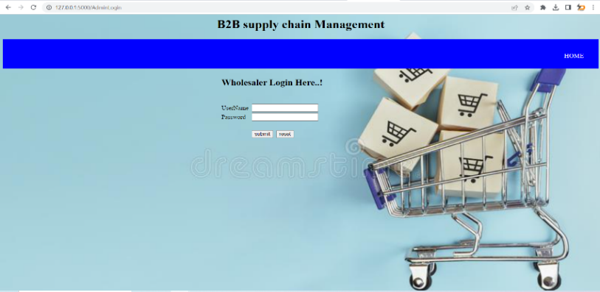

**Fig 2: Wholesaler Login**



**Fig 3: Retailer Login**

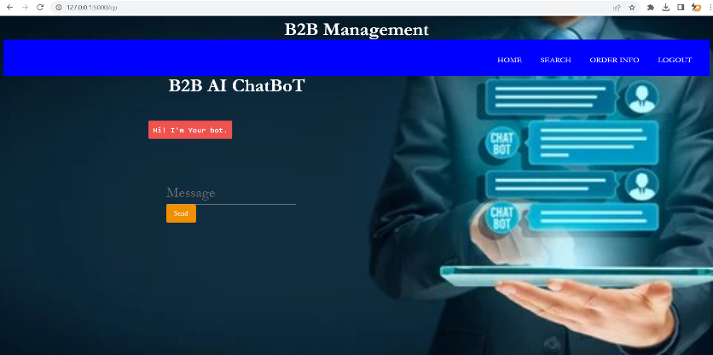

**Fig 4: B2B AI ChatBot**

**X. CONCLUSION**

In conclusion, the use of conversational AI and NLP in B2B context for supply chain partner onboarding can bring several benefits. By automating the onboarding process, businesses can streamline their operations, reduce errors, and save time and money. Additionally, the use of chatbots or virtual assistants can provide a personalized experience for partners, improving their overall satisfaction.However, it is important to note that conversational AI and NLP are not a one-size-fits-all solution. Different businesses have unique needs and requirements, and the technology should be tailored to meet these needs. Furthermore, the use of AI in onboarding should not replace human interactions entirely, as there are situations where a human touch may be necessary.Overall, the use of conversational AI and NLP in supply chain partner onboarding can be a valuable tool for businesses looking to improve their operations and enhance their partner relationships. However, it should be implemented thoughtfully and with careful consideration of the specific needs of the business and its partners.

**XI. FUTURE WORK**

* Chatbot-based Onboarding Assistance: Chatbots powered by conversational AI and NLP can provide real-time assistance and guidance to supply chain partners during the onboarding process. They can answer questions, provide information, and guide partners through the necessary steps, such as submitting required documents, completing forms, and fulfilling compliance requirements. This can reduce the need for manual intervention, save time, and improve the overall onboarding experience for partners.
* Automated Document Verification: Conversational AI and NLP can be used to automate the verification of documents submitted by supply chain partners during the onboarding process. AI algorithms can analyze and validate documents, such as certificates, licenses, and contracts, for authenticity, accuracy, and compliance with regulatory requirements. This can minimize the risk of fraudulent or incorrect documents being submitted and streamline the document verification process.
* Natural Language Processing for Data Extraction: NLP can be used to automatically extract relevant information from unstructured data, such as contracts, invoices, and other documents, submitted by supply chain partners. This can automate the process of extracting and capturing data from various sources, and populate relevant fields in the onboarding system or other databases, reducing manual data entry and improving data accuracy.
* Real-time Status Updates: Conversational AI can provide real-time status updates to supply chain partners regarding the progress of their onboarding process. Chabot can send automated notifications, reminders, and alerts to partners, keeping them informed about the status of their submissions, approvals, and other onboarding activities. This can improve transparency, reduce delays, and enhance partner communication.

**XII. REFERENCES**

1. Kamarudin, F., & Chinniah, Y. (2019). Chatbot for B2B e-commerce supply chain management: A conceptual framework. In 2019 International Conference on Industry 4.0, Artificial Intelligence, and Communications Technology (IAICT) (pp. 1-5). IEEE.
2. Park, J., Ryu, J., & Kim, Y. (2020). Improving B2B customer experience with chatbots: Role of chatbot quality and interaction quality. Journal of Business Research, 113, 253-261
3. Sodhi, M. S., & Tang, C. S. (2012). Supply-chain research opportunities in the era of cyber threats and cyber security. International Journal of Production Economics, 136(1), 241-246.
4. Su, C., Li, Y., & Zhao, Y. (2020). How do chatbots affect customer satisfaction in B2B contexts?. Journal of Business Research, 113, 286-294
5. Van der Meijden, H., Gordijn, J., & Akkermans, H. (2017). The chatbot as an enabler of business model innovation. In Proceedings of the 15th International Conference on Advances in Mobile Computing and Multimedia (pp. 238-242). ACM.
6. Zia, A., Liu, Y., & Hussain, A. (2020). Chatbots in supply chain management: a review. Journal of Ambient Intelligence and Humanized Computing, 11(9), 3697-3715.
7. Adam, M., Wessel, M., & Benlian, A. (2020). AI- based chatbots in customer service and their effects on user compliance. Electronic Markets, 1-19.
8. A. Maiti and R. G. Shilpa, ”Developing a Framework to Digitize Supply Chain Between Supplier and Manufacturer,” 2020 5th International Conference on Computing, Communication and Security (ICCCS), 2020, pp. 1-6, doi: 10.1109/ICCCS49678.2020.9277211.
9. P. Kulkarni, A. Mahabaleshwarkar, M. Kulkarni, N. Sirsikar and K. Gadgil, ”Conversational AI: An Overview of Methodologies, Applications & Future Scope,” 2019 5th International Conference On Computing, Communication, Control And Automation (ICCUBEA), 2019, pp. 1-7, doi: 10.1109/ICCUBEA47591.2019.9129347.
10. X. Song and T. Xiong, ”A Survey of Published Literature on Conversational Artificial Intelligence,” 2021 7th International Conference on Information Management (ICIM), 2021, pp. 113-117, doi: 10.1109/ICIM52229.2021.9417135.