**POTENTIALS OF GREEN BUILDING INDUSTRY IN MINDANAO, PHILIPPINES: AN OVERVIEW**

**Brayll B. Torrefiel1**

1Student, Master of Science in Development Administration- Urban and Environmental Planning, University of Southeastern Philippines, Davao City, Philippines

**ABSTRACT**

This literature review examines the potentials of the green building industry in Mindanao, the second largest island in the Philippines. Mindanao is experiencing extensive urbanization, leading to a significant increase in residential and commercial building construction. However, some of the conventional building practices in the region may contribute negative environmental impacts. To address this, there is a growing need to adopt green building practices that minimize energy consumption and mitigate climate change effects through sustainable design, construction, operation, and demolition. The study discusses the current green building industry and the introduction of the Building Ecological Responsive Design Excellence (BERDE) system, which provides a comprehensive mechanism for evaluating and certifying green building projects in the Philippines. Overall, the literature review underscores the potentials and significance of the green building industry in Mindanao as a sustainable response to climate change and environmental preservation.

**Keywords:** Green Building, Construction, Environment, Sustainability, BERDE, Mindanao

1. **INTRODUCTION**

A significant portion of socioeconomic growth has always been influenced by technology, and its modernization has fueled much of the social advancement over the years. The Philippines is one of several developing nations now experiencing extensive urbanization. Mindanao, the second largest island making up the Philippine archipelago, is home for 26,252,442 individuals, comprising 24.08% of the entire population of the Philippines [1]. With the thriving population in Mindanao, many individuals are moving to metropolitan areas such as Cagayan de Oro, Davao, General Santos, and other key cities in Mindanao. As this trend escalates, the massive construction of buildings negatively impacts the environment [2]. While several developing nations lag with traditional techniques, sustainable technology, such as green building practices, has always been a chief construction component in developed countries.

This paper discusses the potential of the green building industry in Mindanao and the significance of incorporating green building as a sustainable response to climate change.

1. **LITERATURE REVIEW**

**2.1 Building Construction in Mindanao**

Building construction refers to the process and techniques involved in creating structures such as residential homes, commercial buildings, and industrial facilities. It encompasses activities such as designing, planning, erecting, and assembling the various components that make up a building. Building construction involves a combination of architectural, engineering, and construction principles to ensure the safe and functional completion of a structure. The types of building construction can be categorized into residential, commercial, and industrial, according to its usage.

Residential Buildings are categorized as follows: single type, duplex, apartment and/or accessoria, and residential condominiums [3]. The said categorization was classified by the Philippine Statistics Authority's Annual Survey Statistics based on the approved building permit.

Commercial buildings encompass a variety of sizes and are designed for business-related activities, including wholesale and retail trade as well as service industries- examples of commercial buildings include banks, hotels, offices, stores, and entertainment venues[1].

Industrial buildings are specifically designed to support industrial establishments' production and warehousing operations. They serve as facilities for factories, plants, mills, repair shops, machine shops, printing presses, storage plants, and electric generating plants[3].

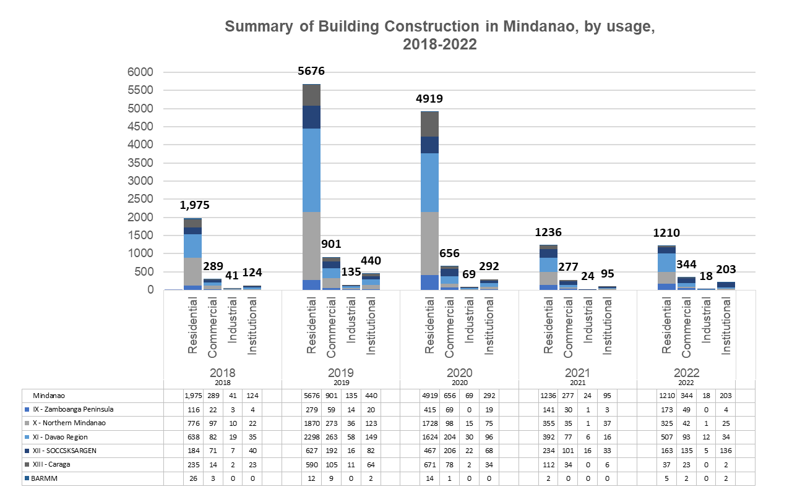Based on the approved building permit report from 2018 to 2022, as shown in figure 1, residential building construction consistently had the highest number of constructed buildings type for five years, followed by commercial, institutional and industrial types of construction. As shown in figures 1 & 2, the building construction in 2022 dropped for all categories due to the COViD pandemic, in which most industries were heavily affected [4].

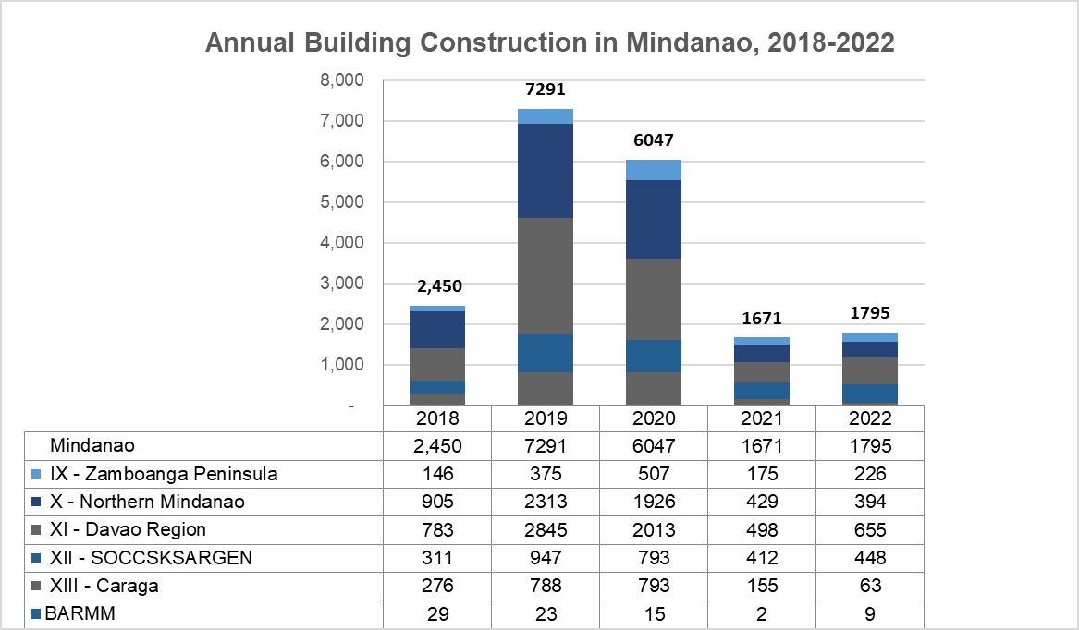**Figure 1.** Summary of Building Construction in Mindanao, by usage, 2018-2022

**Figure 2.** Annual Building Construction in Mindanao, 2018-2022

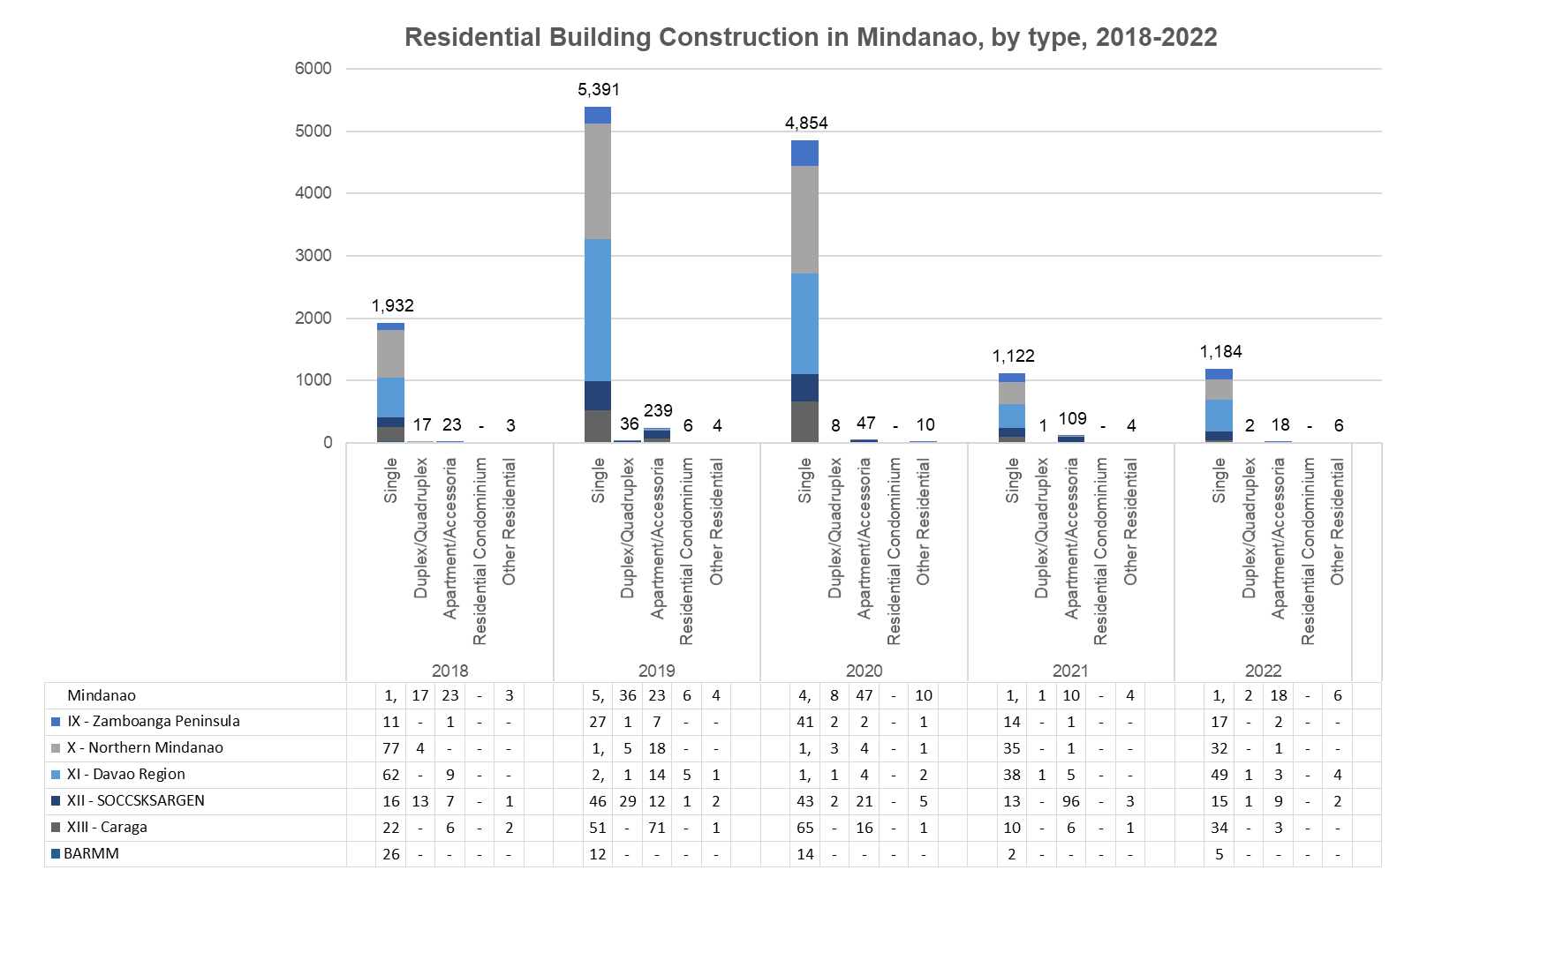**Figure 3.** Residential Building Construction in Mindanao, by type, 2018-2022

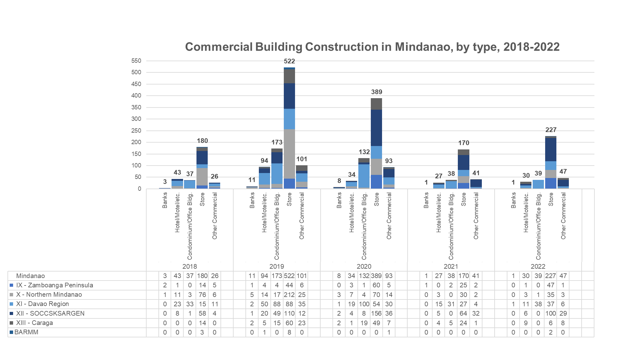As shown in figure 3, the residential–type building consists of the following categories: single, duplex/quadruplex, apartments, condominiums, and others. Among the residential building constructions in Mindanao, the single-type residential building shows the most number in five **years, from 2018 to 2022.**

**Figure 4.** Commercial Building Construction in Mindanao, by type, 2018-2022

The commercial-type buildings in Philippines comprises of banks, hotels, offices, stores and others. Retail stores are the largest figures of constructed commercial buildings for five [5] consecutive years, 2018-2022. However, the construction of commercial -type buildings decreases on year 2020 due to the significant effects of COViD-19 pandemic to both commercial and construction industry [4].

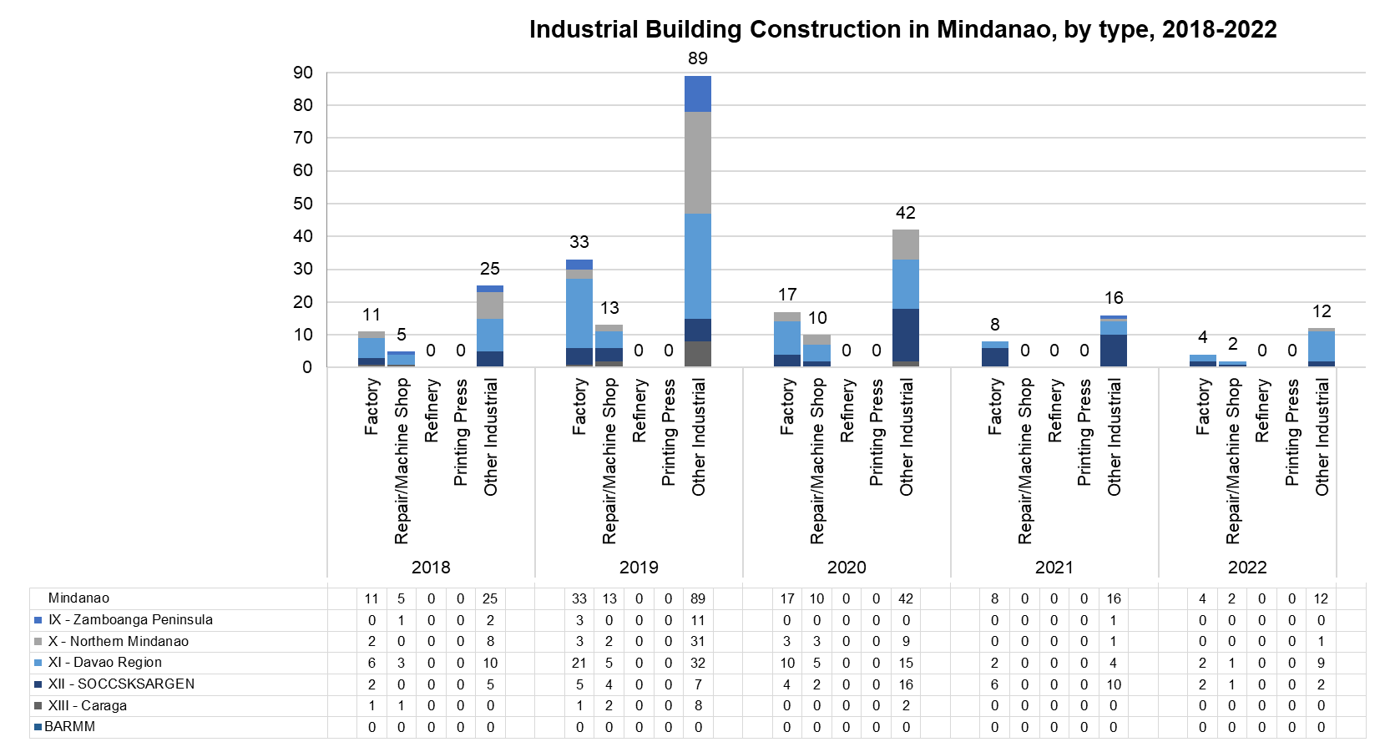**Figure 5.** Industrial Building Construction in Mindanao, by type, 2018-2022

As per PSA's categorization, industrial building construction consists of factories, repair shops, printing press, refinery and others. Among the industrial building construction category, other industrial establishments lead the count, followed by factory, repair shops, refinery and printing press respectively, as shown in figure 5. In regards to other industrial establishments as indicated on the above figure; the Philippine Statistics Authority did not provide further details.

**2.2 Green Building Industry**

With growing populations in Mindanao, the demand for buildings is increasing to provide homes, workplaces, and services. Globally, the building construction sector currently uses more energy than the transportation or the industry sector. It is also the largest polluter, with the greatest potential for significant reductions in greenhouse gas emissions compared to other sectors, at zero cost (Manley, 2015). Developed countries, in particular, have established infrastructure based on codes and design limitations derived from historical climate data. However, future climate projections indicate significant deviations from past trends. Therefore, it is crucial to design new buildings, including those catering to population growth, to withstand the anticipated stresses and loads imposed by the future climate rather than relying on designs tailored to past conditions.

Considering innovation and technology management in construction is essential to transition towards a greener approach. This involves striving for minimal energy consumption and reducing the negative impact of buildings on climate change by modifying their design, construction, operation, and demolition. In today's world, green buildings play a crucial role, leading to the development of new construction technologies to meet the growing demand for sustainability.

In recent years, green building has gained significant attention and acceptance as one of the key measures being implemented and promoted by governments and construction experts to achieve sustainable development within the construction industry [6]. Across the world, several green building rating systems have been established to evaluate and certify environmentally-friendly buildings. These systems are designed to acknowledge buildings that meet specific green criteria or standards [7].

The Philippine Green Building Council [8] founded the Building Ecological Responsive Design Excellence (BERDE) system, which has been officially recognized by the Philippine government, specifically the Department of Energy (DOE), as the country's National Voluntary Green Rating System. BERDE was created to effectively meet the Philippine building industry's demand for addressing climate change and promoting green projects within the country. Additionally, BERDE serves as a comprehensive tool for evaluating, measuring, monitoring, and certifying the performance of green building projects, going beyond the requirements set by existing national and local building codes, environmental laws, regulations, and mandatory standards. The current emphasis in green building efforts is primarily on retrofitting existing commercial and office buildings. Many of the technologies are being introduced on a trial basis to directly observe the effectiveness and outcomes of different green building strategies. Among these strategies, the reduction of energy consumption related to building cooling is seen as a top priority that requires attention in most retrofit projects [8].

|  |  |
| --- | --- |
| **Green** **Building** **Feature** | **Description** |
| Cooling | * Replacement of CFC based refrigerants; * Use of several compressors – to reduce peak demand charges and lower energy consumption associated with cooling; * Variable speed drives; * Variable refrigerant flow system; * Ice thermal air-conditioning systems; * Shadow effect – orienting buildings to take advantage of shadows to reduce heat gain in buildings. |
| Elevators | Optimized operation by zoning |
| Pumps | Better regulation of speed |
| Lighting | * Motion detection, * LED Lighting, * Compact Fluorescent Lamps (CFL), * Soft starters. |
| Building Envelope | * Sun Shields; * Low-e glazing. |
| Renewable energy | * Solar collection |
| Passive strategies used in design | * Study of solar path; * Study of wind and rainfall data; * Proper building orientation; * Natural lighting; * Natural ventilation. |
| Water | * Double/triple Piping; * Reed bed systems. |

**Table 1.** Common Green Building Features in Commercial Buildings [8]

**2.3 Green Building Stakeholders**

On June 25, 2015, the Department of Public Works and Highways [9] officially introduced the Green Building Code. This code is a supplementary document to the National Building Code (Presidential Decree No. 1096). The launch of the Green Building Code was made possible with the World Bank-IFC's support and the Philippine Green Building Initiative (PGBI) technical assistance. The PGBI comprises accredited professional organizations within the building industry [10].

The Green Building Code follows a progressive or phased approach and undergoes regular evaluations by the Secretary of the Department of Public Works and Highways [9] through the National Building Code Development Office (NBCDO). These reviews aim to make necessary updates, incorporate emerging efficient technologies, expand its applicability to different building uses or occupancies, and replace outdated measures. The National Building Code Development Office (NBCDO) will be the hub for advancing and advocating green buildings in the Philippines. It will serve as a repository of relevant resources on green buildings, create modules, and deliver training on green building practices. The Executive Director of NBCDO will lead the Technical Working Group (TWG) and can collaborate with the DPWH Secretary to provide compensation for the TWG's services. Additionally, the Executive Director has the authority to hire and compensate consultants, experts, and advisers, within the available appropriations, from relevant government agencies, private businesses, Accredited Professional Organizations (APO), and other associations to fulfill the requirements of the Green Building Code [9]. The TWG comprises authorised representatives from the following institutions as shown in Table 2.

**Table 2.** Philippine Green Building Code Technical Working Group

|  |
| --- |
| CCC : Climate Change Commission |
| DENR : Department of Environment and Natural Resources |
| DILG : Department of Interior and Local Government |
| DOE : Department of Energy |
| DOST : Department of Science and Technology |
| DTI : Department of Trade and Industry |
| GEP : Geodetic Engineers of the Philippines |
| IECEP : Institute of Electronics Engineers of the Philippines |
| IIEE : Institute of Integrated Electrical Engineers |
| PALA : Philippine Association of Landscape Architects |
| PICE : Philippine Institute of Civil Engineers |
| PIEP : Philippine Institute of Environmental Planners |
| PIID : Philippine Institute of Interior Designers |
| PSME : Philippine Society of Mechanical Engineers |
| PSSE : Philippine Society of Sanitary Engineers |
| UAP : United Architects of the Philippines |
| BOMAP : Building Owners and Managers Association of the Philippines |
| PABA : Philippine Association of Building Administrators |
| PABO : Philippine Association of the Building Officials |

Green building stakeholders include various parties, such as end users, building owners, finance entities, green building consultants, security personnel, ICT consultants, and environmental compliance entities. Private enterprises are the dominant forces in the green building industry in the Philippines. The real estate development sector, which focuses on constructing residential, commercial, and industrial buildings, is highly competitive within the country. Listed in Table 3 are some of the existing and well-known real estate developers in Mindanao, all of which are private companies, play a significant role in this industry, and are primarily engaged in constructing contemporary residential and commercial structures.

|  |  |
| --- | --- |
| Ayala Land | Megaworld Corporation |
| SM Development Corporation | FTC Group Of Companies Corp. |
| DMCI Homes | Torre Lorenzo Development Corp. |
| Filinvest Land | Damosa Land, Inc. |
| Vista Land | Cebu Landmasters |
| Robinsons Land Corp. | Phinma Properties |

**Table 3.** Existing Real Estate Developers in Mindanao

**2.4 Green Building Development in Mindanao**

The Philippines and the local government units are beginning to make green buildings a part of their key environmental strategy. Many modern technologies have originated in the western world, and the Philippines can draw inspiration from this thriving market. Numerous globally-utilized technologies are excellent examples, including Light-Emitting Diode (LED) lighting, low-energy-consuming HVAC systems, wastewater treatment methods, rainwater harvesting practices, and solar and wind energy utilization. These technologies offer valuable insights and potential solutions for the Philippines to adopt and implement. As green building technologies are gradually introduced to the Philippines, Mindanao's atmosphere is already embracing the implementation of the Philippine Green Building Code as it manifested growing numbers of Green-building certified structures in the region, as shown in the Table 4.

|  |  |  |
| --- | --- | --- |
| **Project** | **Green Building Certification** | **Location** |
| Limketkai Luxe Hotel | LEED NC 2009 Gold | Cagayan de Oro, Northern Mindanao |
| Pioneer House CDO | LEED CS 2009 Platinum | Cagayan de Oro, Northern Mindanao |
| UnionBank - Davao | LEED v4 ID+C Retail Gold | Cabaguio Ave., Davao City, Davao Region |
| Felcris Centrale | BERDE for New Construction Recognized | Quimpo Blvd., Davao City, Davao Region |
| Damosa Diamond Tower | EDGE Certification from Sintali-SGS | Lanang, Davao City, Davao Region |

**Table 4.** Green-Building Certified Structures in Mindanao, [5, 11-14]

1. **DISCUSSION AND CONCLUSION**

Residential and commercial buildings are the most significant number of building construction in Mindanao. With the continuing increase of construction after the number drop during COViD pandemic in 2020, the demand for structures is still increasing to provide homes, workplaces, and services for the growing population in the region. As this trend escalates, the massive construction of buildings negatively impacts the environment with conventional building construction methodology.

Considering innovation and technology management in construction is essential to transition towards a greener approach that involves minimal energy consumption and reducing the negative impact of buildings on climate change by modifying their design, construction, operation, and demolition. Nowadays, green buildings play a crucial role, leading to the development of new construction technologies to meet the growing demand for sustainability in Mindanao, in which both the private and public sectors need to be adaptable. A knowledgeable and well-informed group of industry stakeholders is crucial to adapt to rapid changes effectively.

In the need to address the issue of climate change and to facilitate green projects in the Philippines, Building Ecological Responsive Design Excellence (BERDE) was developed. Furthermore, BERDE has been created as a comprehensive mechanism for evaluating, quantifying, tracking, and certifying the performance of green building projects that go beyond the requirements set by national and local building codes, environmental regulations, and mandatory standards.

With the existing numbers of Green Building certified structures in Mindanao nowadays, the government's initiative towards promoting the Philippine Green Building Code, in collaboration with industry professionals, real estate developers, and other private sectors, indicates a potential for green buildings in the region.

1. **REFERENCES**

[1] PSA, P.S.A., *QuickStat.* Health, 2020. 1227(1229): p. 1232.

[2] UNCommittee, P., *Agenda 21, Rio Declaration, Forest Principles*. 1992: New York: United Nations.

[3] PSA, P.S.A., *Construction Statistics from Approved Building Permits.* 2022.

[4] Palcis, R., Jr., *The Impact of COVID-19 on the Construction Industry in the Philippines: Examining the Effects on Supply Chains, Worker Safety, and Project Timelines*. 2023.

[5] GBIG, G.B.I.G., *Limketkai Luxe Hotel / De Oro Construction Supply Building.* Green Building Information Gateway, 2012.

[6] Zhang, X., *Green real estate development in China: State of art and prospect agenda—A review.* Renewable and Sustainable Energy Reviews, 2015. 47: p. 1-13.

[7] WorldGBC, *What is a green building rating tool?* 2017. (2017b).

[8] PHILGBC, *BERDE WORKING PAPER SERIES.* 2011.

[9] DPWH, D.o.P.W.a.H., *Philippine Green Building Code User Guide.* Philippine Green Building Code User Guide, 2015.

[10] de Jesus, A., *Philippine Green Building Code*, in *Philippine Daily Inquirer*. 2015.

[11] GBIG, G.B.I.G., *Pioneer House CDO.* Green Building Information Gateway, 2013.

[12] GBIG, G.B.I.G., *UnionBank - Davao Cabaguio Branch.* Green Building Information Gateway, 2017.

[13] GBIG, G.B.I.G., *Felcris Centrale - BERDE for New Construction.* Green Building Information Gateway, 2013.

[14] EDGE. *Damosa Diamond Tower*. 2021 [cited 2023 May 20, 2023]; Available from: <https://edgebuildings.com/project-studies/damosa-diamond-tower/>.

[15] Moises Jr, C. (2020). *Online data collection as adaptation in conducting quantitative and qualitative research during the COVID-19 pandemic*. European Journal of Education Studies, 7(11).