**ANALYZING THE DRIVERS OF LAND USE/LAND COVER CHANGES IN THE CONTEXT OF MT. PATUNG, DAVAO DE ORO: A CASE STUDY**

**Gabrielle Franz P. Crucio1**

1Student, Master of Science in Development Administration – Urban and Environmental Planning, University of Southeastern Philippines – Mintal Campus, Mintal, Davao City, Philippines

**ABSTRACT**

Land use/land cover change (LULCC) is a globally recognized phenomenon resulting from human activities that have transformed a significant portion of Earth's terrestrial surface. This study focuses on the land use/land cover change in Mt. Patung, a mountain range in Davao de Oro, Philippines. The area has experienced modifications due to the emergence of tourism establishments, leading to an influx of local and foreign visitors. The study aims to evaluate the potential environmental risks associated with these modifications and promote sustainable urban development. Remote sensing and land change modeling are utilized to analyze land development trends and processes. Land cover maps from the Department of Environment and Natural Resources (DENR) for the years 2010, 2015, and 2020 are collected and processed through a land change modeler. The results indicate changes in land cover types, including reductions in open forest and perennial crop areas and the emergence of annual crops, brush/shrubs, built-up areas, and grasslands. The findings highlight the interplay between human activities and natural processes, emphasizing the need for careful land management and conservation practices. This research contributes to understanding land use dynamics and informs decision-making for sustainable land use practices in Mt. Patung and similar contexts.

**Keywords:** land use and land cover change, change detection, land change modeler, Mt. Patung.

1. **INTRODUCTION**

Humans have been modifying land for thousands of years to meet their needs and have resorted to modifying Earth's terrestrial surface, and this is now a globally well-known phenomenon, Land use/land cover change (LULCC) (Shi, Jiang et al. 2018). Human impact on Earth is significant and continuously expanding, with human activities having transformed approximately 30% to 50% of the planet's land surface (Vitousek, Mooney et al. 1997). LULCC is occurring at a much higher rate and with much greater intensity than in the past. It is influenced by a combination of socioeconomic factors and the inherent characteristics of the natural environment (Bürgi, Hersperger et al. 2005). Socioeconomic driving forces, such as economic activities, population growth, and technological advancements, play a role in shaping the patterns of LULCC. Additionally, the natural endowments of a particular area, including its climate, topography, and natural resources, also influence how the landscape evolves. These factors together determine the pathways and directions in which the landscape develops due to human activities.

Land use and land cover changes (LULCC) are recognized as the primary anthropogenic drivers of environmental change across various spatial and temporal scales. In contemporary human communities, the critical environmental challenges revolve around climate change, biodiversity loss, and water, soil, and air pollution. Among these challenges, changes in land cover hold immense significance as a key catalyst for Earth system transformations. Deforestation emerges as an important land cover change due to its extensive implications for both biophysical and biological aspects of ecosystems (Band 1993). Forest cover change (FCC) assumes utmost importance in understanding the global carbon cycle, and alterations in the hydrological cycle, deciphering biodiversity fluctuations, and comprehending the rates and underlying causes of land use change. LULCC shifts are major causes of disruptions to ecosystems and environmental processes at the local, regional, and global levels. Understanding the current global picture of change necessitates a thorough examination of these shifts, and the data on such modifications is essential for making educated decisions in ecological management and environmental planning for the future (Rounsevell, Arneth et al. 2014).

Remote sensing refers to obtaining data regarding an entity or occurrence without direct physical interaction, as opposed to conducting on-site observations (Goetz, Rock et al. 1983). It generates cost-effective multi-spectral and multi-temporal data that can be used to analyze and monitor land development trends and processes and build land use and land cover data sets over time. LULCC modeling has grown in popularity lately in the scientific community.

This study examined the land use/land change cover of Mt. Patung. It is one of the mountain ranges in Davao de Oro that is endowed with a scenic view of the sea of clouds. Located in the municipalities of Pantukan and Maragusan in the heart of barangays Araibo and Mapawa. Since the emergence of tourism establishments in the area offering a venue for tourists to watch the sea of clouds, there has been an influx of local and foreign tourist visits. The potential environmental risks to the urban environment will be evaluated if the modifications are significant. This type of analytical investigation has the potential to be substantial in promoting sustainable urban development and may prove helpful to researchers conducting comprehensive analyses of the region (Kumar, Bhaskar et al. 2015).

1. **METHODOLOGY**

**2.1 Scope of the study**

Mt. Patung, is a mountain range founding the Maragusan and Pantukan, Davao de Oro municipalities. It is under the Ancestral Domain Title (CADT) with a total land area of 10,417.08 hectares comprising 0.05 % of the total land area of the municipality of Maragusan and 19.48 % of the total land area of the municipality of Pantukan. The area has moderately highly weathered sandy to silty soil with a pebble to cobble size andesitic rocks.

**Map 1.** Location Map of Mt. Patung

Mt. Patung is situated on a north-northeast trending ridge with moderate to very steeply sloping topography and its eastern and western flanks are incised by gullies. It has the highest elevation of about 1,025 masl and the lowest elevation of about 640 masl based on IFSAR-generated contour and elevation data taken using GPS. The vegetative cover within the areas is mostly tropical shrubs/grasses and trees, fruit-bearing, and some flowering plants. With the elevation and climate generally cold throughout the day, the place is a good stopover for relaxation and an exciting viewing deck for the sea of clouds that appears early at around 6 AM-7AM, especially if it rains during the previous day. There is a lot of scope for development because the construction of resorts and other establishments resulted in changes in the area's landscape. Some infrastructures are on a steep slope, specifically in Calamba Farm, Cleo Heights Citas Lantawan, Camp Pilare, and Ayuste Nature Park. No buffer zones and mitigating measures were established. One of the scenic overlooks of Calamba Farm, located at the south-western section of the area, is seated on a gully. Due to slope alteration, minor landslides were observed underneath the said structure. Tension cracks along the pathway were also evident, indicating movement in the area. Based on the geo-hazard assessment, Mt. Patung is generally characterized to have high landslide susceptibility except for a limited area along the ridge from the midsection towards the south (Tourism 2021).

**Figure 1.** Mt. Patung Sea of clouds view deck in Calamba Farm

**2.2 Data Collection**

This study investigates land use and land cover alterations in Mt. Patung, three land cover maps from the Department of Environment and Natural Resources (DENR) of the said study area were obtained for three distinct time periods, namely 2010, 2015 and 2020. The area was divided into six (6) land use/land cover types namely: annual crop, brush/shrubs, built-up, grassland, open forest, and perennial crop.

1. **MODELING AND ANALYSIS**

**Figure 2.** Flowchart showing the methodology.

The study involved the acquisition of land cover maps from DENR during three distinct periods, specifically in 2010, 2015, and 2020, through data collection (Figure 2).

The land cover data was provided in a shapefile (.shp) format, which is compatible with the ArcGIS software and can be directly processed. The process of data collection also involved obtaining contour maps, identifying the location of government centers, and documenting the existing local road network. The land cover data for the years 2010, 2015, and 2020 were subjected to clipping procedures to achieve uniform boundaries or dimensions that correspond to the study area that was identified.

**Figure 3.** Clipping

Table 1 shows the calculated land areas in hectares corresponding to each type of land cover for the years 2010, 2015, and 2020 in Mt. Patung. These calculations provide insights into the changes in land cover types and their respective areas over time, allowing for a better understanding of the land use dynamics in Mt. Patung.

**Table 1.** Land Cover Types, in hectares

|  |  |  |  |
| --- | --- | --- | --- |
| **LC types** | **2010** | **2015** | **2020** |
| Annual Crop | - | 0.30 | 30.52 |
| Brush/Shrubs | - | 353.24 | 292.95 |
| Built-up | - | - | 4.80 |
| Grassland | - | - | 0.51 |
| Open Forest | 359.79 | 140.57 | 169.06 |
| Perennial Crop | 153.47 | 19.15 | 15.41 |
| Total | **513.26** | **513.26** | **513.26** |

The "Polygon to Raster (Conversion)" function within ArcGIS software was utilized to convert the trimmed shapefiles representing the three distinct land covers into raster images saved in the .tiff file format. This conversion process enables the representation of the land cover data in a raster format, which is compatible with various analytical tools and allows for further analysis and visualization.

**Figure 4.** Convert and clipped land covers to a raster image.

The process of importing raster data into Land Change Modeler by TerrSet and subsequently converting the raster file to IDRISI raster file format can be achieved through the utilization of the GDAL Conversion Utility. Converting the raster data to a specific format ensures data consistency throughout the analysis process. It allows standardized data representation and avoids any potential compatibility issues that may arise when working with different raster file formats.

**Figure 5.** Import raster data to Land Change Modeler and convert using GDAL Conversion

The session involves the input of two distinct land cover images that represent different time frames. The purpose of this session is to conduct a comparative analysis of land cover changes over time. It can compare and analyze the changes that have occurred in the study area. This is to allow researchers to understand the dynamics of land cover and assess the extent of changes, such as urban expansion, deforestation, or vegetation growth, that have taken place over the specified time intervals.

**Figure 6.** Setup LCM Session Parameters

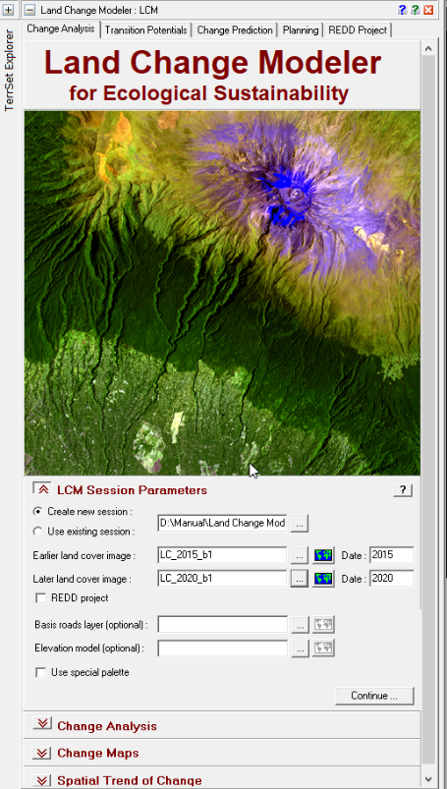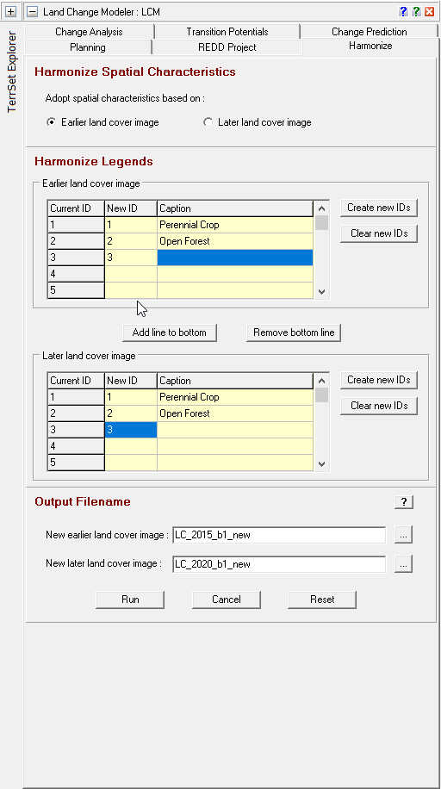

The spatial attributes of the two maps depicting land cover were compared. A change analysis was conducted to discern the gains and losses, as well as other significant alterations, between the two land cover maps.

**Figure 7**. Change Analysis

1. **RESULTS AND DISCUSSION**

Based on the DENR Land Cover 2010, only two (2) land use types were identified: open forest, with land area of 359.79 hectares and perennial crop with 153.47 hectares within the identified study area.

**Map 2.** Land Cover Map of Mt. Patung, 2010

By 2015, there was an increase in brush/shrubs, which covered 353.24 hectares, while open forests decreased to 140.57 hectares. Perennial crops decreased to 19.15 hectares. The new land cover types (annual crop and grassland) appeared, covering 0.30 hectares and 0.51 hectares, respectively.

**Map 3.** Land Cover Map of Mt. Patung, 2015

**Map 4.** Land Cover Map of Mt. Patung, 2020

In terms of gains and losses from 2010 to 2015 land covers a total of 353 hectares of land where attributed to brush or shrub lands. Open forest areas lose 228 hectares of land while gaining 9 hectares of new land areas. While perennial crop, on the other hand, perennial crop lost 145 hectares but gained a new land area of 10 hectares.

**Figure 8.** Gains and losses 2010 - 2015, in hectares

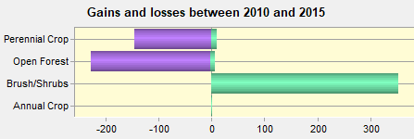

**Map 5.** Gains and losses from one land cover type to another for the years 2010-2015

In Figure 9, the changes in land cover from 2015 to 2020 are illustrated. During this period, there were both gains and losses in different land cover types. Built-up areas and grasslands showed an increase, with built-up areas expanding by 5 hectares and grasslands expanding by 1 hectare.

**Figure 8**. Gains and losses 2015 - 2020, in hectares

**Map 6.** Gains and losses from one land cover type to another for the years 2015-2020

1. **CONCLUSION**

In this study, the Land change modeler by TerrSet detected changes in the area. Some open forests were converted into built-up areas where the tourist attractions are located. This indicates that human activities and infrastructure development have encroached upon the natural forested areas to accommodate tourism-related facilities or urban expansion. However, it is worth noting that there were also areas within the mountain range where open forests gained area. This suggests that certain parts of the mountain range experienced natural regeneration or reforestation, leading to an increase in the open forest cover. The changes in land cover indicate a complex interplay between human activities, such as urbanization and tourism development, and natural processes, such as forest regeneration, within the study area. These changes have significant implications for the local environment and need to be carefully managed to ensure sustainable land use practices and conservation efforts.

The findings of this research will contribute to the understanding of land use/land cover dynamics in Mt. Patung and provide valuable insights for sustainable land management and conservation practices. By identifying the drivers and impacts of land use changes, policymakers, land managers, and local communities can make informed decisions to mitigate negative consequences and promote environmentally sound and socially just land use practices in the study area and similar contexts.

1. **REFERENCES**
2. Band, L. E. (1993). "Effect of land surface representation on forest water and carbon budgets." Journal of Hydrology **150**(2-4): 749-772.

1. Bürgi, M., et al. (2005). "Driving forces of landscape change-current and new directions." Landscape ecology **19**: 857-868.

1. Goetz, A. F., et al. (1983). "Remote sensing for exploration; an overview." Economic Geology **78**(4): 573-590.

1. Kumar, K. S., et al. (2015). "Application of land change modeler for prediction of future land use land cover: a case study of Vijayawada City." Int J Adv Technol Eng Sci **3**(01): 773-783.

1. Rounsevell, M., et al. (2014). "Towards decision-based global land use models for improved understanding of the Earth system." Earth System Dynamics **5**(1): 117-137.

1. Shi, G., et al. (2018). "Land use and cover change during the rapid economic growth period from 1990 to 2010: A case study of Shanghai." Sustainability **10**(2): 426.

1. Tourism, P.-. (2021). Mt. Patung Security and Public Safety Plan 2021-2026.

1. Vitousek, P. M., et al. (1997). "Human domination of Earth's ecosystems." Science **277**(5325): 494-499.