Detection Of Stress in IT Employees Using Machine Learning Technique
Mr. Baskar D¹, Dinesh K², Dhivakar K³, Gunal J⁴
¹Assistant Professor, Information Technology, V.S.B Engineering College, Karur, Tamilnadu, India, e-mail: maalini.cse@gmail.com.
2 UG Scholar, Information Technology, V.S.B Engineering College,
Karur, Tamilnadu, India, e-mail: dinesh6385313244@gmail.com.
3 UG Scholar, Information Technology, V.S.B Engineering College,
Karur, Tamilnadu, India, e-mail: dhivakar676@gmail.com.
4 UG Scholar, Information Technology, V.S.B Engineering College,
Karur, Tamilnadu, India, e-mail: gunalheenaa11@gmail.com.

Abstract- Stress is a significant problem in the workplace, especially for IT employees who work in a highly demanding and rapidly changing environment. Detecting stress in employees can help organizations take proactive measures to prevent burnout and improve employee well-being. Machine learning techniques can provide a powerful tool for stress detection, leveraging the wealth of data available in the workplace. In this study, we suggest using machine learning to identify stress in IT workers. Our approach involves collecting data on various stress-related factors, such as workload, task complexity, and work-life balance, from employees using surveys and wearable devices. We will then use supervised learning techniques, such as logistic regression and decision trees, to build models that can predict stress levels based on the collected data. To evaluate the effectiveness of our approach, we will conduct a case study in an IT company, where we will collect data from a group of employees over a period of several months. We will then compare the performance of our models with traditional approaches, such as self-reported surveys, to assess the accuracy of our stress detection approach. This study intends to show the potential of machine learning methods for stress detection in IT workers, underscoring the need of employing data-driven strategies to enhance employee wellbeing at work.
Keywords: Stress Detecting, XG Boost, Stress Detection in IT Employee, NLP.
I.INTRODUCTION
Stress has become a prevalent issue in today's fast-paced society, particularly at work. IT employees, who work in a highly demanding and rapidly changing environment, are particularly vulnerable to stress, which can lead to burnout, decreased productivity,

and health problems. Therefore, detecting and preventing stress of IT employees is essential to promote their well-being and ensure organizational success.
Machine learning techniques have gained popularity in recent years, providing powerful tools for analyzing and making predictions based on complex data. These techniques can also be applied to detect stress in IT employees, leveraging the vast amount of data that can be collected from surveys, wearable devices, and other sources. In this research, we suggest a machine-learning method for identifying stress in IT workers. Our approach involves collecting data on various stress-related factors, such as workload, task complexity, and work-life balance, using surveys and wearable devices. We will then use supervised learning techniques that can predict stress levels based on collected data. Our study's primary objective is to demonstrate the potential of machine learning techniques for detecting stress in IT employees, highlighting the importance of using data-driven approaches to improve employee well-being in the workplace. Our results can provide valuable insights for organizations looking to implement proactive measures to prevent burnout and improve the employee satisfaction and retention.
MACHINE LEARNING
Machine learning is a branch of AI that focuses on creating algorithms capable of learning from data to recognize patterns and make predictions or decisions. The primary objective of machine learning is to empower computers to learn and enhance their performance through experience, without requiring explicit programming for every task. Machine learning algorithms can be categorized into three primary types: supervised learning, unsupervised learning, and reinforcement learning. In supervised learning, algorithms are trained on labeled data, where each data point has an associated label or target value. The objective is to develop a model capable of predicting labels for new, unseen data based on their features. Unsupervised learning, on the other hand, involves training algorithms on unlabeled data, without any target values. The aim here is to discover patterns and structure within the data, such as grouping similar data points together through techniques like clustering.
II.RELATED WORKS.
Different theses, books, journals, websites, and articles which are related to research have been studied.
In [3] the context of technology-oriented organizations in the digital age, S. Chernbumroong et al. suggested that agile working policies are widely adopted due to their alignment with the prevailing work styles and suitability for organizations that embrace change.
In [6] their study on the work-life balance of women, S.D. Sharma et al. examined stress as a significant and widespread health concern resulting from the interaction between individuals and their environment. Achieving work-life balance is a crucial objective for women in the workforce, and the absence of job satisfaction or stability can lead to a challenging situation for female employees.
In [5] Huijie Lin, et.al considered physiological reactions. Stress has become a prevalent concern in work environments, causing psychological and physiological responses. The utilization of biosensors among employees as wearable devices could enhance stress monitoring in the workplace.
In [1] Ramin Zibaseresht considered COVID-19. After the COVID-19 pandemic, mask detection has emerged as a crucial measure in epidemic prevention and control, being the most practical and effective method available. Implementing an advanced deep learning-based automatic real-time face mask identification system can greatly reduce work-related stress for relevant employees.
In [9] H. Yu, et.al proposed a framework on Bid Data. This research paper introduces a log management architecture that utilizes Big Data Analytics to develop an advanced Security Operations Center (SOC) system. The architecture integrates various notification tools into a single screen for improved efficiency. Additionally, automation is enhanced by consolidating monitoring modules, which can help replace manual tasks typically assigned to new hires in routine operational activities.
In [8] K. Pabreja, et.al displayed a framework for the classifier. This study aims to examine how employee event characteristics influence the performance of classifiers in predicting the likelihood of employee turnover. The goal is to ensure that the classifiers remain interpretable, which is essential for developing retention interventions.
In [4] Reshmi Gopalkrishna Pillai, et.al proposed a framework based on ML. Researchers have utilized data visualization methods and machine learning algorithms to make predictions about the stress levels of employees. Based on the data, we can develop a model that will assist to predict if an employee is likely to be under stress or not.
In [7] Mani Barathi SP S, et.al displayed a real-time environment by ML. We would like to apply machine learning techniques to analyzed stress patterns in working adults and to narrow down the factors that strongly determine stress levels. Towards this, data from the OSMI mental health survey 2017 responses of working professionals within the tech industry were considered.
In [2] P. Sureephong, et.al proposed in a digitally dependent world, Individuals are increasingly experiencing feelings of being overwhelmed and distressed due to computer-related stress, which significantly impacts their daily lives and poses significant challenges. Working with systems results in stress, particularly when an individual is presented to it for a long term of time.
III.PROPOSED SYSTEM
The proposed system for detecting stress in IT employees using machine learning techniques involves collecting data from diverse sources, including surveys and wearable devices, are collected and utilized in supervised learning approaches algorithms to build models that can predict stress levels. The deep learning XG Boost-based deep learning model is deployed to detect the stress condition of IT Employees. Here the project is split into training datasets to train the model and deploy the model. Web UI is created to predict mental stress conditions and give suggestions. XG Boost algorithm has High accuracy and increases overall performance.
XG BOOST
XG Boost is a machine learning algorithm that can predict stress in IT employees based on factors such as workload, job demands, work-life balance, and personal characteristics. By gathering data and labeling employees as "stressed" or "not stressed," XGBoost model can be trained to make predictions. However, it is crucial to ensure the data used is representative of the population of IT employees and to consider the ethical implications of using such a model, which may impact employee well-being and job security.
IMAGE RECOGNITION
Image recognition can be used to detect signs of stress in IT employees by analyzing facial expressions and work environments. This involves training a model to classify new images based on features of stressful or non-stressful environments. However, privacy concerns must be considered, and other machine-learning techniques may be more appropriate in some cases. It's important to use data collected in a responsible and ethical manner.

IV.SYSTEM ARCHITECTURE
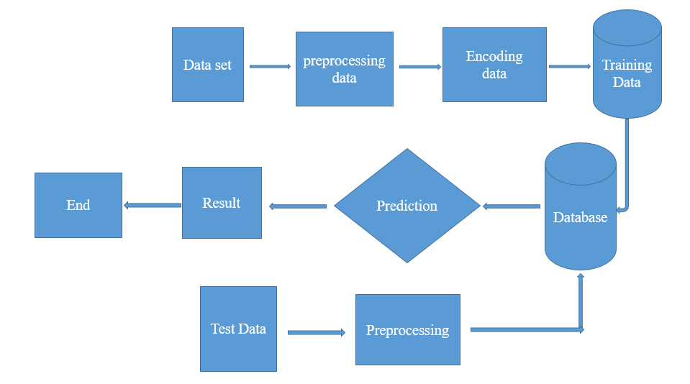
Fig no:1 System Architecture
MODULE LIST
- Data set collation
- Data pre-processing
- Feature Selection
- Training
- Testing
DATA SET COLLATION
Collect data from IT employees regarding their job demands, work-life balance, personal characteristics, health status, and other relevant factors that is crucial to recognize the factors that can potentially contribute to stress. ensure that the data is collected in a privacy-preserving manner and with the informed consent of the employees.
DATA PRE-PROCESSING
Process the collected data by cleaning and formatting it. This may include removing duplicates, handling missing values, and transforming categorical variables into numerical representations.
FEATURE SELECTION
Determine the key features that hold the most significance, that are likely to contribute to predicting stress in IT employees. This may involve using techniques such as correlation analysis, feature importance, and feature engineering. Choose an appropriate machine learning algorithm that is suitable for the problem at hand. In this case, a supervised learning algorithm could be used to train a predictive model.
TRAINING
Train the predictive model using the pre-processed data and the selected features. The process includes dividing the data into training and testing sets, and using the training set to train the model.
TESTING
Evaluate the performance of the model using the testing set.The evaluation of the model's performance can be accomplished by computing different metrics like accuracy, precision, recall, and F1 score. Once the model is trained, it can be deployed in a production environment to predict stress levels in IT employees. The model can be integrated into an employee monitoring system, and notifications can be sent to management when employees are identified as being at high risk for stress.
V.EXPERIMENTS AND ANALYSIS
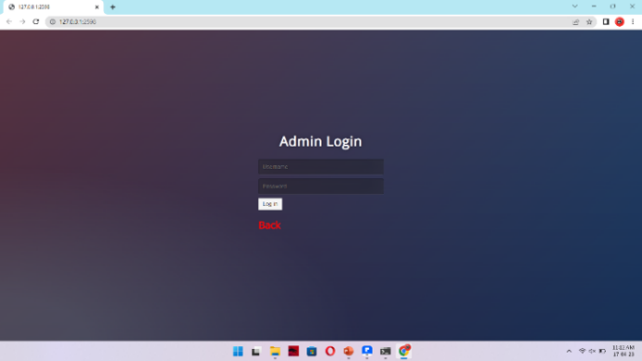
Fig no:2 Admin login
To access the system, the administrator needs to use "admin" as both the username and password. Upon successful login, the administrator gains the ability to identify employee stress. By entering the employee's email ID, the admin can detect the stress level, which is then displayed on the admin page.
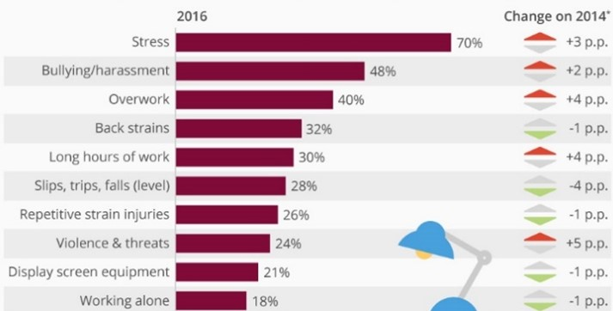
Fig no:3 Graph
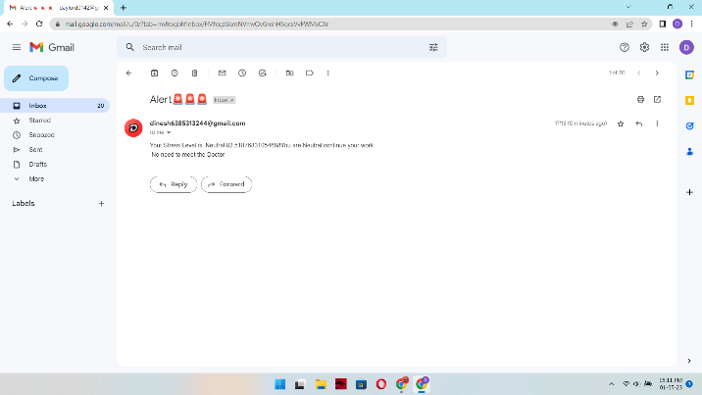
Fig no:4 Output of the Employee
The employee will revise the Gmail from admin with the employee stress level and suggestions.
VI.ALGORITHM
The proposed system algorithm can be outlined as follows:
Step 1: Start.
Step 2: Admin authentication process.
Step 3: Verify the admin's status.
Step 4: Enter the IT Employee Email Id.
Step 5: Click detect button.
Step 6: The camera page will pop up and detect the
Stress.
Step 7: After detecting the stress it sends the output
to both admin and employee.
Step 8: For employees, the output is sent in Gmail as
“ALERT MESSAGE”.
Step 9: For Admin, the employee stress is displayed in
“WEB PAGE” itself.

VII.CONCLUSION
In summary, employing machine learning techniques to detect stress in IT employees offers numerous benefits compared to current systems. These advantages encompass objective and comprehensive evaluation, real-time monitoring, personalized recommendations, enhanced accuracy, and scalability. However, there are also potential disadvantages to consider, such as data privacy and security concerns, bias in data and models, limited scope, cost and complexity, and resistance to change. The proposed system for detecting stress in IT employees using machine learning techniques involves collecting and pre-processing data, training machine learning models, deploying the models in the workplace, and evaluating the system's performance regularly. By leveraging the power of machine learning algorithms, the system can provide a more accurate and reliable assessment of stress levels in IT employees, leading to improved employee well-being, productivity, and organizational success. It is important to carefully plan and implement such a system, with a focus on ensuring data privacy and security, addressing biases in data and models and ensuring that the system is acceptable to employees. With proper implementation, the proposed system can be a valuable tool for promoting employee well-being and success in the IT industry.
VIII.FUTURE WORK
To identify stress, the proposed machine learning approach for detecting stress in IT employees involves collecting data on stress-related factors such as workload, task complexity, and work-life balance using surveys and wearable devices. The collected data will be pre-processed by cleaning and transforming it into a format that can be analyzed, including tasks such as removing missing values, scaling numerical features, and encoding categorical variables. The most relevant features that are predictive of stress levels of IT employees will be selected using techniques such as correlation analysis, feature importance ranking, and dimensionality reduction. The identified features will be utilized to train supervised learning models like logistic regression and decision trees. These models can make predictions about stress levels using the collected data. The approach will be evaluated through a case study in an IT company, comparing the performance of the models with traditional approaches to assess the accuracy of the stress detection approach.
IX.REFERENCE
- Ramin Zibaseresht, How to Respond to the Ongoing Pandemic Outbreak of the Coronavirus Disease (COVID-19) (WHO- World Health Organization), 2020.
- P. Sureephong, W. Dahlan, S. Chernbumroong and Y. Tongpaeng, "The Effect of Non-Monetary Rewards on Employee Performance in Massive Open Online. Courses", International Journal of Emerging Technologies in Learning, vol. 15, no. 1, 2020.
- S. Chernbumroong, P. Sureephong, and Y.Tongpaeng, "The Gamification Element Selection Method", 2019 Joint International Conference on Digital Arts Media and Technology with ECTI Northern Section Conference on Electrical Electronics Computer and Telecommunications Engineering (ECTI DAMT-NCON), pp. 179-183, April 2019.
- Reshmi Gopalakrishna Pillai, Mike Thelwall, Constantin Orasan, “Detection of Stress and Relaxation Magnitudes for Tweets”, International World Wide Web Conference Committee ACM, 2018.
- Huijie Lin, Jia Jia, JiezhonQiu, “Detecting stress based on social interactions in social networks”, IEEE Transactions on Knowledge and Data Engineering, 2017.
- S.D. Sharma, S. Sharma, R. Singh, A. Gehlot, N. Priyadarshini, and B. Twala, "Stress Detection System for Working Pregnant Women Using an Improved Deep Recurrent Neural Network", Electronics, vol. 11, pp. 2862, 2022.
- Mani Barathi SP S, V S Rekha, M. Sujithra and K. Raja Rajeshwari, "Depression and Anxiety Detection with Machine Learning Techniques using Data from Wearable Sensors", YMER journal, vol. 21, no. 9, Sep 2022.
- K. Pabreja, A. Singh, R. Singh, R. Agnihotri, S. Kaushik, and T. Malhotra, "Stress Prediction Model Using Machine Learning", Proceedings of International Conference on Artificial Intelligence and Applications, pp. 57-68, 2021.
- H. Yu and A. Sano, "Passive sensor data based future mood health and stress prediction: Adapting to users' needs through deep learning techniques: Prediction of future mood, health, and stress based on passive sensor data.

