**DESIGN AND DEVELOPMENT OF COLOR SORTING MACHINE USING A CONVEYOR BELT**

**Rutuj Sanjay Khairnar1, Yashodeep Arun Khairnar2, Gaurav Murlidhar Kothawade3,**

**Yash Deepak Kapure4**

1,2,3,4Student, Department of Mechanical engineering, NDMVP’s KBTCOE, Nashik, Maharashtra, India

**ABSTRACT**

In this paper, we present the design and development of color sorting machine using a conveyor belt. This paper describes a working prototype designed for automatic sorting of objects based on the color of the objects. TCS34725 color sensor was used to detect the RGB colors of the product and the Arduino Uno is used to control the overall process. The identification of the color is based on the frequency analysis of the output of TCS34725 sensor. Conveyor belts is used, controlled by DC motor. The experimental results promise that the prototype will fulfill the needs for higher production and precise quality in the field of automation.

***Keywords****: Color sorting; Arduino; conveyor; servo motors; DC motor; RGB Colors.*

1. **INTRODUCTION**

Nowadays, in the present state of intense competition, production efficiency is generally regarded as the key of success. Taking this matter under consideration the project is developed which is very useful for industries. Machines can perform highly repetitive tasks better than humans. Worker fatigue on assembly lines can result in reduced performance, and cause challenges in maintaining product quality. An employee who has been performing an inspection task over and over again may eventually fail to recognize the color of product. Automating many of the tasks in the industries may help to improve the efficiency of manufacturing system. The purpose of this model is to design and implement a system which automatically separates products based on their color. There are three main steps in sensing part, objects detection and recognition. The system may successfully perform handling station task, namely pick and place mechanism with help of sensor. The Arduino microcontroller sends signal to circuit which drives the various motors of the robotic arm to grip the object and place it in the specified location. Based upon the detection, the robotic arm moves to the specified location, releases the object and comes back to the original position.

1. **PROBLEM STATEMENT**

The design and development of a color sorting machine using a conveyor belt aims to address the challenge of efficiently and accurately sorting objects based on their color. The existing methods of manual sorting or traditional sorting machines are time-consuming, labor-intensive, and prone to human error. The problem statement encompasses the need for an automated system that can reliably and rapidly sort objects based on their color using a conveyor belt mechanism. The machine should be capable of handling a variety of objects and accurately divert them into different output bins based on their specific colors.

The key objectives of this project include:

1. Designing a robust conveyor belt system that can handle a continuous flow of objects for sorting.

2. Developing a color sensing mechanism that can accurately identify the color of the objects passing through the conveyor belt.

3. Implementing a real-time decision-making algorithm that can classify the objects based on their color and efficiently divert them into the corresponding output bins.

4. Ensuring the system's reliability, accuracy, and speed in order to achieve high sorting efficiency and minimize errors.

5. Designing the machine in a cost-effective and user-friendly manner, considering factors such as ease of maintenance and scalability for potential future enhancements.

1. **BLOCK DIAGRAM OF THE ARCHITECHTURE OF COLOR SORTING MACHINE**



**Fig.1- Architecture of the color sorting machine**

1. **METHODOLOGY**

In designing of color sorting machine, a flow chart of methods had to be used to describe it systematically. First of all, a process planning had to be charted out. This acts as a guideline to be followed so that, the final model meets the requirement and time could be managed. This would determine the efficiency of the project to be done. Regulating and analyzing these steps are very important as each of it has its own criteria to be followed.

**4.1 The various steps involved in methodology are as follows: -**

Step 1: Problem Definition- A particular problem is taken into consideration and problem definition is prepared. Other parameters such as scope of work, objectives of work are also defined.

Step 2: Literature Review- Searching various research papers and studying them thoroughly. Then collecting the important information from them. Thus, literature review on the title is done thoroughly covering all the aspect of the project. The medium for this research is via internet and books. Essential information related to the project is gathered for referencing.

Step 3: Preliminary Design - Designing a color sorting machine based on the analysis of the solution. Deciding the dimensions of the frame and selection of the electronic devices required for the functioning of the machine. In conceptualization, few designs sketches are prepared manually on a paper which are then reviewed. Then the best design is selected and discussed with the teachers for confirmation.

Step 4: Material Equipment - Selecting material and the required components from market at the best optimum price and quality.

Step 5: Fabrication - After finalizing the design and material, fabrication of model is done and various finishing operations are performed.

Step 6: Final Model - After manufacturing of each component, they are assembled suitably and thus the final model is ready.

Step 7: Analysis - Checking whether the machine is working properly and also test the functioning of all the components.

PROBLEM

STATEMENT

LITERATURE

REVIEW

PRELIMINARY

DESIGN

MATERIAL/

EQUIPMENT

REQUIREMENT

FABRICATION/

ADJUSTMENT

IN DESIGN

FINAL

MODEL

ANALYSIS/

RESULT/

CONCLUSION

**Fig.2- Flowchart of methodology**

1. **RESULTS**

Below given is the picture taken of the trials done after successful assembly of the prototype. This is a scale down model made by our group following the design procedure. The rollers are made by using the axles of a cycle fixed inside 2 inch PVC pipes and the driver pulley of rotated by a DC motor of 100rpm. The length of the conveyor belt in our model is almost 50cm and width is 12cm. The material of the belt of conveyor is of leather. 3 servomotors are attached along the path and they rotate on an angle of 55 degrees. The first servomotor sorts red color box, the second servomotor sorts green color box, the third servomotor sorts blue color box respectively. The Arduino Uno board efficiently processes all the data. The entire project has been made in a cost efficient way and with a motive of increasing automation and efficiency in the production line. Fig 3 shows complete assembly of the model.

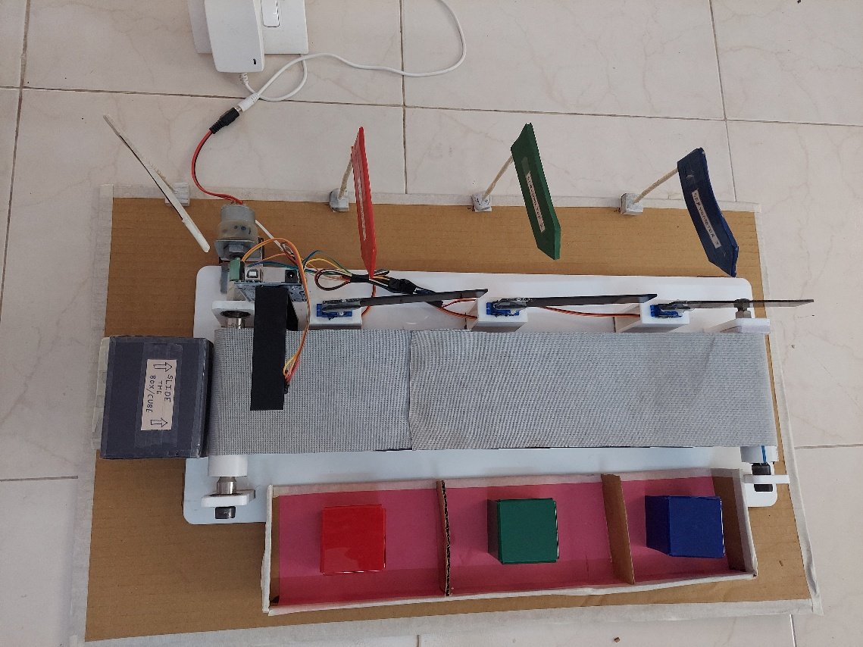

**Fig.3- Completed model**

Advantages:

* Increased Efficiency: Color sorting machines use advanced optical sensors and high speed processors to quickly and accurately detect and sort objects based on their color.
* Enhanced Accuracy: Color sorting machines can detect minute color variations that are difficult for the human eye to perceive, ensuring a high level of accuracy in sorting.
* Improved Quality: By sorting objects based on color, these machines enable precise quality control.
* Cost Savings: Color sorting machines help minimize waste and optimize resources by efficiently segregating objects based on color characteristics.
* Versatility: These machines can be programmed to sort a wide range of objects based on color.

Disadvantages:

* Initial Investment: The cost of purchasing and installing a color sorting machine can be significant, especially for small and medium-sized businesses.
* Maintenance and Training: Like any complex machinery, color sorting machines require regular maintenance to ensure optimal performance.
* Limited Sorting Parameters: While color sorting machines excel at detecting and sorting objects based on color, they may struggle with other parameters such as shape, size, or texture.

Applications:

* Food Processing: Color sorting machines are extensively used in the food processing industry to sort grains, seeds, nuts, fruits, and vegetables based on their color.
* Recycling: Sorting machines play a crucial role in the recycling industry by separating different types of plastics, glass, and other recyclable materials based on their color.
* Textiles: In the textile industry, color sorting machines are employed to classify fabrics, yarns, and fibers based on color.
* Pharmaceuticals: Color sorting machines find applications in the pharmaceutical industry for sorting pills, capsules, and tablets based on color.
* Mining and Ore Processing: These machines can be used in the mining industry to sort and separate ores and minerals based on their color characteristics.

1. **CONCLUSION**

1. The Automatic sorting machine using conveyor belt is basically useful for sorting the products in the industry specifically large scale industries where mass production is carried out.

2. The Machine also reduces the efforts of the workers by reducing the time spent for material handling.

3. The application area of this machine is very wide in industries where automation is built.

4. We have proposed a system which would increases the production rate and accuracy of material handling system.

5. The system would separate objects based on their color and weight as per requirement by the user. And we can modify the system according to their requirement.

6. This project of automatic color sorting is excellent one because of its working principle and wide implementation. By applying the idea of this project an industry can easily sort the required product according to its color. Through it has some limitations, but by having done some modification this concept can be implemented in wide range of application.

7. It can be concluded that time and human effort can be reduced by implementing such project in industries like chemical, food, chip manufacturing and so on.

1. **REFERENCES**

[1] Fuller, J.L., Robotics: Introduction, Programming and Projects, Prentice Hall, 2nd edition, Columbus, Ohio.

[2] Y V Aruna, 2015. “Automatic convey or System with In Process Sorting Mechanism” International Journal of Engineering Research and Applications, ISSN: 2248-9622, vol. 5, Issue 11.

[3] Yeow Khang Yung, 2011. ‟Color Sorting System with Robot Arm‟‟ Faculty of Electronic and Computer Engineering University Technical Malaysia Melaka.

[4] M. C. Mulder, S. R. Malladi, 1991. “A minimum effort control application for Cooperating sensor driven intelligent multi-jointed robotic arm,” Proceedings of the 30th IEEE Conference on Decision and Control, vol. 2, pp. 1573–1578.

[5] Amir Deshmukh, Mahesh Nagane, Vaibhav Avtade, 2016. “Design and Development of Automatic Conveyor Controlling System for sorting of component on color basic, International Journal of Science and Research (IJSR).