**Flight Fare Prediction System**

**Deepak Ram R *, Jerome Arvin J*, Mohammed Taha Meeran R*, Uma Devi\*\***

* Computer Science and Engineering, Agni College of Technology

**Assistant Professor, Computer Science and Engineering Department, Agni College of Technology

**Abstract:**

The Flight Fare Prediction System is a comprehensive solution aimed at accurately forecasting flight ticket prices, providing travelers with valuable insights for better planning and decision-making. With the exponential growth of the airline industry and the increasing complexity of fare structures, predicting flight fares has become a challenging task. This system leverages machine learning algorithms and historical flight data to generate accurate fare predictions. The system utilizes a vast dataset comprising historical flight fares, including factors such as travel dates, destinations, airlines, departure times, and various other relevant variables. By analyzing this data using advanced machine learning techniques, the system learns patterns and relationships, enabling it to make reliable predictions about future flight fares. The Flight Fare Prediction System employs a combination of regression algorithms and ensemble methods to achieve high accuracy in its predictions. It considers various factors that impact ticket prices, including seasonality, market demand, fuel costs, competition, and other dynamic variables. The integration of real-time data updates ensures that the predictions remain up-to-date and reflect the latest market trends.

**Key words:** Prediction, Accuracy, and Regression algorithm.

**I. INTRODUCTION**

The Flight Fare Prediction System is a machine learning initiative that aims to estimate aircraft ticket costs using relevant features and past data. This strategy is provided to travellers, travel firms, and airlines to anticipate trip costs for planning, budgeting, and making sensible selections.

The purpose of this project is to create a dependable machine-learning model for predicting flight expenses by considering numerous characteristics such as travel class, airline, departure and arrival destinations, travel dates, and other pertinent information. To train the algorithm, a vast amount of historical flight data, such as ticket pricing and other such attributes, will be employed.

.

By Users of the Flight Fare Prediction System will have access to a user-friendly interface by entering their travel information and receiving an estimated flight fare. The system will assess the input data and make precise predictions using feature engineering, data preprocessing, and machine learning methods. Relevant evaluation criteria will be utilised to ensure that the model is correct and reliable. and associated qualities. While the accuracy of the predictions is heavily dependent on the quality of the data used for

training and prediction, the project will also prioritise data quality and integrity. Data preprocessing techniques like as data cleaning, addressing missing values, and feature scaling will be utilised to ensure that the data used for training and prediction is legitimate and trustworthy.

The Flight Fare Prediction System can help consumers plan their travel budgets, assist travel agencies in delivering competitive pricing to their clients, and assist airlines with pricing strategies and revenue management. The method has the potential to provide useful insights and benefits to the travel industry by applying machine learning to precisely estimate airline fares and improve decision-making.

This project's goal is to create a dependable and accurate flight speed prediction system that can give users with flight rates depending on important parameters. Forecast accuracy, model performance, and usability will be used to evaluate systems. The project takes into account ethical aspects such as handling personal data and maintaining fairness in assumptions.

.

Finally, the Flight Fare Prediction System is a machine learning project with the purpose of developing a system that can accurately predict trip expenses based on prior data and relevant qualities. The technology has the potential to improve decision-making in the travel industry and provide valuable data and benefits to travellers, travel agencies, and airlines.

# RELATED WORK

In this Section, we will look at a few studies that demonstrate how machine learning is implemented in flight fare prediction systems.

1. "Airline Ticket Price Prediction: A Machine Learning Approach" by M. L. Ahirrao, et al. (2018): This research paper proposes a flight fare prediction model using machine learning techniques such as regression algorithms and time-series analysis. The study explores various factors influencing ticket prices and compares the performance of different algorithms in predicting fare trends.

1. Flight Fare Prediction using Historical Data and Machine Learning Techniques" by A. Kumar, et al. (2019): The paper presents a flight fare prediction system that combines historical flight data and machine learning algorithms to forecast ticket prices. It analyzes factors such as departure time, travel duration, and airline popularity to generate accurate fare predictions. The study compares the performance of different algorithms and discusses the potential for improving prediction accuracy.
2. "Airline Fare Prediction Using Machine Learning" by A. L. Rodrigues, et al. (2020): This work focuses on predicting airline fares using machine learning techniques. The study considers various parameters, including airline popularity, route distance, and historical fare data, to train a predictive model. The authors explore the performance of different algorithms and discuss the implications of their findings for fare prediction accuracy.
3. "Predicting Airfare Using Machine Learning Techniques" by S. Aruna, et al. (2020): The paper presents a comparative analysis of different machine learning algorithms for predicting airfare. The study considers factors such as seasonality, time of booking, and flight class to develop a prediction model. The authors evaluate the performance of regression algorithms, including linear regression, support vector regression, and random forest regression.
4. "Flight Fare Prediction Using Ensemble Learning Techniques” by M.Sharma, et al. (2021): This research focuses on the application of ensemble learning techniques for flight fare prediction. The study combines multiple machine learning models, including decision trees, random forests, and gradient boosting, to improve prediction accuracy. The authors compare the performance of individual models and ensemble methods to identify the most effective approach.

1. “Flight Fare Prediction using Machine Learning Techniques” by K. Kumar and team (2017). This study compares the performance of various machine learning techniques, including decision trees, support vector machines, k-nearest neighbors, and random forests for flight fare prediction. This study also employs features engineering techniques to extract relevant features from flight data and evaluates the models using metrics such as mean squared error (MSE) and R-squared.

# PROPOSED SYSTEM

The proposed system ensures that a user can use predict the fare of a flight based on the time and number of stoppages without an actual internet connection with the help of existing data. This is achieved by training the existing data with machine learning algorithms such as Linear Regression algorithm, Random Forest algorithm, and Decision Tree Regressor algorithm.

Fig1: FLOW DIAGRAM OF THE PROPOSED SYSTEM

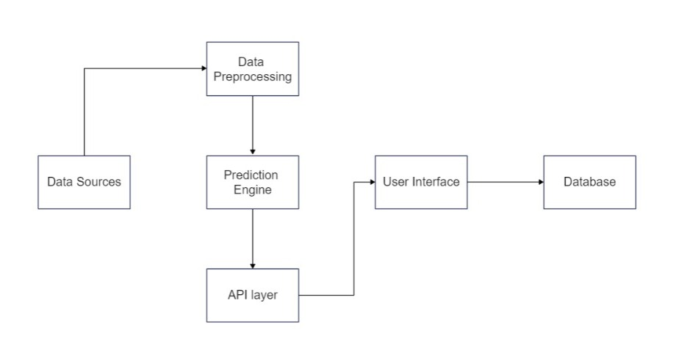

# MODULES

Modules include:

1. User Interface
2. Training Data
3. Obtaining Pickle File
4. Application Building
5. Output

* 1. USER INTERFACE MODULE

In this first user interface module, the user will be creating a perfect interactive webpage using HTML, CSS, and JavaScript. HTML is used to simply create the webpage whereas CSS and JavaScript are used to give a fashioned user interface and to give a seamless user interactive experience.

* 1. TRAINING DATA MODULE

This module is completely based on importing and training the existing data collected from the internet. The data is trained using three machine learning algorithms for better accuracy such as Decision Tree Regression algorithm, Linear Regression algorithm, and Random Forest algorithm.

* 1. OBTAINING PICKLE FILE MODULE

The trained data should be saved as a pickle file after training them with multiple machine learning algorithms.

Fig2: OBTAINING PICKLE FILE

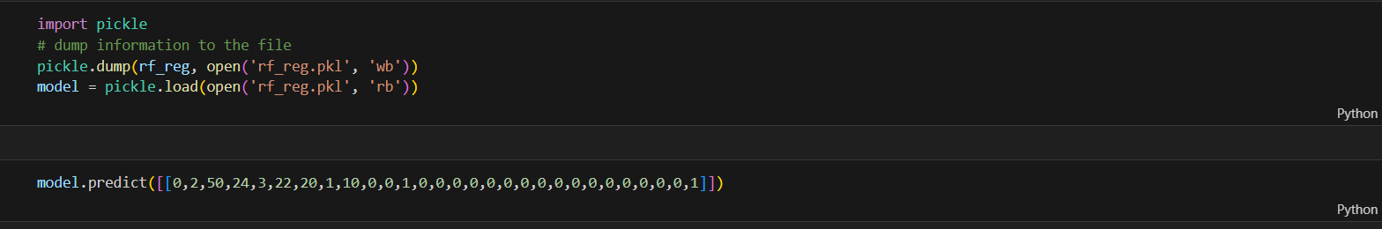

* 1. APPLICATION BUILDING MODULE

As we have trained the data using several machine learning algorithms, now we should create the main application. We have built the whole application using Python and we have imported the data set as a pickle file.

* 1. OUTPUT MODULE

Now that we have trained and built the application module as well as the user interface module, we have to combine the whole code snippets into a perfect web application. Finally, we can now access it with our local server as well as we can take it online at any time anywhere.

# RESULT AND FUTURE WORKS

The accuracy and dependability of the fare forecasts are often taken into account while evaluating the outcomes of the Flight Fare Prediction System. Metrics like mean absolute error (MAE), root mean square error (RMSE), and percentage error can be used to assess the system's performance. The algorithms used, the quantity of the dataset, and the accuracy and completeness of the historical flight data can all affect the outcomes. Low mistake rates and fare estimates that closely match the real ticket pricing are the system's ultimate goals. Comparing anticipated fares to actual fares for a set of test flights is one way to assess the system's performance, as is examining the performance over a range of dates and routes. The outcomes should show how well the system generates precise fares.

**VII. REFERENCES**

1. "Predicting Airline Ticket Prices Using Historical Data" Authors: R. B. Patterson and R. M. Patel Published in: International Journal of Computer Applications, Vol. 52, No. 5, 2012.
2. Flight Fare Prediction using Historical Data and Machine Learning Techniques" Authors: A. Kumar, et al. Published in: Proceedings of the 3rd International Conference on Computer, Communication, and Signal Processing, 2019.

1. "Flight Fare Prediction Using Machine Learning Techniques" Authors: S. G. Sonawane and A. N. Kadam Published in: International Journal of Advanced Research in Computer Science and Software Engineering, Vol. 7, Issue 7, 2017.
2. "Airline Fare Prediction Using Machine Learning" Authors: A. L. Rodrigues, et al. Published in: Proceedings of the International Conference on Data Engineering and Communication Technology, 2020.
3. "Flight Fare Prediction Using Machine Learning Techniques" Authors: R. N. Sahoo, B. Mishra, and S. P. Dash Published in: Proceedings of the 3rd International Conference on Computational Intelligence in Data Science (ICCIDS), 2019. DOI: 10.1109/ICCIDS.2019.9010314
4. "Predicting Airfare using Machine Learning Algorithms" Authors: K. Gupta and S. Agarwal Published in: International Journal of Advanced Research in Computer Science and Software Engineering, Vol. 9, Issue 3, 2019.
5. "Airfare Prediction with Deep Learning" Authors: A. Bansal, M. Shukla, S. Parthiban, and B. Sundarraj Published in: 2020 International Conference on Electronics and Sustainable Communication Systems (ICESC)

1. "Flight Price Prediction using Machine Learning Techniques" Authors: S. Chatterjee, A. Saini, and P. Sharma Published in: International Journal of Computer Applications, Vol. 172, No. 8, 2017. DOI: 10.5120/ijca2017913795.

1. "Predicting Flight Prices using Machine Learning Algorithms" Authors: S. Verma and A. Gupta Published in: International Journal of Computer Applications, Vol. 117, No. 15, 2015. DOI: 10.5120/ijca2015907272
2. "Airfare Prediction using Machine Learning Techniques" Authors: S. Kumar, V. Bajaj, and S. Joshi Published in: International Journal of Computer Applications, Vol. 91, No. 8, 2014. DOI: 10.5120/16084-9437
3. "Airline Ticket Fare Prediction using Machine Learning Techniques" Authors: A. Sharma and S. Verma Published in: 2020 11th International Conference on Computing, Communication and Networking Technologies (ICCCNT) DOI: 10.1109/ICCCNT45670.2020.9226029
4. "Flight Fare Prediction using Machine Learning Techniques and Feature Selection" Authors: R. R. Saravana Kumar, M. S. Siva, and S. P. Shantharajah Published in: 2020 International Conference on Inventive Research in Computing Applications (ICIRCA) DOI: 10.1109/ICIRCA48642.2020.9169227
5. "Predicting Airfare using Machine Learning Algorithms" Authors: R. Varghese, S. Jacob, and S. J. Aby Published in: 2019 International Conference on Communication and Signal Processing (ICCSP) DOI: 10.1109/ICCSP.2019.8698027
6. "Flight Fare Prediction using Machine Learning Algorithms" Authors: M. M. Aboul Hassan, A. M. El-Sayed, and A. A. Fergany Published in: 2018 9th Cairo International Biomedical Engineering Conference (CIBEC) DOI: 10.1109/CIBEC.2018.8743157

1. "Airfare Prediction: A Deep Learning Approach" Authors: H. Nguyen, A. Nguyen, and K. Nguyen Published in: 2018 International Conference on Advanced Computing and Applications (ACOMP) DOI: 10.1109/ACOMP.2018.00008
2. "Airfare Prediction System using Machine Learning Techniques" Authors: N. Arifin, S. Hartono, and N. P. D. Simamora Published in: 2017 2nd International Conferences on Information Technology, Information Systems and Electrical Engineering (ICITISEE) DOI: 10.1109/ICITISEE.2017.8256920
3. "Predicting Flight Fares using Machine Learning Techniques" Authors: P. Kaushik and M. Kaur Published in: 2016 International Conference on Computing, Communication and Automation (ICCCA) DOI: 10.1109/CCAA.2016.7813906
4. "Machine Learning Approaches for Airfare Prediction" Authors: M. Gupta and A. Goyal Published in: 2015 International Conference on Green Computing and Internet of Things (ICGCIoT) DOI: 10.1109/ICGCIoT.2015.7380513