**Overload Protection System For Power Inverter**

**Author Name**

1.Shradha K. Janbandhu 2.Kiran M. Khutemate 3.Prof Umesh G. Bonde

Student(EE) SSCET , Student(EE) SSCET , Asst. Professor(EE) SSCET

***Abstract: An overload protection system for a power inverter utilizes a first circuit for monitoring current to the load from the power inverter to detect an overload and a control circuit to shut off the power inverter when an overload condition is detected. At the same time a monitoring current inverter is turned on to deliver current to the load at a very low power level. A second circuit monitors current to the load from the monitoring current inverter to hold the power inverter off through the control circuit until the overload condition is cleared so that the control circuit may be deactivated in order for the power inverter to be restored after the monitoring current inverter is turned off completely.[1]***

***Keywords:*** ***Solar Panel 12V, 5WInverter Board ,Relay, Microcontroller At-Mega 328p,Setup Transformer, Current Transformer, LCD, Analog Voltage Sensor***

**Introduction**:

DC/AC power converters (inverters) are used today mainly in uninterruptible power supply systems, AC motor drives, induction heating and renewable energy source systems. Their function is to convert a DC input voltage to an AC output voltage of desired amplitude and frequency. The inverter specifications are the input and output voltage range, the output voltage frequency and the maximum output power. An inverter is required to: 1. always operate within its strict specifications, since the inverter may supply power to sensitive and expensive equipment, 2. fail-safely in case of malfunction, since inverters are often used in harsh environments to electronics, for example, outdoors in case of renewable energy applications with wide temperature and humidity variations and 3. record the inverter state and inform the supplied equipment and/or the operator about the cause of failure.[2] This may be a serious problem and can be worst in some areas like hospitals where continuous supply is essential. Even inverters using regular supply may not deliver enough current due to battery capacity, Using these inverters in household may disturb entire work. This project aims at designing an inverter protection system with priority load switching algorithm. When inverter is overloaded then loads are tripped based on priority decided by Arduino. Most of the inverters are suffered from voltage variations, in this project when any voltage variation occurs then microcontroller will switch off all loads connected to the inverter irrespective of the priority. Relays are used in between Arduino and the load; relay is switched on when the signal from Arduino is low and switched off when the signal from Arduino is high. Inverter voltage, battery voltage, load current, temperature, humidity are continuously monitored using Arduino and are displayed on liquid crystal display. Microcontroller reads the data and decides the switching action of electrical devices connected to it through Relays and switches. The Microcontroller is programmed used embedded Arduino Programming language. [3]

**Objective**: The objective of the circuit is an inverter converts the DC electricity from the sources such as batteries or fuel to AC electricity. The electricity can be at any required voltage in particular it can be operate AC equipment designed for mains operation, or rectified to produce DC at any desired voltage. This inverter power output is usable for any load although not practically tested.

**Special Features:** Automatically battery charging by two way (solar power supply/ main power supply). When solar power supply not available then battery charging by main power supply, otherwise battery charged by solar power supply. • Optimizing solar energy. • Uninterrupted power supply means when inverter power supply not available for battery dead or any other faults then load automatically connect with main power supply.[4]

**Motivation behind this Project**

1. In Remote regions carrying out power frameworks units at every condo.

2. Multistoried structures 3. Homes, schools.

4. Street lightings covering an enormous region.

5. Off lattice applications.

6. Solar water warmers. Electric pots sun based vehicles

7. Traffic flagging and in numerous applications.[6]

**Diagram :**

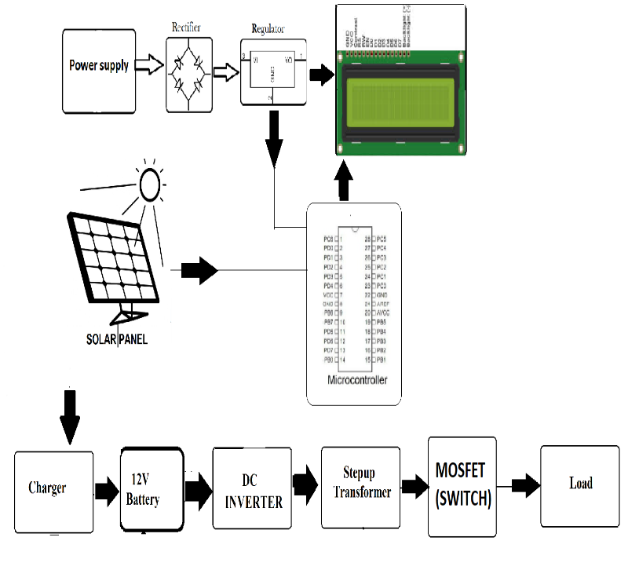

**Advantages and Applications:**

More efficient transmission and distribution of electricity.

• Quicker restoration of electricity after power outages.

• Increased and efficient integration of variable renewable energy system.

• It is inexpensive easy to design.

• It has inbuilt battery charging circuit to charge using mains.

• It is used in homes, office, etc.

• Solar inverter has constantly assisted us in reducing global warming and greenhouse effect, as the solar energy usage in photovoltaic systems mainly depends on the inverter.

• Solar inverter saves our money by reducing our electricity bills or totally eliminates them, in addition it is considered as ac power source to sell electricity to electric power utility and other users.

• Solar inverter is cost effective when comparing with diesel generators.

**Conclusion:**

Sun, being source of clean, pollution-free energy and Photovoltaic power production is gaining more significance as a renewable energy source due to its various advantages. The advantages include everlasting production scheme, ease of maintenance, and direct sunbeam to electricity conversion. However the high cost of installations still forms an obstacle for this technology. Moreover the PV panel output power fluctuates as the weather conditions, such as the luminosity of the solar beam, cell temperature etc. The desired design of the system will produce the desired output of the project. The inverter will supply an AC source from a DC source. The project described is valuable for the promising potentials it holds within. Ranging from the long run economic benefits to the important environmental advantages. This work will mark an attempt and contribution in the field of renewable energy and can be implemented extensively.[11] The described design of the system will produce the desired output of the project. The inverter will supply an AC source from a DC source. The project described is valuable for the promising potentials it holds within, ranging from the long run economic benefits to the important environmental advantages.. With the increasing improvements in solar cell technologies and power electronics, such projects would have more value added and should receive more attention and support.

**Future Scope**:

As whole world is facing a problem of global warming and energy crisis, our project will help to reduce these problems by using solar energy to generate electricity. Solar energy is an infinite source of energy. Main motto of our project is to promote use of renewable energy sources. This project is most useful in our life because in this project one time investment fixed on life time.In future one day nonrenewable energy will end then we will use to the renewable energy. The solar inverter made by us is just a prototype for making future projects which incorporate advanced technologies like micro controlled solar tracking, charge control, etc. this is to show that solar inverters are very cheap and easy to install so that the energy demands are shifted on using renewable sources of energy.

**References:**

[1] Nidhi Patil, Neha Sase, Kunal Chaudhari, Prof. Rehab Upletawala,” Dual Axis Solar Tracking Using LDR With Inverter” International Research Journal Of Engineering And Technology (IRJET) E-ISSN: 2395-0056 Volume: 08 Issue: 05

[2] Swakhar Shome,Souhardya Chakravorty, Subhajit Pal,”Hybrid Inverter With Solar Battery Charger”

[3] Prof. Swapnil Namekar , Fardeen Khan, “Hybrid Inverter With Solar Battery Charger “IJCRT | Volume 10, Issue 11 November 2022 | ISSN: 2320-2882

[4]Rashmi Prof. Ganesh Manasali Shraddha ,” Solar Based Inverter Using Microcontroller” 2022 Ijcrt | Volume 10, Issue 7 July 2022 | Issn: 2320-2882

[5]Prajakta S. Kasulakar Chetan B. Deth.” Single Phase Inverter Using Pwm Technique” International Journal Of Engineering Applied Sciences And Technology, 2020 Vol. 4, Issue 10, Issn No. 2455-2143

[6] G. Nagaraju, A. Satish Kumar , K. Naresh , T. Amar Kiran,” Hybrid Power Generation System With Inverter Using Android Based Load Control”

[7] B. Ravi Teja,Dr. G. Jayakrishna,Akhib Khan Bahamani,” Hybrid Inverter With Solar Battery Charging” **Journal Of Emerging Technologies And Innovative Research**

[8] Srashti Layyar, Tushar Saini, Abhishek Verma, Ashwani Kumar,” **Hybrid Inverter With Wind And Solar Battery Charging** ,Journal Article // [International Journal Of Engineering And Technical Research](https://www.neliti.com/journals/ijetr)

July 2018

[9] Mrunali Patole, Deepali Palange, Aishwarya Gavali, Sphoorti Shivarai,” Hybrid Inverter With Solar Battery Charging System”, International Journal Of Research Publication And Reviews Journal Homepage: Www.Ijrpr.Com Issn 2582-7421

[10] Shamik Chattaraj , Rajeev Kumar , Sajal Maity,” Hybrid Inverter Using Solar CHARGER” International Journal Of Recent Research In Electrical And Electronics Engineering (IJRREEE) Vol. 5, Issue 2