**FOOD SAFETY TRACEABILITY SYSTEM FOR PEOPLE’S HEALTH USING BIG DATA**

**V.N.S. Manaswini1, R. Kranthi Kumar Reddy2, S. Akhil Kumar3, SK. Jaheer Hussain4, B. Sandeep5, Y. Mani Kumar6**

1Assistant Professor, Computer Science Department, Siddhartha Institute of Technology and Science, Hyderabad, Telangana, India

2,3,4,5,6Student, Computer Science Department, Siddhartha Institute of Technology and Science, Hyderabad, Telangana, India

**ABSTRACT**

The non-stop development of the social profitable system, has stimulated a growth in the standard of abiding and multiplied the demand for input preceding in the call for high- quality and secure food has continued to boom. The so- called refections safety approach that the food that people eat below sure situations will now not damage mortal health. common refections safety incidents have stressed the soberness of my country's food safety problems and exposed loopholes in my united States’s food safety supervision. Inside the environment of epidemic forestallment and control, refections safety shadowing, statistics analysis and food protection traceability have come to be redundant critical. at the same time, the most pivotal reason for refections protection troubles is deficient, opaque, and asymmetric statistics. The most abecedarian way to clear up these problems is to do an excellent process of traceability, and establish an affordable and reliable refections protection traceability system. The traceability system is presently a vital manner to make sure food quality and protection and resolve the extremity of trust between consumers and the request. studies on refections safety traceability systems primarily grounded on massive records, synthetic intelligence and the internet of factors gives ideas and ways to clear up the problems of low credibility and delicate statistics garage in the mileage of conventional traceability structures. in this exploration, the refections safety traceability system grounded on huge records and the internet of factors guarantees the integrity, trustability and safety of traceability information from a specialized degree. that's a important answer for enhancing the credibility of traceability records, icing the integrity of data, and optimizing the data garage shape.

**Keywords:** Big data, Food safety, Traceability system, Food safety problems, Two- dimensional law Technology.

1. **INTRODUCTION**

As the worldwide new crown contagion( COVID- 19) epidemic intensifies, there are more and more cases of COVID- 19 spreading via bloodless chain logistics channels. COVID- 19 has end up the maximum essential source of pitfalls to food safety in the bloodless chain logistics system.( 1) indeed though the overall forestallment and manage state of affairs of our use’s new nimbus contagion pneumonia epidemic continues to ameliorate, the bettered spread of the remote place’s epidemic has led to the domestic epidemic forestallment state of affairs of" foreign import and inner forestallment" remains violent. in the environment of epidemic forestallment and manage, food protection monitoring, records analysis, and refections protection traceability have come redundant critical.( 2) substantially for cold chain food imported from foreign places, each food needs to be covered and traced to save you the spread of COVID- 19 contagion and guard the health and safety of the population.

Thus, the establishment of a secure and dependable food safety traceability operation system is an critical demand of the society and the people, and it's also an effective manner to unnaturally break thepost-epidemic technology and guard the health of the crowd. The food protection traceability control system is primarily grounded on motorized identification and data technology to integrate information in the entire chain of refections manufacturing, recycling, garage, transportation and deals.( 3,4)

The development of automatic data period device represented via detectors and wise terminal recognition has enabled speedy enhancement of technology together with notion, size and monitoring primarily grounded at the net of effects( IoT), artificial intelligence and huge records generation. The net of factors and large statistics generation are profoundly converting people's product and actuality, and their significance has gone beyond the compass of communication period( 5,6). The internet of factors is using information technologies conforming of the net and detectors to attach humans and effects together, so that effects may be connected, forming a brand-new community of intelligent sharing of data. artificial intelligence has the massive benefit of simplifying the procedure of the use of statistics, and it may play a big function in regions including refections safety.( 7)

Massive data technology is a fact processing and alertness model primarily grounded on pall computing and distributed computing. it can realize correct vaticination or analysis via the integration and sharing of data and the mileage of reasonable fine algorithms.(8) In refections traceability, the successful mileage of huge information needs to be combined with technologies similar as automatic identification and community advertisement, these 5 main hyperlinks play a part through records seize, information garage, statistics processing, information mining, and information know- how display.

Big data realizes the aggregation and digital operation of records, optimizes the allocation of data means, that's conducive to the consummation of go- near andcross-area supervision that's tough to intrude thru in factual operation. (9) In current times, large data has been considerably used within the agrarian enterprise and has crop as an important force in promoting the metamorphosis of traditional husbandry.

At the equal time, because refection’s exceptional is nearly related to all hyperlinks of manufacturing and circulate, the development of a refection’s great and protection traceability system have to acquire strong help and collective cooperation from upstream and downstream affiliated associations. (10,11) the use of the internet of effects generation to construct a food safety traceability system will mainly reduce the issue of collaboration.

In this environment, data technology is used to perform food safety traceability inside the environment of put over- epidemic situations, and IoT and big information technology are applied to the mess’s protection traceability control machine within the post-epidemic technology (12). icing food safety in the entire manner of food manufacturing, force distribution and deals has come a hot studies issue in the area of refection’s protection for mortal being’s health.The traditional traceability machine is incorporated with the net of factors and huge information period to fete the traceability of the entire agrarian manufacturing process of agrarian and side- line products which include planting, processing, checking out, warehousing, transportation, and income.( 13) This assured that the source of agrarian and side- line products can be traced, go with the inflow can be traced, data may be inquired, and duties can be held responsible to cover mortal being’s fitness and refection’s protection.

Big data technology is a data processing and operation model grounded on pall computing and distributed computing. It can realize accurate vaticination or analysis through the integration and sharing of data and the operation of reasonable fine algorithms. In food traceability, the successful operation of big data needs to be combined with technologies similar as automatic identification and network communication, these five main links play a part through data prisoner, data storehouse, data processing, data mining, and data knowledge display. (14,15) The refection’s protection traceability system erected in this exploration has a perceivable cognizance fashion, traceability of the force, and early caution of troubles. this is of extremely good significance for enhancing the control stage of China's refection’s excellent and safety, precluding food safety injuries, retaining the stability of force and demand, and making sure people's fitness and protection.

1. **Data Collection and Data Processing of Food Safety Traceability Using Big Data**

Inside the food safety traceability gadget, multiple information forms inclusive of numbers, images, and videos are concerned. with the intention to extract powerful information from it, it is essential to use diverse data mining gear and strategies to filter and examine big amounts of statistics in step with particular character desires, on the way to realize the accuracy and personalization of records, and provide users with accurate information aid [11]. There are three varieties of records change structures used on this study:

**a. Python social auth**

A social account authentication/registration mechanism that supports multiple development frameworks which include Django, Flask, Web-py, etc. It presents authorization and authentication aid for extra than 50 provider companies, consisting of Google, Twitter, Sina Weibo and different websites, and the configuration is simple.

**b. Django OAuth Toolkit**

It can assist Django initiatives enforce information and logic OAuth2 capabilities, and may be flawlessly integrated with the Django rest framework.

1. **Database Design**

The database layout of this studies in particular includes ancient information database, actual-time tracking database and web crawling database. The historical database is mainly used for historical statistics query and show, and it also affords records aid for next information evaluation.

1. **Data Processing**

After obtaining a large number of meals-related records, this research constructed a small seek engine for meals. It takes Python’s open sources internet site framework Django as the main frame, and makes use of elastic search era for information garage. It has the traits of clear classification, low article repetition price, robust pertinence, and no advertisements [13]. it can offer users with correct and fast statistics acquisition channels. Elastic search is a distributed database that permits more than one server to function on the identical time, and every server can run more than one Elastic search times. The shape of a small search engine internet site is shown in figure 3B.

The first is the construction of the version layer. according to the layout of information stored in elastic seek, three version training inherited from the doc kind class in elastic search_ dsl are installed, specifically commodity version class, fit for human consumption version magnificence and product version elegance. Corresponding fields are installed consistent with the particular necessities of various types. the second one is the construction of the View layer. in this research, View is especially answerable for the provision of search hints and the key-word search after customers click on the quest and go back to the end result web page. using the Request. GET approach to get the keyword entered via the user and the category of the keyword.After a series of formatting, the keywords are despatched to elastic search in keeping with unique classes, and the back json string is received, and the json string is parsed and looked after, and back to the unique page for show. finally, the development of the Template layer [14]. These studies simplest advanced a small seek engine, so the primary web page best has a search page and an end result show page.

1. **Data Analysis Process**

Machine learning (ML for short) is a branch of synthetic intelligence, which objectives to feed various new policies and movement reference information to the device in line with installed steps. These statistics can be routinely found out with the aid of the gadget to continuously collect experience and obtain “self-development”. synthetic intelligence (AI) refers to the capability of machines to constantly research and observe flexibly in line with various scenarios in actual existence and actual-time facts. Its goal is to independently perform sure precise and interrelated obligations via imitating human behaviour. to be able to reap the desired reason, AI can work collaboratively with a selection of software integration, verification mechanisms, and pattern popularity methods. As stated earlier, after a positive amount of information has been collected, these studies designed a set of rules for the type of various data of rice.

1. **INSTALLATION & SETUP**

**Step 1**: Install python of version 3.6.2 and install pip of version 9.0.1. To check your python version open command prompt and type “python --version”



**Step 2**: Install WampServer version 2.4. After installation import database file to the WampServer and run the server

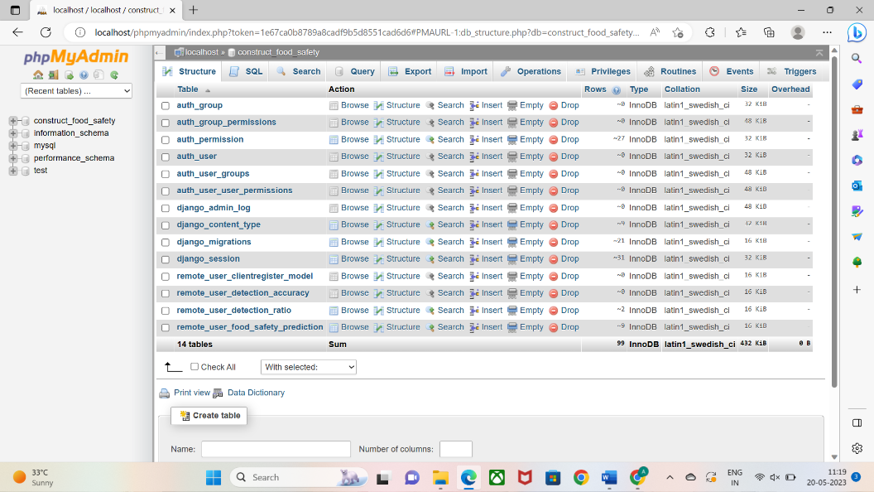

**Step 3**: Install python libraries or modules which are required for this application. The libraries or modules required for this application are:

>>> pip install xlwt

>>> pip install openpyxl

>>> pip install sklearn

>>> pip install pandas

>>> pip install numpy

>>> pip install seaborn

>>> pip install scikit-learn==0.22.2.post1

>>> pip install sklearn-extensions==0.0.2

>>> pip install pyswarms==1.1.0

Open command prompt and install these libraries or modulesThe installation and setup of the application is completed next implementation.

1. **IMPLEMENTATION**
2. **Implementation**

**Step 1**: Open the folder where you have saved the code in your computer



**Step 2**: Then type cmd on the address bar



**Step 3**: Then type “python manage.py runserver”

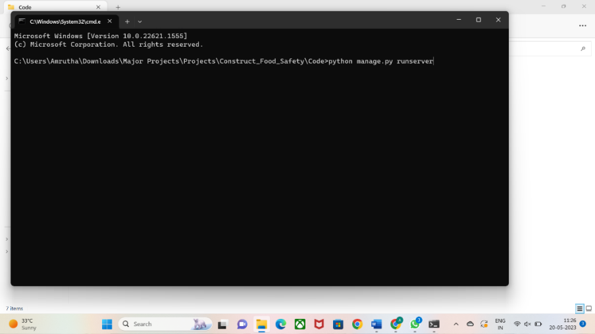

**Step 4**: After typing this you will get a link like this <https://127.0.0.1:8000/> click on it then the application is excuted.

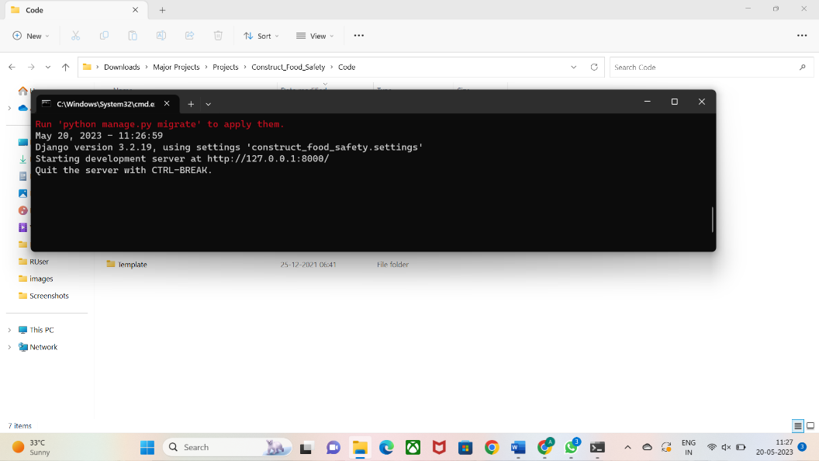

1. **Output Analysis**

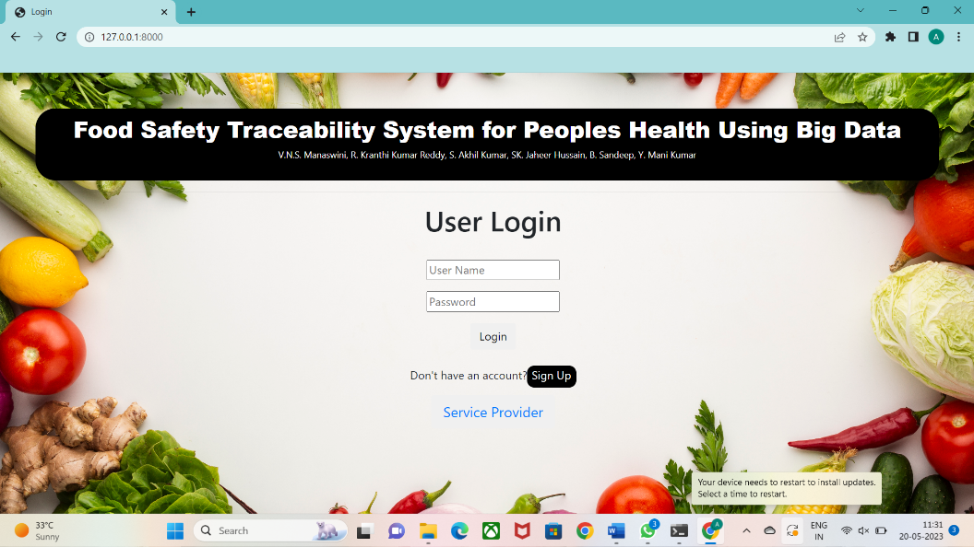

**Fig 5B.1** User Login Interface

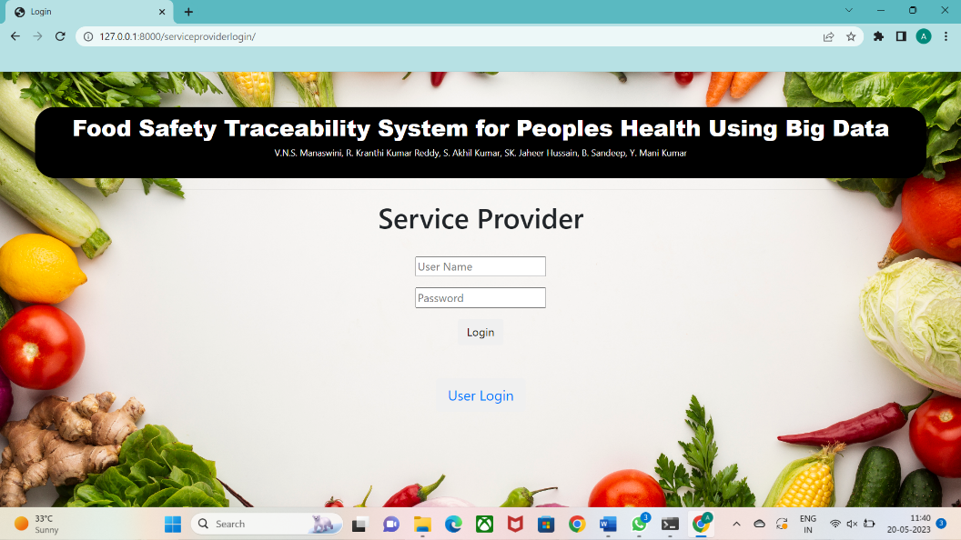

**Fig 5B.2** Service Provider Interface

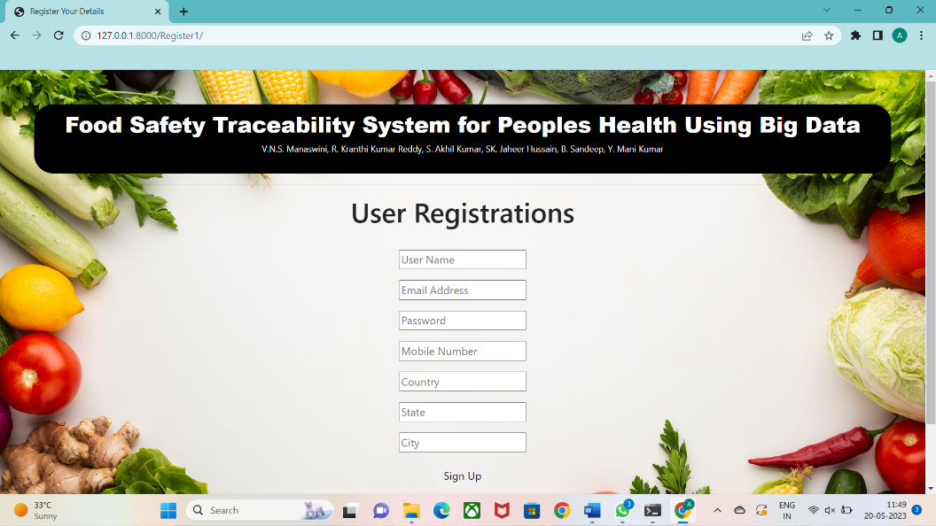

**Fig 5B.3** User Registration Interface

1. **CONCLUSION**

In this paper the context of epidemic prevention and manipulate, strengthening food protection facts evaluation primarily based on the software of food safety traceability generation can successfully enhance the effect of meals safety management, which is conducive to the improvement of epidemic prevention and manipulate, and has realistic charge for the answer of destiny food safety issues in China as an entire. in case you need to higher protect person’s existence, health and safety. using internet of things era to alter food protection can effectively scale back the emergence of predominant meals safety incidents. furthermore, the problem may be identified extra actual-time and efficaciously, and the source of the hazard may be speedy identified, just so the excellent of the food is more guaranteed. this could have a large impact on the meals supply chain. at the same time, below the sensible monitoring of massive data, it's miles tough for corporations within the food supply chain to tamper with the facts, making sure the authenticity of the data. Combining large statistics, the net of factors, the internet and the food traceability device will honestly accumulate openness, transparency, and completeness of records, and strictly manipulate the numerous steps of the food traceability tool, simply so the price of the meal’s traceability device can be absolutely found out. It has to start with completed the traceability necessities for the whole gadget of food products, and additionally supplied community statistics records for food-related industries. The implementation of traceability isn't always best a sensible want to ensure food protection, however additionally the primary method and destiny meals protection measures. through combing and analysing the triumphing food protection traceability system, drawing on advanced domestic and foreign enjoy and achievements, strategically, systematically and structurally, set up a unified and standardized meals safety traceability preferred gadget, and installation a meals safety traceability tool for the government and businesses provide standardized technical steering, it moreover presents widespread aid for the repute quo of third-celebration certification, thereby improving the quantity of food protection traceability and those’d health.

1. **REFERENCES**
2. J. Wang,H. Yue, andZ. Zhou, ‘‘ An bettered traceability system for food quality confidence and evaluation rested on shaggy type and neural network, ’’ Food Control,vol. 79,pp. 363 – 370,Sep. 2017.
3. Q. Lin,H. Wang,X. Pei, andJ. Wang, ‘‘ Food security traceability system rested on blockchain and EPCIS, ’’ IEEE Access,vol. 7,pp. 20698 – 20707, 2019.
4. G Alfian,M. Syafrudin,U. Farooq,M.R. Ma’arif,M.A. Syaekhoni,N.L. Fitriyani,J. Lee, andJ. Rhee, ‘‘ perfecting forcefulness of RFIDbased traceability system for perishable food by applying IoT detectors and machine knowledge model, ’’ Food Control,vol. 110,Apr. 2020,Art.no. 107016.
5. F. Liu,Y. Wang,Y. Jia,S. Hu,L. Tu, andC. Tang, ‘‘ The egg traceability system rested on the videotape prisoner and wireless networking technology, ’’Int.J.SensorNetw.,vol. 17,no. 4,pp. 211 – 216,Apr. 2015.
6. X. Xiao,Z. Fu,L. Qi,T. Mira, andX. Zhang, ‘‘ Development and evaluation of an exceptional traceability system for frozen tilapia fillet processing, ’’J.Sci.FoodAgricult.,vol. 95,no. 13,pp. 2693 – 2703,Oct. 2015.
7. M.M.AungandY.S. Chang, ‘‘ Traceability in a food force chain security and quality perspectives, ’’ Food Control,vol. 39,pp. 172 – 184, May 2014.
8. E. Abad,F. Palacio,M. Nuin,A.G.D. Zárate,A. Juarros,J.M. Gómez, andS. Marco, ‘‘ RFID smart marker for traceability and cold chain monitoring of victuals Demonstration in an international fresh fish logistic chain, ’’J.FoodEng.,vol. 93,no. 4,pp. 394 – 399,Aug. 2009.
9. T. Bosona andG. Gebresenbet, ‘‘ Food traceability as an native portion of logistics operation in food and agrarian force chain, ’’ Food Control,vol. 33,no. 1,pp. 32 – 48,Sep. 2013.
10. F. Tian, ‘‘ A force chain traceability system for food security rested on HACCP, blockchain & Internet of goods, ’’ in Proc. Int. Conf. ServiceSyst.ServiceManage.,Jun. 2017,pp. 1 – 6.
11. J.F. Galvez,J.C. Mejuto, andJ. Simal- Gandara, ‘‘ unborn exceptions on the use of blockchain for food traceability analysis, ’’ TrACTrendsAnal.Chem.,vol. 107,pp. 222 – 232,Oct. 2018.
12. G.P. Danezis,A.S. Tsagkaris,F. Camin,V. Brusic,andC.A. Georgiou, ‘‘ Food authentication ways, trends & arising approaches, ’’ TrACTrendsAnal.Chem.,vol. 85,pp. 123 – 132,Dec. 2016.
13. M. Thibaud,H. Chi,W. Zhou, andS. Piramuthu, ‘‘ Internet of goods( IoT) in high- trouble terrain, health and security( EHS) assiduity A complete review, ’’Decis.SupportSyst.,vol. 108,pp. 79 – 95,Apr. 2018.
14. K. Salah,N. Nizamuddin,R. Jayaraman, andM. Omar, ‘‘ Blockchain- rested soybean traceability in agrarian force chain, ’’ IEEE Access,vol. 7,pp. 73295 – 73305,Aug. 2019.
15. M. Lv,Y. Liu,J. Geng,X. Kou,Z. Xin, andD. Yang, ‘‘ Engineering nanomaterials- rested biosensors for food security discovery, ’’BiosensorsBioelectron.,vol. 106,pp. 122 – 128, May 2018.
16. K. Behnke andM. Janssen, ‘‘ Boundary conditions for traceability in food force progressions exercising blockchain technology, ’’Int.J.Inf.Manage.,vol. 52,Jun. 2020,Art.no. 101969.