**CONTROL PLAN FOR AN INDEPENDENT WIND ENERGY SYSTEM**

**U. Srilatha1, D. Aravind2*, P. Manisagar3, MD Rizwan Ahmed4, Abdul Ahmed5, B. Ravali6**

1 Assistant Professor, Electrical& Electronics Engineering, Nigama Engineering College.

2, 3,4,5,6, UG Scholar, Electrical& Electronics Engineering, Nigama Engineering College. TS. India

**ABSTRACT**

Conventional sources are mainly reliant on current energy needs. However, the focus now is on renewable energy sources because conventional sources are becoming more and more scarce and expensive. Wind energy is regarded as one of the most established alternative energy sources currently accessible. The wind energy conversion system (WECS) is presently used to address both grid-connected and stand-alone load needs since it has a competitive cost for electricity generation. However, wind flow is sporadic by nature. Power supply continuity is ensured by using proper backup storage technologies. In order to meet the demands of a 3-kW stand-alone dc load representing a base telecom station, a 4-kW hybrid wind and battery system's viability is examined in this article provides controlled charging and discharging of batteries, a charge controller for battery banks is created using tracking of the turbine maximum power point and battery state of charge. The pitch control approach ensures the mechanical security of the WECS. Both control strategies are combined, and their effectiveness is tested in MATLAB/SIMULINK using a variety of load and wind profiles.

**Keywords:** Maximum power point tracking (MPPT), pitch control, state of charge (SoC), wind energy conversion system (WECS).

1. **INTRODUCTION**

The ever-increasing demand for energy is currently being met by renewable sources due to the depletion of traditional supplies and concern over environmental deterioration [1]. Wind energy is seen as one of the promising sources of renewable energy for the future [3] due to its comparatively low cost of electricity production [2]. However, wind flow is stochastic by nature. Therefore, in-depth laboratory testing is required to create an effective control strategy for wind energy conversion systems (WECS). stand-alone loads are powered by renewable sources of energy. With this renewed interest in wind technology for stand-alone applications, a great deal of research is being carried out for choosing a suitable generator for stand-alone WECS. A detailed comparison between asynchronous and synchronous generators for wind farm applications is made in [4]. The major advantage of asynchronous machines is that the variable speed operation allows extracting maximum power from WECS and reducing the torque fluctuations [5]. An induction generator with a lower unit cost, inherent robustness, and operational simplicity is considered as the most viable option as a wind turbine generator (WTG) for off-grid applications [6]. However, the induction generator requires capacitor banks for excitation at isolated locations. The excitation phenomenon of a self-excited induction generator (SEIG) is explained in [5]– [7]. The power output of the SEIG depends on the wind flow which by nature is erratic. Both amplitude and frequency of the SEIG voltage vary with wind speed. Such arbitrarily varying voltage when interfaced directly with the load can give rise to flicker and instability at the load end. So, the WECS are integrated with the load by power electronic converters in order to ensure a regulated load voltage [8]. Again, due to the intermittent characteristics of wind power, a WECS needs to have an energy storage system [9]. An analysis of the available storage technologies for wind power applications is made in [9] and [10]. The advantage of battery energy storage for an isolated WECS is discussed in [10]. With battery energy storage it is possible to capture maximum power [11] from the available wind. A comparison of several maximum power point tracking (MPPT) algorithms for small wind turbines (WT) is carried out in [12] and [13]. In order to extract maximum power from WECS the turbine needs to be operated at optimal angular speed [13]. However, [11] do not take into account the limit on maximum allowable battery charging current nor do they protect against battery overcharging. In order to observe the charging limitation of a battery a charge controller is required. Such a charge control scheme for battery charging for a stand-alone WECS using MPPT is explained in [14]. However, in this paper also the maximum battery charging current is not limited. The dis- continuous battery charging current causes harmonic heating of the battery. The terminal voltage instead of the state of charge (SoC) is used for the changeover from current mode to voltage mode. Also, the MPPT implementation is highly parameter-dependent and will be affected by variations of these parameters with operating conditions. Moreover, as the wind speed exceeds its rated value, the WT power and speed need to be regulated for ensuring mechanical and electrical safety [15]. This is achieved by changing the pitch angle to the required value [16]. The structure of the essay is as follows. In Section II, the power converter topology and a brief description of the hybrid wind-battery system that powers an off-gird dc load are provided. Section III discusses the control strategy that consists of the charge controller for the battery and the pitch controller for the turbine. The results of simulating the hybrid system with various wind profiles and load fluctuations are reported in Section IV, validating the effectiveness of the suggested control logic. The paper is concluded in Section V.

1. **INDEPENDENT WIND ENERGY SYSTEM**

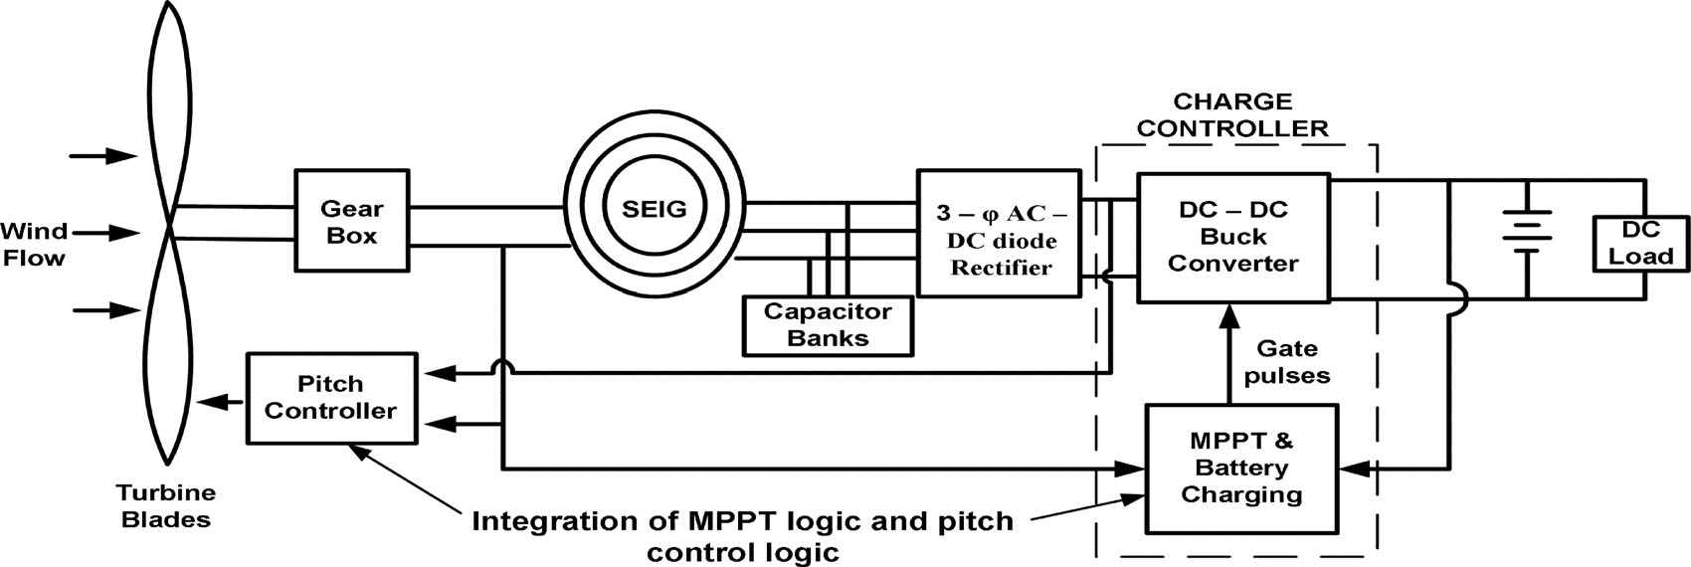The wind flow is erratic in nature. Therefore, a WECS is integrated with the load by means of an ac–dc–dc converter to avoid voltage flicker and harmonic generation. The control scheme for a stand-alone hybrid wind-battery system includes the charge controller circuit for battery banks and pitch control logic to ensure WT operation within the rated value. The control logic ensures effective control of the WECS against all possible disturbances

Fig. 1. Layout of Independent hybrid wind–battery system.

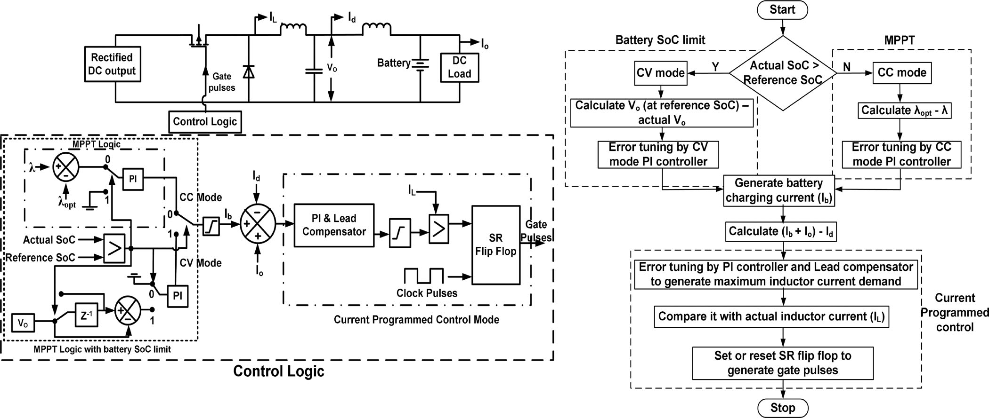

**Fig. 2. Block schematic and flowchart of the charge controller circuit for battery.**

1. *Charge Controller for the Battery Bank*

This section discusses in detail the development of a charge controller circuit for a 400 Ah, C/10 battery bank using a dc–dc buck converter in MATLAB/SIMULINK platform. Generally, the batteries are charged at C/20, C/10, or C/5 rates depending on the manufacturer’s specification where C specifies the Ah rating of battery banks. So, the battery bank system considered in the design can be charged at 20, 40, or 80 A. But, in this paper, C/10 rate (i.e., 40 A) for battery charging is chosen. However, the current required for charging the battery bank depends on the battery SoC. A typical battery generally charges at a constant current (CC), i.e., C/10 rate mode till battery SoC reaches a certain level (90%–98%). This is referred to as CC mode of battery charging. The CC mode charges the battery as fast as possible. Beyond this SoC, the battery is charged at a constant voltage (CV) which is denoted as CV mode of battery charging in order to maintain the battery terminal voltage.

1. *Control Strategy*

The implementation of the charge control logic as shown in Fig. 2 is carried out by three nested control loops. The outermost control loop operates the turbine following MPPT logic with battery SoC limit. To implement the MPPT logic, the actual tip speed ratio (TSR) of the turbine is compared with the optimum value. The error is tuned by a PI controller to generate the battery current demand as long as the battery SoC is below the CC mode limit. Beyond this point, the SoC control logic tries to maintain constant battery charging voltage. This in turn reduces the battery current demand and thus prevents the battery bank from overcharging. The buck converter inductor current command is generated in the intermediate control loop. To design the controller, it is essential to model the response of the battery current (*Ib* ) with respect to the inductor current (*IL* ).

1. **MODES OF BATTERY CHARGING**
2. *CC Mode of Battery Charging*

In CC mode, the battery charging current demand is determined from the MPPT logic. MPPT is implemented by comparing the actual and optimum TSR (*λ*opt). The error is tuned by a PI controller to generate the battery charging current as per the wind speed. In this mode, the converter output voltage rises with time while the MPPT logic tries to transfer as much power as possible to charge the batteries. The actual battery charging current that can be achieved does not remain constant but varies with available wind speed subject to a maximum of C/10 rating of the battery. The battery charging current command has a minimum limit of zero. In case the wind speed is insufficient to supply the load even with zero battery charging current the inductor current reference is frozen at that particular value and the balance load current is supplied by the battery.

1. *CV Mode of Battery Charging*

In the CC mode, the battery voltage and SoC rise fast with time. However, the charge controller should not overcharge the batteries to avoid the gasification of electrolytes [14]. As a result, once the battery SoC becomes equal to the reference SoC the controller must switch over from CC mode to CV mode. In CV mode, the battery charging voltage is determined from the buck converter output voltage (*Vo)*. The value of the converter voltage when the battery SoC reaches 98% is set as the reference value and is compared with the actual converter output voltage. The error in the voltage is then controlled by a cascaded arrangement of PI controller and lead compensator to generate the inductor current reference. It is then compared with the ac1`tual inductor current by a logical comparator to generate gate pulses in a similar way as described in Section A. In this mode, the converter output voltage is maintained at a constant value by the controller action. So, in CV mode the battery voltage and SoC rise very slowly with time as compared to CC mode. The battery charging current slowly decreases with time, since the potential difference between the buck converter output and battery terminal gradually reduces.

1. *Pitch Control Mechanism*

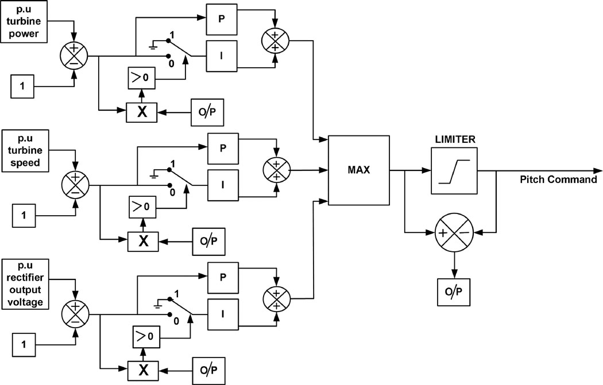The WT power output is proportional to the cube of wind velocity [15]. Generally, the cut-off wind speed of a modern WT is much higher compared to the rated wind speed [9]. If the WT is allowed to operate over the entire range of wind speed without the implementation of any control mechanism, the angular speed of the shaft exceeds its rated value which may lead to damage of the blades. So, it is very much essential to control the speed and power at wind speeds above the rated wind speed. This is achieved by changing the pitch angle of the blade. Such a mechanism is referred to as the pitch control of WT. The power coefficient (*Cp* ) versus TSR (*λ*) characteristics of the WT considered in this study for different pitch angles are shown. As examined from the characteristics, at a pitch angle of zero degrees the value of *Cp* is maxima. But the optimum value of the power coefficient reduces with an increase

Fig. 3. Pitch control scheme for a stand-alone WECS.

pitch angle. This happens because with an increase in blade pitch, the lift coefficient reduces which results in decreasing the value of *Cp* [15]. So, the pitch control mechanism controls the power output by reducing the power coefficient at higher wind speeds. Below the rated wind speed the blade pitch is maintained at zero degree to obtain maximum power. The pitch controller increases the blade pitch as the WT parameters exceed the rated value. The reduction in the value of *Cp* by pitching compensates for the increase in WT power output under the influence of higher wind speeds. Apart from regulating the WT parameters, it is also essential to control the output voltage of the ac–dc rectifier to avoid overvoltage conditions in the WECS. Hence, the pitch controller ensures that with desirable pitch command, the WT parameters and the rectifier output dc voltage are regulated within their respective maximum allowable limits to ensure the safe operation of the WECS.

1. *Pitch Control Scheme*

The pitch control scheme is shown in Fig. 3. As seen in the p.u. value of each input is compared with 1 to calculate the error. The errors are tuned by the PI controller. The “MAX” block chooses the maximum output from each PI controller which is then passed on to a limiter to generate the pitch command for the WT. The actual pitch command is compared with the limited value. The lower limit of the pitch command is set at zero. There arises an error when the actual pitch command goes above or below the specified limit. This is multiplied by the error obtained from each of the comparators. The product is compared with zero to determine the switching logic for the integrator. This technique is carried out to avoid integrator saturation. The pitch controller changes the pitch command owing to variations in turbine rotation speed, power, and output voltage of the rectifier, which ensures the safe operation of the WECS.

.

1. **RESULTS AND DISCUSSION**

A WECS needs to be efficient to ensure continuous power flow to the load. The effectiveness can be achieved by integrating the hybrid wind-battery system with suitable control logic. This includes the charge control logic and the pitch control logic. The charge controller regulates the charging and discharging

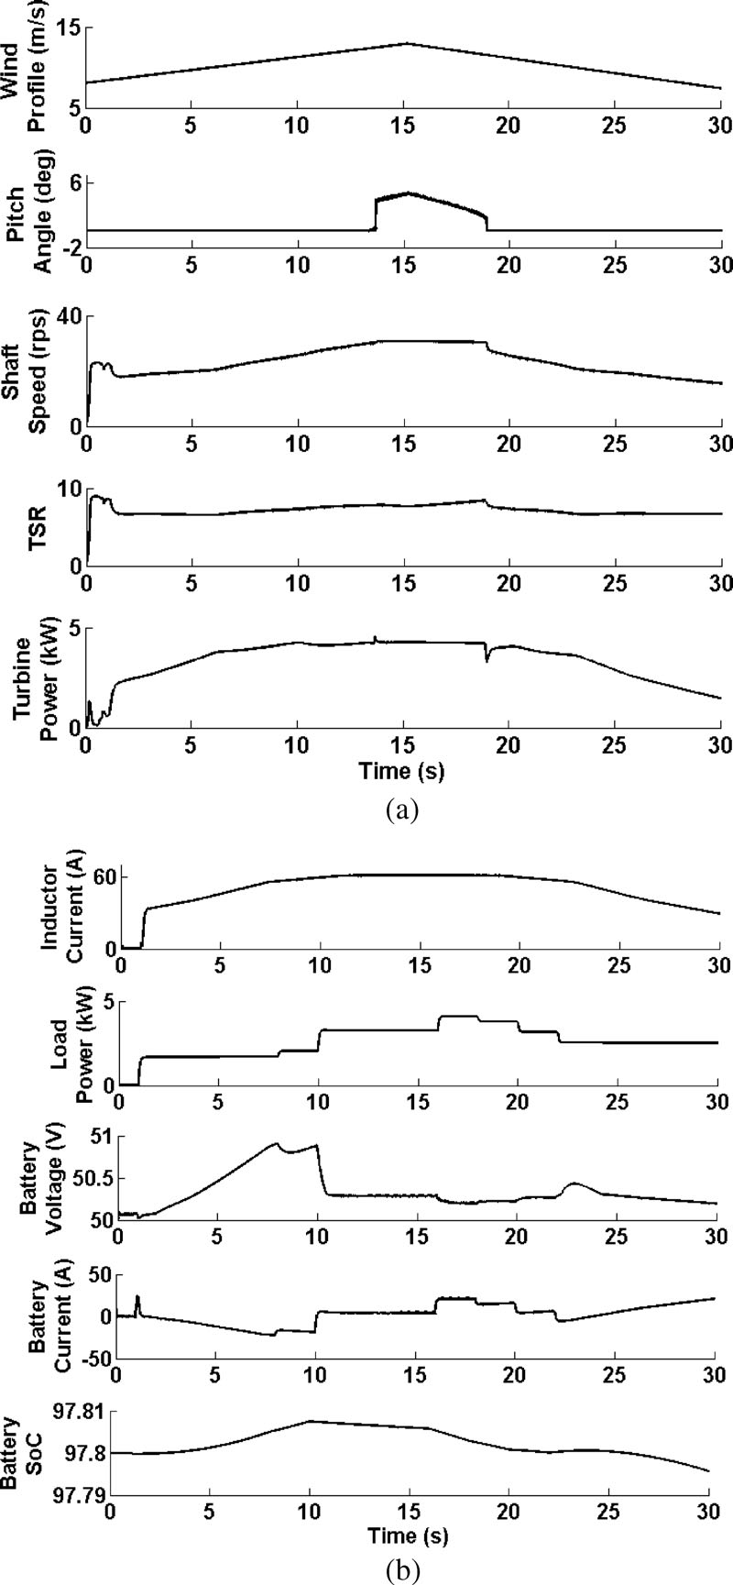

**Fig. 4.** (a) WT and (b) battery parameters under the influence of gradual variation of wind speed.

# 

**Fig. 5.** (a) WT and (b) battery parameters under the influence of step variation of wind speed.

# 

**Fig. 6.** (a) WT and (b) battery parameters under the influence of arbitrary variation of wind speed.

**5. CONCLUSION**

The power available from a WECS is very unreliable in nature. So, a WECS cannot ensure uninterrupted power flow to the load. In order to meet the load requirement in all instances, a suitable storage device is needed. Therefore, in this paper, a hybrid wind-battery system is chosen to supply the desired load power. To mitigate the random characteristics of wind, flow the WECS is interfaced with the load by suitable controllers. The control logic implemented in the hybrid setup includes the charge control of the battery bank using MPPT and pitch control of the WT for assuring electrical and mechanical safety. The charge controller tracks the maximum power available to charge the battery bank in a controlled manner. Further, it also makes sure that the battery’s discharge current is also within the C/10 limit. The current programmed control technique inherently protects the buck converter from the over-current situation. However, at times due to MPPT control the source power may be more as compared to the battery and load demand. During the power mismatch conditions**,** the pitch action can regulate the pitch angle to reduce the WT output power in accordance with the total demand. Besides controlling the WT characteristics, the pitch control logic guarantees that the rectifier voltage does not lead to an over-voltage situation. The hybrid wind-battery system along with its control logic is developed in MATLAB/SIMULINK and is tested with various wind profiles. The outcome of the simulation experiments validates the improved performance of the system.

**6.REFERENCES**

1. D. Sahin, “Progress and recent trends in wind energy,” *Progress in Energy Combustion Sci.*, vol. 30, no. 5, pp. 501–543, 2004.
2. R. D. Richardson and G. M. Mcnerney, “Wind energy systems,” *Proc. IEEE*, vol. 81, no. 3, pp. 378–389, Mar. 1993.
3. R. Saidur, M. R. Islam, N. A. Rahim, and K. H. Solangi, “A review on global wind energy policy,” *Renewable Sustainable Energy Rev.*, vol. 14, no. 7, pp. 1744–1762, Sep. 2010.
4. M. T. Ameli, S. Moslehpur, and A. Mirzale, “Feasibility study for replac- ing asynchronous genrators with synchronous generators in wind farm power stations,” in *Proc. IAJC – IJME, Int. Conf. Eng. Technol.*, Music City Sheraton, Nashville, TN, US, ENT paper 129Nov. 17–19, 2008.
5. G. K. Singh, “Self excited generator research—A survey,” *Electric Power Syst. Res.*, vol. 69, no. 2/3, pp. 107–114, 2004.
6. R. C. Bansal, “Three-phase self-excited induction generators: An overview,” *IEEE Trans. Energy Convers.*, vol. 20, no. 2, pp. 292–299, Jun. 2005.
7. S. C. Tripathy, M. Kalantar, and N. D. Rao, “Wind turbine driven self excited induction generator,” *Energy Convers. Manag.*, vol. 34, no. 8, pp. 641–648, 1993.
8. A. Chakraborty, “Advancements in power electronics and drives in inter- face with growing renewable energy resources,” *Renewable Sustainable Energy Rev.*, vol. 15, no. 4, pp. 1816–1827, May 2011.
9. F. D. Gonza´lez, A. Sumper, O. G. Bellmunt, and R. V. Robles, “A review of energy storage technologies for wind power applications,” *Renewable Sustainable Energy Rev.*, vol. 16, no. 4, pp. 2154–2171, May 2012.
10. N. S. Hasan, M. Y. Hassan, M. S. Majid, and H. A. Rahman, “Review of storage schemes for wind energy systems,” *Renewable Sustainable Energy Rev.*, vol. 21, pp. 237–247, May 2013.
11. A. M. D. Broe, S. Drouilhet, and V. Gevorgian, “A peak power tracker for small wind turbines in battery charging applications,” *IEEE Trans. Energy Convers.*, vol. 14, no. 4, pp. 1630–1635, Dec. 1999.
12. R. Kot, M. Rolak, and M. Malinowski, “Comparison of maximum peak power tracking algorithms for a small wind turbine,” *Math. Comput. Simul.*, vol. 91, pp. 29–40, 2013.
13. M. Narayana, G. A. Putrus, M. Jovanovic, P. S. Leung, and S. McDonald, “Generic maximum power point tracking controller for small-scale wind turbines,” *Renewable Energy*, vol. 44, pp. 72–79, Aug. 2012.
14. K. Y. Lo, Y. M. Chen, and Y. R. Chang, “MPPT battery charger for stand-alone wind power system,” *IEEE Trans. Power Electron.*, vol. 26, no. 6, pp. 1631–1638, Jun. 2011.
15. E. Hau, *Wind Turbines Fundamentals, Technologies, Application, Economics*, 2nd ed. New York, NY, USA: Springer, Dec. 2005.
16. H. Camblong, “Digital robust control of a variable speed pitch regulated wind turbine for above rated wind speeds,” *Control Eng. Practice*, vol. 16, no. 8, pp. 946–958, Aug. 2008.