**AIR CONDITIONING USING ENGINE EXHAUST GAS**

**Vaisagh P1, Sathil PT2,**

1P G Scholar, 2Assistant Professor

1Mechanical Engineering,

1Malabar College of Engineering and Technology, Thrissur, India

**ABSTRACT**

An absorption refrigerator is a refrigerator that uses a heat source to provide the energy needed to drive the cooling system. In this thesis, the energy from the exhaust gas of an internal combustion engine is used to power an absorption refrigeration system to air condition an ordinary vehicle. Here the air conditioning generator capable of extracting the waste heat of an engine without decrease in the overall efficiency of the engine. COP of the system can be increased by minimizing the cyclic thermal load. ANSOL software is conduct the transient thermal analysis on the evaporator coil.

**Keywords:** ANSOL Software, Waste Heat, Generator, Engine

1. **INTRODUCTION**

Air conditioning is the process of removing heat from controlled space or from a substance and moving it to a place where it is un objectionable. The primary purpose of air conditioning is lowering the temperature of the enclosed space or substance and then maintaining that lower temperature as compared to the surroundings. Cold is the absence of heat, hence in order to decrease a temperature, one should "remove heat", rather than "adding cold." The basic objective of developing a vapour absorption refrigerant system for cars is to cool the space inside the car by utilizing waste heat and exhaust gases from engine. The air conditioning system of cars in today’s world uses “Vapour Compression Refrigerant System” (VCRS) which absorbs and removes heat from the interior of the car which is the space to be cooled and further rejects the heat to be elsewhere. Now to increase an efficiency of car beyond a certain limit vapour compression refrigerant system resists it as it cannot make use of the exhaust gases from the engine. In vapour compression refrigerant system, the system utilizes power from engine shaft as the input power to drive the compressor of the refrigerant system. Hence the engine has to produce extra work to run the compressor of the air conditioning system thus utilizing extra power. This loss of power of the vehicle for air conditioning can be removed by using this type of air conditioning system. By using the VARS it does not require any additional amount of power, it use a power from the exhaust gas of the internal combustion engine. Then the overall efficiency can be increased. Here the COP value can be increased by minimizing the cyclic thermal load or temperature gradient.

1. **METHODOLOGY**

For this system we have considered vapor absorption system. This system is more useful and applicable to our system. The machine is to provide 40 liters capacity of air conditioning with the components. The air conditioning system obtained was modified in order to accommodate the waste heat fixing the generator tube to the exhaust pipe. The pipe coming from engine exhaust is connected to the one end of the generator tube and the other end of the generator tube is free to atmosphere. When the engine starts working the exhaust gases are made to pass through the generator where the heat is recovered, which later escapes in to atmosphere.

**SILENCER**

**ENGINE**

**AMMONIA REFRIGERATOR**

Fig 1

1. **LIST OF MATERIALS**

Table 1 List of materials

|  |  |  |
| --- | --- | --- |
| **PARTS** | **QTY.** | **MATERIAL** |
| Engine | 1 | 4 Stroke |
| Air conditioning setup | 1 | Ms |
| Blower fan | 1 | Aluminum |
| Generator | 1 | Silver |
| Heat exchanger | 1 | Copper |
| Fuel tank | 1 | Plastic |
| Frame | 1 | Mild Steel |
| Battery | 1 | 12v |

1. **CALCULATION**

Heat loss through the exhaust gas Volumetric efficiency = 0.8 to 0.9

Density of petrol= 0.7489 g/cc

Calorific value of petrol = 45.5 MJ/kg

Density of air fuel= 1.167

Capacity = 75cc

O/P power = 12.6 bhp at 3000 rpm

SFC = 22kg/kWh

mf = SFC*power

=220*12.6 =2772 g/h

=0.77g/s

Volume rate = VS*N = 0.75*10-4*1500 = .1125m3/min

ma = ηρnVs = 0.9*1.167*1500*0.75*10-4 =0.118 kg/min =0.0019kg/s

me =mf+ ma = 0.00077+0.0019 =0.00267 kg/s

Waste heat in engine, Qe = meCpΔT =0.00267*2.13*(336-30) = 1.740kj

Heat obtained in generator Qg = Qe*ε Let ε = 0.8

Qg = 1.74*0.8 = 1.392 kJ/s

Refrigerating effect is = 3.5 kJ/s

∴ COP = RE/Qg= 3.5/1.392 = 2.51

1. **SOFTWARE ANALYSIS**

Here we conducting the transient thermal analysis by using the ANSOL software. The aim of the analysis is to attain the thermal properties of the evaporator coil in VARS through fundamental understanding of thermal conductivity properties. The results obtained from this analysis are useful for the prediction of the thermal conductivity, temperature gradient, heat flux, cyclic thermal load in copper tube COP of the system. our aim is how to increase the COP value without changing the engine power. Here we consider a mesh having 3028 nodes and having 1234 elements and we conducting the transient thermal analysis on the nodes at various temperature.

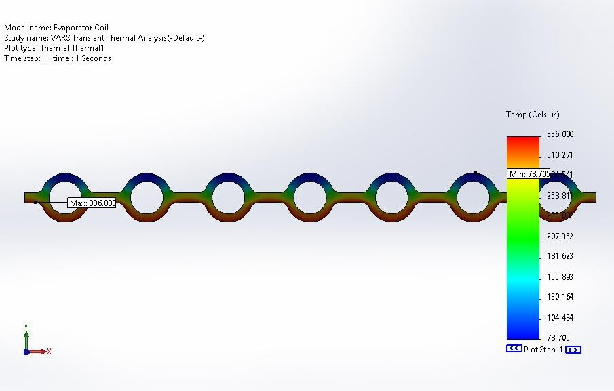

Fig 2 transient thermal analysis (time step:1 seconds)

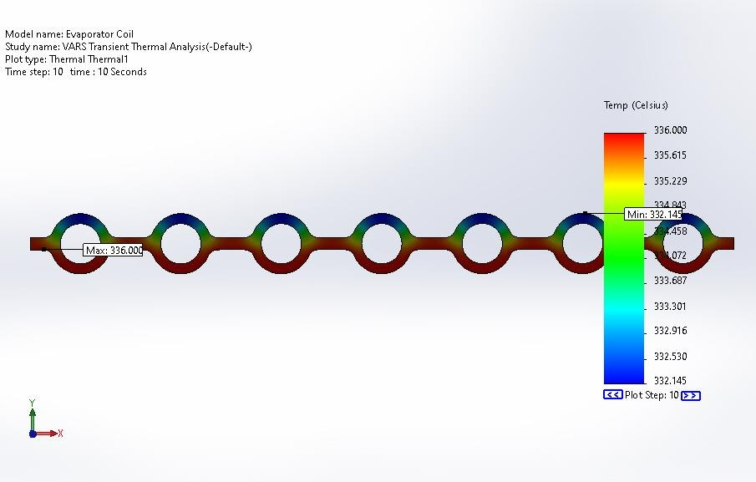

Fig 3 transient thermal analysis (time step:1seconds)

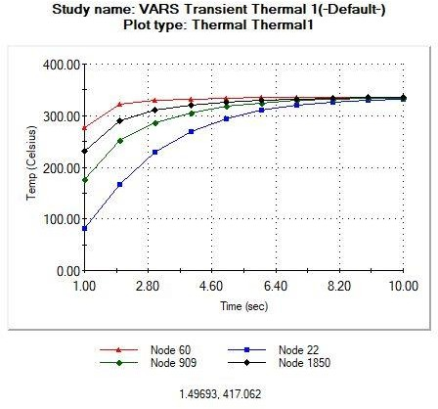

Fig 4 Temp vs Time graph(node 60, node 22, node 909, node 1850 )

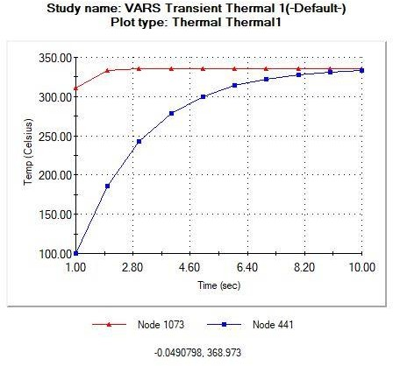

Fig 5 Temp vs Time graph (node 1073 and node 441)

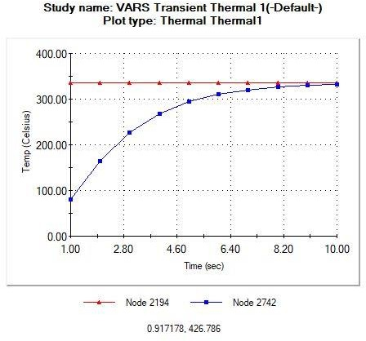

Fig 6 Temp vs Time graph (node 2194 and node 2742)

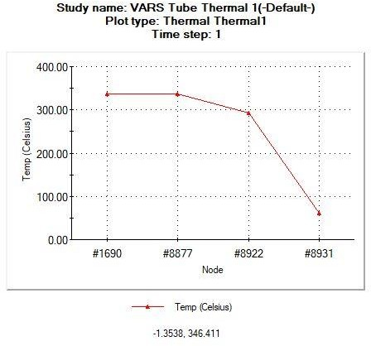

Fig 7 Temp vs Time graph

1. **RESULT AND DISCUSSIONS**

In the case of the auto mobile air conditioning system the cooling affect produced is sufficient. In vapour compression refrigeration system it requires an extra power. It will decrease the overall efficiency of the engine. But in vapour absorption refrigeration system the exhaust gas heat is used as a power. Therefore, if the air conditioning process is achieved without using the mechanical output internal combustion engines, there will be a net reduction in the emissions and fuel consumption.

In this thesis, we use a four strokes engine having 75cc, output power is 12.6Bhp. Here we get a COP value is 2.51. By the software analysis it is clear that the mass flow rate is increased by increasing the volume of the evaporator tube. Here the COP value is low compared to the actual system. This value can be increased by reducing the cyclic thermal load and heat flux.

1. **CONCLUSION**

An absorption is a type of refrigerator that uses a heat source. In this, thesis the energy the energy from the exhaust gas of an engine is used as the heat source. This arrangement does not require any external power. The variation of the friction factor has a better improvement in compared with copper tube with the Aluminum tube. Reynolds number is varied in the inner and outer surface of the evaporator tubes. By this effect mass flow rate and convective heat transfer coefficient is also increasing. The reduction in the cyclic heat flux and temperature gradient will increase the COP.

**ACKNOWLEDGEMENTS**

We would like to extend sincere gratitude towards the Mechanical engineering department of Malabar College of Engineering and Technology, Thrissur, India for providing us with the facilities required to complete this project work successfully.

1. **REFERENCES**

• Anand Sankar, Abhijith (2017) Utilization of exhaust heat from engine for air conditioning, International advanced research journal in science and engineering   
• K. Veera Raghavan, Utilization of exhaust gas for cooling truck cabin by VARS, International journal of latest trend in engineering and technology-2016

• S. Subramanian, Air conditioning using exhaust gas of automobiles, international journal of mechanical engineering and technology -2017

• Manish S, Mahesh, Automobile AC by utilizing exhaust gases, international journal for research in applied science-2015

• M Sampath Kumar, Karthik Payam, Generation of air conditioning using exhaust gases and cooling water of an automobile, international journal of trend in scientific research and development-2019

• Naik Mohammed Shoaib, Design of car air conditioning using exhaust gas, international research journal of engineering and technology-2020

• Manrique JA, Water refrigeration system, international journal of mechanical engineering and technology -2017

• Dhananjay, Chouhan Rahul, Automobile AC by utilizing waste heat, international journal for research in applied science

• M. Talbi A.B. Agnew b, *a academic of maritime studies, Tripoli-Libya b department of mechanical, materials and manufacturing engineering, university of new castle upon Tyne ne17ru, UK

• A proposed model for utilizing exhaust heat to run automobile air-conditioner, November 2006, Bangkok, Thailand.