Virtual Room design

Dhanush shetty

Department of Computer Application

PES University

Bengaluru, India

dhanushshetty712@gmail.com

Dr.Venna S

Department of computer application

PES University

Bengaluru,India

*Abstract***—This is an android based application that virtually shows items like sofas. cupboard etc. These things are virtually shown using google arcore.**

# Introduction

While building or constructing a home clients will have a different idea as to how they are going to set or display their room but on the other hand the design engineer will have a different idea as to how they will present the clients room. This will often lead to the client not accepting their room or changing the room design. Many times this happens as a result of the design engineers not being able to visualize their work to the clients. This application that is going to be built will be made on an android application.

As this is built for android application is be used and run almost everywhere so its quite portable which is a must for any kind of design engineers application, Not only that this application can also be used to further view the given product in the AR on the given platform. AR is what it seems like: reality, improved with intuitive advanced parts. The most usually utilized AR applications these days depend on smartphones to exhibit the carefully expanded world:

clients can enact a smartphone’s camera, view this present reality around them on the screen, and depend on an AR application to improve that world in quite a few different ways through computerized overlays. Various gadgets can show AR, and the rundown is just developing: screens, glasses, handheld and cell phones, and head-mounted shows. In understanding what AR is, it’s likewise essential to comprehend what it isn’t.

AR is definitely not a completely vivid encounter like computer generated simulation (VR). While computer generated reality expects clients to wear an extraordinary headset and maneuvers them into a totally computerized world, AR allows them to keep interfacing with the actual world around them.

## Augmented Reality is taken into consideration as a promising era. This era is providing an AR enjoy to the customers with immersive answers in numerous verticals. Likewise, Augmented Reality for the furnishings enterprise is introducing new possibilities for furnishings agencies. They can be capable of promoting their merchandise in a powerful way. AR is allowing the customers to get extra in-intensity info at the object. This is assisting the agencies in furnishings to convert their enterprise prospects

This application can also be upgraded to work with VR as well as with other OS as well.Augmented Reality is tied in with overlaying virtual enlivened objects onto true environmental factors. Clients with the assistance of cell phones can encounter reasonable perception whenever and anyplace. Utilizing AR virtual components, sounds, pictures, and recordings are a circuit in reality climate. Augmented Reality Applications come in two gatherings according to the use by any business brand

II Approach

A. Proposed Solution

The system built will be able to visually show the user how the given set of equipment will look on their homes by which users could serve this as a blueprint for the engineers to show. In this way, AR permits individuals to place 3D models of goods in a live climate to encounter what the room will seem like outfitted. Computer generated Reality, on the contrary hand, is a completely made up virtual setting that likewise rehearses 3D models of wares, and everything else too.It stays testing to pinpoint the invigorating advantages of AR for bequest engineers, planners, sellers, and purchasers. Be that as it may, the picture is clearer in the round of marketing and selling a business, where AR innovation is currently becoming far reaching.

B. AR Core

AR core is one of the main frameworks via which the elements are placed virtually. This ARCore is an official release from Google and this can be integrated to work with any system as needed.ARCore is Google’s foundation for building expanded reality encounters.

Utilizing different APIs, ARCore empowers your telephone to detect its current circumstance, figure out the world and connect with data. A portion of the APIs are accessible across Android and iOS to empower shared AR encounters. ARCore’s movement following innovation utilizes the telephone’s camera to distinguish fascinating focuses, called elements, and tracks how those focuses move after some time. With a blend of the development of these places and readings from the telephone’s inertial sensors, ARCore decides both the position and direction of the telephone as it travels through space.

As well as distinguishing central issues, ARCore can identify level surfaces, similar to a table or the floor, and can likewise gauge the typical lighting nearby around it. These capacities join to empower ARCore to construct its comprehension and might interpret its general surroundings.

III. TOOLS AND LIBRARIES USED

1. Libraries used are as follows.
2. VS Code.

VS Code has an implicit component for tremendous quantities of bundles for testing android applications code age, and it may have a more extreme expectation to learn and adapt for fledglings contrasted with other code editors, Furthermore, it doesn’t have its own incorporated improvement climate (IDE) and depends on outer instruments for certain errands,

for example, investigating and testing. Regardless of these restrictions, VS Code remains a profoundly well known and generally utilized code manager among designers because of its strong highlights, adaptability, and Dynamic people group. It is also quite easy to use and has quite straightforward tools and usage.

1. Android Studio

The main reason for using android studio is that only via this all of the APK building and version deprecation is possible without this it is not possible. Android Studio was first reported at a Google I/O gathering in 2013 and was delivered to the overall population in 2014 after different beta forms. Before its delivery, Android improvement was taken care of transcendently through Obscuration IDE, which is a more conventional Java IDE.

IV. FUNCTIONAL REQUIREMENTS

* Login

These are the people who will actually design the users room after the users have virtually seen the thing that they wanna place. Design engineering is a lifelong field that suits people from specialized and innovative foundations. Since it is a mix of design and engineering, experts in this field ought to have a decent comprehension of different subjects connecting with the two fields. In the event that you are wanting to turn into a design engineer, you want to have a few essential abilities and capabilities. In this article, we characterize what is a design engineer, frame their obligations, pay and vocation prospects, and examine how you can begin a lifelong in this field.

* Selecting items

Users are those people who will be using this application to design their room. The users can simply log in to the system via a google account and start using it. A user is one more name of a record equipped for signing into a PC or administration. For instance, individuals who sign into the PC Trust gatherings are viewed as a user or part. Any PC, administration, or program with numerous records utilizes user accounts that give every user their own authorizations, settings, and different information not available to different users.

* AR view

The main job of the admin is to just check if everything is in control. An admin is an individual who guarantees that an association works productively. Their particular obligations rely upon the kind of organization, association, or element where they work. Most importantly, administrators should be exceptionally coordinated and have great relational abilities.

V. METHODOLOGY

1. process flow

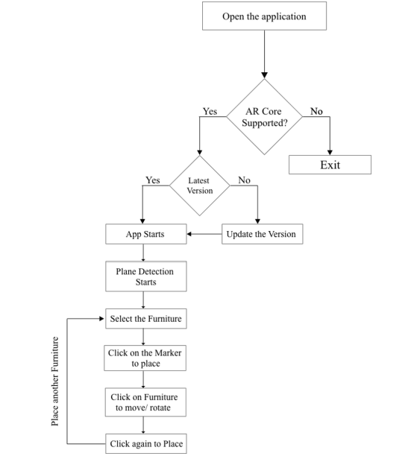

This flow will show exactly how and what kind of feature and functionalities the user can do when they enter into the application.

1. Architecture

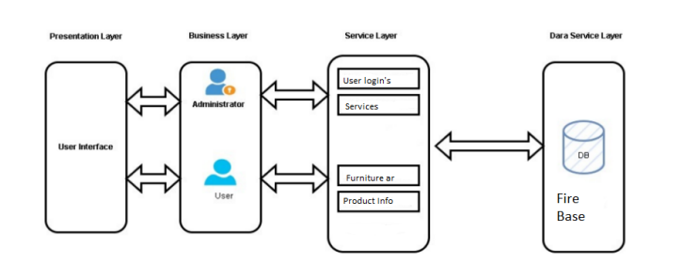

The architecture diagram portrays the visual portrayal of the generally speaking actual parts of the product model. This architecture diagram chiefly comprises four layers to be specific: the show layer, the business layer, the assistance layer, and the information administration layer. The show layer will comprise the connection page through which every one of the clients will associate with the framework. The business layer goes about as a scaffold between the show layer and the help layer. In the business layer ranchers, clients and the administrator will associate with the help layer. The help layer will contain every one of the functionalities of the particular clients. The information administration layer will characterize the capacity part of the framework

VI. RESULTS

The below images are of the project that has been implemented

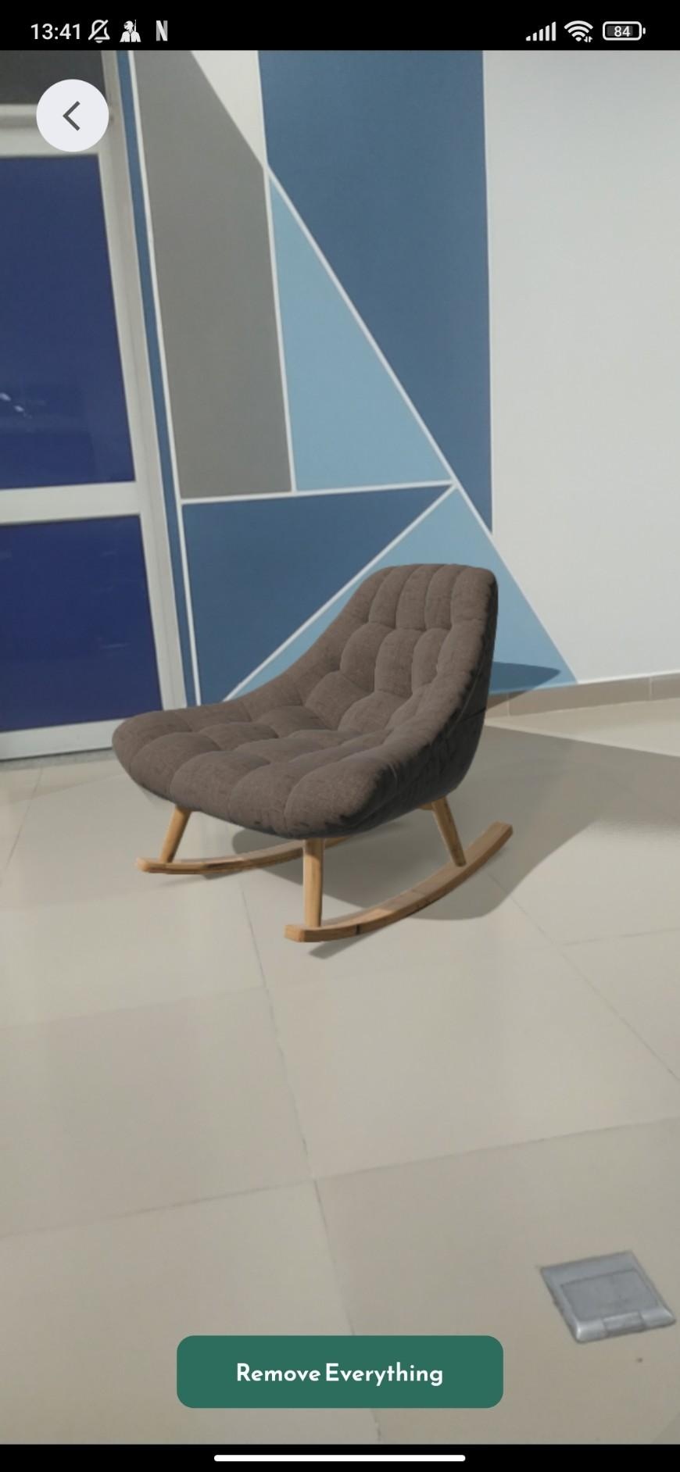 .

CONCLUSION

The system which is developed as of now is useful for users as it can be used to virtually see the products like furniture and various other things so that users can know what will look good in their home. Not only that this system can also be used by design engineers too so that they will be sure what will look good on the place they are constructing.

So as to conclude this project is not only helpful for users but to design engineers as well as visually shows them what will look good on the homes. This project will save time as well as money too. So as to conclude this application as of now works with most efficiency and has no error or bugs that is known of. This application works and delivers everything that is required.

FUTURE WORK

1. Incorporating an IOS system, as this system is only based on android too. This system can be further modified to save user liked designs on cloud so that it can be available Allowing customers to have the option of VR.
2. As of now this application is only working on AR but it can be further optimized enough to run VR on mobile devices using Google cardboard.
3. The application as of now cannot run on browser but it can be made possible to run on web and if it's on web it can run on any devices and OS.
4. This application can be further be worked on to create an e-commerce platform where users can directly buy the items from here

References

1. Carius, L. et al. (2022) “Cloud-based cross-platform collaborative AR in flutter,” 2022 IEEE Conference on Virtual Reality and 3D User Interfaces Abstracts and Workshops (VRW) [Preprint]. Available at: https://doi.org/10.1109/vrw55335.2022.00192.
2. Hargreaves, K. and Jopek, N. (2019) Flutter. Upperthong, Holmfirth, England: Kim Hargreaves.
3. Burd, B. (2020) Flutter. Hoboken, NJ: John Wiley amp; Sons.