**FINAL PAPER – 2 ON STUDY AND DESIGN OF MINI DAM ON ADAN RIVER NEAR BORI GOSAVI VILLAGE**

12345678Jagadambha College of Engineering & Technology, Yavatmal, India

12345678Department of Civil Engineering,

**Prof. Pranay. P. Deogade[1] Sujal Chandu Gawande[2] Ashwin Sunil Jaiswal[3] Aniket Someshwar Chokhat[4]**

**Tejas Anil Patil5 Tejaswini Laxman Thakare6 Vishal Vijay Nagpure7 Shreyash Dinesh Nikhade8**

1Assitant Professor, 2345678Students

**ABSTRACT**

We are attempting to analyse and design a Mini-Dam by Considering many aspects like Water Scarcity, Flood Condition, Drinking and Irrigation, Water Supply, and Agricultural Used in the Present analyse in order to Provide a Mini Dam on Adan River Near Bori-Gosavi Village. After thorough research, we have created a tiny dam that satisfies all requirements.

Communities are given a lifeline by little dams throughout the dry season. This research analyses the construction, management, and operation of a mini-dam on the Adan River and addresses challenges connected to flood conditions. The major objective of this project to provide enough drinkable water to meet future demand while protecting the Bori Gosavi from flooding. Due to its location on the Adan River's bank, Bori Gosavi experiences more severe flooding, and during the summer, water scarcity is an issue due to poor design for water storage. One approach to solving this issue is to build a mini-dam on the Adan River to divert river water and store it. A dam is crucial to the provision of numerous services, including irrigation, modest hydropower generation, fishing, and so forth. By providing enough water, a dam will boost farmers' ability to expand their agriculture. This dam will assist the local community in improving agricultural protection and flood safety.

We study a Mini-Dam that helps the Bori-Gosavi community while not harming the environment. This study led us to the conclusion that the Mini Dam was located one km from the village of Bori-Gosavi. The estimated population of the village in 2088 is 1323. After designing it, we determined that the catchment area is 45.78 km2, the maximum flood discharge is 732 cu.m./sec., and a mini-dam with a height of 12 m is required. We also determined that the dead storage is 1.64808 Mm3, 50% silt in live storage is 0.82404 Mm2, and our net storage is 0.48581 Mm3. Our Mini-Dam protects the village from flooding after this project is complete and reserves water for use in hydro projects, agriculture, fishing, and other uses.

**Keywords:** Mini-Dam, Adan River, Bori-Gosavi, Flood, Fishing, irrigation, Water Scarcity, Discharge, Capacity, Bank

1. **INTRODUCTION**

The availability of water is a critical issue for many rural communities, and the Adan River in the Bori Gosavi Village is no exception. To address this problem, a study and design of a mini dam on the Adan River has been conducted.

This paper outlines the findings of the study, including the feasibility of constructing an earthen dam, and the design considerations that were taken into account. The aim of this project is to provide a sustainable solution for the water needs of the local community. By constructing the mini dam, we hope to improve access to water for agriculture, domestic use, and other purposes. The success of this project could serve as a model for other rural communities facing similar water scarcity issues.

1. **LITREATURE REVIEW**
2. **Cristofano (1965)** :-(Breach erosion of earth fill dams (BEED) model) A computer model has been developed for simulation of breach erosion of earth fill dams (BEED). The model incorporates the processes of surface erosion and slope sloughing to simulate breach enlargement. Depletion of reservoir water is approximated by a volume continuity equation while broad-crested weir hydraulics is utilized to describe flow over and through the breach. Due to the implicit form of these equations, an iterative solution is proposed with convergence achieved within only a few iterations
3. **Harris and Wagner (1967):** - (ANALYSIS OF GRADUAL EARTH-DAM FAILURE) Failure of a dam can result in a major disaster with devastating losses of both human life and property. The phenomenon is time-dependent, multiphase (water-soil interaction), and nonhomogeneous (different materials, various degrees of soil compaction, etc.). The processes involved during an earth fill-dam failure is very dynamic and complicated. Despite the fact that the main modes of failure have been identified as piping or overtopping, little is understood about the location and size of the incipient breach Hydraulics, hydrodynamics, hydrology, sediment transport mechanics, and geotechnical aspects are all involved in breach formation and eventual dam failure.
4. **Johnson and Ills (1976)**: - (Dam-Breach Floods) Dams provide society with essential benefits such as water supply, flood control, recreation, hydropower, and irrigation. However, catastrophic flooding occurs when a dam fails and the impounded water escapes through the breach to cause death and destruction of people and their developments existing in the downstream valley. Usually, the magnitude of the flow greatly exceeds all previous floods and the response time available for warning the populace is much shorter than for precipitation-runoff floods.
5. **Singh and Snorrason (1982):** - (Prediction of Embankment Dam Breach Parameters) studied 20 dam failures and deduced the variation of breach width from2 to 5 times the height of the dam. They observed that it will take 15 minutes to 1 hour for the complete failure of the dam and in the case of failure due to overtopping, the maximum depth before failure ranged between 0.15 to0.61 meters.
6. **MacDonald and Langridge-Mono polis (1984)** :-(Breaching characteristics of dam failure) introduced breach formation factor as the product of breach outflow volume and the depth of water above the breach during failure. They analyzed 42 case studies and concluded that the breach side slope could be assumed to be 1H: 2V in most of the cases, considering the breach shape to be triangular or trapezoidal channel.
7. **Singh and Snorrason (1984):** - (Dam break analysis) Analyzed 8 hypothetical breached dams and compared the results of DAMBRK and HEC-1. They predicted peak outflows by varying breach parameters using both the models. From the conclusion of their work, they showed that for large reservoirs the change in breach width (B w) produce large changes in the range of 35 to 87% in peak out flow in comparison of small reservoirs that produced small changes in the range of 6 to 50 %. They also observed that NWS produced smoother and reasonable flood stage profiles than those predicted by HEC. For steep slopes both the models performed well but for mild slopes, HEC model predicted oscillating and erratic flood stages as HEC model is unable to route flood waves in non-prismatic channels.
8. **NEED OF MINI DAM**

It is widely acknowledged that tiny dams have improved rural people' quality of life by storing water for a variety of applications, including irrigation, cattle, aquaculture, electricity, and flood control. Many national governments and development organisations have been working hard in recent years to build and maintain small dams as part of their efforts to improve the management of water resources.

Governments considering implementing small dam programmes are looking for best practises and lessons learned for ensuring the sustainability and safety of existing and new small dams, for managing them from an integrated water resources management perspective, and for enhancing their benefits. This is because they recognise the significance of small dams for improving rural livelihoods, increasing food production, and reducing poverty.

1. **ADVANTAGES OF MINI DAM**
2. This project's primary objective is to safeguard the Bori Gosavi against flooding and provide enough drinkable water to meet future demand.
3. Due to its location on the Adan River's bank, Bori Gosavi experiences more severe flooding, and during the summer, water scarcity is an issue due to poor design for water storage.
4. One solution to this issue is to build a mini-dam on the Adan River a km distant from Bori Gosavi in order to store a river water.
5. Dams facilitate the provision of several services, such as drinking and irrigation, water supply, moderate hydropower generation, fishing, and other applications. By supplying enough water, dams will encourage farmers' agricultural expansion. The surrounding population will benefit from improved agricultural protection and flood safety thanks to this dam.
6. **METHODOLOGY**
7. Site Selection: Identify a suitable location for the mini dam on the Adan River near Bori Gosavi village. Consider factors such as water flow, topography, and accessibility.
8. Hydrological Study: Conduct a hydrological study of the Adan River to determine the water flow rate, seasonal variations, and potential flood risks.
9. Environmental Impact Assessment: Assess the potential environmental impacts of the mini dam, including its effect on the river ecosystem, wildlife, and nearby communities.
10. Feasibility Study: Conduct a feasibility study to determine the technical and economic viability of the mini dam. Consider factors such as construction costs, maintenance expenses, and potential revenue streams.
11. Design and Engineering: Develop detailed engineering plans and designs for the mini dam, including its size, shape, and materials.
12. Permitting and Regulatory Compliance: Obtain all necessary permits and comply with all relevant regulations and laws governing the construction and operation of the mini dam.
13. Construction: Build the mini dam according to the approved plans and designs, using appropriate construction techniques and materials.
14. Testing and Commissioning: Test the mini dam to ensure that it functions properly and meets all safety and performance standards.
15. Operation and Maintenance: Establish a plan for the ongoing operation and maintenance of the mini dam, including regular inspections, repairs, and upgrades as needed.
16. Monitoring and Evaluation: Monitor the performance of the mini dam over time and evaluate its impact on the local environment, economy, and community. Make any necessary adjustments to improve its effectiveness and sustainability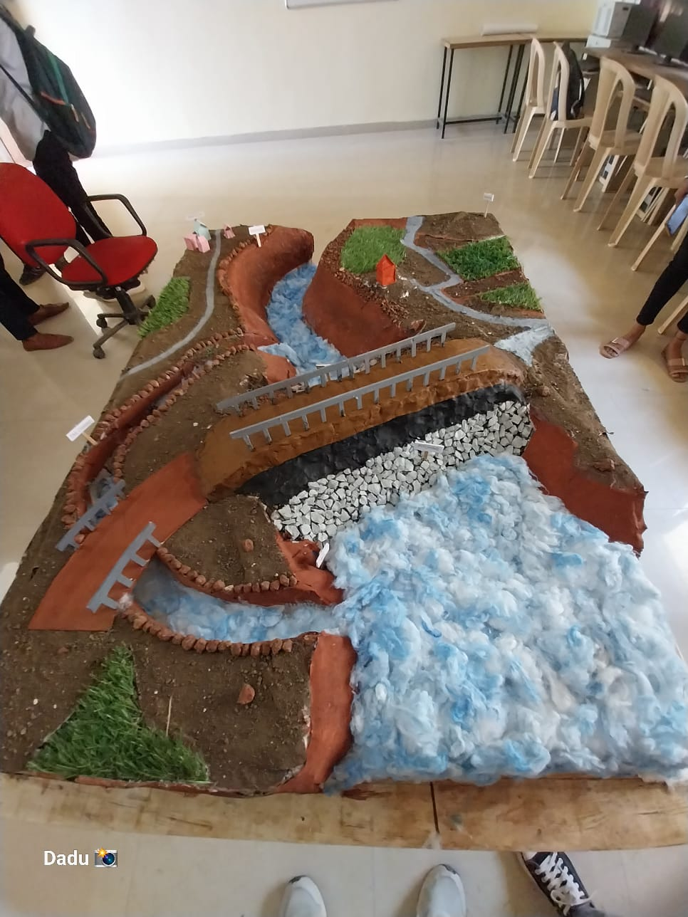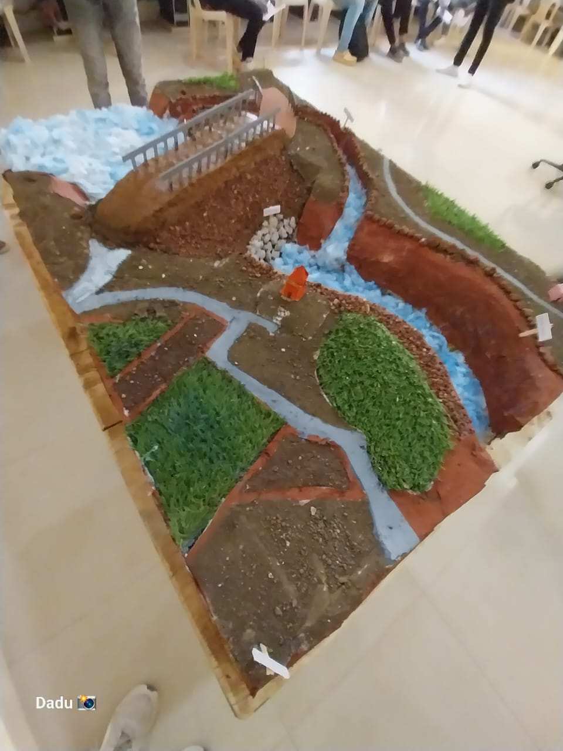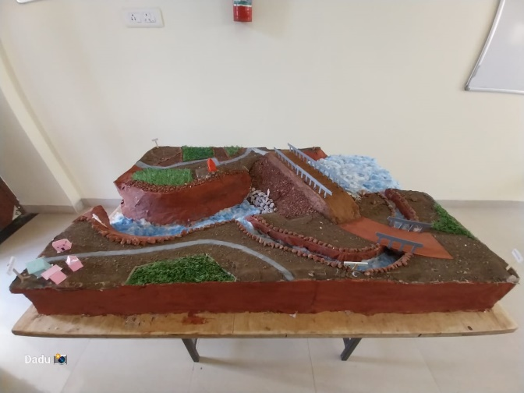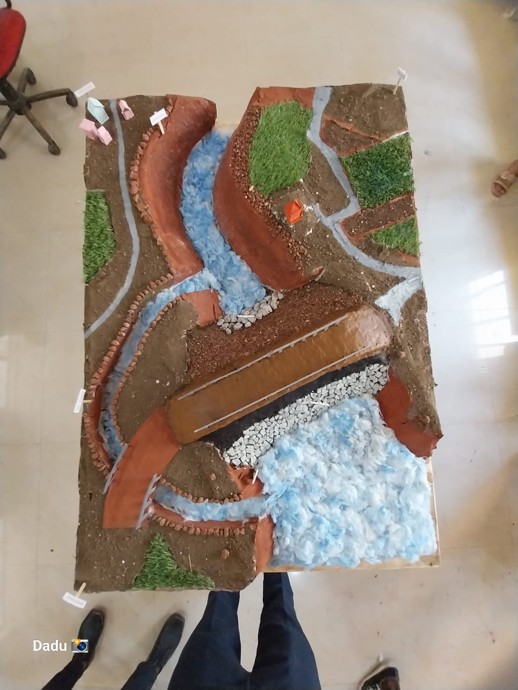.
17. Prospective Model: Use the data collected from the previous steps to create a prospective model for the mini dam, including projections for its energy production, revenue generation, and potential environmental impacts. Use this model to inform decision-making and guide ongoing monitoring and evaluation efforts.

**Figure: Modular Representation of Mini Dam on Adan River Near Bori-Gosavi Village**

1. **OBJECTIVES AND FUTURE SCOPE**
2. **OBJECTIVES**
3. The objective of the project study and design of mini dam on Adan River near Bori Gosavi village is to assess the feasibility of constructing a mini dam, evaluate the potential environmental impacts, design a sustainable and efficient dam structure, and develop a plan for the generation of renewable energy that benefits the local community while preserving the ecological integrity of the surrounding area.
4. The use of a mini-dam to lessen or stop the harmful impacts of floodwaters on people and animals.
5. It benefits farmers and others in the agricultural industry in the long term by replenishing the soil's deficient nutrients.
6. It boosts agricultural output and makes the soil more fruitful.
7. It lessens the impact of flood disasters or their intensity on society and the economy.
8. The tiny dam helps the ecosystem by introducing new predators and prey, which balances the aquatic population.
9. **FUTURE SCOPE: -**

The future scope of the study and design of a mini dam on Adan River near Bori Gosavi village includes:

1. Conducting detailed surveys and assessments of the local hydrology, geology, and ecology to better understand the potential impacts of the dam on the environment and surrounding communities.
2. Developing a comprehensive plan for the management and conservation of the Adan River watershed to ensure the long-term sustainability of the mini dam and its associated infrastructure.
3. Exploring innovative technologies and approaches for generating renewable energy from the dam, such as hydropower, solar power, and wind power, to maximize its benefits for the local community.
4. Engaging with local stakeholders, including community members, government officials, and environmental organizations, to ensure that the project is aligned with their needs and priorities.
5. Monitoring and evaluating the performance of the mini dam over time to identify opportunities for improvement and adaptation in response to changing environmental and social conditions.

Overall, the future scope of this project is to create a sustainable and resilient mini dam that provides clean energy and economic opportunities for the local community while protecting the natural resources and biodiversity of the Adan River ecosystem.

**7. CONCLUSION**

We believe that the mini-dam on the Adan River close to the village of Bori Gosavi protects the community from flooding and provides enough drinkable water to meet future demand because it is the.

After conducting an online survey and analysis, we recommend placing our little dam one km from the village of Bori Gosavi in order to protect the locals from flooding.

After completing the design of the mini dam, we learn that the project must be finished in a way that benefits the community of Bori-Gosavi while causing no harm to the community's environment. After conducting this study, we discovered that our catchment area is 45.78 km2, and after designing it, we obtained a Mini-Dam with a height of 12 m and a 60-year design. After this project is finished, our Mini-Dam shields the village from flooding and stores water for use in hydro projects, agriculture, fishing, and other uses.

There would be numerous advantages for the farmers in Bori Gosavi Village and the nearby villages if this project is successful. Given how busy this river is during the summer, we assume that this project will assist the locals in improving agricultural protection in a very short amount of time and the safety from unrestricted flooding.

**8. REFERENCES**

1. Bulletin 88 (1993) Rock foundations for dams [this bulletin presents analyses and treatment of problems of rock foundations for dams.
2. Bulletin 90 (1993) Dams and Environments: Geophysical Impacts [refers to chapter 5.1 of this article].
3. Bulletin 109 (1998) Dams less than 30 m high: cost savings and safety improvements [80 % of large dams are lower than 30 m: many have huge storages; many information's of the bulletin apply also to high dams]
4. U.S. Natural Resources Committee, Subcommittee on Small Water Storage Projects, 1938, "Low Dams - A Manual of Design for Small Water Storage Projects", First Edition, p. 108.
5. hydrologic Engineering Centre, (2010a). "HECRAS River Analysis System, Hydraulic Reference Manual," CPD-69, United States Army Corps of Engineers, Hydrologic Engineering Centre, 609 Second Street, Davis, California.
6. Wahl, Tony L., (1988). “Prediction of Embankment Dam Breach Parameters”, A Literature Review and Needs Assessment, Water Resources Research Laboratory, U.S. Department of the Interior, Bureau of Reclamation, Dam Safety Office, 1988.
7. Cristofano, Eugene A., (1965). “Method of Computing Erosion rate for Failure of earth fill Dams”. U.S. Bureau of Reclamation, Engineering and Research Centre, Denver CO; 1965.
8. Harris, G.W., Wagner, D. A., (1967). “Outflow from Breached Dams”. University of Utah, Logan, Utah, USA.
9. Johnson, F.A. and Illes, P., (1976). “A Classification of Dam Failures”. Water Power and Dam Construction, 28(12), p. 43 – 45.
10. Singh, Krishan P. and Snorrason A., (1982). “Sensitivity of Outflow Peaks and flood Stages to the Selection of Dam Breach Parameters and Simulation Models. University of Illinois, State Water Survey Division, Surface Water Section, Champaign, IL, 179 pages; June 1982.
11. MacDonald, Thomas C., and Langridge Monopolis, J, (1984). “Breaching characteristics of dam failures”. ASCE Journal of Hydraulic Engineering, Vol. 110, No, 5, May 1984, pages 567-586.
12. Singh, Krishan P., and Snorrason, A., (1984). “Sensitivity of Outflow peaks and flood stages to the selection of dam breach parameters and simulation models”. Journal of Hydrology, Vol. 68, Issues 1-4, February 1984, pages 295-310. Global Water: Science and Engineering the Ven Te Chow memorial Volume.
13. Petra Check, A. W., and Sadler, P. A., (1984). “Routing of Dam Break Floods.” International Water Power and Dam Construction, v. 36, p. 29-32.
14. Froehlich, David C. (1987). “Embankment Dam Breach Parameters”. Hydraulic Engineering, Proceedings of the 1987 National Conference, ASCE, Williams’s burg, VA, pages 570-575.
15. Wurbs Ralph A., (1987). “Dam breach flood wave models”, Journal of hydraulic engineering, vol. 113, 1987, pp.29-46.
16. Singh, V.P., Skarlatos, P.D., Collins, J.G. and Jourdan, M.R., (1988). “Breach Erosion of earth fill Dams (BEED) Model”. Natural Hazards, Volume 1, pages 161-180.
17. Von Thun, J. Lawrence, and Gillette, D. R., (1990). “Guidance on breach parameters.” Unpublished internal document, U.S. Bureau of Reclamation, Denver, CO. March 1990, 17 pages.

1.
2.
3.
4.