Pothole Detection System

Shylee Veronica, Poojashree C, Himangshu Das, Mangesh Thakur *Guided by Dr. Mallikarjun K. Director of School of Computing and Information Technology*

*REVA University*

Bengaluru, India

***Abstract*— The maintenance of the road for daily commute is necessary in order to avoid traffic congestions and accidents.. One of the major causes for road accidents in Indian roads is due to the potholes and humps. Potholes are bowl-shaped openings on the road that can be up to 10 inches in depth and are caused by the wear-and-tear and weathering of the road Hence there is a need for an automated system that is quick, scalable and cost effective for gathering information about road defects. Human intervention checks are performed manually, resulting in poor road maintenance, particularly in villages. In this digital era, it becomes essential to identify and report these potholes to the corresponding authorities in an automated version. We propose a system for road pothole detection using computer vision and deep learning. We make use of YOLO v5 algorithm to identify and detect the potholes from the provided data set. It is a novel convolutional neural network (CNN) that detects objects in real-time with great accuracy. This approach uses a single neural network to process the entire picture, then separates it into parts and predicts bounding boxes and probabilities for each component. These bounding boxes are weighted by the expected probability. The method “just looks once” at the image in the sense that it makes predictions after only one forward propagation run through the neural network. It then delivers detected items after non-max suppression (which ensures that the object detection algorithm only identifies each object once).**

***Keywords—potholes, intervention, automation, condition, monitoring***

1. INTRODUCTION

Road damage not only causes accidents but also affects the drive quality. Frequent encounters with potholes causes vehicle damage as well. Autonomous vehicles have gradually received stronger attention due to its commercial value, but they still have some safety issues, such as hitting potholes . Hitting Potholes can affect driving comfort and increases maintenance costs of vehicles. If the depth of the Potholes is large the rate of accidents is also high. Once the pothole is formed its depth can grow several inches it may cause increase in traffic. Potholes on roads are especially dangerous for drivers when cruising in high speed. Because the driver can hardly see potholes on road surface. Moreover, it can also endanger lives of passengers. According to the report titled Road Accidents in India — 2021, the number of accidents caused by potholes is 3,625 while in 2020 it was 3564.

To address these issues the research work is taken up to develop suitable techniques for pothole detection system. It is proposed to address issues such as uneven lighting, presence of water in potholes etc.

Several technologies are developed for detection of pothole.

(**Zhen Zhag, Xiao Ai, C.K. Chan and Naim Dahnoun, 2014) proposed a stereo vision based pothole detection system**. The disparity map generated from an efficient disparity calculation algorithm is used. Obtained disparity map is converted into a world coordinate system (WCS) .The connected component labelling (CCL) algorithm is applied, here potholes can be labelled as pothole .

**(Vigneshwar .K, HemaKumar.B,2016) proposed Detection and Counting of Pothole using Image Processing Techniques**. Detection and counting of potholes using different image processing techniques helps in classification of different types of road profile. The K-Means clustering based segmentation was preferred for its fastest computing time and edge detection based segmentation is preferred for its specificity

**(Dhwani Desai1, Abisheik Soni2, Dhruv Panchal3, Sachin Gajjar,2019)Design, proposed Development and Testing of Automatic Pothole Detection and Alert System**. Automatic Pothole Detection and Alert System is developed using ultrasonic sensor, accelerometer, stereo camera and Global Positioning System (GPS) integrated with Raspberry Pi. Accelerometer sensors will identify severity of potholes only when the vehicle cross the pothole.

**(Rui Fan, Member, IEEE, Umar Ozgunalp, Brett Hosking, Ming Liu, Ioannis Pitas,2019) proposed Pothole Detection Based on Disparity**. It focuses on a)Disparity transformation b) Undamaged road area extraction c)Disparity map modeling and pothole detection. The parameters set for pothole detection cannot be applied to all cases. Therefore, it can be planned to train a deep neural network to detect potholes from the transformed disparity map.

**(Kanza azhar et al (1) in 2016) proposed computer vision based detection and localization of potholes in asphalt pavement images**. Histogram of gradients features is the method used for pothole detection. The nave bayes Classifier is used to train and classify features resulting in the labeling input as pothole or non-pothole images. Laser sensor and accelerometer sensor are used hence it is cost effective.

**(Manjunath HT in 2019) proposed a method on detecting and classifying potholes in Indian roads using Wavelet Based Energy Modules**. This method is divided into 3 stages

,wavelet energy module is created in order to detect the image, using edge based segmentation technique is used to extract the region of interest, neural network is used to classify the pothole.

**(S B Amruthavarshini ) proposed Kirchoff’s theory and gaussian model-based mining algorithm used to detect road irregularities**. System automatically updates information about potholes and humps in the cloud and sends it to vehicle.If the vehicles are not properly connected the contacts are reversed or they are not connected to correct contact or they are not connected at all.

**Yaqi Li Christos Papachristou Daniel Weyer** in their paper, propose a stereo vision system which detects potholes during driving. Theu use parameters obtained from camera calibration with checkerboard to calculate the disparity map.

**Rongbang Li Carolyn Liu proposed Road Damage Evaluation via Stereo Camera and Deep Learning Neural Network.** The system contains a stereo camera and a laser

diode that is capable of projecting multiple laser dots. The stereo camera collects images while the laser diode projects easily identifiable marks on the pavement

**Shebin Silvister proposed Deep Learning Approach to Detect Potholes in Real-Time using Smartphone.** The system which uses deep learning algorithms and is integrated with smartphones to detect potholes in real-time. Single Shot Multi-box Detector (SSD) looks for pothole

1. TECHNOLOGIES FOR POTHOLE DETECTION.

# Template matching

Template matching method can be termed as a naive approach for detecting objects in an image. In this method, a template of the object which we want to detect is slid across the image and the correlation of the template with the input image is captured. The location where the correlation is the highest is predicted as the location of the object.

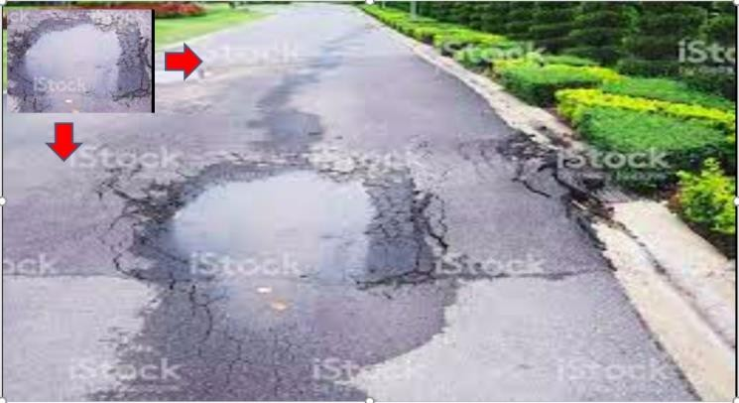

# RCNN Framework

This framework was originally introduced by [Girshik et al. in](https://arxiv.org/abs/1311.2524) [2013.](https://arxiv.org/abs/1311.2524) There have been several modifications to the original architecture, resulting in better performance over time. For some time the RCNN framework was the go to model for object detection tasks.

The original RCNN algorithm contains the following key steps

* + Extract regions which potentially contain an object from the input image. Such extractions are called regions proposals extractions. The extraction was done using an algorithm like [selective search.](http://www.huppelen.nl/publications/selectiveSearchDraft.pdf)
  + Use a pretrained CNN to extract features from the proposal regions.
  + Classify each regions extracted, using a classifier like Support Vector Machines ( SVM).

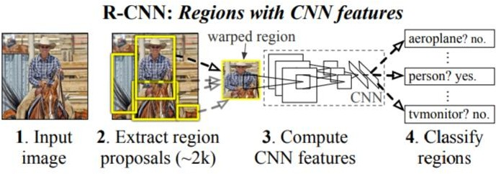

# FAST-RCNN

A significant improvement was made to the original RCNN algorithm, by the same author, within a year of publishing of the original paper. This algorithm was named Fast-RCNN. In this algorithm there were some novel ideas like Region of Interest Pooling layer. The Fast-RCNN algorithm used a CNN for the entire image to extract feature map from it. A fixed size window from the feature map was extracted and then passed to a fully connected layer to get the output label for the proposal regions. This step was termed as the Region of Interest Pooling. Two sets of fully connected layers were used to get class labels of the regions along with the location of the bounding boxes for each region.

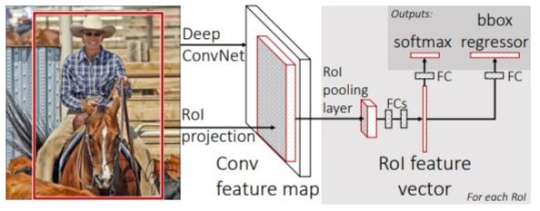

# YOLO Algorithm

YOLO which is an acronym for 'You only look once' is a simple algorithm which treats object detection task as a single regression problem processing an image from its pixels to bounding coordinates and class probabilities in a straight through process. This algorithm has at its core a single convolutional network which predicts multiple bounding boxes and class probabilities simultaneously.

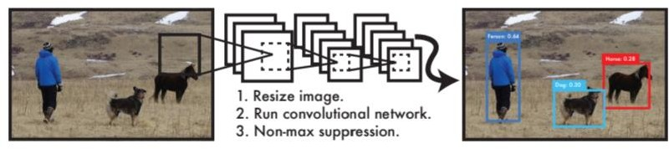

1. METHODOLOGY

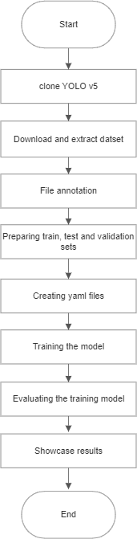

In this paper, we train YOLO V5 model for detection of potholes on road. YOLO stands for “You Only Look Once”,it is one of the popular object detector in use.The algorithm is designed such that predictions would be generated for single pass of forward propagation. YOLO can achieve high accuracy and most suitable for real time detection. YOLO take a batch of images of shape (m, 224,224,3) and then outputs a list of bounding boxes along with its confidence scores and class labels, (pc,bx,by,bw,bh,c). The output generated will be a grid of dimensions S x S ( eg. 19 x 19 ) with each grid having a set of B anchor boxes. Each box will contain 5 basic dimensions which include a confidence score and 4 bounding box information. Along with these 5 basic information, each box will also have the probabilities of the classes. So if there are 10 classes, there will be in total 15 ( 5 + 10) cells in each box.

* + The start of the process in YOLO is to divide the image into a S x S grids. Here S can be any integer value. For our example let us take S to be 4.
* Each cell would predict B boxes with a confidence score.
* These B boxes are called the anchor boxes.

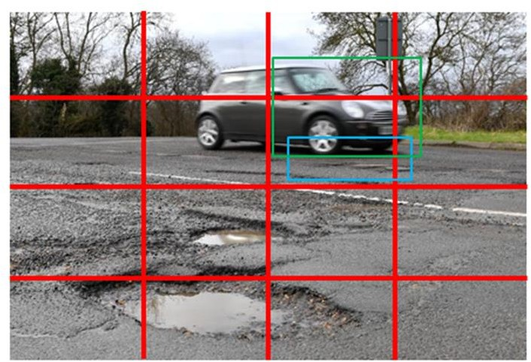

* This process of predicting boxes happens for every cell within the image.
* In the course of this step multiple overlapping boxes will be predicted across all the grids of the image.

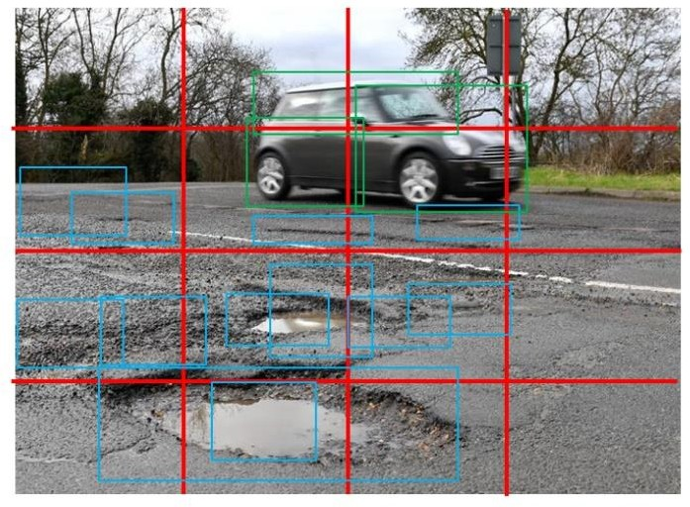

* Along with the boxes and confidence scores a class probability map is also predicted.
* 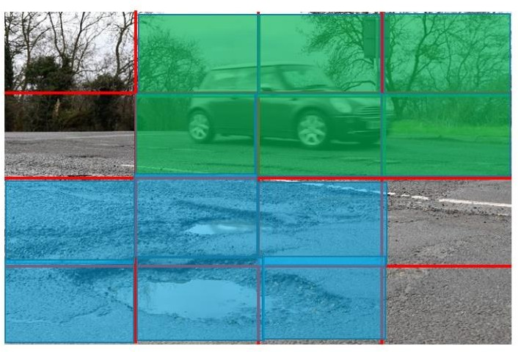A class probability map gives the likelihood of the presence of a class in each of the cell.

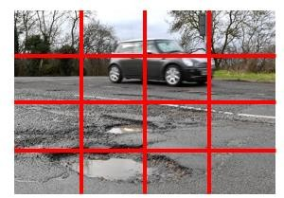

* + Finally non maxima suppression is applied to reduce the number of overlapping boxes and get the bounding boxes of only the objects we want to classify.

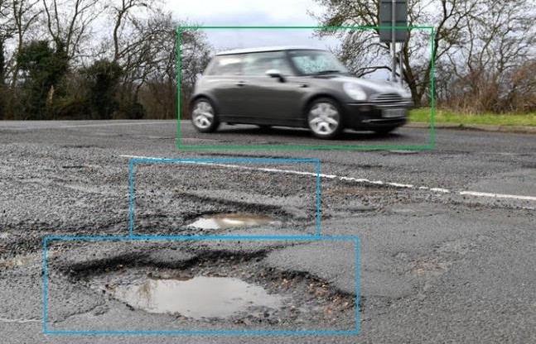

1. RESULTS

Hence a pothole detection system was developed using YOLO v5 algorithm

Each cell would predict boxes with a confidence score as shown in the figures below.

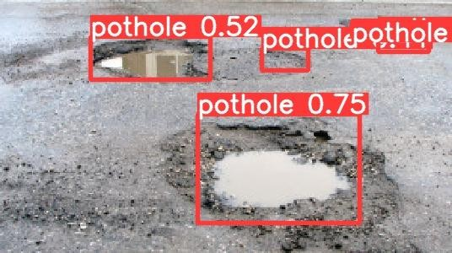

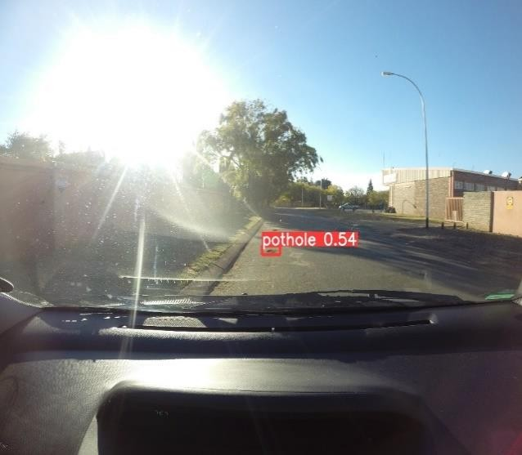

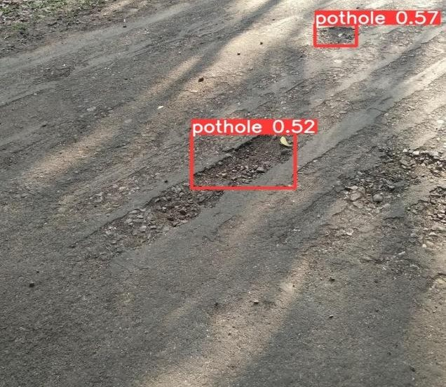

1. CONCLUSIONAND FUTURE WORK

In this paper, a YOLOv5 model is trained to detect the potholes on road.The model predicts the anchor boxes , confidence score along with class probability map. With the help of bounding boxes obtained , potholes can be detected. As future work we would extend the experiments to collaborate the concerned authorities and create robust automated system that detects the pothole and notifies them immediately so that further actions to repair such damages as soon as possible.

1. REFERENCES
2. S. Srivastava, A. Sharma and H. Balot, "Analysis and Improvements on Current Pothole Detection Techniques," *2018 International Conference on Smart Computing and Electronic Enterprise (ICSCEE)*, Shah Alam, Malaysia, 2018, pp. 1-4, doi: 10.1109/ICSCEE.2018.8538390.
3. G. Gu and G. Peng, "The survey of GSM wireless communication system," *2010 International Conference on Computer and Information Application*, Tianjin, China, 2010, pp. 121-124, doi: 10.1109/ICCIA.2010.6141552.
4. H. He, "Yolo Target Detection Algorithm in Road Scene Based on Computer Vision," *2022 IEEE Asia-Pacific Conference on Image Processing, Electronics and Computers (IPEC)*, Dalian, China, 2022, pp. 1111-1114, doi: 10.1109/IPEC54454.2022.9777571.
5. J. Shin, E. Lee, K. Kwon and S. Lee, "Lane detection algorithm based on top-view image using random sample consensus algorithm and curve road model," *2014 Sixth International Conference on Ubiquitous and Future Networks (ICUFN)*, Shanghai, China, 2014, pp. 1-2, doi: 10.1109/ICUFN.2014.6876735.
6. S. S. Rode, S. Vijay, P. Goyal, P. Kulkarni and K. Arya, "Pothole Detection and Warning System: Infrastructure

Support and System Design," *2009 International Conference on Electronic Computer Technology*, Macau, China, 2009, pp. 286-290, doi: 10.1109/ICECT.2009.152.

1. H. J. Anak Undit, M. F. Abu Hassan and Z. M. Zin, "Vision-Based Unmarked Road Detection with Semantic Segmentation using Mask R-CNN for Lane Departure Warning System," *2021 4th International Symposium on Agents, Multi-Agent Systems and Robotics (ISAMSR)*, Batu Pahat, Malaysia, 2021, pp. 1-6, doi: 10.1109/ISAMSR53229.2021.9567892.
2. M. Kodabagi, P. S, B. N and R. H, "Road Condition Monitoring and Information System: Survey," *2022 Third International Conference on Smart Technologies in Computing, Electrical and Electronics (ICSTCEE)*, Bengaluru, India, 2022, pp. 1-5, doi: 10.1109/ICSTCEE56972.2022.10099926.
3. M. Sathvik, G. Saranya and S. Karpagaselvi, "An Intelligent Convolutional Neural Network based Potholes Detection using Yolo-V7," *2022 International Conference on Automation, Computing and Renewable Systems (ICACRS)*, Pudukkottai, India, 2022, pp. 813-819, doi: 10.1109/ICACRS55517.2022.10029263.
4. B. -h. Kang and S. -i. Choi, "Pothole detection system using 2D LiDAR and camera," *2017 Ninth International Conference on Ubiquitous and Future Networks (ICUFN)*, Milan, Italy, 2017, pp. 744-746, doi: 10.1109/ICUFN.2017.7993890.
5. S. Thiruppathiraj, U. Kumar and S. Buchke, "Automatic pothole classification and segmentation using android smartphone sensors and camera images with machine learning techniques," *2020 IEEE REGION 10 CONFERENCE (TENCON)*, Osaka, Japan, 2020, pp. 1386- 1391, doi: 10.1109/TENCON50793.2020.9293883.
6. R. Sathya, B. Saleena and B. Prakash, "Pothole Detection Using YOLOv3 Model," *2023 IEEE International Students' Conference on Electrical, Electronics and Computer Science (SCEECS)*, Bhopal, India, 2023, pp. 1-7, doi: 10.1109/SCEECS57921.2023.10063116.
7. M. S. Hossain, R. B. Angan and M. M. Hasan, "Pothole Detection and Estimation of Repair Cost in Bangladeshi Street: AI-based Multiple Case Analysis," *2023 International Conference on Electrical, Computer and Communication Engineering (ECCE)*, Chittagong, Bangladesh, 2023, pp. 1- 6, doi: 10.1109/ECCE57851.2023.10101579.
8. D. R. Rajan, M. K. Faizan, R. Kundelu, N. Nandal and

V. S. Gunda, "Deep Learning Based Pothole Detection," *2023 International Conference on Emerging Smart Computing and Informatics (ESCI)*, Pune, India, 2023, pp. 1-5, doi: 10.1109/ESCI56872.2023.10100020.

1. B. K. S B, G. S, M. Kishore, S. R and A. D. J, "Real- time Pothole Detection using YOLOv5 Algorithm: A Feasible Approach for Intelligent Transportation

Systems," *2023 Second International Conference on Electronics and Renewable Systems (ICEARS)*, Tuticorin, India, 2023, pp. 1678-1683, doi: 10.1109/ICEARS56392.2023.10085336.

1. S. Sen *et al*., "Pothole Detection System Using Object Detection through Dash Cam Video Feed," *2023 International Conference for Advancement in Technology (ICONAT)*, Goa, India, 2023, pp. 1-6, doi: 10.1109/ICONAT57137.2023.10080856.
2. R. Sathya, B. Saleena and B. Prakash, "Pothole Detection Using YOLOv3 Model," *2023 IEEE International Students' Conference on Electrical, Electronics and Computer Science (SCEECS)*, Bhopal, India, 2023, pp. 1-7, doi: 10.1109/SCEECS57921.2023.10063116.
3. K. R and N. S, "Pothole and Object Detection for an Autonomous Vehicle Using YOLO," *2021 5th International Conference on Intelligent Computing and Control Systems (ICICCS)*, Madurai, India, 2021, pp. 1585-1589, doi: 10.1109/ICICCS51141.2021.9432186.
4. E. S. T. K. Reddy and R. V, "Pothole Detection using CNN and YOLO v7 Algorithm," *2022 6th International Conference on Electronics, Communication and Aerospace Technology*, Coimbatore, India, 2022, pp. 1255-1260, doi: 10.1109/ICECA55336.2022.10009324.
5. E. N. Ukhwah, E. M. Yuniarno and Y. K. Suprapto, "Asphalt Pavement Pothole Detection using Deep learning method based on YOLO Neural Network," *2019 International Seminar on Intelligent Technology and Its Applications (ISITIA)*, Surabaya, Indonesia, 2019, pp. 35-40, doi: 10.1109/ISITIA.2019.8937176.
6. S. Shah and C. Deshmukh, "Pothole and Bump detection using Convolution Neural Networks," *2019 IEEE Transportation Electrification Conference (ITEC-India)*, Bengaluru, India, 2019, pp. 1-4, doi: 10.1109/ITEC- India48457.2019.ITECINDIA2019-186.
7. D. R. Rajan, M. K. Faizan, R. Kundelu, N. Nandal and

V. S. Gunda, "Deep Learning Based Pothole Detection," *2023 International Conference on Emerging Smart Computing and Informatics (ESCI)*, Pune, India, 2023, pp. 1-5, doi: 10.1109/ESCI56872.2023.10100020.