DESIGN OF A ROBOT USING ARDUINO

# G N Meghana1, Poornima K2, Sulu Padma Kumar3, Sahana V4, Dr. K. Balakrishnan5

## 1,2,3,4Students, Dept of CSE, Sambhram Institute of Technology, Bangalore, India. 5Associate Professor, Dept of CSE, Sambhram Institute of Technology, Bangalore, India.

DOI: https[://www.](http://www.doi.org/10.58257/IJPREMS31221)do[i.o](http://www.doi.org/10.58257/IJPREMS31221)r[g/10.58257/IJPREMS31221](http://www.doi.org/10.58257/IJPREMS31221)

# ABSTRACT

This project builds voice control car that can be controlled by voice commands which reacts in accordance to the corresponding voice command. However noise and distance handling require future development. Simple voice commands like left, right, forward, back, stop are used to run the car. These commands are given to Bluetooth module via an android application. The Bluetooth module and control unit are combined to store and test the voice commands. When an instruction for the automobile (car) is identified, a command message is sent to Arduino Nano, the Microcontroller of the car by the Bluetooth device. This command is analyzed by the microcontroller and followed up. In the vehicle, ultrasonic sensor can be utilized to become aware of the obstacles.

**Keywords:** Voice Control car, android application, Bluetooth module, Arduino Nano, Microcontroller, ultrasonic sensor, obstacle.

# INTRODUCTION

Arduino Nano is a microcontroller board based on the ATmega328P. It has 14 digital input/output pins (of which 6 can be used as PWM outputs), 6 analog inputs, a 16 MHz quartz crystal, a USB connection, a power jack, an ICSP header and a reset button. It contains everything needed to support the microcontroller; simply connect it to a computer with a USB cable or power it with a AC-to-DC adapter or battery to get started.. You can tinker with your UNO without worrying too much about doing something wrong, worst case scenario you can replace the chip for a few dollars and start over again. "Uno" means one in Italian and was chosen to mark the release of Arduino Software (IDE) 1.0. The Uno board and version 1.0 of Arduino Software (IDE) were the reference versions of Arduino, now evolved to newer releases. The Uno board is the first in a series of USB Arduino boards, and the reference model for the Arduino platform; for an extensive list of current, past or outdated boards see the Arduino index of boards. The L298 is an integrated monolithic circuit in a 15- lead Multi watt and PowerSO20 packages. It is a high voltage, high current dual full-bridge driver designed to accept standard TTL logic levels and drive inductive loads such as relays, solenoids, DC and stepping motors. Two enable inputs are provided to enable or disable the device independently of the input signals. The emitters of the lower transistors of each bridge are connected together and the corresponding external terminal can be used for the connection of an external sensing resistor. An additional supply input is provided so that the logic works at a lower voltage. Bluetooth is a wireless technology standard for exchanging data over short distances (using short wavelength UHF radio waves in the ISM band from2.4 to 2.485 GHz) from fixed and mobile devices, and building personal area networks (PANs). Range is approximately 10 Meters (30 feet). These modules are based on the Cambridge Silicon Radio BC417 2.4 GHz Bluetooth Radio. This is a complex chip which uses an external 8 Mbit flash memory[1-2].

# LITERATURE SURVEY

1. "Design and Implementation of Voice Controlled Car Using Arduino" by P. B. Malarvizhi and S. Thangamani (2018): This paper discusses the design and implementation of a voice-controlled robotic car using an Arduino board. The authors used voice recognition software to control the movement of the car.
2. "Voice Controlled Robotic Car" by P. L. N. N. N. Sai, P. Sai Kumar, and T. V. V. R. Reddy (2017): This paper presents a voice-controlled robotic car that can be controlled using simple voice commands. The authors used an Arduino board and Bluetooth module to control the car.
3. "Design and Development of Voice Controlled Autonomous Car" by S. Gupta and S. Verma (2019): This paper discusses the design and development of a voice-controlled autonomous car. The authors used a Raspberry Pi board and a voice recognition module to control the car.

# 3. PROBLEM STATEMENT

1. Objective shows that it is indeed possible for a user to learn to effectively manipulate real world objects with only verbal voice as a control mechanism.
2. The proposed results provide strong evidence that the further development of voice- controlled robotics will be successful.
3. This system would find wide variety of applications. Mainly systems such as household appliances like washing machines microwave ovens etc. will become voice controlled in future**.** In such case this research will work out practically

satisfying the need of the day efficiently.

BLUETOOTH MODULE

DC MOTOR 1

MOTOR DRIVER

DC MOTOR 2

# SYSTEM ARCHITECTURE

POWER SUPPLY

ULTRASONIC SENSOR

ARDUINO NANO

**Figure 1:** System Architecture

VOICE CONTROLLED APP

In this proposed device we perform a variety of research on control style variants for robots. It shows that it’s feasible to study to successfully manipulate actual world objects with solely voice (human voice) as a control mechanism. The reason of this lookup is to provide simple robotic hardware architecture so that this shape can focal point on Bluetooth connection infrastructure. It is also beneficial for academic robotics due to the fact human beings can construct their personal robots with low cost. When the app is operating in the system, a microphone on the mobile is used to identify user voice commands. Commands are interpreted and the program utilizes Google's speech-recognition software to translate voice to text within the app. The text will then be sent with the aid of Bluetooth to the receiver part. The microcontroller Arduino Nano has 32kB of ISP flash memory, 2kB of RAM and 1kB of EEPROM. The panel incorporates serial communication connectivity with UART, SPI and I2C. The MCU will operate at 16MHz clock speed. The digital Arduino I / O pins 3, 4, 5 and 6 are programmed as output pins in this design. For serial communication with the Bluetooth unit, pins 0 and 1 of Arduino are used. Text obtained with the aid of Bluetooth is forwarded to Arduino Nano microcontroller panel by the usage of UART serial conversation protocol. The voice commands to the robotic device are dispatched via Bluetooth with the aid of an Android device. These commands are received on the robotic device by using Bluetooth module set up on it. The motor driver circuit is used to manipulate the velocity of the car. The complete circuitry is powered by the usage of a 12V rechargeable battery hooked up on the system.

# HARDWARE AND SOFTWARE REQUIREMENTS

Hardware Requirement

* + Arduino Nano.
  + L293D Motor Shield.
  + Bluetooth Module HC-05.
  + Ultrasonic Sensor HC-SR-04.
  + Battery 12 volts.
  + 2 DC Motors (12 V 200 rpm).
  + Android phone.
  + Power supply Software Requirement
  + Arduino IDE.
  + Android Voice Application

# WORKING

In this project, the movements of the wheelchair are controlled with the help of an Android application. The above figure is the block diagram of voice controlled car. The proposed system uses voice recognition -based android mobile to control the Car. An Android application is to be developed for this purpose. The android mobile is connected to microcontroller fitted inside Car via a Bluetooth controller. The provided Android application gives simple user-interface to the user for voice recognition to control the direction of motion of Car. Based on voice recognition the corresponding signal is sent via a Bluetooth controller to the microcontroller, which takes actions as a form of output. If the user voice command is Go- ahead direction, then both the motors are made to move in the same direction and with the same speed. Similarly is the Go- back direction. If the user's voice command is Turn left/right direction than the polarity of both the motors are reversed correspondingly.

# ALGORITHM

1. Define the pins for the ultrasonic sensor and the relays.
2. Initialize the serial communication for debugging purposes.
3. Set the pin Mode for the ultrasonic sensor and the relays.
4. Define a function "obstacle" to measure the distance using the ultrasonic sensor.
5. In the loop function, measure the distance using the ultrasonic sensor and print it to the serial monitor.
6. If the distance is less than 20, turn off all the relays and print "obstacle detected" to the serial monitor.
7. If there is serial data available, read it and store it in a variable "data in".
8. If the received command is "*forward#", turn on the forward relays and turn off the rest.
9. If the received command is "*backward#", turn on the backward relays and turn off the rest.
10. If the received command is "*right#", turn on the right relays and turn off the rest.
11. If the received command is "*left#", turn on the left relays and turn off the rest.
12. If the received command is "*stop#", turn off all the relays.
13. Clear the "data in" variable after processing the received command.

# RESULTS

The voice control car can recognize and respond to voice commands. By integrating a speech recognition module with Arduino, you can program the robot to listen for specific voice commands and perform corresponding actions. For example, you could use voice commands like "forward," "backward," "right," "left," "stop" to control the car’ movement. The robot incorporates sensors, such as ultrasonic sensors, to detect obstacles in its path. The ultrasonic sensor emits sound waves and measures the time it takes for the waves to bounce back after hitting an object. By analyzing this data, the car can determine the presence and distance of obstacles.

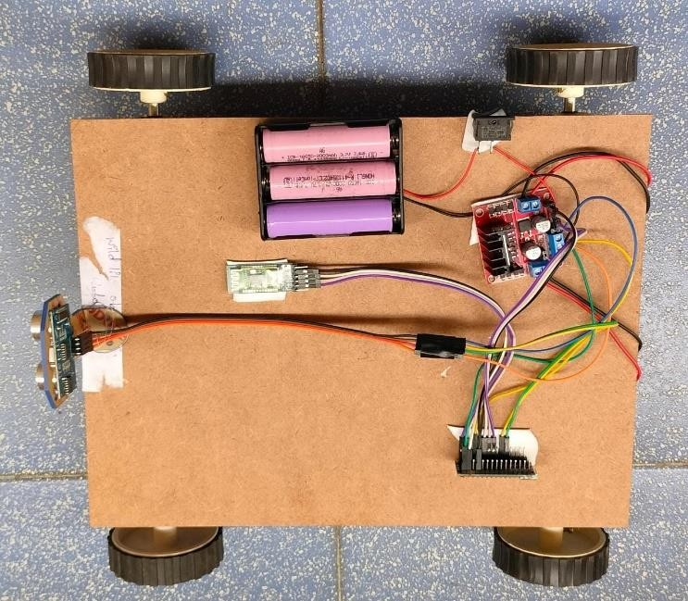

**Figure 2:** Top view of the model

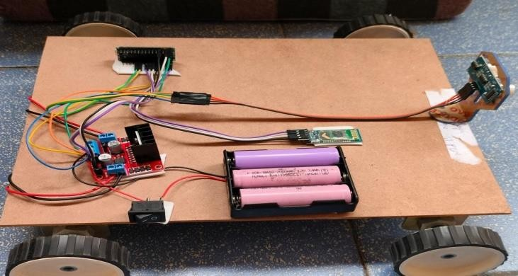

**Figure 3**: Experimenting on rough terrains

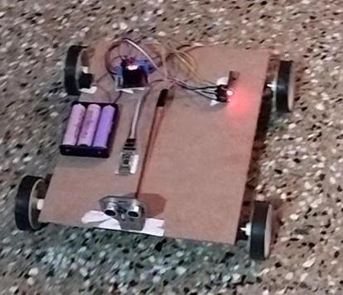

**Figure 4**: Final result

# FUTURE SCOPE

* + The system can be adapted to make it for the external environment by adapting the GPS location and the user can make the selection to go through it.
  + The other way is that the path will be stored as the video and the car can travel automatically by recognizing various past patterns.
  + Machine Learning: Use machine learning algorithms to improve the speech recognition accuracy of the system and enable it to learn and adapt to different users' voices and accents.
  + Sensor Fusion: Integrate multiple sensors, such as cameras, lidars, and ultrasonic sensors, with the robotic car to

enable more advanced functionalities, such as object detection, tracking, and recognition.

* + Wireless Communication: Integrate wireless communication modules, such as Wi-Fi, Bluetooth, or Zigbee, with the robotic car to enable remote control and data transmission.

1. **CONCLUSION**

In conclusion, the voice-controlled car demonstrates the feasibility and potential of using natural language interfaces, such as voice commands, to control intelligent robotic systems. By integrating a voice recognition module with an Arduino board and a motor driver circuit, the project team designed and built a functional robotic car that can move in different directions based on voice commands given by the user. Through the implementation and testing of the voice- controlled robotic car, the project team identified the advantages and limitations of such systems. The voice-controlled robotic car provides a user-friendly and intuitive interface for controlling the movement of the robot, which can be beneficial in various applications, such as healthcare, education, and entertainment. However, the system's performance may be affected by various factors, such as speech recognition accuracy, noise interference, power consumption, and environmental variations.

# REFERENCES

1. B.S. Armour E.A. Courtney-Long M. H. Fox H. Fredine and A. Cahill "Prevalence and Causes of Paralysis- United States 2020" American journal of public health vol. 106 pp. 1855-1857 2020.
2. A. Chaudhry M. Batra P. Gupta S. Lamba and S. Gupta "Arduino Based Voice Controlled Robot" 2021 International Conference on Computing Communication and Intelligent Systems (ICCCIS) pp. 415-417 2020.
3. B.J. Dudgeon J.C.Deitz and M. Dimpfel "Wheelchair Selection" Occupational therapy for physical dysfunction vol. 7 pp. 498-522 2020.
4. M. A. Goodrich and A. C. Schultz Human-robot interaction: a survey Now PublishersInc2021.
5. S. K. Gaikwad B. W. Gawali and P. Yannawar "A review on speech recognition technique" International Journal of Computer Applications vol. 10 pp. 16-24 2021.