**DATALOSS PREVENTION SYSTEM USING LOCATION DEFINED NETWORK**

Deepika A1, Devadharshini R2, Sathyasudhan R3, Santhi priya D4

*1,2,3 UG student, Department Of Computer Science and Engineering*

*4 Assistant Professor, Department of Computer Science and Engineering*

*N.S.N College of Engineering and Technology, Karur, Tamil Nadu, India.*

|  |
| --- |
| **ABSTRACT**  Data sharing and access are capabilities that the business and organizations require in the most of these days .Remote working and mobile access to resources and collaboration platforms made it easier to access data and resources from anywhere, anytime. Employees want to access documents and email from different devices, and from various locations at a time. Access from untrusted networks is always a threat to businesses. This might result in data loss and overexposure of critical data. To mitigate the deficiencies of logical security mechanisms, and coinciding with the trend of cyber-physical systems, security mechanisms have been proposed that integrate with the physical environment. An innovative Virtual Fence is proposed that uses a location data and geospatial intelligence. Geospatial data analysis enhances understanding, insight, decision-making, and prediction. Location intelligence (LI) is achieved via visualization and analysis of geospatial data. Then improve the security of data access in Data Server for a company or any other specific locations using the location-based cryptosystem. Virtual Fence provides a means to secure sensitive information within an organization. It can be set to Off, On, Restricted View or Read Only. Once a geo-fenced boundary is defined, opportunities what businesses can do is limited by only their creativity. The main benefit of setting up such a geo fence is avoiding data leakage.  **KEYWORDS**: Geo fence, Data sharing, Data leakage, Location. |

**INTRODUCTION**

Cloud computing is the delivery of different services through the Internet. These resources include tools and applications like data storage, servers, databases, networking, and software. Cloud computing can be both public and private. These services are a system of networks that supply hosted services. There is also a hybrid option, which combines elements of both the public and private services. Cloud Computing is a combination of the use of computer technology (computing) and Internet-based development (cloud). Cloud computing is a general concept of other recent technological trends that are widely known to include SaaS, Web 2.0 with the general theme of being dependent on the Internet to provide users with computing needs. For example, Google Apps provides general business applications online that are accessed through a web browser with software and data stored on the server.

**TYPES OF CLOUD SERVICES**

Regardless of the kind of service, cloud computing services provide users with a series of functions including:

* Email
* Storage, backup, and data retrieval
* Creating and testing apps
* Analysing data
* Audio and video streaming
* Delivering software on demand

Cloud computing is being used by a number of different organizations from big corporations to small businesses, non -profits to government agencies, and even individual consumers.

Cloud computing is not a single piece of technology like a microchip or a cell phone. Rather, it's a system primarily comprised of three services: Software-as- a-service (SaaS), Infrastructure-as-a-service (IaaS), and platform-as-a-service (PaaS).

**Software-as-a-service (SaaS)** involves the licensure of a software application to customers. Licenses are typically provided through a pay-as-you-go model or on- demand. This type of system can be found in Microsoft Office's 365.

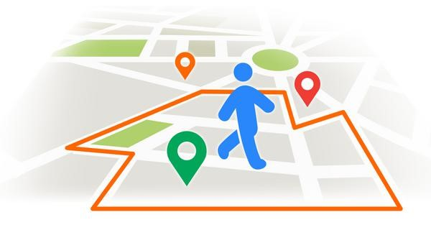**Infrastructure-as-a-service (IaaS)** involves a method for delivering everything from operating systems to servers and storage through IP-based connectivity as part of an on-demand service. Clients can avoid the need to purchase software or servers, and instead procure these resources in an outsourced, on-demand service. Popular examples of the IaaS system include IBM Cloud and Microsoft Azure.

**Platform-as-a-service (PaaS)** is considered the most complex of the three layers of cloud-based computing. PaaS shares some similarities with SaaS, the primary difference being that instead of delivering software online, it is actually a platform for creating software that is delivered via the Internet.

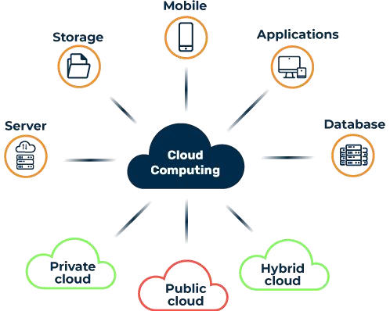

**Cloud Services**

**PROBLEMS IDENTIFIED**

The advantages of cloud computing are frequently touted as cost-efficient, reliable, manageable, and more secure than legacy computing. Yet cloud computing possesses security risks despite it being more secure than legacy computing. The security disadvantages of cloud computing remain worrisome. Most cloud service providers implement relevant security standards and industry certifications to ensure that their cloud environment remains safe. However, storing data and business-critical files in virtual data centres can potentially open you up to risks.

**GEOSPATIAL INTELLIGENCE**

A Geo-fence is a feature that defines a virtual boundary around a real-world geographic area. Every time the user enters or exits the boundary of a particular area, actions are often triggered during a location-enabled device. Usually, the user will receive a notification with certain information that supported its location in real-time. The main advantage of this technology is that it creates a fusion between the virtual world and the real one.

**Geo Fence**

**GEO FENCING:**

Geo fencing is a location-based service in which an app or other software uses GPS, RFID, Wi-Fi or cellular data to trigger a pre-programmed action when a mobile device or RFID tag enters or exits a virtual boundary set up around a geographical location, known as a geo fence. Depending on how a geo fence is configured it can prompt mobile push notifications, trigger text messages or alerts, send targeted advertisements on social media, allow tracking on vehicle fleets, disable certain technology or deliver location-based marketing data. Some geo fences are set up to monitor activity in secure areas, allowing management to see alerts when anyone enters or leaves a specific area. Businesses can also use geo fencing to monitor employees in the field, automate time cards and keep track of company property.

**WORKING OF GEO FENCING:**

To make use of geo fencing, an administrator or developer must first establish a virtual boundary around a specified location in GPS- or RFID-enabled software. This can be as simple as a circle drawn 100 feet around a location on Google Maps, as specified using APIs when developing a mobile app. This virtual geo fence will then trigger a response when an authorized device enters or exits that area, as specified by the administrator or developer.

**EXISTING APPLICATION**

• **Rideshare** – Geo fences are a key component of Uber’s service. For example, the app assigns rides to the drivers closest to the user’s perimeter or location.

• **Ski resorts** - Operators can notify skiers when they are approaching off limits areas and prevent accident.

• **National parks** - Hikers download a geo fencing-enabled app that tells park rangers where they are at any given time. This way, they can act faster in case of an emergency.

• **Assisted Living** - Nursing homes can set up a perimeter around their facilities and know if a resident wanders off. They can also track patients when they go to medical checkup,

• **Warehouses** - Workers receive push notifications when trucks enter the geo fence. This way they can have everything ready before it reaches the loading area.

• **Pet tracking** - This is a no-brainer. By fitting your pet with a GPS collar, you can know in real-time when your furry one leaves your property.

• **Movers** - Some movers don’t rent their trucks for long-distance hauls. Geo fencing allows them to charge extra if a client takes a vehicle outside city limits.

**DISADVANTAGES**

* It requires the key for authentication.
* It only protects data access.
* It does not wipe out the data.

**PROPOSED SYSTEM**

Geo fence will provide an introduction to Geo Server authentication and authorization subsystems, such as basic/digest authentication and CAS support, check through the various identity providers, such as Geo fence boundaries, MAC (Media Access Control), IP (Internet Protocol), as well as providing examples of custom authentication plug-in for Geo Server, integrating it in a home-grown security architecture. This system creates the victim file for wipe out the data, when the data is attempted to open outside of the geo fence.

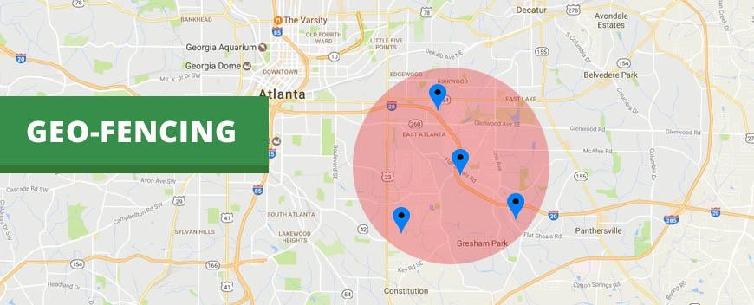

**Geo-Fence Area**

**VIRTUAL FENCE:**

A Geo-fencing is a feature in a software program that uses the Global Positioning System (GPS) to define geographical boundaries. To check whether a person is within a geo fence range to make use of different algorithms such as Ray-casting, Winding Number, TWC (Triangle Weight Characterization) and Circular Geo fencing using Haver sine Formula. Geo fencing is security, when anyone enters or leaves a particular area, an alert passes to server. This system creates the victim file for wipe out the data, when the data is attempted to open outside of the geo fence.

**MODULES DESCRIPTION**

**Cloud Service Provider Dashboard**

In this module we develop a cloud application, or cloud app, it is a software program where cloud-based and local components work together. This model relies on remote servers for processing logic that is accessed through a web browser with a continual internet connection. Cloud application servers typically are located in a remote data centre operated by a third-party cloud services infrastructure provider. Cloud-based application tasks may encompass email, file storage and sharing. Third-party data sources and storage services can be accessed with an application programming interface (API). Cloud applications can be kept smaller by using APIs to hand data to applications or API-based back-end services for processing or analytics computations, with the results handed back to the cloud application. Vetted APIs impose passive consistency that can speed development and yield predictable results. Data stored on cloud services is instantly available to authorized users.

**Cloud Storage Server**

Cloud storage servers are virtual storage facilities provided by cloud service providers that help to store and access multiple files without the requirement of any direct physical device. Web storage server can be accessed via the internet. File Cloud offers the cloud storage in affordable cost and without any downtime. The cloud storage servers continuously run with the help of these data centres and are maintained by the cloud service providers. Data centres secure your files from any kind of damage and make those files available whenever you want to access it via the internet. Applications access cloud storage through traditional storage protocols or directly via an API. Many vendors offer complementary services designed to help collect, manage, secure and analyse data at massive scale. There are three types of cloud data storage: object storage, file storage, and block storage. Each offers their own advantages and has their own use cases

**Object Storage**

Applications developed in the cloud often take advantage of object storage's vast scalability and metadata characteristics. Object storage solutions like Amazon Simple Storage Service (S3) are ideal for building modern applications from scratch that require scale and flexibility, and can also be used to import existing data stores for analytics, backup, or archive.

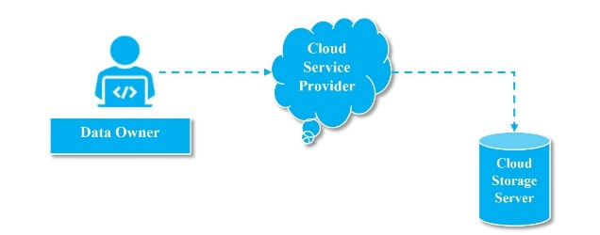

**Geo Fence Boundary Fixing**

**SYSTEM ARCHITECTURE**

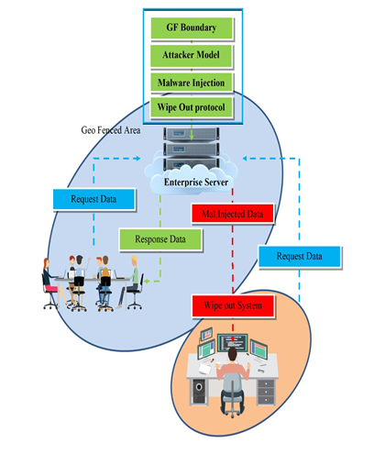

**TESTING**

**Unit Testing**

Unit testing is usually conducted as part of a combined code and unit test phase of the software lifecycle, although it is not uncommon for coding and unit testing to be conducted as two distinct phases.

**Test strategy and approach**

Field testing will be performed manually and functional tests will be written in detail.

**Test objectives**

All field entries must work properly. Pages must be activated from the identified link. The entry screen, messages and responses must not be delayed.

**Features to be tested**

Verify that the entries are of the correct format. No duplicate entries should be allowed. All links should take the user to the correct page

**INTEGRATION TESTING**

Software integration testing is the incremental integration testing of two or more integrated software components on a single platform to produce failures caused by interface defects. The task of the integration test is to check that components or software applications, e.g. components in a software system or – one step up – software applications at the company level – interact without error.

**Test Results:**

All the test cases mentioned above passed successfully. No defects encountered.

6.2.3 Acceptance Testing

User Acceptance Testing is a critical phase of any project and requires significant participation by the end user. It also ensures that the system meets the functional requirements.

**Test Results:** All the test cases mentioned above passed successfully. No defects encountered.

**FUNCTIONAL TESTING**

Functional tests provide systematic demonstrations that functions tested are available as specified by the business and technical requirements, system documentation, and user manuals.

**CONCLUSION**

A geo fence is a virtual boundary, which prompts notifications when people enter or leave the “fence”. This technology is increasingly used by businesses for brand awareness improved customer engagement and increased sales. Other advantages include better performance measurement, advanced scalability, and identification of potential customers.

Businesses can use geo fencing to market their products , engage with social media users , keep track of their employees’ movements , and for personal location monitoring. Firms like Uber, Wal-Mart, and Sephora have gained more followers, app downloads, and customer engagements thanks to the use of geo fencing technology. It also generates the victim files; it automatically checks the geo - fencing boundary values and wipe out the system and files when geo - fencing and MAC Address is mismatch.

**REFERENCES**

[1] Adam Bowers, Cong Liao, Douglas Steiert, Dan Lin, Anna Squicciarini, Ali Hurson,”Detecting Suspicious File Migration Or Replication In The Cloud”, IEEE Trans Secure Comput,. vol 18,no.1,Jan 202**1**.

[2] R. Mokadem and A.Hameurlain, “A data replication strategy with tenant performance and provider economic prot guarantees in cloud data centres,” J. Syst. Softw., vol. 159, Jan. 2020, Art. no. 110447.

[3] Y. Mansouri, A. N. Toosi, and R. Buyya, “Cost optimization for Dynamic replication and migration of data in cloud data centers,” IEEE Trans. Cloud Comput., vol. 7, no. 3, pp. 705718, Jul. 2019.

[4] A. E. Abdel Raouf, N. L. Badr, and M. F. Tolba, “Dynamic data reallocation and replication over a cloud environment,” Concurrency Comput., pract. Exper. vol. 30, no. 13, Jan. 2018, Art. no. e4416.

[5] N. Mansouri, M. K. Rafsanjani, and M. M. Javidi, “DPRS: A dynamic Popularity aware replication strategy with parallel download scheme in cloud Environments,”Simul. Model. Pract. Theory, vol. 77, pp. 177-196, Sep. 2017.

[6] C. Liao, A.Squicciarini, and L. Dan, “Last-hdfs: Location-aware storage Technique for hadoop distributed file system,” in IEEE International Conference on Cloud Computing (CLOUD), 2016.

[7] Y. Mansouri and R. Buyya, “To move or not to move: Cost optimization in a dual cloud-based storage architecture,” J. Netw. Comput. Appl., vol. 75, pp. 223235, Nov. 2016.

[8] J. Li, A. Squicciarini, D. Lin, S. Liang, and C. Jia, “Secloc: Securing Location sensitive storage in the cloud ,” in ACM symposium on access control models and technologies (SACMAT), 2015.

[9] A. Albeshri, C. Boyd, and J. G. Nieto, “Enhanced geo proof: improved Geographic assurance for data in the cloud,” International Journal of Information Security, vol. 13, no. 2, pp. 191-198, 2014.

[10] N. Paladi and A. Michalas, ““ one of our hosts in another country”:

Challenges of data geolocation in cloud storage,” in International Conference

on Wireless Communications, Vechicular Technology, Information Theory and Aerospace & Electronics Systems (VITAE), 2014, pp. 1-6.

[11] G. J. Watson, R. Safavi-Naini, M. Alimomeni, M. E. Locasto, and S.Narayan, “Lost: location based storage,” in proceeding of the 2012 ACM Work shop on Cloud Computing security workshop. ACM, 2012, pp.59-70.