**Smart City Automation Using IoT**

**Mr. Prakash Hongal1,** **Mr. Arunkumar Joshi2,** **Prasad Dani3,** **Keerthi R Jyothi4,** **Sandeep Korvar5**

1,2 Assistant Professor, Computer Science Engineering, SKSVMACET, Lakshmeshwar, Karnataka, India

3,4,5Student, Computer Science Engineering, SKSVMACET, Lakshmeshawar, Karnataka, India

**ABSTRACT**

The IOT is a recent communication paradigm that envisions a near future in which the objects of everyday life will be equipped with micro-controllers, transceivers for digital communication, and suitable protocol stacks that will make them able to communicate with one another and with the users, becoming an integral part of the Internet. Most of the world's population today lives in cities. By 2030, the population of the cities around the world is expected to grow from 3.3 billion to 5 billion people. Due to resource constraints, there will be a problem in the future to provide all the services to the residents. To continue to serve and improve the standard of living of the growing population, it is necessary to develop smart cities based on IOT. The current project work aims at controlling & monitoring the street lights and electric poles remotely through IOT. Measurement of harmful wastes in the water bodies ( based on conductivity). Detection of harmful gases in the atmosphere & also monitoring of Garbage in asmart way.

**Keywords:** Iot, Applications, Cloud Computing, Smart City

**INTRODUCTION TO IOT**

The Internet of things (IoT) is the inter-networking of physical devices, vehicles (also referred to as "connected devices" and "smart devices"), buildings, and other items embedded with electronics, software, sensors, actuators, and network connectivity which enable these objects to collect and exchange data. Ever since the idea of a smart city was first introduced, Internet of Things technology has been a key pillar of smart city development. As technology advances and more countries embrace next-generation connectivity, IoT technology will continue to grow and have a bigger effect on the way we live. As urban populations worldwide are expected to grow in the next few decades, cities need to be more efficient and develop smarter infrastructures. This is possible through advanced technology and networks, such asIoT (Internet of Things)and sensors, which together form a smart city solution. Adopting smart city technology will soon be a necessity rather than an option.

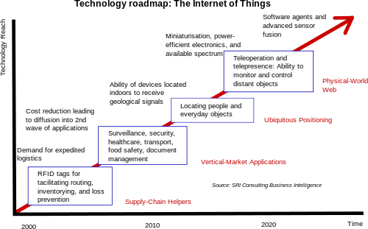

**Fig 1**: Roadmap of IoT

* 1. **Application of IoT**

According to Gartner, Inc. (a technology research and advisory corporation), there will be nearly 20.8 billion devices on the Internet of things by 2020. ABI Research estimates that more than 30 billion devices will be wirelessly connected to the Internet of things by 2020. As per a 2014 survey and study done by Pew Research Internet Project, a large majority of the technology experts and engaged Internet users who responded—83 percent—agreed with the notion that the Internet/Cloud of Things, embedded and wearable computing (and the corresponding dynamic systems) will have widespread and beneficial effects by 2025. As such, it is clear that the IoT will consist of a very large number of devices being connected to the Internet. On the other hand, IoT systems could also be responsible for performing actions, not just sensing things. Intelligent shopping systems, for example, could monitor specific users' purchasing habits in a store by tracking their specific mobile phones. These users could then be provided with special offers on their favorite products, or even location of items that they need, which their fridge has automatically conveyed to the phone.

* + 1. **ENVIRONMENTAL MONITORING**

Environmental monitoring applications of the IoT typically use sensors to assist in environmental protection by monitoring air or water quality, atmospheric or soil conditions, and can even include areas like monitoring the movements of wildlife and their habitats.

* + 1. **INFRASTRUCTURE MANAGEMENT**

Monitoring and controlling operations of urban and rural infrastructures like bridges, railway tracks, on- and offshore- wind-farms is a key application of the IoT. The IoT infrastructure can be used for monitoring any events or changes in structural conditions that can compromise safety and increase risk. It can also be used for scheduling repair and maintenance activities in an efficient manner, by coordinating tasks between different service providers and users of these facilities. IoT devices can also be used to control critical infrastructure like bridges to provide access to ships.

* + 1. **ENERGY MANAGEMENT**

Integration of sensing and actuation systems, connected to the Internet, is likely to optimize energy consumption as a whole. It is expected that IoT devices will be integrated into all forms of energy consuming devices (switches, power outlets, bulbs, televisions, etc.) and be able to communicate with the utility supply company in order to effectively balance power generation and energy usage. Such devices would also offer the opportunity for users to remotely control their devices, or centrally manage them via a cloud based interface, and enable advanced functions like scheduling (e.g., remotely powering on or off heating systems, controlling ovens, changing lighting conditions etc.). Besides home based energy management, the IoT is especially relevant to the Smart Grid since it provides systems to gather and act on energy and power-related information in an automated fashion with the goal to improve the efficiency, reliability, economics, and sustainability of the production and distribution of electricity.

**1.2 INTRODUCTION TO SMART CITY**

A smart city is an urban development vision to integrate information and communication technology (ICT) and Internet of things (IoT) technology in a secure fashion to manage a city's assets. These assets include local departments' information systems, schools, libraries, transportation systems, hospitals, power plants, water supply networks, waste management, law enforcement, and other community services. A smart city is promoted to use urban informatics and technology to improve the efficiency of services. ICT allows city officials to interact directly with the community and the city infrastructure and to monitor what is happening in the city, how the city is evolving, and how to enable a better quality of life. The idea of smart city came into formulation owing to the need to accommodate rapid urbanization of the age. Interest in smart cities continues to grow, driven by a range of socioeconomic and technological developments across the globe. It is due to the increasing number of smart cities that established suppliers from energy, transport, buildings, and government sectors are moving into the smart city market, while start-ups are addressing a range of emerging opportunities in the same field.

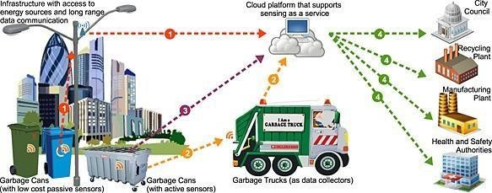

**Fig 2**: Smart city applications

**PROBLEM STATEMENT**

“Smart City automation for auto-generation of complaints regarding public utilities and 24 hours monitoring of pollution through IOT and sensors”

Several usable architecture systems are utilized in urban areas due to the cost of management, investment, and complexity are high. In the years ahead, it is normal that urban areas and other metropolitan places will experience asset circulation challenges related with an increment in populace stream, energy issues because of the exhaustion of petroleum product assets, expanded speculation overheads, spiraling support and the high costs because of maturing framework and inappropriate land asset usage, among others. Creative and new practical frameworks are fundamental to limit the effect of these eminent challenges.

**OBJECTIVES**

* Automatic street light control and pole complaint.
* Drainage Block detection.
* Water supply automation.
* Industrial pollution monitoring.

# **1.3 METHODOLOGY**

IS ANY SIGNAL

RECEIVED FROM

DRAINAGE BLOCK

DETECTION

SENSOR

AREA WISE

SOLENOID

VALVE FOR

WATER SUPPLY

Initialize NODE MCU

STREET LIGHT

ARRANGEMENT

DRAINAGE

ARRANGEMENT

TURN ON

OR OFF

RELAY

BLYNK

CLOUD

SERVE

IS ANY FAULT

SIGNAL

RECEIVED

FROM STREET

LIGHT SENSOR

IS ANY

SIGNAL

RECEIVED

FROM

INDUSTRIAL

POLLUTION

INDUSTRY FITTED

WITH CO2 SENSOR

**Fig 3:** Methodology

**1.3.1 Street light complaint generation circuit:**

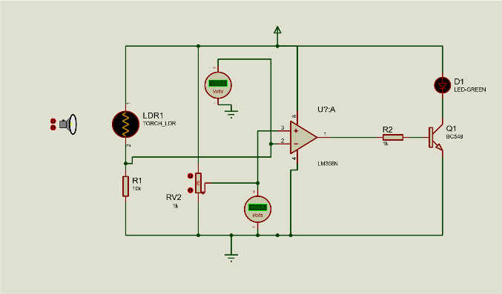

**Fig 4:** Street light complaint generation circuit

In street light monitoring system at the evening when the lights going to ‘on’ the optical sensor which is a photodiode or LDR (light dependent resistor) can be used, in case of availability of light(on) the sensors sense this illumination & provides the normal data to the driving stage. If at evening the street light doesn’t glow then the optical sensor senses this abnormality & provides a data to the driving unit & further this data has been converted in to the logical data now this data is send through WI FI module and controller.

**1.3.2 Drainage sensing circuit:**

For the sensing of drainage level in the cap of the toilet can be possible with float type sensor which goes to detect the level of the water. The float sensor detects the level of the liquid. When the water level exceeds the safe limit it now this data is sent through WI FI **.**



**Fig 5:** Drainage sensing circuit

**1.3.3 Solenoid valve operation for water supply:**

The switching unit consists of relay. Relay is an electromechanical switch & it works on the principle of energizing an electromagnet. It consists of primary coil, 2 contacts one is normally open contact “NO” & the other is normally closed contact “NC”& pole normally identified a common. The input for the relay coil can be connected to the required DC coil energizing voltage from its COM, N/O and N/C terminal any device of any voltage can be connect for switching actions. The control signal from the controller drives the particular solenoid valves.

**1.3.4 Industrial pollution monitoring:**



Fig 6: A MQ135 sensor on a small PCB.

The MQ135 is a cheap gas sensor that is primarily intended for detecting the presence of flammable gases. It is marketed as a generalized “air quality” sensor, rather than precision device for measuring the concentration of any specific gas. Nevertheless, according to the data sheet the MQ135 is capable of measuring the concentrations of several gases, one of which is CO2. This makes it an attractive low-cost alternative to more specialized (and more expensive) CO2-specific sensors. Much has been written about using the MQ135 as a CO2 sensor, mostly focusing on using it together with Arduino. This article will, firstly, discuss the working principles of the MQ135 sensor and how to read the data sheet, and secondly present how to use it with the PSLab.

**RESULTS**

Smart Cities are the need of the century where everyone is interested in super fast progress and at the same time there is a requirement that the progress becomes sustainable. The Smart City is the ideal way in which the country progresses.

Smart Cities should promote innovation, equality and wider reach of services to all citizens. IOT plays a key role in making cities smarter, openness of data and interconnection and interoperability between different data sources and services is a key requirement. In conclusion it can be said that as India is a developing nation and the “Smart Cities” might help in raising the standard of living of the people by providing all facilities required and it can contribute to the economic growth of the country and may also be helpful for other initiatives like Make in India, Digital India etc. This project can place India among top nations of the world.

* At evening the street light doesn’t glow then the optical sensor senses this abnormality & provides a data to the driving unit.
* When the water level exceeds the safe limit then the data is sent through WI-FI module and controller.
* To make automation for water supply we are using here solenoid valves which are going to control the action of closing and opening to supply the water to the areas.
* If the industries exceeds beyond specified PPM then the Co2 sensors detects and send to pollution

**3. CONCLUSIONS**

Astute smart cities offer a fertile environment to host astute software applications which ease life of people. They sanction efficiently controlling of resources and adaptive management of flows. Immensely colossal magnitudes of amassed data and involute quandaries to solve for ascertaining optimization of different metrics inspirited us to design the above-mentioned solutions described in the paper. This paper tries to take the most efficient yet simpler solutions through the multiple solutions that exist and tries to compile them into a single amalgam for it to be effective and at the same time tries to prevent certain known problems from arising during its implementation

**REFERENCES**

[1] Tintu Joseph , Roopesh Jenu, Ajmal K Assis,Sajith Kumar V A, Sasi P M, Dr. Alexander G, “IoT Middleware for Smart City ”, Centre for Development of Advanced Computing, Trivandrum, India, 2017.

[2] Nabil Ouerhani, Nuria Pazos, Marco Aeberli, Michael Muller, “IoT based Dynamic Street Light Control for Smart Cities ”, International Symposium on Networks, Computers and Communications, pp. 171175, Switzerland, 2016.

[3] Sanchit Bhasin, Tanupriya Choudhury, Subhash Chandra Gupta, PraveenKumar, “Smart City Implementation Model Based on IoT ”, 2017.

[4] Fehda Malik, Munam Ali Shah, “Smart City: A Roadmap Towards Implementation ”, 23 rd international Conference on Automation and Computing, University of Huddersfield, pp.. 29-34, Huddersfield, UK, 2017.

[5] Rohaida Husin, Syed Abdul Mutalib Al Junid, Zulkifli Abd Majid, Zulk-ifli Othman, “Automatic Street Lighting System for Energy Efficiency based on Low Cost Microcontroller “, International Journal of simulation Systems, Science, and Technology, pp. 43-48, Vol. 13, Malaysia, 2012.

[6] Anto Merline M, Vimalathithan R, “Smart City: Issues and Reserch Challenges in Implementation ”, IEEE International Conference on Smart Grid and Smart Cities, pp. 263-266, Coimbatore, India 2017.

[7]Gaurav Sarin “Developing Smart Cities using Internet of Things : An Emperical study”, 3rd International Conference on Computing for Sustainable Global Development, pp. 40-43, Vol.4, NewDelhi, India, 2016.