**Chapter 1: INTRODUCTION**

* 1. **INTRODUCTION**

Nowadays, in the present state of intense competition, production efficiency is generally regarded as the key of success. Production efficiency includes the speed at which production equipment and production line can be lowering material and labor cost of the product, improving quality and lowering rejects, minimizing downtime of production equipment and low cost production equipment.

Taking this matter under consideration the project is developed which is very useful for industries. Machines can perform highly repetitive tasks better than humans. Worker fatigue on assembly lines can result in reduced performance, and cause challenges in maintaining product quality. An employee who has been performing an inspection task over and over again may eventually fail to recognize the color of product. Automating many of the tasks in the industries may help to improve the efficiency of manufacturing system.

The purpose of this model is to design and implement a system which automatically separates products based on their color. This machine consists of three parts: conveyor belt, color sensor, and dc motor. The output and input of these parts was interfaced using Atmega 38P microcontroller. To reduce human efforts on mechanical maneuvering different types of sorting machines are being developed. These machines are too costly due to the complexity in the fabrication process. A common requirement in the field of color sorting is that of color sensing and identification. Mainly the color sorters are used in agricultural machineries like rice sorter, beans sorter, peanut sorter etc. Color sorters are used in other, industrial applications also like quartz sand sorter, plastic granule sorting of colored nuts and bolts etc. It reduces the human effort, labor and cost.

There are three main steps in sensing part, objects detection and recognition. The system may successfully perform handling station task, namely pick and place mechanism with help of sensor. The Arduino microcontroller sends signal to circuit which drives the various motors of the robotic arm to grip the object and place it in the specified location. Based upon the detection, the robotic arm moves to the specified location, releases the object and comes back to the original position.

**1.2 PROJECT PLANNING**

To begin with, the main ideation of this project began during the time of our internship period, in the sixth semester. In this internship, we saw how different process and departments work together, communicating with each other to make a desired product or component. If any of this manufacturing process comes to halt, the company would have to bear heavy losses. So, in order to minimize necessary that all the process should work smoothly. Also, the overall efficiency of the system, plays a major role in the production. Therefore, to increase this efficiency the speed of the production needs to be increased.

There in the industry, we observed that most of the work of sorting was done manually. This manual sorting was a time consuming process and mostly dependent on the skill of the worker. Worker fatigue on assembly lines can result in reduced performance, and cause challenges in maintaining product quality. So, there was a high chance of sorting a wrong component ahead of the dispatch. This can decrease the image of the company in the market and have to bear losses. This problem of manual sorting can be solved by introduction of automation in it.

Automation can easily speed up the process as it can perform highly repetitive task better than humans, with high accuracy and precision. This will in turn will increase the efficiency of the system. Therefore, generating higher profits for the company.

* 1. **HISTORY**

The history of color sorting machines can be traced back to the early 1900s when farmers used manual methods to sort and grade their crops by hand. However, with the advent of automation and the need for increased efficiency, automated sorting machines began to emerge in the mid-20th century.

The first color sorting machines used basic technology such as photoelectric sensors and mechanical sorters to separate products based on color and size. These early machines were limited in their capabilities and were often used in a single product line.

In the 1980s, the development of digital image processing technology led to the creation of more advanced color sorting machines. These machines used digital cameras and computer algorithms to analyze each individual product and sort them based on a variety of characteristics including size, shape, and color. This allowed for greater accuracy and efficiency in the sorting process.

Today, color sorting machines are used in a wide variety of industries including agriculture, food processing, and recycling. They continue to evolve and improve with advancements in artificial intelligence and machine learning, allowing for even greater accuracy and efficiency in the sorting process.

# PROBLEM STATEMENT

Based on a survey conducted in a helmet manufacturing company named Hero Corp, there was a problem regarding the count of the total manufactured products and also, there were various assembly lines for every different colored helmet.

The main idea was to provide a single conveyor for all the different colored products which would decrease the work space and labor cost but also provides the basic function of segregating different colored objects into its respective boxes.

Also, the accurate count of the manufactured products could be centralized using wireless communication. In a food packaging industry huge amount of time and labor is invested. An object sorting robot would decrease the time, work space and labor cost while providing the basic function.

To decrease human works in operating the mechanical machines, different functionality robotic arms are established. Different functionality arms that are used in robotics are designed and developed to handle the jobs that are repeated. Different considerations are taken care to design the automation system.

To design a high strength mechanical structure, these are the important parameters are to be consider and those are load bearing capacity, optimum weight, degree of rotation and speed of movement. In the form of designing an electronics system the specification of the used electronics devices are to be considered

**1.5 OBJECTIVES**

1. The objectives of this project is to write color recognizing and color sorting code. And to integrate color recognizing, sorting and motor with microcontroller.
2. To make the process of sorting the material, this Color sorting is being designed.
3. In some of industries use man power to transfer the material form one place to other by repeating this for a period of time it will cause injuries to an operator.
4. The use of this machine make the work simple for the operator, and no longer to bend and lifts up the materials, this reduce the cause of injuries to the operator and increasing the work efficiency.
5. This technology enables to have more accurate and efficient sorting on production lines across a wide range of industries, saving time, labor and money.

# 1.6 SCOPE OF WORK

1. By replacing the DC motors by Stepper motors we can increase the accuracy of the system, also the life of the system increases.
2. The sensors used in the system can be replaced by cameras for digital processing which is done using ‘‘MATLAB’.
3. Robotic arm can be used instead of flippers and containers to place the object at desired locations, thus making the process of sorting more effective.
4. Required Modifications can be done to inspect cracks, defects on the surface of the object etc.
5. Also we can use such system with some modifications for various types of inspection such as holes diameter, height, thickness, surface defect.
6. Segregation based on size can be done by installation of sieves of various sizes.
7. Some rubber grippers can be used. It increases surface resistance which helps to avoid slipping of conveyor belt.
8. Color sorters can also be used in the diamond industry. The transparency of the diamond can measured by the color sorter and used as a measurement of its purity, and the diamonds ca[n be mechanically sorted accordingly. This has an advantage over fluorescence](https://en.wikipedia.org/wiki/X-ray_fluorescence) methods of robotically detecting purity, since purer diamonds are less likely to fluorescence.

# 1.7 METHODOLOGY

PROBLEM

STATEMENT

LITERATURE

REVIEW

PRELIMINARY

DESIGN

MATERIAL/

EQUIPMENT

REQUIREMENT

FABRICATION/

ADJUSTMENT

IN DESIGN

FINAL

MODEL

ANALYSIS/

RESULT/

CONCLUSION

**The various steps involved in methodology are as follows: -**

**Step 1**: **Problem Definition-** A particular problem is taken into consideration and problem definition is prepared. Other parameters such as scope of work, objectives of work are also defined.

**Step 2: Literature Review-** Searching various research papers and studying them thoroughly. Then collecting the important information from them. Thus, literature review on the title is done thoroughly covering all the aspect of the project. The medium for this research is via internet and books. Essential information related to the project is gathered for referencing.

**Step 3: Preliminary Design -** Designing a color sorting machine based on the analysis of the solution. Deciding the dimensions of the frame and selection of the electronic devices required for the functioning of the machine. In conceptualization, few designs sketches are prepared manually on a paper which are then reviewed. Then the best design is selected and discussed with the teachers for confirmation.

**Step 4: Material Equipment -** Selecting material and the required components from market at the best optimum price and quality.

**Step 5: Fabrication -** After finalizing the design and material, fabrication of model is done and various finishing operations are performed.

**Step 6: Final Model -** After manufacturing of each component, they are assembled suitably and thus the final model is ready.

**Step 7: Analysis -** Checking whether the machine is working properly and also test the functioning of all the components.

In designing of color sorting machine, a flow chart of methods had to be used to describe it systematically. First of all, a process planning had to be charted out. This acts as a guideline to be followed so that, the final model meets the requirement and time could be managed. This would determine the efficiency of the project to be done. Regulating and analyzing these steps are very important as each of it has its own criteria to be followed.

So during our internship we observed that the most of the sorting process work was done manually. So, we decided if we can add some automation in this process then considerable amount of time and energy can be saved. Because machine can perform highly repetitive task better than humans.

Before coming on any conclusion we decided to have a talk with industries workers and the managers there, and after doing a lot of research and studying research papers from various sources. We concluded that we can add automation in the process of sorting. Hence decreasing the time, money spent in sorting and increase in production, thereby increasing the overall efficiency of the industry.

After doing research we gathered the materials and components needed for our project. The basic materials needed were an Arduino Nano V3.0, DC motors, Servomotors, color sensor, Conveyor system, etc. After getting the parts we designed the 3D view in AutoCAD, and started the designing and doing calculations of our project. The bearings and conveyor design data was collected from P.S.G Design data book and made all the necessary calculations

**1.8 LIST OF PARTS USED IN COLOR SORTING MACHINE**

**1. Arduino UNO R3 board.**

This board comes with all the features required to run the controller and can be directly connected to the computer through USB cable that is used to transfer the code to the controller using IDE (Integrated Development Environment) software, mainly developed to program Arduino.

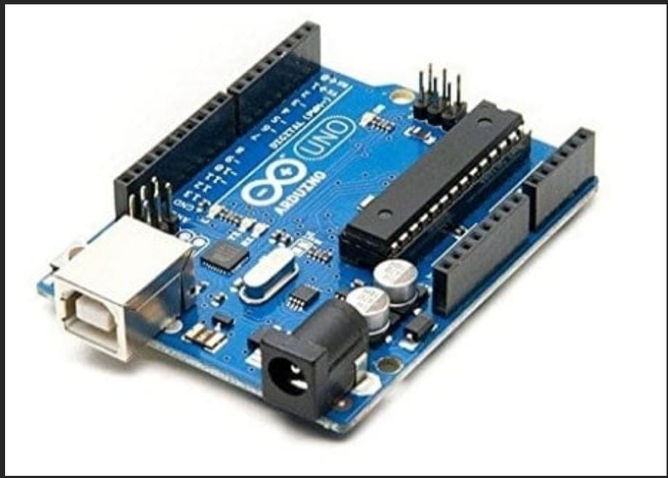

Fig1.8.1 Arduino UNO board

The detailed specification of the Arduino Nano board is as follows:

* Operating Voltage: 5 V
* Input Voltage(recommended): 7-12 V
* Input Voltage (min and max): 6-20 V
* Digital I/O Pins: 14

(of which 6 provide PWM Output)

* Analog Input Pins: 6
* Flash Memory: 32 KB
* Clock Speed: 16 MHz

**2. Servomotors**

It is tiny and lightweight with high output power. This servo can rotate approximately 180 degrees (90 in each direction) and works just like the standard kinds but smaller. You can use any servo code, hardware, or library to control these servos. It comes with 3 horns (arms) and hardware. The Specifications of Servomotors are mentioned below:

[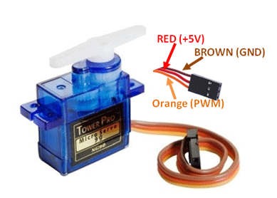](https://components101.com/sites/default/files/component_pin/Servo-Motor-Wires.png)

Fig.1.8.2 Servomotor

The detailed specification of the servomotor is as follows:

* Operating Voltage is +5V typically
* Torque: 2.5kg/cm
* Operating speed is 0.1s/60°
* Gear Type: Plastic
* Rotation: 0°-180°
* Weight of motor: 9gm
* Package includes gear horns and screws

**3. Color Sensor (TCS-34725)**

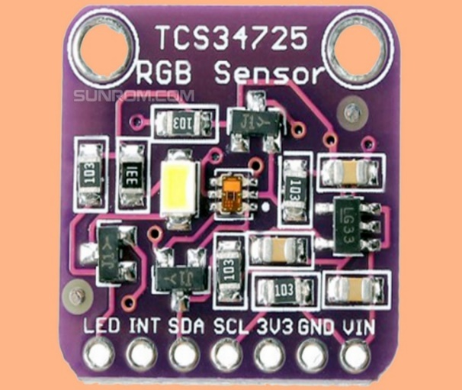

Fig.1.8.3 TCS color sensor

The detailed Specifications of color sensor is as follows:

* Interface: I^2C
* Sensing Range: RGB
* Sensor Type: Light Color Sensor
* Supplied Contents: Board(s)
* Utilized IC/Part: TCS34725
* Voltage-Supply: 3.3V~5V

**4. Conveyor System**

Conveyors system is a piece of material handling equipment that carries material from one location to another. Conveyors are especially useful in an application involving the transportation of heavy materials.

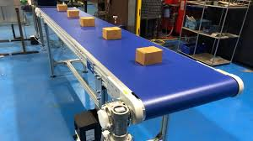

Fig.3.8.4 Conveyor Belt

**Chapter 2: LITERATURE REVIEW**

The Design of sorting machine and adding automation with a conveyor belt is a very complex process to execute.  The system needs to satisfy industry requisitions. This is an industrial automation based application. It shows the concept of normal conveyor belt, but with some intelligence. We can also call it as intelligent conveyor belt, as it has also ability to sort the object of different color and size. By developing such sorting system, the production rate of the manufacturing industry has been increased since these sorting systems reduces the time for production which wasn’t possible with human resources.

The compilation of system and interfacing of various elements, sensors, servo motors, hardware and software package interfacing of the system is prescribed by the “Software interfacing of TCS34725 color device with Arduino”.

**LIM JIE SHEN [1]**, the paper shows a new approach for continuous recognition and sorting of objects into desired location. Image or colors processing nowadays attract massive attention as it leads to possibility of widening scope of application in different field with the help of modern technology. During this paper color sorting automation is research designed and created with Arduino UNO microcontroller, TCS34725 color device, SG90 tower professional servo motor and alternative physical science element. They found that color device provides totally different results once it tested outside and indoor. This gave the knowledge of how a robot is used for the sorting process and no manual help or labor was needed.

**Dhanoj. M [2],** he researched on automatic arm primarily based color sorting robot isn’t the good treatment to TCS3200 color device. They were additionally used liquid crystal display to display the color detected. In image process image is captured mistreated with real time system like digital camera so objects are often sorted as per our demand like on the idea of shapes and colors. Direct interfacing of motors with a controller gives a little bit over load on whole system operation to overcome this drawback the motor driver circuit is used to provide high current to motor. We are using L293D IC to build motor driver circuit.

**P. Shinde, et. al [3]**,he Described Sorting of Objects Based on Weight, Color, and Type on A Conveyor Line Using PLC. They have proposed a system which would increase the accuracy and Production rate of material handling systems. The system would separate out objects based on their form i.e. metal or non-metal, weight and color as per as consumer requirement. Usage of PLC with the frame of logic gates will make program alteration easy and thus, we can modify the system according to the requirements

**N. Aarthi1, P. Sahithi et.al [4]**, they researched on Automated Object Sorting Using Raspberry Pi. There published work gave different ideas in which this sorting mechanism can be taken into consideration. They said sorter not reduces the manual effort but conjointly the time required, hence increasing the efficiency.

**Aye Myat Myat Myo, Zar Chi Soe et.al [5]**, automatic color sorting machine using Arduino mega microcontroller. The paper describe system can work with success and classify the thing by its color. The color sorting machine may be a good color sorter that may acknowledge RGB color balls and Drop the balls within the right place”. There are classifiers that use PIC microcontrollers however cannot. Several are often simply created exploitation Arduino programming. “The real benefit of this technique is that it reduces the time needed for color sorting, which makes this system more economical than the present one”. This sorter not solely reduces the manual effort but conjointly the time required., but also forestall color blind individuals from selecting the wrong color and being unable to settle on the proper color

**V. Rautu, A. P. Shinde et.al [6]**,sorting of objects based on color, weight and type on a conveyor line using PLC. They gave us the knowledge of how different sensors are responsible and helpful for the sorting based on weight and color.

**Ch. Shravani, G. Indira et.al [7]**, Arduino based color sorting machine using TCS3200 color sensor. Sorting objects is an essentially mechanical process that requires hard work. Chronic manual organization leads to consistency problems. The most important aspect of machines is their ability to perform tedious tasks better than humans. Worker burnout in sequential manufacturing structures can lead to reduced execution and purpose issues when it comes to holding the object well. An employee who has repeatedly researched may eventually forget to recognize the color of the article, but not a machine. Based on the shading of the TCS3200 shading sensor coupled with servomotors and Arduino, this document was used near the organization of elements that are fully used on shading.

**N. Monika, C.R. Pramod, et .al [8]**, Arduino based color sorting machine, there is a wide range of many products in our daily life, and the manufacture of these products occurs in many large and small industries. It is consistent with the organization's commitment to quality. Too many items to sort. Organizing elements in an industry is a tedious process that is usually done physically. However, classifying items by physical methods is more time-consuming. To save time and be accurate in sorting, we introduce automatic color sorting machine. Color sorter is a device that sorts the object by its color. We use the TCS3200 color sensor to detect the color of any object and after detecting the color. The servo motor rotates and according to mechanism the object will be allocated to particular box. They can be used in a variety of applications where color discrimination and color classification is important. Some of the application areas are agribusiness (color sorting of grain), food industry, diamond and mining industry, recycling, etc.

# 2.1 REVIEW OF PAPERS

Table no. 2.1: Review of papers

|  |  |  |  |  |
| --- | --- | --- | --- | --- |
| **Sr.no** | **Year of publication** | **Author Name** | **Journel Name** | **Findings** |
| 1. | 2019 | Ch shravani, G Indira, V Appalaraju. | International journal of innovative technology ISSN: 2278- 3075 | It is a sorting mechanism based on coloration. It uses microcontroller for processing. |
| 2. | 2018 | Himanshu Patel , Riya Joy , Selin Macwan , Hardik Modi | International journal of applied engineering research ISSN: 0973-4562 | Internet of thing module is used. It gives us an idea how a robot can be used for sorting |
| 3. | 2017 | Aung thike, Zin Zin Moe San, Dr. Zaw Min Oo | International journal of science and engineering applications ISSN: 2319- 7560 | They have used electronics machine building and programming. Arduino based working. |
| 4. | 2019 | DA Jakkan, Chaugule Bharat Sudhakan , Jagtap Sanket vilas , Khan Umar Aslam | MAT journal of embedded system and processing | Cloud platform and Wi-Fi module is used along with Arduino UNO controller. |
| 5. | 2014 | LIM JIE Shen , Irda Hassan | Hassan Journal of engineering science and technology EURECA-2014 | Arduino Uno and robot is used, they have tested for different color selections, also developed hardware software algorithm. |

**2.2 OBSERVATIONS FROM LITERATURE REVIEW**

In the first research paper, as mentioned in the above table, we found that Arduino based color sorting machine using TCS3200 color sensor. Sorting objects is an essentially mechanical process that requires hard work. So our finding is about a sorting mechanism based on coloration. It uses microcontroller for processing.

In the second research paper, as mentioned in the above table, we found out that Internet of thing module can be used for sorting of materials. It gives us an idea how a robot can be used for sorting. This internet of thing can be used to integrate the robots with the computer to increase the efficiency and speed.

In the third research paper, as mentioned in the above table, we found out that automatic color sorting machine can be used using Arduino mega microcontroller. The paper describe system can work with success and classify the thing by its color.

In the fourth research paper, as mentioned in the above table, we found out that they have used electronics machine building and programming. Arduino based working.

In the fifth research paper, as mentioned in the above table, we found out that cloud platform and Wi-Fi module is used along with Arduino UNO controller Arduino Uno and robot is used, they have tested for different color selections, also developed hardware software algorithm.

**CHAPTER 3: DESIGN AND CALCULATIONS**

# Calculating the Torque of the Conveyor

Table 3.1 represents the main mechanical properties of the conveyor belt and some mechanical coefficients.

Table no. 3.1 Mechanical properties

|  |  |
| --- | --- |
| **Properties** | **Value** |
| Stainless Steel density | 8000 Kg/ m3 |
| Belt density | 1200 Kg/ m3 |
| Belt thickness | 0.005 m |
| Belt width | 0.2 m |
| The diameter of the pulley | 0.058 m |
| Friction coefficient μ | 0.35 |

Belts and other similar elastic or flexible machine elements are used in conveying systems and in the transmission of power over comparatively long distances. Because of its inherent advantage that it can absorb a good amount of shock and vibration. It can take care of some degree of misalignment between the driven and the driver machines. Figure shows a flat belt geometry.

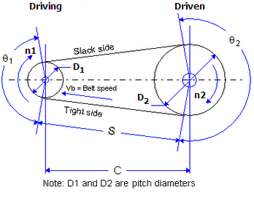

Fig 3.1.1: Flat belt geometry

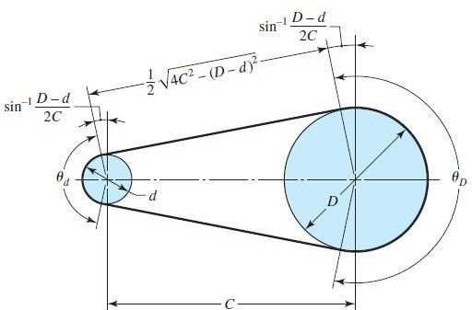

Fig 3.1.2: Flat belt geometry

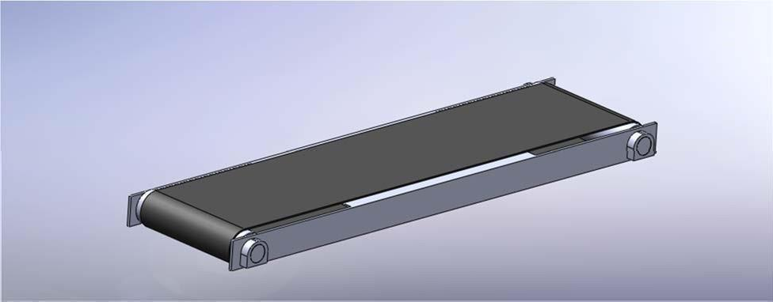The following Figures show our conveyor Figure, Top view Figure and all dimensions shown are in mm.

Fig 3.1.3: Conveyor Isometric view

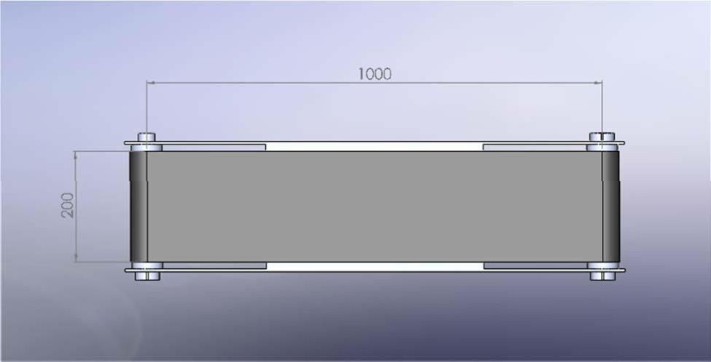

Fig 3.1.4: Top View

The angle of contact in the driven and driver roller

Θd = п – 2 sin-1(D-d/2C)

= п

ΘD = п – 2 sin-1(D-d/2C)

= п

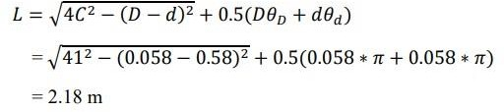The length of the belt is found by summing the two arc lengths with twice the distance between the beginning and end of the contact. The result is

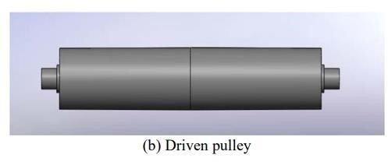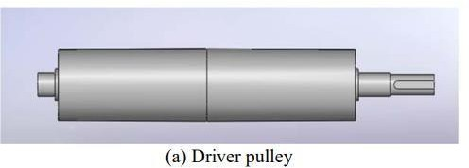

## Fig 3.5 & 3.6: Driver and Driven Pulley

Where:

D: diameter of the large pulley

d: diameter of the small pulley

C: center distance

Θ: angle of contact

L: total length of the conveyor belt (m)

The area of the belt= L*W

= 2.18 x 0.2

= 0.436 m2

The Volume of the belt= thickness x area

= 0.005 x 0.436

= 2.18 x 10-3 m3

The mass of the belt= density x volume

= 1200 x 2.18 x 10-3

= 2.616 kg

We suppose that the belt will carry ten pieces of steel with following dimensions (0.05, 0.05, and 0.05) m. Volume of one piece = length x width x height

=0.05 x 0.05 x 0.05

=1.25 x 10-4 m3

Mass of object = 10 x ρsteel xVolume of one piece

= 10 x 8000 x 1.25 x 10-4

= 10 kg

The total mass (M) = Mass of belt + Mass of object

= 2.616 + 10 = 12.616 kg

The force produced from this mass

F = M x g

= 12.616 x 9.8 = 123.76 N

The friction force Ff =  F x μ

= 123.76 x 0.35

= 43.32 N

The belt motor torque found by substitution in Newton’s second law:

*ΣM0 = J0 Ӫ*

T-F*f* × r-*Ct Ӫ = J0 Ӫ*

T=*J0 Ӫ +Ct* θ̇ + *Ff .r*

*α= Ӫ*

Now we have to calculate the mass moment of inertia

*J0= ½ mequivalent* ×  *r2*

*T=½ mequivalent* ×  *r2 α+Ct ω* + *Ff .r*

*Maximum speed= 0.05 m/s*

*ω= speed/r = 0.05/0.029*

*= 1.72 rad/sec*

*α= dω / dt = ω2- ω1 / t2-t1*

*ω2=1.72 rad/sec*

*t2= 0.5sec*

*α=3.44 rad/sec2*

*mequivalent = mbelt + 2mpulley + mobject*

*mpulley = ρsteel* × area of pulley × length of the pulley

= 8000×0.0292×Π×0.2

= 4.23kg

Mass moment of inertia *J0 = mequivalent* × 0.029

=0.0177kg/m2

T=*J0 Ӫ + Ct* θ̇ + *Ff .r*

The value of the bearing friction (Ct) is taken from the table

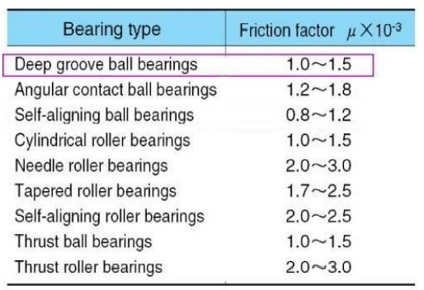Table 3.2: Bearing Coefficient Factor (Ct)

= (0.0177 x 3.44) + 4 x (1.5 x 10-3 x 1.72) + (43.32 x 0.029)

= 1.33 Nm

Therefore the torque we consider for conveyor belt is 1.33 Newton.

# 3.2 CALCULATING THE POWER OF MOTOR

After calculating the required torque of the conveyor motor we can now calculate the required power by equation

Pout = w.T

= 2.2876 watts

Where:

V: Volume (m^3)

A: Area (m^2)

M: mass (kg)

**ρ: density of stainless steel (kg/m^3)**

**Ct: Bearing coefficient factor**

µ: Friction coefficient

Jo: Mass moment of inertia

α: Angular acceleration

ω: Angular velocity

**3.3 BEARING DESIGN**

In this section, we will choose appropriate bearing. Figure illustrates the main part of the ball bearing.

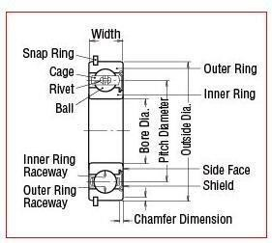

Fig 3.2.1 the main parts of the ball bearing

We have to compute the forces by applying these equations

Fx = ma

Fy =0

Fx = 10 x 118.62

= 1186.2 N

Fy = Total mass x g

= 123.76 N

The resultant radial force, Fr = Fx2 + Fy2 = √ (1186.2) ² + (123.76) ²

= 1192.64 N

Now the desired radial load Fd = Fr = 1192.64 N

We have to calculate catalog load rating (dynamic load rating) C10

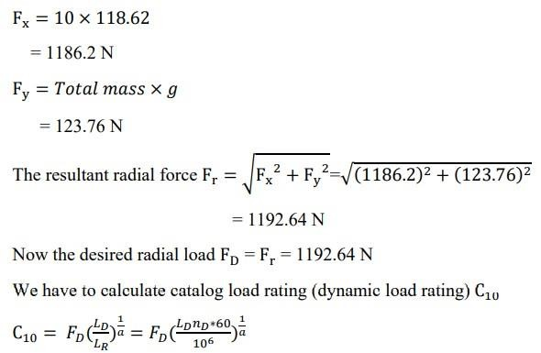

Where:

LD : desired life, hours

nD : Desired speed, rev/min

a: Load factor

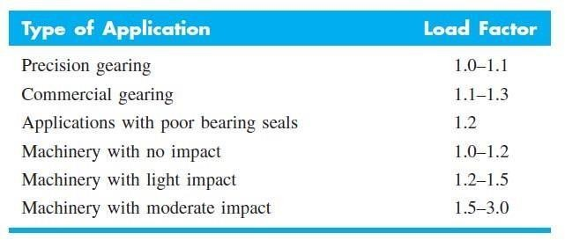Table 3.3:Load application factor

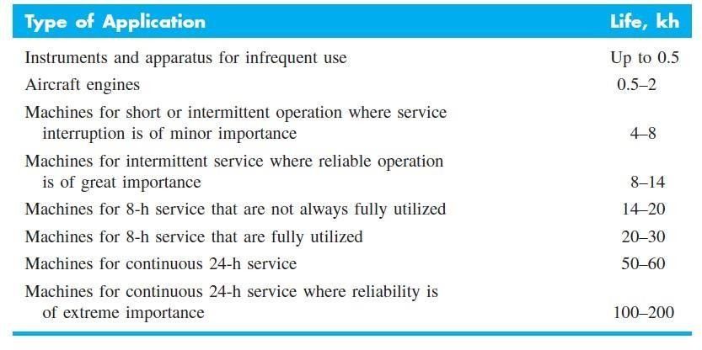 Table 3.4: Bearing-life recommendations

From, a= 0.7

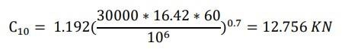And from Table 5.3, Ld = 30 kh

Table 3.5: Dimensions for single-row 02-series deep-groove and angular- contact ball bearing

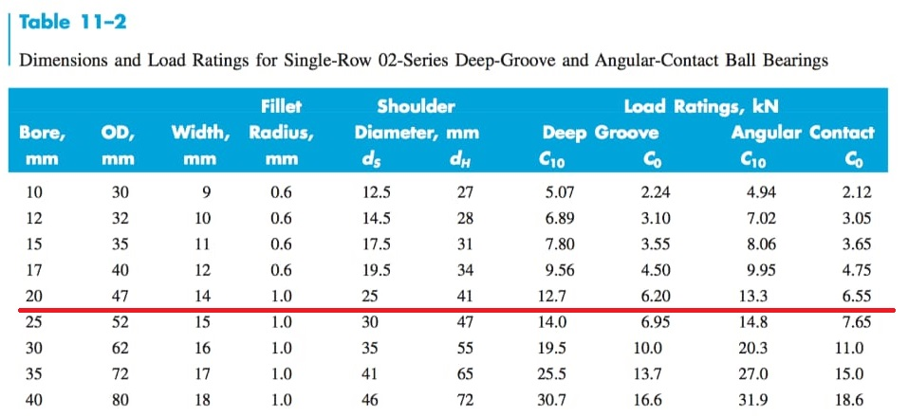

From Table, we choose a bearing with the following specification

Bore = 20 mm, OD = 47 mm and width = 14 mm

Hence we have finalised to use Single row deep groove ball bearing for our application

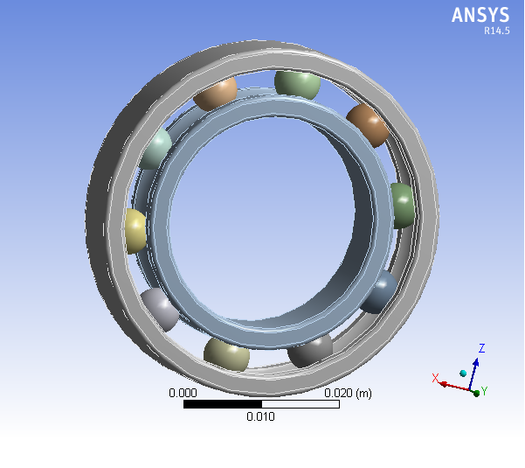

Figure 3.3.1: Block bearings – bearing house

**Chapter 4: WORKING AND FLOWCHART**

**4.1 CONNECTIONS LINE DIAGRAM**

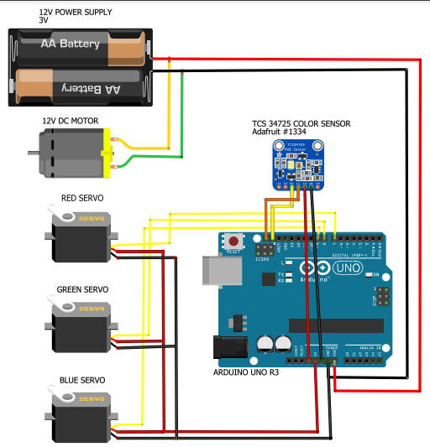

Fig.4.1 Connection of parts

**4.2 WORKING**

The proposed system is designed for automatic sorting of Red or Green or Blue colored products. The prototype consists of two DC motors, conveyor belt, a PIC and a color sensing circuit using TCS34725. DC motors are used to control the conveyor belts. After integrating the programmed PIC and the TCS34725 circuitry with the structure of the model, we measure the frequency of signals corresponding to each color by observing them on a CRO.

Based on this study the timer delay value is adjusted by reprogramming the PIC. The time required for the product to reach the corresponding container in the separator placed on second conveyor belt is also considered. The end section consists of a DC motor (12V, 100rpm), which is used to control the movement of the conveyor belt in order to position the according to the sensor output.

Table 4.1: Machine Components

|  |  |  |
| --- | --- | --- |
| **SR.NO.** | **COMPONENTS** | **DESCRIPTION** |
| 1 | Shaft | 20mm diameter |
| 2 | Bearing | Inner diameter 20mm  Outer diameter 45mm |
| 3 | Acrylic color Box | 3 Boxes (Red, Blue, Green) |

**4.3 FLOWCHART**

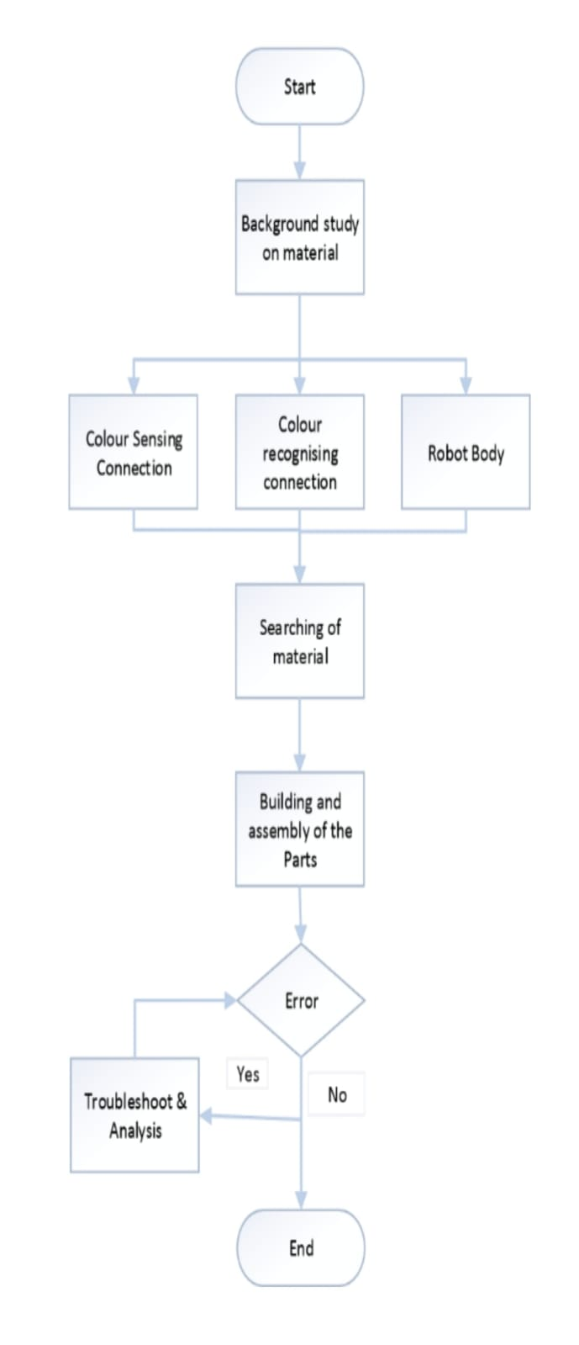

**Chapter 5: TESTING**

During the time of our initial testing, the Arduino board which we used was Arduino Nano V3 board. After doing some trials on this board, we found that the processor of Arduino Nano board was not compatible to our requirements. Since, the processor of Nano board is not much powerful and capable to handle the data efficiently. Moreover, the current fluctuated many times and our color sensor got damaged.

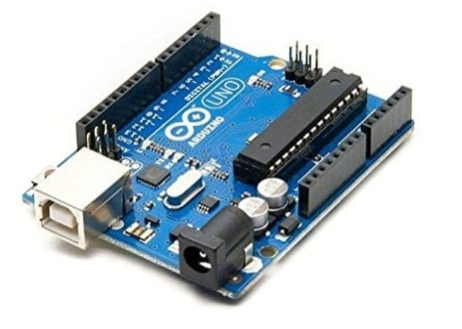

Fig. 5.1 Arduino UNO board

Therefore, after a series of trial and testing events, we decided to replace the Arduino Nano board with Arduino UNO board, which has a high processing capacity and fulfils our requirement.

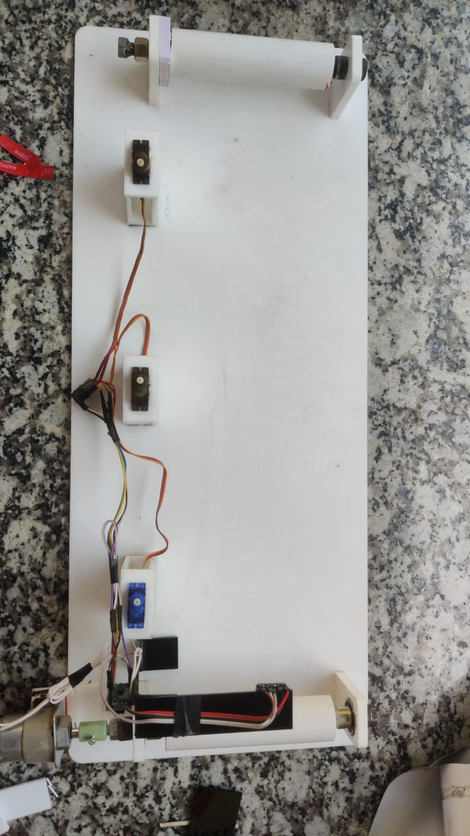

Fig. 5.2 Testing of the sensor

After selecting the appropriate Arduino board, we compared different color sensors online and tried to select the desired sensor, which will be cost effective and fulfil our requirement for our project model. For this we compared almost three to four color sensors which are available in the market. For example, TCS3200, TCS34721, TCS34723, TCS34727and TCS34725. Later, comparing all these sensors, there detailed specifications and costing, we come to a conclusion and decided to use TCS34725 color sensor, this sensor was cost effective and completed our objective.

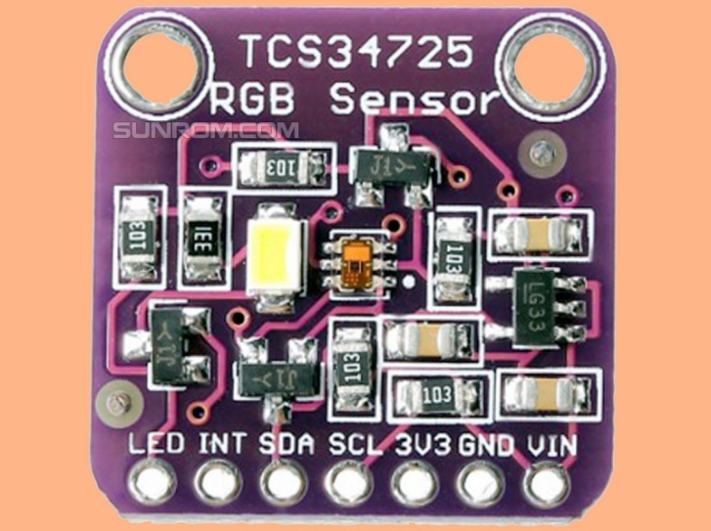

Fig 5.3 TCS 34725 color sensor

At the initial stage of programming, we just had the basic knowledge of how programming is done in Arduino, and also we didn’t had any expertise in this field of coding. So, for this we took some help of our friends who had good knowledge and hands on experience with Arduino.

To begin with, the first error which we experienced with our programming was that that the sensor failed to detect the RGB color of the box, and also after replacing the sensor with new, one the problem still prevailed. Later, we found out that the problem was not with the color sensor, but with the program itself. The problem with the code was that, the wavelength of the Red, Green and Blue color was not justified correctly in the program and because of that the sensor failed to reorganize the color. So, we corrected the, mistake and rectified the mistake.

The second problem we faced while doing the programming was, after detecting the color of the box by the sensor, the closing time of the mechanical arm was not matching with the speed of the box on the belt. And the mechanical arm failed to sort the box in the compartment. The problem with this time delay was in the code, we were facing difficulty to match the time of closing of mechanical arm and with the speed of the box. So, what we did was we calculated the time delay using hit and trial method and the time delay we set was 2 sec for Red color flapper, 3 sec for Green color flapper and 5 sec for Blue color flapper.

**Chapter 6: AURDINO PROGRAMMING**

// Libraries included

#include "Servo.h"

#include "Wire.h"

#include "Adafruit_TCS34725.h"

// Initialize servo object

Servo myservo;

Servo myservo2;

Servo myservo3;

// Initialize the color sensor object

// parameters see: https://learn.adafruit.com/adafruit-color-sensors/program-it

Adafruit_TCS34725

tcs=

Adafruit_TCS34725(TCS34725_INTEGRATIONTIME_50MS, TCS34725_GAIN_1X);

// setup () is executed once when the Arduino starts

void setup() {

// Serial communication to output the value in the serial monitor

Serial.begin(9600);

Serial.println("Starting Color Sorting Machine");

delay(500);

// Check whether the Color Sensor reports back

if (tcs.begin()) {

// Everything OK

Serial.println("Sensor found");

} else {

// No sensor found. Freeze the program at this point

Serial.println("TCS34725 not found ... process stopped!");

while (1); // Halt!

}

// The servo is connected to PWM pin 3

myservo.attach(7);

myservo2.attach(8);

myservo3.attach(9);

// Drive servo in basic position

myservo.write(180);

myservo2.write(180);

myservo3.write(180);

delay(1000);

}

// loop () is repeated as long as the Arduino is running

void loop() {

// The sensor returns values ??for R, G, B and a clear value

uint16_t clearcol, red, green, blue;

float average, r, g, b;

delay(100); // Farbmessung dauert c. 50ms

tcs.getRawData(&red, &green, &blue, &clearcol);

// Get average of RGB

average = (red+green+blue)/3;

// color values ​​by average,

// all values ​​are now around 1

r = red/average;

g = green/average;

b = blue/average;

Serial.print("\tClear:"); Serial.print(clearcol);

Serial.print("\tRed:"); Serial.print(r);

Serial.print("\tGreen:"); Serial.print(g);

Serial.print("\tBlue:"); Serial.print(b);

if ((r > 1.4) && (g < 0.9) && (b < 0.9)) {

Serial.print("\tRED");

myservo.write(115);

delay(2000);

}

else if ((r < 0.9) && (g > 1.2) && (b < 1.1)) {

Serial.print("\tGREEN");

myservo2.write(115);

delay(3000);

}

else if ((r < 0.95) && (g < 0.95) && (b > 1.2)) {

Serial.print("\tBLUE");

myservo3.write(115);

delay(5000);

}

else {

Serial.print(" No object detected please keep object");

myservo.write(180);

myservo2.write(180);

myservo3.write(180);

}

// output line break

Serial.println("");

// Adjust waiting time for serial debugging

delay(100);

}

**Chapter 7: RESULTS AND DISCUSSIONS**

Below given are the pictures taken of the trials done after successful assembly of the prototype. This is a scale down model made by our group following the given design procedure. The rollers are made by using the axles of a cycle fixed inside 2 inch PVC pipes and the driver pulley of rotated by a DC motor of 100rpm. The length of the conveyor belt in our model is almost 50cm and width is 12cm. The material of the belt of conveyor is of leather. 3 servomotors are attached along the path and they rotate on an angle of 55 degrees. The first servomotor sorts red color box, the second servomotor sorts green color box, the third servomotor sorts blue color box respectively. The Arduino Uno board efficiently processes all the data. The entire project has been made in a cost efficient way and with a motive of increasing automation and efficiency in the production line. Fig 5.1 shows complete assembly of the model.

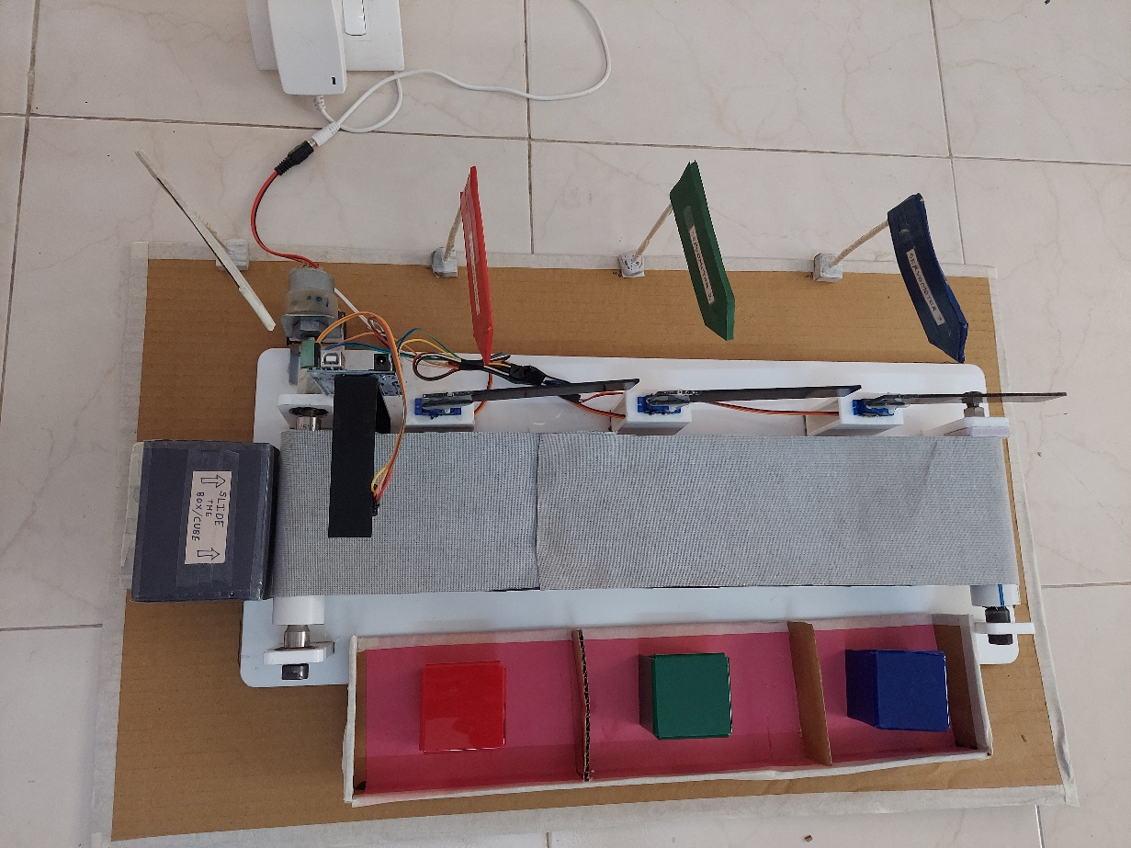

Fig 7.1: Completed model

1. Red color detection

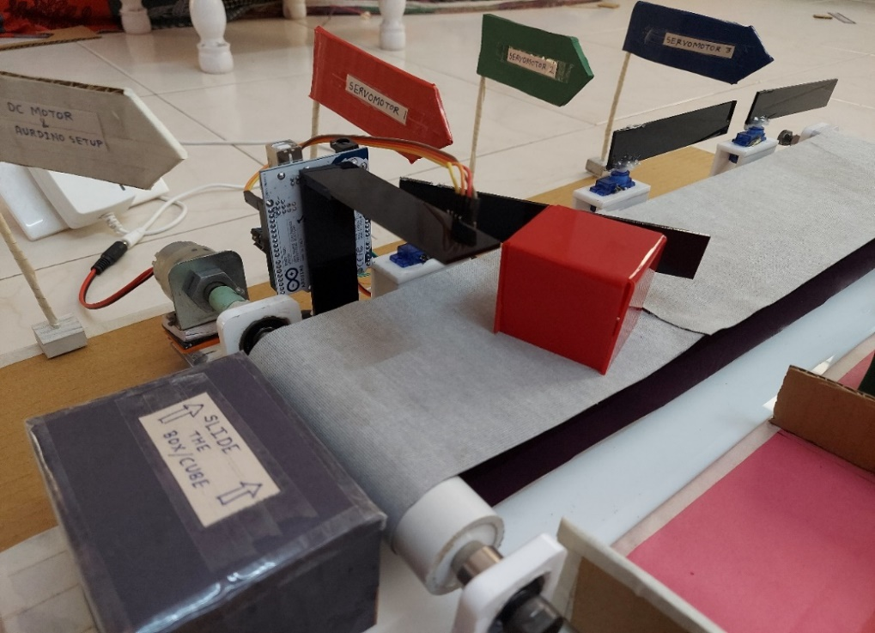

Fig. 7.2: Red color detection

While doing the operation sensor detected the red color successfully and the flapper sorted the correct color and dispatch into the collection box.

2. Green color detection

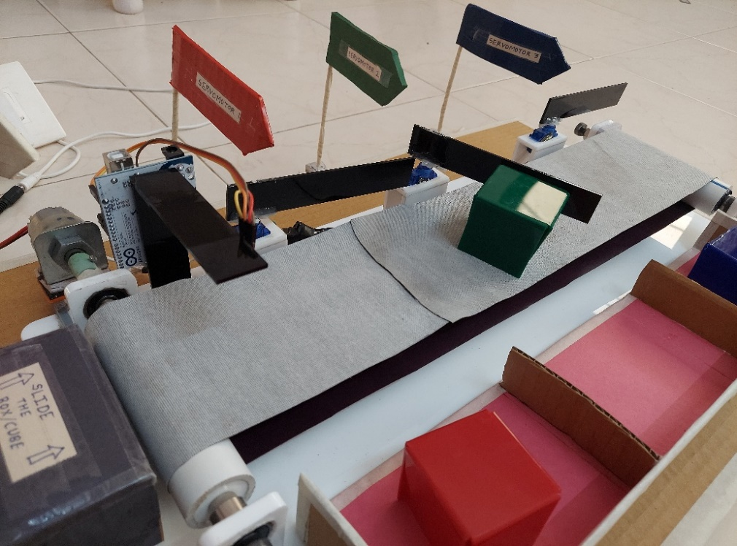

Fig 7.3: Green color detection

While doing the operation sensor detected the Green color successfully and the flapper sorted the correct color and dispatch into the collection box.

3. Blue color detection

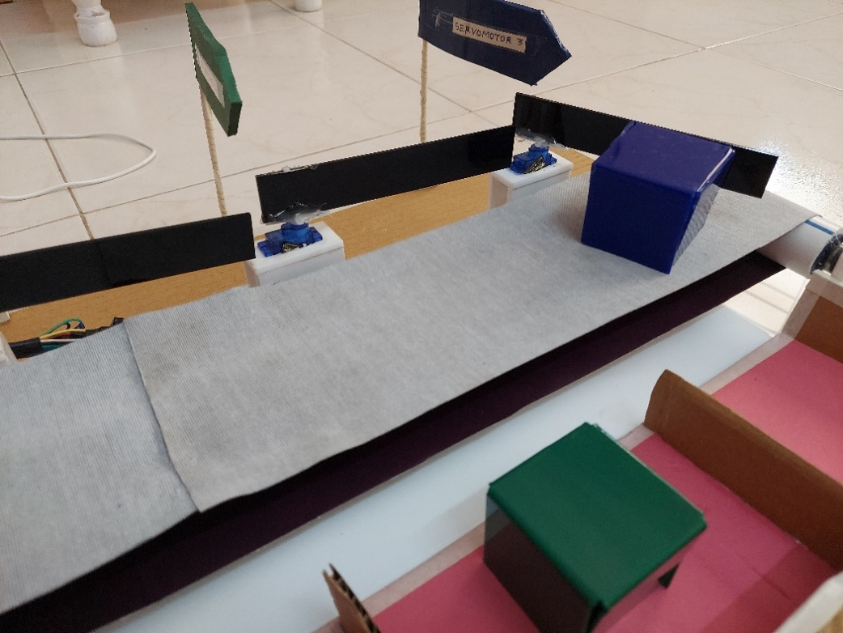

Fig 7.4: Blue color detection

While doing the operation sensor detected the Blue color successfully and the flapper sorted the correct color and dispatch into the collection box.

**Chapter 8: ANALYSIS IN ANSYS WORKBENCH**

**8.1** **Ball bearing analysis**

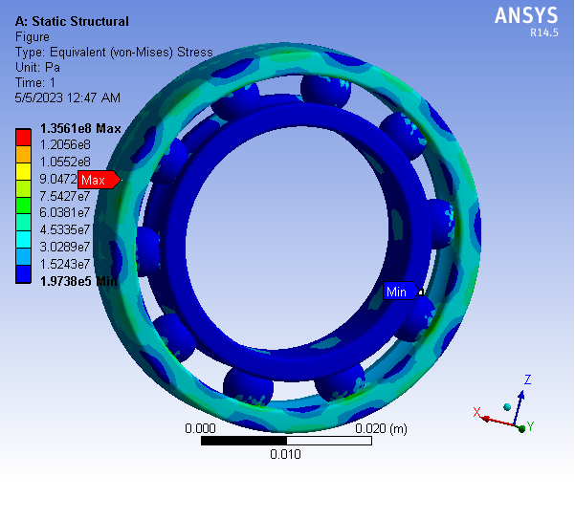

Fig. 8.1.1 Stress analysis of bearing

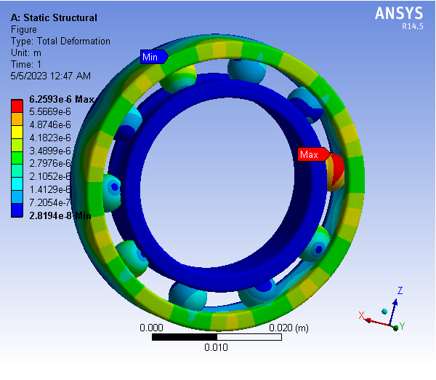

Fig. 8.1.2 Deformation analysis of bearing

**8.2 Conveyor belt analysis**

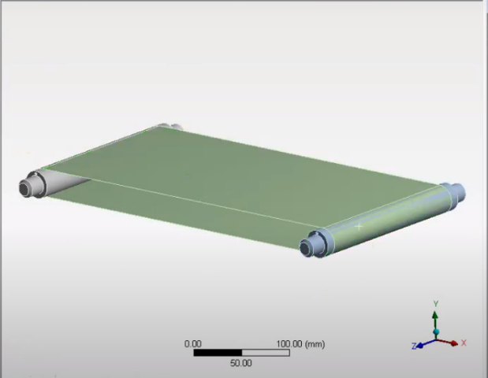

Fig. 8.2.1 Geometry of belt

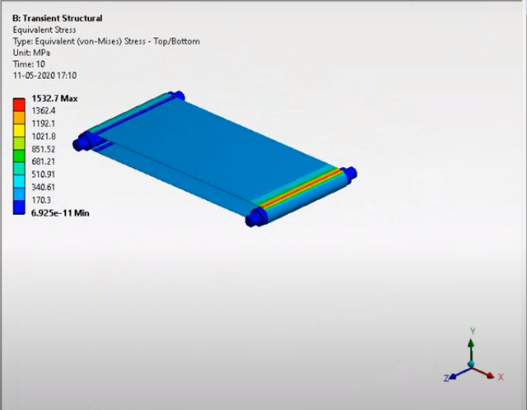

Fig. 8.2.2 Deformation stresses

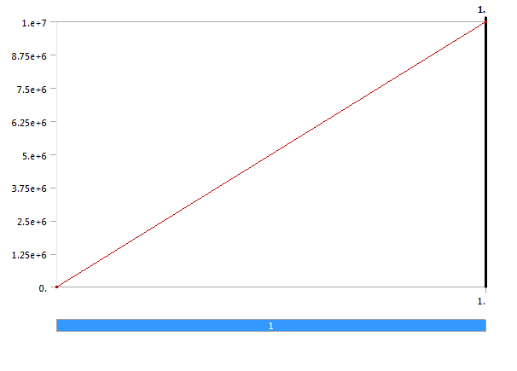

Fig.8.2.3 Bearing Graph

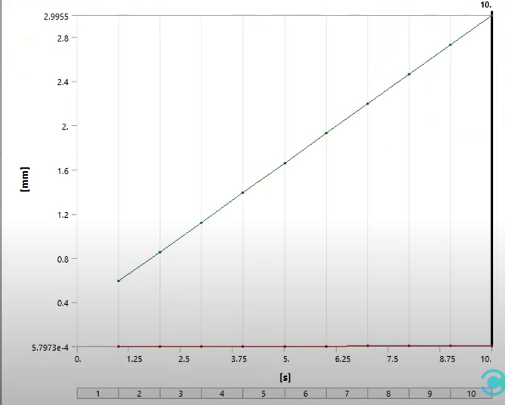

Fig.8.2.4 Conveyor belt Graph

**Chapter 9: ADVANTAGES, DISADVANTAGES & APPLICATIONS OF THE COLOR SORTING MACHINE**

* **ADVANTAGES**

1. Increased Efficiency: Color sorting machines use advanced optical sensors and high speed processors to quickly and accurately detect and sort objects based on their color. This automation significantly improves the efficiency of the sorting process, leading to higher productivity and reduced labor costs.
2. Enhanced Accuracy: Color sorting machines can detect minute color variations that are difficult for the human eye to perceive, ensuring a high level of accuracy in sorting. This helps eliminate human error and ensures consistent and reliable sorting results.
3. Improved Quality Control: By sorting objects based on color, these machines enable precise quality control. Defective or substandard items can be identified and removed from the production line, ensuring that only high-quality products reach the market.
4. Cost Savings: Color sorting machines help minimize waste and optimize resources by efficiently segregating objects based on color characteristics. By removing defective or inconsistent items early in the process, the overall production costs are reduced.
5. Versatility: These machines can be programmed to sort a wide range of objects based on color, making them highly versatile across various industries. They can handle different materials such as grains, fruits, vegetables, plastics, textiles, and more

* **DISADVANTAGES**

1. Initial Investment: The cost of purchasing and installing a color sorting machine can be significant, especially for small and medium-sized businesses. The initial investment may pose a barrier for some companies, although the long-term benefits often outweigh the upfront costs.
2. Maintenance and Training: Like any complex machinery, color sorting machines require regular maintenance to ensure optimal performance. Additionally, operators need proper training to operate and maintain the machines effectively. This can require additional resources and expertise.
3. Limited Sorting Parameters: While color sorting machines excel at detecting and sorting objects based on color, they may struggle with other parameters such as shape, size, or texture. For industries where multiple factors need to be considered during sorting, additional equipment or manual intervention may be necessary.

* **APLLICATIONS**

1. Food Processing: Color sorting machines are extensively used in the food processing industry to sort grains, seeds, nuts, fruits, and vegetables based on their color. They help remove foreign materials, defective items, or unripe produce, ensuring a higher quality of processed food products.
2. Recycling: Sorting machines play a crucial role in the recycling industry by separating different types of plastics, glass, and other recyclable materials based on their color. This enables efficient recycling processes and reduces contamination in recycled products.
3. Textiles: In the textile industry, color sorting machines are employed to classify fabrics, yarns, and fibers based on color. This ensures consistent dyeing processes and helps maintain color uniformity in finished textile products.

1. Pharmaceuticals: Color sorting machines find applications in the pharmaceutical industry for sorting pills, capsules, and tablets based on color. This helps prevent the mixing of different medications and ensures accurate packaging.
2. Mining and Ore Processing: These machines can be used in the mining industry to sort and separate ores and minerals based on their color characteristics. They help improve the purity of the final products and optimize the extraction process

**Chapter 10: PROPOSED WORK**

|  |  |  |  |  |  |  |  |  |  |  |  |
| --- | --- | --- | --- | --- | --- | --- | --- | --- | --- | --- | --- |
| **Activity** | **Jul** | **Aug** | **Sep** | **Oct** | **Nov** | **Dec** | **Jan** | **Feb** | **mar** | **Apr** | **May** |
| Finalization of topic |  |  |  |  |  |  |  |  |  |  |  |
| Survey and research |  |  |  |  |  |  |  |  |  |  |  |
| Conceptualization & Designing |  |  |  |  |  |  |  |  |  |  |  |
| Project Stage-I Submission |  |  |  |  |  |  |  |  |  |  |  |
| Assembly/Fabrication/Simulation |  |  |  |  |  |  |  |  |  |  |  |
| Experimentation & Trials |  |  |  |  |  |  |  |  |  |  |  |
| Black book writing & Final Submission |  |  |  |  |  |  |  |  |  |  |  |

Table 10.1: Proposed work of project

**Chapter 11: COST ESTIMATION**

Table 11.1: Cost estimation of project

|  |  |  |
| --- | --- | --- |
| **SR.NO.** | **COMPONENTS/PARTS** | **APPROXIMATE COST** |
| 1 | Arduino board | 750 |
| 2 | Color sensor | 500 |
| 3 | Servo motor | 250 x 3 =750 |
| 4 | DC motor | 300 |
| 5 | Conveyor system parts | 1500-2000 |
| 6 | Fabrication cost | Upto 2000 |
| 7 | Transportation | 300-500 |
| 8 | Other miscellaneous | 1500-2000 |
| TOTAL COST OF THE PROJECT | | Rs.7500-8800 |

**Chapter 12: FUTURE SCOPE**

1. Replacing DC motors by stepper motors to increase accuracy.
2. Sensors can be replaced by cameras for digital processing which is done using ‘MATLAB’.
3. Robotic arm can be used instead of flippers and containers to place the object at desired locations, thus making the process of sorting more effective.
4. Modifications can be done to inspect cracks, defects on the surface of the object etc.
5. Also we can use such system with some modifications for various types of inspection such as holes, diameter, height, thickness, surface defect.
6. Segregation based on size can be done by installation of sieves of various sizes.
7. Some rubber grippers can be used. It increases surface resistance which helps to avoid slipping of conveyor belt.

**Chapter 13: CONCLUSION**

1. The Automatic sorting machine using conveyor belt is basically useful for sorting the products in the industry specifically large scale industries where mass production is carried out.

2. The Machine also reduces the efforts of the workers by reducing the time spent for material handling.

3. The application area of this machine is very wide in industries where automation is built.

4. We have proposed a system which would increases the production rate and accuracy of material handling system.

5. The system would separate objects based on their color and weight as per requirement by the user. And we can modify the system according to their requirement.

6. This project of automatic color sorting is excellent one because of its working principle and wide implementation. By applying the idea of this project an industry can easily sort the required product according to its color. Through it has some limitations, but by having done some modification this concept can be implemented in wide range of application.

7. It can be concluded that time and human effort can be reduced by implementing such project in industries like chemical, food, chip manufacturing and so on.

**REFERENCES**

[1] Fuller, J.L., Robotics: Introduction, Programming and Projects, Prentice Hall, 2nd edition, Columbus, Ohio.

[2] Y V Aruna, 2015. “Automatic convey or System with In Process Sorting Mechanism” International Journal of Engineering Research and Applications, ISSN: 2248-9622, vol. 5, Issue 11.

[3] Yeow Khang Yung, 2011. ‟Color Sorting System with Robot Arm‟‟ Faculty of Electronic and Computer Engineering University Technical Malaysia Melaka.

[4] M. C. Mulder, S. R. Malladi, 1991. “A minimum effort control application for Cooperating sensor driven intelligent multi-jointed robotic arm,” Proceedings of the 30th IEEE Conference on Decision and Control, vol. 2, pp. 1573–1578.

[5] Amir Deshmukh, Mahesh Nagane, Vaibhav Avtade, 2016. “Design and Development of Automatic Conveyor Controlling System for sorting of component on color basic, International Journal of Science and Research (IJSR).

[6] S.V.Rautu, “sorting of objects based on color, weight, and type on a conveyor line using plc,”IOSR Journal of mechanical and civil engineering (IOSR-JMCE), ISSN22781684.

[7] Zanella, A., Bui, N., Castellani, A., Vangelista, L. and Zorzi, M., 2014. Internet of things for smart cities. IEEE Internet of Things journal, 1(1), pp.22- 32.

[8] Al-Fuqaha, A., Guizani, M., Mohammadi, M., Aledhari, M. and Ayyash, M., 2015. Internet of things: A survey on enabling technologies, protocols, and applications. IEEE Communications Surveys & Tutorials, 17(4), pp.2347-2376.

[9] Shen, L.J. and Hassan, I., 2015. Design and Development of Color Sorting Robot. JOURNAL OF ENGINEERING SCIENCE AND TECHNOLOGY, 10, pp.71-81.

[10] Machine Vision Based Automated Object Sorter Using Digital Image Processing MATLAB1Shalu Chopra, 2Ritu Kadyan 1Student of Master Technology,2 Assistant professor 1GangaTechnical Campus, Jhajjar,Haryana,India

[11] Wongphati, M., Matsuda, Y., Osawa, H. and Imai, M., 2012, September. Where do you want to use a robotic arm? And what do you want from the robot?. In RO-MAN, 2012 IEEE(pp. 322-327).

[12] Reddy, D.K., 2014. Sorting of Objects Based on Color By pick And Place Robotic Arm and with Conveyor Belt Arrangement. Int. J. Mech. Eng. & Rob.Res, 3(1)

[13] Arduino based color sorting machine using TCS3200 color sensor: International journal of innovative technology and exploring engineering (IJITEE) ISSN: 2278-3075, Volume-8, Issue-6S4, April-2019.

[14] IOT color based object sorting machine:International Journal of applied engineering research ISSN: 0973-4562 Volume 13, Number 10(2018).

**PHOTOGRAPHS**

