**Assistive Device For Visually Impaired Person Using Image Processing**

**Bhagyshri Asole 1, Sneha Rewatkar 2, Bramhadeo Wadibhasme 3**

1Student, **123**Electronics & Telecommunication Department,

Wainganganga College of Engineering and Management Nagpur

2Designation, Department, Institute, Nagpur, Maharastra, India

3 Assistant Professor, Department, Institute, Nagpur, Maharastra, India

**ABSTRACT**

As per the report by World Health organization there are around 40 million people in this world who are blind. As object recognition technology has developed recently, various technologies have been applied to autonomous vehicles, robots, and industrial facilities. However, the benefits of these technologies are not reaching the visually impaired, who need it the most.

computers Vision technology is crucial in understanding the information contained in image formats. The details of an object that are in the form of a picture can be treated to find. The object locating method is proposed in this research to assist visually challenged people. To match diverse items, the SIFT can extract distinguishing features from a picture.

**Keywords:** Image processing, Computer vision, Object detection, Object Classification.

1. **INTRODUCTION**

One of the most necessary senses on which people depend to interact with the objects in the real world is Vision. Vision enabled people look in the surrounding and instantly understand which objects are in the surrounding, how far they are, and how to interact with them [9]. It is easier for vision enabled people to carry out their everyday activities since they can clearly see all the objects in their surroundings, any obstacles they come across, other people and hence is easy to interact with these objects. Whereas, visually impaired people have to struggle a lot to deal with real world due to their everyday chores and jobs. It’s a known fact that, there are around 285 million visually impaired people in the world, approximately equal to the 20% of the Indian population and being visually impaired hinders a lot of day to day activities. Thus it is one of the most important thing for blind people to know their surroundings, and to understand what objects they come across.

1. **LITRATURE SURVEY**

Different types of literature which provide the brief idea regarding the object detection with different methods.

[1] Understanding of Object Detection Based on CNN Family and YOLO by Juan Du1, in 2018. In this paper You Only Look Once (YOLO) algorithm is discussed after the background descriptions of CNNs. YOLO V1 and V2, are the two versions of YOLO mentioned in this paper. YOLO’s algorithms, characteristics and layers are listed. By comparing YOLO with Faster R-CNN on speed, complexity, accuracy and cost their advantages and disadvantages are exposed. At last, the conclusion of YOLO and Faster R-CNN is summarized with the outlook to the CNN future.

[2] Object Detection and Distance Estimation Tool for Blind People Using Convolutional Methods with Stereovision by Jonathan Shen, Ruoming Pang, Ron J. Weiss, in 2019.In this paper, a system that can provide information about object in the surrounding is made. This system can also measure the distance of detected object through camera which is combined with glares, to make it easy for the blind people who use it. This tool certainly can help them to recognize object in the surroundings and improve their skill and ability. This system use camera as main sensor, which works like human eyes, to provide real time video as visual data. The algorithm used is CNN algorithm.

[3] Object Recognition App for Visually Impaired by Avanti Dorle, Piyush Pimplikar, Pranit Bagmar, Atharva Rajkuvar, in 2019. This paper describes about an android application that combines various methods to build an android application that will not just help the visually impaired people to recognize objects around in real time but will also assist them as quickly as possible by giving an audio output. Object detection and recognition is done using SSD(Single shot detector) algorithm. This algorithm gives very accurate results for real time object and has proven to be faster than other alternate algorithms. The application further makes use of android TextToSpeech API and android tensorflow APIs to give output in the form of audio.

[4] Real-Time Object Detection with Yolo by Geethapriya. S, N. Duraimurugan, S.P. Chokkalingam, , in 2019. The motive of the paper is to study YOLO algorithm in depth. It also aims to compare its speed, accuracy, complexity with different object detection and distance estimation algorithms. YOLO algorithm looks the image completely by predicting the bounding boxes using convolutional network and the class probabilities for these boxes and detects the image faster as compared to other algorithms. To study different application of YOLO.

[5] Real-Time Object Detection for Visually Challenged People by SunitVaidya, Niti shah, nishia shah, in 2020.

In this paper the proposed application make use machine learning techniques and image processing to determine real-

time objects through the use of camera and notify the blind person about the object and its distance through the audio

and analysis which is performed in your research work should be written in this section. A simple strategy to follow is to use keywords from your title in first few sentences.

1. **METHODOLOGY**

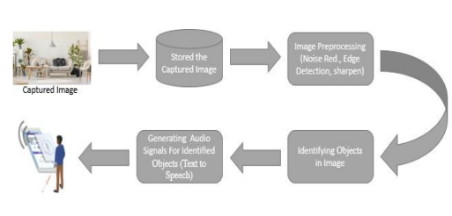

**Fig. 1 Proposed Methodology**

**Read image**: -Very first step of image processing is read the training as well as testing images.

**Converting color image to grayscale image:** -color isn’t required to recognize and detect an image -Color images are represented in three channels (i.e. Red, Blue and Green) perhaps gray image contains only one channel. - converting to gray scale image reduces time consumption for processing image as well as extra space required to store in memory

**Resizing Image:**-Images must be resized to basic heights and widths before they are fed to algorithm. -for that standardizing is done in case of preprocessing and scaling of image.

**Object Identification:** Feature is extracted by sift method. Those features are extracted by the specific object and compared it with the dataset to detect the specific object. Once the object is identified then it will be send it to the text to speech conversion.

1. **RESULTS AND DISCUSSION**

The input query image is shown in fig 5(a). The image is process with filter to remove noise present in the image. So the filter used here is median filter. The filter used is median filter shown in fig 5(b). Image is segmented and dilated shown in fig.5(c). Later the feature is extracted and compared with stored feature. The output image is detected shown in fig 5(d).

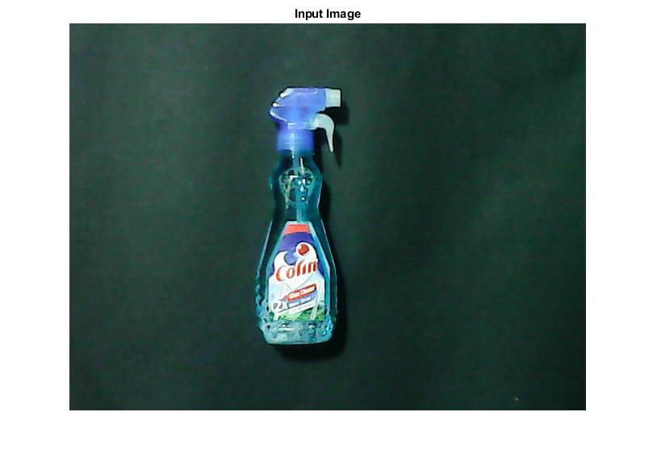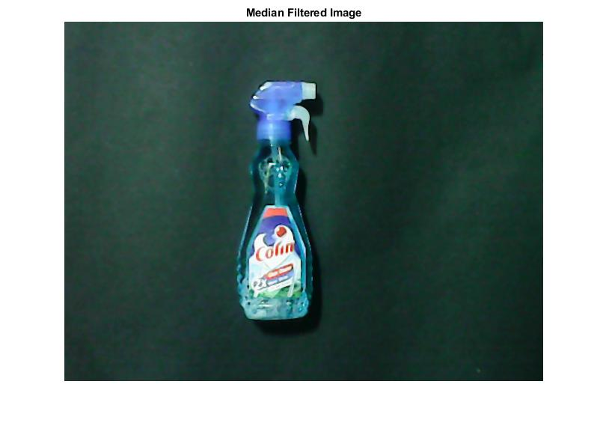

**Fig. 5 (a) Input Image Fig. 5 (b) Filter Image**

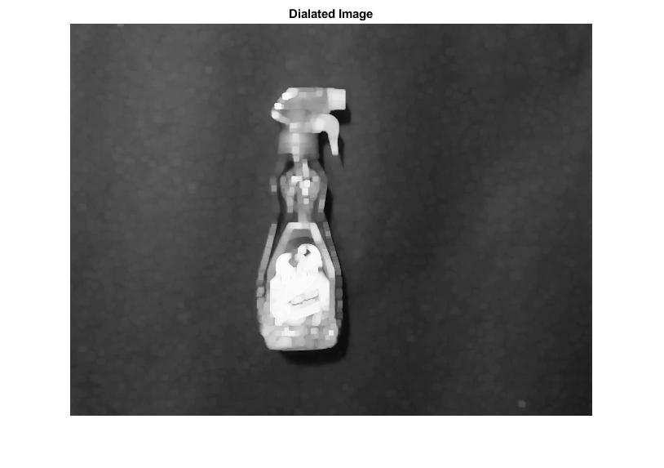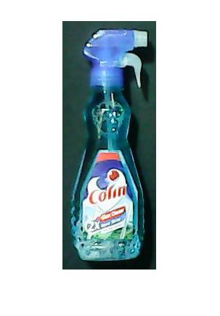

**Fig. 5 (c) Dilated Image Fig. 5 (d) Output Image**

1. **CONCLUSION**

The design of object detection based on SIFT is studied and implemented to detect the object present for the query input. The proposed system consists of guidance system for the visually impaired people. An examination of numerous works on object detection indicates SIFT may produce favourable outcomes in terms of robustness, scale invariance, luminance invariance, and noise factor. As a result, our primary goal will be to demonstrate the optimum way for detecting objects. The best result will be available to the user in the form of detected object information in the form of voice.

1. **REFERENCES**
2. Ross Girshick, Jeff Donahue, Trevor Darrell, and Jitendra Malik, “Rich feature hierarchies for accurate object

detection and semantic segmentation”, in 2014

1. Redmon. J , Farhadi. A, “YOLO9000: better, faster, stronger”, in 2016
2. Hanen J abnoun I, F aouzi Benzarti I, Hamid Amiri I, “Object Detection and Identification for Blind People in

Video Scene”, in 2016

1. Juan du, “Understanding Object detetction based on CNN Family and YOLO”, in 2018.
2. Rui Li , Jun Yang, “Improved YOLOv2 Object Detection Model” in 2018
3. Geethapriya. S, N. Duraimurugan, S.P. Chokkalingam
4. Avanti Dorle, Piyush Pimplikar, Pranit Bagmar, Atharva Rajkuvar, “Object Recognition App for Visually

Impaired” in 2019

1. Jonathan Shen, Ruoming Pang, Ron J. Weiss, Mike Schuster, Navdeep Jaitly, Zongheng Yang, ARXIV,

“Object Detection and Distance Estimation Tool for Blind People Using Convolutional Methods with

Stereovision”, in 2019

[10] Sunit Vaidya, Niti shah, nishia shah,“Real-Time Object Detection for Visually Challenged People”, in 2020