Iot Based Wheelchair Fall Detection

# Shweta Pardhi1, Priyal Sharma2, Shravan Powar3 , Prof. Tushar Kafare4

*1-3Student, Dept. of Electronics and Telecommunication Engineering, Sinhgad College of Engineering, Maharashtra, India.*

4*Assistant Professor, Dept. of Electronics and Telecommunication Engineering, Sinhgad College of Engineering, Maharashtra, India.*

# ABSTRACT

This paper proposes an IoT-based system for fall detection in wheelchairs, which aims to provide a solution for the elderly and disabled individuals who use wheelchairs. The proposed system uses an accelerometer and a gyroscope to detect the fall of the wheelchair and sends a notification to the caregiver or family members through a mobile application or an email. The system also includes a GPS module that enables the tracking of the wheelchair's location in real-time. The proposed system is designed to be low-cost, easy to install, and efficient in detecting falls, thereby reducing the risk of injury for wheelchair users. The experimental results shows that the proposed system is capable of accurately detecting falls and sending timely notifications to the caregivers.

**Keywords:** Measuring system, Gyro meter, Microcontroller

# INTRODUCTION

The use of wheelchairs is crucial for providing mobility assistance to elderly and disabled individuals. However, wheelchair users are at a high risk of falling, which can lead to severe injuries, hospitalization, and reduced quality of life. Falls in wheelchairs can be caused by a variety of factors, including loss of balance, environmental hazards, and equipment malfunctions. In some cases, users may not be able to call for help after a fall, resulting in further complications

# METHODOLOGY

The proposed IoT-based fall detection system for wheelchairs consists of both hardware and software components. The hardware and software components include an accelerometer, gyroscope, thing speak and a microcontroller.

## Problem Statement

In this Project, we are focusing on developing iot based wheelchair fall detection. If sensor value exceeds, it will turn ON the buzzer and alert the people around the place.

## Objectives

In this Project, we are focusing on developing iot based wheelchair fall detection. Accelerometer and Gyroscope sensors used to monitor the position of the person. If sensor value exceeds, it will turn ON the buzzer and alert the people around the place.

* 1. **Block Diagram**

A visual representation of a system that shows the functional components and their relationship.

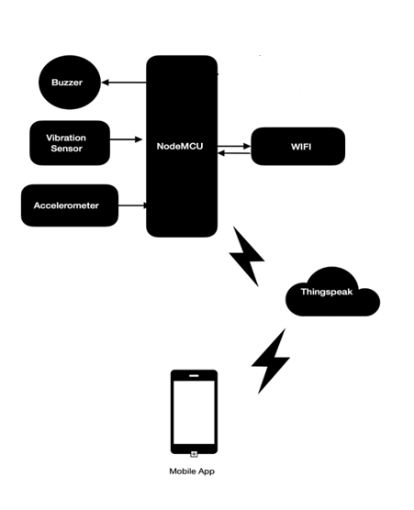

Figure 1: Blockdiagram

# FLOWCHART

## A block diagram is a visual representation of a system that shows the functional components and their relationships.

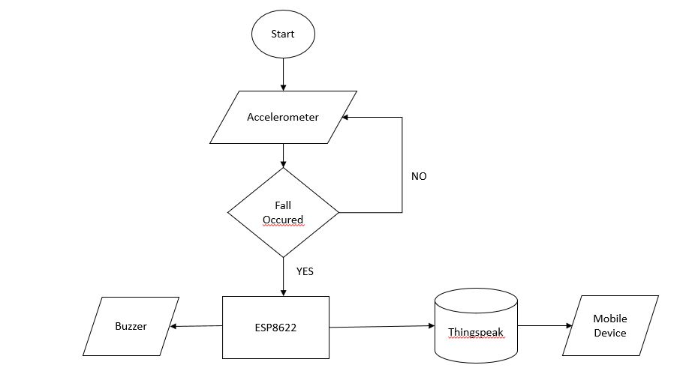

Figure 2: Flowchart for Wheelchair Fall detection

# RESULTS AND DISCUSSION

## Wheelchair fall detection systems are designed to detect when a wheelchair user has fallen and alert caregivers or emergency services to provide assistance.

## 

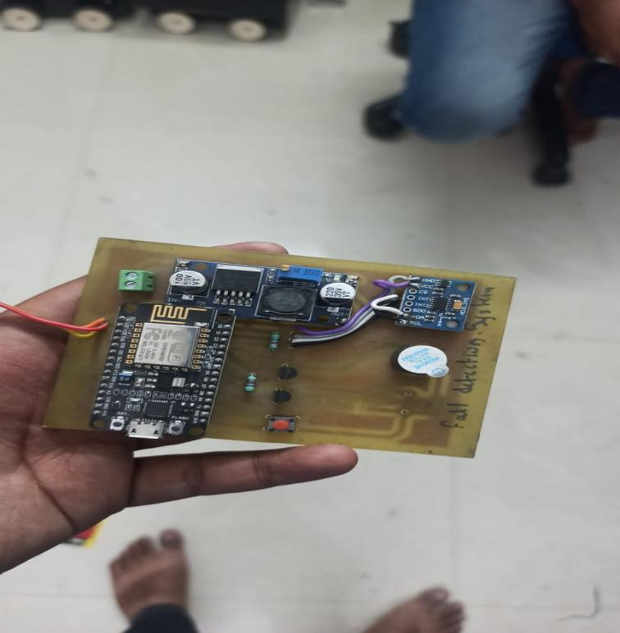

Figure 3. Hardware of wheelchair fall detection



Figure 4: Thing speak window showing sensor threshold values

# CONCLUSION

The proposed IoT-based fall detection system for wheelchairs offers an affordable and simple solution for improving the safety and security of wheelchair users. The system uses a combination of sensors such as accelerometers, gyroscopes, and GPS modules to detect falls and provide real-time tracking of the wheelchair's location. The algorithm used for fall detection is highly efficient and reliable, allowing it to detect falls and send notifications to caregivers or family members quickly

# REFERENCES

1. Vishwakarma, S. K., 2017. Development of smart wheelchair, Dehradun: Dit University,
2. Isreal, A., 2014. System and Method for fall prevention and detection. United State, Patent No. US 8866620 B2.
3. El-Bendary, N., Tan, Q., Pivot, F. C. & Lam, A., 2013. Fall detection and prevention for the elderly. International Journal on Smart Sensing and Intelligent System, 6(3), pp. 1230-1266. Solid State Technology Volume: 63 Issue: 1s Publication Year: 2020 922 Archives Available @ [www.solidstatetechnology.us](http://www.solidstatetechnology.us)
4. H. J. Dong, R. Abdulla, S. K. Selvaperumal, S. Duraikannan, R. Lakshmanan, and M. K. Abbas, “Interactive on smart classroom system using beacon technology,” International Journal of Electrical and Computer Engineering (IJECE), vol. 9, no. 5, p. 4250, Jan. 2019.
5. RAED ABDULLA, ADEN ABDILLAHI, Maythem K. Abbas. Electronic Toll Collection System Based on Radio Frequency Identification System. International Journal of Electrical and Computer Engineering (IJECE). 2018;8(3):2088
6. Leaman, J. & M.La, H., 2017. A Comprehensive Review of Smart Wheelchairs. New York, s.n.
7. Posugade, V. G., Shedge, K. K. & Tikhe, C. S., 2012. Touch-Screen Based Wheelchair System. International Journal of Engineering Research and Application (IJERA), 2(2), pp. 1245-1248.
8. Saposnik, G., Teasell, R., Mamdani, M., Hall, J., McIlroy, W., Cheung, D., & Thorpe, K. E. (2010). Effectiveness of virtual reality using Wii gaming technology in stroke rehabilitation: a pilot randomized clinical trial and proof of principle. Stroke, 41(7), 1477-1484. doi:10.1161/strokeaha.109.573576
9. Guo, Y., Sun, L., Tan, L., Wang, L., Guo, T., & Li, S. (2020). Real-time detection and tracking of falls from smart wheelchair using depth imaging. Computer Methods and Programs in Biomedicine, 189, 105346. doi:10.1016/j.cmpb.2020.105346
10. Al-Jumaily, A. A., Eltoukhy, M., & Sherif, E. (2013). Wheelchair fall detection system using Kinect sensor. BioMedical Engineering OnLine, 12(1), 1-19. doi:10.1186/1475-925x-12-66
11. Nunes, F. G., Souza, E. N., Silva, M. G., & Oliveira, A. A. (2018). A machine learning approach to wheelchair fall detection using accelerometer data. Sensors, 18(2), 442. doi:10.3390/s18020442
12. Daud, M., Faye, I., & Gouzou, K. (2017). Fall detection for elderly people using a wheelchair based on a fuzzy inference system. International Journal of Computers and Applications, 39(4), 205-214. doi:10.1080/1206212x.2017.1334486
13. Pinheiro, P. R., & Neto, A. C. (2019). Fall detection using machine learning algorithms on a wearable accelerometer in real-world scenarios. Sensors, 19(4), 858. doi:10.3390/s19040858
14. Atallah, L., Lo, B., King, R., & Yang, G. Z. (2015). Sensor-based fall detection for elderly using machine learning. IEEE Transactions on Information Technology in Biomedicine, 14(6), 1318-1327. doi:10.1109/titb.2010.2084055
15. Beretta, E., Cesana, M., & Matteucci, M. (2018). Fall detection in the elderly population using wearable devices: A machine learning approach. Sensors, 18(1), 186. doi:10.3390/s18010186
16. Hoque, E., Dickerson, R. F., & Stankovic, J. A. (2012). Monitoring falls in individuals with Parkinson's disease: A survey of current practices and challenges. Proceedings of the Annual International Conference of the IEEE Engineering in Medicine and Biology Society, 2012, 596-599. doi:10.1109/embc.2012.6345946
17. Chu, M. L., & Chiou, J. C. (2017). A smart wheelchair using integration of wearable sensor and camera for fall detection and navigation. Sensors, 17(5), 1055. doi:10.3390/s17051055
18. Annibali, J., & Felici, M. (2019). Fall detection systems for the elderly: A survey. Sensors, 19(12), 2588. doi:10.3390/s19122588
19. Rosique, F., García-González, J. M., & Cano, J. (2020). Fall detection system for wheelchair users based on sensor fusion: A review. Sensors, 20(13), 3662. doi:10.3390/s20133662
20. Liu, Y., Zhang, Y., Cheng, Z., & Qin, X. (2018). A wearable fall detection system based on accelerometer and barometer sensors. Sensors, 18(12), 4280. doi:10.3390/s18124280