Gym Maintenance System
978-1-7281-4514-3/20/$31.00 ©2020 IEEE

Md wajid zaheeruddin Department of Computer Application PES University Bengaluru, India shareefbhaiii0@gmail.com
Mrs.Samyukta D kumata
Department of Computer Applications
PES University
Bengaluru, India.

Abstract
The Gym Maintenance system is developed for maintaining the various resources associated with the gym. It is a user-friendly application. This is a fully-fledged system that will be the backbone of the whole management of the gym. The Gym Maintenance System focuses mainly on managing daily records. This system helps to keep track of customers and track activities with respect to their chosen services. The system also provides users with various body trackers as compared to other systems.
- INTRODUCTION

The Gym Maintenance system is developed for Gym owners - for maintaining the records, and the clients who have taken admission in that gym - for providing the daily workout schedule and Diet ,and the staff members of the gym - for keeping an eye on the customers and their daily activities , keeping track of the number of gym equipments, payments of the customers ,etc. these are some of the features of this application which make it a must have application for every gym.

The main use of this application is that it reduces the problems like maintenance of physical inventories, data loss due to wearing off of the inventory and also the security of the data is provided in this system. Ease of Use
Purpose
The purpose of this paper is to introduce a digital platform for gym owners to manage their resources effectively. The platform acts as a central hub for managing all aspects of the gym, from scheduling and membership management to equipment inventory and staff coordination. With the increasing trend towards digitization in the fitness industry, this platform offers a solution that streamlines the process of gym management and provides owners with real-time information on their operations.
Provides a platform for the customers associated with the gym that the system is developed for. The customers can keep track of their daily activities, view diet and workout schedules according to the services the customer is signed for.Finally, complete content and organizational editing before formatting. Please take note of the following items when proofreading spelling and grammar:
II. APPROACH
Proposed solution
The proposed system is developed for Gym owners - for maintaining the records, and the clients who have taken admission in that gym - for providing the daily workout schedule and Diet ,and the staff members of the gym - for keeping an eye on the customers and their daily activities , keeping track of the number of gym equipments, payments of the customers ,etc. these are some of the features of this application which make it a must have application for every gym.
The main use of this application is that it reduces the problems like maintenance of physical inventories, data loss due to wearing off of the inventory and also the security of the data is provided in this system.
Scope and Limitations
It is a web application and not an android application, it has no multi language support users has to use it in the English language.
This web application provides its services for the gym owner (admin), customers who are subscribed to the gym and the staff associated with the gym. Users of both applications agree that the system is highly useful.

Proposed Solution
The proposed system makes it easy for maintaining the records, and the clients who have taken admission in that gym - for providing the daily workout schedule and Diet ,and the staff members of the gym - for keeping an eye on the customers and their daily activities , keeping track of the number of gym equipments, payments of the customers ,etc. these are some of the features of this application which make it a must have application for every gym
- The main use of this application is that it reduces the problems like maintenance of physical inventories, data loss due to wearing off of the inventory and also the security of the data is provided in this system.

III. TOOLS AND LIBRARIES USED
- Visual Studio Code, or VS-Code, is a popular and free code editor that helps programmers write, debug, and improve code with its intelligent approach. It is often considered as an integrated development environment (IDE), although some argue that it is only a compiler or an editor. A code editor is an important tool for programming, and in the past, developers used basic text editors or more advanced editors like the VI or Sublime Text Editor. However, as programming languages evolved, these simple editors could no longer support the complex frameworks and development needed for many projects. VS-Code, on the other hand, supports a wide range of coding languages and allows users to customize the editor to meet their needs. It provides essential support for developers, and users can easily access libraries and add them to their code. With its ease of use and customizable features, VS-Code has become a favorite among many programmers.
- PHP : PHP is a server scripting language, and a powerful tool for making dynamic and interactive Web pages. PHP is a widely-used, free, and efficient alternative to competitors such as Microsoft's ASP. PHP (Hypertext Preprocessor) is a server-side scripting language used for web development. It's used to create dynamic web pages and can interact with databases to store and retrieve data. PHP code is embedded in HTML and runs on a web server, generating HTML pages which are then sent to the client's browser. PHP is widely used and is supported by many web hosting providers, making it a popular choice for developing small to large-scale websites. Some of the popular websites built using PHP include Facebook, Wikipedia, and WordPress. Be aware of the different meanings of the homophones “affect” and “effect”, “complement” and “compliment”, “discreet” and “discrete”, “principal” and “principle”.
- MySQL is a widely used relational database management system (RDBMS). it is free and open-source. it is ideal for both small and large applications.
MySQL is a popular open-source relational database management system (RDBMS). It is widely used to manage large amounts of structured data, such as customer information, product catalogs, and financial records. MySQL uses Structured Query Language (SQL) to manage data and provides a range of features including transactions, triggers, and views. MySQL is known for its reliability, stability, and fast performance, making it a popular choice for web-based applications and online businesses. It can run on a variety of operating systems including Windows, Linux, and macOS, and can be used in combination with many popular programming languages such as PHP, Java, and Python. In addition to its use in web development, MySQL is also used in data warehousing, logging applications, and content management systems. With its flexible and scalable architecture, MySQL has become one of the most widely used relational database management systems in the world.The prefix “non” is not a word; it should be joined to the word it modifies, usually without a hyphen.
- Bootstrap is the most popular CSS Framework for developing responsive and mobile-first websites. Bootstrap 5 is the newest version of bootstrap.
Bootstrap is a free and open-source framework for web development that provides pre-designed components for building a website. It was created by Twitter and is now maintained by a group of developers at Twitter and the open-source community. Bootstrap is made up of HTML, CSS, and JavaScript and is optimized for responsiveness, allowing a website's layout to adjust automatically to various screen sizes and devices. Using Bootstrap saves time and effort in the website building process. With its pre-designed components, developers can quickly create prototypes and full websites without having to start from scratch. The large community of Bootstrap users also means that there are many resources available to assist developers, such as tutorials, examples, and custom components. In summary, Bootstrap is a valuable tool for web development that can save time, enhance the design consistency of a website, and make it easier to create a website that is responsive and optimized for mobile devices.
- Vanilla CSS is a minimal baseline stylesheet for any web project. It includes a basic reset and default styling for all HTML5 elements.
Vanilla CSS is a term used to describe writing CSS styles without relying on any frameworks or libraries. This means writing the styles directly into the stylesheet of your web page. Vanilla CSS is a simple, basic form of CSS, and it can be a good choice for smaller projects where you don't need many pre-made components. Writing CSS from scratch gives you more control and helps you understand how CSS works. However, for larger projects with more complex requirements, using a framework like Bootstrap or Foundation might be more efficient, as they provide a set of pre-designed components to help create a polished and consistent website. In conclusion, Vanilla CSS is a useful option for smaller projects or developers who want to write CSS from scratch, while frameworks can be more helpful for larger projects with complex requirements.

IV. FUNCTIONAL REQUIREMENTS

Admin

Admin should Log in and Logout with the respective credentials. The admin can approve the
request of the customers who have registered for the gym. The administrator of a gym is respon-
sible for overseeing various aspects of the gym, including equipment, members, and staff. They
keep track of customers’ diet and exercise plans and ensure that they receive the appropriate
services and information

Customer

Customers will login and logout with their credentials. Customers can view the diet and work-
out schedules provided according to his plan and services chosen. Customers can also make to-
do lists, view reminders of their subscription and also the announcements related to the gym

Staff
Staff members will log in and log out with the respective credentials associated with their ac-
count. The staff can manage the gym equipments, take attendance, view gym reports of the
gym. The staff can also view announcements announced related to the gym.

V. METHODOLOGY
Data Flow Diagram
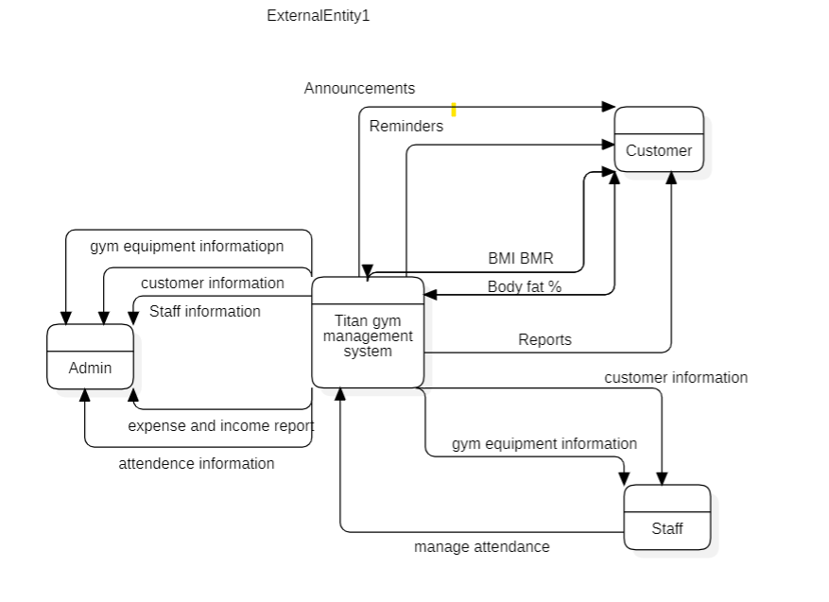It is the Context diagram for the system . It has mainly three external entities like Admin, Customers and the Staff. It shows the flow of data between different entities and the system.
A context flow diagram is a diagram that shows how information, data, or control flows in a system. It is used to give a general idea of the relationships between different components in a system. The diagram uses simple shapes and symbols to represent the components and arrows to show the flow of information. The main purpose of a context flow diagram is to understand the bigger picture of a system, find any weak points, and improve it. It is used in a wide range of fields like software development, business improvement, and system analysis.

Architecture Diagram
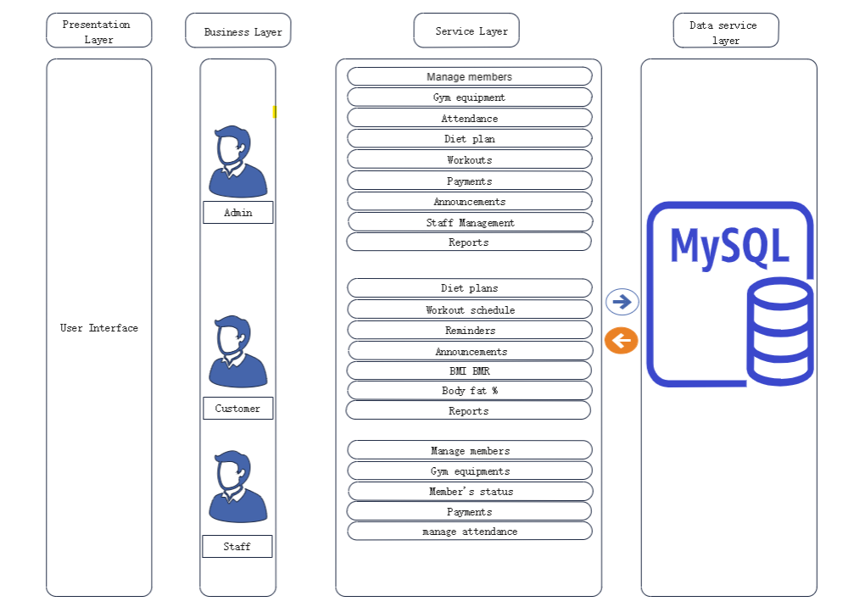

The architecture diagram depicts the visual representation of the overall physical components of the software model. This architecture diagram mainly consists of the four layers namely presentation layer, business layer, service layer and the data service layer.
Presentation layer will consists of the interaction page through which, all the users will interact with the system. Business layer acts like a bridge between the presentation layer and the service layer. In the business layer Admin, Customers, Staff will interact with the service layer.
Service layer will contains the all the functionalities of the respective users. Data service layer will defines the storage component of the system.
Activity Diagram
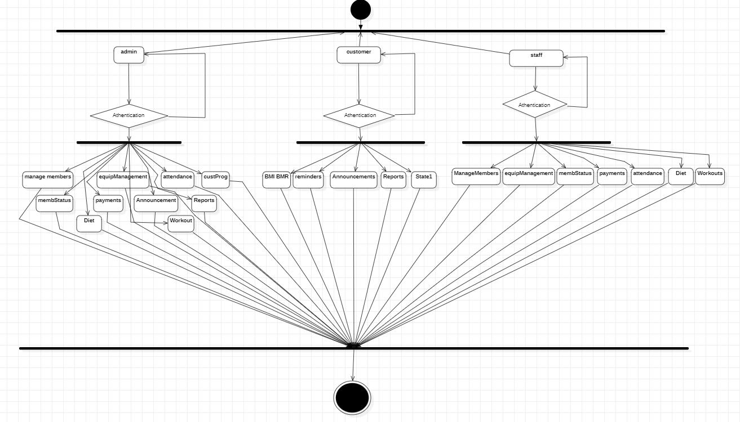
An activity diagram is a tool used in the Unified Modeling Language (UML) to display the steps and decisions involved in a process or system. It's used to show the dynamic elements of a system and the flow of tasks. The diagram consists of rounded rectangles, representing the various activities, and arrows indicating the flow of control between them. These arrows can also be labeled to explain the conditions that dictate the flow of control. Activity diagrams can be used in many fields such as software development, business process modeling, and system analysis. They are particularly useful for complex processes and for presenting the flow of activities to stakeholders and team members. The purpose of activity diagrams is to show how a process operates, to identify the necessary tasks and decisions, and to spot any potential errors, risks, or inefficiencies. By using activity diagrams, you can gain a better understanding of the flow of activities in a system and the requirements for it to function correctly.
Use case diagram
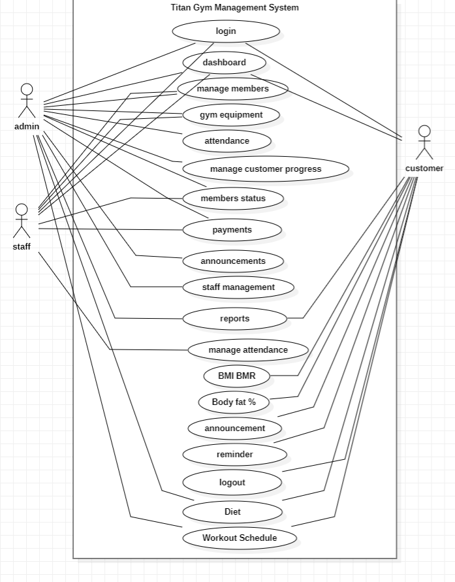

A use case diagram is a diagram used to show the ways in which a system can be used and to identify the entities that interact with the system. It is part of the Unified Modeling Language and is used in software development, business process modeling, and system analysis. In a use case diagram, there are three main components: actors, use cases, and relationships. Actors are the entities that interact with the system, like a user or an external system. Use cases are the various ways the system can be used, such as creating an account or making a purchase. The relationships between the actors and use cases are shown using lines or arrows and show how they interact with each other.

Database diagram
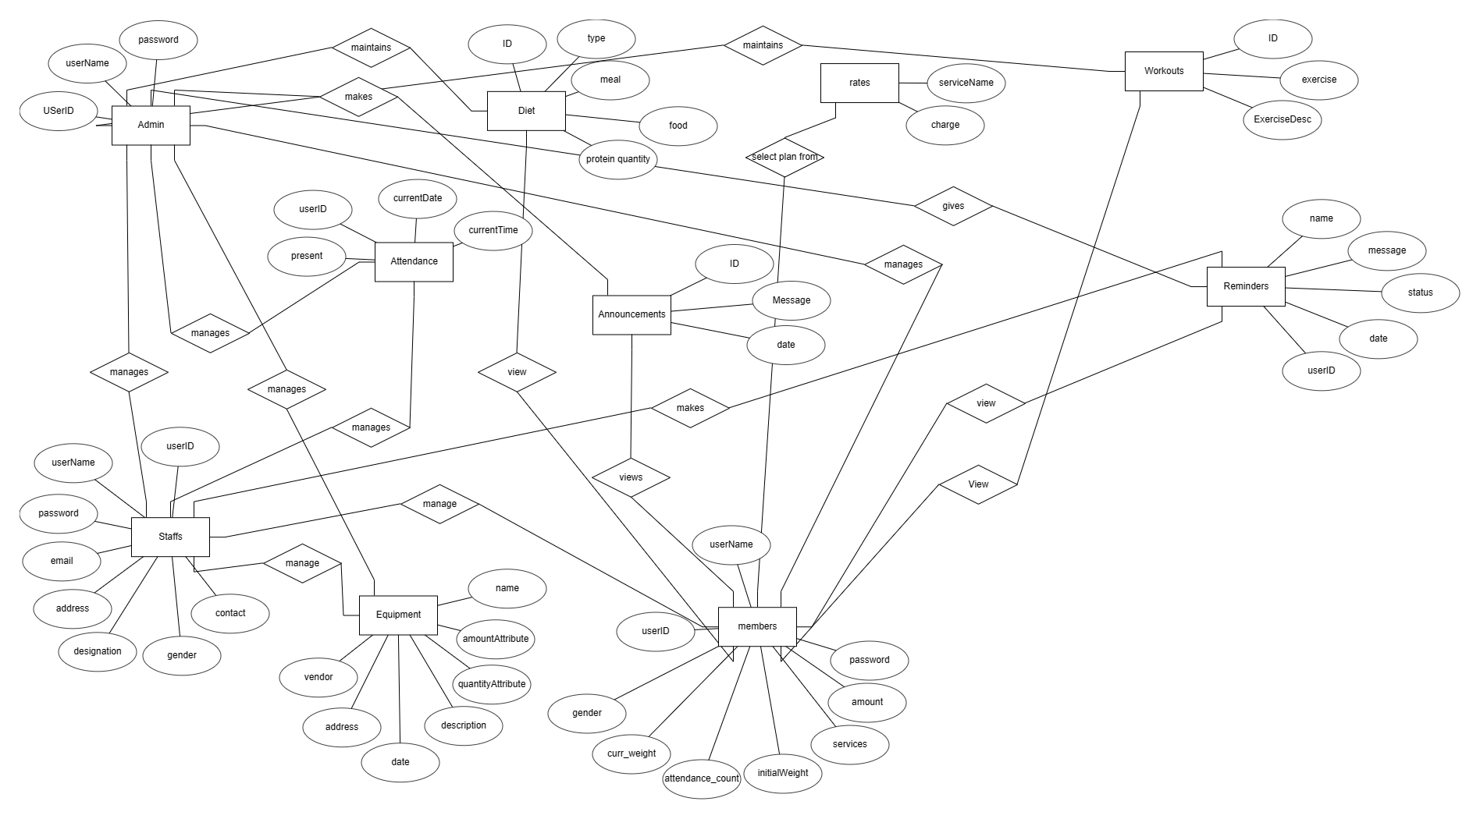
In the above ER diagram the relationship between different entities used in this system is shown.
An ER diagram, short for Entity-Relationship diagram, is a visual representation of entities and how they relate to each other. It's used in the design of databases. The diagram consists of entities, which represent objects or concepts, and relationships, which describe the connections between entities. In an ER diagram, entities are shown as boxes with descriptive labels, and relationships are shown as lines connecting the entities. These lines are labeled to describe the type of relationship, such as one-to-many or many-to-many. Attributes, which are the characteristics of entities, are listed inside the entity boxes. ER diagrams are a helpful tool in designing databases as they provide a visual representation of the relationships between entities. This helps to ensure that data is organized in a logical and meaningful way. Additionally, ER diagrams can be used to communicate the structure of a database to stakeholders and to identify potential issues or limitations in the data structure. Overall, ER diagrams play an important role in database design, providing a way to visualize data relationships and improving the efficiency and structure of the database.
VI. RESULTS
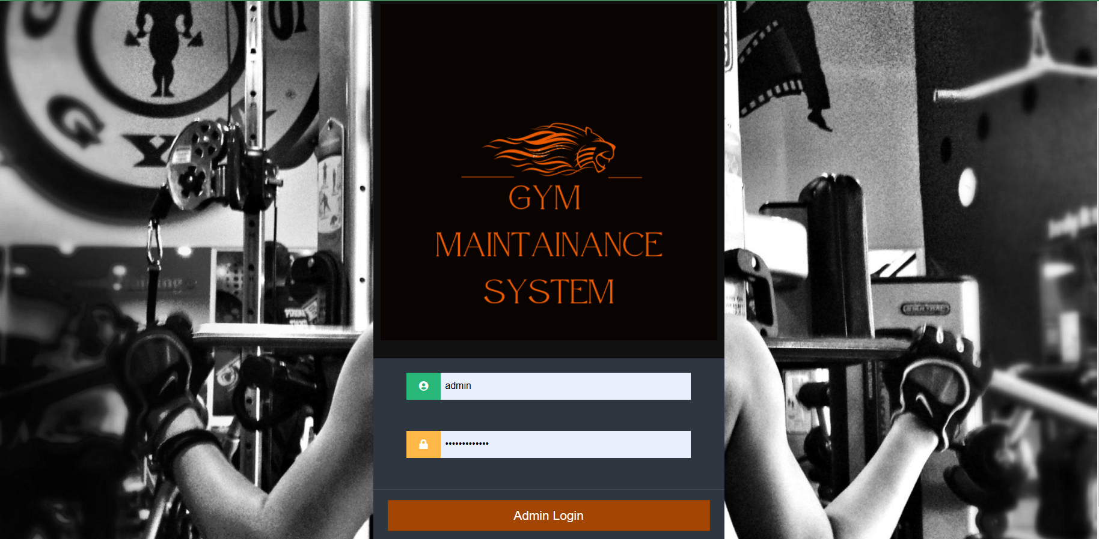
This is the Login page. This is a common login page from where the login menu can be chosen whether to login as an admi or switch to customer or a staff login page.
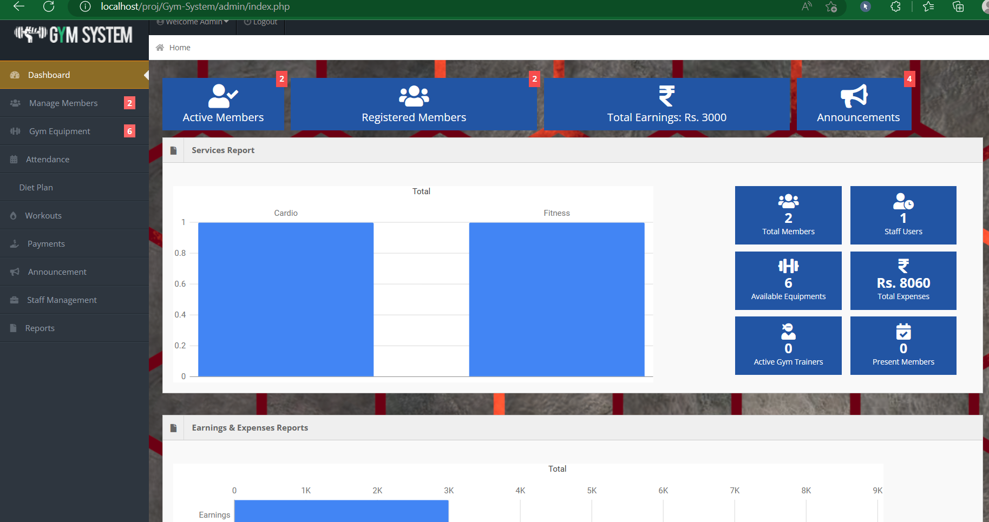
This is an admin dashboard.

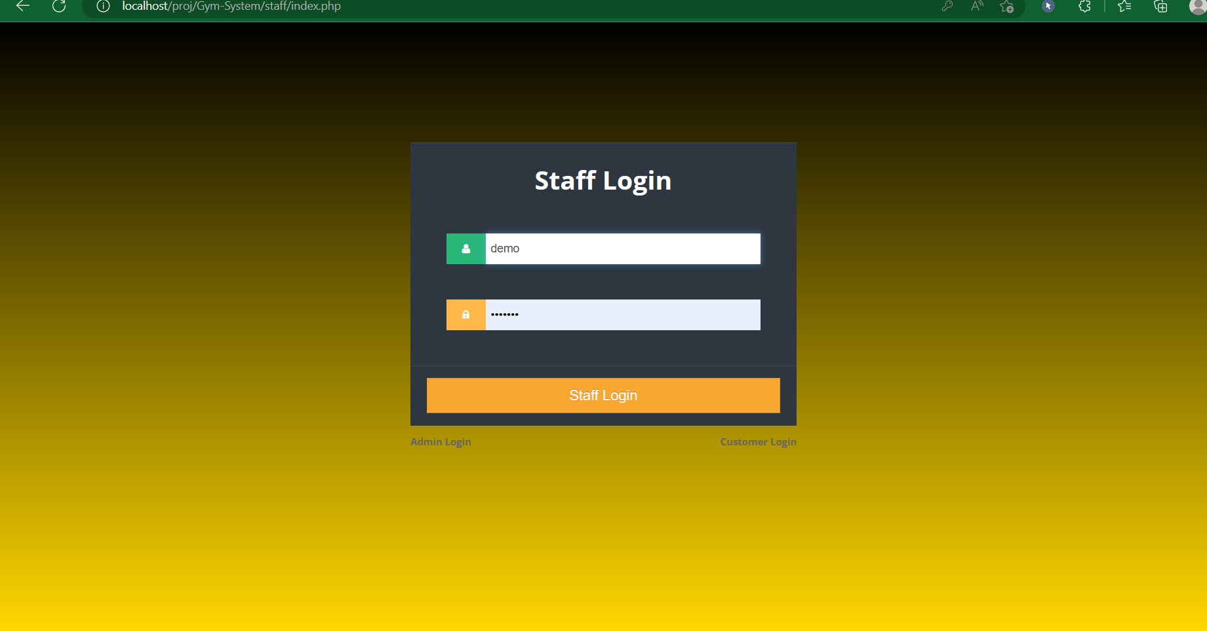
This is a staff login page. From here the staff members can login and access the system.

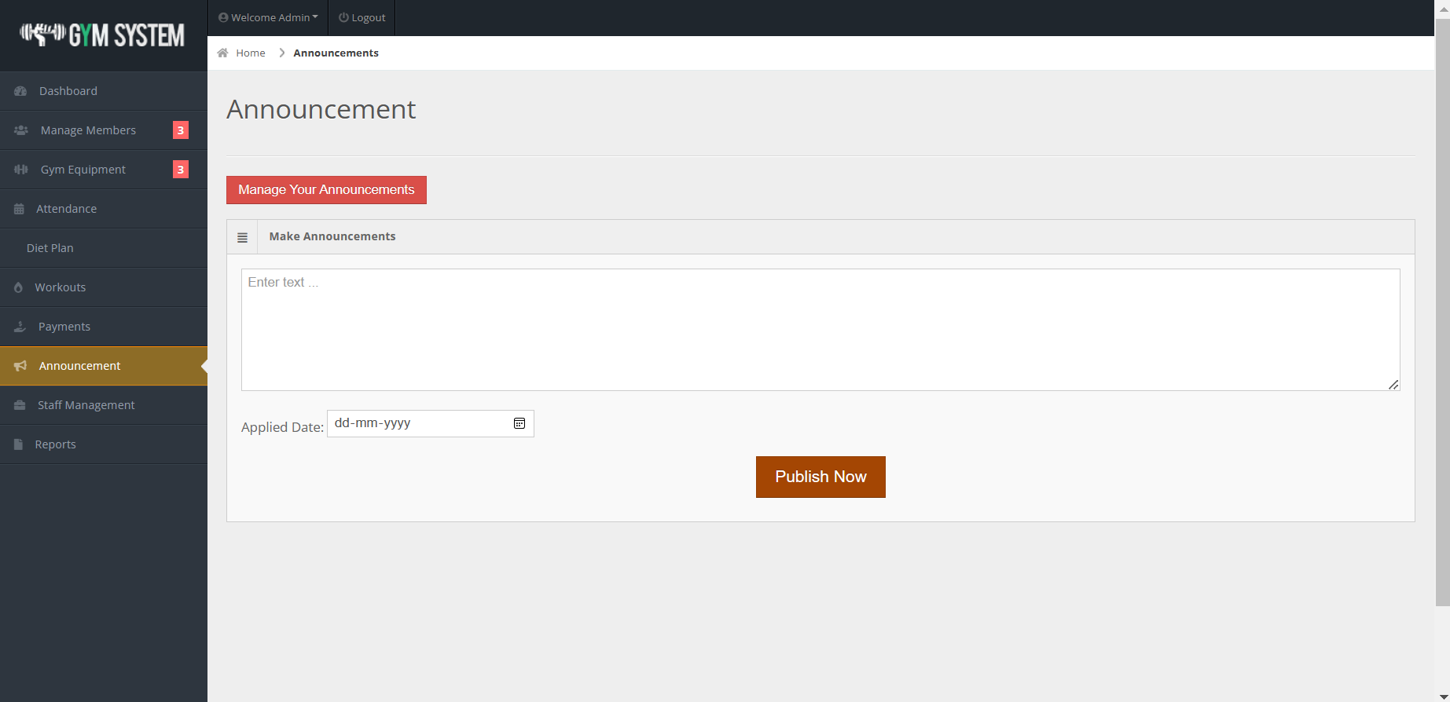
This is the announcement page from where the admin can announce the announcements and these announcements are displayed to the customers.

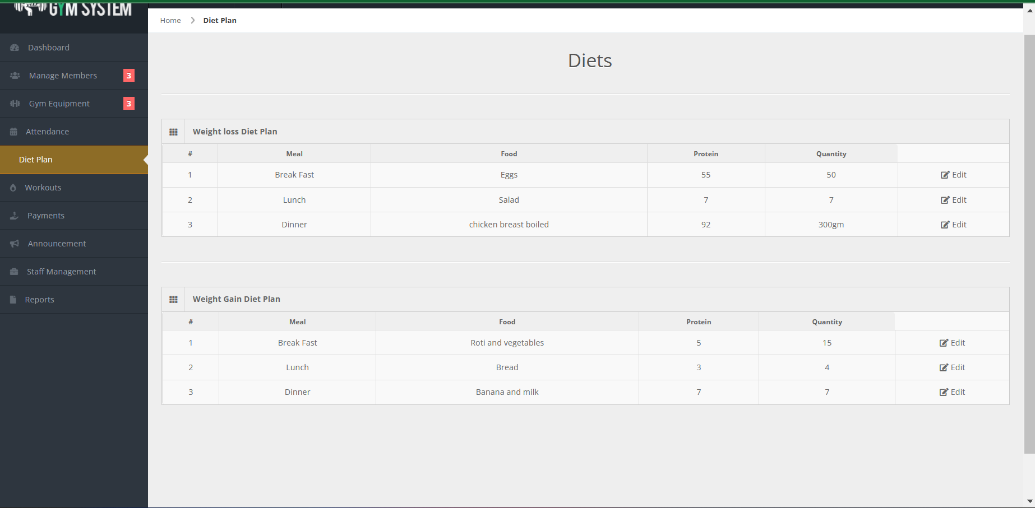
This si the diet menu. The admin can view or edit the diet for different services. There are basically two diet plans. One is for weight gain and another is for weight loss.

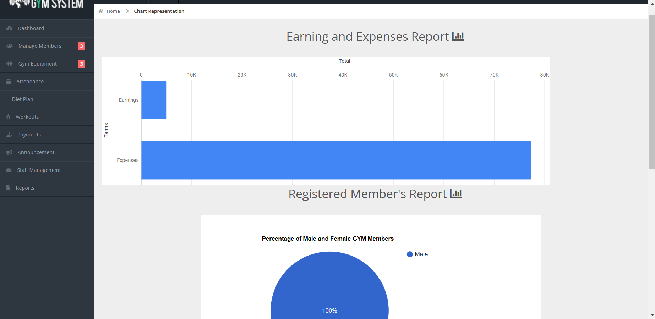
This is the reports page of the admin. Here the analytic data in the graphical form is displayed.

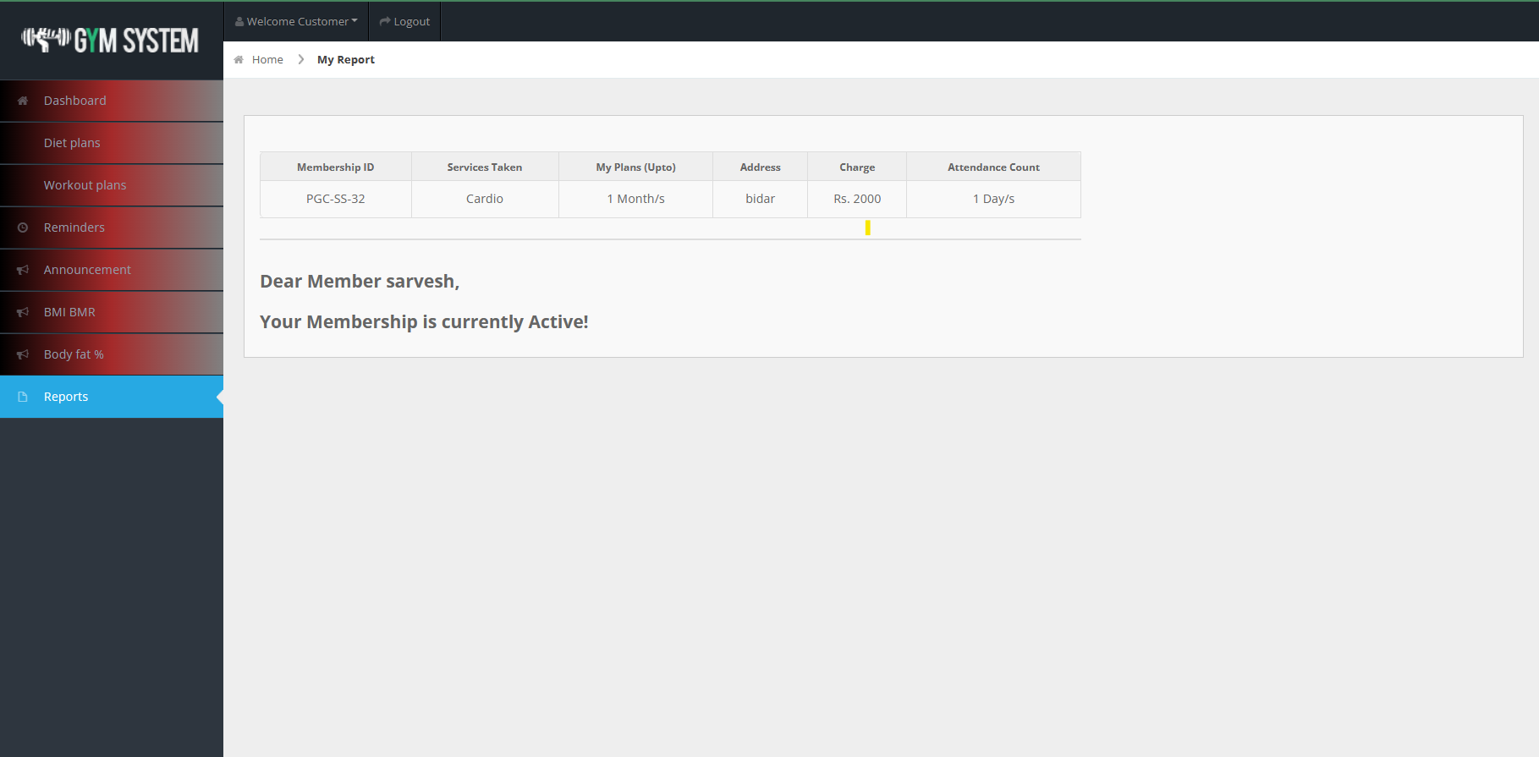

This is the customer reports page. Here the customer can see the report of his plan.
CONCLUSION
In conclusion, gym maintenance systems are of vital importance for gym operators to maintain their facilities and provide a satisfying experience for their customers. The system can streamline maintenance scheduling, keep track of equipment repair progress, and monitor supply inventory, leading to more efficient and error-free operations. With the help of a well-designed maintenance system, gyms can create a safer and more appealing environment, attracting more members and ultimately boosting revenue.
References

- Katzmarzyk PT, Perusse L, Rao DC, Bouchard C. Familial risk of overweight and obesity in the Canadian population using the WHO/NIH criteria. Obes Res. 2000..
- Wang H, Wang J, Liu MM, et al. Epidemiology of general obesity, abdominal obesity and related risk factors in urban adults from 33 communities of northeast china: the CHPSNE study.
- Wylie-Rosett J, Herman WH, Goldberg RB. Lifestyle intervention to prevent diabetes: intensive and cost effective. Curr Opin Lipidol. 2006.
- Hill JO. Can a small-changes approach help address the obesity epidemic? A report of the Joint Task Force of the American Society for Nutrition, Institute of Food Technologists, and International Food Information Council. Am J Clin Nutr. 2009.

