# ACCIDENT CRASH DETECTING USING DEEP LEARNING

**Author: V. ATCHAYA1, MCA, Department Of Computer Science, And Applications, Periyar Maniammai Institute Of Science And Technology, Vallam, Thanjavur**.

**Dr.G.PREETHI2, MCA.,M.Phil.,M.tech.,Ph.D.,Assistant Professor,** **Department Of Computer Science, And Applications, Periyar Maniammai Institute Of Science And Technology, Vallam, Thanjavur.**

**ABSTRACT**

Using a new approach of the convolution neural network of the deep learning algorithm to predict accidents in locations with high traffic. Traffic accidents are the main unnatural death culprit on a global scale. This is a result of the population and car expansion, which has increased the accident rate. Delays in medical treatment and notification are the main causes of fatality. When an accident occurs, the suggested system notifies the closest hospital. A simple mail transmission protocol is used to send information to the closest rescue team, police station and hospital once an accident has been detected using the convolution neural network technology. Obtain the vehicle identification number from the number plate, then search the database for the applicable person's data.

**KEYWORDS**: Deep learning, convolution Neural Network, accident detection, alerting system.

**1. INTRODUCTION**

Nowadays, there are more and more car accidents. Serious risks are posed to persons, as well as to both private and public property.**[1]** One of the main causes of mortality worldwide is traffic accidents.**[2]** The first is the COLLISION AVOIDANCE SYSTEM (CAS), which was formerly known as the Collision Avoidance Control (CAC) and may be installed in automobiles.**[3]** There are two main methods that assist to tackle such difficulties and the cause of death. Through sensors, this system gauges the separation between the two cars and then automatically adjusts the accelerator or applies the brakes for emergency stopping. When compared to Back CAS and Lane Departure Warning Systems, Front CAS's performance is more impressive. Some governments enact legislation as a result of these systems' effective performance.

Some governments passed regulations requiring the installation of CASs in every car as a result of these systems' effective functioning. For instance, similar laws were passed in Europe and Japan. Because artificial intelligence has advanced, even start-up businesses can now construct CAS systems, when in the past only large corporations could do so.

The second system is EMERGENCY ROAD CALL SERVICE, which may identify traffic collisions and provide quick rescue after relaying the information to emergency rescue organisations.**[4]** The Emergency Medical Services reduces the mortality rate by 6%. The law was established to allow the installation of an e-call terminal throughout Russia and Europe.

The current approach uses sound or video analysis to find accidents. To determine if the input is accidental or not, they employ machine learning and deep learning techniques including Support Vector Machine, Gaussian Mixture Models, and Learning Vector Quantization. This could perform poorly since it just uses one type of data, which could be audio or video data. The suggested system, Accident Crash Detection, improves performance utilising input from humans that includes both audio and visual data. The suggested method may be used in a variety of settings, including courtrooms, police departments, and insurance firms.

The most frequent event nowadays is a traffic accident. Regardless matter the form of transportation we choose, including walking, accidents nevertheless occur often. According to a road accident report conducted by the WHO, approximately 1.35 million individuals have perished in road accidents and 20 to 50 million have had non-fatal injuries.**[5]** The proposed system introduced a system for detecting accidents using the CNN (CONVOLUTIONAL NEURAL NETWORK) algorithm. This system detects accidents using open-circuit video and sends an alert message to the rescue team. It also detects licence plates and sends victim information to the team via message. The death rate in our nation might go down as a result.

**2. LITERATURE SURVEY**

# Most of the victims who affects receive helps from drivers, passengers and other people who are all around them. If accident occurs on empty road and no one is on the road for send them to hospital. By considering those problems, a method is proposed to detect high speed head-on and single vehicle collision, giving an alarm is needed. This researcher proposed Internet of vehicles (IOV) based on deep learning called Deep Crash. It includes In-Vehicle infotainment (IVI) telemetric platform with a vehicle self-collision detection sensor and a front camera, a cloud-based deep learning server, and a cloud-based management platform. When accident detects, information is uploaded to cloud based database server for self-collision vehicle accident recognition, and a emergency alert is given. This research results the accuracy of traffic accidents reach 96% and emergency call is approximately in 7 seconds. [1]

More people die as a result of the rising number of traffic accidents. Delay in alerting emergency personnel is the primary factor in fatal accidents. Traffic congestion or poor communication with the medical team are the causes of this delay. Using mobile phones, vehicle ad-hoc networks, and GPS/GSM-based systems, this researcher offered crash prediction. **[2]**

An AUTOMATIC CAR ACCIDENT DETECTION was suggested by this researcher. This device can speed up the reaction time of the rescue crews and raise the bar for road safety. Machine vision and cooperative vehicle infrastructure systems (CVIS) are the foundations of this. This is done in order to increase the precision of accident detection using roadside equipment in CVIS. They create the YOLO-CA model of deep neural networks. Additionally, they employed multi scale feature fusion. The findings of the research demonstrate the accuracy of 90.02% on average in detecting the vehicle collision in 0.0461 seconds. **[3]**

Major car accidents that result in severe injury or death can occasionally be brought on by health problems while driving. It is completely impossible to identify drivers' health conditions and cure them or avoid accidents before they happen. In order to identify symptoms and assess drivers' internal states, a novel technique using a multi-sensor based driver monitoring system was developed in this research. They created a system using pseudo-symptoms information. Experiments' findings demonstrated the effectiveness of the suggested system. Every person experienced pseudo headaches and sleepiness differently. A driver monitoring system with several sensors was therefore more efficient**. [4]**

To identify accidents on CCTV and notify the rescue crew, the researcher employs computer vision. People did not receive medical attention right away after the accident. Numerous individuals died as a result of this. Early technology could notify the victims' family members after an accident, but the car's sensors might occasionally be damaged or malfunction. They developed computer vision and artificial intelligence approaches to address these issues, allowing Android applications to identify incidents and notifications. To find the accidents, they applied the YoloV3 algorithm. **[5]**

a vehicle collision detection system In order to notify medical crises and save many lives, the author described a method for detecting vehicle crashes utilising an AI-based traffic monitoring system. IP cameras and sensors are included in this system. The system monitors moving items in real time, such as cars, bicycles, buses, and other vehicles, identifies crashes, and immediately notifies the local emergency team so they can take the appropriate medical action.**[6]**

Accident rates have been rising quickly in recent years. Due to delays in emergency medical attention, several individuals perished in accidents. To identify accidents, transmit emergency warning services, and save many lives, the author developed an intelligent accident detection system. This essay also suggested a method for submitting an automobile insurance claim. System will assist in obtaining the date and time of the incidents, allowing them to timely submit their insurance claims. **[7]**

# The method for providing quick emergency assistance is proposed in this research article for situations like accidents, fire accidents, theft, and medical crises, among others. The author suggested a system using a smart phone's inbuilt sensors to identify car accidents, notify them to local emergency services, and provide a real-time location for emergency rescue teams to save casualties. [8]

# The study suggested a "Smart Accident and Rescue System." If an accident happens, information is sent to a web server, and from there, it is sent to family members, traffic control centres, and police stations. The technique is able to pinpoint the site of the accident's occurrence. Using Google Maps, the car may also choose an alternate path. Additionally, information is sent through wireless server to the closest hospital. The ambulance can go to the scene of the accident and save the lives of the victims. [9]

# The author suggested combining three major components, such as GSM, GPS, and vibration sensors, into a single system. Adriano will set the programme when an accident happens, and the sensors will detect the collision. When the threshold value rises, Adriano will use GPS to determine the current position and GSM to send a warning message. As a result, victims will receive emergency assistance more quickly. [10]

The most crucial things now are accident identification and notification. since the number of fatal accidents is greatly growing. Accidents are detected and reported using system-based Internet of Things (IOT). The suggested system uses the cloud for information management, computation, and storage. Fog computing, a middleware architecture that delivers cloud-like services closer to end devices, was designed to address the latency issue. The study suggested an accident detection and response system with cheap costs and short reaction times, often known as an emergency response and disaster management system. . A new Android application uses the smart phone's sensors to find accidents. The location of accidents is determined by the local hospital using the Global Positioning System (GPS).The ambulance is dispatched to the scene by the emergency department.**[11]**

# 3. PROPOSED SYSTEM

# The proposed system uses Object Detection and Transmission System (ODTS).The accident detects through live CCTV cameras by using Object Detection techniques. The object detection and features extracted by Convolution Neural Network (CNN) algorithm. The visual and temporal features extraction phase and the datasets are trained by the CNN algorithm. The proposed system achieved the accuracy of 98% in detection of accidents in public traffic accidents datasets. Accidents vehicles images are input for the research. Using CNN algorithm, the proposed system will be able to recognize the difference between images of a vehicle which is met with accident.

# Ultimately CNN is used to convert these data images into useful form of matrices. When we give the images as input the system will used to identify the images that is it accident images or not. This is happening because we already trained the system that how exactly the accident images looks like. After detecting the accident images, the alert message will send to police department and to the rescue team through SMS.

# After the police department arrives the accident spot, the number plate will be detected using Optical Character Recognition (OCR) by them and get the details of the victim through SMS. The proposed system may decrease the delay in time for getting medical help and also decrease the rate of death by road accidents.

# 3.1 PROPOSED SYSTEM BLOCK DIAGRAM

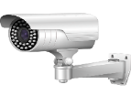

**CAMERA**

**PC/LAPTOP**

**DL (CNN) ACCIDENT DETECTION**

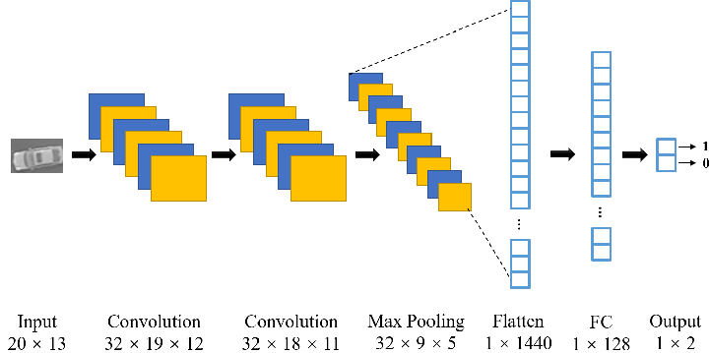

# 

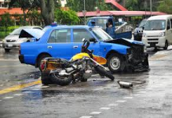

**ACCIDENT DETECTED**

**4. MODULES**

1. Image Collection

2. Image Preprocessing

3. Importing Modules

4. Training Dataset

5. Testing Dataset

6. Camera Interfacing

7. Email Alert

8. Number Plate Recognition.

**5. METHODOLOGY**

One of the most significant artificial neural networks is the convolution neural network. The domains of video and image recognition are where it is most often employed. In contrast to other multi-layer convolution models, CNN's convolution and pooling layers come before the fully linked hidden neuron layer. The input is taken and processed using the convolution and pooling layer. The classification of the photos takes place on the following fully connected layer, which is utilized to produce the output. The photos are processed using CNN using numerous layers of arrays. Applications like face and image recognition leverage this.

In contrast to other neural networks, which focus on feature extraction, CNN accepts the input as a 2D array and operates the pictures directly. This is why it is superior to other neural networks.**[17]**

**5.1 LAYERS OF CNN**

1. Input layer
2. Convo layer (Convo + ReLU)
3. Pooling layer
4. Fully connected(FC) layer
5. Soft max/logistic layer
6. Output layer
7. **INPUT LAYER**

It contains image data. This data is represented by 3D matrix. We have to reshape it to a single column.

1. **CONVO LAYER**

Feature of the images are extracted in this layer so it is also called as Feature Extractor layer. It calculating the dot product between receptive fields. The output will be input for the next layer.

1. **POOLING LAYER**

It is used to reduce the spatial volume of input image. It is used between convo layers.

1. **FULLY CONNECTED LAYER**

It involves weights, neurons and biases. It connects one layer neurons to other layer neurons.**[18]**

**6. SOFTWARE REQUIREMETS**

1. Python
2. Numpy
3. Opencv
4. Pandas
5. Tensor flow
6. Pillow
7. Keras
8. Pytesseract
9. Twilio Sms

**7. SCREENSHOTS**

**ACCIDENT DETECTED**

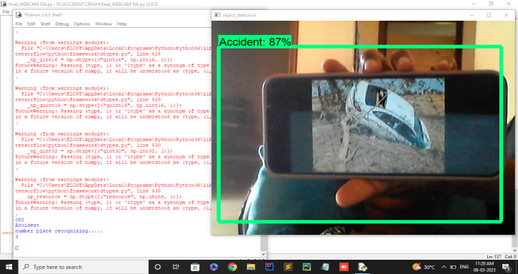

**Fig.1** Detecting the accident images through open cv

**GETTING MESSAGE WHEN ACCIDENT DETECTED**



**Fig.2** getting message in our mobile phone after detecting the accident

**NUMBER PLATE DETECTION**

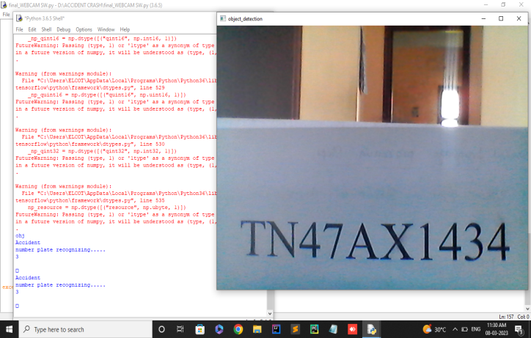

**Fig.3** scanning the number plate to get the

Information of the victim

**GETTING DETAILS OF VICTIM THROUGH SMS BY DETECTING NUMBERPLATE**



**Fig.4** getting the details of the victim through

SMS in our mobile

**8. ADVANTAGES OF PROPOSED SYSTEM**

1. Accurate and fast detection
2. Automated detection
3. Low cost
4. Scalability
5. Real-time response
6. Improved safety

**9. APPLICATION**

1. Automotive industry
2. Public safety
3. Transportation industry
4. Insurance industry
5. Smart cities
6. Law enforcement

**10. RESULT AND DISCUSSION**

Tensor flow was employed in deep learning for the suggested model. The model's ckpt format, which is suited for 2D data like the kaggle dataset, would be the framework's input. every test. train and csv. A csv file contains data and a label. Both training and assessment include using that term. CNN is used to find accidents. This technology is better at spotting accidents in real-time video or still photos.CNN is used to categorise various object kinds in pictures and movies. It is capable of correctly identifying accident photographs. Details on the accident victim can be found by utilising optical character recognition to read number plates. To identify the characters in an image or video, OCR is utilised. These two solutions can speed up emergency response times and promote road safety.

**11. FUTURE ENHANCEMENT**

In this project of ACCIDENT CRASH DETECTION USING DEEP LEARNING ALGORITHM, it can detect the accident and send the alert message to the rescue team and get the victim details using number plate detection.

In the future scope of this project is to implement this method everywhere that sense to fix this in all the roads of our country. We must do this project to get in to the government to implement everywhere. This project may be modified to send the rescue team's alert even more quickly, allowing them to save the victim.

**12. CONCLUSION**

In conclusion, the combination of number plate identification using OCR and accident detection using convolution neural networks (CNNs) can offer various advantages for strengthening road safety and emergency response times. CNNs are effective in swiftly and reliably identifying possible mishaps in the present, which can speed up emergency service response times. In contrast, number plate recognition by optical character recognition (OCR) can assist in identifying the cars involved in collisions, potentially making it simpler to hold drivers responsible for their conduct. These devices are especially useful in hit-and-run collisions, where the drivers depart the scene before help arrives. By determining the car involved in the collision's licence plate,

The driver can be located and prosecuted by law authorities for their acts. However, the precision of the algorithms, the dependability of the hardware, and the quality of the data all affect how well these systems work. Additionally, it is crucial to take into account privacy issues and make sure that data is utilized in line with all applicable rules and laws.

Overall, the combination of number plate identification using OCR and accident detection using CNNs has the potential to increase road safety and speed up emergency response times.

**13. REFERENCES**

**[1]** Gang R, Zhuping Z. “ Traffic safety forecasting method by particle swarm optimization and support vector machine.”“Expert Systems with Applications.”2011;38(8):10420–4. doi:10.1016/j.eswa.2011.02.066

**[2]** Sarraf R, McGuire MP. Integration and comparison of multi-criteria decision making methods in safe route planner. Expert Systems with Applications. 2020;154:113399. doi:10.1016/j.eswa.2020.113399

**[3]** H. L. Wang and M. A. Jia-Liang, ‘‘A design of smart car accident rescuesystem combined with WeChat platform,’’ J. Transp. Eng., vol. 17, no. 2,pp. 48–52, Apr. 2017.

**[4]** J. White, C. Thompson, H. Turner, H. Turner, and D. C. Schmidt,‘‘Wreckwatch: Automatic traffic accident detection and notificationwith smartphones,’’ Mobile Netw. Appl., vol. 16, no. 3, pp. 285–303,Jun. 2011.

**[5]** WHO. Global Status Report on Road Safety 2018. Accessed: Dec. 2018.

# [6] Wan-Jung Chang, Liang-Bi Chen et al “Deep Crash: A Deep Learning-Based Internet of Vehicles System for Head-On and Single-Vehicle Accident Detection with Emergency Notification”IEEE-2019

# [7] Unaiza Alvi, Muazzam A. Khan Khattak et al “A Comprehensive Study on IoT Based Accident Detection Systems for Smart Vehicles”IEEE-2020

# [8] Daxin Tian, Chuang Zhang et all “An Automatic Car Accident Detection Method Based on Cooperative Vehicle Infrastructure Systems” IEEE-2019

# [9] Hiroaki Hayashi, Mitsuhiro Kamezaki et all “Toward Health–Related Accident Prevention: Symptom Detection and Intervention Based on Driver Monitoring and Verbal Interaction”IEEE-2021

# [10] Rutik Desai, Akash Jadhav,Suraj Sawant ,Neha Thakur “Accident Detection Using ML and AI Techniques”

# [11] Prof.L.K.Wani; Md Maaz Momin; Sharwari Bhosale et all “Vehicle Crash Detection using YOLO Algorithm” IJCSMC, Vol. 11, Issue. 5, May 2022, pg.75 – 82

# [12] Tejas Chopda, Sarthak Kale, Sumit Gotpagar et all “Survey on Intelligent Accident Detection System and Emergency Services Alert System” International Journal of Advanced Research in Science, Communication and Technology (IJARSCT) Volume 2, Issue 1, November 2022

# [13] Arsalan Khan, Farzana Bibi, Muhammad Dilshad, et all “Accident Detection and Smart Rescue System using Android Smartphone with Real-Time Location Tracking” (IJACSA) International Journal of Advanced Computer Science and Applications, Vol. 9, No. 6, 2018

# [14] Pranto Karmokar,Saikot Bairagi,Anuprova Mondal “Smart Accident Detection And Rescue System” Daffodil International University Dhaka, Bangladesh April 2019

# [15] Sharmila Gaikwada, Mahek Khannaa, et all “Systematic Literature Survey on Accident Alert & Detection System” MCT’s Rajiv Gandhi Institute of Technology, Mumbai, India

**[16]** Bilal Khalid Dar, Munam Ali Shah et all “Delay-Aware Accident Detection and Response System Using Fog Computing” IEEE-2019

**[17]**https://www.techtarget.com/searchenterpriseai/definition/convolutional-neural-network

**[18]**https://www.analyticsvidhya.com/blog/2021/05/convolutional-neural-networks-cnn/