SMART MEDICINE REMAINDER SYSTEM ANDROID APPLICATION

**Gurusamy.M (312820104024), GokulaKrishnan. A (312820104022), Arun Kumar. A (312820104010)** Student, Computer Science and Engineering, Agni College of Technology, Chennai-600 130, Tamil Nadu, India

**Mrs. Umadevi Venkat G**, Assistant Professor, Computer Science and Engineering, Agni College of technology, Chennai-600 130, Tamil Nadu, India

**ABSTRACT**

This is an Android-based application that incorporates a method for setting up automated alarms. It emphasises communication between the doctor and patient. Patients do not need to remember when to take their medications because they can set an alert for when to take their medications. The alarm may be set for a variety of medications and timings, including the day, hour of the medication. They will receive a notification through system-based message, as preferred by the patients. They can look for doctors by illness. Patients will be given contact information based on their availability. Additionally, users can view various articles about medical topics and health care advice. The system places a strong emphasis on user interface and simple navigation. Many of these medical reminder systems have been created, but in our work, we have tried to create a system that is affordable, time-saving, and supports medication adherence too.

**KEYWORD**

Medication Adherence, Medication Remainders to Others, Automatic Alarm, Reminder, Notification, and Scheduler for Medication.

1. INTRODUCTION
2. II. Patients include all people, including instructors, students, businesspeople, housewives, and children. We all have busy schedules as well. Nowadays, life is demanding and full with responsibilities. As a result, people are prone to a variety of oilments, and it is our job to keep our own health and fitness. Someone may help care for the patient if he or she stays at home, but if the patient travels or lives in another city or state away from home, it is difficult for family members to call them and continually remind them to take their prescription as recommended.
3. We completely rely on technologies, especially smart phones, in our technologically advanced and reliant way of life. Everyone owns a smart phone today. As a result, we have the chance to employ technology more effectively and make it work for us. Additionally, it is a significant part of daily life and aids in our continued fitness in a variety of ways.

### RELATED WORK

Numerous medication systems have been created using various platforms and ideas. The use of apps for healthcare is expanding, but there are significant problems with how well they work. A mechanism to remind kids to take their medications is called My Medi Health [3]. It operates on portable devices such smart phones, offering user interfaces for setting up medication regimens and user notifications to remind users about the time and kind of medicine in accordance with the established schedule. To make sure that patients really take their drugs, several systems utilise sensors, radio-frequency identification (RFID), or motion detection technology. [4][5][6]. Based on data synchronisation, Park et al suggested a method for medication reminder synchronisation. It sends messages based on data synchronisation and OMA (open mobile alliance) that contain the patient's .

They don't offer a facility for physicians to schedule appointments, don't offer disease-specific doctor searches, and merely need mandatory notice. Users are unable to modify the default alarm tone on some systems. Without a doctor's prescription, the scheduled reminder automatically offers any medication, dosage, etc., which may result inpatients suffer injury. Last but not least, a lot of the systems on the market need specialised hardware that must be obtained

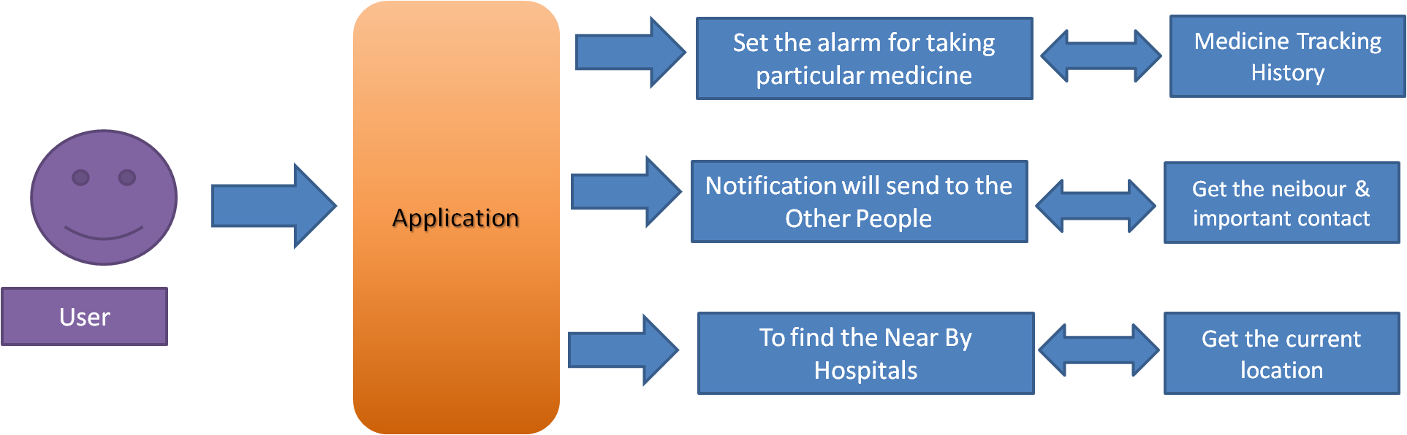

1. **PROPOSED SYSTEM AND IMPLEMENTATION**

The suggested system, which is based on the Android based operating system, will alert users when it's time to take their medications and will sound an alarm automatically if they forget.

Google and the Open Handset Alliance collaborated to create Android, a Linux-based operating system primarily intended for touch-screen mobile devices like smartphones and tablet computers. Android was created from the bottom up to provide developers the tools they need to make engaging mobile applications that make the most of a device's capabilities. Only because Android has a large market share is the system's choice of operating system. ADF, which offers an API for application development and contains services for creating GUI apps, data access, and other component kinds, is another feature of Android. The framework is intended to make it easier to reuse and integrate components. An obligatory XML manifest file is used to create Android applications. Values in the manifest file are associated to the program during compilation. This file gives the Android platform crucial data it needs to manage the life cycle of an application. Descriptions of the app's components and other architectural and configuration details are a few examples of the kind of information that may be found in a manifest file. The following categories of components can exist: activities, services, broadcast receivers, and content providers [10].

1. CONCLUSION

On various platforms, a number of medication reminder systems have been developed. Many of these systems call for specialized hardware to remind patients when to take their medications. New hardware purchases grow more expensive and time and resource intensive. Therefore, an effort has been made in the provided work to implement a system that is affordable, accessible, and improves medication adherence. Medication non-adherence decreases a treatment's efficacy and costs the health care systems money [14] [15]. The patients will receive a schedule of medication intake times along with a description of the medication, notice through message an automatic alarm ringing system, and a navigation system.

**SCREEN SHOTS(EXAMPLES)**

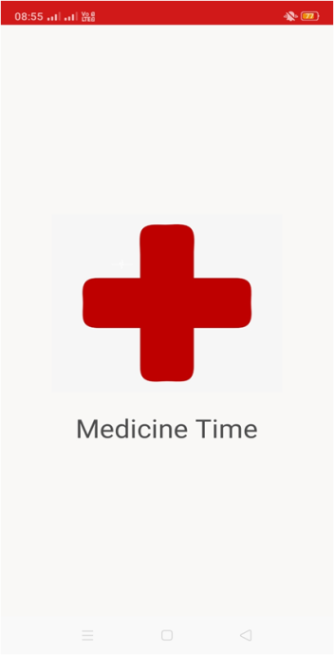 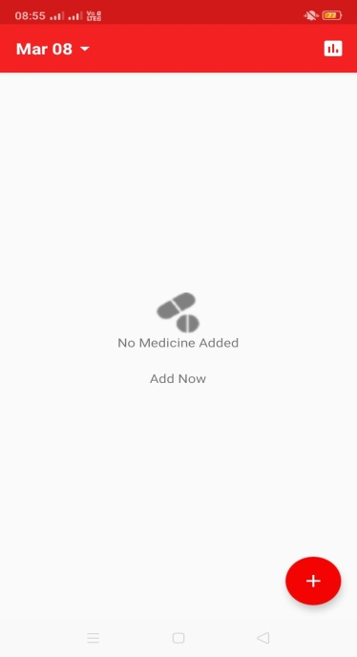 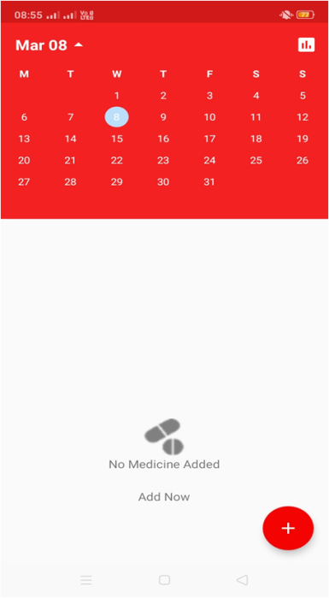

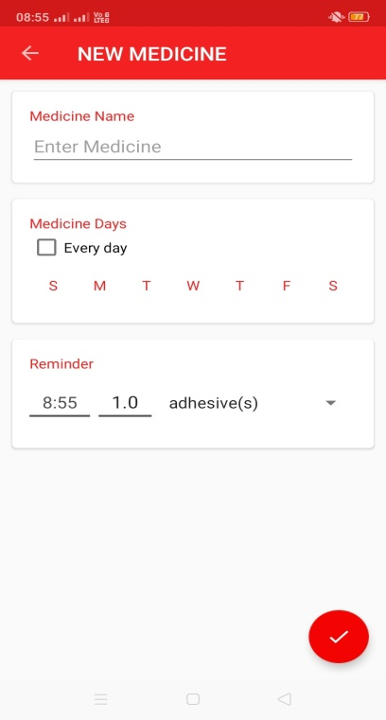 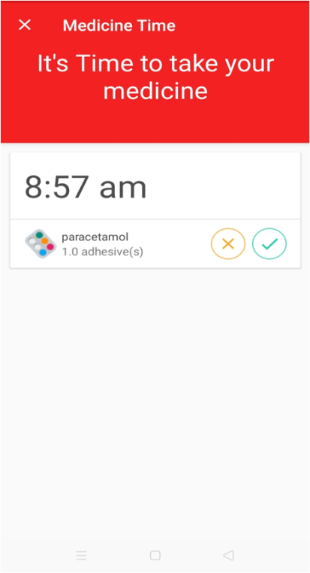 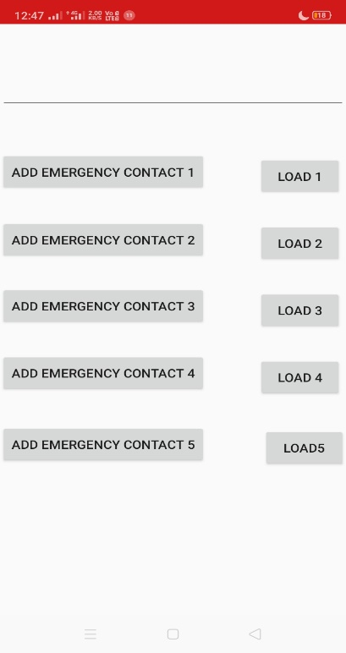

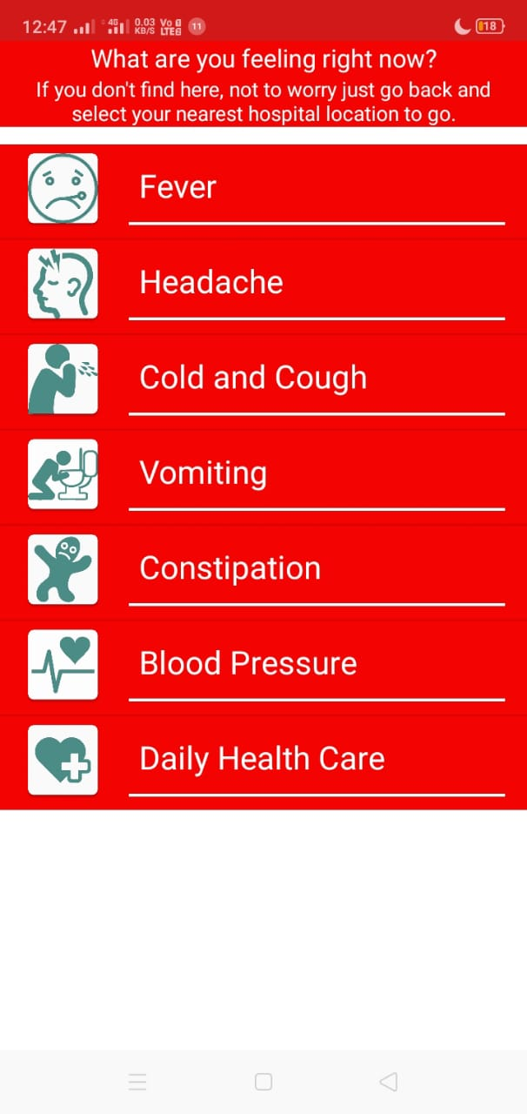 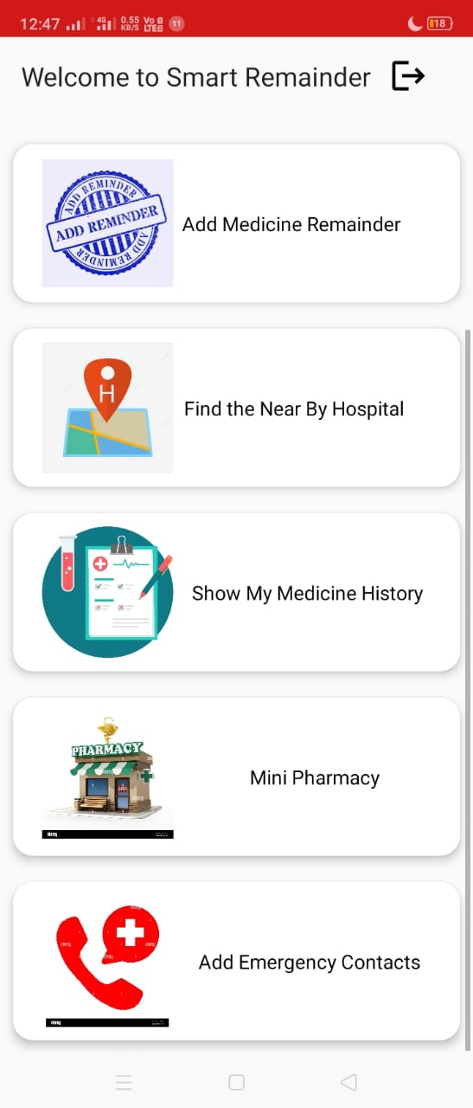

1. REFERENCES

[1] Park, KeeHyun & Lim, SeungHyeon, (2012) “Construction of a Medication Reminder

Synchronization System based on Data Synchronization”, International Journal of Bio-Science and

Bio-Technology, Vol.4, No. 4, pp1-10.

[2] "Smartphone medication adherence apps: Potential benefits to patients and providers", available at:

<http://www.ncbi.nlm.nih.gov/pmc/articles/PMC3919626/>

[3] Slagle, J.M., Gordon, J.S., Harris, C.E., Davison, C.L., Culpepper, D.K., Scott P. and Johnson, K.B.,

(2011) “MyMediHealth – Designing a next generation system for child-centered medication

management”, Journal of Biomedical Informatics, Vol. 43,No. 5, pp. 27-31.

[4] Becker, E., Metsis, V., Arora, R., Vinjumur, J.K., Xu, Y. and Makedon, F. (2009) “SmartDrawer:

RFID- Based smart medicine drawer for assistive environments”, Proc. of Pervasive technologies

related to assistive anvironments, June, pp 1-8.

[5] Ammouri, S. and Bilodeau, G.A. (2008) “Face and hands detection and tracking applied to the

monitoring of medication intake”, Proc. of Canadian Conf. on Computer and Robot Vision, May, pp.

147-154.

[6] Batz, D., Batz, M., Lobo, N.D.V. and Shah, M. (2005) “A computer vision system for monitoring

medication intake”, Canadian Conf. on Computer and Robot Vision, May, pp. 362-369.

[7] Prasad, B., (2013) “Social media, health care, and social networking”, Gastrointest Endosc. Vol. 77,

pp 492–495.

[8] Zao, J.K., Wang, M.Y., Peihsuan, T. and Liu, J.W.S., (2010) "Smart Phone Based Medicine In-take

Scheduler, Reminder and Monitor", IEEE e-Health Networking Applications and Services

(Healthcom), pp 162 – 168.

[9] “Android”, available at: <http://www.openhandsetalliance.com/android_overview.html>

[10] Mahmood, R., Mirzaei, N., Malek, S., (2014), “EvoDroid: Segmented Evolutionary Testing of

Android Apps”, FSE’14, November 16–21, 2014, Hong Kong, China

[11] "Medication Adherence", available at: <http://circ.ahajournals.org/content/119/23/3028.full>

[12] “Healthful Reminders for Medications, Beyond an Apple a Day”, available at:

<http://www.nytimes.com/2010/09/30/technology/personaltech/30smart.html?_r=0>

[13] “Thinking Outside the Pillbox: A System-wide Approach to Improving Patient Medication

Adherence for Chronic Disease” (2009), A NEHI Research Brief July 2009, New England Healthcare

Institute.

[14] Hughes, D. A., Bagust, A., Haycox, A., and Walley, T.O.M. (2001) “The impact of non-compliance

on the cost effectiveness of pharmaceuticals: a review of the literature”, Health Economics, pp. 601615.

[15] “Adherence to long term therapies: Evidence for Action” (2003), Report by World Health

Organization