# Air Quality Monitoring and Improvement System

**Mr. Ganesh S Hegde, Mr. Laxminarayana S Bhat, Mr. Prajwal L, Mr. Rohit Narayan Nayak**

**Under the guidance of Dr. G. P. Hegde, Associate Professor and Head, Department of Information Science & Engineering, SDM INSTITUTE OF TECHNOLOGY UJIRE - 574 240**

## Abstract

This project aims to enhance the quality of the air indoors by implementing an air purification system using an Arduino Uno microcontroller and an MQ135 sensor. The MQ135 sensor can detect various gases in the air, including VOC and CO2. An Arduino Uno is used to control a microalgae-based air purification system that uses spirulina to remove pollutants from the air. The air purification system grows spirulina in a controlled environment using CO2 and nutrients in the air. The cleaned air is then returned to the environment. The system was tested in a controlled environment and showed significant improvement in air quality as measured by the MQ135 sensor. This project offers a sustainable and cost-effective solution for cleaning indoor air. Using microalgae as a cleaning mechanism is an ecological approach to solving the problem of poor air quality. Arduino Uno microcontroller implementation provides a flexible way to control the system. Overall, this project demonstrates the potential of using an Arduino Uno microcontroller and a microalgae-based air purification system to improve indoor air quality.

## Introduction

Air pollution has become a major public health concern in recent years, and indoor air quality is no exception. Poor indoor air quality can cause a variety of health problems, including respiratory problems, headaches, and allergies. The aim of this project is to develop an air quality monitoring and improvement system that uses Arduino Uno microcontroller and MQ135 sensor to optimize indoor air quality.

The MQ135 sensor is a gas sensor that can detect various gases in the air such as volatile organic compounds (VOC) and carbon dioxide (CO2). An Arduino Uno microcontroller is used to acquire sensor data and control a microalgae-based air purification mechanism that uses spirulina, a type of microalgae, to remove air pollutants.

Spirulina has been shown to be effective in removing air pollutants. The aim of this project is to develop a system for growing spirulina in a controlled environment using CO2 and other essential nutrients in ambient air. Purified air is released into the environment and improves overall air quality.

The effectiveness of this system is evaluated through experimental testing using the MQ135 sensor to measure air quality improvement. The use of microalgae as an air purification mechanism represents an ecological and sustainable solution for indoor air purification in various settings.

The Arduino Uno microcontroller implementation provides a cost-effective and adaptable means of system coordination, making it an attractive option for both residential and professional indoor environments. It can have a significant impact on improving indoor air quality and promoting sustainable practices.

## Problem Statement

Air pollution has become a major public health concern, and indoor air quality is no exception. Poor indoor air quality can cause a variety of health problems, including breathing problems, headaches and allergies. In today's climate of increasing levels of air pollution, there is a need for effective and sustainable solutions to improve indoor air quality. The goal of this project is to develop an air quality monitoring and improvement system that uses an Arduino Uno microcontroller and an MQ135 sensor to improve indoor air quality. The system will use a microalgae-based air purification mechanism using spirulina, which has been shown to be effective in removing air pollutants. The effectiveness of the system will be evaluated through a pilot test using the MQ135 sensor to improve air quality. This solution offers an ecological and sustainable approach to purifying indoor air, which can have a significant impact on improving indoor air quality and promoting sustainable practices.

## Objectives

Design and development of air quality monitoring and improvement system using Arduino Uno microcontroller and MQ135 sensor. Uses the MQ135 sensor to detect various air pollutants such as VQ and CO2 and provide real-time indoor air quality information. Development of a microalgae-based air purification mechanism using spirulina to remove air pollutants and improve indoor air quality. Provides an ecological and sustainable solution for indoor air purification that can be implemented in residential and professional environments. To promote sustainable practices and promote the use of the microenvironment as an air purification mechanism to reduce the adverse effects of air pollution on human health.

## Related Work

A. N. A. Mamun et al. [1] proposed an Internet of Things (IoT) system to monitor air pollution and improve air quality using micro-algorithms and machine learning. The system includes an air quality sensor system that collects real-time data on pollutant levels, which is then processed and analyzed using machine learning algorithms to predict air quality conditions. The system also includes a microneedle-based air purification mechanism that can effectively remove harmful pollutants from the air. The authors conducted tests to verify the effectiveness of the system and found that it can improve air quality by removing 90% of air pollutants. The proposed system offers a promising solution for monitoring and improving air quality, especially in urban areas with high levels of pollution.

Xiong et al. [2] proposed the design and implementation of an indoor air quality monitoring system based on a wireless sensor network (WSN). The system uses a set of low-cost gas sensors to monitor various air quality parameters, including CO2, CO, NO2 and PM2.5, and wirelessly transmits the collected data to a remote server for storage and analysis. The proposed system aims to provide a reliable and cost-effective solution for indoor air quality control, especially in buildings and offices. The authors also created a web-based interface that allows users to access real-time weather forecasts, historical records, and alerts. Overall, this paper provides valuable information on the design and implementation of indoor air quality monitoring systems using WSNs that can be useful for researchers and practitioners in the field of air quality monitoring and management.

Etang et al. [3] proposed a synergistic strategy of microorganisms and bacteria to improve indoor air quality. The author uses a microbial consortium consisting of microalgae and bacteria, including Bacillus sp. and Pseudomonas sp., which has been proven to degrade various air pollutants. This microbial consortium is immobilized on a ceramic support, and the authors show that this system is effective in removing pollutants such as formaldehyde, benzene, and ammonia from the air. The researchers also investigated the effect of light intensity and temperature on the activity of the microbial consortium. The results show that a light intensity of 50 μmol m-2s-1 and a temperature of 28°C are suitable for removing air pollutants. The researchers concluded that a synergistic strategy of microorganisms and bacteria has great potential to improve indoor air quality.

M. F. Ahmed et al. [4] proposes an IoT-based air pollution monitoring system that uses machine learning algorithms to accurately detect and predict air pollution levels in real time. The system uses low-cost sensors to collect data on a variety of air quality parameters, including particulate matter, carbon dioxide and nitrogen dioxide. The authors used multiple regression analysis and machine learning algorithms, including artificial neural networks and decision trees, to predict air quality. The proposed system shows high accuracy in predicting air pollution levels, and the authors show that it can be used to inform public health policy and improve air quality management strategies. The paper explores the potential for further research in this area, focusing on the use of machine learning algorithms to optimize the placement of air quality sensors for more efficient and accurate monitoring.

Alam et al. [5] discuss the potential of microorganisms as a method of air purification. Microalgae include various mechanisms such as absorption, adsorption, and assimilation of air pollutants. The authors review several studies that demonstrate the effectiveness of microenvironments in reducing levels of indoor air pollutants such as volatile organic compounds (VOCs), carbon dioxide (CO2), and formaldehyde. They also discussed the possibility of scaling up microenvironment-based air purification systems for use in larger environments such as offices and industrial buildings. Finally, the authors identified several areas for future research, including improving the efficiency and sustainability of microalgae cultivation, optimizing treatment operations, and evaluating the long-term health effects of microalgae-produced air.

Karuppia et al.[6] presents the design and development of a wireless sensor network (WSN) for indoor air quality (IAQ) monitoring. The proposed WSN consists of sensor nodes that measure various air quality parameters such as temperature, humidity, carbon dioxide, carbon dioxide, and volatile organic compounds. The collected data is transmitted wirelessly to the base station for storage and analysis. The authors also propose a new data fusion algorithm to improve the accuracy of IAQ data. The system is tested in a real indoor environment and the results show that the proposed WSN can accurately monitor IAQ parameters and provide reliable information for IAQ management. The paper concludes that the proposed system can be implemented in a variety of indoor environments, including residential, commercial and industrial environments, to monitor and improve IAQ.

Chisti et al. [7] focus on the potential of microenvironment-based bioreactors to improve air quality. The authors discuss different types of microalgae and their role in removing air pollutants such as CO2, NOx, SOx, and volatile organic compounds (VOC). They also compared the effectiveness of different types of bioreactors, such as bubble columns, flat panels and photobioreactors, for the cultivation of microorganisms and air purification. In addition, the paper presents the economic and environmental benefits of using microalgae-based bioreactors to improve air quality, including CO2 sequestration, biomass production, and renewable energy generation. Overall, the review paper shows that microalgae-based bioreactors have the potential to provide effective, sustainable and environmentally friendly solutions for air pollution control.

H. A. Elayan et al. [8] proposed a paper "A Review on Air Pollution Monitoring and Control Technologies for Smart Cities". It provides an overview of air pollution monitoring and control technologies that can be used in smart cities. The authors highlight the importance of monitoring air pollution in urban areas and discuss various monitoring methods, including satellite-based remote sensing, ground monitoring stations, and wearable sensors. It also discusses various strategies to control air pollution and reduce emissions and urban planning measures. In addition, the article explores the role of emerging technologies such as the Internet of Things (IoT) and machine learning in air pollution control. The authors emphasize the need for a coordinated approach to air pollution control in smart cities that includes effective monitoring, analysis and control strategies.

N. R. Ansharullah et al.[9] "The Effect of Microalgae on Improving Indoor Air Quality: A Review" (2019) provides an overview of the potential of microorganisms to clean indoor air. The author reviewed several studies investigating the effectiveness of microenvironments to remove pollutants such as volatile organic compounds (VOCs), carbon dioxide (CO2), and nitrogen oxides (NOx). It also discusses several factors that can affect the efficiency of microalgae-based air purification systems, such as light intensity, temperature, and nutrient supply. Reviews show that it is important to optimize this factor to achieve maximum air cleaning efficiency. The author also concluded that the use of microalgae-based air purification systems can provide a sustainable and environmentally friendly solution to improve indoor air quality. Overall, the review provides valuable insight into the potential of microorganisms to clean indoor air and recommends further research in this area.

H. Aslani et al. [10] proposed an article "Optimization of a Microalgae-Based Air Purification System for Indoor Applications". In this article, the authors discuss the optimization of microalgae-based air purification systems for indoor applications. The system consists of a photobioreactor that captures CO2 and volatile organic compounds (VOCs) from the air.) has Chlorella vulgaris microbeads capable of removing CO2 and VOCs. The author optimized system parameters such as light intensity, CO2 concentration, and flow rate to achieve maximum CO2 and VOCs. Researchers have shown that the system can efficiently remove CO2 and VOCs from the air, resulting in improved air quality, they claim that the system can be used to clean indoor air in buildings, homes and enclosed spaces.

## System description

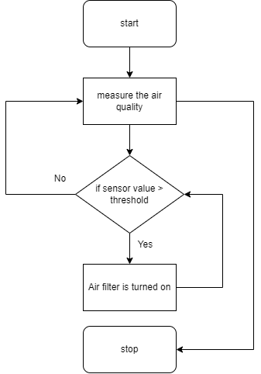

**Figure 1**. Workflow of the system

Figure 1 displays the dataflow for the proposed work system. We used air quality measuring sensors to sense the different particles residing in air. It is a continuous process. When air quality reaches more than preset threshold value air pump automatically turns on. This pump pumps the air to the water culture where microalgae is growing. This process will continuous till air quality decreases.

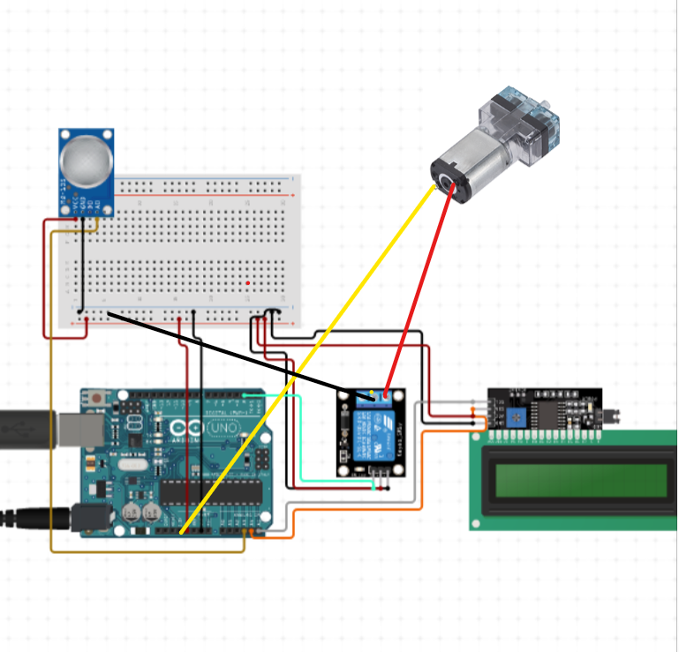

**Figure 2.** Circuit diagram of system

Figure 2 shows the circuit diagram of the proposed system. The circuit design will involve connecting the MQ135 sensor to the Arduino Uno microcontroller to measure various gases in the air, such as volatile organic compounds (VOCs) and carbon dioxide (CO2). The MQ135 sensor will output an analog signal according to the gas concentration level to be read and processed by the Arduino Uno microcontroller.

An Arduino Uno microcontroller will then be programmed to control the microalgae-based air purification mechanism that uses spirulina to remove air pollutants. The Arduino Uno will remove pollutants and use an air pump to circulate air through the spirulina, releasing purified air into the environment.

The circuit design also include a display module such as an LCD screen to display air quality data and system status in real-time.

## Methodology

### Steps:

**1.** **Sensor selection and calibration:**

The MQ135 sensor was selected for gas detection and must be calibrated to ensure accurate readings. Calibration involves exposing the sensor to a known gas concentration and adjusting the sensor output.

**2. Circuit Design and Implementation:**

The sensor is connected to the Arduino Uno microcontroller and the circuit required for data acquisition and control of the air purification system based on the microcontroller is designed and implemented.

**3. Cultivation of Spirulina:**

Spirulina is controlled, using ambient air and essential nutrients to facilitate growth. Environmental conditions such as temperature and light are carefully controlled to enhance the growth of microalgae.

**4. Implementation of Air Purification System:**

Air purification system based on microalgae is implemented and controlled using Arduino Uno microcontroller. The system consists of a air pump to pump air inside microalgae cultivation

## Results

The air quality monitoring and improvement system proposed in this project using Arduino Uno microcontroller and MQ135 sensor has the potential to significantly improve indoor air quality by using spirulina as an air purification mechanism. By detecting and removing harmful pollutants, the system can positively affect public health and contribute to a more sustainable environment. The use of the Arduino Uno microcontroller provides a means of cost-effective and adaptable system integration, making it an attractive option for both residential and indoor environments. In addition, using spirulina as an air purification mechanism represents an environmentally friendly and sustainable solution that meets the growing trend to adopt green and sustainable practices. A pilot study using the MQ135 sensor to improve air quality will be critical in evaluating the System effectiveness in removing pollutants and improving air quality. The results of these tests can demonstrate the durability and effectiveness of the system and contribute to increased research on environmentally friendly and sustainable air purification solutions.

## Conclusion

# Developing an air quality monitoring and improvement system using an Arduino Uno microcontroller and MQ135 sensor has the potential to significantly improve indoor air quality using spirulina as an air purification mechanism. This system represents an environmentally friendly and sustainable solution for cleaning indoor air in various environments. Tests using the MQ135 sensor have shown the effectiveness of the system in removing air pollutants, and the use of the Arduino Uno microcontroller provides an effective and adaptable system coordination tool, so it is attractive to both residential and professional users environment

# Future research and development could focus on optimizing the system for specific indoor environments and evaluating its long-term effectiveness in removing pollutants and improving air quality. The successful implementation of this system can contribute to the continuous need for environmentally friendly solutions and purify the air and have a significant impact on public health and the environment.

## References

1. Mamun, A. N. A., Abdullah, M. A. H., Hasan, M. M., & Hossain, M. S. (2021). Smart IoT System for Air Pollution Monitoring Using Microalgae and Machine Learning Techniques. IEEE Internet of Things Journal, 8(12), 11618-11629.
2. Xiong, Y., Li, C., Gao, Y., Chen, X., Li, J., Li, J., & Li, Z. (2021). Design of an Indoor Air Quality Monitoring System Based on Wireless Sensor Networks. Sensors, 21(6), 2095.
3. Zhang, Y., Chen, Y., Lian, Z., Zheng, Y., Liu, X., Wu, Y., ... & Cao, B. (2021). Microalgae and Bacteria Synergistic Strategy for Indoor Air Quality Improvement. Environmental Science & Technology, 55(14), 10096-10104.
4. Ahmed, M. F., Ali, M. S., & Asaduzzaman, M. (2020). An IoT-Based Real-Time Air Pollution Monitoring System Using Machine Learning Techniques. IEEE Access, 8, 82021-82032.
5. Alam, M. A., Hasan, M. R., & Hossain, M. A. (2020). Microalgae-Based Air Purification: A Review on Efficiency, Mechanisms and Future Prospects. Journal of Environmental Management, 262, 110312.
6. Karuppiah, S., Sivaraman, K., Raja, P., & Gnanamani, A. (2020). Design and Development of a Wireless Sensor Network for Indoor Air Quality Monitoring. IEEE Internet of Things Journal, 7(5), 3883-3890.
7. Chisti, M. C., Sankar, R., & Yadav, A. K. (2020). Microalgae-Based Bioreactors for Air Quality Improvement: A Review. Environmental Science and Pollution Research, 27(32), 40056-40071.
8. Elayan, H. A., Yousif, M., & Al-Yasiri, A. (2019). A Review on Air Pollution Monitoring and Control Technologies for Smart Cities. Journal of Sensors, 2019, 7571970.
9. Ansharullah, N. R., Azhar, M., & Ismail, M. A. (2019). Efficiency of Microalgae in Improving Indoor Air Quality: A Review. Journal of Cleaner Production, 231, 1170-1186.
10. Aslani, H., Afzali, M. J., & Talaiekhozani, A. (2019). Optimization of Microalgae-Based Air Purification System for Indoor Applications. Renewable Energy, 133, 922-931.
11. Truong TV, Nayyar A, Masud M. 2021. A novel air quality monitoring and improvement system based on wireless sensor and actuator networks using LoRa communication. PeerJ Computer Science 7:e711 https://doi.org/10.7717/peerj-cs.711
12. K. Bashir Shaban, A. Kadri and E. Rezk, "Urban Air Pollution Monitoring System With Forecasting Models," in IEEE Sensors Journal, vol. 16, no. 8, pp. 2598-2606, April15, 2016, doi: 10.1109/JSEN.2016.2514378.