**SMART BLIND STICK USING IOT**

**Abirami M1, Nagavi K2**

1Student, EEE, Sree Sowdambika College of Engineering, Aruppukottai, Tamil Nadu, India

2Assistant Professor, EEE, Sree Sowdambika College of Engineering, Aruppukottai,Tamil Nadu, India

**ABSTRACT**

In this paper, a smart blind stick guidance model for visually disabled citizens has been presented. Ultrasonic sensor is added to the transmitter and receiver of the stick. If there is an obstacle in the path buzzer or voice module will alert the blind person. The sensors are used to monitor the pulse rate and oxygen level of the blind person. The Global Positioning System (GPS) is a radio navigation system that provides reliable positioning, navigation, and timing services to civilian users on a continuous worldwide basis. For anyone with a GPS receiver, the system will provide location and time information for an unlimited number of people in all weather, day and night, anywhere in the world. GPS based blind man device with user input interfacing (remote controlled based) intellectually finds the current location and gives the alert to the blind man if it was his destination area. Node MCU is the heart of the device. It stores the data of the current location which it receives from the GPS system, so that it can make use if the data stored to compare with the destination location of the user. By this it can trace out the distance from the destination and produce an alarm to alert the user in advance. Here instead of an alarm sound the blind man can directly hear the location recorded by the user itself

**Keywords:** guidance for blind, alert to blind man, GPS Tracker, GSM Module, Alarm sound to blind man, location recorded

1. **INTRODUCTION**

Visually impaired people have acuity 6/60 or the horizontal extent of this visual field with both eyes open less< 200, which means they cannot or face difficulty in identifying objects around them from the research, it has been found that around 10% of blind people from the total world population have no usable eyesight at all to help them move around independently and safely. This electronic device is designed to solve this issues, to record information about the obstacles presence in a road, active or passive sensor can be used. In this device we use active sensor. So the active sensor, the sensors emits a signal and receives a distorted vision of the reflected responses from objects irradiated with artificial generated energy sources. These kind of active sensor are capable of sensing and detecting far and near obstacles. In addition to it, it can determine the accurate measurement of the distance between the blind and the obstacle.

1. **METHODOLOGY**

The smart stick, is basically an embedded system integrating the ultrasonic sensor to detect obstacles in front of the blind from ground level height to head level height in the range of 150 mm a head, infrared flame sensor to fire near the blind person. Ultrasonic sensors, water level sensor and infrared flame sensor collect real time data and send it to microcontroller. After processing this data, the microcontroller actives the buzzer to buzz and invokes a warning message to the user. The water sensor to detect water spreads and puddles. A rechargeable battery is used to power the circuits with 9V (DC).

1. **MODELING AND ANALYSIS**

After giving power supply to device, sensors on device will start taking readings. This readings are continuously sent to microcontroller. Microcontroller will compare this readings with the threshold values given to it .This threshold values can vary from person to person. After comparing this threshold values , Microcontroller will send “Help” message accordingly. GPS is used in device to continuously track device. Using IOT technology we can continuously monitor changes in sensors values. Position of device can also be track continuously. At the receiver side device like laptop, mobile phone, raspberry pi etc can be used to see sensor values and position. The device at receiver should be connected to internet in order to receive data from transmitter.

**Figure1:Block Diagram**

1. **RESULTS AND DISCUSSION**
   1. **Functional Requirements**

The following steps are initiated when the unusual behavior of the user is detected. The decision is made by the inputs given by the various sensors like pulse rate sensor, temperature sensor and unusual motion detected by the motion sensor. The situations are pre-programmed into the system based upon which the device makes the decision and is handled by the smart phone app.

1. Assign the transmitter and receiver pins of GPS module.
2. Set the serial buffer with baud rate 9600 and bit rate 4800.
3. Now set a loop which will then trigger the following actions:

a) Scan the contact number from SIM.

b) Get data from GPS module.

c) Convert the longitude and latitude obtained from GPS into a Goggle URL.

d) Attach this URL with an alert message.

e) Send this message to pre-selected ICE(In Case of Emergency) numbers from SIM memory periodically until device is reset.

* 1. **Performance Requirements**

Performance Requirements (PR) are necessary for system design and development. There are three classes of performance requirements: response time (how fast the system can handle individual requests, what a real user would experience), throughput (how many requests the system can handle), and concurrency (how many users or threads work simultaneously).

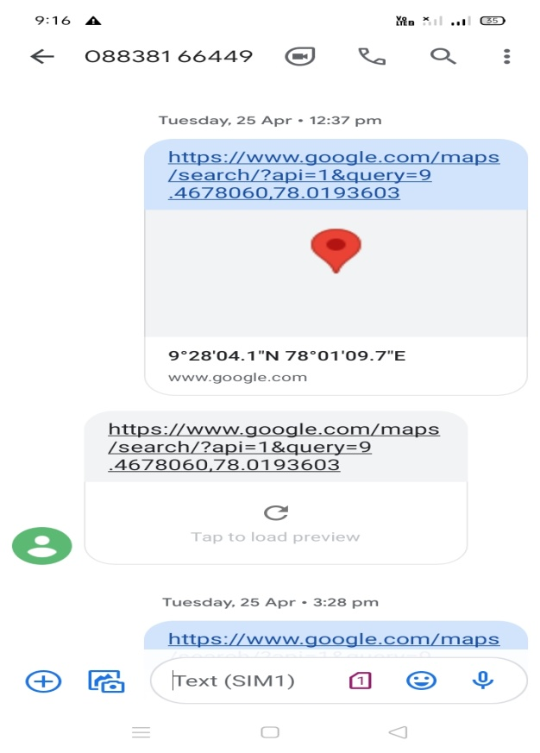

**Figure2:**Result

1. **CONCLUSION**

The Smart Stick for blind acts as a basic domain for the forthcoming generation of more aiding devices to help the visually challenged people to be more safe. It is effective and affordable. It leads to good results in detecting the obstacles lying ahead of the user in a range of 4 meters, detecting stairs, water pits, puddles, fire,etc., This system offers a cheap, reliable, low power consumption and robust solution for navigation with obvious short response time. Though the system is hard-wired with sensors and other components, it is light in weight. Further aspects of this system can be improved via wireless connectivity between the system components thus increasing the range of the sensors and implementing a technology for determining the speed of approaching obstacles While developing such a massive solution, visually impaired and blind people will be more relieved in all developing countries across the globe

**ACKNOWLEDGEMENTS**

First and foremost, we thank **GOD** whose blessings have bestowed on us the will power and confidence to carry out our project successfully. Next we thank **Our Parents** who provided full support for us with their prayers and wishes. We express our sincere thanks to **Dr. K. ARULMOZHI,M.Tech., Ph.D.,** Principal, Sree Sowdambika College of Engineering, Aruppukottai for providing all the necessary facilities for us. We are extremely grateful thank to our Head of the Department **Dr.R. SIVASANGARI,M.E.,Ph.D,** professor of EEE forherable guidance, continuous encouragement and moral support throughout the project work.

1. **REFERENCES**
2. T. MPandurang N. Kathar1, Prof. D.L.Bhuyar2 “Design and Implementation of Driver Drowsiness and Gas Intoxication DetectionUsing Raspberry PI” In International Journal of Innovative Research in Computer and Communication Engineering (An ISO 3297: 2007 Certified Organization) Vol. 4, Issue 8, August 2016 ,pp.14617-14625.
3. Supraja A1, Bhanu Sri A2, Mary Posonia A3“DRUNK AND DRIVE DETECTION USING IOT”In International Journal of Pure and Applied Mathematics Volume 118 No. 20, 2018, pp. 4304-4306.
4. Anil Kumar Patnik, Mondi KVS Manichandu, J.S.S. Keerthi Students, G. Satish, Y. Chanukya “Drunk and Drive Detection with Ignition Lock Using Raspberry PI” In International Journal and Magazine of engineering, Technology, Management and Research ISSN No.:2348- 4845 Volume No:6 (2019), Issue No: 4 (April) pp. 1-4.
5. Fathima Jabeen A, Dr. B. Ramamurthy, N.Anju Latha “Development and implementation using Arduino and Raspberry Pi based Ignition control system” In Advances in Computational Sciences and Technology ISSN 0973-6107 Volume 10, Number 7 (2017) pp. 1989-2004.
6. Akalya Chellappa, Mandi Sushmanth Reddy, R. Ezhilarasie, S. Kanimozhi Suguna, A.Umamakeswari “Fatigue Detection Using Raspberry Pi 3” In International Journal of Engineering & Technology, 7 (2.24) (2018) pp. 29-32
7. Nagalaskhmi T S, Nirmala L, Akash Soragaon “Raspberry Pi based Embedded System for Vehicle Automation over Internet ” In International Journal of Advanced Research in Computer and Communication Engineering ISO 3297:2007 Certified, Vol. 5, Issue 12, December 2016 pp. 255-259
8. Megha.A, Kavya.S, Akshatha.C.Tilagar, Divya.D.V, Prof. Vanishree Abhay “Implementation of Driver Drowsiness and other Features using Arduino and Raspberry PIIn International Journal for Scientific Research & Development Vol. 7, Issue 03, 2019 ISSN (online): 2321-0613 pp. 637-643.
9. Fathima Jabeen A, Dr. B. Ramamurthy, N.Anju Latha “Development and implementation using Arduino and Raspberry Pi based Ignition control system” In Advances in Computational Sciences and Technology ISSN 0973-6107 Volume 10, Number 7 (2017) pp. 1989-2004.
10. Akalya Chellappa, Mandi Sushmanth Reddy, R. Ezhilarasie, S. Kanimozhi Suguna, A.Umamakeswari “Fatigue Detection Using Raspberry Pi 3” In International Journal of Engineering & Technology, 7 (2.24) (2018) pp. 29-32