**The impact of the moon on airplanes during flight**

***By: Dr. Rohan Nasser Obied***

**Abstract**

***Purpose:*** The purpose of this research is to explore and analyse the effect of the moon during airplanes flights

***Methodology:*** The research methodology included the reliance on a secondary qualitative approach, where data was collected from secondary data resources. An inductive approach was used to analyse the results and research trends shift from specific to general. The relevant articles were collected by keywords that were further examined through the systematic literature review, which comprised critical apprehension of all literary resources in light of their conclusions and association with this research’s main purpose.

***Findings:*** The research findings were related to the effect of the moon’s light and its intensity on the flight of airplanes. Through a systematic literature review, it was explored that the full moon shines over the flight aircraft wings, and the moon acts as a guide to airplanes in the presence of heavy clouds. The results showed that an airplane’s flight is largely impacted by the full moon’s gravity and the new moon’s gravity. The changes and modifications between a full moon and a new moon are affected–and worth undergoing. The results also demonstrated that Newton's law is preferred to the Bernoulli principle to clarify the concept of lift which is about the air flowing over the wing eventually refracted descending by the wing’s angle, and Newton stated that there has to be an opposite and equal reaction. The altered phases of the moon also indicated the modified effects on airplane flight due to the light intensity and gravity of the moon.

***Recommendations:*** The proposed recommendations for this study included applying quantitative research in the domain of the effect of the moon on the flight of the airplane. There is a need to enhance the knowledge and insight in this domain to improve aviation safety.

**Keywords:** *Impact of the moon, light intensity, the moon’s gravity, the flight of the airplane*

**1. Introduction**

Gravity and air are the two basic factors to consider when flying an airplane. Airplanes have been here for generations and have been altered, modified, and redesigned to face the challenges of gravity and low air pressure. Concerning the gravity problem, there are two things two consider, gravity originated from the earth and gravity that an airplane experiences from the moon (Abe, Funase, 2018). With the advent of new technology, new airplanes can easily fly at higher altitudes which makes them vulnerable to the moon’s gravity. Initially, flying an old plane was easier, and there was a negligible effect of the moon's gravity because they used to fly close to the earth. No matter how or where you fly, you must contend with gravity because it permeates everything, and you cannot escape it. Air is also impossible to ignore. You must fly through the "stuff" of the air, which creates the forces of lift and drag.

Airplane flights require a steady altitude and air beneath their wings for stability. As the plane goes closer to the moon, the air starts to decrease, and the gravity of the moon starts affecting its propulsion and stability (Andino, 2019). Thus, the moon affects airplane flights. There is a safe distance that needs to be kept for a plane to keep a steady position. The aircraft must continue to produce approximately the same amount of lift as its weight to maintain its constant altitude. In this regard, the gravity of the moon mustn't disturb the balance. This is why it is always safe for planes to fly from a safe distance; otherwise, they can go into ‘coffin corners’.

The stability of the plane is influenced by the position of the moonn greatly. The moon must be in the proper location in the sky relevant to the plane's height and flight path. When the moon's phase changes, the low moon creates tiny planes in the sky because it is too low on the horizon and far away, whereas the high moon, when in its full phase, greatly affects planes since it is considerably closer to the earth (Bowen & Kisida, 2019). Different technologies are now being employed to build aircraft that can easily go from point A to point B without being impacted by the moon by absorbing the gravity of the moon to maintain the exact latitude and stability.

* 1. **Aims and objective**

The aim of the study is to understand the role and effect of the moon on an airplane flight. There is a general understanding that the light and gravity of the moon play a significant role in the stability of the plane.

* + 1. **Objectives:**
* To examine the effects of moon gravity on an airplane flight.
* To analyse the effects of moonlight intensity on an airplane flight.
  1. **Research Questions:**
* What is the effect of the moon on an airplane flight?
* Do moonlight intensity and gravity affect the stability of an airplane flight?
  1. **Research Significance**

There are very few studies which tried to examine the effects of the moon on an airplane flight. It is critical to understand the effects of the moon’s gravity and the moon’s light on the stability of an airplane flight. Thus, this study has tried to fill that gap by analysing the effect of the moon on airplane flight by using a systematic literature review. According to old literature studies in this study, old planes used to fly near the earth, which is why the effect of the moon on the flight pattern was negligible. However, with new technologies being introduced, it has now become critical to examine the effect because new planes fly high, and the probability of being affected by the moon’s light and gravity is higher.

**2. Review of Literature**

Moon has a significant effect on the flight of airplanes, and it creates an accelerating force due to gravity on the surface. The airplanes that fly very close to the earth are less affected by the moon’s gravity as compared to the planes that fly high. The gravitational field of both the earth and the moon affects the plane. An airplane which is at long distance flight maintains a steady altitude and constant displacement from the earth's centre (Tucker, 2022). It maintains the same amount of lift as it has a constant altitude. A full moon has a significant effect on VFE flying because the light may act as traffic, and flying may get influenced by the effect of ambient light conditions. A research study showed that there is a major effect of artificial and natural light on the flight. This chapter critically reviewed the literature related to this study.

***2.1: Moon’s gravity and velocity of the airplane***

Airplane flight gets affected by the gravity of the moon because when the airplane leaves the earth’s gravity, then it establishes an orbit about it and has a main point at the moon. Space flight changes its velocity after entering the moon’s gravity because when it enters the moon then, its gravity changes in comparison to the earth’s gravity and due to a change in gravitational force, its velocity also changes (Brown, 2022). The research investigated that the moon increases the plane's findings because it established a scenario in which the results revealed that along the stars, the moon makes the natural light environment that planes may utilise for alignment and visual direction.

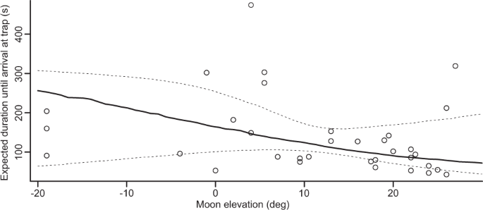

*Figure 1(Moon Elevation, 2018)*

According to the Cox PH model, the period of the flight was seen as the median period anticipated (*p* = 0.014, *n* = 34). The findings indicated that within 8 minutes for arrivals after release and be around overall individuals (Storms, et al., 2022). Circles signify the actual measured values, and sunk outlines specify the levels of the confidence interval of the period of prediction at α = 5% level assessed by bootstrapping.

The gravitational acceleration of the moon is reliant on the mass of the airplane body and the distance the airplane is from the centre of mass. The moon has mass, so some gravity can never be zero. The gravitational acceleration of the moon that results in the airplane flight is

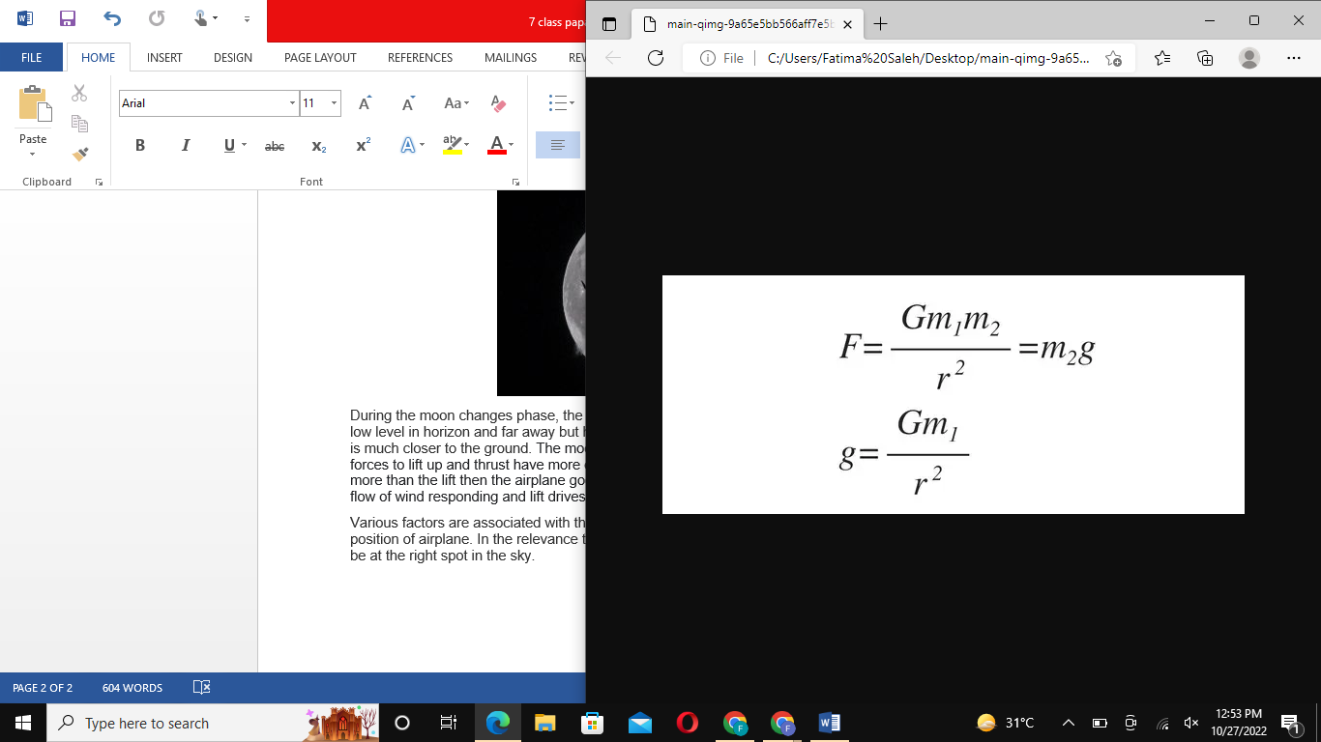

*Figure 2(Formula of gravitational acceleration, 2017)*

The moon impacts airplanes' flights because of atmospheric resistance. Night flights provide general aviation pilots with the experience of the traffic (Avdellidou et al., 2021). When night flights are drawn, then the clearance attitude of the route is also provided, which provides instructions to the flight instructor. Flight activities are effective due to moonlight experiences. It provides indirect effects on flight accommodation prospects. According to Abe et al. (2018), flight models and meteoroid impacts the surface functions and influx rate of the earth and moon. It also provides the mission plan related to seismometers. The influx rate of interplanetary clouds of dust also affects the surface status of the flash observer. The survey of detection of impact of lunar flashes the coordinates of earth. Meteoroids, as well as constructed elements, affect lunar functions and impact the flight structure.

*2.2 Night Flights and phases of the moon*

Night flights are commonly the best a common aviation pilot can practice, and the resistance of air present in the form of traffic during flight is light. Supervisors experienced more wind and shortcuts, and these were calmer. Besides these, the overall accident rates at night are more likely to be fatal, but the consequences have a significant impact during the different phases of the moon (Runnels & Gebre-Egziabher, 2022). During preflight, the phase of the moon, changes, and modifications between a full moon and a new moon are affected–and worth undergoing. The weather with the phases of the moon also has a direct effect on the conditions of the flights. Low overcast, even a 25,000 ft. cloudy weather can block the moon and the speed of the flight. The destination of the airport and route of flight and associated factors enhance the risk with VFR (visual flight rules). A full moon may create a big difference for VFR (visual flight rules) flying to ensure that clouds would not block it.

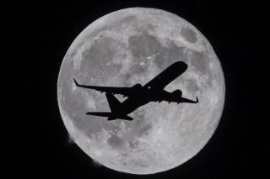

*Figure 3: (Visual flight rules, 2019)*

Various factors are associated with the right spot on the moon and the position of the airplane. In the relevance to the path of flight and the altitude of the plane, the moon has to be at the right spot in the sky (Murugavel & Somanathan, 2021). During the moon changes phase, the low moon gives the sky tiny planes because they have to low level on the horizon and are far away, but the high moon with the full phase gives great luminous light because it is much closer to the ground. The moon's gravity has a significant effect on the flying plane as it forces lift and thrust. If the moon’s drag and gravity are more than the lift, then the airplane goes down.

Airplanes use the earth's resistance to facilitate the lift, which makes them able to fly. The moon’s gravitational force creates the spinning energy, and the gravitational force pulls the objects towards itself and keeps them down. The phases of the moon also affect the speed and horizon of the airplanes. The full moon has a significant impact on the speed of light because here, the light intensity is more and acts as a traffic rush in the pathway of airplanes.

Night takeoff accidents are the most common, and that night conditions were the most common reasons when there was no illumination of the moon. A research study indicated that during the recent 10 years, a total of 153 airplane accidents have occurred in the absence of illumination from the moon (Estaff, 2022). The reason was that there was no vision horizon between the ground and space. The amount of light present for the flight may vary significantly and is dependent upon the changing phases of the moon. Hence, the absence of the moon and the low horizon caused night takeoff accidents (Murugavel & Somanathan, 2021). The pilots may feel difficult to approach the exact locations or land. The visual maintenance conditions involve the celestial light and sufficient light of the moon, which have good visibility for the pilot in flying, while no moon or clouds may enhance the chances of accidents and create a low horizon and reduce the visibility. The maximum horizon leads to instrumental flying.

***2.3 Lift, drag, thrust, and speed of the airplane***

Thrust is a procedure of motion that is provided by a jet engine. It uses the same rules to create a lift to move the plane forward instead of up. Lift is a lot more complex than thrust. In detail, it is very debatable (Liu & Zhang, 2019). An airplane wing has a specific shape, called an airfoil, that humps more on top as compared to the bottom. In the air, the wing of an airplane splits into two cricks, top and bottom. According to the Bernoulli principle, faster-moving air has low pressure. So the area beyond the wing is commonly said to have less pressure than the area under the wing that is generating lift. Newton's laws are usually preferred over the Bernoulli principle to clarify lift. The Newtonian notion is about the air flowing more than the wing is ultimately refracted descending by the angle of the wing, and Newton said there has to be an equal and opposite reaction. Therefore, the wing is moved upward.

Gravity has a major effect on the flying of airplanes. It inclines the wing of an airplane or decreases the speediness of the airplane, and pockets of instability form along the top of the wing. Lift is reduced, and the plane enters a stall and falls from the sky (Andino, et al., 2019). Skilled pilots can improve a plane from a stall by indicating the downward and enhancing the speed of the plane. Due to moonlight and gravity, there was a disturbance in airplane flights. But the new inventions and technologies in solar power planes remove the hurdles of light and gravity of the moon in the pathways of flight. These inventions have a significant influence on smooth and clear flight and pathways because they overcome the hurdles of the moon’s gravity. Parabolic flight planes work with zero gravity because the planes themselves produce gravity-free circumstances and alternate the downward and upward arcs within the levels of flight.

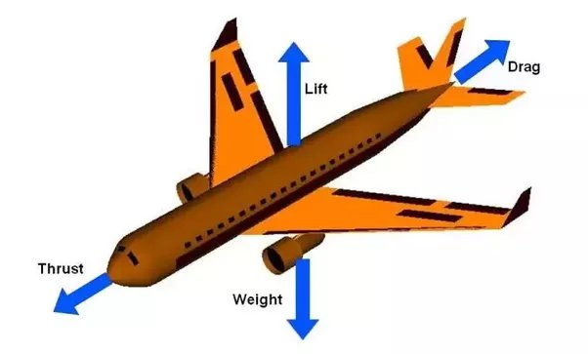

*Figure 4 (Weight and thrust of air-plane, 2018)*

The moon’s gravity is important for an airplane flight, as the centre of gravity is the point where the aircraft balances. There is also a possibility to suspend at this point. The centre of the earth's gravity affects the stability and sustainability of airplanes, and inside the specified limits, there have establishments by the aircraft manufacturers (Kembhavi & Khare, 2020). The moon’s gravity and drag are necessary to pull the plane to slow down its speed and lead down. An airplane can never fly without gravity or zero gravity. These are specially designed planes that provide the microgravity environment for flight pathways. The different phases of the moon create various levels of gravity levels which have a significant impact on the flight of airplanes.

**Chapter 3 Research Methodology**

***3. 1. Introduction***

This chapter will focus on how this study was conducted. For a better understanding of this direction, it will implement the Research Onion Model, which includes the six layers of research. These include the research strategy, research approach, research philosophy, research choices, research choices, time horizon, and data analysis procedures and techniques (Melnikovas, 2018). The chapter is focused on highlighting the domain of ethical considerations, which is a key aspect to be noted of any scale and kind of research as it can forecast its efforts through complicated legal implications.

***3. 2. Application of Saunders’ Research Onion Model***

The following research onion model is demonstrated through a selection of specific domains in light of this research which is further preceded by details and justifications on the mentioned choices;

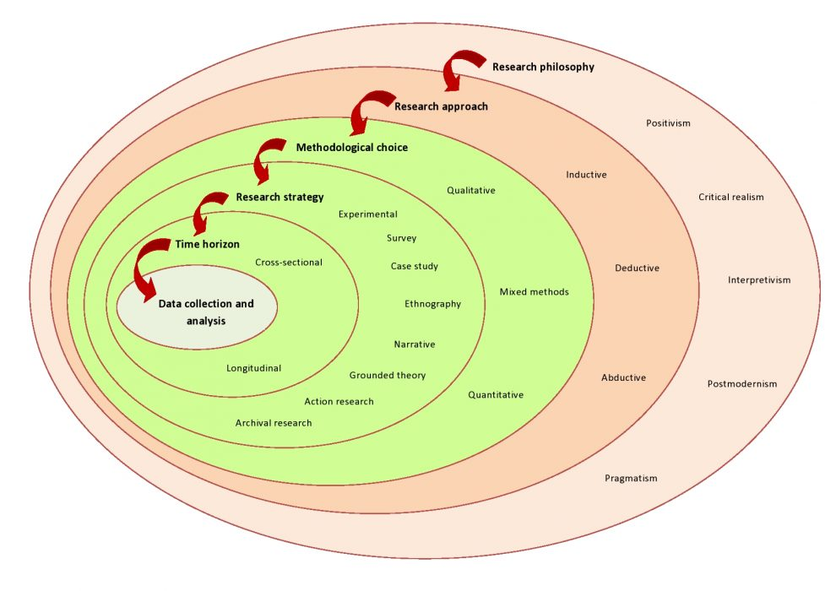

**Figure:** Research Onion Model for this research.

*Source: (Melnikovas, 2018)*

***3. 2. 1. Research philosophy:***

Research philosophy deals with the nature, source, and origin of knowledge. In other terms, research philosophy is a belief in how data about a phenomenon are collected, analysed, and used. Two types of research philosophies are common in research, Interpretivism philosophy and positivism philosophy. The positivism philosophy has its domain in numbers and figures. That is, the positivist research philosophy is mainly used in the case of quantitative data (Park, Konge & Artino, 2020). If the data is not in numeric form, you should convert it to numeric form by assigning specific codes to the different results. In this way, the data becomes quantitative and amenable to positivism. In the interpretivism philosophy, data are based on descriptive responses in the form of non-numeric opinions, views, and comments (Alharahsheh & Pius, 2020). In other words, the interpretivism research philosophy is applied to qualitative data. If the data is in numeric form, it must be converted to descriptive form, with specific results and results associated with different entries. In this way, the data become qualitative and amenable to interpretivism. In this research, interpretivism philosophy was used to explore the impact of the moon on the flights of airplanes.

***3. 2. 2. Research approach:***

A research approach is primarily a plan and strategy for conducting research, consisting of research goals, data collection, analysis, and interpretation (Manning & Stage, 2015). There are two main types of research approaches: deductive and inductive. In the inductive research approach, research trends shift from specific to general. In this research type, research goals are developed after data evaluation. In deductive approaches, research trends shift from general to specific (McCormack & O'Mahony, 2018). In this approach, research goals are formulated before data analysis. In this research, the inductive approach was used.

***3. 2. 3. Research strategy:***

Grounded theory was used as a research strategy in this research. In this strategy, the conclusions are gathered and analysed on theoretical grounds because the nature of the data is descriptive. After that, a detailed answer to the research question and topic can be established (Chun Tie, Birks & Francis, 2019). This strategy was also selected because it related more readily to the qualitative perspective that research was reliant upon for data gathering and analysis.

***3. 2. 4. Research choices:***

Data collection is the crucial phase of research because it results in the effectiveness or significance of the research results. Usually, there are two sources of data collection in academic research; primary and secondary. The primary data is collected from surveys, interviews, observations, or measurements at specific times to record the responses. On the other hand, secondary data utilise the existing data provided by other researchers, websites, articles, or public institutions (Bowen et al., 2017). This research was carried out using secondary data sources as the nature of the study allows research based on existing data and literature. As compared to the mixed method or quantitative approach, the qualitative method was more feasible because it provided a more purposeful use of time and resources through which a more detailed and theoretically supported data structure could be established.

***3.2.5. Inclusion and Exclusion Criteria***

For the systematic review, only the publications and other data from the official websites were included in the study to effectively present the findings. Only English language studies were selected for global recognition and as an official language. Credible sources, including scholarly articles and journals, were used in the research. All the outdated and irrelevant data was excluded from making this study more authentic and applicable for analysing the impact of the moon on the flight of the airplane.

Articles and information more than five years old were excluded from the research for updated results. Based on this criterion, the study was completed, and it assisted the researcher in remaining within study standards and reducing vague information. It is concluded that these inclusion and exclusion criteria have increased the current study's credibility and reliability, including the relevancy to the study's aim.

***3. 2. 6. Time horizon:***

The cross-sectional research study was chosen as the time horizon for this study because this approach helped in gathering and analysing data in a short period (Mihara & Higuchi, 2017). Against the longitudinal approach, which relies on the gathering of Data through multiple phases and longer periods, this approach was also carried out due to a lack of time resources, because of which data could not be gathered over a longer period.

***3. 2. 7. Data analysis techniques and procedures:***

The data for this research was gathered by identifying keywords and then using them to identify associated literature. The literary articles which were gathered through this keyword-based search were further analysed through the case of systematic literature review, which included critical apprehension of all literary sources in light of their findings and association with this research’s main topic and aim (Xiao & Watson, 2019). Through this means, the management of SLR within this research was ensured, which further led to a greater deal of gathering and analysing related data in the form of a review of the literature.

***3. 2. 8 Ethical Considerations***

The domain of ethical considerations should not be ignored by any researcher. This is because neglecting this matter could lead to serious consequences in the form of legal proceedings and claims made by those who feel offended or used unlawfully (Ketefian, 2015). Since this research was based on a qualitative approach, there were fewer chances of any ethical issues being involved. Still, even then, for any inclusion or inspiring content, the authors of specific studies were cited within the study to maintain a code of transparency and respect for the ones who presented those pieces of research.

**4. Results and Discussion**

Through the systematic review of articles, the following papers have been analysed, which were further explored, and discussed in light of this research’s topic as well as objectives within the chapter to follow:

|  |  |  |  |  |
| --- | --- | --- | --- | --- |
| **S. No.** | **The Title of the Paper** | **Author/s and Year** | **Methodology** | **Findings** |
| **1.** | [Barnstormers, Wing-Walking and Flying Circuses](https://books.google.com/books?hl=en&lr=&id=3J5hEAAAQBAJ&oi=fnd&pg=PP1&dq=full+moon+and+aeroplanes+flight&ots=ZQmunovX1q&sig=hTpYHx0aULfJvL-L3hkRP5k3PhI) | Brown, P, 2022 | Qualitative review of the moon orbits | The research findings demonstrated that a full moon shines over the flight aircraft wings, and in the presence of clouds, the moon provides the guide to the airplanes |
| **2.** | [Representations of Flight and Aviation](https://www.gale.com/binaries/content/assets/gale-us-en/primary-sources/intl-gps/intl-gps-essays/full-ghn-contextual-essays/ghn_essay_pha_mclean1_website.pdf) | Mclean, 2018 | Qualitative review of studies relating to the moon’s gravity on the flight of airplanes | The changes and modifications between a full moon and a new moon are affected–and worth undergoing. |
| **3.** | ['The Fundamental Magic of Flying': Changing Perspectives in Anne Morrow Lindbergh's North to the Orient and Virginia Woolf's The Years and Between the Acts](https://link.springer.com/chapter/10.1007/978-3-030-60555-1_10) | Amra, 2018 | Narrative study to explore the effect of the moon on the flight | Findings reflected that airplane speed gets affected by the moon’s gravity. Gravity slows down the speed of the airplane and also pulls it down. |
| **4.** | The Theory of Flight | Ndlouv, 2018 | The qualitative overview through systematic review | The moonlight and the velocity significantly affect airplane flight. |
| **5.** | [Meteorological Astrology (Astrometeorology)](https://brill.com/view/book/9783657705160/BP000025.xml) | Grove, 2020 | The qualitative overview of the recent trends was analysed through the relevance of the research topic. | The findings indicated that Newton's laws are usually preferred over the Bernoulli principle to explain lift. The Newtonian idea states that air flowing over the wing is ultimately altered by the angle of the wing, and Newton said there has to be an opposite and equal reaction. Therefore, the wing has moved upward. |
| **6.** | [Aviation incidents in the West Kimberley](https://search.informit.org/doi/abs/10.3316/INFORMIT.561951798802506) | Hough, 2019 | Qualitative overview | The findings of this study are related to the derivation of related concepts, such as phases of the moon and the different effects of the new moon and the full moon on flight |

**Table 01.** SLR table for the research

***4.1. Key Findings:***

The first finding is related to the moon’s light and its intensity to explore the effect on the flight of airplanes. Through literature review, it was explored that the research findings demonstrated that the full moon shines over the flight aircraft wings, and in the presence of clouds, the moon acts as a guide to airplanes (Tucker, 2022). The next finding is about the demonstrations of flight and aviation, which revealed that aero-plane flights are largely produced by the full moon's gravity and new the moon’s gravity. The changes and modifications between a full moon and a new moon are affected–and worth undergoing.

The next finding is about the domain of this research and the idea of lift. The findings indicated that Newton's laws are usually preferred over the Bernoulli principle to clarify the idea of lift (Bowen & Kisida, 2019). The findings of this study are related to the derivation of related concepts, such as the phases of the moon and the different effects of the new moon and the full moon on the flight.

***4.2 Discussion***

The key takeaway from the domain of this research on the topic of the influence of the moon on the flight of airplanes can be linked in the context of aligning how affected this factor really is. Since there are many other philosophers who have impacted this context of moonlight intensity and gravity, it is significant to narrate it to the domain of having multiple sources of effect on flying airplanes. Many scholars and astronaut experts discuss that the philosophy of Newton is successful because it gives the concept of lift. The Newtonian idea is about the light and air flowing over the wing being eventually refracted by the angle of the wing, and Newton said there has to be an opposite and equal reaction. Therefore, the wing is moved upward as the speed varies. Therefore, the Bernoulli principle is less preferred than Newton’s law (Engle, 2013). This research proposed that gravitational acceleration affects the velocity of airplanes and the light of the moon has a significant effect as the full moon’s light acts as a traffic rush for planes. The altered phases of the moon and gravity affect the speed of airplanes. The low gravity enhances the chances of pulling down the planes, and light intensity also affects the speed. Innovative supper planes have overcome this problem because these planes can create a gravity-free environment which enhances the efficiency and speed of the planes (Andino, 2019). Gravity has a major effect on the flying of airplanes. It inclines the wing of an airplane or decreases the speed of the airplane, and pockets of instability form along the top of the wing. Lift is reduced, and the plane enters a stall and falls from the sky

The results are also consistent with the previous findings. Hence, it was reported that the pilots failed to climb attitude appropriately by the flight instruments due to night, which may lead to adverse consequences. Night takeoff accidents are the most common, and that night conditions are the most common reasons when there is no illumination of the moon. It has been indicated that light models and meteoroid impacts the surface functions and influx rate of the earth and moon. It also provides the mission plan related to seismometers. The influx rate of interplanetary dust also affects the surface status of the flash observer.

**5. Conclusion**

The essence of this paper lies in the understanding of how the moon has an impact on the flights of air-plane. The research gathered an understanding of reviewed literature, and after data was collected through secondary data resources, the systematic literature review was applied. The results concluded that airplane flight might be affected by the gravity of the moon because when the airplane escapes the gravity of the earth, then it establishes an orbit around it and has the highest point on the moon (Liu & Zhang, 2019). Space flight changes its velocity after entering the moon's gravity because when it enters the moon then, its gravity changes in comparison to earth and due to the change in gravity, its velocity also changes. The findings of this study are related to the derivation of related concepts such as the phases of the moon and the different effects of the new moon and the full moon on the flight. The research findings demonstrated that the full moon shines over the flight aircraft wings, and in the presence of large clouds, the moon acts as a guide to airplanes. Night flights have more chances for general aviation accidents if compared with daytime (Andino, 2019). During a moonless night or night with low light intensity, there are no chances for a visible horizon. In addition to this, there is also a lack of sufficient starlight. The factor of lower light and night leads to plane crashes or accidents. Hence, it was reported that the pilots failed to climb attitude appropriately by the flight instruments due to nights which may lead to adverse consequences.

***5.1 Recommendations***

The following directions have been advised to ensure that future studies working on the same topic have better opportunities in terms of generating fruitful results and theoretical understandings

* SMS training should be introduced that is necessary to improve aviation safety. There is a need to enhance the knowledge and insight into the area of moonlight intensity for the pilot and flight administration. There is a need to introduce solar planes that may work in the absence of light, and the low illumination of the moon creates no effect on them.
* Future studies should be based on quantitative means of approaching the research problem, as this would allow for the researchers and scholars to gather more vital information that was not available through secondary means and so that a view of the general public on the said matter can also be gained for study purposes. This inclusion of a quantitative approach will also provide more structured and effective research in the form of high reliability and less biased information, which is usually found in the case of qualitative studies (Heale & Twycross, 2015). Through this inclusion of a quantitative approach, the study will also become one having valid results that relate more closely to the research topic.

**References**

Abe, S., Funase, R., Yano, H. and Yanagisawa, M., 2018. Flight Model Development Status of Lunar Impact Flash Observing Camera DELPHINUS on Exploration CubeSat EQUULEUS. *42nd COSPAR Scientific Assembly*, *42*, pp.B0-2.

Andino, M. Y., Lin, J. C., Roman, S., Graff, E. C., Gharib, M., Whalen, E. A., & Wygnanski, I. J. (2019). Active flow control on vertical tail models. *AIAA journal*, *57*(8), 3322-3338.

Avdellidou, C., Munaibari, E., Larson, R., Vaubaillon, J., Delbo, M., Hayne, P., Wieczorek, M., Sheward, D. and Cook, A., 2021. Impacts on the Moon: Analysis methods and size distribution of impactors. *Planetary and Space Science*, *200*, p.105201.

Bloomfield, J., & Fisher, M. J. (2019). Quantitative research design. *Journal of the Australasian Rehabilitation Nurses Association*, *22*(2), 27-30.

Bowen, D. H., & Kisida, B. (2019). Investigating Causal Effects of Arts Education Experiences: Experimental Evidence from Houston's Arts Access Initiative. Research Report for the Houston Independent School District. Volume 7, Issue 4. *Houston Education Research Consortium*.

Brown, P. (2022). *Barnstormers, Wing-Walking and Flying Circuses*. Air World.

Chun Tie, Y., Birks, M., & Francis, K. (2019). Grounded theory research: A design framework for novice researchers. *SAGE open medicine*, *7*, 2050312118822927.

Estaff (2022). *Dark and Deadly Nights*. [online] Aviation Safety. Available at: <https://www.aviationsafetymagazine.com/features/dark-and-deadly-nights/>

Gaches, S., & Gallagher, M. (2019). Children as research consultants: The ethics and rights of no research about them without consultingwith them. In *The Routledge international handbook of young children’s rights* (pp. 484-503). Routledge.

Higuchi, S., Osaki, Y., Kinjo, A., Mihara, S., Maezono, M., Kitayuguchi, T., ... & Saunders, J. B. (2021). Development and validation of a nine-item short screening test for ICD-11 gaming disorder (GAMES test) and estimation of the prevalence in the general young population. *Journal of behavioral addictions*, *10*(2), 263-280.

Ishtiaq, M. (2019). Book Review Creswell, JW (2014). Research Design: Qualitative, Quantitative, and Mixed Methods Approaches. Thousand Oaks, CA: Sage. *English Language Teaching*, *12*(5), 40.

Kembhavi, A., & Khare, P. (2020). Gravity: The Force that Governs the Universe. In *Gravitational Waves* (pp. 33-54). Springer, Singapore.

Kumar, R. (2018). *Research methodology: A step-by-step guide for beginners*. Sage.

Liu, R. L., Zhang, Z. J., Jiao, Y. F., Yang, C. H., & Zhang, W. J. (2019). Study on flight performance of propeller-driven UAV. *International Journal of Aerospace Engineering*, *2019*.

Manning, K., & Stage, F. K. (2015). What is your research approach? In *research in the college context* (pp. 29-54). Routledge.

McLean, S. (2018). Representations of Flight and Aviation.

Melnikovas, A. (2018). Towards an explicit research methodology: Adapting research onion model for futures studies. *Journal of Futures Studies*, *23*(2), 29-44.

Morsanyi, K., McCormack, T., & O'Mahony, E. (2018). The link between deductive reasoning and mathematics. *Thinking & Reasoning*, *24*(2), 234-257.

Oliver, P., 2010. The student's guide to research ethics. *McGraw-Hill Education*

Park, Y. S., Konge, L., & Artino, A. R. (2020). The positivism paradigm of research. *Academic Medicine*, *95*(5), 690-694.

Runnels, K. J., & Gebre-Egziabher, D. (2022, September). Gravitational Acceleration Maps for Initialisation and Ambiguity Resolution of Pulsar-Based PNT in Space. In *Proceedings of the 35th International Technical Meeting of the Satellite Division of The Institute of Navigation (ION GNSS+ 2022)* (pp. 1917-1932).

Storms, M., Jakhar, A., Mitesser, O., Jechow, A., Hölker, F., Degen, T., & Degen, J. (2022). The rising moon promotes mate finding in moths. *Communications biology*, *5*(1), 1-6.

Tucker, S. D. (2022). *Nazi UFOs: The Legends and Myths of Hitler s Flying Saucers in WW2*. Frontline Books.

Xiao, Y., & Watson, M. (2019). Guidance on conducting a systematic literature review. *Journal of planning education and research*, *39*(1), 93-112.