PATIENT HEALTH MONITORING SYSTEM USING IOT

M.Samuel, EEE, Sree Sowdambika College Of Engineering, Virudhunagar, Tamilnadu, India.

Dr.R.Muthukumaran M.E.**,**Sree Sowdambika College Of Engineering, Virudhunagar,

Tamilnadu, India.

## ABSTRACT

The healthcare monitoring systems has emerged as one of the most vital system and became technology oriented from the past decade. Humans are facing a problem of unexpected death due to various illness which is because of lack of medical care to the patients at right time. The primary goal was to develop a reliable patient monitoring system using IoT so that the healthcare professionals can monitor their patients, who are either hospitalized or at home using an IoT based integrated healthcare system with the view of ensuring patients are cared for better. A mobile device based wireless healthcare monitoring system was developed which can provide real time online information about physiological conditions of a patient mainly consists of sensors, the data acquisition unit, microcontroller (i.e., Arduino), and programmed with a software (i.e., JAVA). The patient’s temperature, heart beat rate, EEG data are monitored, displayed and stored by the system and sent to the doctor’s mobile containing the application. Thus, IoT based patient monitoring system effectively monitor patient’s health status and save life on time.

**Keywords:** Arduino, JAVA, IoT, data acquisition unit, mobile application etc.

## INTRODUCTION

The increased use of mobile technologies and smart devices in the area of health has caused great impact on the world. Health experts are increasingly taking advantage of the benefits these technologies bring, thus generating a significant improvement in health care in clinical settings. Likewise, countless ordinary users are being served from the advantages of the M-Health (Mobile Health) applications and E-Health (health care supported by ICT) to improve, help and assist their health.

According to the constitutions of World Health Organization (WHO) the highest attainable standard of health is a fundamental right for an individual. As we are truly inspired by this, we attempt to propose an innovative system that puts forward a smart patient health tracking system that uses sensors to track patient vital parameters and uses internet to update the doctors so that they can help in case of any issues at the earliest preventing death rates.

Patient Health monitoring using IoT is a technology to enable monitoring of patients outside of conventional clinical settings (e.g. in the home), which may increase access to care and decrease healthcare delivery costs. This can significantly improve an individual's quality of life. It allows patients to maintain independence, prevent complications, and minimize personal costs. This system facilitates these goals by delivering care right to the home. In addition, patients and their family members feel comfort knowing that they are being monitored and will be supported if a problem arises.

1. **LITERATURE REVIEW**

S. J. Jung and W. Y. Chung studied the Flexible and scalable patient’s health monitoring system in 6LoWPAN . The main advantage of this enabling factor is the combination of some technologies and communications solution. The results of Internet of Things are synergetic activities gathered in various fields of knowledge like telecommunications, informatics and electronics.

K. S. Shin and M. J. Mao Kaiver studied a cell phone based health monitoring system with self analysis which incorporates IoT [13] a new paradigm that uses smart objects which are not only capable of collecting the information from the environment and interacting the physical world, but also to be interconnected with each other through internet to exchange data as well as information.

Gennaro tartarisco and Tabilo Paniclo had studied a Maintaining sensing coverage and connectivity in large sensor networks mainly includes the information about how to build or develop a new computational technology based on clinical decision support systems, information processing, wireless communication and also data mining kept in new premises in the field of personal health care.

Cristina Elena Turcua studied Health care applications a solution based on the Internet of Things survey aims to present a detailed information about how radio frequency identification, multi-agent and Internet of Things technologies can be used to develop and improve people’s access to quality and health care services and to optimize the health care process.

Gubbi, Jayavardhana, Buyya, Rajkumar, Marusic, Slaven, Palaniswami, Marimuth studied the Internet of Things (IoT): A vision, architectural elements, and future direction which

proposes on demand positioning and tracking system. It is based on Global Positioning enabled devices and suitable for large environments. Smart phones between two terminals are used for making initial communication. The initial communication is performed by synchronization phase.

J.L. Kalju developed a system, which is capable of measuring different physiological parameters and are used to design a system for heart rate reconstruction for rate adaptive pacing .

Loren Schwiebert, Sandeep K.S. Gupta and Jennifer Weinmann studied the strength of smart sensors which are developed from the combination of sensing materials along with combined circuitry for other biomedical applications .

Gentili G.B proposed a simple microwave technique to monitor the cardiac activity. This technique is dependent on changes in modulation envelope of amplitude modulated waves passing through the body . It explained the use of wireless microsensors networks for medical monitoring and environmental sensing.

Reza S.Dilmaghani(2016) in their study found the design of Wi-Fi sensor network that is capable of monitoring patient’s chronic diseases at their home itself via a remote monitoring system. So immerging of wireless sensor technology individual test like only blood pressure, heart rate, temperature etc. can be measured but this research project enables all this parameter together to be measured under single system, and also thus all can be worn by patient and processed data send toward internet through internet of things(IOT).

1. **Proposed work**
   1. **Introduction**

In this proposed work the vital parameters such as temperature, EEG and heart beat readings which are monitored using Arduino Uno. These sensors signals are send to Arduino Uno via amplifier circuit and signal conditioning unit (SCU), because the signals level are low (gain), so amplifier circuit is used to gain up the signals and transmit the signals to the Arduino Uno. Here patients body temperature , EEG and heart rate is measured using respective sensors and it can be monitored in the screen of computer using Arduino Uno connected to a cloud database system as well as monitored anywhere in the world using internet source.

The proposed method of patient monitoring system monitors patient’s health parameters using Arduino Uno. After connecting internet to the Arduino uno, it is connected to cloud database system which acts as a server. Then the server automatically sends data to the receiver system. Hence, it enables continuous monitoring of the patient’s health parameters by the doctor. Any abrupt increase or decrease in these parameter values can be detected at the earliest and hence necessary medications can be implemented by the doctor immediately.

* 1. **Signal Conditioning Unit**

This sensor is a cost-effective board used to measure the electrical activity of the heart. This electrical activity can be charted as an ECG or Electrocardiogram and output as an analog reading. ECGs can be extremely noisy, the AD8232 Single Lead Heart Rate Monitor acts as an op amp to help obtain a clear signal from the PR and QT Intervals easily.

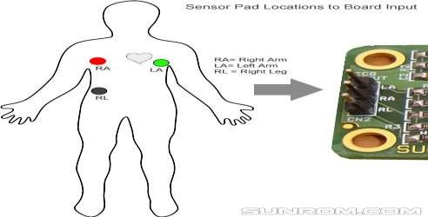

# Block Diagram

**Fig.2.1 Position of Sensor Pads Input**

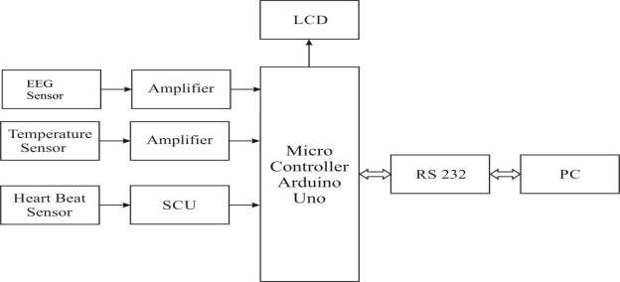

**Fig 3.1.Block diagram of sensors connected with the PC**

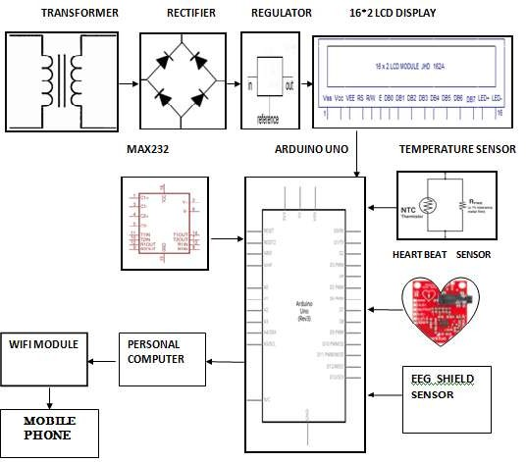

**Fig.3.2 Block diagram of Health monitoring system**

1. **RESULTS AND DISCUSSION**
   1. **Operating Mechanism**

**STEP 1:** The Heartbeat sensor is fixed to the patient’s finger. This contains an IR sensor in it

.Every pumping we get pulse from that sensor. This sensor output is given to the arduino via Signal conditioning unit for amplification



## STEP 2

**Fig 4.1 Heart beat sensor**

NTC type thermistor is used as a temperature sensor. This temperature sensor output varies based on the temperature, this output is also given to arduino.

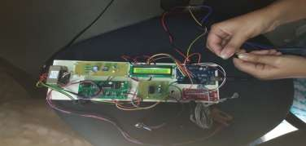

## STEP 3

**Fig.4.2 Temperature sensor**

EEG sensor is a cost-effective board used to measure the electrical activity of the heart. This electrical activity can be charted as an ECG or Electrocardiogram output as an analog reading. ECGs can be extremely noisy, the AD8232 Single Lead Heart Rate Monitor acts as an op-amp to help obtain a clear signal from the PR and QT Intervals easily and connected to arduino.

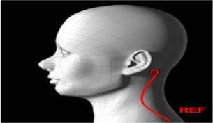

**Fig 4.3 EEG sensor**

**STEP 4**

All these values are transferred to PC via RS 232 and by using the URL,it is transferred to the mobile app created.

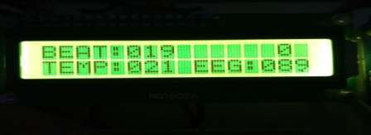

**Fig 4.4 Output in LCD**

# Output in the Mobile Application:

The output is displayed in the form of string in a particular interval of time. The application is very simple as it just displays the analog values followed by a statement describing the kind of value displayed.



**Fig4.5 Output displayed in the mobile application device**

* 1. **Testing and findings health care unit**

The Patient Health Monitoring System developed is tested using various persons with normal to abnormal health conditions. The various testing and findings producing results with minimal error rate and the observations are listed below.

* + 1. **Temperature Findings**

The NC type thermistor used is programmed to display the value at room temperature for demo purposes with minimal error of + or – 5.

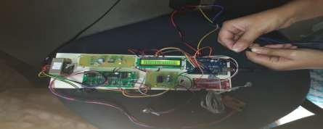

**Fig 4.6 temperature sensor**

|  |  |  |  |
| --- | --- | --- | --- |
| Testings | Normal value | Observed value | Error rate |
| Person 1 | 24 | 28 | +4 |
| Person 2 | 24 | 30 | +6 |

**Table 4.1 Observed temperature readings**

* + 1. **ECG Findings**

The IR sensor is used to measure the pulse rate in the error range of + or – 6.

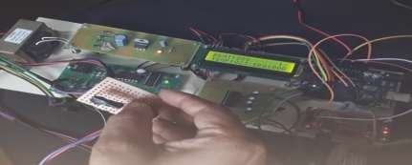

**Fig 4.7 ECG measurement sensor**

|  |  |  |  |
| --- | --- | --- | --- |
| Testings | Normal value | Observed value | Error rate |
| Person 1 | 74-78 | 72 | -2 |
| Person 2 | 74-78 | 84 | +6 |

**Table 4.2 ECG values observed from different person**

* + 1. **EEG Findings**

The EEG sensor is used with electrodes with error rate indicating the status as active or inactive.

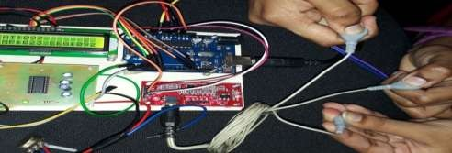

**Fig 4.8.EEG measurement sensor**

|  |  |  |  |
| --- | --- | --- | --- |
| Testings | Normal value | Observed valued | Status |
| Person 1 | 100-300 | 131 | Active |
| Person 2 | 100-300 | 165 | Active |

**Table 4.3 EEG values observed from different person**

* + 1. **Data display in the mobile application unit**

The day to day vital parameters such as heart beat, body temperature, EEG signals can be displayed in the mobile phone and the same can be send to the doctor during emergency situations.

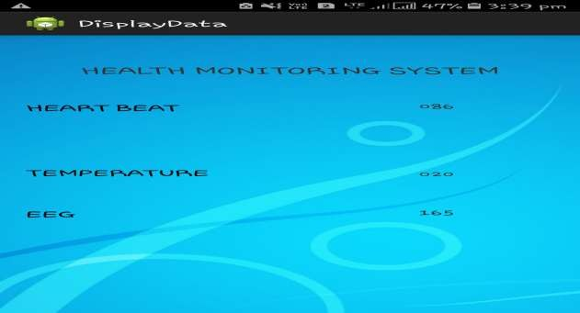

**Fig .4.9 Output displayed in the mobile application unit**

**V CONCLUSION**

The proposed system of patient health monitoring can be highly used in emergency situations as it can be daily monitored, recorded and stored as a database. In future the IOT device can be combined with the cloud computing so that the database can be shared in all the hospitals for the intensive care and treatment.

**References**

1. S. J. Jung and W. Y. Chung, “Flexible and scalable patient’s health monitoring system in 6LoWPAN,” Sensor Lett., vol. 9,no. 2, pp. 778–785, Apr. 2011.
2. W. Y. Chung, C. Yau, K. S. Shin, and R. Myllylä, “A cell phone based health monitoring system with self- analysis processor using wireless sensor network technology,” in Proc. 29th Annu. Int. Conf. Eng. Med. Biol. Soc., Lyon, France, 2007, pp.
3. G. Lawton, “Machine-to-machine technology gears up for growth,” Computer, vol. 37, no. 9, pp. 12–15, Sep. 2004.
4. C. Kim, A. Soong, M. Tseng, and X. Zhixian, “Global wireless machineto- machine standardization,” IEEE Internet Comput., vol. 15, no. 2, pp. 64–69, Mar.–Apr. 2011.
5. Real time wireless health monitoring application using mobile devices, International Journal of Computer Networks & Communications (IJCNC) Vol.7, No.3, May 2015, Amna Abdullah, Asma Ismael, Aisha Rashid, Ali Abou-ElNour, and Mohammed Tarique.
6. Secured Smart Healthcare Monitoring System Based on Iot, International Journal on Recent and Innovation Trends in Computing and Communication Volume: 3 Issue: 7, Bhoomika.B.K, Dr. K N Muralidhara.
7. Real time wireless health monitoring application using mobile devices, International Journal of Computer Networks & Communications (IJCNC) Vol.7, No.3, May 2015, Amna Abdullah, Asma Ismael, Aisha Rashid, Ali Abou-ElNour, and Mohammed ,Tarique.
8. Secured Smart Healthcare Monitoring System Based on Iot, International Journal on Recent and Innovation Trends in Computing and Communication Volume: 3 Issue: 7, Bhoomika.B.K, Dr. K N Muralidhara.
9. Goutam Motika, Abinash Prusty,” Wireless FetalHeartbeat Monitoring System Using ZigBee & IEEE 802.15.4 Standard”, 2011 Second International Conference on Emerging Applications of Information Technology, 978-0- 7695-4329-1/11, 2011 IEEE DOI 10.1109/EAIT.2011.89 .
10. S. M. Mahalle, P. V. Ingole, “Design and Implementation of Wireless Body Area Sensor Network Based Health Monitoring System”, International Journal of Engineering Research & Technology, Vol. 2 Issue 6, pp. 105- 113, June 2013.
11. M.Prakash, CJ Kavitha Priya, “An Analysis of Types of Protocol Implemented in Internet of Things Based on Packet Loss Ratio”, Proceedings of International Journal of Information and Communication Technology for Competitive Strategies, ISBN: 978-1-4503-3962-9, DOI: https://doi.org/10.1145/2905055.2905085, 4th – 5th Mar 2016
12. M. Prakash, U. Gowshika, T. Ravichandran, “A Smart Device Integrated with an Android for Alerting a Person’s Health Condition: Internet of Things” Indian Journal of Science and Technology, Vol 9 (6), February 2016. DOI: https://doi.org/10.17485/ijst/2016/v9i6/69545
13. Dr.A.Sabanayagam, G.Anish Girija,” DESIGN AND MODELING OF MOBILE HEALTH MONITORING SYSTEM”, International Journal of Innovations in Scientific and Engineering Research (IJISER),vol4,no 2,pp.63- 65,2017.
14. “Healthcare Monitoring System Using Wireless Sensor Network”, D. Mahesh Kumar, Department of Electronics, PSG College of Arts and Science, Coimbatore - 641 014.Volume 04, Issue 01 Pages:1497-1500 (2012), ISSN:0975-0290.
15. https://[www.ibm.com/blogs/internet-of-things/6-benefits-of-iot-for-healthcare/](http://www.ibm.com/blogs/internet-of-things/6-benefits-of-iot-for-healthcare/)

70