**GEO-ATTENDANCE**

VISHNU PRIYA N R1 | PARTHIBAN K2 | THARUN G3 |MUTHU KUMARAN N4

Assistant Professor, Department of Computer Science and Engineering1 Students, Department of Computer Science and Engineering2,3,4

Agni college of Engineering, Chennai, Tamil Nadu, India.

**ABSTRACT:** The project report describes a method that makes use of geolocation-based technology to increase the effectiveness of attendance marking. The project's major goal is to streamline the attendance monitoring procedure to make it quicker and more precise. As it eliminates the need for manual attendance tracking, which may be time-consuming and prone to mistakes, the system is especially valuable for organisations with large numbers of employees or students.

**NOTE:** GOOGLE MAP API, MARKINGMANUAL COORDINATES, MONGODB.

**INTRODUCTION**

The sentence discusses the shortcomings of the conventional way of taking attendance and offers a remedy. It emphasises how time-consuming the conventional way of taking attendance is, particularly when there are a lot of students. Since marking attendance takes longer the more pupils there are, this could lead to a loss of instructional time. The geo-based attendance system is proposed as a solution to this issue. To establish if a user is within a certain area or set of coordinates, this system leverages the user's current location. This saves crucial class time by doing away with the necessity for manual attendance taking. The benefit of the geo-based attendance system over other current market available attendance apps is also highlighted in the statement. Many attendance apps employ the less precise set region of radius technique. The geo-based attendance system, however, is more accurate and precise because it records the specific coordinates of the location. Additionally, the geo-based attendance system was created as a web-based application, allowing users to access it from both desktop and mobile devices without having to install anything. As a result, there is no longer a requirement for storage space on the device, improving its use and accessibility.

In conclusion, the paragraph implies that the geo-based attendance system is a more effective, exact, and practical alternative to the conventional technique of recording attendance, saving important class time, and delivering correct attendance data.

**CURRENT SYSTEMS**

Ramco Attendance app is a comprehensive solution for managing employee attendance and time tracking. The app is designed to simplify the process of attendance management and provide real-time visibility into employee attendance data. The system registers attendance within a specified radius upon arrival at the location, enabling marking of attendance at the edge of the diameter without entering the premises, thereby resulting in a lagging-free experience.

**PROPOSED SYSTEM**

A few issues with the existing attendance method may reduce the process's overall effectiveness. For instance, the current system can be sluggish and call for a lot of information to record attendance, which can be a laborious effort for both the staff and the students. Additionally, for a few reasons, including technical failures and mistakes made by humans, the accuracy of the attendance records may be affected.

We have proposed a new attendance system that is intended to be quicker and more precise than the present system to address these problems. The precise coordinates of our college site are obtained by our proposed approach by using the sophisticated features of Google Maps. As soon as we receive the coordinates, we translate them into a polygon that precisely depicts the layout of our construction.

We can establish a virtual wall around the whole university campus. This line will serve as a fictitious fence that only records attendance when the student or staff member is present inside of it. Furthermore, because our system is based on cutting-edge technology, there are less opportunities for technological failures or human error, which could jeopardise the accuracy of the attendance records. As a result, our suggested approach will be more dependable and produce attendance records that are more accurate.

As a result, our system will only need a specific rectangular space to record attendance, which will make the procedure more effective and quicker. In conclusion, our suggested attendance method is a major upgrade over the current one. We have developed a virtual barrier that only registers attendance when the student or staff member is present within it by utilising powerful Google Maps features and translating them into a polygon. This increases the process' efficiency and guarantees correct attendance records.

**METHODOLOGIES:**

**AUTHENTICATION:**

The crucial functions of user authentication and authorization have been made easier by the user interface (UI) that has been created. Users will find it straightforward and easy to log in to their accounts securely and effectively because to this UI's intuitive and user-friendly design. The user interface will also make it possible for new users to sign up by generating individual IDs just for students, expediting the registration procedure and guaranteeing that every student has a distinct and recognisable account. Users may feel secure knowing their accounts are safe and their privacy is always safeguarded with this UI.

**DATABASE:**

The choice of database can significantly affect a system's efficiency and efficacy when it comes to storing massive amounts of data. In this instance, MongoDB has been chosen as the preferable database for keeping track of students' login and logout information. Due to MongoDB's improved performance and scalability over conventional SQL databases, the choice to adopt it was made. MongoDB is a great option for storing the vast array of data connected to user logins and logouts because of its document-based data format, which can handle complicated data structures with ease. MongoDB is a potent tool for meeting the demands of a system that needs high-performance and dependable data storage because of its capacity to horizontally grow, spread data over several servers, and manage massive amounts of data. Overall, using MongoDB as the system's database guarantees that user data is saved securely and effectively, enabling the best possible system performance and user experience.

**LOCATION TRACKING:**

This cutting-edge solution makes use of the Google Maps API's strength to locate accurate coordinates and gain real-time access to users' whereabouts. The potential of inaccurate or fake attendance records is eliminated by the system's use of this cutting-edge technology, which allows it to register users' attendance with pin-point accuracy. Users can be sure that their attendance is being monitored precisely thanks to the system's seamless integration with the Google Maps API, and managers can depend on the data to make choices based on the most recent information available. A seamless and effective user experience is further ensured by the system's capacity to access location data, which enables it to give users crucial information like projected arrival times and distance estimates.

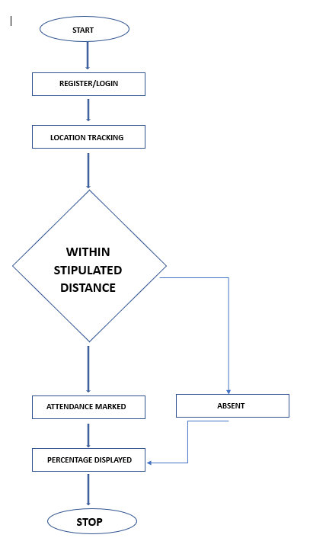

**LOCATION VALIDATION:**

A careful process is used to manually mark the coordinates to guarantee that the system records the user attendance with pin-point accuracy. To do this, a polygon that accurately depicts the layout of the facility where attendance is being taken must be created. This method of mapping the building's physical layout allows the system to establish extremely precise coordinates, giving attendance records a dependable and exact location. The manual marking of coordinates provides for a higher degree of control and precision since it takes into consideration any quirks or peculiarities of the building's design. The system can offer extremely precise and trustworthy attendance records by fusing this methodology with cutting-edge technology, giving users and administrators useful information.

**ATTENDANCE RECORD:**

The system creates a CSV file with thorough attendance records, making user verification easier and giving administrators and students useful attendance data. Each student's name is listed here, along with a record of their attendance that shows how many days they were present and absent. Additionally, the system calculates each student's attendance as a percentage, making it simple and quick to compare and analyse attendance data. Administrators can utilise this useful attendance data to spot trends and patterns, make educated judgements, and take the required steps to raise attendance rates. Students can also use this information to monitor their own progress in meeting attendance standards, pinpoint areas for improvement, and take action to ensure they do so. The system makes sure that administrators and students have the knowledge they need to make informed decisions and raise attendance rates by delivering this thorough attendance data in an intuitive CSV file format.

**SCOPE OF THE PROJECT**

This endeavour aids in Keep track of the person's clocking in and out. The information on participant attendance was automatically recorded in an CSV file. It eliminates the time-wasting aspects of the manual attendance system.

**REFERENCE**

|  |  |
| --- | --- |
|  | 1. Shoewu, O. O. M. Olaniyi, and Lawson, “Embedded Computer-Based Lecture Attendance Management System”, African Journal of Computing and ICT (Journalof IEEE Nigeria Computer Section), 4(3):27 – 36, 2011. |
|  | 1. Cheng, K., L. Xiang, T. Hirota, and K. Ushijimaa (2005),“Effective Teaching for Large Classes withRental PCs byWeb System WTS”, Pro. Data Engineering Workshop(DEWS2005), 1D – d3 (inJapanese). |
|  | 1. Jamil, T. ; Dept. of Electr. &Comput. Eng., Sultan Qaboos Univ., Al Khod, Oman, Automatic attendance recording system using mobile telephone, Telecommunications Forum (TELFOR), 2011 19th 1297 - 1299. |
| . | 1. Saraswat, Chitresh; Kumar, Amit, An Efficient Automatic Attendance System using Fingerprint Verification Technique. International Journal on Computer Science & Engineering . 2010, Vol. 2 Issue 2, p264-269 |
|  | 1. QinghanXiao ;Interdept. Biometrics Working Group, Gov. of Canada, ON ;Xue Dong Yang, A facial presence monitoring system for information security, Computational Intelligence in Biometrics: Theory, Algorithms, and Applications, 2009. CIB 2009. IEEE   Workshop on, March 30 2009-April 2 2009 , 69 - 76 |
|  |  |

**ACKNOWLEDGEMENT:**

We are thankful to Ms. N R VishnuPriya, CSE Department, Dr. L Sharmila, HOD-CSE, Agni College of Technology, OMR, Chennai for providing the support for this work.