**INVESTIGATION ON HOOKED STEEL FIBER REINFORCED CONCRETE WITH PARTIAL REPLACEMENT OF CEMENT WITH**

**DOLOMITE**

**1J.Sree Naga Chaitanya, 2 Dr.K.Chandramouli, 3Sk.Sahera, 4Dr.D.Vijayakumar,5Shaik. Siddaiah**

1,3 Assistant Professor, 2Professor & HOD, 4Professor & Principal, 5B. Tech Student

1,2,3,4,5Department of Civil Engineering, NRI Institute of Technology, Visadala (V), Medikonduru (M), Guntur, Andhra Pradesh, INDIA.

**ABSTRACT**

Today, in order to strengthen concrete, we use additives that change its physical characteristics. Concrete is a collection of particles that are tightly linked together and stimulates the properties of rock as an engineering material. Limestone comes in the form of dolomite. Dolomite has the chemical formula CaMg(Co3)2. It contains a lot of calcium and magnesium carbonates. High-quality base steel bar, which has outstanding mechanical qualities including high tensile strength, is used to create hooked steel fibre. Concrete reinforced with steel fibres is designed to support enormous loads by combining concrete's compressive strength with steel's tensile strength.Dolomite can replace cement in a percentage of 0, 5, 10, 15, 20, and 25%. Combinations of concrete may have hook steel fibres added in various proportions, such as 0%, 0.5%, 1%, 1.5%, and 2%. The test will be administered at 7 and 28 days of age.

**Key words:** Dolomite, Hooked steel fibres, Compressive strength and Split tensile strength.

**1.INTRODUCTION**

Concrete is made of aggregate, which is a solid and chemically inert particle material (often sand and gravel), bound together by cement and water. Cement, water, sand, and aggregates like gravel or crushed stone are the main ingredients in the creation of concrete. By combining these materials, concrete is guaranteed to be sturdy, long-lasting, and the right consistency for its intended usage..

Dolomite contains 40% magnesium carbonate and 60% calcium carbonate. When lining tunnels, steel fibres are frequently employed. It is mostly utilised to build highway pavements and airport runways. Precast concrete is most frequently used to increase tensile strength. In shotcrete, they are employed. utilised in parking structure construction. Dolomite is used as a source of magnesium oxide, a decorative stone, a concrete component, and in study conducted by process to produce magnesium.

Because their anchorage mechanisms, length, and tensile strength give more pull-out resistance and may further improve the performance of the structural element than smooth fibre, hooked steel fibres are the most commonly utilised for structural purposes. Concrete is made with coarse aggregates, which are granular and uneven materials like sand, gravel, or crushed stone. High-quality base steel bar, which has outstanding mechanical qualities including high tensile strength, is used to create hooked steel fibre.

**2. OBJECTIVES**

1. To optimize the usage of dolomite in cement..

2. To obtain the compressive and split tensile strength by addition of hooked fibres in concrete..

**3. MATERIALS**

**3.1 Cement:**

The cohesive and adhesive properties of cement are enhanced by the addition of water. the hydraulic cements are the name given to these cements. most of these are composed of clay, silicates derived from limestone, and lime aluminates.

**3.2 Fineaggregate**:

.As the granular material's particles are so small that they can fit through a 4.75mm screen, it is referred to as fine aggregate. Aggregate is the granular material used to make concrete or mortar. It is frequently used in the building sector to enhance concrete volume, making it a material that saves money. However, you should be fully aware of the fine aggregate size, its density, and grading zone two river sand.  
 **3.3 Coarse aggregate**:

In the present research, 20 mm coarse aggregate that complies with IS: 383- 1970 is used. The pycnometer test is used to measure the specific gravity of aggregates. The material utilised for the work was passed through a 20 mm sieve and retained on a 4.75 mm sieve after sieve analysis to determine the aggregate fineness modulus. In comparison to fine aggregate, coarse aggregate has a smaller surface area..

**3.3 Water:**

Water is one of the most crucial building materials because it is required for many activities, including making mortar, mixing cement, curing work and more. The quality of water used has a direct impact on durability of the mortar and cement concrete in construction.

**3.4 Dolomite:**

Dolomite is burned at low temperatures, which causes it to absorb water readily, making it less durable than porcelain or stoneware. Similar to limestone, dolomite is formed in warm, shallow marine settings where calcium carbonate mud accumulates in the form of shell pieces, faeces, coral fragments, and carbonate precipitates.

**3.5 Hooked steel fibres:**

Hooked steel fibre is produced from high-quality base steel bar with outstanding mechanical qualities, such as high tensile strength. The hooked end fibre is an incredibly adaptable steel fibre that may be used in precast, shotcrete, and pouring applications, among many other steel fibre reinforced concrete solutions.

**4. EXPERIMENTAL RESULTS**

**4.1 Compressive strength**

The 150mm x 150mm x 150mm cube specimens were cast, tested in a compression testing equipment for 7 and 28 days while curing the concrete, and then shown in Table.

**Table 1: Compressive strength of concrete with Dolomite as partial replacement of cement in concrete**

|  |  |  |  |
| --- | --- | --- | --- |
| **S. No** | **Dolomite** | **Compressive Strength, N/mm2** | |
| **7 days (N/mm2)** | **28 days**  **(N/mm2)** |
| 1 | 0% | 33.63 | 49.46 |
| 2 | 5% | 35.54 | 51.81 |
| 3 | 10% | 37.49 | 54.18 |
| 4 | 15% | 39.01 | 55.89 |
| 5 | 20% | 37.37 | 53.40 |
| 6 | 25% | 35.94 | 51.43 |

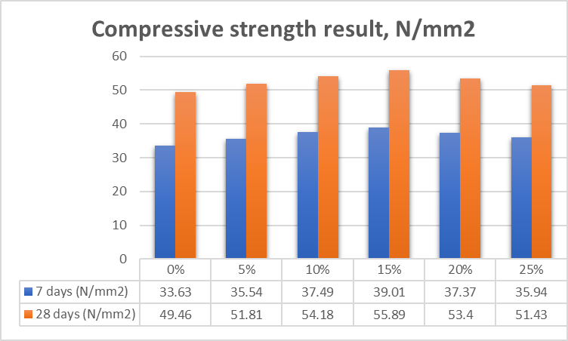

**Graph1: Compressive strength of concrete with Dolomite as partial replacement of cement in concrete**

#### Table 2: Compressive strength of concrete with Hooked steel fibre in concrete

|  |  |  |  |
| --- | --- | --- | --- |
| **S.No** | **Hooked steel fibers** | **Compressive Strength, N/mm2** | |
| **7 days (N/mm2)** | **28 days**  **(N/mm2)** |
| 1 | 0% | 33.63 | 49.46 |
| 2 | 0.5% | 34.41 | 50.45 |
| 3 | 1% | 36.32 | 51.88 |
| 4 | 1.5% | 34.04 | 50.21 |
| 5 | 2% | 34.34 | 50.44 |

#### 

#### Graph 2:Compressive strength of concrete with Hooked steel fibre in concrete

**Table 3 : Compressive strength of concrete for combined partial replacement of cement by 15% Dolomite+1%Hooked steel fibre in concrete.**

|  |  |  |  |
| --- | --- | --- | --- |
| **S.No** | **Combined replacements(%)** | **Compressive Strength, N/mm2** | |
| **7 days (N/mm2)** | **28 days**  **(N/mm2)** |
| 1 | 0% | 33.63 | 49.46 |
| 2 | 15%Dol+1%Hsf | 39.92 | 57.12 |

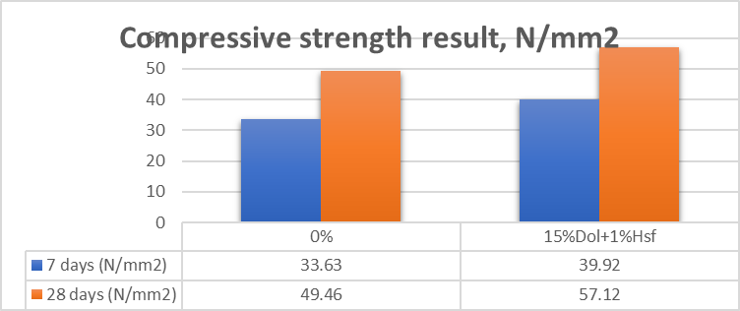

**Graph 3: Compressive strength of concrete for combined partial replacement of cement by 15% Dolomite+1%Hooked steel fibre in concrete.**

## 4.2 Split tensile strength results

#### For determining the splittensilestrength at 7 and 28 days, the cylindrical specimens (150 mm in diameter x 300 mm in height) were inspected.A compression testing device's loading surface is surrounded horizontally by a cylindrical sample.

**Table 4: Split tensile strength of concrete with Dolomite as partial replacement of cement in concrete**

|  |  |  |  |
| --- | --- | --- | --- |
| **S. No** | **Dolomite** | **Compressive Strength, N/mm2** | |
| **7 days (N/mm2)** | **28 days**  **(N/mm2)** |
| 1 | 0% | 3.34 | 4.84 |
| 2 | 5% | 3.58 | 5.17 |
| 3 | 10% | 3.66 | 5.31 |
| 4 | 15% | 3.93 | 5.66 |
| 5 | 20% | 3.69 | 5.29 |
| 6 | 25% | 3.54 | 5.05 |

#### 

#### 

**Graph 4: Split tensile strength of concrete with Dolomite as partial replacement of cement in concrete**

#### Table 2: Split tensile strength of concrete with Hooked steel fibre in concrete

|  |  |  |  |
| --- | --- | --- | --- |
| **S.No** | **Hooked steel fibers** | **Compressive Strength, N/mm2** | |
| **7 days (N/mm2)** | **28 days**  **(N/mm2)** |
| 1 | 0% | 3.34 | 4.84 |
| 2 | 0.5% | 3.36 | 4.93 |
| 3 | 1% | 3.59 | 5.13 |
| 4 | 1.5% | 3.28 | 4.95 |
| 5 | 2% | 3.41 | 4.98 |

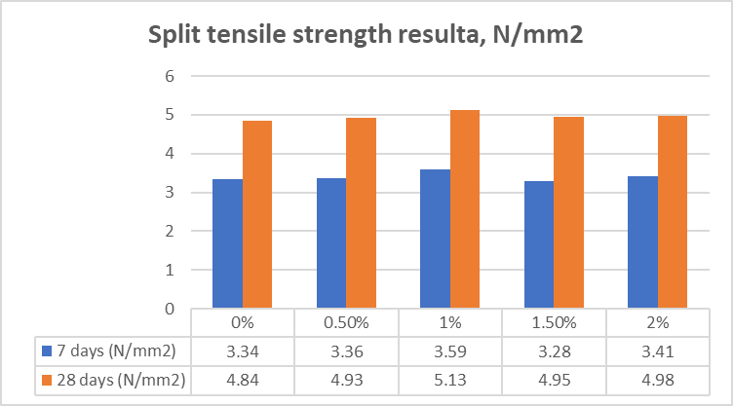

**Graph 5: Split tensile strength of concrete with Hooked steel fibre in concrete**

**Table 6 : Split strength of concrete for combined partial replacement of cement by 15% Dolomite+1%Hooked steel fibre in concrete.**

|  |  |  |  |
| --- | --- | --- | --- |
| **S.No** | **Combined replacements(%)** | **Compressive Strength, N/mm2** | |
| **7 days (N/mm2)** | **28 days**  **(N/mm2)** |
| 1 | 0% | 3.34 | 4.84 |
| 2 | 15%Dol+1%Hsf | 4.06 | 5.82 |

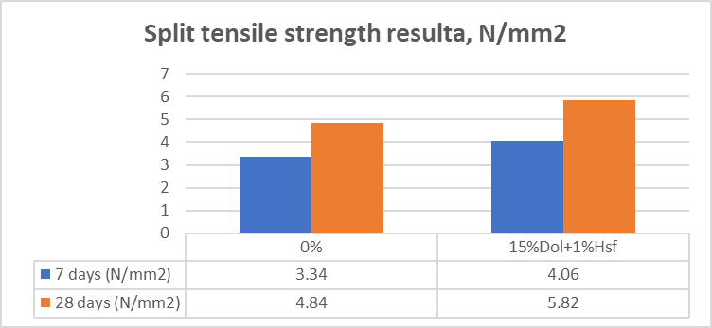

**Graph 6: Split strength of concrete for combined partial replacement of cement by 15% Dolomite+1%Hooked steel fibre in concrete.**

1. **CONCLUSION**

* At 15% replacement of cement by dolomite the achieved compressive strength of concrete 39.01N/mm2 for 7days and 55.89N/mm2 for 28days.
* At 1% replacement of fine aggregate by Hooked Steel Fibers the achieved compressive strength of concrete is 36.32 N/mm2 for 7days and 51.88N/mm2 for 28days.
* The combined replacement of compressive strength of with 15% dolomite powder and 1% of hooked steel fiber at 7 days and 28 days are 39.92 N/mm2 and 57.12 N/mm2
* At 15% replacement of cement by dolomite the achieved split tensile strength of concrete is 3.93N/mm2 for 7days and 5.66N/mm2 for 28days.
* At 1% replacement of fine aggregate by Hooked Steel Fibers the achieved split tensile strength of concrete is 3.59N/mm2 for 7days and 5.13 N/mm2 for 28days.
* At 15% replacement of cement by dolomite the achieved split tensile strength of concrete is 3.93N/mm2 for 7days and 5.66N/mm2 for 28days.
* At 1% replacement of fine aggregate by Hooked Steel Fibers the achieved split tensile strength of concrete is 3.59N/mm2 for 7days and 5.13 N/mm2 for 28days.

**6. REFERENCES**

1. Nitin Kumar1, Sangeeta2, A Review study on use of Steel Fiber as Reinforcement Material with Concrete, (12) (4) (2015)

2. Vijay M. Mhaske1, Rahul D. Pandit2, A. P. Wadekar3, study on behavior on high strength crimped steel fibre reinforced concrete for grade m90

3.Sandeep R. Gaikwad, 2Dr. A. Z. Chitade, A Review on Literature of Fiber Reinforced Concrete with Silica Fumes, In recent years, an emerging technology termed

4.Shahiron Shahidana, Mustaqqim Abdul Rahim, Nik Suharliza Nik Zol, Muhammad Azizi Azizand, Properties Of Steel Fiber Reinforcement Concrete With Different Characteristic Of Steel Fiber

5.Kanagaraj1, G.Siddesh, R.K.Santhoshkumar3, D.Thirumoorthi4, experimental investigation on steel fiber reinforced concrete

6.Niraj Kumar Singh, Baboo Rai, a review of fiber synergy in hybrid fiber reinforced concrete

7.Romanbabu M. Oinam1a, P.C. Ashwin Kumar2b and Dipti R. Sahoo, Cyclic performance of steel fiber-reinforced concrete exterior beam-column joints, (16) (5) (2019).

8.J.D. Chaitanya kumar1, G.V.S. Abhilash2, P. Khasim Khan3, G. Manikanta said, V. Taraka Ram Experimental Studies on Glass Fiber Concrete, (5) (5) (2016)

9. Dr.K.Chandramouli, J.Sree Naga Chaitanya, Dr.N.Pannirselvam, A. Murali Krishna.

Ultra High Strength Concrete by Using Alccofine. Volume 9, Issue 8 August 2021.

10. Dr. K.Chandramouli, J. Sree Naga Chaitanya, Dr.N.Pannirselvam, G.Jayasurya. Experimental Study on Papercrete Concrete. Vol. 8, Issue 7, July 2021.

11. P.Kavya1, Dr. K.Chandramouli , J. Sree Naga Chaitanya , Dr.N.Pannirselvam , G. Hari Chandra Prasad. Strength Behaviour of Geopolymer Concrete by Using Different Mineral Admixtures. Volume 8, August 2021.

12. CH.Vijay, J.Sree Naga Chaitanya, Dr.K.Chandramouli, Dr.N.Pannirselvam, G.Sai Srinivasulu. Strength Studies on Pervious Concrete. Volume 8, August 2021.

13. J. Sree Naga Chaitanya, Dr. K. Chandramouli, M. Anil kumar, Dr.N.Pannirselvam. An Experimental Investigation on Properties of Concrete by Partial Replacement of Cement with Dolomite and Fine Aggregate with Crushed Sea Shell Powder. Volume 8, August 2021.

14. L.Harish, G.Harikrishna, N.Swamulu, CH.Dhanush, A.Rajendra, Partial Replacement of Cement with Dolomite Powder.

15. Preethi, Prince Arulraj. Effect of Replacement of Cement with Dolomite Powder on the Mechanical Properties of Concrete. Vol. 2, April 2015.