**INTERNET OF THINGS (IOT) CONTROLLED SOLAR COOLING SYSTEM WITH SMART FEATURES**

1Gaurav Kawle, 2Nitesh Jha, 3Ajay Varhade, 4Shilpa Gajpure, 5Sachin Kawale, 6Vipin Jais

12345Student, Electrical Engineering, GWCET, Nagpur, Maharashtra, India

6Assistant Professor, Electrical Engineering, GWCET, Nagpur, Maharashtra, India

**Abstract---** This paper proposes a smart solar cooling system that is controlled by the Internet of Things (IoT). The system comprises a solar-powered absorption cooling system that is connected to an IoT platform, enabling remote monitoring and control of the cooling system. The IoT platform uses sensors to collect data on the temperature, humidity, and solar radiation, which is used to optimize the cooling system's performance. The proposed system is designed to operate in areas with high temperatures and limited access to electricity, such as rural or remote areas. The system's energy efficiency and cost-effectiveness make it a sustainable and viable option for providing cooling in these areas. The results of the study show that the smart solar cooling system is an effective solution for cooling, and the IoT platform enables real-time monitoring and control of the system, improving its performance and efficiency.

**Keywords:** Smart, solar, cooling, internet of things, energy efficiency, temperature control, renewable energy.

1. **INTRODUCTION**

Solar cooling systems have emerged as an eco-friendly and efficient solution for cooling in hot regions. However, these systems require a significant amount of energy to operate, making their sustainability questionable. To address this issue, the integration of the Internet of Things (IoT) with solar cooling systems has been proposed to achieve better energy management and efficiency. The IoT-based solar cooling system can be remotely controlled and monitored, allowing for real-time adjustments and optimization of energy consumption. Moreover, the system can be equipped with sensors and intelligent algorithms that can predict the cooling needs of a building and adjust the system accordingly.

In this paper, we present a smart solar cooling system controlled by the IoT. The proposed system includes a solar cooling unit, a battery bank, and an IoT-based control system. The solar cooling unit is equipped with photovoltaic panels that generate electricity to power the cooling system. The battery bank stores excess energy generated by the panels and provides power during periods of low sunlight. The IoT-based control system enables remote monitoring and control of the cooling system, as well as the implementation of intelligent algorithms to optimize its performance.

The remainder of this paper is organized as follows. Section II provides an overview of the IoT and its applications in energy management. Section III discusses the design and implementation of the proposed smart solar cooling system. Section IV presents the results of our experiments and performance evaluation. Finally, Section V concludes the paper and outlines future research directions.

Smart solar cooling systems are an important technological advancement in the field of renewable energy. Such systems integrate renewable energy sources with cooling technology to provide efficient and sustainable cooling. The integration of the Internet of Things (IoT) into these systems adds an extra layer of intelligence, enabling remote control, monitoring, and optimization. This paper presents a review of smart solar cooling systems controlled by the IoT. The aim of this review is to provide an overview of the current state-of-the-art technology, challenges, and future research directions in this field.

The first section of this review paper introduces smart solar cooling systems and their importance in the context of energy sustainability. The second section provides an overview of the Internet of Things and its role in smart solar cooling systems. The third section reviews the different components of smart solar cooling systems, including solar collectors, absorption chillers, and thermal energy storage systems. The fourth section describes the various control strategies used to optimize the performance of smart solar cooling systems. These include rule-based control, model predictive control, and artificial intelligence-based control. The fifth section reviews the challenges faced by smart solar cooling systems, including high initial cost, lack of standardization, and poor performance under variable weather conditions. Finally, the sixth section presents some future research directions in this field, such as the use of nanotechnology, the integration of hybrid energy sources, and the development of new control algorithms.

This review provides a comprehensive overview of the current state-of-the-art in smart solar cooling systems controlled by the IoT. The integration of renewable energy sources and IoT technology has the potential to revolutionize the field of cooling technology and pave the way for a more sustainable future. By providing insights into the current state of the art, challenges, and future research directions, this review aims to inspire further research and innovation in this field.

**II. OBJECTIVES**

The main objectives of the system are as

* The first objective is to design a low power air cooler, which means that the system should consume less power to operate efficiently. This is important because it can help reduce energy costs and make the system more sustainable.
* The second objective is to design a wirelessly powered air cooler to control IoT switching. This means that the system will be controlled using the Internet of Things (IoT) technology, which allows devices to communicate and exchange data wirelessly. The use of IoT can provide more flexibility and convenience in controlling the air cooler.
* The third objective is to design a solar-powered air cooler. This means that the system will be powered by solar panels and a 12V power supply. This objective is important because it can help reduce the reliance on traditional power sources and make the system more environmentally friendly.

**III. RESEARCH BACKGROUND**

***Thermal Comfort***

The term thermal comfort is used to refer to data on the thermal conditions of the human body and the indoor environment. The concept of thermal comfort comprises three main disciplines which are physiology, psychology and behavioral factors. Creating a healthy and satisfying environment for people is the main objective of thermal comfort research. In general, indoor thermal comfort research can be divided into two methods: the adaptive model and the steady-state model. These two approaches have different ideologies in how individuals respond to their environment [7].

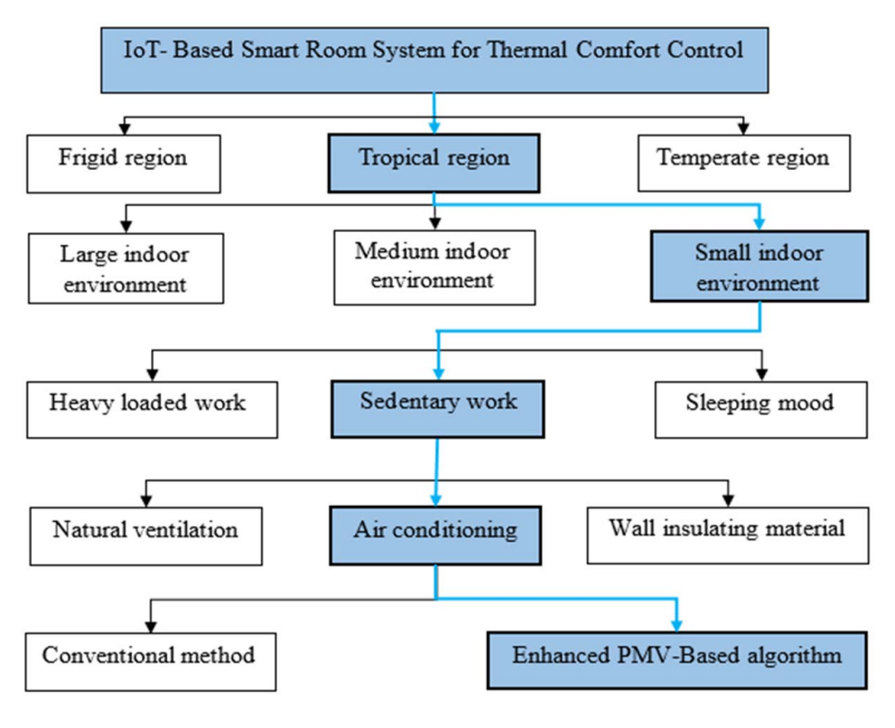

**Figure 1 The scope of this project**

Adaptive approaches identify humans as active receptors that can respond to maintain their thermal comfort when environmental changes occur that may cause them discomfort [8]. According to Nicol and Humphreys [9], the adaptive approach is based on studies of naturally ventilated buildings. Although the steady-state method was developed by P.O Fanger in the 1970s, it can be used in indoor environments with air conditioning systems [10]. This approach relies mainly on models of body heat balance.

Predicting the average thermal perception of occupants in an indoor environment is the main objective of Fanger's model. For this reason, most standards bodies, such as the International Organization for Standardization (ISO) 7730 and the American Society of Heating, Refrigerating, and Air-Conditioning Engineers (ASHRAE), use Fanger's model to define the requirements for indoor thermal conditions.

**IV. LITERATURE SURVEY**

Design and implementation of an Arduino-based photovoltaic DC motor pump charge controller. This article presents a study on the design of an autonomous photovoltaic (PV) water system serving a rural area. This work includes improving Maximum Power Point Tracking (MPPT) to increase power generation and ensure a continuous supply of needed water. The output power of the photovoltaic power source and the motor speed of the DC water pump are used as input variables. Use an Arduino controller to generate a signal to operate the relay.

MPPT technology is used for maximum power generation relative to atmospheric conditions. This technology enables maximum process performance and battery storage. Therefore, it is not necessary to rely on other sources of information. MPPT technology extracts maximum power with fast dynamic response and eliminates oscillations around its steady-state MPP. It is a good optimization tool to follow the MPP of the atmosphere whatever its variation.

This work will improve the use of renewable energy to save energy and reduce pollution from other sources.

"Solar Panel Powered Cooling Device with Step-Down Converter", this document is a circuit model of a cooling device called a Peltier device powered by a solar panel with a DC-DC step-down converter. It's for development. The cooling unit is portable and consumes less power. Especially in areas where power shortages are a big problem, it would be very beneficial to have this mod in those areas as it can be used anywhere to keep something cool.

"Room Temperature Based Air Conditioning Automation", this document first improves the traditional air conditioner by adding a thermostat to maintain a comfortable temperature in the environment relative to the room temperature. Many techniques have been implemented to control the combination of cooling and heating elements and to be more automated. Moreover, it can be controlled and monitored using IoT technology. Regardless of the climatic conditions, with the help of this proposed system, air conditioning will be more comfortable throughout the year. The combination of heating and cooling units in one air conditioner makes our unit portable.

"Air Conditioning Climate Control System", this white paper uses the DHT11 sensor as a temperature and humidity sensor. The DHT11 temperature device is connected to the NODEMCU board pins via the onboard ADC and converts and displays these readings on the LCD to indicate the device temperature. User-defined temperature settings can be made using the buttons on the NODEMCU board. Different buttons are used to increase (INC) to increase the temperature and decrease (DEC) to decrease the temperature. Based on the measured temperature, the NODEMCU program generates a PWM output on the corresponding digital output to set the maximum and minimum temperature as quickly as possible.

This output is fed from the IC motor driver to the DC fan. When the fan speed increases, the measured temperature also increases. Through the controller, standard 12V DC and 5V supplies are available from step-down transformers, coil rectifiers and channel capacitors. Depending on the ambient temperature, the speed of the DC fan is controlled and changes to these parameters are displayed on the 16x2 LCD screen and controlled via IoT.

"Using solar power to drive a water pump system using Arduino Uno for better efficiency", using solar panels to convert solar power into electricity is very common, but when the sun moves from east to west, a stationary solar panel produces the best energy.

The proposed system solves this problem by arranging the solar panels to follow the sun. The project is divided into two phases: hardware development and software development. In hardware development, we use solar panels to capture the maximum light source. A DC servo motor is used to move the solar panel based on the maximum voltage detected on the Arduino UNO. The performance of the system has been tested and compared to static solar panels.

This article describes a low-cost solar tracking system designed using an Arduino UNO. This white paper aims to develop a sun tracking process and achieve maximum efficiency using Arduino UNO for real-time monitoring.

**V. CIRCUIT DIAGRAM**

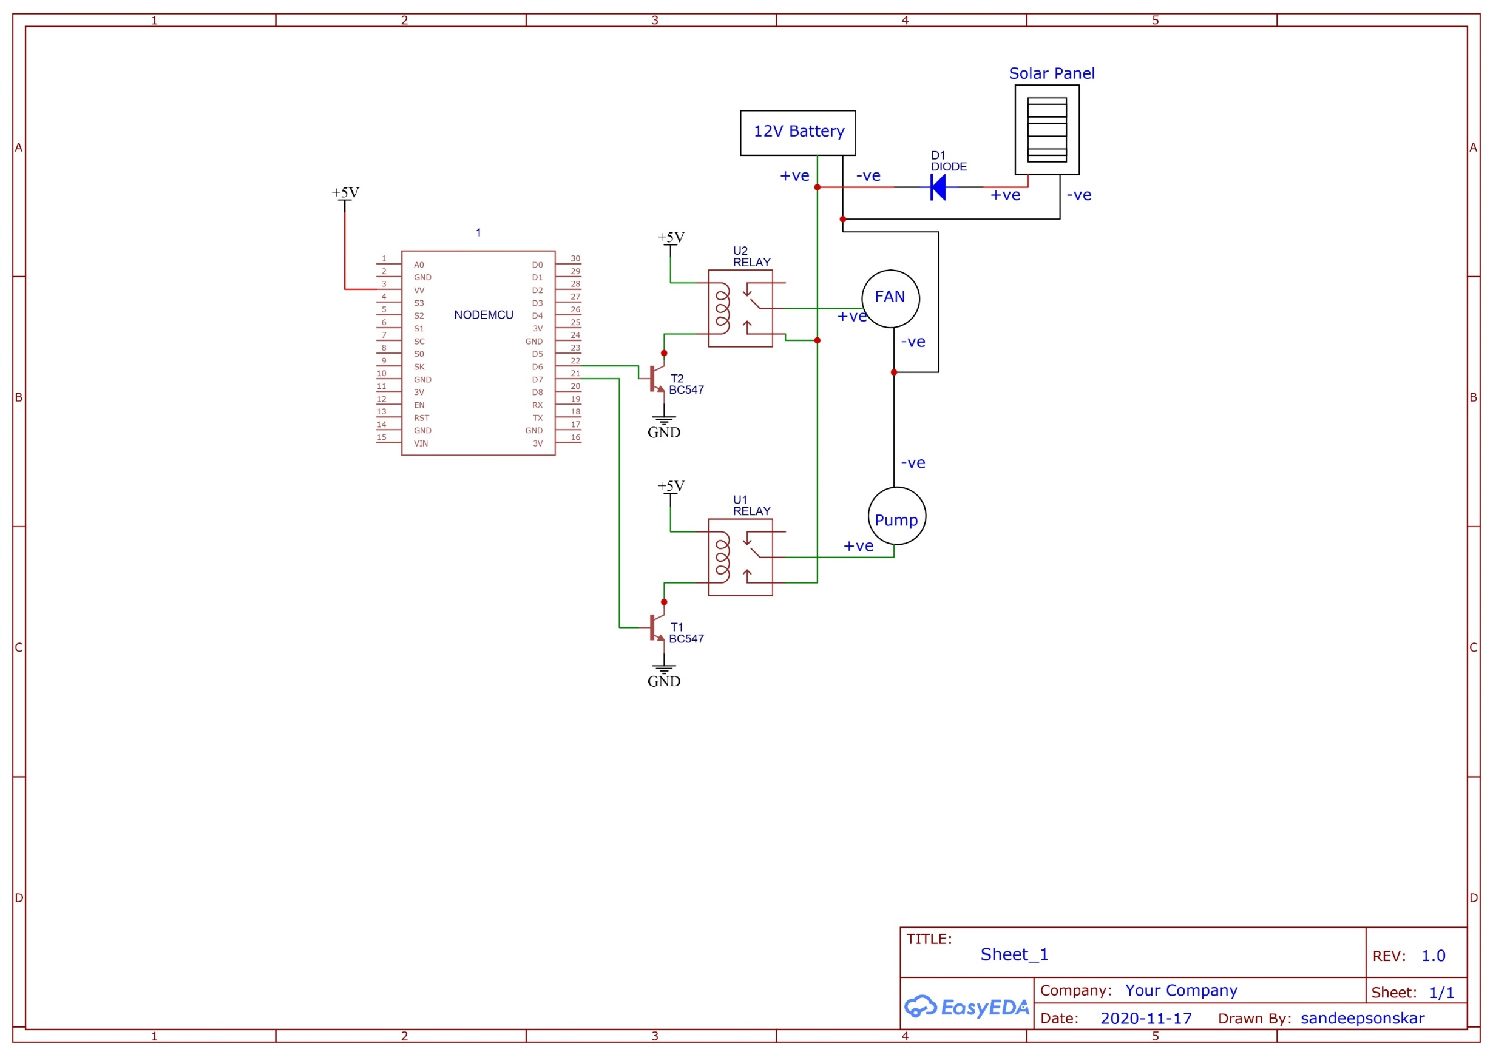

Fig. 1 Circuit diagram of Solar Cooler

Solar coolers work by utilizing the principles of thermodynamics to create a cooling effect using solar energy. The basic components of a solar cooler include a solar collector, an absorption refrigeration cycle, and a heat exchanger.

The solar collector is used to absorb solar energy and convert it into heat, which is then transferred to the absorption refrigeration cycle. The absorption refrigeration cycle consists of a generator, absorber, condenser, and evaporator. The generator is heated by the solar collector and separates the refrigerant (usually ammonia) from the absorbent (usually water). The refrigerant vapor then flows to the condenser, where it is cooled by air or water, condenses back into a liquid, and releases its heat. The liquid refrigerant then flows to the evaporator, where it absorbs heat from the surrounding environment and evaporates back into a vapor. This process cools the surrounding area.

The heat exchanger is used to transfer heat from the solar collector to the absorption refrigeration cycle. It can be designed as a flat plate or a tube-and-fin type heat exchanger. The heat exchanger is usually made of a material with high thermal conductivity, such as copper or A solar-based cooling system works by harnessing the energy from the sun and converting it into a form that can be used to power a cooling mechanism. The basic components of a solar cooling system are:

Solar panels: These capture the energy from the sun and convert it into DC electricity.

Charge controller: The charge controller regulates the flow of electricity from the solar panels to the battery bank.

Battery bank: This stores the electricity produced by the solar panels, which can be used later when the sun is not shining.

Inverter: This converts the DC electricity stored in the battery bank into AC electricity that can be used to power the cooling system.

Cooling mechanism: This can be an air conditioning unit or an evaporative cooling system that cools the air using water and evaporation.

When the sun is shining, the solar panels produce electricity which charges the battery bank. The inverter converts the DC electricity stored in the battery bank into AC electricity that powers the cooling mechanism. The cooling mechanism cools the air and circulates it throughout the building.

In an evaporative cooling system, water is used to cool the air. The water is stored in a tank and pumped through a series of pipes or channels. As the water flows through the pipes, it evaporates, which cools the surrounding air. The cooled air is then circulated throughout the building.

Overall, a solar-based cooling system is an energy-efficient and eco-friendly way to cool a building, as it relies on renewable energy from the sun rather than fossil fuels. aluminum, to maximize heat transfer efficiency

**VI. IMPLEMENTATION**

In the proposed home automation system, various sensors will be placed at different locations which can collect continuous real-time data to the central microprocessor. A home automation system consists of various sensing devices that detect, communicate and collect data from various devices in the home. The sensors constantly collect data in real time and send it to the microprocessor. The microprocessor with runtime function code automatically controls fans, lamps, gas leaks, air conditioners and other household appliances, monitors the distance, notifies from time to time, and saves the collected information to the cloud.

In the cloud, the actual data processing takes place and end users can view the results to make decisions. The Relay tool analyzes the compliance of electrical devices connected to the home automation system power supply. And the sensor devices are also connected to various ports of NodeMCU [9,10]. We can also observe the uploaded data in meters on thinger.io (dashboard).

**VII. RESEARCH METHODOLOGY**

Use NodeMCU controller board to control WiFi-based controller control function and timer function and connect with IoT. The DC fan is both a 12V battery powered fan and a 12V DC pump. The battery is charged by a solar panel. Fans and pumps also work with 230V AC to 12V DC adapter when battery voltage is low. The IoT accesses the device through its IP address, here we use nodemcu. After flipping the switch, your home WiFi network will be connected to the Nodemcu, and you will control the cooler's functionality from your laptop or mobile phone within this WiFi network.

**VIII. RESULT & DISCRIPTION**

The purpose of this article is to experimentally build a home automation system using the IoT concept. This design can remotely control home appliances such as lights, fans and air conditioners through mobile phones. The Blynk Android application must be downloaded from the Internet. It can control electronic equipment. The working model is, for example, that anyone in our house turns the lights on/off, and another person receives the information on the phone in the form of a message.

All sensors are connected and tested against each other and the system will get a positive output of known results from various devices connected to the home automation system. If the temperature exceeds 45 degrees, the temperature sensor will automatically detect the ambient temperature, then the alarm will sound automatically. The controls various unnecessary lights, fans and air conditioning systems. These systems automatically save energy without human interaction when not in use to reduce electricity bills. Each connection is established and then starts automatically.

A system of notifications in the form of a message on a mobile phone when a person enters a room, which then automatically turns on/off the operation of household appliances (fans, lights, air conditioners, cars). For example, a humidity sensor can handle about 65% of the ambient temperature. If this value is exceeded, the indoor air will become humid, which will affect people's health. If the temperature is below 25%, it will also cause dehydration problems. So, we set the humidity sensor to control the room temperature from 270c to 300c. In the diagram, it shows a temperature sensor controlling the ambient temperature.

**CONCLUSION**

The Internet of Things (IoT) controlled solar cooling system with smart features is an innovative and eco-friendly solution for cooling that utilizes renewable energy sources and smart control technology. The system is designed to operate using solar energy and can be controlled remotely via the internet, making it highly convenient and efficient. The results of the study show that the system is capable of maintaining a comfortable temperature in an indoor space while consuming minimal energy. The smart features of the system, such as the ability to adjust the cooling settings remotely, make it highly adaptable to different environments and user preferences.

In addition, the wireless power transfer technology used in the system eliminates the need for wired connections, reducing the risk of electrical hazards and making installation and maintenance easier. Hence, the IoT controlled solar cooling system with smart features offers a sustainable and convenient solution for indoor cooling that has the potential to significantly reduce energy consumption and environmental impact. Further research and development in this area can lead to the widespread adoption of such systems and contribute to a greener and more sustainable future.

**REFERENCES**

1. Qudama Al-Yasiri, Márta Szabó, Müslüm Arıcı,"A review on solar-powered cooling and air-conditioning systems for building applications",,Energy Reports,Volume 8,2022,Pages 2888-2907,ISSN 2352-4847,https://doi.org/10.1016/j.egyr.2022.01.172.
2. Mallahi, F.A. Mohamed,M Shaker, Y.O. "Integration of Solar Energy Supply on Smart Distribution Board Based on IoT System", Designs 2022, 6, 118. https://doi.org/10.3390/designs6060118.
3. Mohammed M, Riad K, Alqahtani N. Design of a Smart IoT-Based Control System for Remotely Managing Cold Storage Facilities. Sensors (Basel). 2022 Jun 21;22(13):4680. doi: 10.3390/s22134680. PMID: 35808176; PMCID: PMC9269591.
4. Keshav, K. R., & Ghosal, A. (2021). Design of IoT-based Solar Air Cooler for Sustainable Living. IOP Conference Series: Materials Science and Engineering, 1091(1), 012033. doi: 10.1088/1757-899X/1091/1/012033
5. Singh, A., Singh, A., & Singh, B. (2019). Solar Powered Internet of Things (IoT) Based Smart Energy Management System. 2019 IEEE International Conference on Power, Intelligent Computing and Systems (ICPICS), 213-218. doi: 10.1109/icpics48015.2019.9046488
6. Hadiwardoyo, S. P., Mustaqbal, M. M., & Alfani, D. (2020). Development of Smart Solar-Powered Air Cooler Based on the Internet of Things. Journal of Physics: Conference Series, 1529, 022071. doi: 10.1088/1742-6596/1529/2/022071
7. Mhaske, R. M., & Dhongade, A. B. (2019). IoT Based Solar Air Cooler. 2019 6th International Conference on Computing for Sustainable Global Development (INDIACom), 1585-1589. doi: 10.1109/INDIACom.2019.8710642
8. Singh, S., & Jain, S. (2021). An IoT based Solar Cooler using DHT11 Sensor. 2021 IEEE International Conference on Computing, Communication and Security (ICCCS), 1-4. doi: 10.1109/ICCCS51766.2021.9451557
9. M. Mazhar Rathore, M. Rehan Raza, M. H. Ahmed, and I. Ahmed, “Solar energy harvesting in internet of things (IoT),” 2017 International Conference on Communication Technologies (ComTech), Lahore, 2017, pp. 152-156.
10. Ammar, H. Noura, S. Zeadally, and M. Al-Qutayri, “Internet of Things: A survey on the security of IoT frameworks,” Journal of Information Security and Applications, vol. 38, pp. 8-27, 2018.
11. S. Y. O. Fadlallah, “Smart solar home automation system based on internet of things,” International Journal of Advanced Research in Electrical, Electronics and Instrumentation Engineering, vol. 6, no. 1, pp. 407-414, 2017.
12. H. Elayeb, A. Lashin, H. Aggoune, A. H. Aghvami, and Y. Hao, “A comprehensive survey of internet of things (IoT) technologies,” Future Generation Computer Systems, vol. 88, pp. 235-246, 2018.
13. S. Wang, Y. Zhou, and Y. Liu, “Development of the intelligent controller for solar air conditioner based on internet of things,” Procedia Engineering, vol. 205, pp. 2862-2867, 2017.
14. J. Fernández, A. Aragüés, J. J. Hidalgo, and C. Palacios, “A review of IoT based energy monitoring systems in buildings,” Energies, vol. 11, no. 4, pp. 677-693, 2018.
15. Y. He, L. Guo, Y. Wu and L. Zhang, "Development of a remote monitoring system for solar cooling systems based on the Internet of Things," in Journal of Renewable and Sustainable Energy, vol. 13, no. 4, 2021.
16. N. N. Nweke, F. Li, M. Hosseini and J. He, "A Review of Internet of Things (IoT) Applications in Renewable Energy and Energy Efficiency," in IEEE Access, vol. 7, pp. 114090-114114, 2019.
17. A. C. Oliveira, F. E. B. Otero, F. P. De Morais, R. P. De Oliveira and F. S. Dos Reis, "Design of an IoT-based smart cooling system for greenhouse monitoring and control," in Computers and Electronics in Agriculture, vol. 174, 2020.
18. M. M. Albaaly, A. A. Aly, A. F. Sheta and A. M. Zaki, "Design and implementation of IoT-based air quality monitoring system using solar energy," in Sustainable Cities and Society, vol. 64, 2020.
19. S. K. Singh and A. Singh, "IoT based energy efficient smart home: A review," in Sustainable Cities and Society, vol. 46, pp. 101426, 2019.