**AUTOMATIC PHASE SELECTOR IMPLEMENTATION USING AMONGST AVAILABLE PHASE SUPPLY**

1Sonu Bawane, 2Rakesh Lanjewar, 3Ajay Bhanarkar, 4Ashwini Bharadkar, 5Suraj Upadhyay, 6Ojaswini Rakhade, 7Prof. N. D. Dhapodkar

123456Student, Electrical Engineering, GWCET, Nagpur, Maharashtra, India

7Assistant Professor, Electrical Engineering, GWCET, Nagpur, Maharashtra, India

**Abstract**— Power cuts are a common problem. This affects industrial production and the construction of new factories and buildings. It can be bypassed by using a generator or some other form of backup power. But since it takes time to manually turn on the generator, it saves time and money. It is often observed that a single-phase fault in an electrical distribution network causes approximately 70% of outages while the other two phases operate normally. Therefore, an automatic phase selector system is required in any three-phase domestic or commercial power system to supply critical loads in the event of a phase failure. In this case, no backup power supply is required. Also, since the phase changes instantaneously within seconds, it does not take time. The main objective of this article is to give an overview of the concept of automatic phase switching for 220 to 240 VAC. However, this model is for automatic phase change (phase selector), which is designed for three-phase A.C. Input power for single phase output applications. There are many designs that perform almost the same function such as single-phase inverters, two phase automatic transfer switches and three phase automatic transfer switches.

**Keywords**— Automatic phase selector, power failure, single phase load.

**I. INTRODUCTION**

It is well known that when a fault occurs in an overhead transmission line system, high frequencies are generated by instantaneous voltage and current changes at the fault point. Electromagnetic pulses, called traveling waves, propagate along the transmission line in both directions from the fault point. Electrical infrastructure is extremely vulnerable to many forms of natural and severe physical events. This can suspiciously affect the overall performance and stability of the mesh. Low fault impedance.

The fault current is relatively high during a fault. Power flow is diverted to the point of failure and the supply voltage becomes unbalanced affecting adjacent areas. Early error detection is important, so a kit with a microcontroller has been designed to speed up the process. The resistance and inductance of the transmission line conductor are evenly distributed along the length of the line. The traveling wave fault location method is generally more suitable for long lines. 50 Hz transmission lines longer than 80 km are considered to have the property that voltage and current waves propagate down the line at finite speed. Traveling wave methods for transmission line fault location have been reported for a long time. Later developments used high-speed digital recording techniques that exploit shifted wave conversions generated by defects. Electrical infrastructure is currently more susceptible to multiple forms of natural and malicious physical events that directly affect grid stability. Some parameters will be affected.

Therefore, there is an urgent need to equip the old transmission line infrastructure with high-performance data communication networks to meet future operational needs such as real-time recording and control required for smart grid integration. . Due to this technology, real-time monitoring is required. Many power transmission companies rely primarily on circuit indicators to locate faulty sections of their transmission lines. However, identifying the exact location of these failures remains difficult. Although fault indicator technology offers a flexible method for detecting permanent faults, technicians and patrols still have to physically travel and inspect equipment for an extended period of time to find the faulty part of its transmission line.

It is well known that when a fault occurs in an overhead transmission line system, high frequencies are generated by instantaneous voltage and current changes at the fault point. Electromagnetic pulses, called traveling waves, propagate along the transmission line in both directions from the fault point. Electrical infrastructure is extremely vulnerable to many forms of natural and severe physical events. This can suspiciously affect the overall performance and stability of the mesh. Low fault impedance.

The fault current is relatively high during a fault. Power flow is diverted to the point of failure and the supply voltage becomes unbalanced affecting adjacent areas. Early error detection is important, so a kit with a microcontroller has been designed to speed up the process.

This research provides an economic basis for the design of real-time data transmission networks. In order to observe the state of the electrical system in real time, sensors are placed in different network components.

These sensors allow fine measurements of various physical or electrical parameters and generate a wealth of information. Sending this information to the control center at the right time and in a cost-effective manner is a key challenge that must be met to build a smart smart grid. To ensure this, this project uses relays as sensor switches for the transmission line, if a phase is cut, the corresponding relay will close, so the controller is notified and uses the relay network to transfer the load to the other phase. a current sensor is used to check the power of the load, if it exceeds the required limit, the load will again be shifted to another phase.

**II. LITERATURE SURVEY**

Su Chen, GCza Jobs [1] Growing concern over power quality and availability has led to the search for solutions to eliminate or mitigate critical load issues caused by distribution system failures. Both serial and parallel active power supplies have been proposed and used for this purpose. This article discusses and compares the potential of D-STATCOM and DVR to provide these functions. It introduces compensator rating factors that define the ability of the compensator to withstand the load voltage in the presence of single-phase and three-phase faults. Algorithms required to perform voltage support are derived and alternatives are discussed, including the use of sequence components and DC voltage regulation.

Anu P, Divya R, Dr. Manjula G Nair [2] Most of these loads consume more reactive power, which increases power losses and reduces the system's ability to circulate active power. In this article, a STATCOM-based controller for a three-phase system supplying single-phase loads is presented. The objectives of the controller in the system are to compensate for inductive loads to achieve near unity power factor, to balance source currents by eliminating the effects of unbalanced loads, and to filter harmonic load currents to form sinusoidal source currents. A simulation model of the system was developed in MATLAB SIMULlNK and tested with linear and nonlinear loads under balanced and unbalanced conditions.

L.S. Eczéma, B.U. Peters, O. Harris [3] Electricity supply is unstable in Nigeria and most developing countries. This has a negative impact on electricity consumers and equipment operated by primary sources of electricity supply in these regions of the world. In this article, we provide an automatic transfer mechanism that transfers user loads from generators to power sources in the event of a power failure. It automatically senses when utility power is restored and returns the load to that source when generator power is lost.

This mechanism has been tested and we have recorded a good result. Therefore, it is important to provide continuous power through a nearly seamless connection between main power and backup power sources such as generators.

Ahmed, MS, Mohammed, A. S., Agusiobo, O.B. [4] A phase selector is a mechanism used to alternate or switch between power phases depending on the availability of power from either phase. For decades, phase failures frequently occurred in the phases of the network, which required manual switching of fuses from one phase to another.

However, the subject of this article is the design of a phase selector using an automatic switching mechanism. During its operation, it transfers the load of the user towards an available source in the event of failure of the national electrical network, and automatically detects the return of the source to the failed phase and returns the load to this source. During this design process, several tests are performed, such as continuity testing of contactors and relay coils to determine low resistance, continuity testing of contacts on materials used to ensure free flow of current, the conduction of the wires and the whole system. Simulations were also performed using Proteus. electronic software.

**PROBLEM STATEMENT**

In our daily life, we need to change the system in order to reduce the problems in our personal life. Now in modern science and technology there is an idea to develop a system which can be applied in various applications in our daily life. Therefore, we opted for the concept of an automatic phase switch for three-phase applications. If there is low voltage on any two phases, if we want all devices to work in this state, i.e. normal range.

**OBJECTIVE**

The main objectives of this research are as follows:

1. To select automatically a voltage that is present in power line.

2. To avoid stress and inconvenience in manually selecting of phase voltage.

3. To build a system that can be able to choose any voltage that appears to be of high potential among other voltage.

**III. METHODOLOGY**

**1. BASIC IDEA:**

In this topic, the load is shifted to different phases based on the phase selector which selects the phases based on the availability of the phases and using the transformer, rectifier, IC-7812 regulator, LM-324 operational amplifier, three phases are avoided Short circuits, Zener diodes, resistors and relays. Therefore, for convenience, an indicator light indicates which phase is running with load.

**2. STAGE OF IMPLIMENTATION:**

The automatic phase changer design was implemented in three units are as given below.

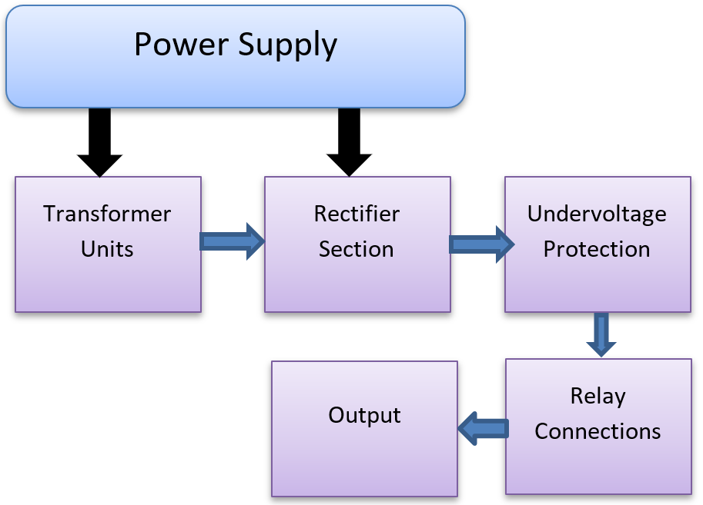

**Fig. 1 Stages of Implementation**

**3. DESIGN DEVELOPMENT AND CONSIDERATIONS**

When designing phase selectors, we provide a number of overvoltage and undervoltage protections for those considerations, conditions, and situations that provide accurate and healthy phasing to the load. This is shown by following the truth table.

given these circumstances and the fact that the power supply from the electricity supplier has its ups and downs) do not tell anyone until they have decided in this part of the world. Therefore, the conditions and issues considered are as follows; Assume the three-phase power supply is 240 volts single phase at a frequency of 50 Hz.

1. If assume a load of 5 kW.
2. When all three-phase power is present, the output in Table 1 above is the healthy phase.
3. When two of the three phases are present, the output from Table 1 above is the healthy phase.
4. The relay logic implements with multiple phases in contact with each other The above condition and the output of this condition were considered when designing the phase selector control. For a given truth table, "X" is the output of all states present in the given system in the particular row table, i.e. "1" means enabled and "0" means disabled or no output of the phase selector.

**IV. BLOCK DIAGRAM/CIRCUIT DIAGRAM**

In this section, the load is moved to different phases according to the phase selector which chooses your phases according to their availability and avoids the short circuit of the 3 available phases. Using transformers, rectifiers, voltage regulators, operational amplifiers, Zener diodes, resistors and relays.

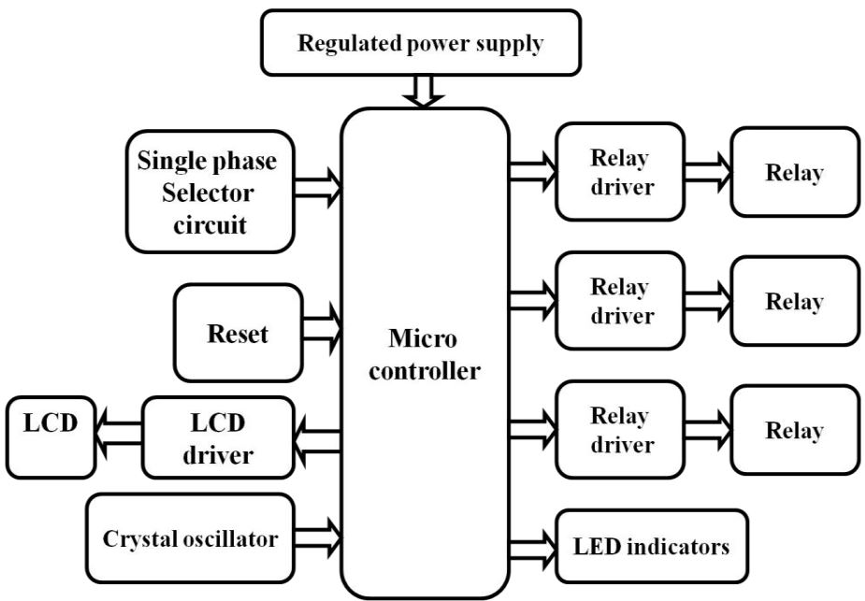

**Fig. 2 Block Diagram**

**V. SYSTEM DESIGN AND IMPLEMENTATION**

The system design and implementation were carried out according to the system’s block diagram below:

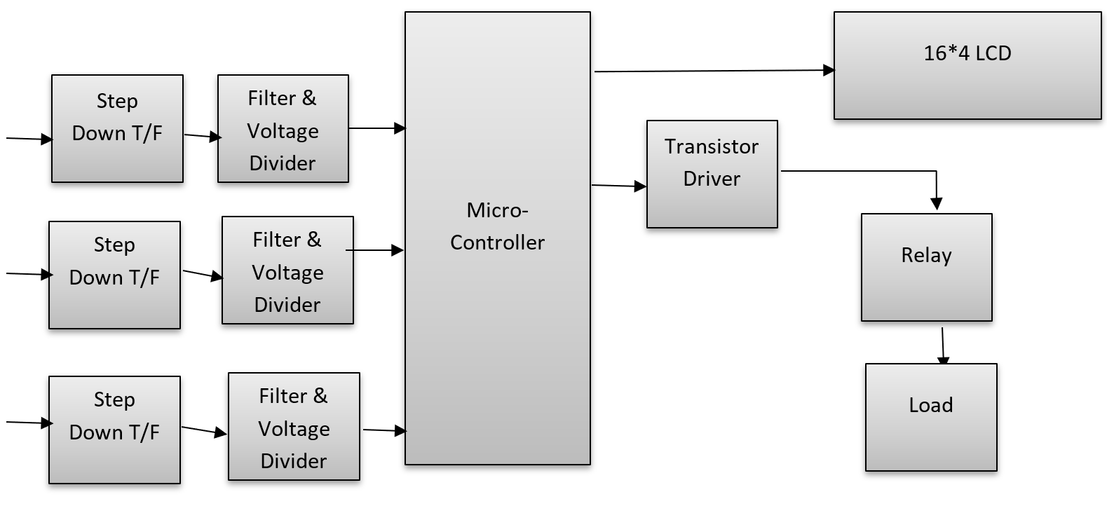

**Fig. 3: Block Diagram of Automatic Phase Changer with optimal selector.**

**A. Phase Voltage Sensing Unit:**

A strain sensor is a sensor used to calculate and monitor the strain of an object. Voltage sensors can determine AC and DC voltage levels. The input of this sensor is a voltage. The unit is mainly composed of a power supply and a detection unit. It is at this point that the three-phase mains voltage is converted from AC to DC, filtered and passed through a voltage divider to the microcontroller.

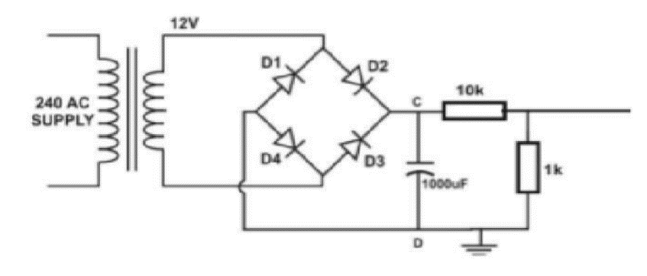

**Fig. 4: Phase Voltage Sensing Unit**

**B. Microcontroller Unit**

The processing unit consists of a PIC16F877a microcontroller which performs all logical operations. The logic programmed into the MCU works by detecting the three different phases of the step-down filtered DC voltage obtained using a voltage divider and processes the information.

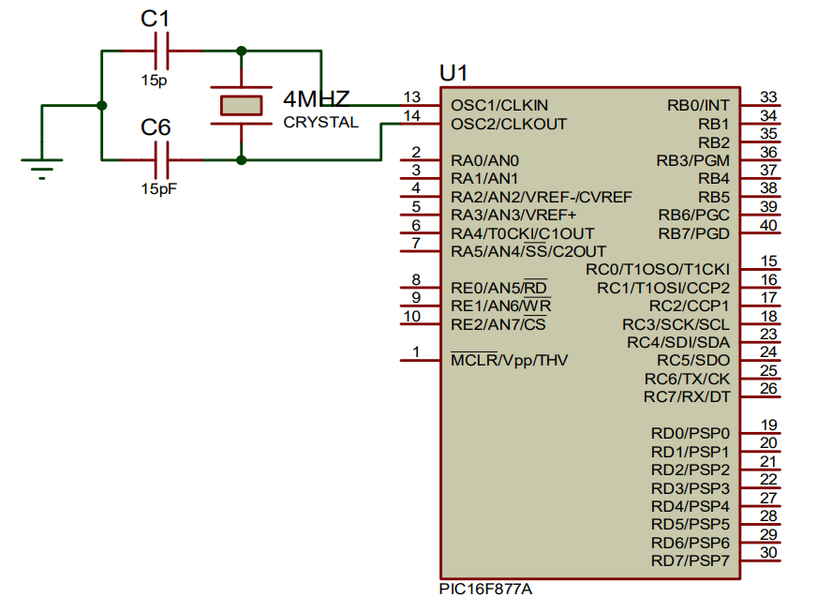

**Fig. 5: Microcontroller Unit**

**C. LCD Display Unit**

The LCD display unit displays the state of the resultant phase voltage switching and digital selection of the system.

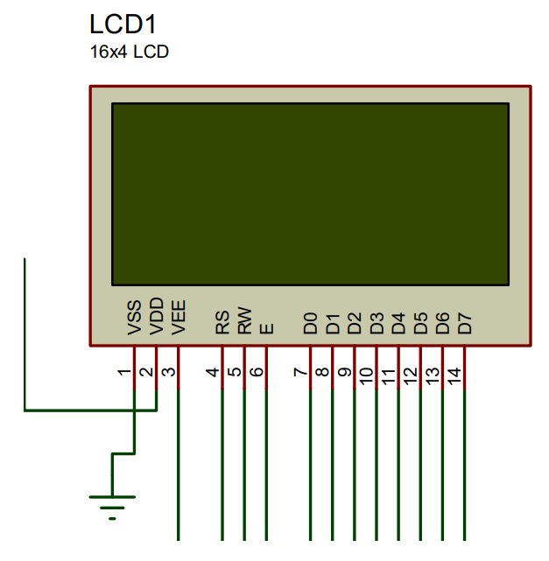

**Fig: 6: Display Unit**

It consists of a liquid crystal display [LCD] unit, a 16 x 4 module connected to a microcontroller to display the healthiest available phase selected to power the load during processing. It indicates the various outputs of the microcontroller in an easily understandable digital form for the observer. It displays setpoints, process variables and the current status of the entire system.

**VI. CIRCUIT MODE OF OPERATION**

The automatic phase selector and switching circuit consists of three transformers T1, T2 and T3 connected to each phase of the mains supply. These transformers step down the phase voltage from 240V AC to 12V AC. The full-wave bridge rectifier circuit is used to convert the step-down voltage of 12 V AC to a pulsating voltage of 12 V DC. This pulsating 12 VDC voltage is filtered through electrolytic capacitors into a pure 12 VDC voltage. The 12V dc is further stepped down to a maximum of 4V dc through a voltage divider network as shown in the circuit below. The lowered 4V DC voltage is fed into the PIC16F877a microcontroller unit for further comparison and processing. The programmed logic residing in the ROM of the microcontroller unit does all the DC voltage processing and outputs the phase signal with the healthiest phase available (most stable, safest and most usable). The processed signal is sent to the corresponding pin, activating the start switch/toggle circuit connected to it to power the load without any power failure notification.

**RESULT**

Phase prioritization selection tests were performed on the implemented works to determine the effectiveness of the design. This test is performed by first energizing all 3 phases and removing power to each phase in turn. Table 1 shows the logical results of the test, where a "1" indicates the availability of power in the phase or the phase operates between 180V and 220V AC. A "0" indicates a power failure for that phase, whether the phase is operating below 180V or above 220V AC. The automatic power selector circuit is designed to switch from one phase of the power supply to another in the event of a power loss during the run phase or under or over voltage conditions programmed into the microcontroller. This is confirmed by varying the input voltage using a variable resistor and it can be seen that the best phase with the best phase voltage is selected.

|  |  |  |  |  |
| --- | --- | --- | --- | --- |
| **Red Phase** | **Yellow Phase** | **Blue Phase** | **Output** | **Active Phase** |
| 0 | 0 | 0 | OFF | None |
| 0 | 0 | 1 | ON | Blue |
| 0 | 1 | 0 | ON | Yellow |
| 0 | 1 | 1 | ON | Yellow |
| 1 | 0 | 0 | ON | Red |
| 1 | 0 | 1 | ON | Red |
| 1 | 1 | 0 | ON | Red |
| 1 | 1 | 1 | ON | Red |

**Table 1: Logical Result of test carried out**

**VII. DISCRIPTION OF MAIN COMPONENTS**

**Micro controller:**

The at89S51 is a low-power, high-performance 8-bit CMOS microcontroller with 4 KB of system-integrated programmable flash memory. The device is manufactured using Atmel's high-density non-volatile memory technology and is compatible with the industry standard 80C51 instruction set and pinout. On-chip flash memory allows program memory to be reprogrammed in-system or by conventional non-volatile memory programmers. Combining a versatile 8-bit processor with system-integrated programmable flash memory on a single chip, the Atmel AT89S51 is a powerful microcontroller that provides a highly flexible and cost-effective solution for many embedded control applications.

**LCD:**

A liquid crystal cell consists of a thin layer (about 10 microns) of liquid crystal sandwiched between two glass plates with transparent electrodes deposited on their inner surfaces. Since the two glass plates are transparent, the battery is called an osmotic battery. When one glass is transparent and the other has a reflective layer, the cell is said to be reflective. The LCD screen itself does not generates any illumination. In fact, its visual effect entirely depends on the lighting from external sources.

**WIFI MODULE:**

1. ESP8266 is a wifi-enabled system-on-chip (soc) module developed by espress if system. It is mainly used to develop IOT (Internet of Things) embedded applications. It uses a 32-bit RISC processor based on the tensilica xtensa L106 running at 80 MHz (or overclocked to 160 MHz). It has 64 KB boot ROM, 64 KB instruction RAM and 96 KB data RAM.

External flash memory is accessible via SPI.

2. The ESP8266 module is a low-cost standalone wireless transceiver for IoT terminal development.

3. To communicate with the ESP8266 module, the microcontroller must use a set of AT commands.

The microcontroller communicates with the ESP8266 module using a UART with a specified baud rate.

4. Many third-party manufacturers produce different modules based on this chip.

**APPLICATIONS**

1. Used in industrial applications

2. Used in corporate offices

3. Used in shopping malls

4. Used in agricultural fields

5. Communicating with a PCs serial interface

6. Serial communication

7. Used to provide data transfer between any

8. Transmitters to system

9. It also supports RTS, CTS mechanism.

**ADVANTAGES**

1. Ideal for efficiently switching to generator power.

2. Necessary for uninterrupted electrical power supply.

3. Ideal for less accessible generators.

4. The device is cheap, reliable and easy to operate.

5. Whenever there is power outage, it reduces manpower stress.

6. Safety for operator from the risk of shock.

**CONCLUSIONS:**

The proposed system shows the results of an automatic phase selector giving us the desired results. When a connected phase does not exist, the active phase is automatically selected. The motor will continue to run until we manually cut off the 12V supply to the motor, the only problem when none of the three phases are on. Implementing a timer circuit that automatically shuts off power to the motor after a set time can solve this problem. However, to save time and ensure uninterrupted work, our main goal is to automatically select the active step. This objective has been successfully achieved here.

**REFERENCES**

1. Su Chen, GCza Jobs, ‘‘Series and Shunt Active Power Conditioners for Compensating Distribution System Faults’’, Vol. 142, No. 1, Jan. 1955.
2. Anu P,Divya R, Dr. Manjula G Nair, ‘‘STATCOM Based Controller for a Three Phase System Feeding Single Phase Loads’’ 2015 IEEE International Conference
3. L.S. Ezema, B.U. Peter, O.O. Harris, ‘‘DESIGN OF AUTOMATIC CHANGE OVER SWITCH WITH GENERATOR CONTROL MECHANISM’’, ISSN: 2223-9944 Vol. 3, No. 3, November 2012
4. Ahmed, M.S., Mohammed, A.S., Agusiobo, O.B, ‘‘Single Phase Automatic Change-Over Switch, AU J.T. 10(1): 68-74)’’.
5. Steven M. Hietpas, Mark Naden,”Automatic Voltage regulator using an AC Voltage-Voltage Converter,” IEEE Transaction on Industrial Application, Vol 36,no 1, January-February 2000.
6. Gua-Kiang Hung, Chih- chang Chang, “Automatic Phase Shift Method for Islanding Detection of Grid–Connected Photovoltaic Inverters,” IEEE Transaction on Energy conversion, Vol.18. No.1, March 2003.
7. Erika Twining, “Grid Current Regulation of a Three Phase Voltage Source Inverter With an LCL Input Filter,” Transaction On Power Electronic, Vol .18, No .3 May 2003. Mariusz Malinowski and Jasinski
8. Abdullahi Abuh. " Microcontroller Based Automatic Power Selection Switch." IOSR Journal of Electrical and Electronics Engineering (IOSR-JEEE) 14.1 (2019): 35-41.
9. Ofualagba, Godswill. Design and Simulation of Automatic Phase Selector and Changeover Switch for 3-Phase Supply. International Journal of Novel Research in Electrical and Mechanical Engineering. 4. 28-35, 2017.
10. Oduobuk, E., Ettah, E., Ekpenyong, E., Design and implementation of automatic three phase changer using LM324 quad integrated circuit. International journal of engineering and technology research, 2(4), 1-15, 2014.
11. Deepak Kumar Jain and Dr. G. K. Singh, "Automatic Phase Changer", International Journal of Engineering Trends and Technology, vol. 3, no. 5, pp. 739-742, May 2012.
12. Prasanna Kumar Sahu and Sujit Kumar Pradhan, "Design and Implementation of an Automatic Phase Changer", International Journal of Advanced Research in Electrical, Electronics and Instrumentation Engineering, vol. 5, no. 6, pp. 5564-5570, June 2016.
13. M. Ibrahim and M. A. Abdelsalam, "A Novel Microcontroller Based Automatic Phase Changer for Three-Phase Electrical Systems", 2019 2nd International Conference on Computer Applications & Information Security (ICCAIS), pp. 1-5, March 2019.
14. Abhishek Kumar Sharma, M. M. A. Beg, and N. S. Poonia, "Automatic Phase Changer", International Journal of Engineering Research and General Science, vol. 3, no. 4, pp. 757-762, July-August 2015.
15. S. S. Sutar, S. S. Shidore, and S. R. Salvi, "Automatic Phase Changer Using Microcontroller", International Journal of Advanced Research in Electrical, Electronics and Instrumentation Engineering, vol. 6, no. 1, pp. 4645-4652, January 2017.
16. S. B. Patil and S. M. Chaudhari, "Automatic Phase Selector Implementation Using Amongst Available Phase Supply," 2019 International Conference on Sustainable Energy, Electronics and coMputing System (SEEMS), Greater Noida, India, 2019, pp. 472-477, doi: 10.1109/SEEMS.2019.8916037.
17. N. V. Karan, R. N. Sah and R. K. Singh, "Automatic Phase Selector for Three Phase Supply System," 2018 Second International Conference on Computing Methodologies and Communication (ICCMC), Erode, India, 2018, pp. 672-677, doi: 10.1109/ICCMC.2018.8472879.
18. V. D. Kakade, S. G. Khairnar, S. S. Salunkhe and N. N. Bhagat, "Automatic phase selector using microcontroller," 2017 International Conference on Nascent Technologies in Engineering (ICNTE), Pune, India, 2017, pp. 1-5, doi: 10.1109/ICNTE.2017.8283933.
19. P. R. Pai, S. S. Pai and P. S. Pai, "Automatic phase selector," International Conference on Power Electronics, Drives and Energy Systems for Industrial Growth, 1996. Proceedings. PEDES '96, New Delhi, India, 1996, pp. 137-141 vol.1, doi: 10.1109/PEDES.1996.565318.
20. R. N. Kumara, N. R. Kumar and K. M. V. Manikanta, "Design and Implementation of Automatic Phase Selector for Three-Phase Supply System," 2019 Second International Conference on Advanced Computational and Communication Paradigms (ICACCP), Gangtok, India, 2019, pp. 596-599, doi: 10.1109/ICACCP48007.2019.8935106.