**The comparison Between JADE and SPRINGS mobile Agents and framework**

**Gaurav Arya 1, Mrs Shikha2**

**1Student, computer science and engineering, JP Institute of Engineering & Technology , Meerut, UP, INDIA**

**1Assistant Professor, computer science and engineering, [JP Institute of Engineering & Technology , Meerut, UP, INDIA](http://jpiet.in/)**

**1aryagaurav135@gmail.com,2 shikhadhankar022@gmail.com**

**Abstract:-**

A number of platforms have been created as a result of the recent fervent interest in mobile agent technology. While some of them have just been utilised for research, others have been employed to create things for sale. The community is currently seeking for uses for these platforms that will make them useful.

In the literature, some comparisons of the functionalities of various mobile agent systems have been published. To the best of our knowledge, no published study that contrasts the platforms' actual performance has been done.

Here, we compare the performance of eight Java-based Mobile Agent systems, including Aglets JADE and SPRINGS, in an experimental investigation.

This study offers some information about the reliability, security, and performance of each platform.[5]

**Keywords**: Mobile Agents, Performance, security and the robustness, communication.

**Mobile Agents:-**

The mobile agent strategy has expanded on the mobile code approach (e.g. applet). [2]

In the near future, this strategy could supplant the traditional client-server model. The mobile agent strategy, which builds on the applet approach, allows for the transfer of code, data, and context from one host to another. [1]

Agents that are currently running on one host transfer their context to another host and continue running there. Mobile agents usually migrate on their own, whereas mobile code and mobile objects are usually transported by a third party.

A mobile agent runs on a device that will eventually provide the resource or service required to complete its task. If the required resource or service is not found on that machine, the mobile agent's state information is saved, and migration to a machine that has it begins, allowing the execution to resume at the new machine. [9]

A computational entity that acts autonomously on behalf of other entities is known as an agent.

• Acts somewhat more pro-actively or less reactively than usual.

• Displays some degree of the essential qualities of cooperation and learning.

A software entity that resides in a software environment is called a mobile agent.

It carries over some of the traits of a software agent (as defined above). Several communication options from the classic client-server model are offered by mobile agents.[2]

All of the models listed below must be present in a mobile agent: agent modelling.

An example of a model would be a computing model, a security model, a communication model, and ultimately a navigation model. A distinct category of mobile things are mobile agents.[1]

They are independent, intelligent programmes that navigate networks looking for and using services on behalf of users.

They have actions, states, and places. Mobile agents are self-sufficient.

because they have the freedom to choose their own destinations and activities.

They can determine how long they live, whether or not to abide by requests from outside sources, and whether or not to take certain actions, including travelling.[6]

independent of any external request, through a network to new computers.

At the new machine, execution continues where it left off rather than starting over from scratch. Moving from one space to another, mobile agents can transport their States with them. The area serves as a server of some sort and serves as a destination for agents. Spaces are static things as opposed to mobile actors.

An agent is loaded into a space where it can execute after being approved at a space.

Agent execution is governed by space-imposed resource limitations and security restrictions.[10]

**Mobile Agents Objective:-**

The mobile agent archetype is appropriate for a wide range of tasks, with some particular applications in the stock market and computerised traffic jams.[8]

These ranges require a lot of cash activity. The consumer will only place his money in a mobile agent now if he is confident that it is secure and that the agents can trust people who are responsible for it or exchange some private messages.[2]

This is one reason that a lookup power for mobile agents that has its own preferences when employed in these fields was taken into consideration.

Because agents are naturally mobile and can move about the network freely as a result, they become increasingly vulnerable to different types of attacks.

These assaults expose the privacy-related drawbacks of mobile agents. The majority of these incursions show that using mobile agents fully will likely continue to be restricted.[9]

**JADE:-**

Telecom Italia Lab has been developing JADE Since July 1998, it has been open source, and it was released in February 2000. It is a well-known agent platform that follows FIPA. [1]

An agent is made up of more than one concurrent (and non-preemptive) behaviours that can be blended dynamically.

The availability of a range of equipment (such as these for far flung administration and monitoring of agents, as properly as monitoring of exchanged messages) and the potential to combine Jess1 ought to be benefits (a rule engine that permits JADE sellers to "reason" the use of understanding supplied in the shape of declarative rules).[2]

The most important drawback of JADE is that mobility is now not a essential feature. As a result, it focuses on different elements that are necessary in the improvement of multi-agent systems. [2]

**SPRINGS**

Recently SPRINGS, developed by way of the Distributed Information Systems Group at the University of Zaragoza in Spain, focuses on scalability and dependability in situations involving a reasonable to giant quantity of cellular agents. (available upon request and beneath non-stop development).

The skills of different usual structures like Voyager and Grasshopper had an have an impact on on how it used to be created.

It suggests a locally primarily based hierarchical architecture, comparable to preceding systems (such as Grasshopper and JADE).[10]

By the use of dynamic proxies as a substitute than configuration archives to map locations, it presents complete vicinity transparency for each calls and movements. The programmer in reality desires to specify the target's identify for motions. Additionally, it tries to minimise the stay When sellers pass quickly, they can also stumble upon a lock problem.

According to the experimental outcomes in [4], SPRINGS outperforms different structures in instances involving a giant wide variety of very dynamic cellular agents.

The reality that SPRINGS does no longer enable agent verbal exchange the usage of the general FIPA may additionally be its largest drawback.

Additionally, it does not offer state-of-the-art safety features.

Despite being easy to use, it does no longer grant the consumer with any interactive tools. Last however no longer least, due to the fact it is a new platform, there is no longer a whole lot records handy about it.[10]

**QUALITATIVE COMPARISON AMONG MOBILE AGENT PLATFORMS [7]**

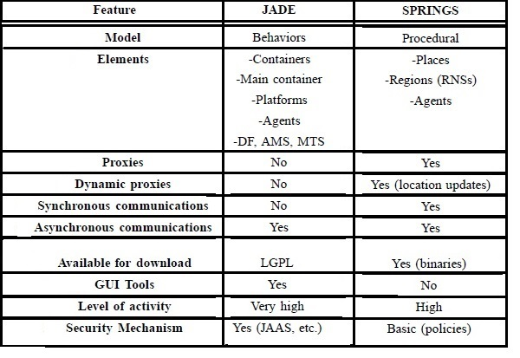

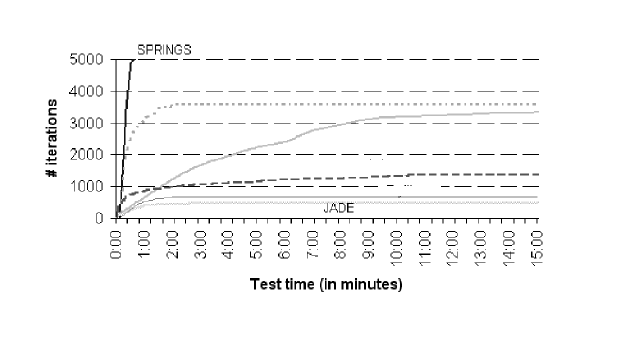

**Comparison of Mobile Agent Framework**

|  |  |  |  |  |
| --- | --- | --- | --- | --- |
| **Features** |  | **JADE** | | **SPRINGS** |
| **Communication** |  | **Very Good: FIPA standards are compatible with following agent communication guidelines. [6]** | | **The fact that SPRINGS does not allow agent communication using the standard FIPA may be its biggest drawback.[5]** |
| **Security** | **Authentication** | **Very good Prior to connecting any container, the mechanism must be verified.[4]** | | **Basic (policies)** |
| **Permission** | **Good: Each representative needs to be approved.** | | **It doesn't offer complex protection measures.** |
| **Message Encryption** | **possess services for communication encryption and signing**  **(FIPA)[1]** | | **possess services for communication encryption and signing[3]** |
| **Performance** | **In our initial test, 100 agents are used to assess the platforms' performance in the outlined scenario. Figure 1 depicts the evolution of each test over time, including the number of agents who have completed their 50 iterations and the total number of iterations done to date. We can see from this exercise that:** | | **JADE Tryllian (66 iterations, zero retailers completed, unable to strengthen on the grounds that time instantaneous 2:00) and Yuri (66 iterations, zero marketers completed) carried out the worst in this check (460 iterations, 9 retailers finished, unable to development due to the fact that time immediately 3:00). [5]** | **SPRINGS successfully completes the test in 40 seconds.[3]** |

**Conclusion**

JADE and SPRINGS were compared using a comparative study that was based on four different evaluation criteria. We utilised In the first section, there is a framework for evaluating the agent.

Performance, security, robustness, and communication were the four evaluation criteria that were chosen. The results revealed that JADE's communication is superior to SPRINGS' communication when the same scenarios were conducted on both toolkits.

JADE's security standards are superior to SPRINGS' They displayed their preference for SPRINGS over JADE in the mobility criteria.

The findings from phase three revealed that whereas SPRINGS has a straightforward GUI, JADE's GUI includes several options for managing and monitoring the agent.[10]

**References :**

**1. Ayan Rajput and Sandeep Rana “The Comparison of Mobile Agent Platforms Grasshopper and James Framework” / Elixir Comp. Engg. 167 (2022) 56276-56279**

**2. Raquel Trillo, Sergio Ilarri and Eduardo Mena Comparison and Performance Evaluation of Mobile Agent Platforms IEEE *Xplore*: 22 January 2008 Print ISBN:0-7695-2859-7.**

**3. Comparison and Performance Evaluation of Mobile Agent Platforms**

**4. C. Bomer, The Grasshopper Mobile Agent Platform Allowing Short-term Active Broadband Intelligent Network Implementation 1999.**

**5. Paulo Sim~oes1** , **Luis Moura Silva1 ,** , **james: A Platform of Mobile Agents for Telecommunication Network Management, August 1999.**

**6. Sharma, Bhawana et Arun Gangwar.Agents Mobiles : Object if, Plates-Forms et Architecture (IJEMR).**

**7. U. Kumaret S. Gambhir, A New Approach to Key Distribution Through Mobile Agent Fingerprint Authentication“, 2016 3rd International Conference on Computing for Sustainable Global Development New Delhi, S. 3441-3445, 2016.**

**8. Sharma, Bhawana, and Arun Gangwar. "Mobile agents: Objective, platforms and architecture (IJEMR) (2012).**

**9.** **G.Samaras "Mobile agents: Comparison and performance evaluation of mobile agent platforms,", January 2007.**

**10.** **Juan M. Corchado, and Jos'e M. Molina Platform comparison and performance evaluation for mobile agents**