**SMART WEARABLE SAFETY JACKET DESIGN FOR COAL MINERS**

**M.K.CHANDRASEKARAN1, R.AKSHAYA2, U.ASHWINI3, V.KAMALI4, G.S.MOHANA SAKTHI5**.

HEAD OF DEPARTMENT1, UG SCHOLAR2, UG SCHOLAR3, UG SCHOLAR4, UG SCHOLAR5.

DEPARTMENT OF COMPUTER SCIENCE & ENGINERRING, VIVEKANANDHA COLLEGE OF TECHNOLOGY FOR WOMEN, NAMAKKAL, TAMIL NADU, INDIA.

**ABSTRACT**

An IOT-based device called a "Smart Safety Jacket" is used to keep workers at mining and construction sites safe. Research on the mining and construction industries led to the statistical report that claims accidents always have a combination of hazards and causes. A gas explosion or dust explosion could lead to the collapse and flooding of subsurface workings. Similar to how a fire could discharge poisonous substances. Utilising explosives could result in an earthquake that collapses mine workings and traps miners underground. The majority of fatalities from explosives were caused by miners being too close to the blast, followed by misfires, premature blasts, and explosive fume poisoning. Seismicity caused by mines must be added to that list. Hazardous gases like carbon dioxide, carbon monoxide, methane, ethane, propene, etc., are present in the mining area and will harm the miners by causing disease. All of the aforementioned problems may be prevented if the right precautions are taken. The Smart Safety Jacket, an IOT device that is mounted on the safety jacket, is needed to solve this problem. This smart wearable safety jacket is connected with the different type of sensors like Temperature Sensor, Humidity Sensor, Ultrasonic sensor, Gas sensor and Notification Panel. These Wi-Fi-connected sensors make the network more relevant and valuable than ever. Real-time data from the mining environment can be seen and managed remotely from any location by translating sensor data into actions. The information is collected from the mining environment by the network-connected sensors, processed by controllers, and stored in a database for further use. The information can be monitored through an Blynk app and personal computers remotely.

The miner must put on the network-linked smart safety jacket (connected with the sensors) while working underground. The sensor status should be checked by a monitor in the control room who is always keeping an eye on the miners and the mining site, and the monitor should inform the miners in case of any urgent situations. Thus the mining environment and miners will be protected from the hazard Ensure where issues might occur at the mining site by trapping real-time data and allow adjustments to be made before anything can go wrong.

**I. INTRODUCTION**

In today’s era where safety and security is the top most priority in various critical processes similarly in coal industries the people assure the same thing. While studying the latest facts it has been reported about one incident by International Alliance in Support of Workers in Iran. This incident held inside Sanjdi coal mine near Quetta, Baluchistan in which 6 people died due to poisonous gases. The Industrial Global Union along with Pakistan Central Mines Labor Federation is very much conscious about this problem and yet this issue is unsolved with any optimum solution. The suggested system can never be implemented inside coal mine but if managed on a wireless sensor network and then implemented accordingly the thousands of lives which are wasted inside several local coal mines can be saved at right time. Moreover, the number of efficient sensors proposed in this paper make this solution one of its kinds.

The scientific community and businesses are interested in wearable devices with diverse sensor types for gathering characteristics relevant to several measurable areas. The constant monitoring of a user's health as it is influenced by behavioural, physiological, psychological, and most crucially, environmental characteristics has been demonstrated to be very effective with these technologies. In addition to typical wearable’s that can only measure parameters in one domain, hybrid biophysical and environmental aspects. The metallurgical, chemical, mining, and food industries are just a few of the numerous industrial sectors where hybrid solutions are having a significant impact on worker safety. Workers in these industries are regularly exposed to risky situations that might be damaging to their health. Notably, exposure to high temperatures, as well as exposure to harmful gas leakages connected to combustion operations or steel manufacturing additives, are frequent risks in the metallurgical business. Similar to the chemical sector, where chemical products are frequently employed to preserve or cure food items, there is always a danger of exposure to hazardous gases associated with chemical reactions in the food business. Additionally, gas exposure from drilling or excavation operations, falls, and injuries from collapses are also persistent risks for miners. Therefore, wearable devices can improve workplace safety, offer real-time monitoring of the worker's health during risky operations, and analyse the gathered data for quick response in an emergency. Conversely, wearable technology needs to meet a number of requirements in terms of usability, sensor setup, cost, and data accessibility. The scientific community and businesses are interested in wearable devices with diverse sensor types for gathering characteristics relevant to several measurable areas. These technologies have shown to be very useful for tracking a user's health over time as it changes in response to environmental, behavioural, physiological, psychological, and other factors. In addition to typical wearable’s that can only measure parameters in one domain, hybrid solutions for monitoring several parameters have evolved, such as devices that can assess both biophysical and environmental aspects.

**II. METHODOLOGY**

The variables in a coal mine are detected and tracked using an Arduino microcontroller. The temperature sensor, humidity sensor, IR flame sensor, and gas sensor all provide real-time measurements. They are all linked together by a transceiver and a microcontroller. The information is transmitted to the microcontroller, and Xbee WPAN IEEE 802.15.4 is used for communication between the gateway and the particular node. The XBee protocol is used to transmit the data to the control room, as was already described. An alert message is delivered to the system when something is out of the ordinary, and it is also displayed on an LCD screen connected to an Arduino at the entrance to the coalfield. Additionally, Arduino is used to programme and control a buzzer, which triggers in response to any abnormal reading detected by above sensors.

A microcontroller with just a push button connected to it is used to control a smart helmet. A ZigBee transceiver is also a part of the microcontroller. To ensure the greatest level of worker safety in the coalfield, this action has been done. An emergency notification describing the worker's condition is sent to the control centre whenever a worker presses a panic button, allowing for immediate medical treatment to be given.

**III. SYSTEM DESCRIPTION**

This block design of a prototype incorporates the sensors that would be required in a coalfield and is coupled to a microcontroller to detect environmental variables, as shown in Fig. 1. The LM35 temperature sensor, DHT11 humidity sensor, MQ2 gas sensor, and an IR flame sensor were all wired into the Arduino Uno microcontroller. We've programmed the Arduino board so that any abnormality in the parameters as mentioned above will result in an alert, and the buzzer will be activated. These sensors allow for the continuous measurement of air density, temperature, humidity, and gases present in the coalfield.

All of the readings will be shown on a 16x2 LCD panel that was added. This LCD will be installed at the coalfield's entrance so that workers can monitor the real-time conditions there and take appropriate action. The ZigBee Protocol has been used to establish dependable and safe communication with the control room. The XBee transmitter and receiver are used to transmit the environmental parameters of the coalfield, and they are connected with the aid of the XCTU software so that the appropriate actions can be taken promptly in emergency situations. Below is a block schematic, Fig. 2. A smart helmet with a push button, buzzer, and ZigBee transmitter is another safety device.

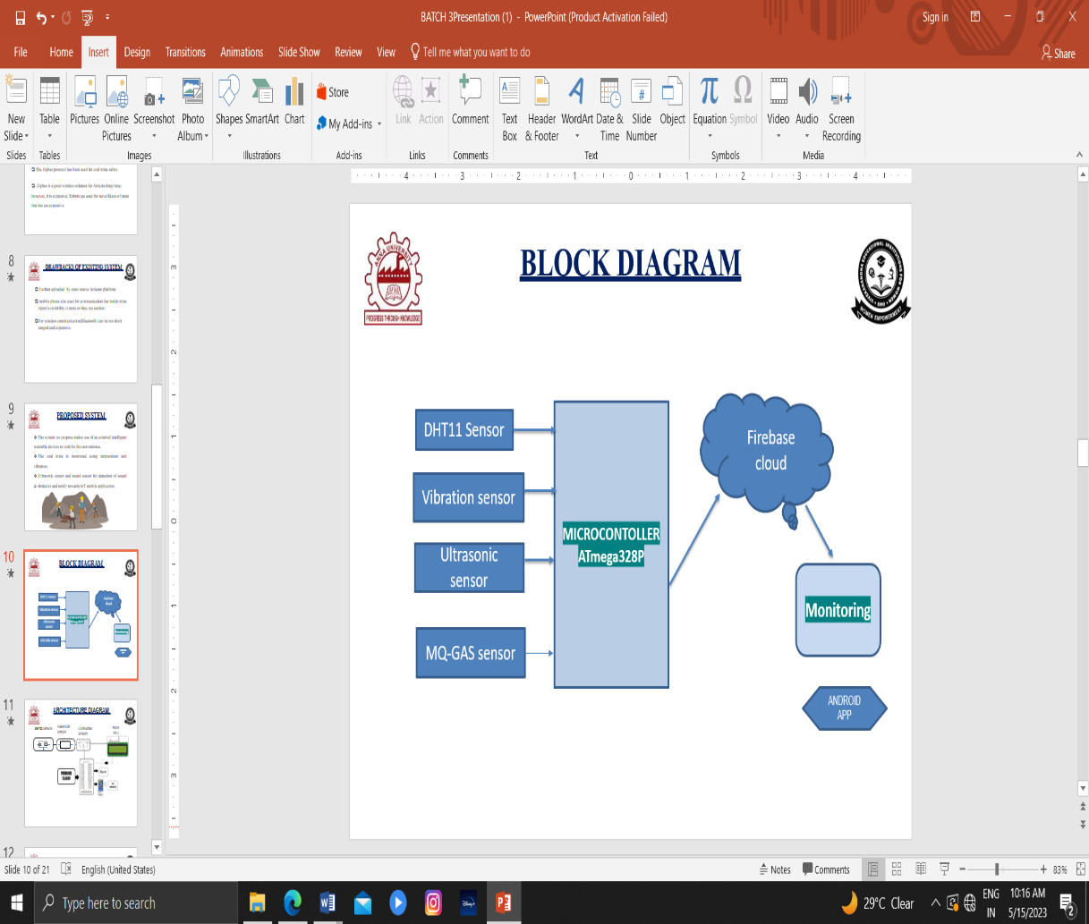Any employee who feels uneasy or needs medical treatment at any time can press the emergency button to activate the bell and send a ZigBee emergency message to the control centre.

**Fig 1: Block diagram of smart helmet**

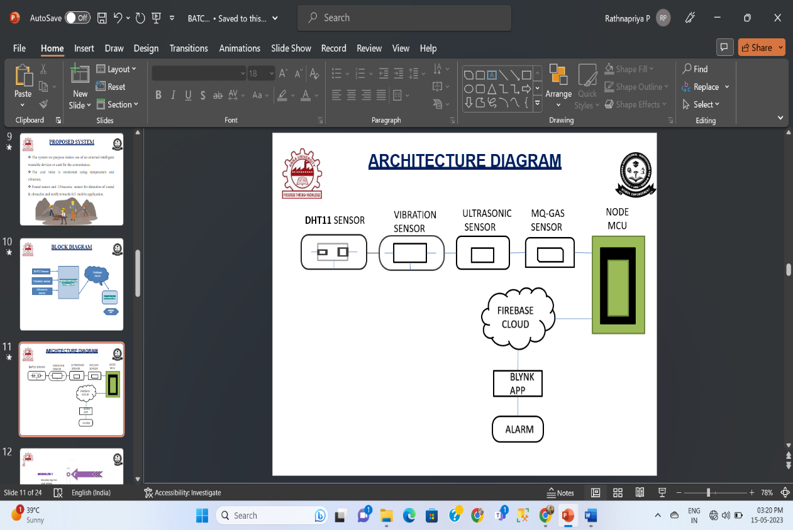Here we use 3 sensors namely DHT11 Sensor, Vibration sensor and Ultrasonic Sensor. All these 3 sensors are connected to a Microcontroller - ATmega328P. The information received to the microcontroller is sent to firebase cloud which is monitored, then the app receives the information. That information can be seen as notification from the mine who uses the app. DHT11 Sensor is used to measure the humidity and temperature inside the coal mine and alert the miners when the humidity range has crossed the limit. Vibration sensor is used to alert the miners when landslides are about to occur by sensing the vibrations of the underground. Inside the mine, an ultrasonic sensor uses ultrasonic sound waves to detect the distance to an item.

**Fig 2: Architecture diagram**

The microcontroller connects the DHT11 sensor, vibration sensor, and ultrasonic sensor. The Node MCU, which is used to transport the data to the fire-based cloud through Wi-Fi, alerts the miner when something is odd. Later, the information is relayed to the microcontroller, and an alarm is set off and a message of warning is delivered to the mine employees via the Blynk app.

**III. WORKING**

**3.1 TRANSFORMER**

The potential transformer will reduce the power source voltage level from 0 to 230 volts to 0 to 6 volts. The precision rectifier, which is built with the aid of an op-amp, will next be linked to the secondary of the potential transformer. Precision rectifiers have the benefit of producing peak voltage as DC while the remainder of the circuits only produce RMS.

**3.2 BRIDGE RECTIFIER**

The circuit is known as a bridge rectifier when four diodes are linked as in the figure. The network's diagonally opposed corners serve as the circuit's input, while the remaining two corners serve as the network's output. Assume that the transformer is in good working order and that points A and B have positive and negative potentials, respectively. With point A's positive potential, D3 will be skewed forward, while D4 will be skewed backward.

Point B's negative potential will cause D1 and D2 to move in the opposite direction. D3 and D1 are now forward biased, allowing current to flow through them; D4 and D2 are reverse biased, preventing current flow. The secondary of the transformer serves as the conduit for current flow, which travels from point B via D1, up through RL, through D3, and back to point B. The solid arrows point in this direction. Across D1 and D3, waveforms (1) and (2) may be seen.

**3.3 IC VOLTAGE REGULATORS**

Voltage regulators are among the frequently utilized ICs of the VA family. The electronics for the reference source, comparator amplifier, control device, and overload protection are all housed on a single integrated circuit (IC) in the regulator IC unit. A fixed positive voltage, a fixed negative voltage, or an adjustable set voltage can all be regulated by IC devices. The regulators can work with load currents between hundreds of milliamps and tens of amps, which translates to milliwatts and tens of watts in terms of power ratings.

The following units make up the power supply unit:

A. Step down transformer

B. Rectifier unit

C. Input filter

D. Regulator unit

E. Output filter

**IV. RESULT AND DISCUSSION**

The alert message from different sensors are sent to the miner through Blynk app and alarm sound is generated for different sensors by different beep sounds. The automations, DataStream, events and other information of the sensors can be viewed in the Blynk app. It also shows the readings of the different sensors.

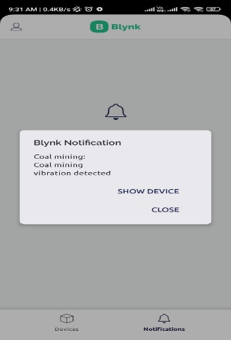

**Fig 3: Output of the Vibration Sensor in Blynk app**

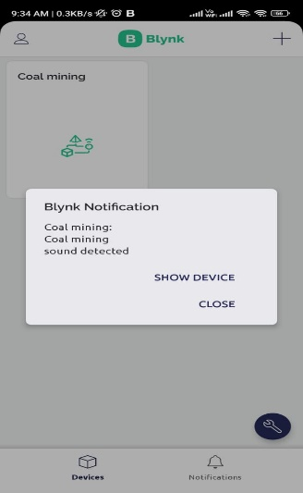

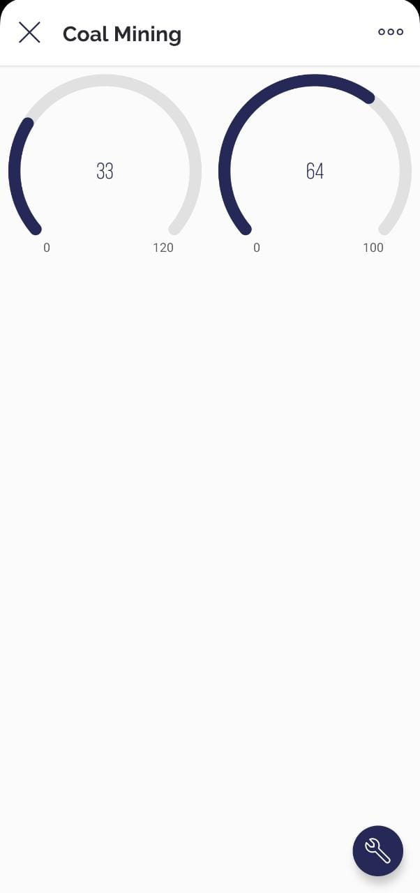**Fig 4: Output for Sound Sensor in Blynk app**

**Fig 5: Ranged output of Vibration and Sound**

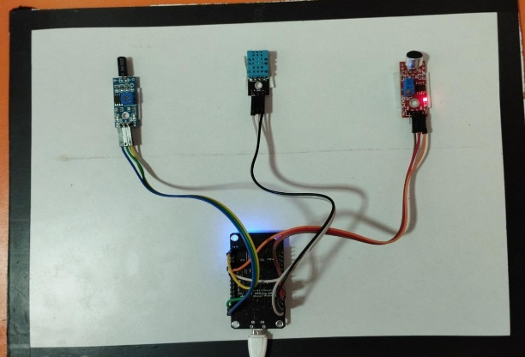

**Fig 6: Simulated output**

**V. CONCLUSION**

There are several elements, particularly in coal mines, that have an impact on worker health, including the presence of dangerous gases, mine depth, temperature, and oxygen levels. Many mishaps involving this work have already been documented. To recover the injured individual from the accident scene, rescue crews invest a lot of time and money. A system that not only provides precise position, depth, and GPS locator but also monitors the miner's pulse rate to offer prompt medical aid with the highest priority when necessary has been created to address this issue. As a result, the fully developed suggested embedded system for coal miners not only offers the necessary parameters to stay in touch with all miners & learn about their current health state, such as the availability of harmful gas, oxygen level, pulse rate, etc. Additionally, the recommended approach will make it simple to rescue them and dig where they may have a better chance of saving the most lives.

**VI. FUTURE SCOPE**

In further development, sensors may be added to the Arduino board to expand the smart wearable safety jacket. To verify the worker's condition, additional sensors can be used, such as a heart rate monitor or an alcohol sensor. The environment at the mining site may also be monitored by adding a methane gas, and carbon monoxide sensor. When a high concentration of hazardous gases is discovered, the pedestrian worker can be alerted to the risk. The employee might then adhere to the necessary procedures to guarantee safety.

**VII. REFERENCES**

1. Y. Shi, J. Chen, J. Hao, J. Bi, M. Qi and X. Wang, "Statistical Analysis of Coal Mine Accidents of China in 2018," 2019 Prognostics and System Health Management Conference (PHM-Qingdao), (2019).
2. Ericsson, M., Löf, O. Mining's contribution to national economies between 1996 and 2016.
3. Hong Chen, Hui Qi, Ruyin Long, Maolong Zhang, Research on 10-year tendency of China coal mine accidents and the characteristics of human factors, Safety Science, Volume 50, Issue 4, (2012).
4. Dennen, R S, and Stroud, W P. Radar hazard Detection in a coal structure. United States : N.p., (1991).
5. Hebblewhite, Bruce. (2009). Mine safety–through appropriate combination of technology and management practice. Procedia Earth and Planetary Science. 1.13-1910.1016/j.proeps.2009.09.005, (2009).
6. T. Liu et al., "Advances of optical fiber sensors for coal mine safety monitoring applications," 2013 International Conference on Microwave and Photonics (ICMAP), (2013).
7. Jiang Y, Li Z, Yang G, Zhang Y, Zhang X. Recent progress on smart mining in China: Unmanned electric locomotive. Advances in Mechanical Engineering. March 2017.R. K. Kodali, T. Devi B. and S. C. Rajanarayanan, "IOT Based Automatic LPG Gas Booking and Leakage Detection System," 2019 11th International Conference on Advanced Computing (ICoAC),(2019).
8. T. H. Nasution and L. A. Harahap, "Predict the Percentage Error of LM35 Temperature Sensor Readings using Simple Linear Regression Analysis," (2020) 4rd International Conference on Electrical, Telecommunication and Computer Engineering (ELTICOM),

(2020).

[9] M.Kalaiselvi and N.Nisha Sulthana "Automatic Monitoring Of Gas Leakage Detection And Gas Booking Alert System For Smart Home Using Iot ", International Journal of New Innovations in Engineering and Technology, ISSN: 2319-6319, Special Issue on ICET -2020.

[10] N.Nisha Sulthana and M.Kalaiselvi " An IOT based Tracking and reporting System for Stolen Laptop", International Journal of New Innovations in Engineering and Technology, ISSN: 2319-6319, Special Issue on ICET -2020.