**REAL TIME APPLICATION FOR VEHICLE ANTITHEFT & DROWSINESS DETECTION USING COMPUTER VISION & IOT**

**Vani.B1, Rakesh Gowda R H2, Srivatsa N Bhandari3, Sushmitha M J4, Monika N5**

1Assitant Professor, Dept of CSE, Sambhram Institute of Technology, Bangalore, Karnataka, India

2Student, Dept of CSE, Sambhram Institute of Technology, Bangalore, Karnataka, India

3Student, Dept of CSE, Sambhram Institute of Technology, Bangalore, Karnataka, India

4Student, Dept of CSE, Sambhram Institute of Technology, Bangalore, Karnataka, India

5Student, Dept of CSE, Sambhram Institute of Technology, Bangalore, Karnataka, India

**ABSTRACT**

Enhancement in vehicle technology system is getting increased research popularity and adding a vehicle theft security system in order to avoid getting vehicle theft in the parking and sometimes driving in unsecured places. The proposed system provided security and better theft control by using facial recognition, when the unauthorized person tries to start the ignition and will be notified by the application. The system uses Microprocessor raspberry pi along with a pie cam and WIFI controller installed in the vehicle the implemented system is very simple with greater security for vehicle anti-theft protection and low-cost technique compared to others.

**Keywords:** Security, raspberry pi, facial recognition, Haar Cascade, LBPH.

1. **INTRODUCTION**

The main idea of IoT is that not only the objects interact with each other but also with the people in order to improve the quality of life. IoT allows our surrounding physical objects to be interconnected and exchange information via wireless networks such as Radio Identification (RFID) and Wireless Sensor and Actuator Networks (WSAN). Security system is one of the main applications of IoT. The security system and anti-theft protection, automation aims to offer services like energy, security, healthiness monitoring, accessibility, and communication management. In our prototype, we use a Raspberry Pi module and Pi camera as a reader and face recognition as a medium of authentication. Once the user is validated, the car door opens automatically and our system monitors the driver to detect the drowsiness, if drowsiness detected system will make alarm and stop the engine automatically to prevent from the accidents via the Raspberry Pi microcontroller.

1. **METHODOLOGY**

Step 1: Pi camera board connected to the car door; the microcontroller will action the lock to unlock in case that is an authorized user based on the face recognition.

Step 2: We have the Pi camera, which reads the frames and sends the gathered information to Raspberry Pi board in order to verify the authentication of the user and act consequently.

Step 3: For authenticating user of the car, we are using LBPH face recognition algorithm.

Step 4: Pi camera continuously monitor the driver of car, if the driver feels drowsy, our microcontroller will stop the engine automatically and alarm will be on.

Step 5: To detect the drowsiness we are using the Haar Cascade & CNN features, based on the eye blinking it will detect drowsiness of the driver.

Step 6: Regarding the power supply, Raspberry Pi 4 can be powered via a C-Type cable connection, AC/DC adapter. Thus, we assume the power supply is not an issue for our implementation.

* 1. **HAAR Cascade Face Detection**

Haar Cascade is a machine learning object detection algorithm used to identify objects in an image or video. It is a machine learning based approach where a cascade function is trained from a lot of positive and negative images. It is then used to detect objects in other images.

The algorithm has four stages:

1. Haar Feature Selection
2. Creating Integral Images
3. Adaboost Training
4. Cascading Classifiers

It is well known for being able to detect faces and body parts in an image, but can be trained to identify almost any object. Let us take face detection as an example. Initially, the algorithm needs a lot of positive images of faces and negative images without faces to train the classifier. Then we need to extract features from it.

First step is to collect the Haar Features. A Haar Feature considers adjacent rectangular regions at a specific location in a detection window, sums up the pixel intensities in each region and calculates the difference between these sums.

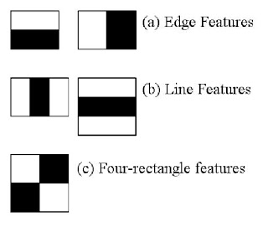

**Figure 1:** Haar Features

Integral images are used to make this super-fast. But among all these features we calculated, most of them are irrelevant. For example, consider the image below. Top row shows two good features. The first feature selected seems to focus on the property that the region of the eyes is often darker than the region of the nose and cheeks. The second feature selected relies on the property that the eyes are darker than the bridge of the nose. But the same window applying on cheeks or any other place is irrelevant.

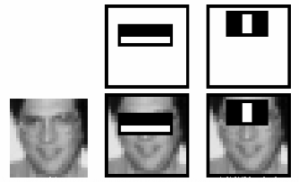

**Figure 2:** Haar feature implementation

So, selecting the best features out of 160000+ features is accomplished using a concept called adaboost which both selects the best features and trains the classifiers to use them. This algorithm constructs a “strong” classifier as a linear combination of weighted simple “weak” classifiers. The process is as follows:

During the detection phase, window of the target size is moved over the input image, and for each subsection of the image and Haar features are calculated. The difference is then compared to learn threshold that separates non-objects from objects. Since each Haar feature is only a “weak classifier” (its detection quality is slightly better than random guessing) a large number of Haar Features are necessary to describe an object with sufficient accuracy and are therefore organized into *cascade classifiers* to form a strong classifier.

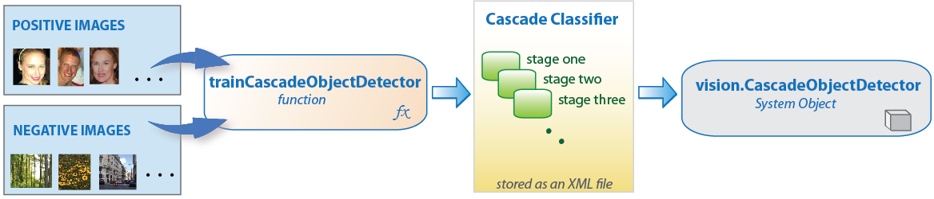

**Figure 3:** Cascade classifier

* 1. **CNN Classification**

CNN model at present, the typical architecture of neural network is divided into the following categories: LeNet5, AlexNet, ZF NET, GooLeNet, and VGGNet, the following system will contain LeNet5 architecture for a detailed analysis. LeNet5 is a CNN classic structure that existed long ago, and it is mainly used in the recognition of handwritten fonts. It contains a total of seven layers of structure, except for the input layer, each of the other has training parameters, and each layer contains a plurality of Feature Maps, we can extract the input features through a convolution kernel. Each feature contains multiple neurons. The picture below shows the architecture of LeNet5:

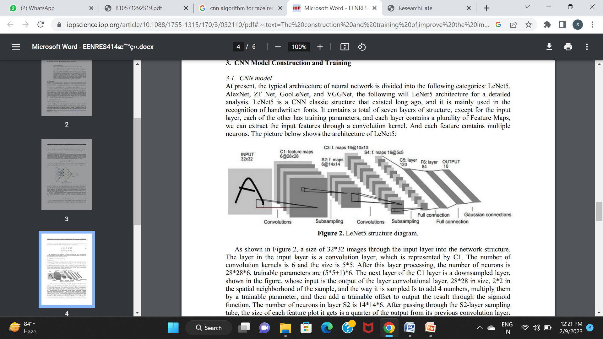

**Figure 4:** CNN Architecture

As shown in Figure, a size of 32*32 images through the input layer into the network structure. The layer in the input layer is a convolution layer, which is represented by C1. The number of convolution kernels is 6 and the size is 5*5. After this layer processing, the number of neurons is 28*28*6, trainable parameters are (5*5+1) *6. The next layer of the C1 layer is a down sampled layer, shown in the figure, whose input is the output of the layer convolutional layer, 28*28 in size, 2*2 in the spatial neighborhood of the sample, and the way it is sampled is to add 4 numbers, multiply them by a trainable parameter, and then add a trainable offset to output the result through the sigmoid function. The number of neurons in layer S2 is 14*14*6. After passing through the S2-layer sampling tube, the size of each feature plot it gets is a quarter of the output from its previous convolution layer. The layer after S2 is still a convolutional layer, with a total of 16 convolutional kernels, and the size of each convolution kernel is the same as that of C1. This layer is called the C3 layer in the above figure. The size of the output feature layer in this layer is 10*10. The 6 features in the S2 layer are connected with all the features in the C3 layer. The feature obtained in this layer of the figure is different combination of the output features of the previous layer. The S4 layer is the same as the S2 layer, and its sampling type is 16. So far, the network structure has reduced the number of neurons to 400. The next layer of C5 is still a convolutional layer, which is fully connected with the previous layer, the size of its convolution kernel is still 5*5, this time C5 layer image processing, the image size becomes 5-5+1=1, which means that only one neuron is 120. The last layer of F6, this layer is a fully connected layer, by calculating the input vector and the weight vector between the dot product, plus a bias, and finally through the sigmoid function to deal with the results.

1. **MODELING AND ANALYSIS**

Design of the project is the primary solution for any problem in the context. The design of the system plays a crucial role in affecting the quality of the software.

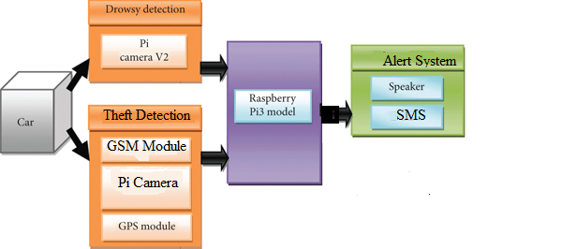

**Figure 5:** System architecture

In the system architecture, system will capture the face of driver and detects the eye and calculate the blink rates and if the driver is sleeping, then it will sound the alarm.

Here all the components are connected to raspberry pi centrally for all the processing. GSM module and GPS modules are used to send alert notifications and detect the location respectively; as well as two Pi cameras are used to detect face for unauthorized and authorized face of the person entering the vehicle and to check for drowsiness of the driver while driving respectively.

Figure.3 shows the work flow and sequence of the system proposed:

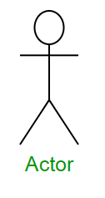

Theft Detection

Drowsiness Detection

System

1. Initialize System

2. Capture face image

3. Face Recognition

4. If Face Matched

5. Open Car Door

6. Detect Drowsiness

7. If Drowsy

8. Buzzer On

5. Buzzer ON & Send SMS

8. Read next frame

**Figure 6:** Sequence diagram

This project is implemented using the following modules:

* **Dataset collection:** The dataset used for this model is created by us. To create the dataset, we wrote a script that captures eyes from a camera and stores in our local disk. We separated them into their respective labels ‘Open’ or ‘Closed’. The data was manually cleaned by removing the unwanted images which were not necessary for building the model. The data comprises around 7000 images of people’s eyes under different lighting conditions. After training the model on our dataset, we have attached the final weights and model architecture file “models/cnnCat2.h5”.
* **CNN Architecture:** The model we used is built with Keras using**Convolutional Neural Networks (CNN)**. A convolutional neural network is a special type of deep neural network which performs extremely well for image classification purposes. A CNN basically consists of an input layer, an output layer and a hidden layer which can have multiple numbers of layers.
* **Detect Face in the image:** To detect the face in the image, we need to first convert the image into grayscale as the OpenCV algorithm for object detection takes gray images as the input. We do not need colour information to detect the objects. We will be using Haar cascade classifier to detect faces.

1. **RESULTS AND DISCUSSION**

**Face detection**: The below figure clearly shows a trained face being matched with proper given name and ID for an authorized/ registered person trying to unlock the vehicle. Hence, the antitheft detection is working in place properly detecting and matching the face of the authorized person.

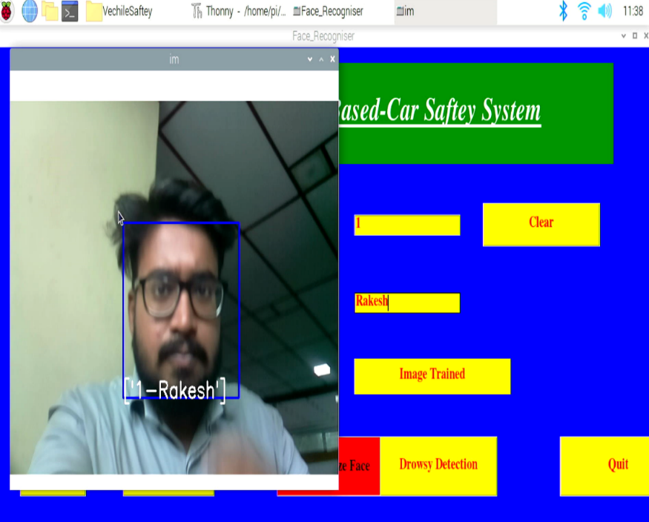

**Figure 7:** Face detecting

When the face doesn’t match and some unauthorized person is trying to get into the vehicle forcibly, an alert SMS is sent to the registered owner of the vehicle notifying him/her that “someone is trying to open your car door”.

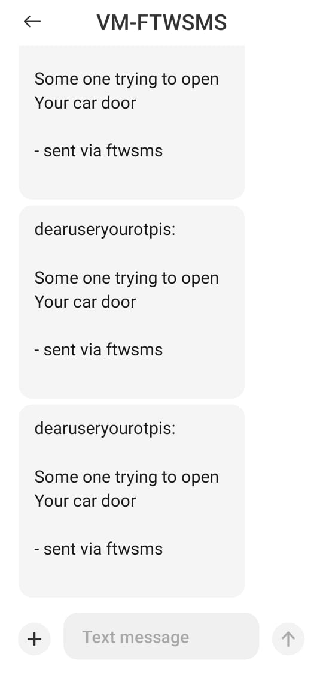

**Figure 8:** SMS Alert

**Drowsiness detection**: In the presented below figure it is clearly noticeable that the system is able to detect eyes and facial expressions of a person. If the person is feeling sleepy and his eyes are closed for over 5 seconds then there appears a signal “closed” as shown on screen.

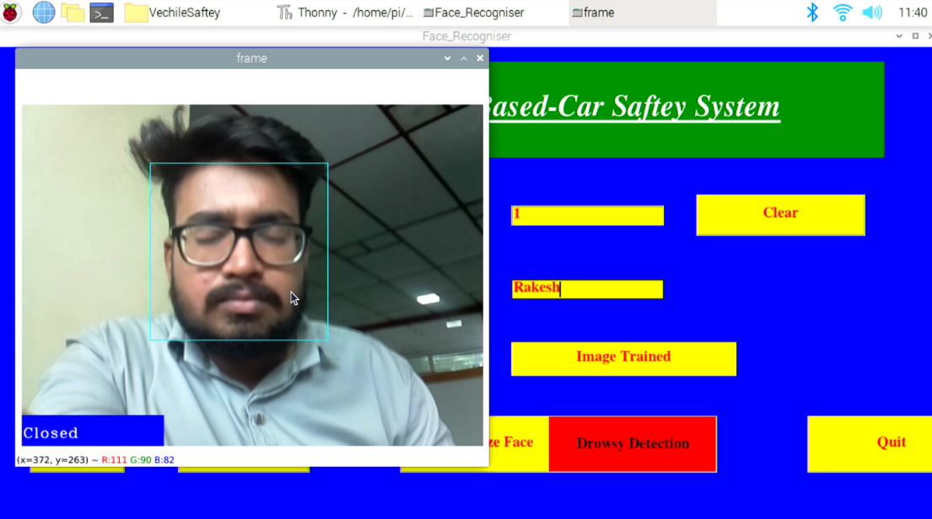

**Figure 8:** Drowsiness detection

1. **CONCLUSION**

A novel algorithm for the driver’s state of alertness monitoring through the identification of the fight against falling asleep has been proposed based on the analysis of changes of faces. Moreover, it has also been proposed as a method to provide a confidence quality level of the face. In addition, the obtained quality signal level has been combined with the drowsiness detection algorithm in order to improve the classification results by means of reducing the number of false positives due to changes of measured eye blink rate associated not to drowsiness but body movements or talking.

For future enhancements, the two approaches will be tested under other challenging datasets to demonstrate their efficiency against a variety of driving conditions. Furthermore, the ability to combine the two proposed approaches to improve results is being investigated. On the other hand, significant efforts are being performed to deal with video streams processing in order to integrate this detection system with IoT systems via cloud computing. In addition, we will prepare a prototype for the proposed algorithm.

1. **REFERENCES**

[1] Q. Abbas and A. Alsheddy, ‘‘Driver fatigue detection systems using multisensors, smartphone, and cloud-based computing platforms: A comparative analysis,’’ Sensors, Intell. Sens. Syst. Vehicle, vol. 21, no. 1, p. 56, Dec. 2020, doi: 10.3390/s21010056.

[2] M. Ramzan, H. U. Khan, S. M. Awan, A. Ismail, M. Ilyas, and A. Mahmood, ‘‘A survey on state-of-the-art drowsiness detection techniques,’’ IEEE Access, vol. 7, pp. 61904–61919, 2019, doi: 10.1109/ ACCESS.2019.2914373.

1. A. Rafid, A. R. Niloy, A. I. Chowdhury, and N. Sharmin, ‘‘A brief review on different driver’s drowsiness detection techniques,’’ Int. J. Image, Graph. Signal Process., vol. 10, no. 3, pp. 41–50, 2020, doi: 10.5815/ijigsp.2020.03.05.
2. P. Choudhary, R. Sharma, G. Singh, and S. Das, ‘‘A survey paper on drowsiness detection & alarm system for drivers,’’ Int. Res. J. Eng. Technol., vol. 3, no. 12, pp. 1433–1437, 2016.
3. M. Q. Khan and S. Lee, ‘‘A comprehensive survey of driving monitoring and assistance systems,’’ Sensors, vol. 19, no. 11, p. 2574, Jun. 2019, doi: 10.3390/s19112574.
4. L. Chen, X. Zhi, H. Wang, G. Wang, Z. Zhou, A. Yazdani, and X. Zheng, ‘‘Driver fatigue detection via differential evolution extreme learning machine technique,’’ Electronics, vol. 9, no. 11, p. 1850, 2020, doi: 10.3390/electronics9111850.
5. V. E. M. Arceda, J. P. C. Nina, and K. M. F. Fabian, ‘‘A survey on drowsiness detection techniques,’’ in Proc. CEUR Workshop, vol. 2724, Nov. 2020, pp. 152–161.
6. L. M. Bergasa, J. Nuevo, M. A. Sotelo, R. Barea, and M. E. Lopez, ‘‘Real-time system for monitoring driver vigilance,’’ IEEE Trans. Intell. Transp. Syst., vol. 7, no. 1, pp. 63–77, Mar. 2006.
7. M. J. Flores, J. M. Armingol, and A. de la Escalera, ‘‘Real-time warning system for driver drowsiness detection using visual information,’’ J. Intell. Robot. Syst., vol. 59, no. 2, pp. 103–125, Aug. 2010, doi: 10.1007/s10846- 009-9391-1.
8. S. Abtahi, B. Hariri, and S. Shirmohammadi, ‘‘Driver drowsiness monitoring based on yawning detection,’’ in Proc. IEEE Int. Instrum. Meas. Technol. Conf., May 2011, pp. 1–4, doi: 10.1109/IMTC.2011. 5944101.
9. Amritha Nag, Nikhilendrao J N, Mrutyunjay Kalmath, “IOT Based Door Access Control Using Face Recognition”,2018 3rd International Conference for Convergence in Technology (I2CT), pp 1-3
10. M. Poushya, k. Rupasari, N. Supritha, K. Hema and R. Tejaswini, “IOT Based Vehicle Theft Detection”,2018 IRE Journals, Electronics and Communication Engineering (ECE), Vasireddy Venkatadari Institute of Technology, pp 52-55.
11. Prof.K.T. Jadhao and Prashanth Balraj Balla “IOT Based Facial Recognition Security system”,2018 Alamuri Ratnamala Institute of Engineering and Technology (ARIET) pp 1-4.
12. Prabal Deep Das, Sharmila Sengupta, “Proposing the systems to provide protection of vehicles against theft and accident”,2016 IEEE Conference On Recent Trends In Electronics Information Communication Technology”, pp 1681-1685.
13. S. Padmapriya & Esther Annlin KalaJames, “Real Time Smart Security System Using Face Detection and Recognition”,2012 International Conference on Computer Communication and Informatics (ICCI-2012) , pp 1-6.
14. Website about the raspberry pi power supply [online] Available: <https://magpi.raspberrypi.org/articles/power-supply>
15. website about the Raspberry-Pi 3 B+ and related topics. [Online]. Available: <https://www.raspberrypi.org/products/raspberry-pi-3-model-b-plus/>
16. website about Pi Camera [online] Available : <https://wiki.eprolabs.com/index.php?title=Raspberry_Pi_Camera_Module>
17. website about door locking system[online] Available: [https://www.scienceabc.com/innovation/abs-sensors-anti-lockbreaking- system-technology-cars-work.html](https://www.scienceabc.com/innovation/abs-sensors-anti-lockbreaking-%20system-technology-cars-work.html)
18. MEMS Sensor [online] Available: <https://images.app.goo.gl/wSbV2Xbz8k5GrgKN7>
19. buzzer [online] Available: <https://en.wikipedia.org/wiki/Buzzer>
20. DC motor [online] Available: https://en.wikipedia.org/wiki/DC_motor-cars-work.html