**TRUSTABLE E-COUPON SERVICE USING PUBLIC BLOCKCHAIN**

**ANGELO SIEON V *, Lalith Kishore V *, GOKUL S *, RAJAESH KANNA R\***

*Computer Science and Engineering, Agni College of Technology

**Assistant Professor,ComputerScience, and Engineering Department,

Agni College of Technology

**ABSTRACT:**

The rising popularity of e-commerce has led to the widespread adoption of electronic coupons (e-coupons) due to their convenience and portability. However, traditional e-coupon services that rely on centralized servers often face security concerns. Centralization can result in issues like counterfeit e-coupons, difficulties in proving ownership, and the possibility of double-spending on expired e-coupons. In order to address these challenges, we have developed an innovative e-coupon service that harnesses the power of blockchain technology to enhance security.Our approach involves the creation of a dedicated server that facilitates the e-coupon service and interacts seamlessly with the blockchain system. To ensure the integrity of the e-coupon business logic and implementation information, we have developed a smart contract on an Ethereum-based blockchain system. By leveraging this blockchain infrastructure, we can establish a trustable and transparent environment for e-coupon transactions.Through rigorous experimentation and analysis , we have demonstrated that our proposed service significantly bolsters security while incurring only minimal performance impact when compared to existing e-coupon services. By integrating blockchain technology, we provide a robust solution that effectively addresses the concerns surrounding e-coupon security, paving the way for a more reliable and trustworthy e-commerce experience.

**Keywords**: E-coupon, Enhanced security,

E-coupon service, Server, Smart contract,

Integrity.

**INTRODUCTION:**

The traditional couponing process has several limitations, including fraud, counterfeiting, and lack of transparency. Coupons can be easily replicated or forged, leading to financial losses for businesses and dissatisfaction among consumers. Additionally, the centralized nature of couponing systems often results in a lack of transparency, making it difficult to verify the validity and authenticity of coupons.In contrast, a blockchain-based e-coupon service addresses these challenges by providing a decentralized and tamper-proof system. Blockchain, as a distributed ledger, allows for secure and transparent recording of coupon transactions, making it virtually impossible to alter or manipulate coupon data once it is recorded. Each coupon transaction is stored in a block, which is linked to previous blocks through cryptographic hashes, creating an immutable chain of information. This ensures the integrity and transparency of coupon transactions throughout the entire process.Furthermore, because blockchain is decentralised, there is no need for a single authority to regulate and operate the e-coupon service. Instead, consensus mechanisms, such as proof-of-work or proof-of-stake, enable network participants to validate and verify coupon transactions, ensuring the system's reliability and security. This peer-to-peer network topology also eliminates the possibility of a single point of failure and improves the e-coupon service's resilience.

**BLOCKCHAIN**

Blockchain technology possesses a core feature of decentralization, which sets it apart from conventional systems. Instead of depending on a central authority or intermediary to validate and authorize transactions, blockchain employs a consensus mechanism like proof-of-work or proof-of-stake, enabling network participants to collectively agree on transaction validity. This decentralized consensus ensures the security and resilience of the blockchain network by eliminating a single point of failure or control.The implementation of blockchain technology offers several advantages. Transparency is a significant benefit as the complete transaction history is accessible to all network participants. This transparency fosters trust and accountability among users as they can independently verify and validate transactions. Additionally, security is achieved through cryptographic techniques that verify and protect transactions, making it highly challenging for malicious actors to tamper with the stored information in the blockchain. Efficiency is another notable advantage provided by blockchain technology. By automating and streamlining processes, blockchain reduces the need for intermediaries in various transactions, leading to reduced costs and delays. Removing intermediaries simplifies and accelerates the exchange of assets or information, resulting in improved efficiency and user experiences.In conclusion, the decentralized nature, transparency, security measures, and efficiency of blockchain technology contribute to its widespread adoption across diverse industries. By leveraging these characteristics, blockchain serves as a robust foundation for transforming traditional systems and enabling innovative solutions.

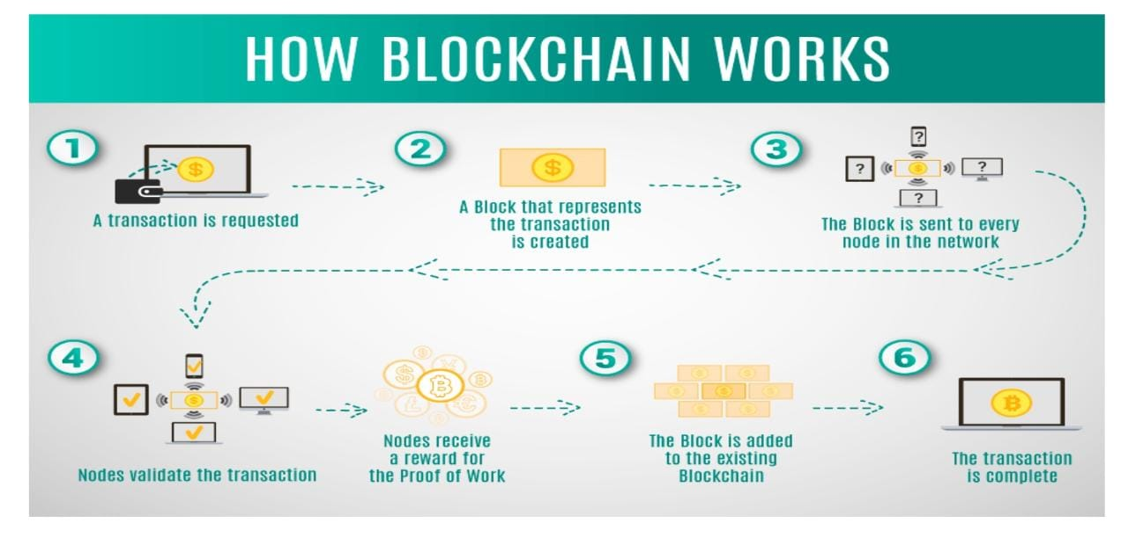

**Fig .1: WORKING OF BLOCKCHAIN**

**DESIGN AND IMPLEMENTATION**

Our innovative e-coupon service capitalizes on blockchain technology and smart contracts, presenting a secure and dependable solution that brings about a paradigm shift in traditional e-coupon services. By integrating blockchain into our system, we establish a foundation that elevates the security and usability of e-coupons. Blockchain technology guarantees the integrity of e-coupon business logic by ensuring transparent and tamper-proof rules and conditions. Through the utilization of smart contracts, we automate the execution of these business rules, eliminating the need for manual verification and reducing the potential for human errors. Additionally, our system safeguards the accuracy of e-coupon data. By leveraging the immutable nature of blockchain, we create an auditable and transparent transaction history that provides a dependable record of e-coupon ownership and usage. This fosters trust among users while mitigating the risks associated with counterfeit e-coupons and the misuse of expired ones.To summarize, our e-coupon service harnesses the power of blockchain technology and smart contracts to ensure the integrity of e-coupon business logic and safeguard the accuracy of associated data. By implementing these innovations, we deliver a secure and efficient platform for e-coupon transactions, revolutionizing traditional e-coupon services and offering users enhanced security and usability.

**NODE PACKAGE MANAGER**

NPM, also known as Node Package Manager, revolutionizes package management in Node.js projects by providing a streamlined approach. It offers a multitude of advantages, including a vast package library, version control features, a user-friendly command-line interface, a configuration file for project settings, the ability to define custom scripts, and options for extensibility. By incorporating NPM into the development workflow, it greatly enhances productivity and fosters collaboration among developers. One of the primary benefits of NPM is its extensive package library. With a wide range of pre-built packages available, developers can easily integrate third-party code into their projects, saving valuable time and effort. This rich ecosystem enables developers to leverage existing solutions and focus on creating unique functionalities without starting from scratch. Version control is another crucial aspect facilitated by NPM. It empowers developers to specify specific package versions or version ranges in their projects, ensuring consistency and reproducibility. This seamless integration of version control enables effective collaboration and eliminates compatibility issues, particularly in projects involving multiple contributors. NPM's command-line interface (CLI) simplifies package management tasks by providing intuitive commands for package installation, update, and removal. The CLI also offers functionalities for project initialization, running tests, and executing custom scripts defined in the package. json file. This user-friendly command-line interface streamlines development workflows and makes package management straightforward and efficient. The package .json file serves as a configuration file for NPM projects, allowing developers to define project details, dependencies, scripts, and other settings. This centralized file establishes a standardized structure and simplifies the management of project-specific configurations. Additionally, NPM supports custom scripts, enabling developers to define and execute project-specific tasks effortlessly. This flexibility facilitates the automation of various development tasks, resulting in increased productivity and reduced repetitive manual work. Lastly, NPM provides options for extensibility, empowering developers to customize and extend its functionalities. Through the utilization of plugins and modules, developers can tailor NPM to their specific requirements, incorporating additional features and enhancing their development workflows. In conclusion, NPM simplifies package management in Node.js projects by offering a comprehensive package library, version control capabilities, a user-friendly command-line interface, a configuration file, custom scripts, and options for extensibility. By leveraging these features, developers can enhance productivity, collaborate effectively, and seamlessly manage project dependencies, leading to more efficient and streamlined development processes.

**TRUFFLE FRAMEWORK**

The Truffle Framework simplifies the development of decentralized applications (dApps) on the Ethereum blockchain by providing a robust set of tools and functionalities. It supports developers in every stage of the development process, from writing and compiling smart contracts to testing and deploying them. By offering an efficient and standardized development environment, Truffle enables developers to focus on creating innovative dApps without getting bogged down by the complexities of blockchain development.

**GANACHE**

Ganache is a widely adopted tool among Ethereum developers, providing a controlled and efficient local blockchain environment for the development and testing of smart contracts. Its intuitive user interface, customizable features, and smooth integration with the Truffle Suite make it an essential component of the Ethereum development ecosystem. Developers heavily rely on Ganache to establish a simulated blockchain network, allowing them to securely and confidently test and experiment with their smart contracts. By offering this secure and controlled environment, Ganache enables developers to streamline their development workflows, ensuring efficiency and reliability throughout the process.

**Build Interacting with Smart Contract**

Interacting with smart contracts entails deploying them on a blockchain network using tools like the Truffle Framework or Remix IDE. To simplify access to the contract's functions and data, a contract abstraction acts as a bridge. Libraries such as Web3.js or Ether.js provide APIs for seamless communication with the Ethereum blockchain. Connecting to the desired blockchain network requires a provider like Ganache or a test net. Once connected, creating a contract instance using the contract abstraction and library enables smooth interaction with the deployed smart contract. Transactions can be sent to modify the contract state, while constant functions can be called to retrieve data. When engaging with smart contracts, several important considerations come into play. Handling transaction parameters, such as gas limits and prices, is crucial for successful execution. Subscribing to contract events allows real-time updates and notifications. Additionally, implementing error handling and input validation ensures the integrity and security of the smart contract interaction process. In summary, interacting with smart contracts involves deploying them, utilizing contract abstractions and libraries, connecting to the blockchain network, creating contract instances, sending transactions, retrieving data, and considering factors like transaction parameters, event handling, error management, and input validation. These considerations guarantee effective and reliable interaction with smart contracts on the Ethereum blockchain.

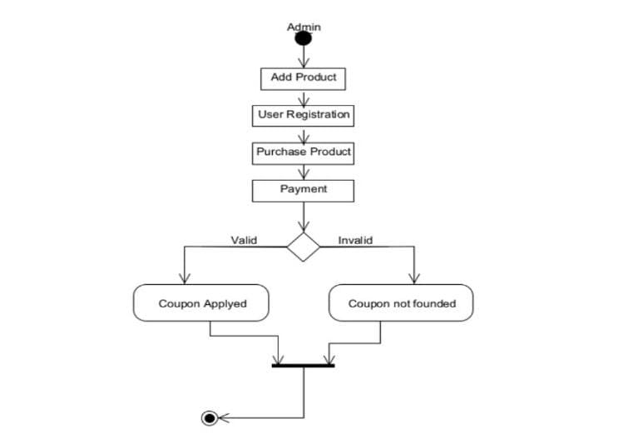

**Fig. 2: FLOW DIAGRAM**

**RELATED WORK**

**[1] Author name:**

C. Blundo, S. Cimato & A. De Bonis

**Description:**

The increasing popularity of electronic coupons (e-coupons) as a form of advertising is due to the ease and speed of internet usage. It emphasizes that the potential of digital coupons has not been fully utilized on the web, mainly due to the lack of efficient techniques for generating and distributing e-coupons. The abstract discusses the need for models and protocols that ensure the security of e-coupons. Additionally, it mentions the presence of a lightweight implementation of a protocol that prioritizes user privacy by eliminating the need for a registration phase. Overall, the abstract sets the stage for a paper that explores secure e-coupon models and protocols while introducing a privacy-preserving implementation.

**[2] Author name:**

JONGBEEN HAN, YONGSEOK SON AND HYEONSANG EOM

**Description**:

The vulnerabilities inherent in centralized e-coupon services, such as forgery and double-spending, are effectively addressed in a proposed solution that harnesses the power of blockchain technology. The solution introduces a new e-coupon service that incorporates a server responsible for facilitating the service and interacting with the blockchain system. Additionally, a smart contract is implemented on the blockchain to ensure the integrity of the e-coupon business logic and information. The implementation specifically utilizes an Ethereum-based blockchain system. Through extensive experimentation, the results showcase a significant improvement in security without imposing a substantial performance burden when compared to existing e-coupon services. Ultimately, the paper presents a compelling solution that utilizes blockchain technology to enhance the security of e-coupon services.

**[3] Author name:**

Alessandro Sebastian Podda and Livio Pompianu

**Description:**

The paper focuses on exploring the application of blockchain technology as an immutable register for tracking and certifying digital coupons. The authors conduct a comprehensive analysis and comparison of different blockchain-based couponing systems. They begin by presenting a general schema for digital coupons and defining the desirable properties that an effective couponing system should possess. A sample of these systems is then selected for further examination, including their design choices, properties, and smart contract code. Through their study, the authors provide valuable insights into the unique features and implementation solutions employed by the analyzed systems. These findings contribute to a better understanding and further exploration of blockchain-based couponing systems. The paper emphasizes the potential of such systems in improving traceability, preventing counterfeiting, and enabling novel usage scenarios for digital coupons. By harnessing the power of blockchain technology, these systems offer enhanced security and transparency, opening up new possibilities and opportunities within the couponing industry.

**[4] Author name:**

Jianjia He and Ni Zhang

**Description:**

The paper presents the development of a resource matching platform for an industry interconnection supply and demand network, utilizing the Alliance blockchain. The platform's main goal is to enhance collaboration efficiency and enable the efficient allocation of resources during the trading process. The paper provides an overview of the steps involved in resource trading on the platform, emphasizing the use of smart contract technology to simplify transactions. The implementation includes the design and implementation of triggering mechanisms and algorithm rules for smart contracts using Remix IDE. The platform is subjected to testing, which demonstrates successful transaction processes between the supply and demand sides. By leveraging blockchain technology, the platform ensures the security and transparency of information while establishing a trust mechanism. This leads to a reduction in redundant steps and improved operational efficiency within the industry interconnection supply and demand network, as resource allocation efficiency is enhanced. In summary, the paper showcases the development of a resource matching platform for an industry interconnection supply and demand network, based on the Alliance blockchain. Through the utilization of smart contract technology and blockchain features, the platform simplifies resource trading, enhances security and transparency, and improves operational efficiency within the industry interconnection supply and demand network.

**[5] Author name:**

Dino Arnaut, PhD2,Damir Bećirović, PhD3

**Description:**

The paper examines the financing challenges that small and medium-sized enterprises (SMEs) encounter in developing countries, specifically in terms of traditional bank financing. It highlights the emergence of junior markets as dedicated segments on stock exchanges, offering an alternative funding option for SMEs. However, the issue of liquidity remains a significant concern for these markets. To address this challenge, the paper suggests integrating blockchain technology into junior stock exchanges to enhance their functionality. By leveraging blockchain, the registration of stocks and shares of SMEs can be decentralized and secured, providing a transparent and efficient solution. The use of blockchain simplifies equity transactions and enables direct peer-to-peer interactions between SMEs, entrepreneurs, and investors. The proposed model aims to improve access to finance for SMEs, recognizing their crucial role in job creation and economic development. By employing blockchain-based junior stock exchanges, the paper proposes that both developing and developed countries can foster the growth and development of SMEs, thereby contributing to overall economic progress. In summary, the paper explores the financing challenges faced by SMEs and proposes the integration of blockchain technology in junior stock exchanges to address liquidity concerns. Through blockchain, the proposed model aims to streamline equity transactions and facilitate peer-to-peer interactions, ultimately supporting the growth and development of SMEs in both developing and developed countries.

**BLOCK DIAGRAM**

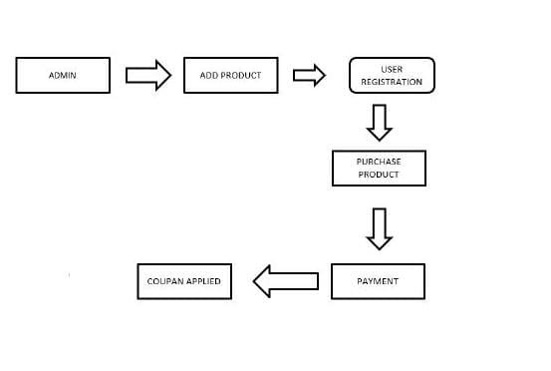

**PROPOSED SYSTEM**

The proposed system for a secure e-coupon service based on blockchain involves developing a decentralized architecture using an Ethereum-based blockchain. A smart contract will be created for e-coupon management, ensuring transparency and integrity. Digital signatures or multi-factor authentication will be integrated for user verification. The blockchain's distributed ledger will securely store e-coupon information, while consensus algorithms and transaction validation will prevent double-spending. A user-friendly interface will be designed for browsing, selection, and redemption. Extensive testing and optimization will be performed for optimal performance and user experience.

**FUTURE SCOPE**

* Decentralized Coupon Management: Implement a decentralized system where e-coupons are managed on a blockchain, ensuring transparency, immutability, and secure storage of coupondata.
* User-Friendly Interface: Design an intuitive and user-friendly interface for users to easily browse, select, and redeem e-coupons, enhancing the overall user experience.
* Enhanced Security: Leverage the inherent security features of blockchain technology, such as encryption and decentralization, to provide increased security and protection against forged e-coupons and unauthorized access.
* Compatibility and Integration: Ensure compatibility with existing e-commerce platforms and systems, enabling seamless integration with various merchants and coupon providers.
* Blockchain Interactions: Develop a server that acts as an interface between the e-coupon service and the blockchain, enabling seamless interactions for coupon issuance, distribution, and redemption.

**RESULT**

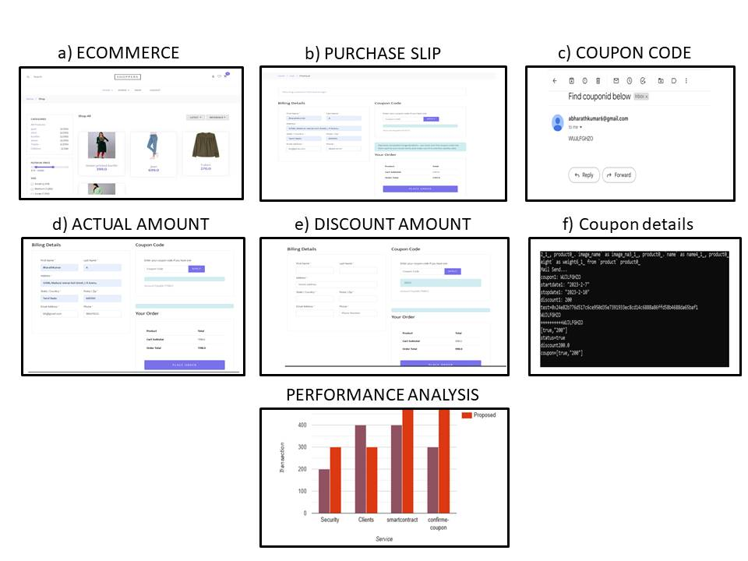

**REFERENCES**

[1] C. Blundo, S. Cimato, and A. De Bonis, ‘‘Secure E-coupons,’’ Electron.Commerce Res., vol. 5, no. 1, pp. 117–139, Jan. 2005.

[2] JONGBEEN HAN, YONGSEOK SON, AND HYEONSANG EOM.1Department of Computer Science and Engineering, Seoul National University, Seoul 08826, Republic of Korea,2School of Computer Science and Engineering, Chung-Ang University, Seoul 06974, Republic of Korea.

[3] Alessandro Sebastian Podda and Livio Pompianu,University of Cagliari,Via Ospedale 72, Cagliari (Italy).

[4] Design of a Blockchain-Based Service Platform for Industrial, Interconnection Supply and Demand Networks, Jianjia He and Ni Zhang *.Business School, University of Shanghai for Science and Technology, Shanghai 200093, China;hejianjia@usst.edu.cn.

[5] GODINA 3, BROJ 3 (2020) ISSN 2566-4522VISOKA ŠKOLA“INTERNACIONALNA POSLOVNO – INFORMACIONAAKADEMIJA” TUZLA.

[6] Haimanot Fiseha Chernet1, Sunil Kumar Jilledi2(2020), “A Next-Generation Smart Contract and Decentralized blockchain Platform: A case study on Ethiopia”, Eritrea Institute of Technology, vol.1, issue.1-2020.

[7] Hung Dang, Tien Tuan Anh Dinh(2019), “Towards Scaling Blockchain Systems via Sharding”, International Conference on Management of Data, 2019.

[8] Iuon-Chang Lin, Chia-Chi Wu(2018), “ A Secure E-coupon System for Mobile Users”, International Journal of Computer Science, VOL.6 No.1, Jan 2018. 46

[9] Jiaping Wang, Hao Wang(2019), “Monoxide: Scale Out Blockchain with Asynchronous Consensus Zones”, ICT/CAS, Sinovation Ventures; Hao Wang, Ohio State University, 2019.

[10] Jongbeen Han, Yongseok Son, and Hyeonsang Eom(2022), “A Secure E-Coupon Service Based on Blockchain Systems”, Seoul National University, Seoul 08826, Republic of Korea, 2022.

[11] Khaled Salah, Haya R. Hasan(2018), “Proof of Delivery of Digital Assets Using Blockchain and Smart Contracts”, Nov2018. Digital Object Identifier 10.1109/ACCESS.2018.2876971.

[12] M. Fahim Ferdous Khan, Ken Sakamura(2022), “Design and Implementation of a Secure and Distributed Electronic Voucher Management System”, DOI: 10.1145/3556223.3556264 Conference 2022: The 10th International Conference on Computer Management.

[13] M. Francisca Hinarejos, Amador Jaume Barcelo(2022), “A Secure Solution for a Blockchain-Based Consortium Promotional Scheme”, Nov 2022. Digital Object Identifier 10.1109/ACCESS.2022.3221424.

[14] M. Francisca Hinarejos, Josep-Lluis(2020), “A Solution for Secure Multi-Party Certified Electronic Mail Using Blockchain”, June 2020. Digital Object Identifier 10.1109/ACCESS.2020.2998679.

[15] Rahul Garg, Parul Mittal, and Vikas Agarwal(2019), “An Architecture for Secure Generation and Verification of Electronic Coupons”, IBM India Research Lab, 2019.

[16] Satoshi Nakamoto(2018), “Bitcoin: A Peer-to-Peer Electronic Cash System”,

[17] Shailak Jani(2019), “Smart Contracts: Building Blocks for Digital Transformation”, Journal of Scientific and Engineering Research, 2019, 5(5):538- 541. 47

[18] Steven M. Schneider, Kirsten A(2020), “The Web as an Object of Study”, SUNY Institute of Technology,2020.

[19] Sue-Chen Hsueh, Jia-He Zeng(2018), “Mobile Coupons Using Blockchain Technology”, Chaoyang University of Technology, Taichung – 2018.

[20] Thomas Wolfi(2019), “Public-Key-Infrastructure Based on a Peer-to-Peer Network”, Hawaii International Conference on System Sciences – 2019