**Automata converter NFA to DFA conversion**

**Tanish N1, Praveenkumar G2 , Mrs. UmaDevi G3**

­­­1,2Student, Computer Science and Engineering, Agni College of Technology

3Assistant Professor, Computer Science and Engineering, Agni College of Technology

**ABSTRACT**

Automata theory is an exciting topic in Computer Science where we develop models for logic that defines the running of any machine. In this project, we are developing an automata converter using C#. Conversion of NFA to DFA is done by Automata converter. Automata is used to depict the computation of any machine’s functioning. Here we use an algorithm to convert NFA to DFA in an efficient way.

**Keywords** — Converter, NFA, DFA, C#, Automata, Computation

**INTRODUCTION**

In automata theory, the concepts of NFA to DFA are essential in computation. NFA and DFA are used to design the computation of languages in any machine. This is a system that depicts a model with a given input. A particular output is generated for the given input. The input is used to get the output in a validated manner.

Finite Automata uses 5 – tuples for computation purpose. They are,

**Q** – Finite Set of States

**∑** - Input Alphabets

**δ** – Transition Function i.e., the Transitions that occur in the automata.

**q0**– Initial State where q0 is in Q

**F** – Set of Final States

Every DFA can be taken as a NFA but, every NFA cannot be taken as a DFA, but we can convert an NFA into its equivalent DFA.

**NFA Transition Diagram** :

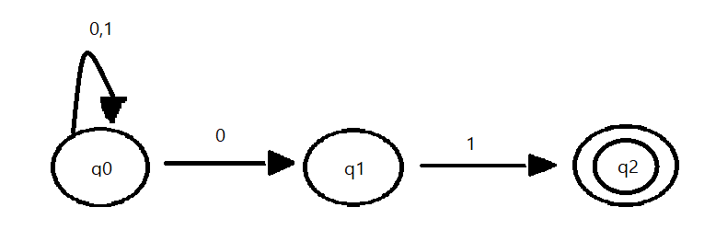

**NFA Transition Table :**

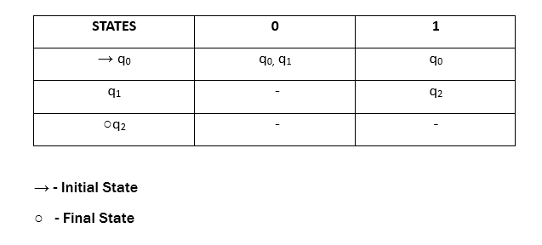

**DFA Transition Table :**

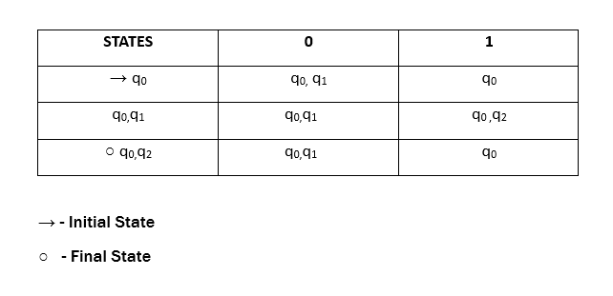

**DFA Transition Diagram :**

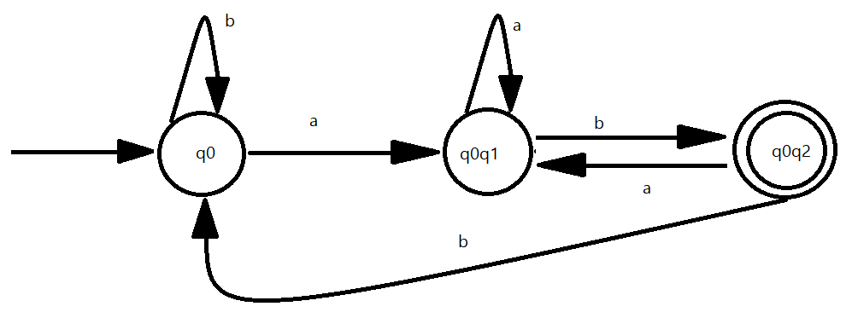

**LITERATURE SURVEY**

[1] "NFA to DFA Conversion in C" by Janhavi Gangurde, Komal Thakare, Aarti Ghuge, Shivam More, Rohan Waware” (2023): This paper provides a review of conversion in C language. The authors have also provided some future scopes in this area of research.

[2] "Converting an NFA to a DFA with programming C++ by M. Davoudi-Monfared*, R. shafiezadeh garousi, E. S. Haghi, S. Zeinali and S.Mohebali” (2015). This study explains the factor for converting NFA to DFA using several classes and different algorithm using C++.The authors said for the future purpose turing machine to implement in computers in C++.

**EXISTING SYSTEM**

1. Automata Theory : It is a mobile application that provides theory explanations of all the automata concepts. This application also provides some exercises with solutions.
2. Automa : A mobile application that provides conversions such as Regular Expressions to DFA, CFG to CNF , DFA minimization etc..

1. AutomaTaker : An application for mobile devices that provides visual representation of Automata as per the user requirements or the inputs given by the user.

**PROPOSED SYSTEM**

In the proposed system, Autover – is an automata converter developed in C#, which converts NFA to DFA. It gets an input string from the user and generates the tuples of NFA. There are 5 tuples in NFA , they are, “initial state, final state, number of states, transitions, input variables”. After generating the tuples, a possible NFA transition is generated with possible transitions. Then the generated NFA is checked for its validity. The NFA is validated by checking it for exceptions. The exceptions that may arise are, duplicate state, duplicate transitions,etc. and finally the NFA is generated.

Then the tuples for the equivalent DFA are generated. The transitions for the DFA are generated, and they are validated for any exceptions.

After validating the transitions, the output is a DFA for the given NFA.

**SOFTWARE USED:**

Tools : Visual Studio

Language :C# (C Sharp)

**FLOW DIAGRAM**

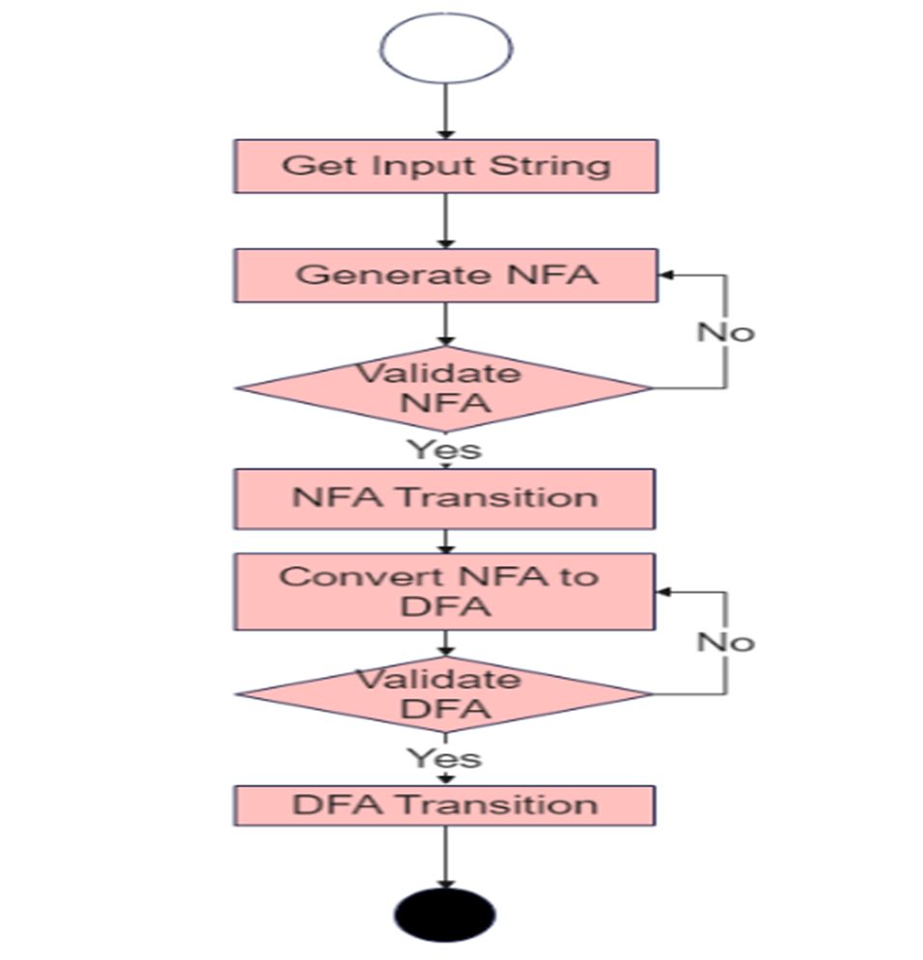

**SYSTEM ARCHITECTURE**

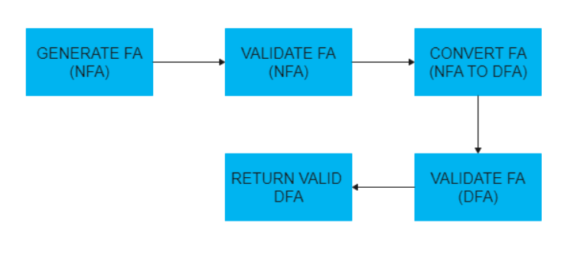

**CONCLUSION**

In this paper, the properties and exact usage of automata, both NFA and DFA have been discussed. This paper deals with the conversion of automata, here we convert NFA to DFA by the use of an efficient algorithm. We have used C# as language for developing the converter.

In future the converter will be improved with visualization of automata and other changes as and when required.

**REFERENCES**

[1] "NFA to DFA Conversion in C" by Janhavi Gangurde, Komal Thakare, Aarti Ghuge, Shivam More, Rohan Waware” (2023)

[2] "Converting an NFA to a DFA with programming C++ by M. Davoudi-Monfared*, R. shafiezadeh garousi, E. S. Haghi, S. Zeinali and S.Mohebali” (2015)

[3] "Deterministic vs. Non - Deterministic Finite Automata in Automata Processing" by Farzana Ahmed Siddique, Tommy James Tracy II, Nathan Brunelle, Kevin Skadron (2022)

[4] “Introduction to the Theory of Computation” by Micheal Sipser (2012)

[5] "Theory of Computation” by Manish Ranglal Singh, Shreya Guptan (2019)