SMS Classification Application

Pranali Valve¹, Swati Tile², Sanjana Tarle³, Prajakta Pandit, Ms. Rakhi S. Pagar⁵
Matoshri College Of Engineering And Research Centre, Eklahare, Nashik, India^{1, 2,3,4,5}
pranalivalve2001@gmail.com¹
tileswati2001@gmail.com²
tarlesanjana28@gmail.com³
panditprajakta5143@gmail.com⁴

ABSTRACT
Short Message Service (SMS) is an integral service of the mobile phone users to communicate with people which is faster and convenient way. Text classification is the process of classifying messages into predefined categories based on its contents. To control these limitations, we have accomplish a mobile application with title SMS Classification - Text Messenger which solves real time problems of text messaging. Our system provides core services of text messaging and beside to those various facilities such as classification of messages derived on personal, company, favourites, OTP, transactional, social and user defined categories like Starred messages, send SMS in secure manner. To overcome various limitations, we have proposed a mobile application with title SMS Classification Application - Text Messenger which solves real time problems of text messaging. In the proposed model we have used encryption and decryption for more security.

Keywords: Android SMS App, SMS, Categorization, Text Messaging App, Messenger.

I. INTRODUCTION

Currently, SMS is necessary part of every mobile user for getting important alerts, communication, banking OTPs etc and many other things. Alongside of the basic services there is opportunity to improve it. To reduce various limitations, we are developing an android application is going to increase the use of SMS by people in their regular life [1]. The user will avail all the facilities in the single application which would give him the easy interface for SMS and will make it comfortable to use it. Also, the various kind of new features are added to the application that will be helpful in removing the drawbacks faced in the current SMS applications in mobile devices [2].

Short Message Service (SMS) is a text Messaging functional component of a Web, Phone, or mobile communication systems. SMS Application is an interface or the middleware between the human and message to communicate with each other. SMS Application can be beneficial in personalized and adding the various features with respect to the user interface SMS messages are thought to be more cost effective to deliver and more likely to receive a faster response than letters. Confidentiality, dependability, security and speed of SMS are one of the most important promised industries such as financial industries, health care and enterprises, energy and commodities trading demand in their mission-critical procedures.

In this paper, we focus on some well-known applications of text categorization and also propose a new model for the classification of text SMS into some predefined categories.

II. LITERATURE REVIEW

The exhaustive literature survey consisting of the conceptual base for this project is briefly outlined here.
Short Message Service (SMS): SMS is growing in its applications. Besides companies and banks, but surprisingly Libraries, Doctors and many other functionality providers are using SMS as a inter communication between media and customers. Customer feedback, marketing, delivery tracking and Promotion of most of the service providers is depend on SMS [1].
Mobile Chat: This is the trendiest function over mobile phone networks. This paper preferred to analyse customer’s desire to use Mobile Messaging Applications (MMA) in India. This identifies that Indian students use SMS application, to pass the time and show themselves and variety of the functions in MMA. Understand usefulness also plays a major role in student’s intention to use MMA [2].
Voice SMS: User can send messages to the entered phone number or the number of contacts from the phonebook. It is an SMS application developed to permit a user to record and convert oral messages into text message. The SMS application is adjusted to input messages in English. In this paper we will give basic properties of the speech recognition and used algorithm. Speech recognition for Voice SMS adopt a strategy based on Hidden Markov Model (HMM).

A. Existing systems
Following existing applications that provides various feature on SMS but having some limitations to satisfy the users:

- Evolve SMS: This application has following properties:
  - Multimedia support
  - Password protection
  - Sliding conversations
  - Privacy
- 8 SMS: This application has following properties:
  - Stock Messages
  - Reply from popups
  - Clean Message

III. AIMS AND OBJECTIVES
- To develop the system for mobile phone users to communicate with people which is faster and convenient way.
- To categories the messages based on company, transactional, due dates, encryption and decryption.
- To filter data in user defined categories with color codes, searching with customized date, schedule text delivery, remainders for due dates.
- To implement the system for starred messages, pinned chats inside the application.

IV. SYSTEM ARCHITECTURE

Firstly, the SMS will be received by the mobile i.e., by the mobile SMS application. For all the procedure to be occurring the android application must be set as the in-built messaging application of the user. As soon as the message is received by the application the message is searched for the tokenization and being read for finding the particular keywords for finding its correct category. After this process the feature extraction procedure is being executed and on the basis of it the message is finally being segregated. Figure 1 shows representation of the system architecture.
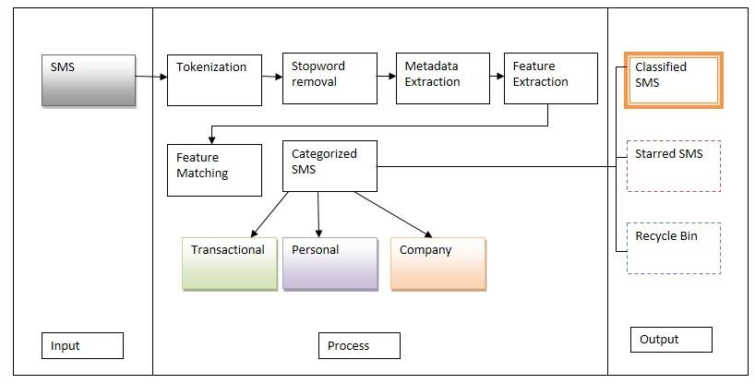
Figure 1. System Architecture

We have used tokenization, pattern matching, feature extraction. and keyword matching algorithms to classify the SMS. Stop word removal is used to remove general words like “a”, “an”, “the” etc.

V. ALGORITHM
1) Tokenization:
It will scan the text message, split the text by space, split the sentence by line and create tokens. It also used for searching reason. It helps protect message from the negative data.
- Input: Text/SMS
- Output: Token list
2) Stop word Removal:
It is one of the most commonly used preprocessing step. Stop word removal call tokenizer. Matches all the tokens in SMS, if matches found then execute next process and if matches not found then remove these words and clean the data. It helps to remove the low-level information from text in order to give more focus to the important information.
- Input: Text/SMS
- Output: Clean the data
3) Metadata Extraction:
It provides information about others data. It focuses on titles, subtitles and headings. It extracts prespecified types of facts from written texts or speech transcripts and converting them into structured representation (Ex. Text file/DB).
- Input: Text/SMS
- Output: Entities
4) Feature Extraction:
It is the filtration apply technique. It reduces redundant data from message.
- Content based filtering technique: Analyze words, occurrence of words, distribution of words, phrases the content and segregate them into categories.
- Adaptive filtration: Classify the incoming message into various groups and based on the comparison score of every group and then categorized.
5) Regular Expression:
Regular expression are patterns used to match character combination in strings. Create regular expression using regex class give the pattern to regular expression check match found by RE and if RE match create new category.
- Input: Text/SMS
- Output: Classify SMS
6) Pattern Matching:
It checks user mobile no digit by RE. Check length of digits.
- Input: Text/SMS
- Output: Classify SMS
7) Advanced Encryption Standard (AES):
AES is a symmetric encryption algorithm. The AES algorithm is used for encryption and decryption.
VI. USED TECHNOLOGY
Android: The system’s user interface is built using android. In this system android is used for front end development.
Java: The system is developed using the Java programming language, which is a popular language used for android development. In this system java used for Back end development.
System Cache: System cache is used for preprocessing on messages and store that SMS.

IX. MODULES AND RESULTS
1. Home Page
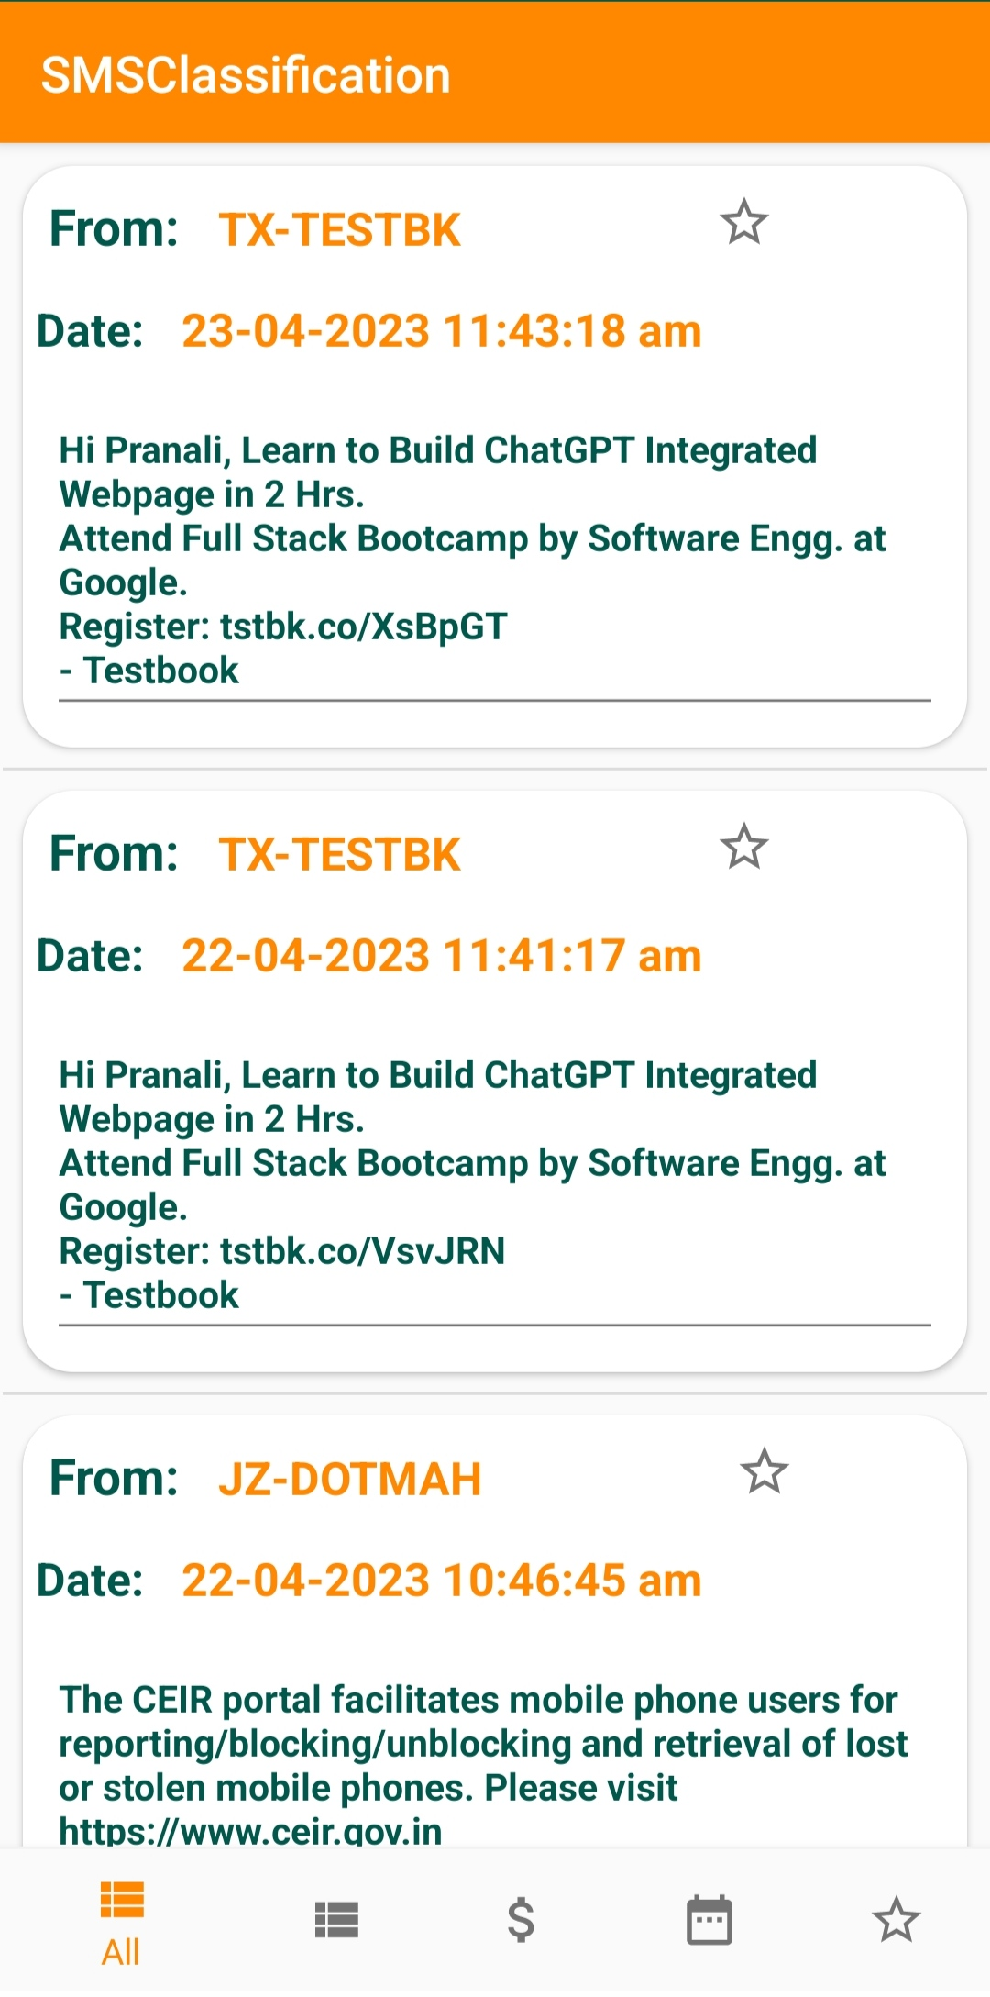
This image describes the system home page. In this there are shows all messages in "All" tab.
2. Company Module
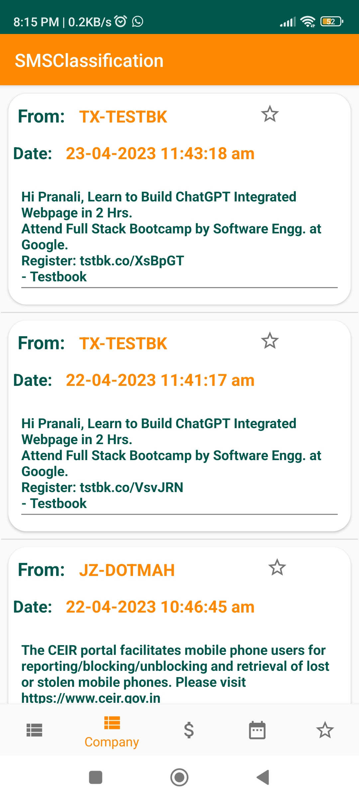
This image describes all company related messages are separate.

3. Transactional Module:
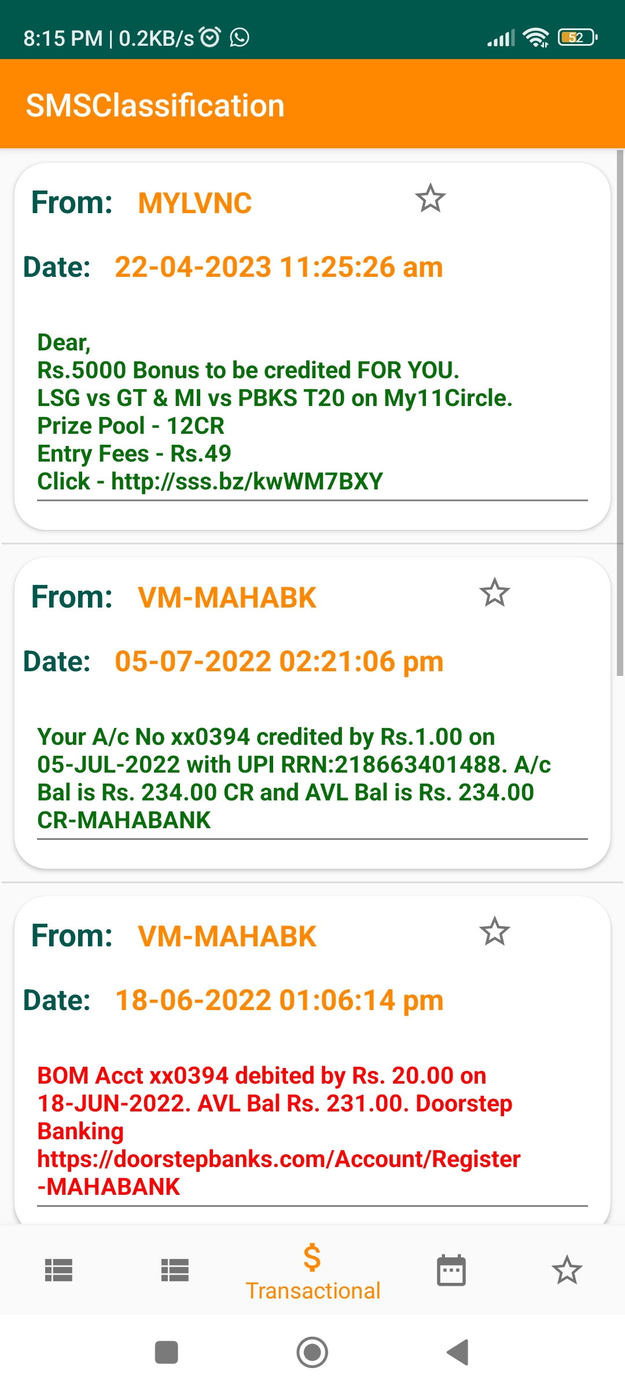

This image shows the all-transactional messages are separated in separate tab named "Transactional".

4. Due Dates
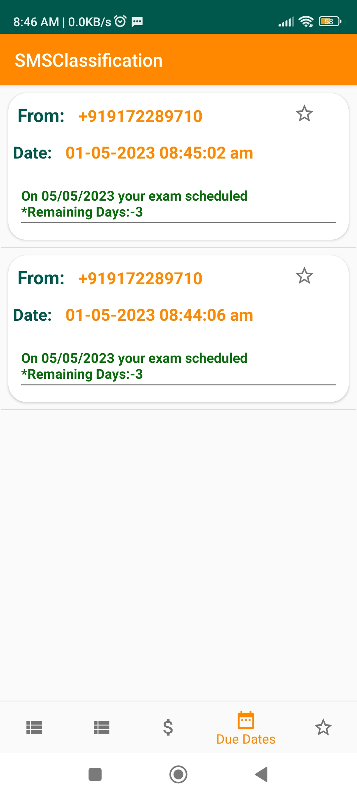
This image shows due dates for messages in separate tab.

5. Favourite
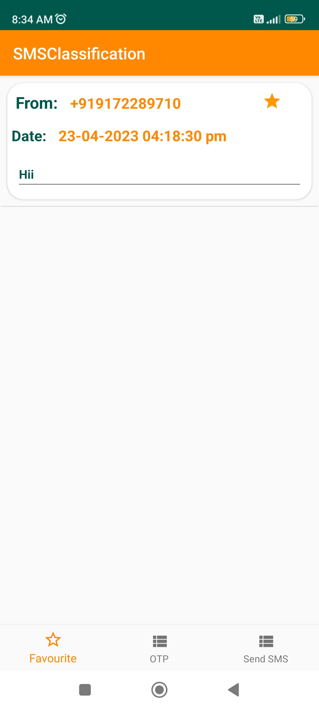

This image shows the all-favourite messages in separate tab.

6. OTP
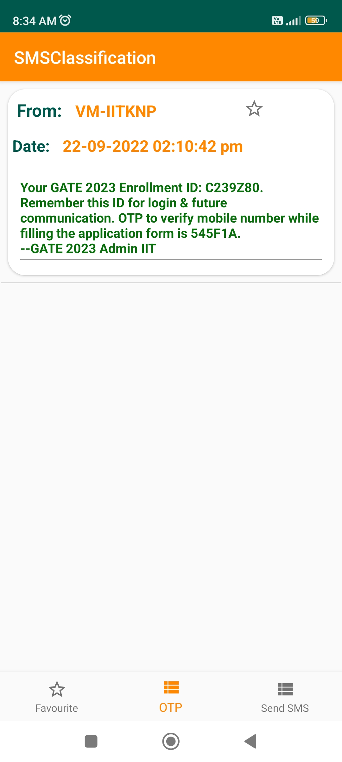
This image shows the all OTP related messages are come in OTP section.

7. Encryption and Decryption Module
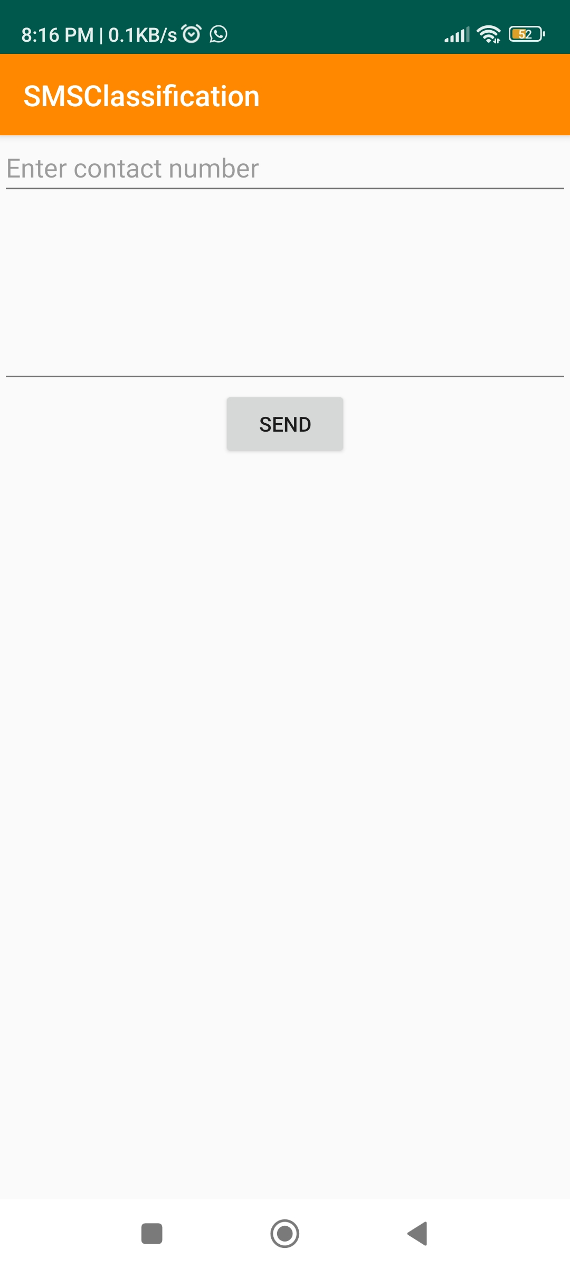
This image shows the process of encryption and decryption.
X. CONCLUSION
In this system user will available all the facilities in the single application which would give him the ease get of SMS and will make it comfortable to use it. Also, the various kind of new features are added to the application that will be helpful in removing the drawbacks faced in the current SMS applications in mobile devices.

XI. REFERENCES
[1] Uysal, A.K., Gunal, S., Ergin, S., et al.: ‘The impact of feature extraction and selection on SMS spam filtering’, Elektron. Elektrotech., 2013, 19, (5), pp. 67–72
[2] Junaid, M.B., Farooq, M.: ‘Using evolutionary learning classifiers to do mobile spam (SMS) filtering’. Proc. of Genetic and Evolutionary Computation Conf., Dublin, Ireland, July 2011, pp. 1795–1802
[3] Almeida, T.A., Hidalgo, J.M.., Yamakami, A.: ‘Contributions to the study of SMS spam filtering: new collection and results’. Proc. 11th ACM Symp. Document engineering, New York, USA, September 2011, pp. 259–262
[4] Bozan, Y.., Çoban, Ö., Özyer, G.T., et al.: ‘SMS spam filtering based on text classification and expert system’. 23nd Signal Processing and Communications Applications Conf. (SIU), Malatya, Turkey, May 2015, pp. 2345–2348
[5] Delany, S.J., Buckley, M., Greene, D.: ‘SMS spam filtering: methods and data’, Expert Syst. Appl., 2012, 39, (10), pp. 9899–9908

[6] Ho, T., Kang, H., Kim, S.: ‘Graph-based KNN algorithm for spam SMS detection’, J. Univers. Comput. Sci., 2013, 19, (16), pp. 2404–2419

[7] Uysal, A.K., Gunal, S., Ergin, S., et al.: ‘A novel framework for SMS spam filtering’. Int. Symp. Innovations in Intelligent Systems and Applications, Trabzon, Turkey, July 2012, pp. 1–4

[8] Fernandes, D., Costa, K.A.P., Almeida, T.A., et al.: ‘SMS spam filtering through optimum-path forest-based classifiers’. IEEE 14th Int. Conf. Machine Learning and Applications (ICMLA), Miami, FL, USA, December 2015, pp. 133–137

[9] Karasoy, O., Balli, S.: ‘Developing mobile application for content base spam SMS filtering and comparison of classification algorithms’. Int. Artificial Intelligence and Data Processing Symp., Malatya, Turkey, September, 2016, pp. 47–53

[10] Arifin, D.D., Shaufiah, , Bijaksana, M.A.: ‘Enhancing spam detection on mobile phone short message service (SMS) performance using FP-growth and Naive Bayes classifier’. IEEE Asia Pacific Conf. Wireless and Mobile (APWiMob), Bandung, Indonesia, September 2016, pp. 80–84

