Finding Missing Person Using AI

Prof. Vani B

*Dept. of Computer science Sambhram Institute of Technology Bengaluru, India*

Lokesh Singh, Rohan Khati, Devesh Srivastava, Abhishek Bhagat

*Dept. of Computer Science Sambhram Institute of Technology Bengaluru, India*

***Abstract*—Facial recognition is a biometric technology that employs mathematical algorithms to create a unique facial print of an individual. This information is then stored in a database as mathematical or graphical representations of the person's facial features. The face recognition model implemented in our system utilizes this data to detect and match an individual's face against the database. If a match is found, it will trigger an alert to both the law enforcement and the individual's guardians.**

***Keywords—face recognition, KNN, missing person, databases***

1. INTRODUCTION

Every day, an enormous number of people around the world, including children, teenagers, the elderly, and individuals with cognitive impairments such as Alzheimer's, go missing without a trace. Unfortunately, many of these individuals are never found. This paper proposes the implementation of a face recognition system to assist law enforcement and the public in accelerating the process of searching for missing persons.

Using face recognition technology offers significant benefits in locating missing individuals. To streamline the process of finding the missing person, the authors plan to develop an application that can be accessed by volunteers to quickly identify missing persons. This will greatly facilitate the task of law enforcement in finding a specific person.

Furthermore, there is a need to automate the task of finding the missing person by using facial recognition to compare images and verify if they possess similar characteristics. By doing so, the system can verify whether the missing person in the image captured from a particular location is correct. Once confirmed, law enforcement can proceed with the next steps to locate the person from that area. The proposed application will feature data storage for all the missing persons to enable the system to detect image data and trace the missing person.

1. MOTIVATION

The process of finding a missing person in India is a lengthy and time-consuming procedure. It can take a significant amount of time to launch an FIR in a police station, and there is a shortage of personnel available for searching for missing persons. Unfortunately, this leads to many cases remaining unresolved.

The number of missing children in India is alarming. On average, 296 children go missing every day, and half of them remain untraceable. In 2020, during the Covid-19 pandemic, the National Crime Records Bureau reported a total of 108,234 missing children across India. Shockingly, 33,456 of them were girls, 15,410 were boys, and 43,661 remained untraceable by the end of the year.

These statistics are a clear indication of the need for a national Missing Children's repository in India.

Unfortunately, there are no budgets earmarked for tracking missing people, according to an official source.

To address this issue, it is necessary to invest in technology that can aid in locating missing persons. Implementing a face recognition system could accelerate the process of finding missing persons and make the job easier for law enforcement. An application that can be accessed by volunteers could also help in identifying missing persons in a short span of time.

Moreover, there is a need to raise awareness about the issue and educate people on how they can help locate missing persons. This includes teaching individuals how to report missing persons and providing them with resources to aid in the search.

In conclusion, it is essential to take proactive measures to address the issue of missing persons in India. Implementing a national Missing Children's repository, investing in technology, and educating the public can help in locating missing persons and prevent many cases from remaining unresolved.

1. EXISTING SYSTEM

Upon visiting the website, we identified an issue with the process of submitting pictures of suspicious children in a user's area. The submission process is not only complicated, but also lacks anonymity, which can discourage users from participating. Furthermore, those who employ these children are often powerful individuals, making it even more difficult for people to come forward with information. Given the scale of this problem, an automated solution using machine learning should be implemented.

To address this issue, we propose the creation of a tab on the website that provides access to information on missing persons, as well as a tab for recovered children. This would allow users to easily access important information and photographs that can aid in identifying missing children. By using machine learning, we can also automate the process of matching and identifying missing children, making it faster and more efficient.

Overall, improving the submission process for identifying missing children and implementing an automated solution using machine learning would greatly benefit the initiative. This can help to increase the number of people who participate, as well as reduce the time it takes to identify missing children and reunite them with their families.

XXX-X-XXXX-XXXX-X/XX/$XX.00 ©20XX IEEE

1. LITERATURE SURVEY

We did lot of survey and summed up following regarding. literature survey so firstly, S. AYYAPPAN and his fellow mates from IFET College of Engineering have a presented a paper which deals with a similar problem statement and objective. The system proposed by them makes use of Deep. Learning based Facial Feature Extraction and matching with stacked convolutional auto encoder (SCAE). The images of missing Persons are stored in a database. Faces are detected. from those images, and a Convolutional Neural Network learns features. These learned features were utilized for training a multi-class SVM classifier. They used this method to identify and label the kid correctly. The main difference between their work and ours is that we are going to create a dataset of lost persons with the help of people who want to contribute to society (voluntary work).Also we are not going to disclose the details of lost person with the public. And their system involves complex algorithms which make the process of extraction and classification slower [1].

Previously, Shefali Patil and his fellow mates from SNDT Women’s University, Juhu, Mumbai have a presented a paper which deals with a similar problem statement and objective. The system proposed by them uses KNN Algorithm which makes use of 136 * 3 data points to recognize Face. The main disadvantage of using the KNN method is its accuracy 71.28% and also it does not address cross-age face recognition. The main difference between their work and ours is that here we are going to create a dataset using a mobile application with voluntary work of people. We are going to use AWS facial reorganization which has cross-age face recognition. Also, our dataset is going to be stored in the cloud database.[2]

In 2020, Sarthak Babbar, Navroz Dewan, Kartik Shangle and his fellow mates from Jaypee Institute of Information Technology, Noida, India team gave out a paper in which it gave us very clear idea about how Amazon Web Services (AWS) Recognition works and it compares AWS recognition with other algorithms and systems like CDAC- VS, CNN. So this paper helped us in identifying the algorithm that we are going to use in our project e.g. Amazon Web Services (AWS) Recognition Our faces will change with time as our age increases, while the pictures in our dataset remain the same. We intend to study the accuracy of Residual Network (ResNet) for the purpose of cross-age face recognition. The performance is compared to cross-age reference coding (CARC), Amazon Web Services (AWS)Recognition and other techniques on the various data set viz., cross-age celebrity dataset (CACD) and a verification subset CACD-VS. ResNet and AWS Recognition achieved 98.40% and 99.45% accuracy, respectively on the CACD-VS dataset.[3]

In August 2016, Rohit Satle and his team presented a paper which addresses the face recognition system built by using Principal Component Analysis(PCA) method. The two main drawbacks of applying the PCA method are that computational complexity is high, and it can only process faces with similar facial expressions. The main difference

between their project and ours is that our project can identify the particular person even if different facial expressions are there in both images. Our system will also detect particular person’s 2 different images, one image with moustache and another image with no moustache. We will make use of AI for recognition of images which will definitely increases our accuracy level.[4]

According to the research paper presented by Birari Hetal and her fellow mates from Late G.N. Sapkal College of Engineering, who had also deal with the similar problem statement and objective. They have made the Android application for making the task of missing person easier. The Android Application proposed by them makes use of SWF-SIFT algorithm for comparing two images. In their application, only Admin and some trusted people like police, etc., can update the data set continuously. The main difference between their system and our system is that we are going to allow application users for uploading images (update data sets) of suspicious peoples like child beggars whom they think that they are missing. Although the images uploaded by that particular user is not viewed on our application to anyone except Police Department. So we are trying to keep that data in safe hands. [5]

In August 2014, Swarna Bai Arniker and K.Sita Rama Rao his team from Research Centre Imarat, Hyderabad presented a paper which gives use insights of RFID Based Missing Person Identification System This RFID reading equipment may be maintained at all police stations and public gatherings in the future. This has applications for recognizing lost children, physically challenged children, senior citizens and handing them over to their guardians. The prerequisite is that the person must physically put on the RFID tag. So it has limitation of carrying that RFID Chip which will track the particular person.[6]

1. PROPOSED SYSTEM

The proposed system makes use of various methods for finding missing people.

The system structure is presented in **Fig.1.**

Overall Structure of Proposed System To prevail over the drawbacks of previous systems. We are building a system that existing systems were not having.

We plan to add concepts regarding how the interface ought for adding new complaints and how to register the new case. The face recognition model in our system will try to find a match in the database with the help of AWS recognition. It is performed by comparing the face encodings of the uploaded image to the face encodings of the images in the database. If a match is found, it will be notified to the police and the people related to that person along with the location of where the person is found.

The proposed system contains the following Modules: Volunteer Module:

* Volunteer Registration/ Login (Using E-mail ID, Mobile Number, Password, etc.)
* Filling in the details such as the location, age of the suspected missing person and then upload the

image of a suspected missing person. **Police / Authority Module:**

* Police/ Authority Login (Using Email ID, Mobile Number, Password)
* Registering Complaint about the missing person.
* Uploading the image and other details of the missing person (eg. Name, Age, Sex, Living Location).
* Search the uploaded image with a stored database, if found then give result as match found and also send an email to the user and if not then store as a new entry.

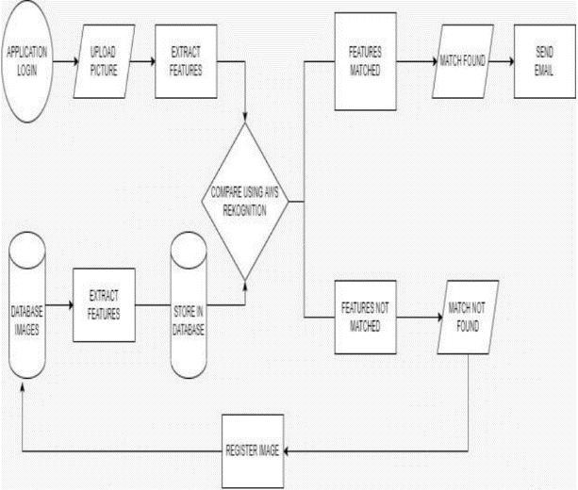

# Fig 1. The system structure.

1. TECHNICAL PROPOSION

When a new image of a missing person is received, the KNN algorithm can be applied to find the k-nearest neighbors in the database of non-missing individuals. If the image of the missing person is similar to one or more individuals in the database, it may be possible to identify the person or generate leads on their whereabouts.

The KNN algorithm can also be used to detect anomalies in a set of images. For example, if a missing person is suspected to be in a certain area, images from that area can be collected and compared to the database of non-missing individuals. If an image is found that is significantly different from the others in the set, it may be an image of the missing person.



# Fig 2. Admin side window

Overall, KNN can be a useful tool for facial recognition in finding missing persons. By creating a database of images and using the KNN algorithm, it is possible to identify individuals who may match the features of a missing person and generate leads on their whereabouts.

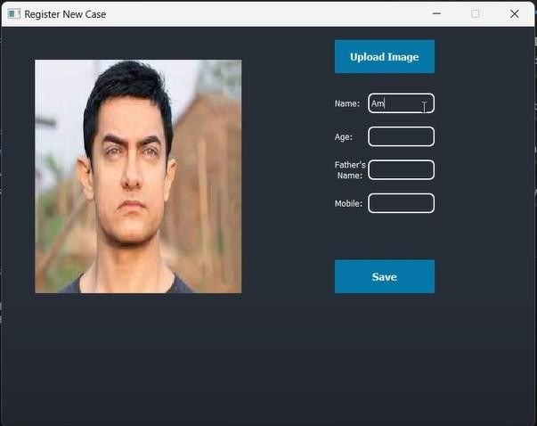

# Fig 3. Admin side after image upload

The K-Nearest Neighbors (KNN) algorithm is a machine learning technique that can be applied to facial recognition for finding missing persons. KNN is a classification algorithm that works by finding the k-nearest neighbors to an input sample based on a distance metric. In the case of facial recognition, the input sample is an image of a missing person, and the k-nearest neighbors are images of individuals in a database that are most similar to the input sample.



# Fig 4. Volunteer side interface

1. CONCLUSION

One-shot learning-based image recognition has emerged as a powerful technology with various potential applications, such as in Hotels, Hospitals, and other industries, where it can be leveraged to instantly identify criminals and enhance security measures. The use of face recognition technology in identifying missing persons has significantly expedited the process, replacing the traditional manual scanning of databases with an efficient and speedy approach.

In the future, the system is expected to be extended by integrating it with public cameras to enable real-time face detection. With this integration, the system will continuously monitor the frames being captured by the public cameras, and once a missing person is identified in any of the frames, the concerned authorities will be immediately notified. This will eliminate the need for manual monitoring, and the system will accomplish the task in a much shorter time frame. Overall, the integration of

face recognition technology and one-shot learning has resulted in a more efficient and reliable approach to identifying missing persons, and further advancements are expected to improve the effectiveness of the system.

REFERENCES

1. S. Ayyappan and S. Matilda, “Criminals and missing children identification using face recognition and web scrapping” IEEE ICSCAN 2020.
2. Shefali patil, Pratiksha Gaikar, Divya Kare, sanjay Pawar, “Find missing person using AI”, International journal of Progressive Research in Science and Engineering, Vol. 2, No. 6, June 2021.
3. Sarthak Babbar, Navroz Dewan, Kartik Shangle, Sudhanshu Kulshreshtra, Sanjeev Patel, “Cross Age Face recognition using Deep Residual Networks “. IEEE 2019 Fifth International Conference on Image Information Processing (ICIIP).
4. Bharath Darshan Balar, D S kavya, Chandana M, Anush E, Vishwanath R Hullipalled, “Efficient Face recognition system for identifying lost people”, International Journal of engineering and standard technology (IJEAT), ISSN:2249-8958, Volume-8, Issue-5 S, May 2019.
5. Birari Hetal, Sanyashiv Rakesh, Porje Rohan, Salwe Harish,” Android Based Application-Missing Person Finder”, IRE Journals, Volume1 Issue 12, ISSN: 2456- 8880
6. Swarna Bai Arnikar, G. Kalyani, D. Meena, M. Lalitha, K. Shirisha, Seetasaikiran, “RFID based missing person identification system”, IEEE 2014 International Conference on Informatics, Electronics & Vision (ICIEV).
7. Sayan Deb Sarkar and Ajitha Shenoy, “Face Recognition using Artificial Neural Network and Feature Extraction”, IEEE 2020 IEEE 7th International Conference on Signal Processing and Integrated Networks.
8. https://trackthemissingchild.gov.in/trackchild/index.ph p National government tracking system for missing & vulnerable children’s.4208/jcm.1512-m2015-0241.